
HOW BELIEFS, ATTITUDES AND VALUES OF INDIVIDUALS IMPACT WORKPLACE BEHAVIOUR




Title page
Student name: Nusrat Yasmin Shitara
Student number: 1712117
Module name: Developing workplace critical thinking
Module code: BMSK5001
Assignment title: how individuals’ beliefs, attitudes and values impact on workplace behaviour
Tutor name: Ernest Ovia

Table of Contents
Executive Summary 4
Part A: Personal beliefs, values and attitudes 4
Introduction 4
Beliefs 4
Values 4
Attitude 5
Part B: Organisational beliefs, values and attitudes 6
Application to my workplace experience 7
My workplace values 7
We put citizens first 8
My personal beliefs, values and attitudes 9
Part C: Application of management theories 10
Introduction 10
Classical Management Theory 10
Scientific Management Theory 11
Administrative management theory 11
Functions of management 12
1. Planning 12
2. Organizing 13
3. Commanding 13
4. Coordinating 13
5. Controlling 14
14 Principles of management 14
Principles of Management and application to my workplace 15
Analysis of Fayol’s theory 18
Conclusion 19
Reference List 20

Executive Summary

The purpose of this paper is to examine in detail the impact values, attitudes and beliefs have on behaviour at the workplace. In order to carry out this analysis, this paper will carry out an application of a management theory to my own experience of work and assess how this has impacted on my own values, attitudes and beliefs.

Part A: Personal beliefs, values and attitudes

Introduction

As human beings each and every one of us has a set of beliefs, values and attitudes which are different to that of others but also which we might collectively share with others. These values, attitudes and beliefs are formed over time and by various factors such as our environment, our cultural experiences, and by those who surround and influence us. Equally, our values, beliefs and attitudes are fluid and change over time.

Beliefs

Belief is an acceptance that something or someone is true or exists. Belief can be formed by various factors which can be tangible and objective, or intangible and subjective. For example, beliefs can be formed by personal experiences or societal or cultural norms – a god example being religious beliefs.
Until a thought or experience is accepted as a ‘belief’ it does not form part of an individual’s identity and what is known as their ‘belief system’.

Values

Values are equivalent to standards that individuals hold themselves to as well as others. It is what an individual considers to be the most important principles to live and abide by in everyday conduct.
It is possible that a belief will convert to a value if it forms an integral part and fundamental character to them. For instance, the belief that lying is bad might be converted into valuing honesty in a person.

Attitude

Attitudes are comprised of three principle elements which are abbreviated as “ABC” – affective, behavioural and cognitive. The first element is the emotional response. The second element is the outward display/behaviour. The final element is the mental evaluation based on the internal values and beliefs. Attitudes are a construct of the psyche which is formulated and constructed by mental and emotional experiences, and which characterise an individual. Attitudes are also formulated of a matrix of experiences, values and beliefs that an individual possesses.
Attitudes in turn then influence how an individual behaves. For instance, having an attitude towards a certain political organisation will be formulated by the underlying values and beliefs they hold, which in turn, influences how they behave. So, in this analogy, an individual might have a negative attitude towards the Conservative political party because they value pro working class agenda and believe the Conservative party benefits the middle class in society and base this on the experiences of the Margaret Thatcher era. All of this influences the behaviour of the individual who votes for the Labour party based on all of these factors.
In addition to and notwithstanding the above, an individual’s attitudes can also be influenced by beliefs and values which are not ingrained and internalised. A good example of this is peer-pressure where, typically teenagers have an attitude towards something which isn’t aligned with their internal values and beliefs, but rather is formed by external and transpiring beliefs and values.

The below diagram illustrates the inter-connected relationship between values, beliefs and attitudes and this influences behaviour.
Figure: 1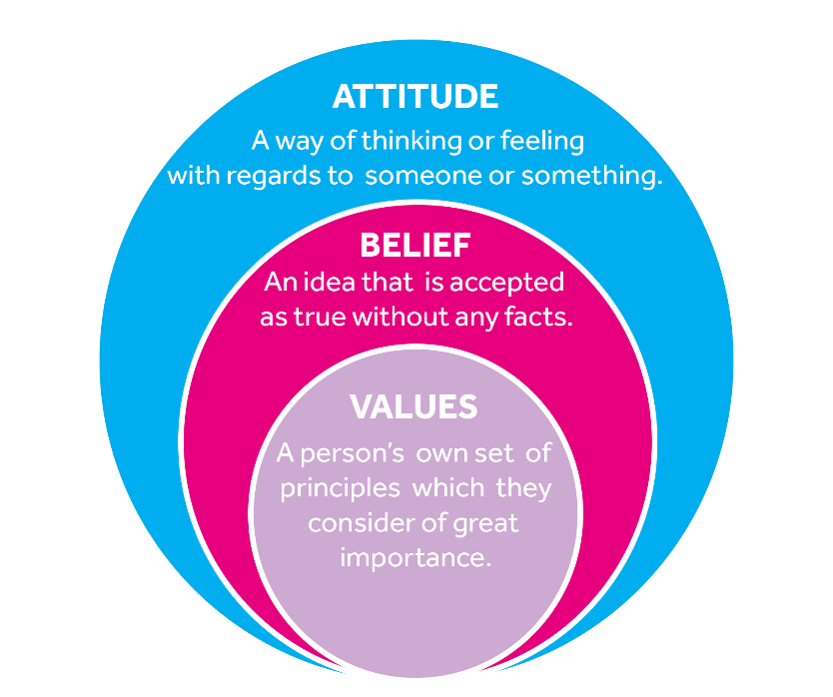

Part B: Organisational beliefs, values and attitudes

Although there might be some similarities, individuals have their own set of beliefs, values and attitudes and this is no more visible than in an organisation, where people are of all ages, race and backgrounds. It is critical to acknowledge, respect and allow for individual differences in beliefs, values and attitudes to flourish. Having said that, such individual beliefs, values and attitudes will need to align to some degree to the core values of an organisation in order for both to be a good fit for each other. As one academic put it, the level of alignment has a direct correlation with how satisfied employees are within their organisation.

Figure: 2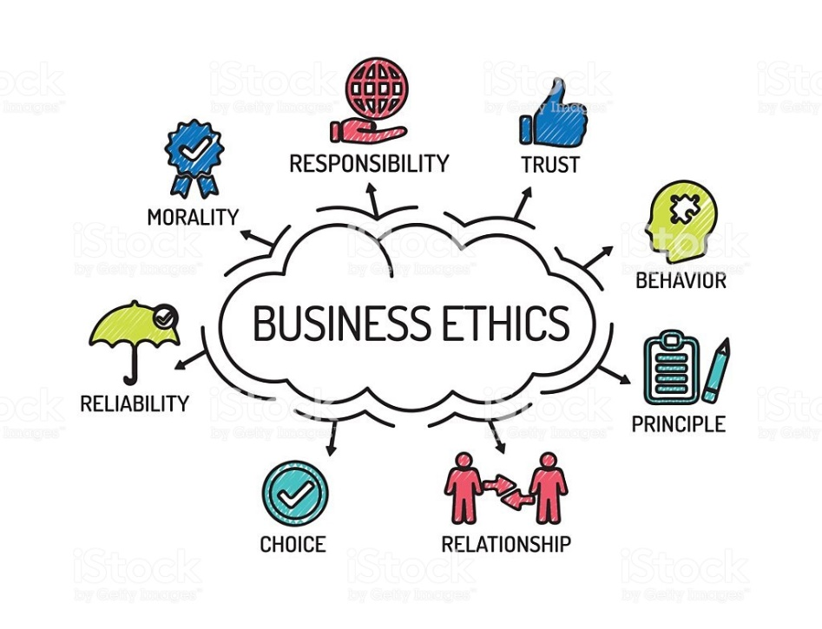

Application to my workplace experience

My previous workplace experience was at Wilkes Green Infant School (now known as William Murdoch Primary School) which is governed by Birmingham City Council.
As the council for the second city in the United Kingdom, Birmingham City Council is the one of the largest local government established in United Kingdom.
In my personal experience, working at Wilkes Green Infant School and for Birmingham City Council was more than just a profession. For me, it was being part of a bigger organisation which provided services across the board to all residents living in Birmingham. They have an open door policy which welcomes employees from all backgrounds and level of experiences.

My workplace values

As set out on the official website for Birmingham City Council, it has the following core values:
- “We put citizens first: We are empathetic and respectful in everything we do
- We are true to our word: When we make promises we keep them.
- We act courageously: We lead, we manage and we tackle the difficult issues: every day, every one of us.
- We achieve excellence: We get things right. First time every time.”

We put citizens first

This value revolved around putting the citizens of Birmingham at the centre of everything that is done and let this drive the agenda rather than other factors, such as politics.
In order to be able to practically deliver on this value, the Council needs to be empathetic and understanding of what issues are important and faced by citizens.
It is also underpins the promotion of equality by ensuring not to discriminate against any person for any reason including, but not limited to, gender, race or disability.

We are true to our word
This value relates to Birmingham City Council delivering on the promises it has made. To do this, the Council must listen to concerns of citizens and make it accessible to its citizens. Being honest and acting with integrity are key to this value.
We act courageously
This value is based on doing what is right even when it might be difficult and acting with integrity. It underlies the need to take responsibility and lead the way for change for the better.
There is also an element of being able to be honest and admit to mistakes and faults – having the courage to do that – but then also making changes to ensure same mistakes are not repeated continuously.
We achieve excellence
Birmingham City Council makes every effort to achieve excellence in what it does. Key to succeeding in doing this is ensuring that there is a clear vision which can only be achieved by being informed of what citizens want, which naturally define the roles and responsibilities of the Council.

My personal beliefs, values and attitudes

As an individual, I have my own set of beliefs, values and attitudes which have developed over time since childhood. As mentioned before, there are various factors which form such beliefs, values and attitudes such as family and friends, cultural and life experiences and religious beliefs. My own individual values, beliefs and attitudes govern how I function as a person and, as such, dictate my attitude and behaviour in the working environment.
With regards to which values, beliefs and attitudes I consider to be core, I would consider family, religious beliefs, honesty and hard working as some of the main values, attitudes and beliefs that define me.
Family
Balancing family life and work commitments is a constant struggle. It is helpful that my workplace also values family life and as a result of that has processes in place which make it easier and acceptable to have a family life at work. For example, work are understanding of emergency childcare arrangements that may arise or that children/someone you care for might have fallen ill suddenly, and will use best endeavours to give you the time off from work in order that you can deal with these matters.
Religious beliefs
My religious beliefs provide a way of life and form the basis of how to conduct myself in everyday life. There are several values that I can think of which also apply to my workplace such as the belief that everyone should be treated equally and behave with honesty and integrity.
On some occasions the religious beliefs can make it seem to be at differing ends to the core values, for instance, that I excuse myself from certain activities, however on a deeper level it is not as it is about inclusion not in spite of our differences but because of our differences.
Hardworking
I value hard work and the concept of everyone working as part of a team to achieve the same objective. I found in my workplace that such behaviour was encouraged and nurtured.

Integrity
I am constantly mindful to respect the values and beliefs of others, even when they are different to my own.

Part C: Application of management theories

Introduction

Management has been defined as the harnessing of principles relating to the functionality of a business, directing the organisation and guiding it in a certain direction. Every organisation needs efficient management and indeed, business history has shown that organisations can fail because of poor management.
In this section of the paper, we will be discussing the different management theories that exist and examining its application to my role in the workplace in the context of my values, attitudes and beliefs.

Classical Management Theory

Classical Management Theory works on the basis that employees have only economic and physical needs. Such a theory excludes societal needs or satisfaction of job. Rather, the focus is on profit-maximization through labour. In other words, focus is on output and that is rewarded by management with salaries and bonuses.
The theory was designed specifically to increase productivity and maximise profit, and the idea developed in the 1900s with huge popularity. The theory is not as popular as it used to be, but nonetheless some of its principles are still relevant today.
Classical Management approach has three different schools of theories:

Scientific Management Theory
Scientific Management Theory is synonymous with Frederick Taylor who is sometimes described as the founding father of this school of thought. Frederick’s approach was to boost productiveness levels by making the process more efficient and streamlined based on a scientific approach. Frederick’s theory was based on the notion that managers were intellectually superior to their employees and had a vested interest to oversee the roles of their subordinates. As such, this theory was suited to manufacturing and production line organisations.

Administrative Management Theory
Administrative Management Theory was the brainchild of Henri Fayol. Whilst the scientific management theory was focused on increasing productivity, Henry Fayol’s theory was concerned with making sure there were effective guidelines in place to manage an organisation. He also pioneered the change of thinking to understand that management was a skill that could be learnt. Previously it was that thought that managers were born with that skill, and it could not be taught.

Bureaucracy Theory
Bureaucracy Theory was promoted by Max Weber who believed that a perfect organisation would have separation of labour roles which were made clear with a chain of hierarchy, with emphasis on everyone having the technical ability to complete their jobs.
In this paper, I will be focusing on the theory coined by Henri Foyal and known as administrative management theory.

Administrative management theory

Henri Fayol was an engineer in his day and became the managing director of the company he worked for.
He believed that management was a skill and, like any other skill, it could be learnt/taught. Fayol drew on his 30 plus years and his managing director experience to develop his theory. Fayol’s theory states that there are five functions and fourteen principles of management.

Functions of management

Fayol developed the five functions of management, which is set out in the illustration below.
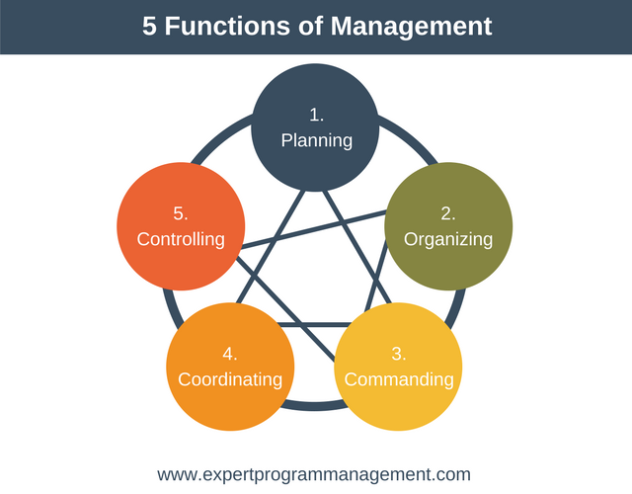
Figure:3

1. Planning
The first function of management is planning. This requires management to think ahead and making decisions based on future projections.
In Fayol’s opinion, the planning stage was the most difficult function out of all the five functions. This is because it required foresight – need to know what your end goal is and have a concrete idea of the steps that need to be actioned to achieve that goal. Planning also requires someone to not only identify in a meaningful, actionable way what steps need to be executed, but also to identify the person or persons who will be the executioner of those steps.

2. Organizing
An organisation that has incredible vision but is not organised, will most likely fail. Like with most things, there has to be structure and order together with some level of governance for an organisation to succeed. This becomes even more important the bigger the size of the company.
An organisation needs to ensure it has enough capital to sustain itself and pay for supplies, salaries etc. It needs to have a governance structure so decisions can be made, by the right people at the right time to ensure efficiency, but also sometimes compliance with laws, regulations and best practices.

3. Commanding
Having clear lines of command and instructions ensures everyone knows what their roles are which are defined enough to give certainty, but also allow for individuals to take responsibility and exercise some autonomy.
Without such parameters in place, roles become blurred and no one within the organisation knows whether certain tasks are being completed or not, or whether there is duplication of work. A good illustration of commanding is the role of a project manager, who ensures everyone is given and knows they have a specific role to complete, but also each person has enough autonomy to use their initiative to complete their role/task.

4. Coordinating
Even where the above three functions exist within an organisation, it will not work properly unless the roles are co-ordinated.
So for example, the delivery of a project to a set deadline, will require all the different roles to perform and deliver at the same time. In order to achieve this, those different roles need to co-ordinate with each other. It may even be the case that some of the roles are intertwined and rely on performance of the other, in order that they can complete their tasks.
Communication plays a key role in ensuring there is effective co-ordination.

5. Controlling
The final function is control. There has to be a degree of control to ensure standards are met and the organisation succeeds. To ensure that the steps are completed to a certain standard which is needed to meet the end goad, management need to exercise control.
The function of control usually happens in a four-step process:
Step 1: Establish performance standards based on organizational objectives.
Step 2: Measure and report on actual performance
Step 3: Compare results with performance and standards
Step 4: Take corrective or preventive measures as needed.
By way of example, management will set standard for a particular role/task. These can be internal standards as well as external standards (i.e. legal requirements). Performance might be measured by output and management will compare the output against last year’s performance but also against peers. If needed, management might take measures to improve performance.

14 Principles of management

Below is a picture diagram of the fourteen principles of management as designed by Henri Fayol.
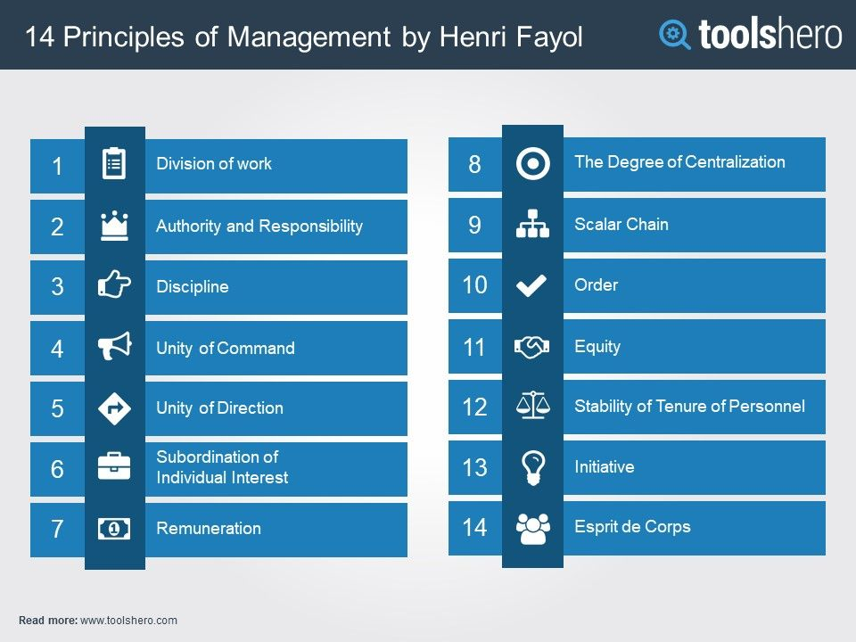
Figure: 4
This paper will apply those principles of Henri Fayol which are most relevant to my workplace.

Principles of Management and application to my workplace

Division of work

It is well regarded by economists that division of labour is key to efficiency in the operation of labour. At my workplace in a primary school, there are several layers of division between management, teaching staff and administrative staff. As it is a primary school the main function is to teach and the teaching staff (teacher, assistants etc) are the first category of labour. The other categories of labour, which are just as important given that the teachers will not be able to do their jobs without them, are the management team and administrative teams.
Everyone has a defined role and knows what is expected from them in that role.

Having said the above however, Fayol’s theory neglects to factor in fluidity between roles. For example a manager’s role at my workplace will be to manage the school from its finances to meeting with local authority. However, most managers were teachers in their previous roles and so, from time to time and when needed, will step into the role of teacher.

Authority and responsibility
Fayol considers authority and responsibility to be two-fold. There is official authority which comes from the position held within an organisation and there is the ‘unofficial’ authority which comes from the respect others show you based on your intelligence, morality and past services.
Authority is the ability to give orders to others who then follow them through according to Fayol.
In the school context, the management team have reporting obligations to the local authority and the Office for Standards in Education (OFSTED). It is their responsibility to make sure the school performs in accordance with those standards. Management, as part of making sure the school is compliant, will request the teaching and administrative staff to carry out certain functions, do a certain thing. Although the successful running of the company is the responsibility of all and everyone plays an instrumental part in the school’s success, everyone has to account to management, who in turn make sure the wider objectives and goals are being met.

Discipline

Discipline relates to enforcement. To ensure people respect authority, follow orders etc there has to be some negative consequences when these do not happen.
Fayol’s theory however is very narrow and simple when it comes to discipline. It does not take into account the other factors that might be at play.
For example, at the primary school I worked at, a staff member who was turning up late for work would, according to Fayol’s theory need to be disciplined without question. However, there is a subjective element and management would want to know the cause of the lateness and see if anything can be done to help. For instance, if it was because of personal issues at home, management would be more understanding.

Unit of Command
This notion is based on the premise that there should be a line of command, being the line of authority – employee reports to one/class of supervisors.
At my primary school, each teaching staff is assigned a mentor, but they also report to each head of subject, who in turn reports to the deputy head and, ultimately the head teacher.
Although the head teacher is the person with the highest level of authority and at the top of the unit of command, there is a chain of others with delegated authority with its own reporting chain.

Unity of Direction
The principle of unity of direction states that the different roles all lead into one plan/one goal.
Whilst the head teacher is ultimately responsible for decision making at the school, his decisions will influenced by the collaboration that takes place between management, teaching staff and administrative staff. .

Equity

For all of the other principles to work, each person has to willingly participate and share and be vested in the same beliefs, values and attitudes. Fayol described this as having an equitable stake and interest in the organisation and the team.
At school everyone is treated fairly and without prejudice and their contributions valued. To show appreciation to those who commit, they are promoted up the ranks.

Hierarchy
Hierarchy is the assignment of authority to individuals within an organisation, depending on their status. Those at the top level should be assigned the most authority, while those at the lower level should be given less authority and always inform their superiors of their work activities.
School management hierarchy is very helpful in providing proper communication channels between members of staff and allows everyone’s thoughts and ideas to be expressed and heard clearly. A chain of command is effective in keeping order and structure in the workplace, and ensures everyone plays their role.

Analysis of Fayol’s theory

Fayol’s concept of management is still used in organisations across the globe today, especially in organisations which are inherently based on order and are mechanical, such as the military for example.

Fayol’s theory has a lot of positives and is used in many organisations today. However, his theory is not without flaws.

Fayol’s theory does not pay any attention to the issues and concerns of employees. It is very management focused and fails to recognise that the needs of management (which is driven by results) is different to the needs of employees (who are driven by ambition, quality of work etc). Sometimes these can be at opposing ends.

Fayol’s theory also fails to recognise the existence and benefit of informal organisation. It also fails to factor in subjective matters which play a part in any organisation. For example, his theory does not consider the impact motivation or feeling valued or feeling like you are a part of something great, can do within an organisation.

Conclusion

On conclusion, from the analysis of the paper it is clear that values, beliefs and attitudes have an impact on how we conduct ourselves in the workplace. There are the personal values, beliefs and attitudes and the organisational values, beliefs and attitudes, which need to align on some level for both to work well in the same environment.
The paper has also illustrated that values, beliefs and attitudes are not static and change over time depending on a person’s cultural and environmental experiences, amongst other things.

Reference List
http://www.pearsoncanada.ca/media/highered-showcase/multi-product-showcase/showcase-websites-4q-2012/M03_LANG1160_05_SE_C03.pdf
https://get-information-schools.service.gov.uk/Establishments/Establishment/Details/103308
https://iedunote.com/14-management-principles-henri-fayol
https://owlcation.com/social-sciences/Teaching-and-Assessing-Attitudes
https://smallbusiness.chron.com/management-theories-concepts-workplace-17693.html
https://www.compare-school-performance.service.gov.uk/school/103317/william-murdoch-primary-school/primary
https://www.coursehero.com/file/p64ah6f/6-Criticism-of-Administrative-Management-Theory-Henri-Fayols-management/
https://www.iaa.govt.nz/for-advisers/adviser-tools/ethics-toolkit/personal-beliefs-values-attitudes-and-behaviour/
https://www.managementstudyhq.com/henri-fayol-principles-of-management.html
https://www.managers.org.uk/~/media/Campus%20Resources/Henri%20Fayol%20%20Planning%20organisation%20command%20coordination%20and%20control.ashx
https://www.researchgate.net/post/how_does_organizational_culture_impact_employee_performance
https://www.toolshero.com/management/five-functions-of-management/
https://www.toolshero.com/toolsheroes/henri-fayol/
www.birmingham.gov.uk/info/20102/jobs/1737/workin_for_birmingham_city_council_in_...

