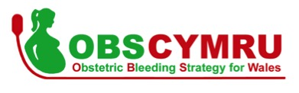

OBSCymru: The Obstetric Bleeding Strategy for Wales
Capturing the Change on a Local and National Scale

Kathryn James
Student Number: 1709370
Welsh Clinical Leadership Training Fellow / Anaesthetic Registrar
January 2016 – July 2018

Project Proposal Word Count: 750/750
Project Report Word Count: 4871/4500
Contents
Content | Page
Project Proposal | 3
Introduction | 3
Methods | 4
Aims of my Leading Service Improvement Project | 4
Achieving the Outcome Measures | 5
Project Report | 6
Background and Leadership Responsibilities | 6
Project Impact | 8
Methodology | 9
Leading Local Change In Obstetric Haemorrhage Management | 9
Establishing Current State | 9
Distributed Leadership within a Hierarchical System | 10
Celebrating Success to Enable Change | 11
Methodology Used to Facilitate Change | 11
Risk Assessment and Standardised Documentation - PDSA | 12
Measurement of Blood Loss Training – Kotter’s Method | 14
ROTEM (point-of-care test for coagulation) Training - PDSA | 16
Capturing the Change | 17
Establishing Current State | 17
Increasing Engagement with the Data | 18
Prudent Data: Collecting only what is needed | 18
Increasing the Usability of the Data | 19
Strategic Leadership of OBSCymru | 20
Results and Discussion | 21
Measurement of Improvement | 21
Outcome Measures | 24
Conclusions | 26
References | 28
Appendices | 31

Project Proposal

Introduction

Obstetric Haemorrhage (OH), or excessive blood loss following childbirth, is a significant problem amongst the maternal population in the UK and Worldwide (World Health Organisation, 2012). Major OH is the leading cause of maternal morbidity and mortality globally (Lennox et al 2014) and the second highest cause of death that is directly attributed to pregnancy in the UK. This has increased from the third highest cause in the most recent national confidential enquiry (Knight M et al 2017).
Advances have been made in the field of OH in the last decade which has informed us that coagulopathy in obstetric patients is rare and that the management of OH should follow a different approach from that of a non-obstetric trauma patient and should be more patient specific (Bell et al, 2010, Aawar et al, 2015, Collins P et al, 2017). This is especially true with regards to transfusion of blood components such as Red Cells, Fresh Frozen Plasma (FFP), Cryoprecipitate, Platelets and Fibrinogen. In addition, point-of-care, video-elastometric testing for clotting (ROTEM) is a useful tool to guide the use of fibrinogen in those patients who are deficient (de Lloyd et al, 2011, Aawar et al, 2015). The test empowers clinicians to transfuse blood components in a prudent manner, according to individual patient need, whilst negating additional risks from unnecessary transfusion and saving blood components for those in greater need. Furthermore, measurement of blood loss (MBL) has been proved to be a more accurate way of determining blood loss than estimation (EBL), which is the method that is traditionally practiced worldwide (Lilley et al., 2015). MBL enables the prompt recognition of OH and combined with an appropriate escalation tool, could help improve maternal outcome (Schorn NM, 2010, Jones, R, 2015).

Observational data from the University Hospital of Wales (UHW) found that during a research period, the improvement with regards to maternal morbidity was greater than could be attributed to the research interventions alone (Moses T et al, 2016). Specifically, there was a reduction in OH ≥2500ml, a decrease in the number of Red Cells, FFP and Platelets being transfused on the Obstetric Unit (OU), a reduction in number of women needing Intensive Care Unit (ICU) admission due to an OH and a decrease in the number of hysterectomies being performed as the definitive treatment for an OH (Moses T et al 2016). This led to the analysis of behavioural change at UHW and the following were recommended to improve maternal morbidity:
- Universal Risk Assessment for Obstetric Haemorrhage
- Measurement of Blood Loss
- Early escalation of the Obstetric MDT (Senior midwife, obstetrician and anaesthetic input)
- Prompt uterotonics and surgical intervention
- Point-of-care guided blood product management
- Effective MDT working

Methods

OBSCymru, The Obstetric Bleeding Strategy for Wales is a national, collaborative, quality improvement project (QIP) aiming to reduce morbidity and mortality from OH in Wales. The standardised framework, or “OBSCymru Approach to Obstetric Haemorrhage” (Figure 1) strives for early recognition and prompt, patient specific management of an OH.

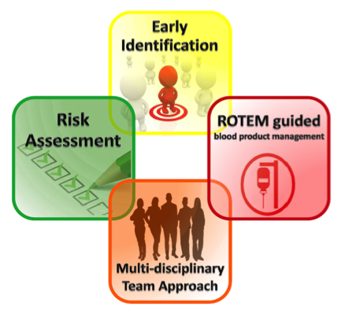

- Universal risk assessment
- Early Identification of haemorrhage by measured blood loss
- Multidisciplinary team working and appropriate escalation
- Patient specific blood product management using ROTEM, a point-of-care, video-elastometric test for clotting.

OBSCymru Approach to Obstetric Haemorrhage Management

Figure 1

Ethical approval has been granted and a data sharing agreement signed by all health boards within Wales. OBSCymru is jointly funded by Welsh Government, 1000Lives Improvement and Werfen, our industry partner. The interventions to be used to drive change in OH include standardised documentation for risk assessment and escalation of care, national MBL education package, ROTEM machines and, most importantly, local MDT Champions empowered to drive change on their local maternity units.

Aims of my Leading Service Improvement Project

The overall aim of OBSCymru is to reduce morbidity and mortality from OH in Wales by using the above standardised framework. My project consists of three parts. Change will be implemented by a range of methodologies including Kotter’s method (Kotter JP, 1996) and the Plan-Do-Study-Act (PDSA) cycle (Deming, 1986, IHI, 2009).

1. Leading Local Change in OH Management
I will lead change locally at three OUs in Wales: Prince Charles Hospital (PCH), Royal Glamorgan Hospital (RGH) and Singleton Hospital (SH), as well as assisting to embed the OBSCymru Approach into normal practice to enable sustainability. I will analyse individual process measures for each intervention at my hospitals to understand the barriers to adoption, as well as working with the teams to find solutions.

2. Capturing the Change
Development of a National Database and Data Platform for all cases of OH ≥1000ml to ensure that results are accurately recorded.

3. Strategic Direction
Drive change on an All Wales scale through contribution to the National OBSCymru MDT Board, as well as promoting the project amongst NHS Leaders.

Achieving the Outcome Measures

Acknowledging that improving quality of care is a complex and often lengthy process (Francis R et al, 2013), I will seek improvement in the process measures for the OBSCymru interventions at my hospitals. By working collaboratively with the OBSCymru team, we aim to show a reduction in morbidity and mortality by achieving the following outcomes (Figure 3):

Figure 3
Outcome Measures
- Reduce the number of women requiring ICU care due to OH
- Reduce the number of women receiving hysterectomy due to OH
- Reduce Red Cell and FFP transfusion
- Reduce the number of patient having massive OH (≥2500ml blood loss)

Project Report

Background and Leadership Responsibilities

OBSCymru, the Obstetric Bleeding Strategy for Wales, aims to provide a leading approach for OH management and a reduction in the variation of care regarding OH management amongst Welsh Maternity Services (WMS). OBSCymru has the potential to impact not only on patients, but also the Obstetric MDT and workforce in the WMS; from both undergraduate to postgraduate level and including NHS Leaders in their respective roles.

OBSCymru was launched as a collaborative QIP in November 2016, led by a National OBSCymru Board comprised from the Welsh Obstetric MDT. It was funded by Welsh Government and ethical approval obtained as well as a data sharing agreement between all health boards and 12 Obstetric Units (OU)s in Wales.

I led the development of the national OBSCymru Measuring Blood Loss education package from January 2016 and took a formal role in the leadership of OBSCymru when I joined the National OBSCymru Board as a Welsh Clinical Leadership Training Fellow (WCLTF) in August 2017. (Figure 4)
Figure 4. OBSCymru Leadership Structure

Following formal project management training as a National Board, we agreed individual roles and responsibilities. My core responsibilities are summarised:

- Leading Local Change in OH Management
Lead local change at three OUs in South Wales - Royal Glamorgan Hospital (RGH) and Prince Charles Hospital (PCH) in Cwm Taf University Health Board and Singleton Hospital (SH) in Abertawe Bro Morgannwg University Health Board (Figure 5).
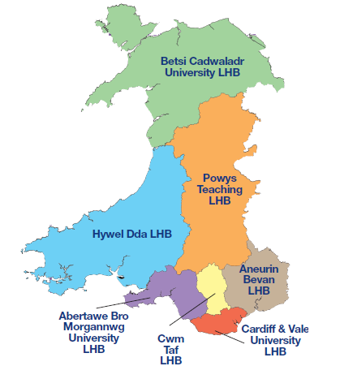
Welsh Maternity Services



Singleton Hospital (SH)
Prince Charles Hospital (PCH)
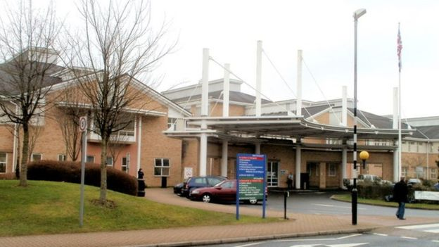

Royal Glamorgan Hospital (RGH)
Figure 5. Wales divided into the seven Local Health Boards. Each blue dot denotes one of the 12 OUs in Wales. RGH, PCH, SH shown by red lines.
- Capturing the Change
Collaborating with 1000lives Improvement and working with the informatics department to ensure the specifically developed OBSCymru database was suitable to collect the required information on OH ≥1000ml across Wales.

- Strategic Leadership of OBSCymru
Drive change on an All Wales scale through contribution to the National OBSCymru MDT Board, as well as promoting the project amongst NHS Leaders.

Project Impact

Patient Impact

30,000 women give birth annually in Wales (Welsh Government, 2013) and OBSCymru has the potential to impact them all. These deliveries take place in Obstetric Units (OUs) which are led by Consultants, Midwifery Led Units (MLUs), which can either be free standing or located alongside OUs, as well as in the Community as Home Births. If a woman experiences an OH, they will be escalated to the OU for appropriate management. The “OBSCymru Approach” has been launched in the 12 OUs in the first instance for this reason.

Workforce Impact

The OBSCymru Approach aims for the maternity workforce to function as an MDT, rather than in the specialty silos that the NHS is so often described as defaulting to (Rimmer A, 2017). OBSCymru will therefore impact on the whole MDT working on the OUs across Wales. (Table below)

Core Obstetric Multidisciplinary Team | Supporting Obstetric Multidisciplinary Team during OH
Obstetrician | Haematologist
Midwife | Haematology Lab Technician
Health Care Assistant | Porters
Anaesthetist | Operating Department Practitioner
 | Registered Theatre Nurse
Champion Team roles were advertised and applicants appointed from each of the MDT namely Obstetrics, Midwifery, Anaesthetics and Haematology. These local Champion Teams, or volunteer armies, have been integral in putting the OBSCymru tools into practice and ensuring communication between the local OU and National OBSCymru Board.

NHS Wales Impact

The OBSCymru approach to OH management has attracted much interest from senior Welsh NHS Leaders, as well as NHS Improvement in England and the Maternity and Children Quality Improvement Collaborative (MCQIC) in Scotland. OBSCymru won a MediWales High Impact Award in December 2017, was shortlisted for a Patient Safety Award in May 2018 and an NHS Wales award in July 2018. The opportunity to collaborate with these external parties and the recognition gained from the awards has increased the impact of OBSCymru on patients not only within Wales by increasing local engagement and promotion of the vision within our workforce, but also in the breadth of the impact as it spreads across the UK and impacts on maternity services elsewhere.

Methodology
Leading Local Change in Obstetric Haemorrhage Management

Establishing Current State
Figure 6

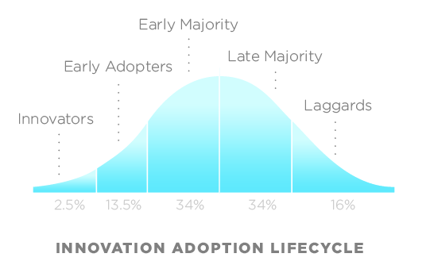
The OBSCymru approach and interventions used to drive change are standardised documentation for risk assessment and escalation of care, the national MBL education package to enable early identification of blood loss, local MDT Champions empowered to drive change and facilitate MDT working on their OU and ROTEM machines and supplementing education to enable point-of-care coagulation tests to achieve patient specific blood product management. (Figure 6)
Figure 7

Whilst the OBSCymru Approach had been introduced to the OUs prior to August 2017, each OU had adopted the changes to varying degrees. This observation satisfies what has been described by the Innovation Adoption Lifecycle (Figure 7) (Rogers, 1967). The OBSCymru interventions had been adopted in accordance with the demographic and psychological characteristics of the defined adopter groups present in the different OUs (Rogers, 1967). This varied not only between the individuals working within one OU, but also between the different OUs due to the differing culture.

In addition to the variation in adoption between OUs and the individuals within them, there was also variation in which OBSCymru interventions had been adopted at each site. I led a visit to my OUs where we discussed the interventions with the MDT systematically, whilst following an Ishikawa Diagram (Ishikawa, 1968) to describe changes from a previous visit, prior to the launch of OBSCymru. We established and agreed where the OU was with each intervention.

Distributed Leadership within a Hierarchical System

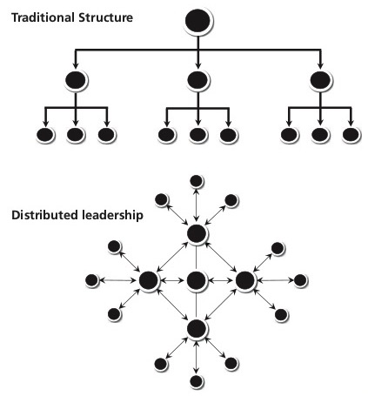
The vision and ethos I promoted within the OUs was one of a Distributed Leadership Mode (DLM), a contrasting and very different structure to that of the Traditional Hierarchical structure of current NHS Leadership (NHS Improving Quality, 2013).
Figure 8 (NHS Improvement, 2013)
I empowered the Champion Teams to utilise the DLM and to use the OBSCymru tools to suit the culture and environment of their own OU. I gave them the authority to use initiative to make change, without the need to ask permission to do so, which is what is traditionally asked from the hierarchical leadership structure of the NHS.
I made the decision to predominantly use a DLM following reflection after the initial OU visit which coincided with my introduction to the model at the Faculty of Medical Leadership and Management: Leaders in Healthcare Conference (Faculty of Medical Leadership and Management: Leaders in Healthcare Conference, 2017).
A DLM (Figure 8) (NHS Improvement, 2013) follows recommendations from the Kings Fund on how to reform the NHS from within. They made a particular emphasis on the importance of team leadership structures (Ham C, 2014). In addition, from our project management training with Imparo, I was able to appreciate the importance of making sure that the individual Champion Teams in the OUs felt that OBSCymru was their own (Imparo, 2017). They needed to believe they were empowered to made decisions and lead change with regards to OH management which were relevant to the culture and behaviours in their hospital. This bottom up approach has been reported as being a way to make service improvements easier (Sathyamoorthy, 2012) and would therefore be more likely to provide engagement in the OBSCymru Approach at the OUs and therefore improve outcomes for women experiencing OH across Wales.

Celebrating Success to Enable Change

Having completed an MIT Course in Applied Neuroscience: Getting the most out of you and your team by Dr Tara Swart (Swart, 2018), I recognised the importance of positive reinforcement though celebrating success. I incorporated this throughout my leadership role with OBSCymru and used the celebration of successes in order to promote the change in OH management and increase engagement. (Carnegie, 1988) I did this as part of informal face-to-face feedback with individuals over minor successes as well as larger scale, strategic decisions. For example, when OBSCymru was awarded a MediWales High Impact Award and shortlisted for a National Patient Safety and NHS Wales award, I ensured that all of my teams were aware of these successes and were congratulated not only by me, but also by their NHS Leaders including the Medical Directors and Heads of Midwifery.

Methodology used to Structure Change

Following my initial visits to the OUs, I reviewed the stage of adoption of the OBSCymru Approach to OH management, as described by the Innovation Adoption Lifestyle (Figure 7) (Rogers, 1967), at each OU with regards to each OBSCymru intervention or deliverable. In order to apply structure and methodology to the change in OH management, I used Kotter’s eight step process (Figure 9) (Kotter JP, 1996) for the larger changes that needed to be made and the Plan-Do-Study-Act (PDSA) Model for Improvement (Figure 10) for smaller changes. (Deming, 1986, IHI, 2009) These methodologies are evidenced below.

For the purpose of this report, I have included one method as an example for each intervention or deliverable. These can then be mapped to a process measure for assessment of success with regards to OBSCymru engagement within my OUs and combined with results from the other nine OUs to evaluate outcome measures.

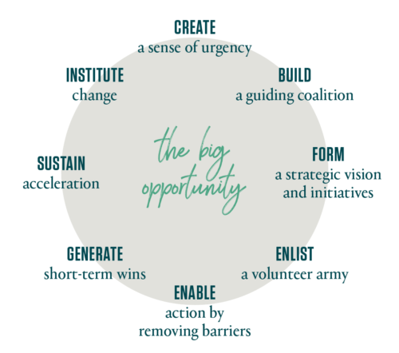
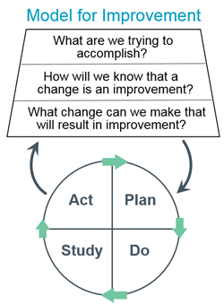
Figure 10
Institute of Healthcare Improvement, 2009
Figure 9. Kotter JP, 2014
Plan Do Study Act Model for Improvement
The 8 Step Process for Leading Change
Risk Assessment and Standardised Documentation – PDSA Model for Improvement

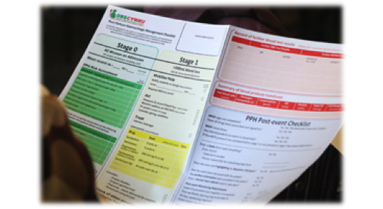
Studies have shown that the best way to reduce error and therefore improve patient safety is to target underlying system failures (National Patient Safety Agency, 2003). The OBSCymru documentation, or 4 Stage Paperwork (Figure 11), is a standardised document which highlights the process to follow in the event of an OH. The integrated risk assessment in Stage 0 allows the Obstetric MDT to identify and assess the risk of that individual woman of having an OH on admission to the OU. If any risks are identified, the paperwork prompts the team to plan accordingly.
Figure 11. OBSCymru Standardised Documentation or 4 Stage Paperwork

What are we trying to accomplish? | How will we know that a change is an improvement? | What change can we make that will result in improvement?
It had been observed through data collection via a staff perception questionnaire and note reviews at one of the OUs that only the Champion Team and early adopters of the OBSCymru Approach were using the 4 Stage Paperwork.

Following an initial meeting as a team, it was agreed that we were trying to accomplish increased compliance with completion of the risk assessment of the 4 Stage Paperwork and set a target of 75% of patients who had an OH. We recognised that an improvement in this would be shown in the data that was being collected by Champion Midwives because they were currently recording data for OHs ≥1000ml. I wanted to ensure that we would capture any change in completion of the risk assessment in all women admitted to the OU, not just those that had an OH. I raised this at the National OBSCymru Board Meeting and it was agreed to collect this additional data as part of the ongoing biannual audits. I worked particularly closely with my Champion Teams, to understand what needed to be changed to make an improvement and subsequently learned that there were barriers to filling the paperwork in relating to usability.

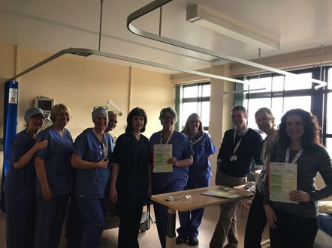
Plan and Do
Figure 12. 4 Stage Paperwork Feedback Session with Singleton Hospital Champion Team and Obstetric MDT
These barriers were echoed in feedback from the other team leaders so we planned a revised draft of the 4 stage paperwork. We each fed back to our OUs who were enthusiastic to assist with planning and drafting of the amended document. I facilitated the feedback process with my OUs and was mindful to be as accessible as possible, based on the individual’s personality preference (Briggs and Briggs Myers, 2015). In order to do this, I communicated via email for feedback, asked for verbal feedback through face-to-face sessions with the wider Obstetric MDT as well as speaking with the Champion Team directly.
Study and Act
After eight weeks of studying the feedback and planning, we re-drafted the new paperwork before asking for additional feedback from the Champion Teams after a trial period in six OUs. Whilst I wanted the 4 Stage Paperwork and the OBSCymru project to have as wide an impact as possible, I wanted to ensure that the Welsh NHS workforce was correctly credited for their hard work. This was the reason I pursued a copyright for the document. There was much discussion about who should host the copyright as we wanted to maintain an All Wales, collaborative feel. If NHS Wales was an organisation with a legal entity, this would have been the most appropriate host, but it is not. Therefore, after much discussion as a board we decided to use 1000Lives Improvement which is governed by Public Health Wales to host the copyright. Throughout this process, I was required to liaise with many external agencies and stakeholders including solicitors in Cardiff and Vale UHB, Intellectual Property Consultants, Commercial Printers as well as 1000Lives Improvement and Public Health Wales who each had a different management structure as described by Handy in 2011. I was required to adapt my working style to fit within the different leadership structures of each host organisation that I was dealing with. This enabled me to acquire the copyright promptly so that my project could progress. (Figure 13) (Handy, 2011).

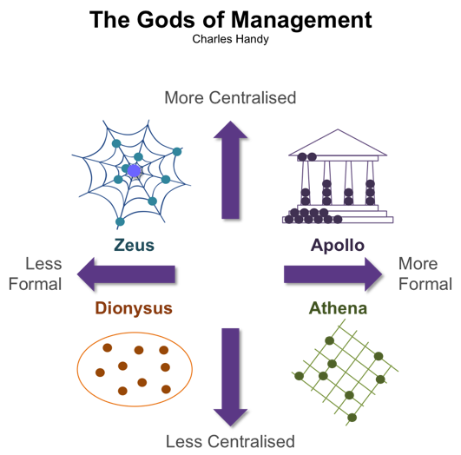
The PDSA cycle (Deming, 1986, IHI, 2009) worked well to not only predefine what we were changing, but to clearly define the steps in the process to both the local and national teams whilst giving us a framework which could be used more quickly than Kotter’s method. This was important as we had to complete this change before the existing copies of the 4 Stage Paperwork had been used up.

Figure 13.

Measurement of Blood Loss Training – Kotter’s Eight Step Process

The MBL training was the OBSCymru intervention which displayed the most variety in adoption between not only the OUs I was leading, but also between the individuals within the Obstetric MDT. For example, one of my OUs was using MBL in 90.6% of all deliveries on the OU in the June 2017 National MBL Audit, whilst another was the only OU in Wales not to engage with the audit process.

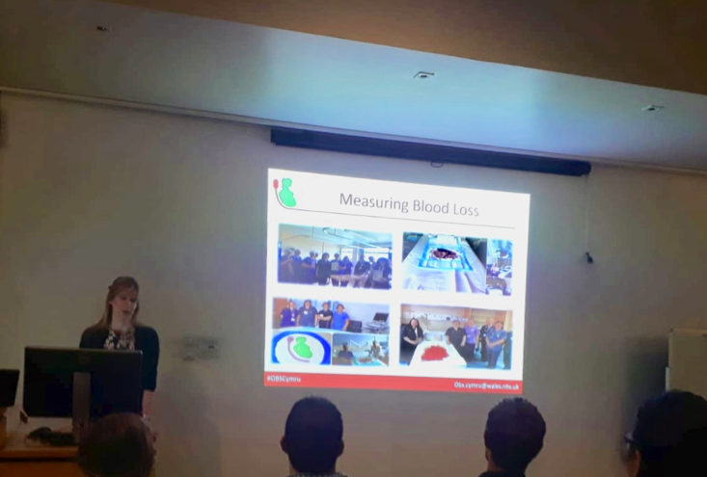
- Creating a Sense of Urgency
Figure 15. MBL Teaching Session and Cascade Learning
Figure 14. Communicating the MBL Vision
I met with the Champion Team representing the Obstetric MDT at the aforementioned OU and highlighted the fact that they were the only OU within Wales not to engage with the audit.

- Build a Guiding Coalition|3. Form a Strategic Vision
I then worked with the MDT (guided coalition) to form a strategic vision and plan for the MBL teaching which I communicated at a local audit day with the Obstetric MDT present (Figure 14). We agreed that MBL was the cornerstone of the OBSCymru approach as it allows the early identification of blood loss to enable the rest of the OBSCymru interventions to be followed, which will in turn impact on OH management.

4. Enlist a Volunteer Army
Whilst I already had a team, I enlisted others to form a wider army, aiming for more of a Distributed Leadership Model (Figure 8) (Ham, C 2014). Key recruits included an additional Consultant Anaesthetist, Intrapartum Lead Midwife, Clinical Research Fellow and the Lead Theatre Nurse.
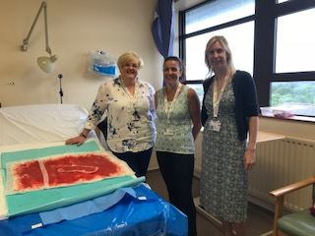
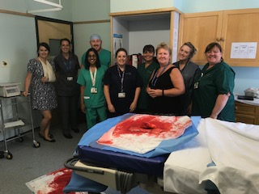
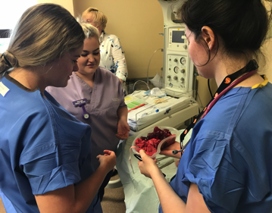
5. Enable Action by Removing Barriers
An important barrier I identified was the absence of reliable leadership within the Champion Team due to long term leave of one of the senior members. I offered support and my assurance that we could work together to improve this situation through the new DLM. In addition I removed some of the barriers to the teaching not being performed by allowing the team access to the online learning materials and OBSCymru teaching plan. I also worked very closely with the Champion Midwife to build her confidence, and thus remove another barrier, in the delivery of these education sessions until she was able to do so independently. I was able to adapt my leadership style to match the needs of the team and the dynamic situation. This complemented the project and allowed me to lead change effectively. I initially had a more directive and then visionary leadership style, which became more of a coaching and then participative style as the project evolved and the confidence and expertise of the team grew. (Goleman, 2000).

6. Generate Short-Term Wins
The short-term win came when the team actively engaged in the next National MBL Audit and achieved MBL in 94.6% of all deliveries on the OU.

7. Sustain Acceleration
There is indication that this change has been sustained as it is also supported by results in the National OBSCymru Database which shows that the MBL rate for May 2018 was 96% for all bleeds ≥1000ml at this OU.

8. Institute Change
MBL is becoming the norm and accepted way at this OU, as well as nationally in Wales which is explored more in the results section.

Following Kotter’s Eight Step Process to lead the team to support this change was very effective. As I originally developed the National MBL education package in January 2016, I enjoyed taking this change further. The model was very useful as it enabled a more indepth look at the change process which allowed me to recognise the true barriers to the change. Without removing these barriers, I doubt the change would have been so successful both at this OU and nationally.

ROTEM (Point-of-Care Coagulation) Testing - PDSA Model for Improvement

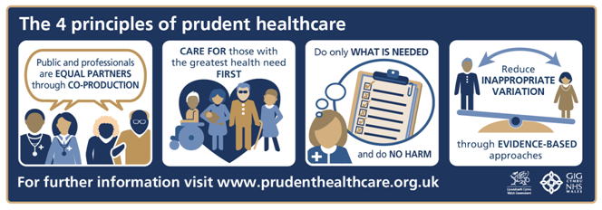
OBSCymru, and specifically the innovative use of ROTEM in all OUs in Wales at 1000ml of blood loss aims to enable clinicians to tailor blood component usage to individual patients, administering fibrinogen concentrate to those who are deficient. This prudent practice (Figure 16) is reducing unnecessary transfusions and avoiding any associated risks to patients, whilst conserving blood components for those at greater need (Public Health Wales, 2014). I used the PDSA cycle to facilitate change surrounding ROTEM. It was particularly useful here because it was a structure we could follow which resulted in increased use of the ROTEM and a change in culture surrounding it.
Figure 16. Prudent Practice and Prudent Health Care
Plan and Do
We met as a team and discussed barriers to using ROTEM. This necessary communication was essential to ensure understanding of the task. Following the meeting, we agreed the following:
- Additional formal training for the Obstetric MDT
- Helpline to call if difficulties with the machine out-of-hours
- Explanation surrounding the workings of the machine and error messages
- Encourage use from the Obstetric MDT to increase familiarity with the device
- Support to extract data from the machine
- Single Champion responsible for inputting ROTEM data onto OBSCymru database.
- Reports from haematology need to be obtained to verify blood transfusions in obstetric patients

I delegated the tasks fairly amongst the team according to skill mix but most importantly enthusiasm of the individual to do the task. I believe this was the most likely reason the delegation of tasks was successful and I will use this again in further leadership roles. I took the roles that would benefit strategically for the whole of OBSCymru, namely working with Werfen to organise MDT training, obtaining the additional information that was required and assisting with contacting Haematology and Welsh Blood Service on an all Wales basis.

Study and Act
After eight weeks, we met again and were pleased that the culture surrounding the ROTEM test was beginning to change on the OU. More of the Obstetric MDT were trained to use the machine and the results were being recorded appropriately on the OBSCymru database. Furthermore, haematology reports regarding blood component use on the OU were being received. When evaluating the change in ROTEM use, we realised that there was a serious clinical case a few weeks previously where the ROTEM was deemed “essential” by the team in guiding clinical management. It was likely that this clinical case where the team were able to see a real benefit in patient outcome because of the use of the ROTEM test for themselves contributed to the change in culture. This was echoed by what we were seeing in other OUs following significant clinical events when the ROTEM machine was necessary to guide appropriate management in a timely manner. This can be explained by the tool of empowering others to learn to think on their own, to troubleshoot difficult situations which will inturn enable the individual to grow into a self-sufficient leader (Themuse, 2014).

Establishing Current State
Capturing the Change

My second leadership role with OBSCymru was to collaborate with 1000Lives Improvement informatics department to oversee the documentation of change occurring as a result of OBSCymru on a national basis. A national database was set up to record all episodes of OH≥1000ml and a data sharing agreement reached between all Health Boards within Wales. This was necessary because the maternity data systems in Wales are not able to function in a co-ordinated or strategic manner because the majority of Health Boards are on different operating systems, collecting different performance indicators, which was also reflected within OH.

Increasing Engagement with the Data

The sustainability of OBSCymru with regards to OH management has two main aspects. Firstly, all of the interventions need to be successfully embedded into normal working practice and the culture of the individual OUs and secondly, the OUs require to take ownership of their data to document and promote any change. Whilst the national database was being completed by Champion Midwives through time funded by OBSCymru, it became apparent that the enthusiasm for the data collection was not universal and it was seen as more of a burden for the majority of the teams; most preferring to teach the MDT about OH and the OBSCymru approach. I offered my team assistance with the data collection, but I could see that the data burden was acting as a large barrier for the project in not only time spent in front of a computer, but also on the detrimental effect it was having on engagement. I co-ordinated meetings with the Informatics Department at 1000Lives Improvement and we decided on a strategy to attempt to remove the barriers from this situation:

- Reduce the data collection by removing non-essential data
- Increase the usability of the database

Prudent Data: Collecting only what is needed, no more, no less

Following initial evidence gathering by meeting with the Champion Team OUs and analysing the OBSCymru database for completeness with the Data Analyst from 1000Lives Improvement, it became apparent that there was a paucity in many aspects of the data that we were collecting which was likely to be due to the large data burden that the teams were being asked to collect. On review of the original data collection sheet (Appendix 1) it was apparent that OBSCymru was asking for a lot of observational data which, although very interesting, did not directly relate to our process or outcome measures. After discussion at the OBSCymru National Board meetings over the year, we were able to reduce the amount of data that we were collecting through repeated PDSA cycles until we reached the much reduced data collection set that we are using today (Appendix 2). I asked for feedback from the Champion Teams at the OUs at every step of the process to ensure we were making the correct changes. These changes were met with very positive feedback from the Champion Teams across Wales which could be reflected in the improved level of completeness of the OBSCymru database.

Increasing the Usability of the Data

Reducing the data burden and time required by the Champion Team to input data onto the OBSCymru database would also be influenced by its’ usability. I assisted the data analyst from 1000lives Improvement in this aspect. Over the year we incorporated a data dashboard or platform into the database as an important area of data science is to visualise the data in dashboards, (Cleveland, 2001). In addition, the sharing, use and interpretation of data is a fundamental step in bridging the gap between organisation and user, and in the context of OBSCymru, the National Board and the OUs (Brown et al, 2017 Matheus et al, 2018).
The inbuilt data platform included run charts and funnels plots of the OUs so they could see their own data in real time. We also added a more human aspect to the database with the use of a two-way communication stream between the OUs and the National Board through a Bulletins section as well as celebrating Public Holidays (Appendix 3).
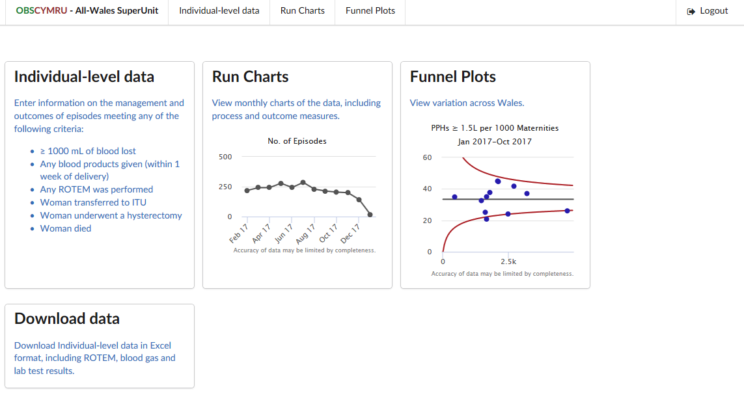
Figure 17. OBSCymru Database and Data Platform

Strategic Leadership of OBSCymru

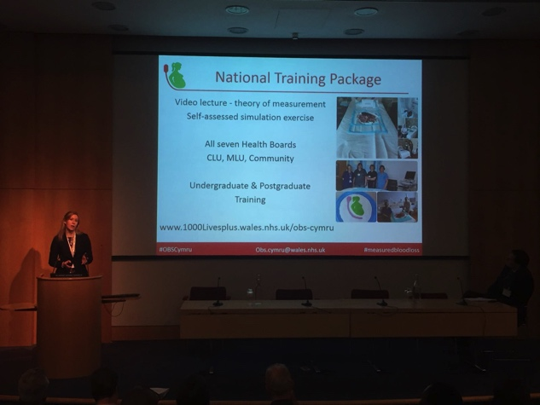
Whilst leading the project with the OBSCymru National Board, I was always mindful of the overall aim of OBSCymru “working together to reduce harm from OH”. I kept our process and outcome measures in the forefront and ensured that everything we did as a project was putting the needs of patients first. I was particularly aware of the fact that OBSCymru was working on an all Wales level, which was something that I was repeatedly informed at various conferences was very difficult to achieve. OBSCymru was not only gathering momentum rapidly, but also gaining international interest. I wanted to ensure that NHS leaders were aware of the early success so they could thank the staff who were working hard to achieve this goal. This in turn would improve engagement with OBSCymru and have a greater impact on maternity services.
I used visionary leadership (Goleman, 2000) to convey the hard work being done by the frontline Obstetric MDT to the relevant NHS leaders and leaders within Welsh Government through formal presentations, as well as to communicate the vision of OBSCymru at National Conferences. In the informal setting whilst shadowing
Figure 18. Communicating the Vision – National Presentation at the RCOG Improving the Quality of Women’s Health.
I was also very dynamic, animated and
enthusiastic when discussing the potential impact of OBSCymru to the Leaders of the NHS that I shadowed including the Deputy Chief Medical Officer, Dr Chris Jones, in Welsh Government as well as the Medical Director of Cardiff and Vale UHB, Dr Graham Shortland and Chief Executive Mr Len Richards which was also visionary leadership, (Goleman, 2000). This Leadership style worked well in both formal and informal applications. Formally the style stimulated lots of interest and the audiences received the information well, which certainly raised the profile of the successes of OBSCymru. This led to increased financial support from Welsh Government and therefore greater resources for the project. In addition, following a formal presentation I gave to the All Wales Medical Directors, they presented a MediWales award certificate to each OU. This was a very successful way of celebrating success and resulted in an observed increase in engagement of OBSCymru by the local teams.

Results and Discussion

Measurement of Improvement

Measures of improvement or process measures can be used to see if we are on track with improving the management of OH and will serve as a surrogate marker for the outcome measures in the short term (IHI, 2013).

Risk Assessment

Run chart showing the proportion of OHs with blood loss ≥1000ml who had a risk assessment performed at my OUs. This is supported by the most recent all Wales audit which shows that a risk assessment was completed in 74.9% of all deliveries in June 2018.

Measurement of Blood Loss

Whilst the results in the OU where I used Kotter’s method (Kotter JP, 1996) were recorded as using MBL in 85% of all OH’s with a blood loss ≥1000ml in August 2017, the culture and confidence regarding MBL that I observed within the OU appeared to be at a level much lower than this. The success that most accurately documents this change is one of culture, notably difficult to report and display graphically. The Champion Team at this OU have been empowered to train the wider Obstetric MDT about the importance of MBL and are now doing so independently, without any support from the National Team. The confidence in the Champion Team members has increased over time and they are working together to achieve their goal. Furthermore, the team engaged with the most recent audit process and had documented MBL rates of 100%. In addition to the sustained change demonstrated by the run chart below, my observation of behavioural and cultural change has been significant, which are more likely to create a sustained change going forward.

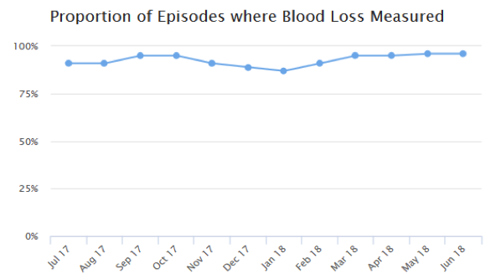
This run chart shows the documented change from EBL to MBL in the OUs over time and currently shows a rate of MBL in 96% of all OH ≥1000ml.

ROTEM (Point-of-Care Coagulation) Testing

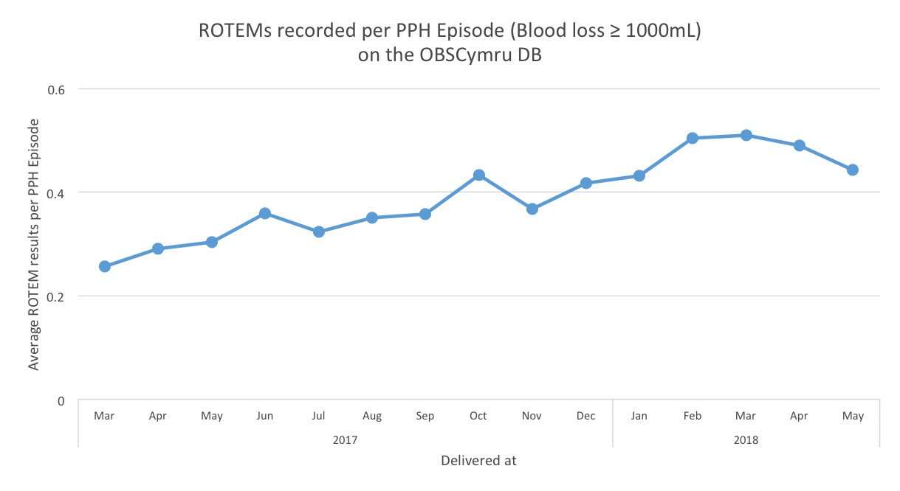
Run chart showing the number of appropriate ROTEMS performed per OH ≥1000ml.

Whilst there has been some improvement in ROTEM use, there is room for more widespread usage of the test. This could be because this OBSCymru intervention has been described by the Champion Teams as the most complex. There is a requirement for individuals to embrace the relatively new point-of-care working where clinicians are empowered to perform the test themselves. They need to accept the additional responsibility of this, as well as understand how to interpret the results and trust the machine before they act on it. As previously mentioned, the Obstetric MDT are becoming more confident with the devices and using them more frequently. They do however, need the time to learn for themselves how useful they can be in an emergency situation and recognise the advantage of having a clotting result in five minutes, rather than 30 minutes, in addition to the added benefits of delivering patient specific management in a prudent manner.

Capturing the Change
OBSCymru National Database Users
The run chart below shows the number of users on the OBSCymru database over time. This can be used as a surrogate marker to show engagement with the data platform. This has steadily increased throughout the year from 54 users in August 2017 to 76 Users in April 2018 as we have worked to increased engagement by the variety of means mentioned above.

Outcome Measures

Outcome Measures
- Reduce the number of women requiring ICU care due to OH
- Reduce the number of women receiving hysterectomy due to OH
- Reduce Red Cell and FFP transfusion
- Reduce the number of patient having massive OH(≥2500ml blood loss)

Establishing a Reliable Outcome to Measure

Overall outcomes described by OBSCymru namely ICU admission, hysterectomy and maternal death are thankfully very small in number. Therefore, we are unlikely to see a change here until the OBSCymru approach is embedded in the culture of WMS and has been for sometime. The other difficultly in looking at outcome measures is that as Wales has gone from a culture of predominantly EBL to MBL so it is difficult to compare the number of patients having a massive OH as the data was recorded differently.
The area where we are expecting to see a change in outcome first is in the number of Red Cell and FFP transfusions.

Provisional data above shows a reduction in Red Cell and FFP transfusions for 2017 and first year of OBSCymru. This is echoed in the results for the first 3 months of 2018 shown in the following table.

 | January – March 2017 | January – March 2018
Total number of OH≥1000mL | 679 | 724
Total Red Cells Transfused (units) | 383 | 317 | 20% decrease
Total Fibrinogen Concentrate Transfused (grams) | 61 | 31 | 49% decrease
Total FFP Transfused (units) | 54 | 36 | 33% decrease
Table below shows provisional blood transfusion results for the first 3 months of 2018 (January to March), compared to the first 3 months of 2017 (January to March) and the percentage decrease.

Conclusions

Leadership Style, Organisational Change Tools, Models and Theories

Throughout this project, I have used the majority of leadership styles as described by Goleman in 2000 (Figure 19) as well a variety of organisational change tools, models and theories such as the PDSA cycle described by Deming in 1986 and more recently, the IHI in 2013.
Figure 19. Six Leadership Styles. Goleman, 2000, Inter Academy Partnership (IAP), 2018

Research into additional change theories relating to the NHS as a complex system, for example, adopting a more distributed model of leadership, the importance of celebrating successes as an engagement tool as well as empowering others to make change for themselves, enabled me to put these skills into practice to develop innovative leadership strategies to effect patient focused improvement with regards to OH in Wales. The majority of the leadership styles, change models and theories were reflected upon and critically evaluated throughout the report with regards to their individual effectiveness to not only my management and leadership, but also in securing outcomes for OBSCymru and OH management.

Referring specifically to my original project aims, I have effectively led change in OH management in PCH, Singleton and RGH as well as nationally, which is reflected in the improved results with regards to MBL, risk assessment completion and ROTEM testing as well as number of database platform users as demonstrated in this report. I have also led OBSCymru strategically as part of the National Board as well as and helped to raise its profile which is exemplified by the MediWales Award and the NHS Wales Award and National Patient Safety Award Shortlistings that we have received.

Patient Focused Improvement
The provisional results of OBSCymru, both with regards to the process and outcome measures from my OUs and nationally are very encouraging, particularly because they are from the first year of OBSCymru when the interventions had not been universally adopted. I therefore anticipate that any change from OBSCymru will be captured more completely in the 2018 outcome data. Ongoing data collection is required to assess sustainability and this has been arranged. Health economics work is also being undertaken to evaluate OBSCymru further.

Despite the early stage in the project, we do have provisional results to show that the management of OH in Wales is changing on a national scale. We have additional evidence that clinicians across Wales are now working together as an MDT to utilise the OBSCymru approach. They are risk stratifying care, measuring blood loss to identify OH promptly and manage appropriately as well as using ROTEM guided blood product management which is patient specific and in a more prudent manner. This has been achieved though much hard work and dedication from not only the whole of the National Team, but most importantly the Champion Teams who have adopted the change and are driving it forward locally. This is a very exciting time for maternity services across Wales, the Welsh NHS, and most importantly, for the patients, and I feel very privileged to have led a part of it.

References
- Aawar, N., Alikhan, R., Bruynseels, D., Cannings-John, R., Collis, R., Dick, J., Elton, C., Fernando, R., Hall, J., Hood, K., Lack, N., Mallaiah, S., Maybury, H., Nuttall, J., Paranjothy, S., Rayment, R., Rees, A., Sanders, J., Townson, J., Weeks, A. and Collins, P. (2015). Fibrinogen concentrate versus placebo for treatment of postpartum haemorrhage: study protocol for a randomised controlled trial. Trials, 16(1).

- Bell SF, Rayment R, Collins PW, Collis RE (2010) The use of fibrinogen concentrate to correct hypofibrogenaemia rapidly during obstetric haemorrhage. International Journal of Obstetric Anaesthesia. 19(2):218-223

- Bradley, P. & Willson, A. (2014) Achieving prudent healthcare in NHS Wales (revised). Cardiff: Public Health Wales

- Briggs, K. and Briggs Myers, I. (2015). The Myers-Briggs Type Indicator.

- Brown, J. Fishenden, M. Thompson, W.Venters Appraising the impact and role of platform models and government as a platform (GaaP) in UK government public service reform: Towards a platform assessment framework (PAF)

- Carnegie, D. and MacMillan, A. (1988). How to win friends & influence people. New York: Simon and Schuster Audio.

- Cleveland, W, S. 2001 Data science: An action plan for expanding the technical areas of the field of statistics International Statistical Review, 69 (1) pp. 21-26

- Collins, P., Cannings-John, R., Bruynseels, D., Mallaiah, S., Dick, J., Elton, C., Weeks, A., Sanders, J., Aawar, N., Townson, J., Hood, K., Hall, J. and Collis, R. (2017). Viscoelastometric-guided early fibrinogen concentrate replacement during postpartum haemorrhage: OBS2, a double-blind randomized controlled trial. British Journal of Anaesthesia, 119(3), pp.411-421.

Data science empowering the public: Data-driven dashboards for transparent and accountable decision making in smart cities doi.org/10.1016/j.giq.2018.01.006

- de Lloyd L, Bovington R, Kaye A, Collis RE, Rayment R, Sanders J, Rees A, Collins PW (2011) Standard haemostatic tests following major obstetric haemorrhage. International Journal of Obstetric Anaesthesia. 20(2):135-141

Deming WE. Out of the crisis, 1986. Cambridge, MA: Massachusetts Institute of Technology Center for Advanced Engineering Study xiii, 1991;507)

- Francis R., Keogh, B and Berwick D. (2013) Patient-centred Leadership: Rediscovering our Purpose. London: The King’s Fund.

- Goleman, D. (2000). Leadership That Gets Results. Harvard Business Review, [online] Available at: http://www.haygroup.com/downloads/fi/Leadership_That_Gets_Results.pdf [Accessed 2 July. 2018].

- Government Information Quarterly, 34 (2)(2017), pp. 167-182, 10.1016/j.giq.2017.03.003

- Ham, C. (2014). Reforming the NHS from within. The King's Fund, pp.25-30.

- Handy, C. (2011). Gods of Management. London: Souvenir Press.

- IAP. (2018). Leadership styles through the actions of great conductors. [online] Available at: http://www.interacademies.org/42395/Leadership-styles-through-the-actions-of-great-conductors [Accessed 10 Sep. 2018].

- Ihi.org. (2013). Science of Improvement: Establishing Measures. [online] Available at: http://www.ihi.org/resources/Pages/HowtoImprove/ScienceofImprovementEstablishingMeasures.aspx [Accessed 18 Jul. 2018].

- Imparo. (2017). Imparo - John Edmonds Approved PRINCE2® project management, Managing Successful Programmes (MSP®) Change Management, Stakeholder Engagement Trainer. [online] Available at: https://imparo.co/about-imparo [Accessed 20 Jul. 2018].

- Ishikawa, K. (1988). Guide to quality control. New York: Unipub/Quality Resources.

- Jones, R. (2015). Quantitative Measurement of Blood Loss During Delivery. Journal of Obstetric, Gynecologic & Neonatal Nursing, 44, p.S41.

- Knight M, et al on behalf of MBRRACE-UK. Saving Lives, Improving Mothers’ Care - Lessons learned to inform maternity care from the UK and Ireland Con dential Enquiries into Maternal Deaths and Morbidity 2013–15. Oxford: National Perinatal Epidemiology Unit, University of Oxford 2017.

- Kotter JP (1996) Leading Change. Boston, Mass.: Harvard Business School Press

- Kotter, JP. (2014). Accelerate. Boston, Mass.: Harvard Business Review Press.

- Langley, G., Moen, R., Nolan, K., Nolan, T., Norman, C. and Provost, L. (2009). The Improvement Guide. Hoboken: John Wiley & Sons, Inc.

- Leadersinhealthcare.com. (2017). About the conference | Leaders in Healthcare Conference. [online] Available at: https://www.leadersinhealthcare.com/about [Accessed 21 Jul. 2018].

- Lennox C et al. Scottish Confidential Audit of Severe Maternal Morbidity: Reducing Avoidable Harm (2014) 10th Annual Report (2012 Data & 10 year summary) Healthcare Improvement Scotland.

- Lilley, G., Burkett-st-Laurent, D., Precious, E., Bruynseels, D., Kaye, A., Sanders, J., Alikhan, R., Collins, P., Hall, J. and Collis, R. (2015). Measurement of blood loss during postpartum haemorrhage. International Journal of Obstetric Anesthesia, 24(1), pp.8-14.

- Moses T, Leslie D, Bell SF, Collis R (2016) The effects on audit and research on postpartum haemorrhage: benefits for all! [Abstract] International Journal of Obstetric Anaesthesia. 21 (S1), S15

- National Patient Safety Agency. Seven steps to patient safety. The full reference guide. February 2004 (available at: www.npsa.nhs.uk/sevensteps).

- NHS Improvement, (2013). NHS Change Day. [online] Available at: https://www.slideshare.net/NHSIQ/the-story-of-change-day [Accessed 20 Jul. 2018].

- Rimmer, A. (2017). The UK needs more generalists, but where will they come from?. BMJ, p.j1116.

- Rogers, E. (1967) Diffusion of innovations. New York: Free Press of Glencoe

- Sathyamoorthy, G. (2012). How a 'bottom-up' approach to innovation is making service improvements easier. [online] Health Service Journal. Available at: https://www.hsj.co.uk/efficiency/how-a-bottom-up-approach-to-innovation-is-making-service-improvements-easier/5040805.article [Accessed 30 Jul. 2018].

- Schorn NM (2010) Measurement of Blood loss: Review of the Literature: Journal of Midwifery and Women’s Health. 55 (1), p20-27.

- Tara, S. (2018). Applied Neuroscience. Unleashing Brain Power For You And Your People. [online] Executive.mit.edu. Available at: https://executive.mit.edu/applied-neuroscience-unleashing-brain-power-for-you-and-your-people-brochure [Accessed 18 Jul. 2018].

- Themuse.com. (2014). How to Train People to Ask You Fewer Questions (and Figure Things Out on Their Own). [online] Available at: https://www.themuse.com/advice/how-to-train-people-to-ask-you-fewer-questions-and-figure-things-out-on-their-own [Accessed 18 Jul. 2018].

- Welsh Government (2011). A Strategic Vision for Maternity Services in Wales. Cardiff. Crown Copyright

- Welsh Government Quality and Safety Sub-group (2013) Strategic Vision for Maternity Services in Wales. Cardiff. Crown Copyright.

- World Health Organization. (2012). Maternal mortality. [online] Available at: http://www.who.int/news-room/fact-sheets/detail/maternal-mortality [Accessed 18 May. 2018].

Appendix 1
OBSCymru Individual Level Data Record Version 1

PPH Episode
Local Identifier Delivered at: Discharged at:
Hospital Number Date: DD/MM/YYYY Time: HH:MM Date: DD/MM/YYYY Time: HH:MM
Number of deliveries Type of delivery: Location of delivery:
Number
Spontaneous Vaginal Delivery (SVD)
Instrumental delivery
Elective (Category 4) LSCS
Category 3 LSCS
Category 2 LSCS
Category 1 LSCS
Other
CLU
MLU
Community

Woman required Level 3 (ICU) care? Hours of Level 3 (ICU) care provided: Number of hours
Yes, for reasons related to PPH
Yes, but for reasons unrelated to PPH
No
Unknown

Critical care
Woman required Level 2 (HDU) care? Hours of Level 2 (HDU) care provided: Number of hours
Yes, for reasons related to PPH
Yes, but for reasons unrelated to PPH
No
Unknown

Uterine atony
Uterine rupture
Uterine inversion
Stage 2 activated (or ≥1000ml blood loss) at: Date: DD/MM/YYYY Time: HH:MM

Blood Loss
Volume of blood loss: volume in ml Was the volume: estimated / measured / unknown (circle answer)
Surgical
Genital tract trauma
Extragenital bleeding

Abruption
Placenta praevia
Placenta accreta/increta
Amniotic fluid embolism
RPOC (Including placenta)

What was the cause of the bleed? (Please select at least one answer)

Cell Salvage
Was cell salvage used? Yes / No (circle answer)
What was the volume of cell salvage blood returned to the patient? volume in mls

Surgical Interventions

Were any of the following surgical interventions performed?
Haemostatic Uterine Suture Yes / No / Unknown (circle answer)
Bakri Balloon Yes / No / Unknown (circle answer)
Internal iliac artery ligation Yes / No / Unknown (circle answer)

Interventional Radiology

Were interventional radiology services involved in this case?
No, not required
No, service not available
Yes, advice only

Yes, performed planned procedure ante-partum
Yes, performed unplanned procedure ante-partum
Yes, performed planned procedure post-partum
Yes, performed unplanned procedure post-partum

Blood Products Used
Red blood cells (units) | Fibrinogen Concentrate (g) | Cryoprecipitate (pools) | FFP  (units) | Platelets  (units) | Factor VII  (microg)

Woman died?
Yes, for reasons related to PPH
Yes, but for reasons unrelated to PPH
No
Unknown

Outcomes
Woman underwent hysterectomy?
Yes, for reasons related to PPH
Yes, but for reasons unrelated to PPH
No
Unknown

Any deliveries ended in neonatal death?
Yes, for reasons related to PPH
Yes, but for reasons unrelated to PPH
No
Unknown

 | Blood Gas Test Results |  |  | ROTEM Test Results
Time | Hb (g/L) | Lactate (mmol) | FIBTEM A5 (mm) |  | EXTEM CT (secs) | EXTEM A5 (mm)

Blood Results

 | Laboratory Results
Time | Haemoglobin ( g/L ) | Platelets ( ×10 ⁹ /L ) | aPTT (secs) | PT (secs) | Fibrinogen ( g/L )

Appendix 2

PPH Episode
Local Identifier Delivered at: Discharged at:
Hospital Number Date: DD/MM/YYYY Time: HH:MM Date: DD/MM/YYYY
Number of deliveries (this pregnancy) Type of delivery: Location of delivery:
Number
Spontaneous Vaginal Delivery (SVD)
Instrumental delivery
Elective (Category 4) LSCS
Category 3 LSCS
Category 2 LSCS
Category 1 LSCS
Other
Consultant Lead Unit
Alongside Midwifery Lead Unit
Freestanding Midwifery Lead Unit
Home
OBSCymru Individual Level Data Record Version 1

Woman received Level 2 (HDU) care?
Yes, for reasons related to PPH
Yes, but for reasons unrelated to PPH
No
Unknown

Outcomes
Woman received Level 2 (HDU) care? (Outside of delivery unit)
Yes
No
Unknown

Hours of Level 2 (HDU) care provided: Number of hours

Woman died?
Yes, for reasons related to PPH
Yes, but for reasons unrelated to PPH
No
Unknown

Woman underwent hysterectomy?
Yes, for reasons related to PPH
Yes, but for reasons unrelated to PPH
No
Unknown

Blood Products Transfused
Volume of blood loss: volume in ml Was the volume: estimated / measured / unknown (circle answer)

All ROTEM Results
Date and Time | FIBTEM A5 (mm) | EXTEM CT (secs) | Date and Time | FIBTEM A5 (mm) | EXTEM CT (secs)

Woman received Level 3 (ICU) care? (Outside of delivery unit) Hours of Level 3 (ICU) care provided: Number of hours
Yes, for reasons related to PPH
Yes, but for reasons unrelated to PPH
No
Unknown

Red blood cells (units) | Fibrinogen Concentrate (g) | Cryoprecipitate (pools) | FFP  (units) | Platelets  (units) | Factor VII  (microg)

Additional data required for Blood Loss ≥ 1500ml

Surgical
Genital tract trauma
Abruption

Placenta praevia
Placenta accreta/increta
Bleeding outside of the genital tract
Uterine atony
Uterine rupture
Uterine inversion

Amniotic fluid embolism
RPOC

What was the cause of the bleed? (Please select at least one answer)

Cause of Bleed
No cause – 1000ml trigger not reached, but ROTEM performed

Surgery & Interventional Radiology

Were any of the following surgical interventions performed?
Uterine Brace Suture Yes / No / Unknown (circle answer)
Bakri Balloon Yes / No / Unknown (circle answer)
Internal iliac artery ligation Yes / No / Unknown (circle answer)

Was Interventional Radiology used?
Yes / No / Unknown (circle answer)

Blood Results
All Coagulation Results
Date and Time | aPTT (secs) | PT (secs) | Fibrinogen (g/L)

Additional data required for Blood Loss ≥ 2500ml
Please pull all notes for Blood Loss ≥ 2500ml

Full Blood Count Results
 | Date and Time | Hb (g/L) | Platelets (x10⁹/L)
1. Pre Delivery
2. Test with first ROTEM
3. On Discharge from Hospital

Thank you for filling out this form, it helps with the data collection tremendously.

Please contact one of your local champions if you would like to become more involved.

Thank you for your ongoing support of OBS Cymru

Appendix 3
Database Engagement
Bulletins
- Updates from OBS Cymru Team – National Team will be able to edit messages for the teams to see – another route of communication to the teams.

Welcome message for everyone when they log in:
- Welcome back to the OBS Cymru Database. How you would like to view your data? Please email Kathryn.james2@wales.nhs.uk with any suggestions or feedback. Thank you
Congratulations Messages:
- Congratulations! You’ve accessed the OBS Cymru database 10/20/30/….times since March 2018. Thank you for all of your on-going support of this All Wales Quality Improvement Project.
- Congratulations! You have used the database the greatest number of times this month out of everyone in Wales! Thank you for your dedication to this All Wales Quality Improvement Project.
- Congratulations! You have dedicated the most amount of time to the database the out of everyone in Wales! Thank you for your commitment to this All Wales Quality Improvement Project.
- Thank you (name) ! You have entered …….episodes this week! Thank you for all of your on-going support of this All Wales Quality Improvement Project.
Seasonal Messages:
Greeting | Picture | Date
Happy St David’s Day from OBS Cymru! |  | March 1^{st –}
Happy Mother’s Day from OBS Cymru! |  | March 10th
Happy St Patrick’s Day from OBS Cymru! |  | March 17th
Happy Easter from OBS Cymru! |  | March 29th– April 5th
Happy St George’s Day from OBS Cymru! |  | April 23rd
Eid Mubarak from OBS Cymru! |  | June 15th
Happy Father’s Day from OBS Cymru! |  | June 17th
Shanah Tova from OBS Cymru! |  | 9th-11th September
Happy Halloween from OBS Cymru! |  | Oct 13st
Happy Diwali from OBS Cymru! |  | November 7th 2018
Happy St Andrew’s Day from OBS Cymru! |  | Nov 30th
Happy Hanukkah from OBS Cymru! |  | December 2nd to 10th
Merry Christmas from OBS Cymru |  | December 12th - 30th 2018
Happy New Year from OBS Cymru! |  | January 1st –January 10th
Happy Chinese New Year from OBS Cymru! |  | Feb 5th 2019
Happy Valentine’s Day from OBS Cymru! |  | Feb 14th 2019

