EFFECTIVE TEAM WORK COMMUNICATION

Table of contents
Table OF figures 3
Introduction 4
Models OF communication 5
Shannon and Weaver 5
Berlo’s Model of communication 7
Schramm model of communication 9
Verbal and non-verbal communication 10
Workplace examples with solutions 12
Active listening and empathic listening 13
Conclusion 15
References 16

Table OF figures
Figure 1: Shannon and Weaver model of communication 5
Figure 2: Berlo’s SMCR Model of Communication 8
Figure 3: Schramm model of communication 9
Figure 4: Verbal Communication skills 10
Figure 5: Characteristics of empathetic listening 14

Introduction
Communication is the process of sharing ideas, thoughts and feeling with other person by making proper use of available medium. Working in an organisation requires good command over communication skills as different type of people with different skills operates under combine goal (Srivastava et al., 2020). Communication can be performed using verbal and non-verbal means to express the feeling of an individual. Effective communications in a team builds the strong network and guide the team mates towards one common goal (Mishra, 2020). As team work states the working of different people with different strengths and weakness together all aligned towards one common organisational goal, it necessary to build strong communication network in order to avoid miscommunication and grudges in a team (Srivastava et al., 2020). The quality of communication fills the gap between effective functioning of the team and helps to build strong organisational structure. The portfolio covers different models of communication and communication skills. It will also cover the poor communication skills and how it affects the functioning of the organisation.

Models OF communication

Shannon and Weaver
Communication plays vital role in determining organisational goals. Inadequate communication leads to grudges and misunderstanding. This affects the organisational functioning. Effective communication guides, motivates and support the team member to achieve personal goals in context to common organisational goals (Mishra, 2020). Communication is the crucial aspect when it comes to performing a task as a team. In organisation it is necessary that the information, message or order should be delivered in same way as given, if not, it can hinder the effective working of organisational functions leads to miscommunication of delivered information. Selection of right medium to deliver the message also plays vital role in communication (Hastings et al., 2020). The model was developed by American mathematician Shannon and Electronic engineer Weaver in year 1948. This model deals with different concepts of communication such as information destination, encode and decode, noise channel, receiver, information source, transmitter, etc in the process of communication. Various components of communication process are:
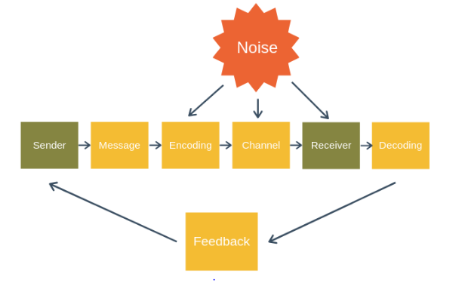
Figure 1: Shannon and Weaver model of communication
(Source: Guffey, 2021)
- Sender- Initially sender encodes the message as per requirement. Sender is the person who delivers the message. Sender chooses the effective medium as per the message to be delivered and sends the desired message to receiver (Hastings et al., 2020).
- Receiver- The receiver is the person for whom the message is designed. The main task of the receiver is to decode the message and send the feedback to sender, in order to get an clear idea whether the delivered message is understood or not (Guffey, 2021).
- Message- This is the main body of communication process. Whole process is designed considering the requirement of message. The selection of right medium depends upon what type of message is to be delivered. Message contains all the necessary content of communication process (Hastings et al., 2020).
- Channel of communication- Once the message is decided, then the medium through which the message is to be delivered is taken into consideration. For example
: email, phone call, radio broadcast, verbal communication, etc. (Guffey, 2021).
- Interface (noise, disturbance, network issues, etc.)- This are termed as barrier that affect the process of effective communication.
- Feedback- The process of communication is incomplete without adequate feedback. Feedback helps the sender to gain the understanding of whether the delivered message is understood by the receiver in same context as delivered or not (Guffey, 2021).

Berlo’s Model of communication
Berlo’s Model of Communication states the process of communication and was developed in year 1960. This model describes different components that help to develop basic communication process. Berlo’s model of communication undertakes emotional aspect of the message and operates on SMCR model. SMCR stands for:
S- Stands for Source
M- Message
C-Channel
R-Receiver
Source- Source also known as sender is the person from whom the thoughts and information originates for exchange. Source transfer the information to the receiver by carefully converting his emotions and thoughts into words. It is essential that the source should consist of effective communication skills, attitude, knowledge, social system and culture.
Message- When the source converts his thoughts into the words it creates the message. this method of creating message through the thoughts generated is called encoding. Message may comprise of the content, element, structure, treatment and code (Srivastava et al., 2020).
Channel- Channel is referred to as medium through which message is transferred from sender to receiver. Throughout the communication process it is essential to choose the right channel of communication to avoid misinterpretation and disturbance (Rizqi, 2021).
Receiver- When the message send by the sender is reaches the receiver, the receiver tries to understand and decode the message to respond accordingly. To ensure smooth flow of the information it is essential that receiver should be on the platform as message can transmit smoothly (Şihmantepe et al., 2021).
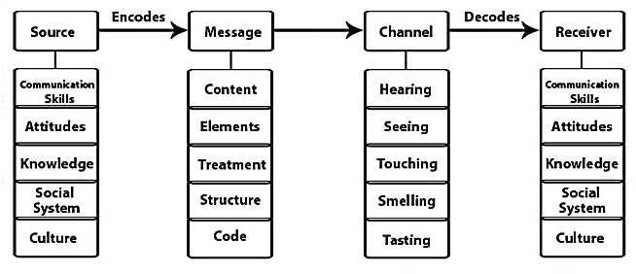
Figure 2: Berlo’s SMCR Model of Communication
(Sources: Şihmantepe et al., 2021)

Schramm model of communication
This model is also known as cyclic communication model as it contains all the basic principles of communication (Şihmantepe et al., 2021). The Schramm model is used to determine how the communication between two individuals works at the time of exchanging attitudes, ideas and information. This model is of belief that communication is the two way process therefore at least one sender or receiver should be present. The communication hereby is undertaken through traditional path whereby sender and receiver are present. and also sender and receiver can be one person which can lead to intra-personal communication. Schramm model of communication is circular in nature therefore attest two parties are involved to send and receive the message. The encoder and decoder along with the message are essential elements in this model. Schramm was of opinion that communication is incomplete unless the feedback is received from the receiver.
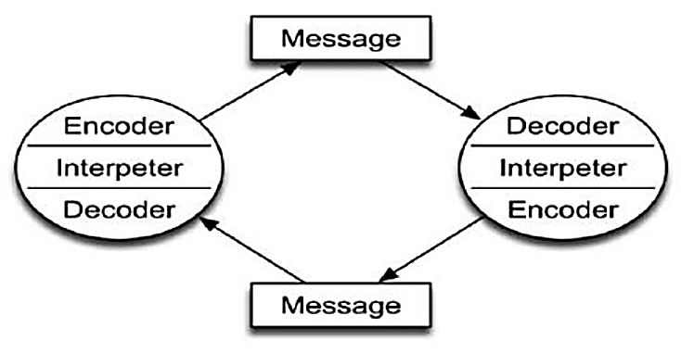
Figure 3: Schramm model of communication
(Source: Rizqi, 2021)

Verbal and non-verbal communication
Verbal and non-verbal are modes of communication which is selected by the sender based on the situation to deliver the message to receiver. Verbal communication is form of communication whereby speech or spoken words are used to exchange message, emotions and information. While non-verbal communication is associated with use of gestures, postures, body language, expressions, etc. to deliver the message (Mir Kamali, 2020). Non-verbal communication does not use words to exchange the information. Types of verbal communications are intrapersonal communication, interpersonal communication, small group communication and public communication. While non-verbal communication can be conducted with help of expressions, body language, eye contact, facial gestures, postures, etc. (Rizqi, 2021). Non-verbal communication play crucial role while presenting or communication with other person as non-verbal communication reflects about one’s views and thoughts without expressing them in words. Through non-verbal communication one can analyse individual emotions, needs, thoughts, intentions without actually expressing it through words.
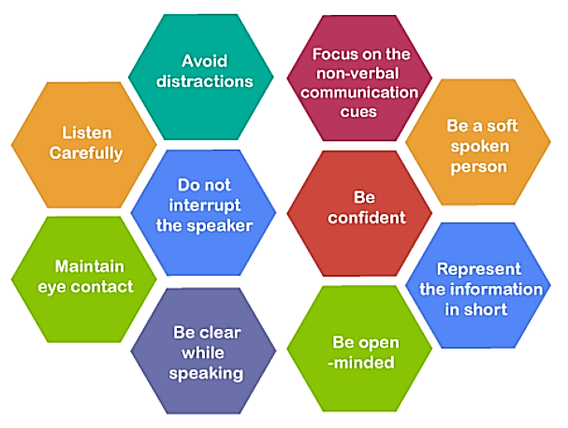
Figure 4: Verbal Communication skills
(Source; Bolten, 2020)
In consideration to the case study of The Chief the importance of business communication is elaborated. Communication is crucial task to achieve aim and objectives of the organisation. Through the case it can be identified that there exist communication factors that led to change in the attitude of CEO. Mark should works towards effective verbal and non-verbal communication. Communication process is said to be successful only when the delivered message is understood by the receiver in same context as delivered by the sender (Şihmantepe et al., 2021). This can be understood with help of feedback. In linear model of communication there is no way of sending feedback to sender. Working in a team at workplace with different type of people, with different skills, thought process and understanding, it is important that one should respect other people’s opinion. Many times the differences in opinion, feedbacks, decisions and conclusion to a topic can take place (Bolten, 2020). It is necessary that one should respect other people’s opinion and perspective. It doesn’t necessarily mean that you agree with their opinions; it just provides clarity and respect towards one opinion. One can politely disagree to other person’s opinion but should not disrespect it (Şihmantepe et al., 2021).
In another case of Barry the difficulties faced in managing staff due to cultural differences and language and diversity are stated. It can be identified that Barry should emphasise on effective training and development to help employees deal with the issues. It is essential that employees should follow effective safe food handling practices therefore Barry should motivate them by using effective communication. Feedback plays vital role in communication process. It helps to give the understanding of whether the deliver message is understood by the receiver in same context as delivered or not (von Lühmann et al., 2020). Providing feedback eliminates the misunderstanding. Providing and receiving feedback is important skill that is required at work place as it gives clear understanding of the communication process. The feedback should be received by the sender in positive manner and should be analysed and implemented accordingly (Rizqi, 2021).
Communication is the process of sharing thoughts and understanding with other person (Rizqi, 2021). Working in business environment requires command over communication skills, in order to build effective team (Rizqi, 2021). Working in a team requires individual to act according to the prevailing condition and should communicate considering various social, cultural as well as personal aspect. Communication skills enhance individual’s personal and professional skills (Mir Kamali, 2020). Showcasing and improving communication skills enhance individual’s personality and provides competitive advantage.

Workplace examples with solutions
Working in organisational culture, requires being patient and calm while conducting the communication process. Poor communication can result into frustration, demotivation and confusion within the employees (Bolten, 2020). It is necessary that one should utilize the effective communication skills and should implement it in order to conduct effective communication process (Şihmantepe et al., 2021). Observing my friend’s telecommunication organisation, I found various poor communications that leads to differences in opinions and creates misunderstanding. Some of the observed poor communication skills are stated below:
Cultural diversity- Since employees in my friend’s telecommunication organisation belongs to different culture and community; it comes difficult to communicate in a regional level. Employees belong to different race, caste, religion, beliefs and works under same workplace (Mir Kamali, 2020). It is not possible to relay on common grounds of delivery of message and understands non-verbal clues. This hinders the effective communication in organisation (Şihmantepe et al., 2021).
Demoralized employees- If the employees are demoralized they lose the interest in their work. Demoralized employees do not wish to communicate efficiently and it creates barrier in organisation. At my friend’s workplace employees feels unappreciated, unvalued, disrespected and disregarded which affects their communication skills. Employees should be valued and considered irrespective of differences in opinions.
Personal issues- Though working at workplace some of the employees were disturbed due to several personal issues. Employer should consider the understanding and should grant some time to resolve the issue (Bolten, 2020). Various employees feel demotivated and lack the spirit to work due to their personal issue. Instead of arguing and pressurizing employees, organisation should consider the issue and allot some mental space and freedom to bounce back (Bolten, 2020).
Undefined objectives- The objectives of individual and organisational objectives should go hand in hand. In order to boost the employee morale and motivate them to work efficiently their objectives should be well understood and should be aligned to organisational objectives (von Lühmann et al., 2020). At my friend’s workplace, employees were disturbed and unorganised as their objectives were not clear which do not motivate them to work harder. Lack of clearly defined objectives creates communication gap between top level management and employees which hinders the effective communication process and affects the organisational goals (Şihmantepe et al., 2021).

Active listening and empathic listening
Effective communication is associated with effective listening skills. In the communication process it is essential that one must practice effective listening and being empathic towards the other. Empathic listening is determined as the structured listening pattern and technique that allows developing effective relationship and strong understanding of the message being conveyed. Empathetic listening takes active listening to new level to promote effective communication. To practice and develop empathic listening one must learn to listen patiently to what other person is trying to express and try to get sense of the feeling of the speaker. Emotional intelligence is essential for empathic and active listening. During the empathic listening listener ensure keeping safe the feeling of the speaker without being defensive. It helps the receiver to be attentive and responsive efficiently to other during the conversation. Empathetic listening helps to prevent misunderstanding by understanding what others are trying to convey. Active listening is the crucial aspect in communication process, as it eliminated the risk of misunderstanding. Active listening creates a sense of trust within the speaker. He feels that he is considered and his thoughts are valued (Mir Kamali, 2020). One must on interrupt while the person is talking. Asking questions, rephrasing, engaging with person and paying attention build the strong listening skills (Rizqi, 2021). One should get indulge in the listening process with other person, so as to understand the view point speaker, if in case you are not willing to agree with the speaker politely disagree them once they are completed with expressing their thoughts (Bolten, 2020).

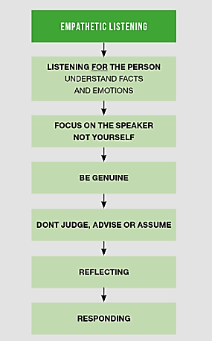
Figure 5: Characteristics of empathetic listening
(Source: Mir Kamali, 2020)

Conclusion
It can be concluded that effective communication provides support to individual’s goal and objectives. Working with different type of people in a team requires command over communication skills. Individual should inculcate communication skills in order to achieve growth at work place. Working in a team with different people with different opinions, beliefs, race, caste, etc. one should respect other people’s opinion. Showing empathy towards other person builds the sense of trust and reliability. Communication plays vital role in shaping one’s personal and professional growth. Poor communication skills hinder the working of organisational growth and leads to low morale in a team. Effective communication skills comprises of active listening, showing empathy, respecting and considering other person’s opinion, use of non-verbal signs, effective body language, etc. in order to boost the communication process and carry out the task with ease. Poor communication leads to misunderstanding, lack of motivation, unorganised staff and miscommunication of thoughts within a team. This affects the overall working of team and affects the organisational goals.

References
Bolten, J. (2020). Intercultural business communication: An interactive approach (pp. 139-155). Routledge.
Guffey, M.E. and Loewy, D. (2021). Business communication: Process & product. Cengage Learning.
Hastings, S.O., Aponte, S., Valverde, E., Gristock, C., Fraser, R., Missigman, M., Bicasan, J. and Rosas, L. (2020). Nonverbal communication and writing deficiencies of graduates: Research by undergraduates for undergraduates. Business and Professional Communication Quarterly, 83(2), pp.204-222.
Mir Kamali, S.M. and Qaem Montazery, A. (2020). Investigating the relationship between organizational learning and communication skills with organizational conflict in the staff of education departments in the four districts of Karaj. Management and Educational Perspective, 2(3), pp.15-42.
Mishra, S.K. and Mishra, P. (2020). Functional Aspects of Communication Skills for Professional Empowerment. Journal of English Language and Literature (JOELL), 7(1), pp.79-85.
Rizqi, M. (2021), February. Learning Tools with SAVI Participation (Somatic, Auditory, Visualization, Intellectual) in Improving Mathematical Communication Skills in the Industrial Revolution Era 4.0. In Journal of Physics: Conference Series (Vol. 1779, No. 1, p. 012063). IOP Publishing.
Şihmantepe, A., Solmaz, M.S. and Aşan, C. (2021). Improving Maritime English Oral Communication Skills in an Online Environment: Engaging Students as Teams. In Trends and Developments for the Future of Language Education in Higher Education (pp. 272-292). IGI Global.
Srivastava, P., Nozari, E., Kim, J.Z., Ju, H., Zhou, D., Becker, C., Pasqualetti, F., Pappas, G.J. and Bassett, D.S. (2020). Models of communication and control for brain networks: distinctions, convergence, and future outlook. Network Neuroscience, 4(4), pp.1122-1159.

