Understanding and Engaging in the Customer Experience
BMSW5103

Laura Pino
1915292

Dr. Patel Nandish

University of Wales Trinity Saint David
02/09/2021

Executive Summary
The paper analysed how Netflix is challenging its flexibility during the COVID-19 situation, which is transforming customer’s behaviours and needs in this period. Netflix is focusing on customer centricity, applying a consumer science methodology, which is helping the CRM system to understand the preferences, culture and taste of its subscribed customers through an analysis of data and algorithms of their profiles (Van Belleghem, 2021). Netflix’s goal is to achieve delivering unique content to watch and using detailed customisation that their different customers require, by proposing to them similar programs that they would be interested in or suggesting original content to watch to create constant engagement (Smith, 2017). However, Netflix is not developing new additional value to customer retention in the form of new offers, especially after their slow growth created from the pandemic situation (Mehta and Richwine, 2021). The SERVQUAL model helps the company to create or potentiate its value proposition from the service they are selling, proposing a deep examination of service quality, generating a system of services that work excellently and satisfy the expectation of their members (Buttle, 2008).

TABLE OF CONTENTS

- Introduction ………………………………………………………………………….p. 4
- Netflix Background …………………………………………………………………p. 4
  - Customer Relationship Management in the Netflix company …………….p. 5
  - Netflix Customer Lifecycle and Value Proposition …………………………p. 5
- Models Review:
  - CRM Value Chain Model ………………………………………………………p. 6
  - SERVQUAL Model ……………………………………………………………..p. 8
  - Total Quality Management …………………………………………………….p. 9
- SERVQUAL Model Selected ……………………………………………………….p. 11
- Application of SERVQUAL Model: FIRST GAP ………………………………….p. 12
  - SECOND GAP …………………………………………………………………p. 13
  - THIRD GAP …………………………………………………………………….p. 13
  - FOURTH GAP ………………………………………………………………….p. 14
  - FIFTH GAP ……………………………………………………………………..p. 14
- Recommendations ………………………………………………………………….p. 16
- Conclusion …………………………………………………………………………..p. 17
- References ………………………………………………………………………..…p. 19

1 Introduction
The report studied the importance of customer relationship management systems in the company Netflix, demonstrating the benefits of this process and showing how the business is maintaining good engagement with their clients. Netflix is a global online streaming entertainment service company, founded in 1997 by Reed Hastings and Marc Randolph, that allows customers to watch original and curated video content through a monthly subscription (Netflix, 2021).
The paper analysed how Netflix is challenging its flexibility during the COVID-19 situation, which is transforming customer’s behaviours and needs in this period. It aims to examine which is the company’s value proposition, highlighting a lack of developing value for customer retention, during their customer lifecycle, to prevent the clientele from switching to other competitors, they need to create an even more personalised service to generate better customer satisfaction. Every business establishes dynamic relationships with its customers that are managed through the technological tool of customer relationship management. The company collects data from its clients and transforms it into knowledge with the help of a marketing team, they then define the company’s value proposition to target which customers they want to acquire; to provide and deliver the best customer service possible to achieve competitive advantage and increase profits (Bergeron, 2002). Considering these changes, Netflix is focused on customer centricity, using their consumer science methodology to analyse data and tailor customers’ profiles with the aim of meeting their needs and satisfying their expectations (Van Belleghem, 2021). Therefore, two models have been analysed, CRM Value Chain and Total Quality Management, with the SERVQUAL model being critically applied for Netflix, to demonstrate the benefits that the company can derive from its implementation. In the end, the report gave a plethora of suggestions in regard to what Netflix could improve to add value to their customer experience.

2 Netflix Background
Netflix was founded in 1997 by Reed Hastings and Marc Randolph, their initial idea was to rent DVDs via postal mail and in 1999 they launched Netfix.com as a subscription service allowing members to rent unlimited DVDs without additional fees. In 2000 the company introduced the personalised recommendations system, which allowed Netflix to use the members data to suggest and promote future rentals to clients based on their previous interactions (Netflix, 2021). Subsequently, they launched customer profiles, where members could create a list of preferences and in 2007, they saw the introduction of their first online streaming service, allowing instant access to watching series and films from the website (Netflix, 2021). Today Netflix is a pioneer of the streaming entertainment service, leading the industry with 167 million subscriptions in over 190 countries, of which the contents are selected and featured based on the different cultures, with the objective of offering a large variety and allowing customers to enjoy the platform around the world (Netflix annual report, 2020).

2.1 Customer Relationship Management in the Netflix company
The strategy of customer relationship management is to build and improve a company’s profitability through maintaining a qualitative engagement with its customer retention, which are the main annual source of profit (Buttle, 2008). In other words, the goal is to implement CRM in the business to maximise profitability, revenue and manage customer satisfaction, by segmenting the clientele based on personal preferences and enhancing their experience (Buttle, 2008).
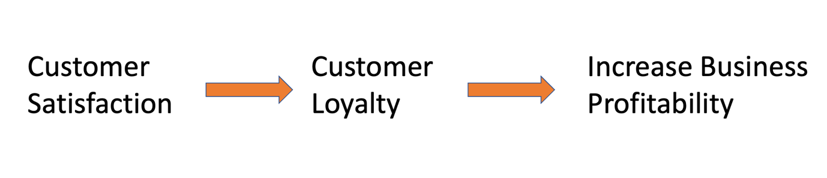 Source: Laura Pino

Netflix is focusing on customer centricity, applying a consumer science methodology, which is helping the CRM system to understand preferences, culture and taste of its subscribed customers through an analysis of data and algorithms of their profiles (Van Belleghem, 2021). Netflix’s goal is to achieve delivering unique content to watch and using detailed customisation that their different customers require, by proposing to them similar programs that they would be interested in or suggesting original content to watch to create constant engagement (Smith, 2017). During the COVID-19 situation, Netflix, had a decrease of subscriptions in the first quarter of 2020 because of their slow production but in the second half, when they release new content, their memberships increased (Mehta and Richwine, 2021).

2.2 Netflix Customer Lifecycle and Value Proposition
The company has a lack in developing new additional value to the customer, which it could identify during its customer lifecycle process, composed of how to acquire new customers, plus developing and adding value to the customer’s retention (Buttle, 2008). Netflix offers thirty days free use of the service to new customers, they can then choose which membership they want to sign on to base on the number of accounts a client needs, and they are free to cancel the service or change their plan each month (Netflix, 2021). A strategy for customer acquiring and retention is important to appeal to them by showing the quality of the services the company is offering and being clear to them in regard to their rights, for example the free subscription cancellation, making the customer aware of what they are purchasing or signing and not feeling trapped by their commitment with the company (Buttle, 2008). The second and third step of the cycle is to develop and add value to customer retention to generate highly valuable propositions for them and trying to reduce customer defection (Buttle, 2008). Netflix’s value proposition is to provide the best quality entertainment service, 24/7 available on-demand access, with a large plethora of original and personalised content in high-definition, designed to be watched by various clients of different ages (Pereira, 2021). Netflix is creating an economical value to the customer, understanding their different requirements, and delivering better value programming than its competitors (Pereira, 2021). Therefore, the company’s value derives from the value of the customer perception that, in Netflix, is showed in their customer satisfaction, having for example a qualitative service accessible from a wide range of clients, competing at a cheap price (Van Belleghem, 2021). However, Netflix is not developing current additional value to customer retention in the form of new offers, especially after their slow growth created from the pandemic situation (Mehta and Richwine, 2021), and it generated a lack in fully understanding customer’s needs. To comprehend the value in a CRM meaning, an equation can be represented for how it works: value = benefits / sacrifices; it shows that a company can increase customers’ perception values by managing customers’ benefits or their sacrifices (Buttle,2008). In other words, the benefits are related to the experiences on the products they are buying, and sacrifices are, for example: monetary, the research made to find the product and physical costs in terms of stress it can generate (Buttle,2008). For instance, if a company reduces one of the customer’s sacrifices, it may be increasing the value in benefits. However, the firms compete in creating better value for the customers, understanding their requirements and needs and delivering the best solution to them; moreover, using a model that is based on customer perceived quality, companies can enhance their quality value (Buttle, 2008).

3. Models Review:
3.1 CRM Value Chain Model
CRM value chain is a model that companies can apply, in both business to business and business to customer when wanting to implement their CRM strategy, and its purpose is to build long term mutual beneficial relationships (Buttle, 2001).
As Fig.1 shows, the model follows five primary stages: customer portfolio analysis, identifying customer to target and delivery value proposition (Buttle, 2001); customer intimacy, after segmenting the customers, to create a database which is accessible from all internal operations that have decisions and impact upon customer behaviours (Buttle, 2001) because the better you know your customer, the more likely the business will build a long term relationship with them (Takur and Chetty, 2019); network development, building strong relationships between stakeholders involved in managing customers (Buttle, 2001); developing a value proposition for customers with which the company will benefit (Buttle, 2001); the fifth step is to manage the relationships between company and customer (Buttle, 2001).
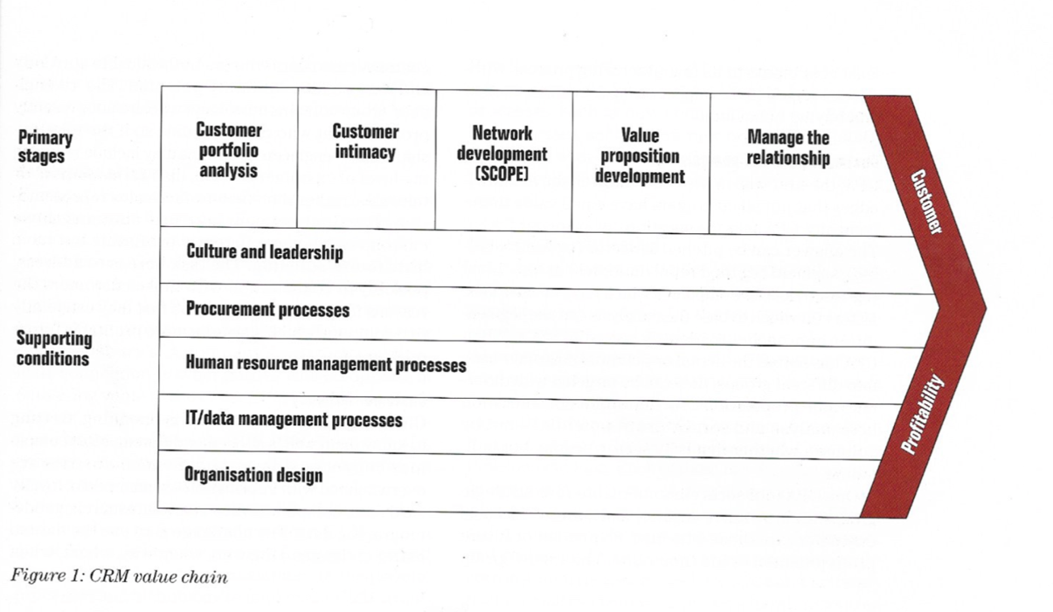
Fig.1 Source: Buttle, 2001

In order to help the business to successfully perform its CRM value chain model, it is necessary to introduce the supporting conditions stage, shown in Fig.1, of which its aspects are: culture and leadership, generating the value proposition and prioritising customer relationship management (Takur and Chetty, 2019); the procurement processes, includes the activities the company must follow to create products and services, through understanding customer profiles and network analysis (Takur and Chetty, 2019); HR management is important because they interact with the customers, thus, they can understand client needs and address them with the use of a strategic CRM system (Takur and Chetty, 2019); IT management is for all data acquired and information technology that CRM converts to develop value proposition and address the customer’s needs (Takur and Chetty, 2019); after settling these processes the organisation is prepared and ready to generate profitability through its model (Buttle, 2001). Moreover, the model’s strength is providing a detailed guide for the companies to understand the processes required to implement a successful and strategic CRM (Buttle, 2001). While the weakness is not considering the competitive analysis as part of its stages, and with every industry being immersed in a dynamic market environment, they should reflect on different strategies to diversify its products and services, to achieve competitive advantages (Buttles, 2009).

3.2 SERVQUAL Model
SERVQUAL model identifies five core components of service quality such us: reliability, responsiveness, assurance, empathy and tangibility; utilising these dimensions to define the concept of gaps when firms discuss customers expectation and service delivered (Kozerska, 2021). The model helps to manage and measure service quality, understanding the internal company processes and finally, customer expectations to identify factors which need improvement (Buttle, 2008). SERVQUAL analyses five gaps between customer expectations and needs with the purpose to help managers focus in identifying tactics and development strategies to close the gaps (Buttle, 2008). The graph in Fig.2, shows where the main gaps are distributed, with whom they are connected, and the blue line defines two areas: customer and company (Buttle, 2008), for instance, gap 5 is the product of gap 1, 2, 3, 4 and if they are closed it means that gap 5 is solved. Gap 1 examines the understanding between customer expectation and what the company think they are delivering to the customers (Buttle, 2008); gap 2 is related to internal management and it occurs when the company fails to create service standards that customers expect (Buttle, 2008); gap 3 occurs when the company’s systems fail in delivering the standards, thus the internal operation or technology have a lack in communication (Buttle, 2008); and the last one, gap 4, is related to the communication between company and customers and it develops when the first parties fail to deliver or perform the initial service promised to the second parties (Buttle, 2008).

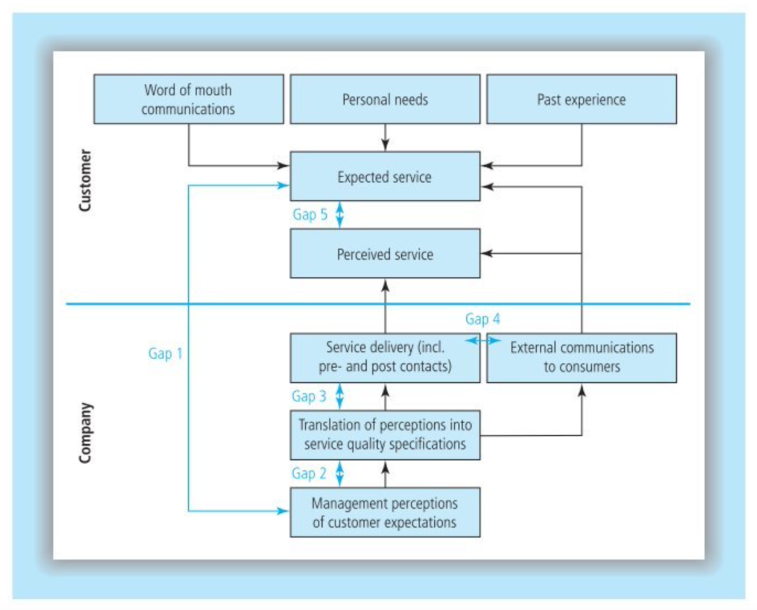
Fig. 2 Source: Buttle, 2008

The model provides an approach for managers to develop measures and manage service quality factors into an understanding of customer expectation, reducing the gap 1 issue (Kozerska, 2021). The strength of the SERVQUAL model is its precision in questioning gaps between internal and external perceptions of the service quality, providing strategic steps of improvement and data to use in the customer relations management resource, in order to maximise the expectations for the clients (Buttle, 2008).
However, the weakness of the model could be that it is not simple to apply in its full meaning and if it is not entirely understood it could easily fail again; or if the company does not have the resource to invest in changing their internal operation (Kozerska, 2021).

3.3 Total Quality Management
Total quality management is an ongoing process which aims to discover problems and reduce or eliminate inaccuracies in management or the supply chain; to fill and reinforce, with training, these errors and be able to improve customer experience (Barone and Anderson, 2021). The goal of the model is to improve the business operation quality in terms of employees’ capabilities and skills towards the organisation’s output, such as products and services (Barone and Anderson, 2021). This process helps businesses to concentrate on their data, effective communication and focalising its strategy (Pratt, 2021). Total quality management is identified as quality control circles, in which it is a method for pursuing quality by constantly monitoring output, therefore, it helps the business to work smarter and with less effort (Eby, 2021).

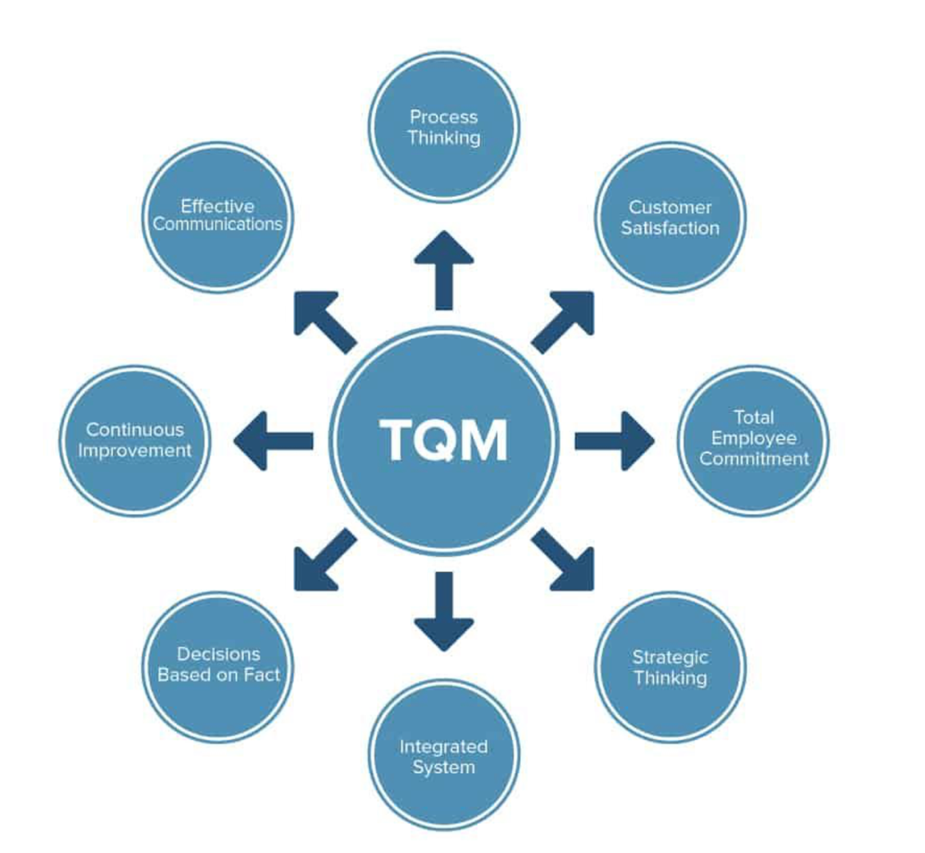
Fig.3 Source: Eby, 2021

As the Fig.3 shows, it is in focus with: customer satisfaction, which corresponds with the final purpose of building this methodological process (Eby,2021); employee commitment, a part of the internal quality company that could empower their skills and knowledge through training (Eby,2021); strategic thinking, where the quality must be the aim of achieving the company’s long-term vision (Eby,2021); integrated system, sharing knowledge aligned with quality principles, keeping stakeholders involved (Eby,2021); decision based on facts, collecting data and information, the organisation can understand if the work is proceeding with its specification and then be able to make decisions (Eby,2021); as a consequence to the previous step, companies can make decisions based on initial goals of continuously improving their quality (Eby,2021); effective communications should be the base of an organisation who want improve its operation (Eby,2021); as a final step there is the process catered, which analyses every process in order to repeat the best one (Eby,2021). In the end, the strength of the high-quality control cycle is to decrease waste by reducing expenses, that can be transformed into lower prices and timesaving, leading to successful implementation and consistent customer values, increasing their loyalty (Gartenstein, 2019). However, its weakness could be its potential failure in reducing costs and following a product’s market quality implementation, which it will not recoup and, consequently, create a loss for the company (Eby,2017).

4 SERVQUAL Model Selected
The Total Quality Management model is a practice that could be used to fill Netflix’s gap as an approach of reviewing the procedures of its performance cyclically and improving internal deficiencies of communication or knowledge (Barone and Anderson, 2021). However, the company needs to be more in focus with tailoring quality services proposed to their customers, increasing the business’ strategic attention of them. Therefore, the CRM value chain was also not selected for the company because one of its weaknesses of not taking into account its competitors and in order to lead innovations in the streaming industry, Netflix must be aware of what competitors, such as HBO and Amazon Prime, are offering to their customers and build new opportunities from their subscriptions (Haughey, 2021). The SERVQUAL model selected will help Netflix to stress this issue by following the gaps analysis, where they could improve consumer expectation and reduce client’s switching companies by adding value to their customer retention. Furthermore, Netflix could start to solve the problem by differentiating between their loyal customers and new ones using their customisation tool’s analysis, such as machine learning, to tailor more additional offers to the retained members (Keenan, 2020). In fact, the advance in using the model allows companies to classify customers and change featured services to specific clients, increasing their satisfaction in a unique way (Q4U SERVQUAL ANALYSIS, 2021). Netflix is a company that covers streaming services around the world, adapting its programs to the differentiating cultures (Netflix annual report, 2020), thus, another advancement of the model is that its framework can be applicable in different countries and cultural backgrounds, being a logical and direct analysis (Q4U SERVQUAL ANALYSIS, 2021). The model helps the company to create or potentiate its value proposition from the service they are selling, proposing a deep examination of service quality, generating a system of services that work excellently and satisfy the expectation of their members (Buttle, 2008). A disadvantage could be identified with the subjective views of the SERVQUAL model; indeed, it is founded from the management perception of customer expectation (Q4U SERVQUAL ANALYSIS, 2021). Moreover, the final conclusion would be influenced from the subjective human vision, consequently, the result generated for the solution found cannot have the same outcome for every situation, but it will depend on different people’s interpretations (Q4U SERVQUAL ANALYSIS, 2021). Another disadvantage is that the model is based on accomplishing customer expectations without taking into account those that represent a dynamic variable in continuous change, thus, the SERVQUAL model can be considered as a permanent solution for the gap found (Q4U SERVQUAL ANALYSIS ,2021). However, Netflix should implement the model analysed, as a tool to improve qualitative service for customer retention, where their gap creates a lack of fully understand customer expectation. Therefore, for a company it is difficult building long-term relationships if customer expectation is not met and understood (Buttle, 2008). To deeply appease its clients, the company must invest in a consistent effort to show them commitment in the relationship, and it occurs when businesses surpass their expectations (Buttle, 2008). It can be shown by a formula which elements are: CD = P > E, that states: customer delight (CD) is equivalent to managing perception (P) and expectation (E) variables; where CD can be influenced by managing expectation or perception (Buttle, 2008). Finding a balance of customer expectation and perception is difficult because if a company tries to focus more attention on the expectation variable, its customers may be likely to move towards a competitor who better performed their perception, and similarly if the management of the expectation is lesser (Buttle, 2008). Netflix is committed to its customers in generating great content at a low cost for which people are willing to pay and challenging itself by offering a various range of different programs to satisfy a large number of subscriptions (Van Belleghem, 2021).

5 Application of SERVQUAL Model: FIRST GAP
Netflix’s customer relationship management is already using its customer science methodology, where their analysis starts from customer centricity and finishes with the goal of customising clients’ profiles, providing the best possible experience (Van Belleghem, 2021). However, Netflix’s model presents a lack of knowledge in the service delivered, thus, with the use of the selected SERVQUAL model the company could increase the quality of the expected service, adding value to customer retention and enhancing their loyalty with the brand. Following the gaps model, the first gap in Netflix is related to management perception of customer expectations and expected service (Buttle, 2008), identifying their lack of value developing for customer retention. Therefore, Netflix could better develop their data collected from customer’s profiles and improve the outcome of the quality of their video service, for example tailoring specific offers to each member and increasing their strategic attention for them (Van Belleghem, 2021).

5.1 SECOND GAP
The second gap is between management perception of customer expectations and transition of perception into service quality specification (Buttle, 2008); this relationship corresponds to their notability in being one of the top online streaming services (Patel, 2021). Netflix wants to entertain its customers, selling attention to them in the form of service customisation, based on clients’ preferences the platform selects and advises a list of programs they are most likely to watch (Van Belleghem, 2021). The company’s way of gathering data on customers follows techniques on consumer science and customer obsession, to which they are based on: existing data, examining past and current behaviour; qualitative data, a research focused on groups and one-on-ones, its usability, then analysing what clients think and reacting to their work; surveys, to understand who the customer is, where they live, one’s preferences; then A/B testing, putting in place the information that Netflix accumulates from its customers and assessing if the analysis corresponds to their findings (Nir and Far, 2021). Moreover, Netflix uses machine learning to help them to examine customer behaviour to divide clients into groups based on their actions or likes of a specific programme (Keenan, 2020). Businesses must be dynamic in their customer relationship management because customer behaviour is constantly changing (Bergeron, 2002). However, their strength in making hypotheses on customer expectations is not being elaborated on with enough depth of customer data, this could be used to add greater service value such as proposing new exclusive content in prime vision, or discounts to retained clientele after a certain amount of loyalty years with Netflix. Furthermore, In the second gap of SERVQUAL model, Netflix could implement its customer science methodology (Van Belleghem, 2021), giving additional value to its service and increasing long-term customer satisfaction and, consequently, loyalty.

5.2 THIRD GAP
The third gap is between service quality specification and service delivery (Buttle, 2008), and after settling the quality service standards the company should the train and inform its employees to make them aware and able to meet these criteria. Netflix’s data driven approach begins with collecting data and then, with the help of the metrics that staff must follow, the employees start to analyse data to convert into customer information, understanding their behaviour and trying to find unexplained changes (Nir and Far, 2021). Netflix is responsible for the knowledge and success of its teams and the company uses organised internal training workshops to facilitate willing members to learn and improve their knowledge management (Gargenta, 2020). The core value of Netflix influences employees on how to act within the company, for example, they encourage and support individual workers to share new ideas or new ways of achieving a specific task, through the organisation, motivating them to help the business to be competitive in terms of innovation (Anderson, 2019). Their long-term strategy is aligned with their focus on innovation, which is the knowledge in anticipating consumer needs and technology trends (Proxy Statement, 2021); content, their experience in entertainment and media services (Proxy Statement, 2021); international, because the company covers over 190 countries, and they need expertise in global business cultures and consumer preferences (Proxy Statement, 2021).

5.3 FOURTH GAP
The fourth gap is between service delivery and external communication (Buttle, 2008). Netflix want to deliver its streaming entertainment service to a large range of different people and propose a core strategy to expand the service globally (Annual report, 2021). They want to offer a tailored and enjoyable customer experience, leading their content innovation and making it a fundamental necessity for individuals, taking particular importance during the COVID-19 pandemic (Van Belleghem, 2021). Indeed, when companies successfully manage customer’s expectations by suggesting products or offering special bargains, they are adding value for their future relationships, creating a long-term effect (Bergeron 2002). Netflix is working to enhance customer satisfaction, involving an emotional connection by studying behavioural segmentation to understand changes and customised preferences (Keenan, 2020). The process in managing consumer experience is recognised as brand identity, which corresponds to the established relationship that a company has built between customer and product (Bergeron 2002). Netflix’s brand identity is related to its offers and its strong powerful global influence, highlighted in their twenty million new subscribers within the first month of lockdown (SHINE, 2020). Managing consumer experience creates brand loyalty, which involves the emotional sphere of customers rather than logic (Bergeron 2002), and Netflix, being a pioneer of streaming entertainment, builds its connections through their content by adding value to products and services (Netflix annual report, 2020). The company then develops a positive relationship and a strong influence over the customer in the future who will then be more likely to stay loyal, however, the negative aspects could be the customer’s frustration in not having an affordable alternative (Bergeron 2002).

5.4 FIFTH GAP
The fifth gap is a consequence of gap four because the two areas involved are: perceived service and expected service (Buttle, 2008). Regarding the perceived service, the company is already successfully influencing customers, as shown by their 167 million subscriptions (Netflix annual report, 2020) and indeed, companies must create interactions with customers to continue to attract and influence them, this happens through touch points (Bergeron 2002). Different touch points exist such as emails, fax, media, personal contact, retail outlets, telephone, web and wireless and they can potentially increase customer satisfaction and loyalty, influencing the relationship between the company and the customer’s perception (Bergeron 2002). Netflix’s touch points are across their advertising on mobile-phone, TV and tablets, emails, Snapchat, Twitter, and word of mouth marketing, for example when individuals comment on seasonal programs (Haughey, 2021). While, regarding the expected service, Netflix is delivering customer satisfaction based on their personalisation programs (NGCX, 2021). Their modern marketing success is their way of creating obsession for these TV shows and movies, being the superior of its competitors like HBO and Amazon Prime (Haughey, 2021). However, the SERVQUAL model could help to analyse the specific gap where Netflix can improve their customisation programme, implementing an additional value to their customer loyalty to maximise profitability. To generate a positive customer retention strategy the company should add customer perceived value, without extra costs for the business (Buttle, 2008). For example, Netflix could develop a loyalty scheme based on the acquisition of new customers through the referrals process, from which satisfied customers will generate 30% of new customers recruiting (Buttle, 2008). Indeed, through word of mouth, Netflix built its network of clients, who, in 2020 during COVID-19, added more than 36 million memberships (Rushe, 2021).

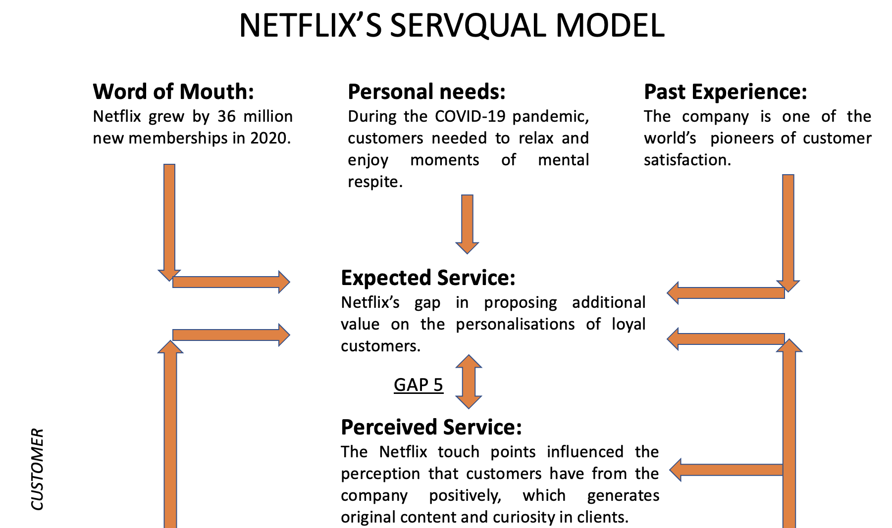

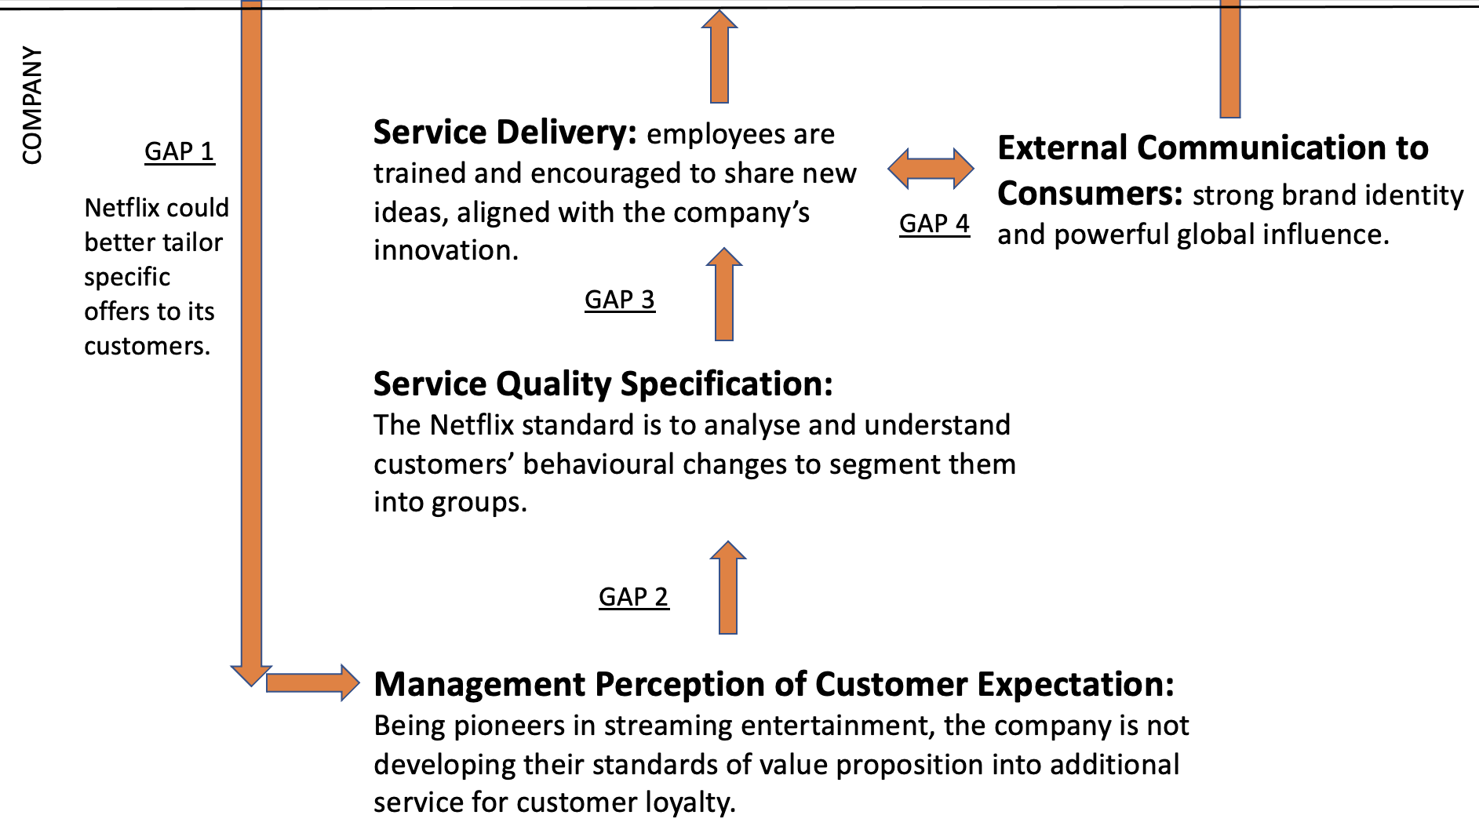 Source: Laura Pino

Netflix, in terms of business to customers, has a strong competitive advantage in having a multi-dimensional analysis to record customers’ data (Haughey, 2021), however the customer relationship management challenge is not losing consumer interest and avoiding client’s from switching to different a competitive platform. By improving their products quality or identifying new opportunities, the customer relationship management can create competitive advantages for the company, increasing profitability and decreasing clients switching (Buttle, 2008). Hence, the customer relationship management core principle is to market consumer data and used the knowledge to accurately target the information, to better contrast waste of marketing budget and improve alienated vision into new prospective clients (Buttle, 2008). Using the SERVQUAL model Netflix could achieve becoming the first company to fully understand customers’ needs and behavioural changes, by implementing specific attention on customer retentions and developing their research and analysis by using their existing customer science model, offering additional value to customer expectation. Finally, when businesses are focussed on implementing and evolving their service quality, it will reflect their customer satisfaction which, consequently, will bring their brand loyalty to the company (Buttle, 2008).

6 Recommendations
The company, in a period such as the COVID-19 pandemic, is challenging customers switching to other competitors (Rushe, 2021) and considering that, recommendations are made based on proposing additional value for customer retention.
The first recommendation is related to Netflix’s surveys, which they use to suggest better client profile and preference customisation (Nir and Far, 2021), however they could generate them to understand what clients would like to receive from the company’s services. For example, asking if they happy and satisfied with what the platform offers, to use that information to implement Netflix’s customer experience.
The second recommendation is referring to loyal clients, who have had their subscription more than one year, the company could offer special premium movie content, in which they can have access only with those conditions. Increasing company value proposition and attention to customers who are unable to go to the cinema.
The third recommendation is made regarding customer discounts, for example, Netflix could offer a 10% reduction to every client who introduces a friend to the platform. This would create and increase the word of mouth network.
Another recommendation, that could help the CRM system during tailoring clients’ experiences, is based on implementing, in the Netflix website, a section where customers can add comments on movies that they have watched.
The last recommendation could be made for family subscriptions, who had difficulties during the various lockdowns, and receive customised offers or promotions related to their membership.
Those suggestions are shaped with the goal to enhance Netflix’s customer relation management in achieving the best engagement with their customers and truly understand their customer’s needs.

7 Conclusion
The report analysed Netflix’s customer relationship management, who stressed the attention in customer centricity to create the best qualitative engagement during the COVID-19 pandemic (Van Belleghem, 2021). Netflix’s CRM used a customer science methodology that tailored one of the best customer experiences (Van Belleghem, 2021). Moreover, the report explained the concept of value proposition and in Netflix, their commitment in delivering the best streaming entertainment service, with a variety of original TV programs and personalised content, available 24/7, is comprehensive (Pereira, 2021). However, the paper found a lack of fully understanding the needs of customer retention during the company customer lifecycle by not proposing additional value for them and increasing the risk of switching to competitors, such as HBO or Amazon Prime. The company in the first quarter of 2020, had a decrease of subscriptions because they had a slowdown in production, due the pandemic situation, which after the second half of the year they managed to recover their loss of memberships by increasing the variety of their content (Mehta and Richwine, 2021). Therefore, CRM Value Chain and Total Quality Management models were discussed to understand if they could help Netflix to overcome its CRM problem with an examination of advantages and disadvantages in implementing them in the company. Afterwards, the SERVQUAL model was applied, with which its service quality analysis helped the study to identify the gaps between the relationships of customer perception and the management perception. From the model selected, the paper proposed with better customisations on special offers to Netflix’s clients that the company could receive an increment of customer loyalty in return, which, in the end, corresponded to the CRM strategy and, consequently, will achieve an increased company ROI, return on investment.

8 References

Anderson, D., 2019. ‘Netflix Inc.’s Organizational Culture & Its Strategic Implications’. Rancord Society. November 18th, 2019. [Online] Available at:
https://www.rancord.org/netflix-inc-organizational-culture-hrm-strategic-implications
(Accessed: 13/08/2021).

Bergeron, B., P., 2002. ‘Essentials of CRM: a guide to customer relationship management’. New York, Wiley, 2002.

Buttle, F., A., 2001. ‘The CRM Value Chain’. The Chartered Institute of Marketing. February 2001. [Online] Available at:
https://www.researchgate.net/publication/228396256_The_CRM_value_chain
(Accessed: 24/07/2021).

Barone, A., and Anderson, S., 2021. ‘Total Quality Management (TQM)’. Investopedia. Mar 16th, 2021. [Online] Available at:
https://www.investopedia.com/terms/t/total-quality-management-tqm.asp
(Accessed: 30/07/2021).

Eby, K., 2021. ‘A Quality Principle: Everything You Need to Know about Total Quality Management’. Smartsheet. Jul 19th, 2021. [Online] Available at:
https://www.smartsheet.com/total-quality-management
(Accessed: 30/07/2021).

Gargenta, A., 2020. ‘Netflix Shares Their Internal Training Checklists’. Plusplus. [Online] Available at:
https://plusplus.co/ideas/netflix-shares-their-internal-training-checklists/
(Accessed: 13/08/2021).

Gartenstein, D., 2019. ‘Advantages & Disadvantages of Total Quality Management Strategies’. CHRON. January 28th, 2019. [Online] Available at:
https://smallbusiness.chron.com/advantages-disadvantages-total-quality-management-strategies-22160.html
(Accessed: 30/07/2021).

Haughey, C., J., 2021. ‘How to Master Modern Marketing Strategy Like Netflix’. Engagebay. [Online] Available at:
https://www.engagebay.com/blog/modern-marketing-tips-netflix/
(Accessed: 10/08/2021).

Keenan, M., 2020. ‘4 Awesome Customer Segmentation Examples (And Why They Work)’. ManyChat. February 24th, 2020. [Online] Available at:
https://manychat.com/blog/customer-segmentation-examples/
(Accessed: 25/07/2021).

Kozerska, M., 2021. ‘MANAGING SERVICE QUALITY – SERVQUAL METHOD: STRENGTHS AND WEAKNESSES’. Advanced Logistic Systems. [Online] Available at:
http://www.als.zim.pcz.pl/files/MANAGING-SERVICE-QUALITY---SERVQUAL-METHOD-STRENGTHS-AND-WEAKNESSES.pdf
(Accessed: 24/07/2021).

Mehta, C., and Richwine, L., 2021. ‘Netflix subscriber growth slows after pandemic boom, shares fall 11%’. Reuters. [Online] Available at:
https://www.reuters.com/business/media-telecom/netflix-misses-expectations-quarterly-paid-subscriber-additions-2021-04-20/
(Accessed: 22/08/2021).

Netflix Annual Report, 2020. ‘UNITED STATES SECURITIES AND EXCHANGE COMMISSION Washington, D.C. 20549’. [Online]. Available at:
https://www.annualreports.com/HostedData/AnnualReports/PDF/NASDAQ_NFLX_2019.pdf
(Accessed: 22/07/2021).

Netflix, 2021. ‘Plans and Pricing’. Netflix.com. [Online] Available at
https://help.netflix.com/it/node/24926/gb
(Accessed: 22/07/2021).

Van Belleghem, S., 2021. ‘Customer Experience at Netflix: 6 lessons we can all learn from!’. Customer Think. January 5th, 2021. [Online] Available at:
https://customerthink.com/customer-experience-at-netflix-6-lessons-we-can-all-learn-from/
(Accessed: 22/07/2021).

Netflix, 2021. ‘The Story of Netflix’. [Online] Available at:
https://about.netflix.com/en
(Accessed: 24/07/2021)

Nir and Far, 2021. ‘How Netflix’s Customer Obsession Created a Customer Obsession’. [Online] Available at:
https://www.nirandfar.com/customer-obsession/
(Accessed: 30/07/2021).

NGCX, 2021. ‘The Netflix Effect: How Netflix's Commitment to Extreme Personalization Is Impacting Customer Expectations’. [Online] Available at:
https://nextgencx.wbresearch.com/blog/netflix-effect-commitment-extreme-personalization-customer-expectations
(Accessed: 13/08/2021).

Patel, N., 2021. ‘How Netflix Maintains a Low Churn Rate by Keeping Customers Engaged & Watching’. [Blog] Available at:
https://neilpatel.com/blog/how-netflix-maintains-low-churn/
(Accessed: 29/07/2021).

Pereira, D., 2021. ‘Netflix Business Model’. The Business Model Analyst. August 27th, 2021. [Online] Available at: https://businessmodelanalyst.com/netflix-business-model/#Value_Proposition_of_Netflix
(Accessed: 28/08/2021).

Pratt, M., K., 2021. ‘Total Quality Management (TQM)’. TechTarget. [Online] Available at:
https://searchcio.techtarget.com/definition/Total-Quality-Management
(Accessed: 30/07/2021).

Proxy Statement, 2021. ‘Proxy Statement and Notice of Annual Meeting of Stockholders, 2021’. [Online] Available at:
https://s22.q4cdn.com/959853165/files/doc_financials/2020/ar/13481_002_Web_BMK.pdf
(Accessed: 30/07/2021).

Q4U SERVQUAL ANALYSIS ,2021. ‘Advantages’. WordPress. [Blog] Available at:
https://q4uweb.wordpress.com/advantages/
(Accessed: 16/08/2021).

Q4U SERVQUAL ANALYSIS ,2021. ‘Disadvantages’. WordPress. [Blog] Available at:
https://q4uweb.wordpress.com/disadvantages/
(Accessed: 16/08/2021).

Rushe, D., 2021. ‘Netflix records dramatic slowdown in subscribers as pandemic boom wears of’. The Guardian. [Online] Available at:
https://www.theguardian.com/media/2021/apr/20/netflix-records-dramatic-slowdown-in-subscribers-as-pandemic-boom-wears-off
(Accessed: 22/08/2021).

SHINE,2020. ‘Netflix – A brand evolution’. The Shine Agency. August 27th, 2020. [Online] Available at:
https://www.theshineagency.com/blog/netflix-a-brand-evolution/
(Accessed: 10/08/2021).

Smith, A., 2017. ‘How to Create a Customer Obsessed Company Like Netflix’. Forbes. December 12th, 2017. [Online] Available at: https://www.forbes.com/sites/anthonysmith/2017/12/12/how-to-create-a-customer-obsessed-company-like-netflix/?sh=69f164636d22
(Accessed: 30/07/2021).

Takur, S., and Chetty, P., 2019. ‘Understanding the importance of Buttle’s CRM value chain model’. Project Guru. March 26th, 2019. [Online] Available at:
https://www.projectguru.in/buttles-crm-value-chain-model/
(Accessed: 29/07/2021).

