MODULE TITLE:
HOTEL PLACEMENT-MANAGING FOOD AND BEVERAGE OPERATIONS
MODULE NUMBER: BMIH6002
MODULE LEAD: NATALIE BRAILSFORD
ASSIGNMENT TITLE: STUDENT LEARNING LOG
STUDENT NAME: MIHAIELA VIOLETA BUGARSCHI
STUDENT NUMBER: 2107140

Table of Contents
Introduction 3
Reflection on Experience and Personal Development 4
Critical Analysis of Work-Based Skills and Technical Knowledge 4
Reflection on Organisational Issues 5
Working Model 5
Future Action Plan 7
Conclusion 8
References 9

Introduction
The Premier Inn North Southampton represents a small hotel business that does not have any on-site restaurant. Here, the guest explores nearby dining options. Further, the food and beverage operations of the hotel are limited to breakfast services that are offered using an external vendor as well as nearby establishments (premierinn, 2023). Thus, the following study will briefly focus on the reflection on experiences and development followed by analysis of skills and knowledge. Further, some of the organisational issues will be highlighted along with future plans for development.

Reflection on Experience and Personal Development
During my time shadowing a supervisory rank in the food and beverage department present in the hotel, I have managed to gain crucial insights regarding the guest service standards. Such an experience has underscored the significance of work-based skills as well as technical knowledge to meet along with exceeding such standards. I have learned the ways by which proper communication, smooth teamwork and task management are crucial to deliver unique guest experiences (lesroches, 2023). Hence, my earlier industry knowledge, academic journey and development has trained me with an effective foundation in such a domain. Therefore, using this experience, I have managed to hone my overall understanding of the particular needs in the food and beverage department by realising the effect of personal attributes to serve guests. Moreover, this experience has also showcased the importance of adaptability, solving problems as well as a proactive method to make sure that smooth operations are conducted followed by continuous learning and growth (hcareers, 2021). Hence, this allowed me to reflect effectively on the requirement for continuous development of my skills as well as knowledge for thriving in such a hospitality sector.

Critical Analysis of Work-Based Skills and Technical Knowledge
The significance of work-based skills as well as technological knowledge to meet every guest standard should not be overstated. During my experience in the hotel, I have faced the major role of such skills along with knowledge to deliver better guest experiences. Particular work-based skills like proper communication, solving issues as well as adaptability has been vital to deal with guest needs effectively and courteously. For example, when a guest had a unique dietary need, the potential to interact about this openly with the kitchen staff to make sure that the request is met demonstrated the significance of such skills. Moreover, technical knowledge, that includes knowing every food safety rules and menu items has been equally vital. Such knowledge helped to empower the teams to offer accurate knowledge to guests to ensure their dietary needs to be addressed effectively. For instance, being very well-versed regarding the menu has helped to confidently make recommendations about dishes to guests which leveraged their dining experience. Lastly, the capacity to navigate as well as use the systems of hotels effectively has helped to provide a smooth guest experience. Thus, such a form of technical knowledge has played a vital role to uphold the overall guest standards (revolutionordering, 2023).

Reflection on Organisational Issues
During my time at Premier Inn North Southampton, I have had organisational problems regarding the dependency on external contractors for laundry-based services. Such an arrangement has led to many occasional delays to deliver freshly cleaned bed sheets as well as the collection of used ones, which directly affected the performance and guest service of the department. Any delays to acquire clean bed sheets hugely affected the overall efficiency of room turnovers that led to guest dissatisfaction since it took longer waiting times for the room to be ready. Also, any risk of bed sheets getting rejected by the laundry contractor leveraged the problems that affected the availability of sufficient linens for the rooms (laundrylux, 2023). Therefore, to deal with such problems, the hotel can implement in-house laundry services to gain more control over this process and lessen the possible delays. Also, deploying a cost-benefit analysis for comparing the expenses of both in-house laundry against external contractors can offer vital insights regarding the solution. Hence, the hotel can focus on the significance of quality control as well as efficiency within the laundry operations by implementing suitable theories based on operation management like the Total Quality Management approach. As a result, the hotel can bring developments in their linen management that would lead to guest satisfaction effectively (ivypanda, 2023).

Working Model
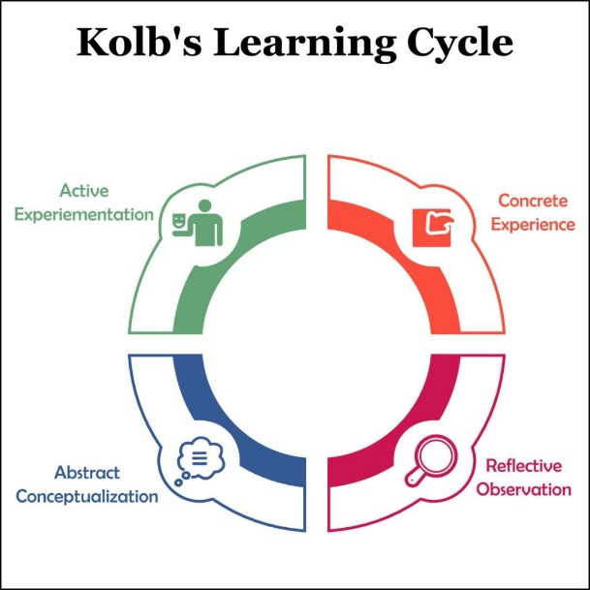
Figure 1: Kolb’s Experiential Learning Cycle
Source: (Main, 2022)
I will make use of Kolb’s Experiential Learning Cycle for reflecting on my overall experience within the food as well as beverage department at the hotel.
Concrete Experience - While I was working in the department, I have faced many issues and opportunities. I have also taken part in tasks which needed proper interaction, teamwork and technical understanding for meeting guest standards. Also, I have seen organisational issues regarding laundry services including its effect on departmental performance.
Reflective Observation - I have realised the significance of work-based skills as well as technical knowledge to deliver better guest experience. Hence, the organisational problem showcased the significance of operational efficiency followed by quality control regarding guest service operations. Also, I have understood the need for enhancing my personal and vocational growth for dealing with such issues properly (Mcleod, 2023).
Abstract Conceptualisation - Such an experience has deepened my overall understanding of the dynamic nature of the hospitality sector. The role of continuous learning followed by skill development to meet the growing guest experience has been underscored. Therefore, the experience helped to gain relevant insights regarding the practical application of suitable theories based on operations management as well as customer service.
Active Experimentation - Therefore, I am planning to deploy an action plan dedicated to leverage my work-based skills and technical understanding. This process includes the development of interaction, teamwork, managing tasks and personal skills. Therefore, I have aimed to align such a plan with my personal along with vocational development goals which would dedicate to my overall professional growth in such industry.

Future Action Plan
There are various areas for development regarding work-based skills as well as technical knowledge. Thus, to improve communication, I will engage in active listening programs and take part in workshops emphasised on proper verbal as well as non-verbal interactions. Moreover, strengthening teamwork would consist of collaboration on various projects to foster an environment of support as well as recognition (brighthr, 2023). The task management skills can be leveraged using time management techniques followed by using task-tracking tools. Also, I have aimed to enhance my own personal skills after enrolling in leadership development programs followed by seeking mentorship from similar professionals. Along with that, I will go through additional training based on CRM by attending seminars regarding hotel trends and practices for elevating guest services (apptivo, 2023). Therefore, such an action plan would align with my overall personal as well as vocational development goals after implementing an effective skill set along with deeper understanding of every guest's standard. This process would directly contribute to the development of my profession in such an industry as it would equip me with the proper expertise required for excelling in such a dynamic and client focused atmosphere.

Conclusion
The shadowing experience within the food as well as beverage department in Premier Inn North Southampton has offered major insights regarding the enhancement of work-based skills along with technical knowledge. The study has showcased the role of proper interaction, smooth teamwork to adapt to task management for delivering better guest experiences. Further, the experience has demonstrated the significance of personal followed by vocational development to shape career prospect aspiration within this department. Therefore, such a reflective journey has focused on the practical application of every theoretical knowledge as well as the importance of hands-on experience to enhance professional growth in this sector.

References
apptivo, (2023). Benefits Of CRM In Hospitality Industry. [Online]Available at: https://www.apptivo.com/blog/benefits-of-crm-in-hospitality-industry/ [Accessed 25 January 2024].
brighthr, (2023). The importance of teamwork. [Online]Available at: https://www.brighthr.com/articles/culture-and-performance/teamwork/the-importance-of-teamwork-in-the-workplace/ [Accessed 24 January 2024].
hcareers, (2021). Improving Your Adaptability: The Most Important Hospitality Skill. [Online]Available at: https://www.hcareers.com/article/career-advice/improving-your-adaptability-the-most-important-hospitality-skill [Accessed 21 January 2024].
ivypanda, (2023). Total Quality Management in the Hospitality Industry Essay. [Online]Available at: https://ivypanda.com/essays/total-quality-management-tqm/ [Accessed 22 January 2024].
laundrylux, (2023). Why You Should Stop Outsourcing Laundry Services and Bring It In-house. [Online]Available at: https://laundrylux.com/blog/why-stop-outsourcing-laundry-services-bring-in-house/ [Accessed 22 January 2024].
lesroches, (2023). Communication skills in the hospitality industry. [Online]Available at: https://lesroches.edu/blog/communication-skills-in-hospitality-industry/ [Accessed 20 January 2024].
Main, P., (2022). Kolb's Learning Cycle. [Online]Available at: https://www.structural-learning.com/post/kolbs-learning-cycle [Accessed 23 January 2024].
Mcleod, S., (2023). Kolb’s Learning Styles And Experiential Learning Cycle. [Online]Available at: https://www.simplypsychology.org/learning-kolb.html [Accessed 23 January 2024].
premierinn, (2023). Southampton North hotel. [Online]Available at: https://www.premierinn.com/gb/en/hotels/england/hampshire/southampton/southampton-north.html [Accessed 20 January 2024].
revolutionordering, (2023). Importance of Information Technology In Hospitality Industry. [Online]Available at: https://www.revolutionordering.com/blog/importance-of-information-technology-in-hospitality-industry#:~:text=Information%20technology%20is%20essential%20for,and%20ensure%20long%2Dterm%20profitability [Accessed 21 January 2024].

