NAME OF STUDENT: Jean Paul Marshall
STUDENT ID: 2023697
NAME OF AWARD: HND Building Studies
MODE: Full time

Contents…………………………………………………………………………………………………….……………..Page-2
Provisional Title of Project………………………………………………………………………………….……..Page-3
Overview…………………………………………………………………………………………………………………..Page-3
Introduction and background…………………………………………………………………………………..Page-3
Aims and Objectives……………………………………………………………………………………….………..Page-3
Research Methodology(ies) and Justification………………………………………………………………………………………………….…….…...Page-3
Important aspects to look at while computing an answer……………………………..………...Page-3
Important things to remember for the researcher………………………………………….…….…Page-3
Conclusion………………………………………………………………………………………………….……….…..Page-3
Limitations……………………………………………………………………………………………………………….Page-5
Literature review…………………………………………………………………………………………….……….Page-5
Recommendations…………………………………………………………………………………………………..Page-8
Reflection…………………………………………………………………………………………………………....….Page-9
References…………………………………………………………………………………………………………..…..Page-10

1. Provisional Title of Project: carbon usage in rebuilding vs retrofitting
A comparison between embodied and operational carbon usage on new builds and old buildings being retrofitted and will time scale be a factor, for example, does a longer time scale change the current results?
2. Overview - What is the work going to be about?
The plan of action is to identify the differences between carbon usage when rebuilding vs retrofitting within the housing sector. Retro fitting is most popular due to the lower costs and speed in which it can be done vs rebuilding. But what if we look at the carbon usage of the construction and operational carbon usage over a hundred years, will it be more carbon friendly over this time scale? So, the aim of this dissertation is to identify the relevant information in relationship to rebuilding vs retrofitting mainly embodied and operational carbon usage.
3. Introduction and background
The researcher i.e., me, has worked in construction for most of his life, starting his career as a labourer. He worked his way through several labouring roles before gaining an adult apprenticeship. In the process of completing his apprenticeship he worked on new builds, retrofits, and older housing stock as well as listed buildings. He decided at an early stage that working with older buildings and prolonging their lifetime is what he wants to do for his career. So today he is studying as a building surveyor and is asking the question are we retrofitting houses with carbon saving modifications instead of rebuilding them to current or even future specifications to save time and money in the short term?
4. Aims and Objectives
The aim is to identify from literature and research findings if retrofitting is really the best long-term plan for a carbon neutral house. But the question is, are we retrofitting houses with carbon saving modifications to save time and money in the short term?
My objectives are.
- To find data that contrasts a new build vs a retrofit house regarding carbon usage.
- To find expert opinions and views
- Look at statistics of both retrofit and new build stored and operational carbon.
- How using reclaimed materials effect new build and retrofitting carbon usage

5. Research Methodology(ies) and Justification:
This document will be using secondary data from leading experts, government data and research journals. The reason this method of research is being used, is because it is based on figures and not opinion. The report will include as much relevant data that can be found in the time frame supplied. This will draw out the data that is needed and will be presented in a way that highlights the question at hand “are we retrofitting to save time and money on the short term?”. The best data sources will be from creditable sources such as government documents, accredited construction, environmental and waste management sources. After gathering all the relevant data from these sources, the data will be dissected and formulated a way to present it over a time scale of around 100 years, to do this the data will be inserted into tables of carbon stored, carbon used, cost and time. The reason for this approach is that the reader can clearly identify the data by viewing the graphs and charts thus creating a clear and distinct view of the data. Graph data is important to display any information that is related to figures as described by (trudeau, 2003) He explains the importance of using graphs and charts to show data, he explains that human beings have a natural ability to view, digest and understand differences, anomalies and trends in data. Graphs were first introduced in the 18th century by Leohard Euler a swiss mathematician and his attempts & eventual solution to the famous Königsberg bridge problem depicted below are commonly quoted as origin of graph theory.

6.Important aspects to look at while computing an answer
- Operational carbon is important to look at particularly, particularly regarding, if the new build will exceed the retrofit operational carbon usage and what the time scale would be, so when would it overtake?
- Embodied carbon when retrofitting we save most of the embodied carbon but will knocking it down and rebuilding eventually outweigh that lost carbon, buy saving carbon with the newest techniques and technology encompassed into the materials and mechanical technology in the newbuild.
- Whole life carbon this is important and identifies what we are asking, it shows the whole carbon past and future,

7.Important things to remember for the researcher
- Carbon usages are a relatively modern but very relevant topic, so getting the relevant information about the buildings from history might be difficult.
- The prosses of making the materials have changed.
- Some technology is still relatively new,
- There are a lot of governing ideas around this topic.
- It’s a lot of information to find and formulate.
8.Conclusion
The researcher will gather as much relevant data as intended to make a clear argument in the debate, but this is a very big debate and is limited to time. They will however do as much as he can and focus the areas that are most important. They will also supply references to all the work so the reader can either check the context or read further with the dissertation and form their own opinion.

9.Limitations
The limitations foreseen include time, amount of information on the subject and the fact this is a broad and relatively new topic. To counter this limitation, the topic area could be reduced to, the importance of stored carbon in retrofitting and reaching green targets.

Literature review
Introduction.
This chapter will introduce the literature review. It will start with the first objective, which will define embodied carbon, then go on to the second objective which will look at whole life carbon. The chapter will then go on to the third objective which will explain refurbishment of buildings. Then go on to the fourth objective which will be reducing embodied carbon. Then go on to the fifth objective Allowing deconstruction. Then go on to the sixth objective which will be, Is refurbishment the best option. Then finally the chapter, which is the seventh objective Is refurbishment the best option.

Embodied carbon
Dr Craig Jones explains that embodied carbon is the amount of carbon released in the process of production and processing of the materials used in the project. Most of the carbon released is from the use of fossil fuels in the production prosses. This applies to all stages of the project such as transport, extraction of materials, refining, construction, and fabrication (Jones, 2015). He explains that historically embodied carbon was overlooked and that it’s actually a very important aspect to look at. He goes on to explain that many older buildings cannot be refurbished to the same standards as new builds and modern construction techniques, but keeping the existing building uses less materials, so there is less embodied carbon. The question he asks is “But is this enough of a carbon swing to sway in favour of refurbishment? Too strengthen his view, we can also look at the transportation of materials and Doctor Watson illustrates the carbon cost in a graph. The graph in figure 1 explains that GC02e/Kg/Km is the equation of embodied carbon per kg of material transported per km travelled.
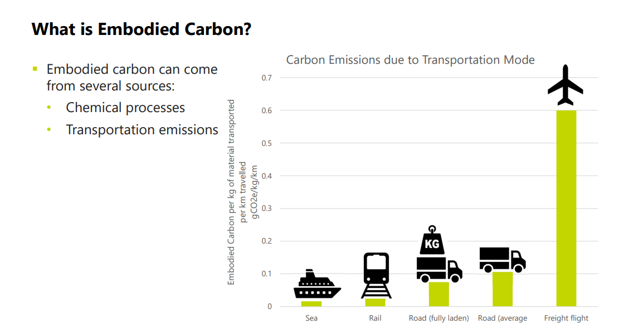
Figure 1. showing the embodied carbon emissions based on transport mode (Watson, 2023).

Whole life carbon
According to the royal institute of chartered surveyors (RICS), whole life carbon is defined as considering all the carbon usage through all life cycles of the project, these include raw materials and their extraction, product manufacturing, transport of items relevant to the project, installation, operational, maintenance, and material disposal. It also includes the future potential for recovery, reuse, and recycling (RICS, 2017). Dr Craig Jones explains that embodied carbon and operational carbon need to be viewed side by side, as embodied carbon is overlooked as we do not see that part. He goes on to explain that the average new build house in the UK uses around 45 tonnes of C02e for its construction That’s equivalent to the same carbon usage as driving around the earth 10 times, it’s important to listen to what he says as this information is built around a small three bedroom house and not a block of flats for example (Jones, 2015). CO₂e is the abbreviation of carbon dioxide equivalent and is how the reading from the Mackay carbon calculator is expressed, this is a calculator that is used to measure how the energy saving plans, you plan to implement affect the UK emissions (GOV.UK, 2023).

Refurbishment of buildings
Dr Jones explains that generic embodied carbon analysis must be different for every refurbishment project as they are all different, He explains that he embodied carbon of the materials for a refurbishment needs to be compared with the additional operational carbon saving for the building under study. He goes on to explain that every building has a different energy use profile. He explains that refurbishment is a very viable option because refurbishment projects don’t need to compete on the same level of thermal performance regarding whole life carbon perspective. He goes on to explain there are lots of refurbished materials that bring carbon benefits when re used (Jones, 2015).

Reducing embodied carbon
Dr Craig Jones explains that there are a lot of ways to reduce embodied carbon, The best option is to reuse as much of the materials in the refurbishment as you can, he states that up to 95 percent of embodied carbon can be saved vs buying new materials. The next best option is to use natural materials such as wood as they have a very low embodied carbon index, Dr Watson reinforces this data with her study, her data shows that a timber build pays back the carbon usage over time, this is illustrated in figure 2 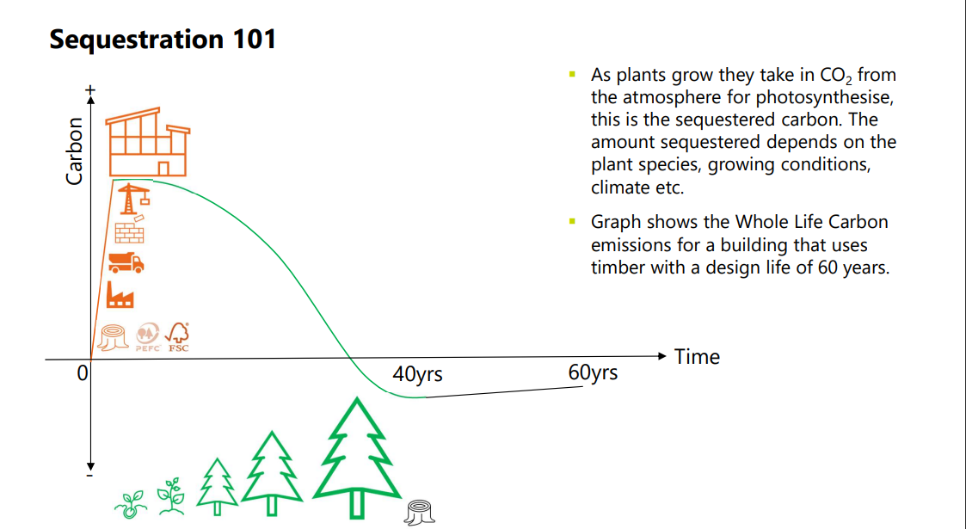
Figure 2shows the whole life carbon emissions for a building that uses timber with a design life of 60 years (Watson, 2023).
Jones goes on to say substituting materials for lower carbon alternatives such as oil-based paints for water-based paints significantly lowers the carbon footprint. He also explains that doing something as small as painting an object with a water-based paint over oil-based paints, makes a considerable difference to lowering the carbon footprint over 50-100 years (Jones, 2015). Doctor Watson confirms what Doctor Jones explains, she explains in her carbon reduction potential graph, that the best approach to carbon reduction is to try to build nothing, but re use what is in place, build in a more intelligent way by using better designs and techniques and focusing on low carbon processes.
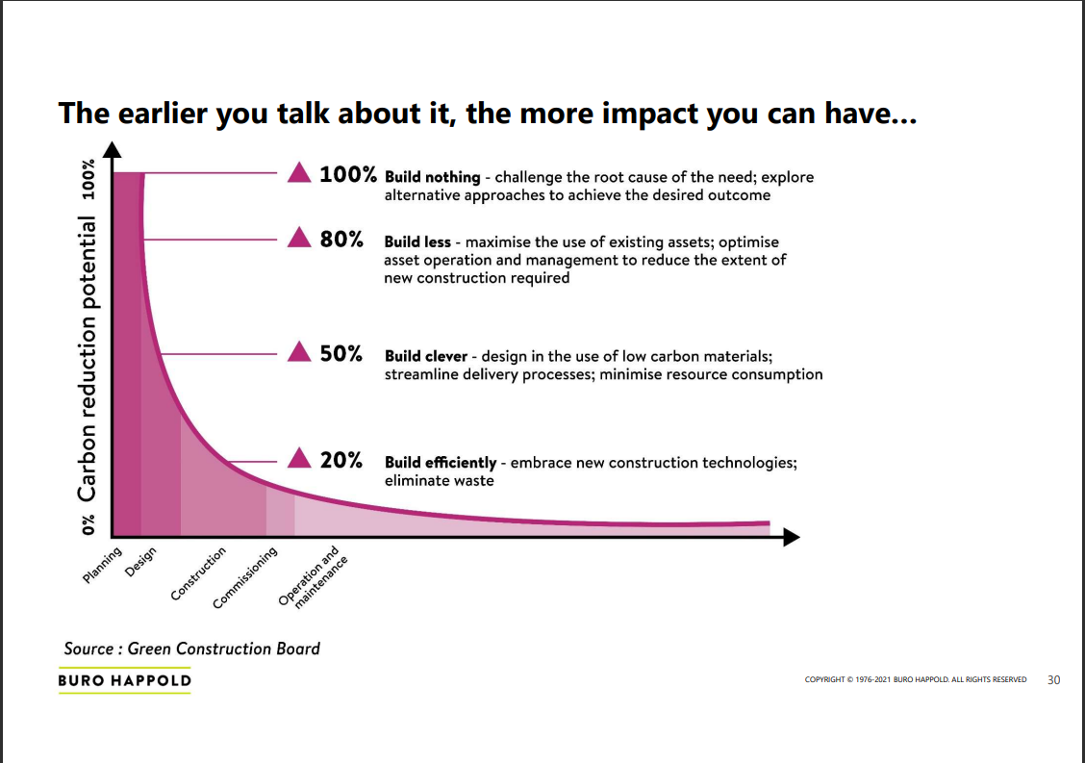
Figure 3showing the differences in impact (Watson, 2023).
She goes on to reinforce the graphical information with facts and figures, these figures show that in 2021 there are 238,306 empty homes in England classed as long-term vacant, Scotland has 43,000 and Wales has 27,000. The data also reveals that, in 2019 there was 172,217 vacant commercial buildings in the United Kingdom. (Watson, 2023). This shows that there is potential to use the housing stock available rather than build new.

Allowing deconstruction
Dr Craig Jones goes on to explain the circular economy when deconstructing, he explains that bricks and mortar have a high carbon rating and should be retained for as long as possible to make sure all the carbon value is used. He explains the way there constructed is important because if they were built from lime mortar, they would be easier to reuse. By reusing the bricks, you save a lot of embodied carbon. He goes on to explain some materials offer such a good saving on carbon in there use that they no longer need to be calculated in as they have paid for them self’s (Jones, 2015).

Is refurbishment the best option?
Dr Craig jones makes a good point, he explains that every project is different as its build up from several different materials, specifications, and designs. He explains that during the refurbishment process that embodied carbon can be paid back by the operational carbon of the items or materials such as a window, he explains that a window can be changed for a more thermal efficient window, but he goes on to explain it’s a bit more difficult in a listed building as there is not always a better thermal option that keeps in with the original look of the building. His statement says “However, double glazed sash timber windows are widely available and help to retain the look of the older building stock whilst reducing its operational energy and carbon footprint. These are compromises that we need to consider”. He goes on to say that when it comes down to the choice of replacement, rebuild or retain its important embodied carbon is looked at. He goes on to explain, that you must look at the reduced thermal performance of refurbishing a building vs the carbon expense of building new. He makes a very good point when he states “Whilst there are cases where rebuilding is the best option, there are considerably more where refurbishment is a better choice. Furthermore, without the choice of refurbishment the UK would lose too much charm and too much character from its older and charming building stock. No doubt with the UK’s looming “zero carbons agenda” homes new analysis will be required (Jones, 2015).

Recommendations and conclusion
The question that was set out is, is retrofitting the best option when comparing with rebuilding? The research completed shows that refurbishment is the most carbon friendly, financial saving and time saving way to meet carbon saving targets. The research also shows that the utilising of current vacant properties would be highly successful. The research also shows that embodied carbon has a big part to play in how we should approach refurbishment vs rebuild, because if we look at the embodied carbon, we can look at where we can save carbon usage not just from the embodied carbon but from the operational carbon, as some of the embodied carbon on re used materials can be deducted from the operational carbon. Looking at the information researched it clearly points to the advantages of refurbishment compared to rebuilding, this can be seen in the data set out. The advantages are not just carbon saving but time saving and financial saving. The data shows that the first option should be too not build but to re purpose vacant buildings, then to refurbish properties with carbon saving technology and finally to rebuild using new building techniques, carbon saving building techniques and modern technology such as solar panels. When looking at the information in the data, the data all comes to the same conclusion, and that is that refurbishment, re using materials where applicable is the most carbon efficient route. It is also highlighted that when building new buildings, that the incorporation of natural material with low carbon values should be used and that designs can be made to incorporate these in the structure, such a timber instead of concrete, water-based paints instead of oil paints and reclaimed materials instead of new. Also, if we look at incorporating carbon saving technology such as solar panels, triple glazed windows, re use of grey water and non-mechanical ventilation we reduce the carbon footprint dramatically over one hundred years. Carbon usage is a big topic at the moment and with the new building regulations, which came into action in June 2020 shows the government’s plan for new building to produce 30 percent less CO2. They intend to do this with their new approved documents, these are approved document L, volume1: dwellings, approved document L, volume2: buildings other than dwellings, approved document F, volume1: dwellings, approved document F, volume2: buildings other than dwellings and the new approved document O covering overheating. These are the standards set out before the government changes the standards again in 2025 (GOV, 2023).
Reflection
· What has this exercise taught you about yourself (personally and professionally) and what will you change going forward?
The main thing I have learnt about myself while completing this piece of work is that I had a view on this subject and the more I researched the more my view changed. I came into this subject with the view that knocking down old buildings and rebuilding state of the art carbon efficient homes was the answer. What I have learnt is this will never work, mainly because of the cost and time it would cost/take to do and because technology is getting more advanced and will continue to do so. So, this shows me that we cannot keep knocking down and rebuilding, but we must look at what is sustainable. Through doing this piece of work I have learnt that nothing is as straight forward as it appears, I mean that I must look at topics I feel strongly about and research them, study them and compare different data and research, rather than looking for evidence to prove myself right. I have learnt that proving myself wrong, is just as important as proving myself right, as this is what will make my professional life successful. Moving forward I need to remind myself that the analysing of all relevant information available to me is needed to make an opinion, as an opinion with no evidence or support is no use in a professional setting. So, to summarise, I need to research the subjects I feel strongly about whether I prove myself right or wrong and do it with an academic approach.

· What was the journey to your goals, including successes and failures; how were issues resolved
The biggest issue I found was finding the information relevant to the subject, then trying to find references that where not just relevant but up to date. When looking for information I found a lot of information on the internet, but a lot was from web pages that where not usable for one reason or another. A lot of the information found was copy and pastes of original study and research. To counter this, I made sure the information I used was from a reputable source, from people with the correct qualifications and experience. The next step was to lay out the information found, in a legible easy to read format. I done this through research of past pieces of work similar to this, and through getting my work looked at by a lecturer and proof reading. The biggest hurdle for me was juggling assignments, when I should have set out time scales for each one. I did set out a schedule in the end, so that I had a timeline to follow to keep me on course.

· Given what you now know, would you do anything differently (if you were to do the project again)?
If doing this piece of work again I would have set myself clearer goals, this would have made researching a lot easier for me. I say this because I researched a lot of stuff I didn’t need or didn’t help me portray what I was trying to. I would have been able to focus on the topics I needed to write this paper making it clearer for the reader and easier to complete. I would also try to approach the subject from a building surveyors’ point of view and not a bricklayer’s point of view, but that will come with time, experience, and education. I would have included my peers and lecturers more in my research, ideas, and presentation as I tend to try do everything based on my own experiences, when I should be using all the resources available to me. I would have set my self-time-based deadlines and objective stages, so I felt a lot more organised. The main thing I would have liked to do is, talk to professionals in person and question them directly, on what their real-life experiences are rather than what’s in a textbook, there real-world struggles while trying to follow the laws and legislations as I think this would have added to what I am trying to convey in this piece of work.
· Has what you have done changed your ambition or strengthened it?
While writing this piece of work I felt very strongly that, knocking down old housing stock would be the best answer. Now that I have researched many different subjects surrounding this. The subjects are based on carbon usage and contain the financial, environmental, and economic impact information I thought was relevant. Through studying these topics, I have learnt a lot from the data and the views of industry regulator and researchers and have a lot more to learn. But by doing all this research and soaking in what I have learnt, has given me more fuel to succeed and to learn as much as I can about this topic. By learning as much as I can, I can apply this in my professional life and, hopefully add some knowledge to help all the people who are trying to change how we do things in the construction industry and hopefully help make a change. This piece of work has changed the way I think of the subject, so proving myself wrong was a benefit to me as I now look at what can be done to save old housing stock rather than just write it off and rebuild. I always liked older buildings but never thought about housing in the same way. Through research I found out older housing stock is just as important to remembering who we are, as a castle is.

References
GOV.UK, 2023. Carbon calculator. [Online]
Available at: https://www.gov.uk/guidance/carbon-calculator
[Accessed 19 april 2023].
GOV, 2023. New homes to produce nearly a third less carbon. [Online]
Available at: https://www.gov.uk/government/news/new-homes-to-produce-nearly-a-third-less-carbon
[Accessed 24 april 2023].
Jones, D. c., 2015. The Environmental Sustainability of Existing Buildings: Refur﻿bish or Replace?. [Online]
Available at: https://circularecology.com/news/the-environmental-sustainability-of-existing-buildings-refurbish-or-replace?utm_content=buffer30852&utm_medium=social&utm_source=twitter.com&utm_campaign=buffer#.V7HfDmVH3L-
[Accessed 04 March 2023].
Jones, D. C., 2023. What's the Difference Between a Carbon Footprint and Embodied Carbon. [Online]
Available at: https://circularecology.com/carbon-footprint-v-embodied-carbon.html
[Accessed saterday january 2023].
surveyors, r. i. o. c., 2017. RICS professional standards and guidance, UK. [Online]
Available at: file:///C:/Users/jpmar/Downloads/whole_life_carbon_assessment_for_the_built_environment_1st_edition_rics%20(1).pdf
[Accessed 04 March 2023].
trudeau, r. j., 2003. introduction to graph theory. dover: Publisher Dover Publications Inc.
Watson, N., 2023. Embodied carbon, definitions, measurment and reduction. [Online]
Available at: https://www.ice.org.uk/media/32ioonlm/embodied-carbon-definitions-measurement-reduction-slides.pdf
[Accessed 21 April 2023].

