Creative practice 4

Word count: 1338

Sam Fenwick

Adam Head

M5X01569

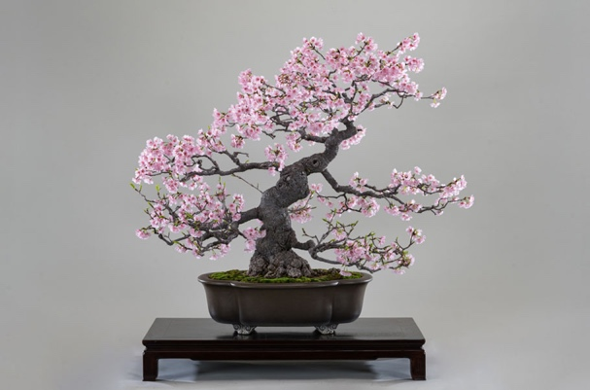
This project required the creation of a hardbody/polygonal, UV unwrapped and retopologised model. The starting point for this was the brainstorming of ideas of what to model and was important to showcase the skills necessary for the industry and to create a model I could be proud of. The initial ideas I had were a snake
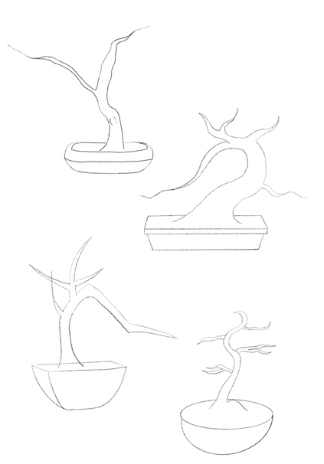
and PS5 controller, although I decided that neither of these ideas were complicated enough. However, it was eventually decided to model a tree, more specifically a cherry blossom bonsai. A bonsai tree can be any type of tree as bonsai means to grow a tree or shrub in a pot. Bonsai is meant to symbolise peace, harmony, and balance, this was very important throughout my design and modelling process as I wanted the tree and branches to flow naturally but still show balance and order.
Once this had been decided, early concept sketches were made of the tree design. Multiple designs were explored, all with different branch positions and directions of movement. Multiple different pot shapes and sizes were also explored.

Additionally, when the chosen tree design was selected, the tree was ready to be created in Maya. I created the pot for the tree to sit in, but shortly abandoned the idea of using Maya as I realised the difficulties there would be with this software when creating an organic looking model as forms are created through basic shapes and lacked fluidity and the organic forms that were needed. I decided I wanted to create my model in Zbrush due to previously seeing work constructed in this program. However, I had never used Zbrush before and this was a very steep learning curve. I experimented in Zbrush and realised how difficult it was to use, the first problem I ran into was only creating red squares on the screen when trying to create a starting point.
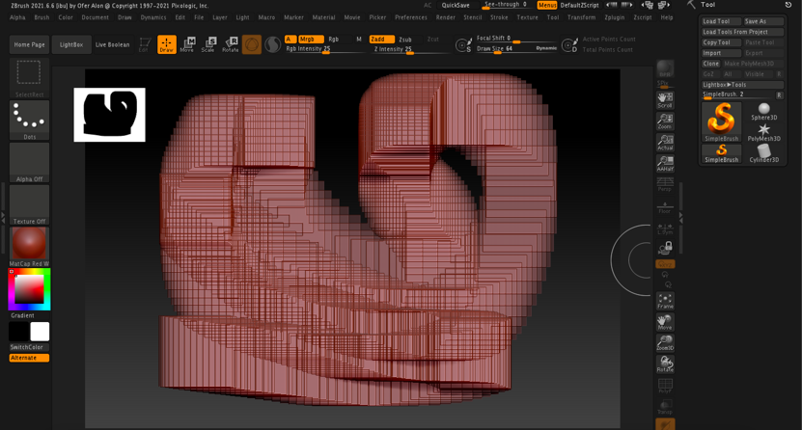
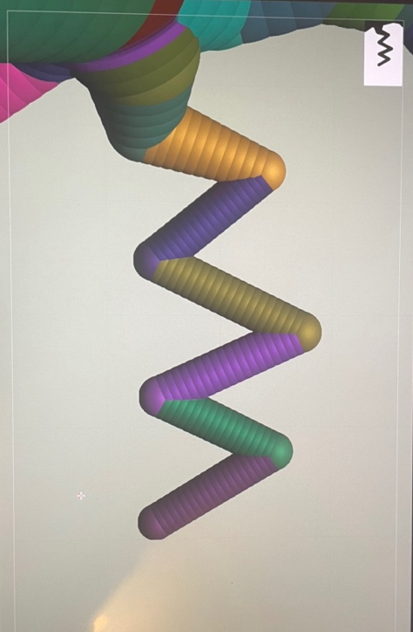
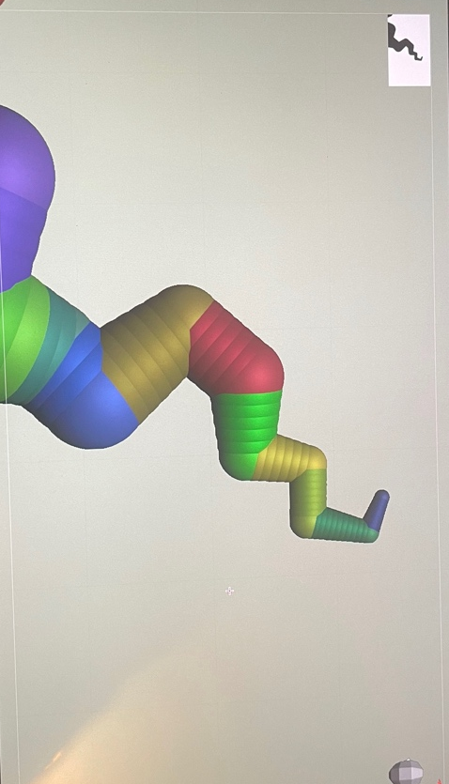
As it turns out, I was working in a 2d plane rather than 3d and didn’t have a tool selected. Once I solved this problem, I tried creating a pot for my tree to sit in, however, I was still struggling with using this new software. The pot proved to be a challenge as I was still in the headspace of trying to create an organic model, although the pot needed to look man made and inanimate. After struggling to create the pot, I chose to abandon this idea and focus on modelling roots to the tree instead.
Once I’d decided to create the roots as well, I began modelling. I discovered the Zsphere tool, it allowed me to add spheres onto spheres to create a base shape for my tree. Once the base model was created, I started using the scale and move tools to give the tree a more natural feel. I made the roots decrease in size towards tips and added smaller sub- roots branching off main roots.

A huge problem I came across was with saving my model. I saved everything as a document which I thought would save everything, however, when I re- opened the document to check that it was saved, I realised that saving as a document was the worst of the 3 possible saving options. Saving as a tool only saves the tool/ model you’ve been working on and saving as a file saves absolutely everything. Saving as a document only saves a 2d version of your 3d model which meant I had lost everything that I had been working on and had to start again. Although this was very frustrating, it now meant I knew how to properly save my model and put me in the mindset of creating an even better model the second time round.

I had now fully made a Zsphere model of my tree, to continue working on my model and to add detail I needed to convert my Zsphere model to a mesh. Once converted to a mesh, I created a UV map.
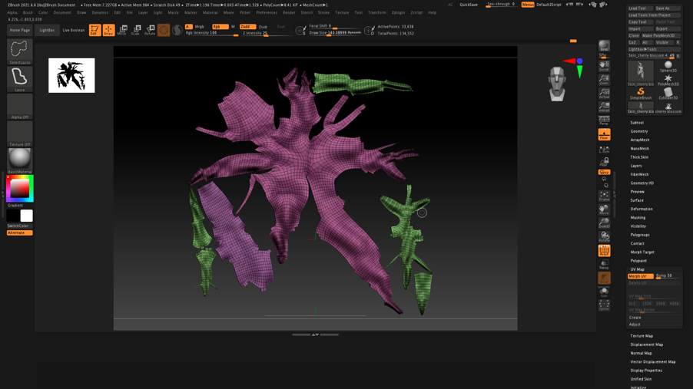
I chose to use the clay build up tool to add detail to the trunk and roots of the tree. I decreased the size of my brush and used lots of little stroke to build up the trunks texture.

Once I was happy with the first stage of detail, it was time to move onto the second. I divided my mesh to add more subdivisions, this allows me to add more detail. Once I divided my mesh, I started grouping the parts of the tree, the trunk, roots, and branches. This allowed me to divide the bottom half of the mesh and add more detail without affecting the upper half/ branches.
With the tree split up into groups, I masked the top half of the tree and added surface noise to the bottom. I used the corrosive noise at a low intensity to give the trunk a rough, bark- like texture.
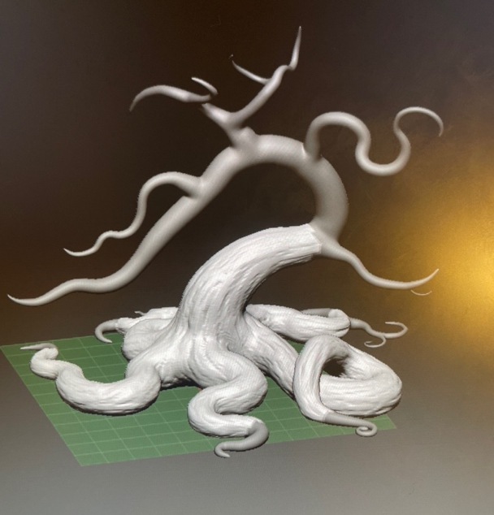
I began dividing the mesh then adding more features until I was happy with how much detail I had put on the tree. I divided my model 7 times which had a dramatic effect on the number of polygons the model had, over 35 million which was way too many. To counteract this, I used Zremesher to reduce the amount of detail and polygons the model had. Now that I had a model with a more realistic polygon count, I had to re-add the lost detail. Projection was the key to this problem; I duplicated the tree then projected the detail from the original onto the model with less polygons. Through this, a model was constructed with a smaller polygon count but still a good amount of detail. Nearing completion, I added dramatic lost features.
I change the material of the model to skin shade 4, this gave me a good base material that I could work on and improve. The base colour of the mesh was a light grey colour, I changed this to a light shade of brown. This was selected so that I can add darker shades where details were needed. To add colour to the deeper grooves, I masked by cavity so that only the indents were selected. I then used the paint brush tool to darken these areas and add any last detail.
With a finished tree, I created a final UV and texture map and then started working on the vegetation for the branches.

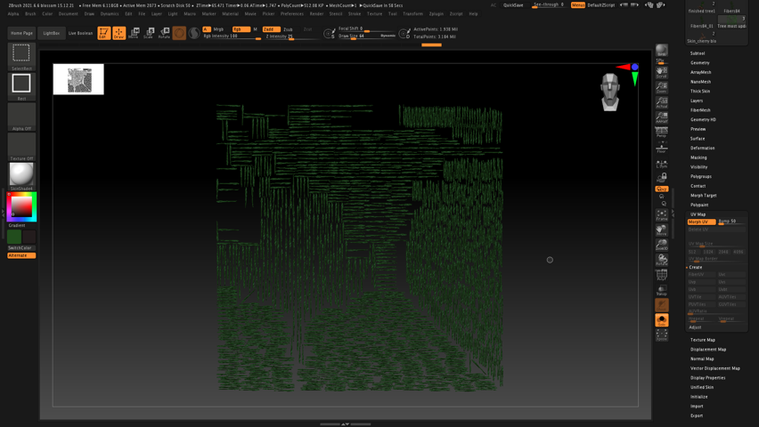
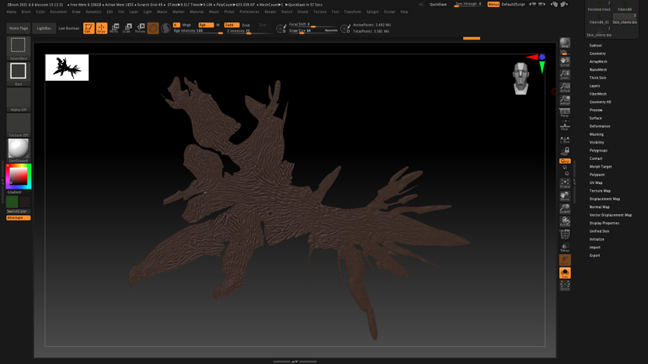
I needed to create the leaves/ vegetation for the branches. I masked the rest of the tree so that only the branches would be affected by the fibre mesh. I tried out many different styles of fibres as well as different thicknesses and a number of individual fibres. A decision was made on a fibre set that gave the tree a very natural feel which I was very happy with. I tried out multiple shades of pink to try to create the cherry blossom aesthetic that I wanted but, in the end, settled on a dark shade of green. I did this because I’d rather be happy with the design of my tree and not follow my original idea than use a colour that looks like my idea but I’m not happy with.

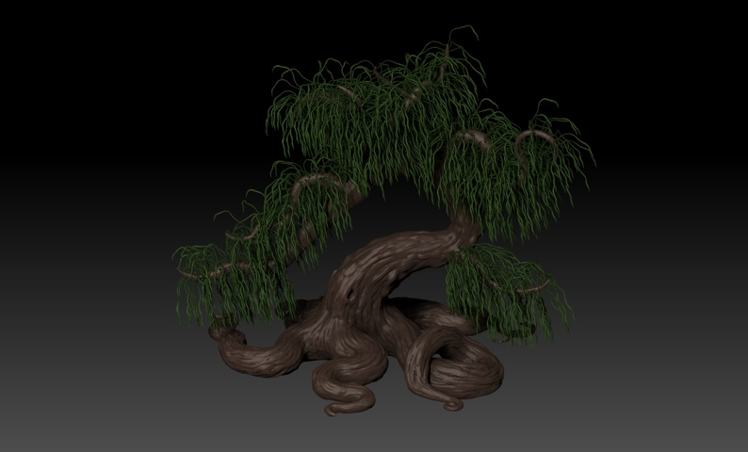
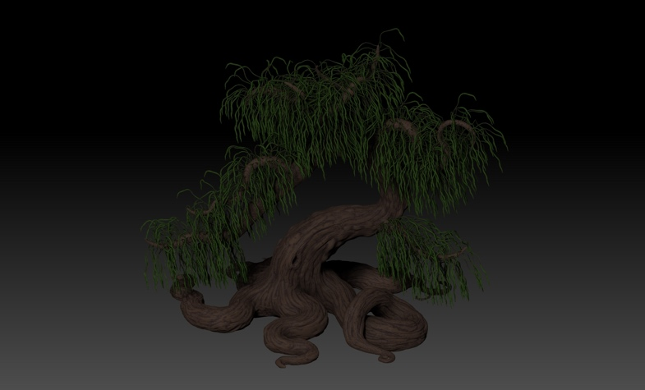
Lastly, I experimented with lighting and material modifiers as I though the tree looked too plastic and not organic enough. I mainly changed the wax modifiers as this changed the way the model reacted to the light. By increasing the intensity of the wax modifier, I was able to have the light disperse over the tree and given it a rough look, instead of having the trunk and vegetation shine in the light.

Overall, I’m very happy with how my “cherry blossom bonsai” turned out. Although it wasn’t how I pictured it, I think it went well for my first ever attempt using Zbrush. I’m excited to see what I can make on Zbrush in the future. If I was to re-create my model, I’d focus more on creating my own leaves/ vegetation and flowers, as well as reducing polygon count but keeping detail.

