Methodology

Introduction
The previous chapter of this dissertation looked at the existing literature surrounding male victims of domestic violence. This chapter will explain to the reader how the study will be carried out. This is referred to as the Methodology. A methodology is a collection of systems, techniques, processes, or principles that are used to carry out a systematic research process for a dissertation. The goal is to provide a unique and important result that will add to the field of study. Research is essential for learning and comprehension. It is the process of increasing awareness and knowledge surrounding a particular subject (Saunders et al., 2016). It helps in identifying areas of strength as well as areas of weakness.
According to Bryman (2016), there are two main types of research: primary and secondary. Primary research is defined by Bryman as data which has been directly collected by the researcher from individuals, rather than relying on pre-existing data which has been collected from previous studies. This is otherwise known as secondary research.
The literature review, highlights that there is distinct absence of current academic research and studies on the issues related to the reasons why male victims of domestic violence under-report the issue. As a result, this study will opt to undertake primary research in order to answer the questions. Conducting this type of research will help to bridge the gap in the existing literature, whilst facilitating a better understanding of society’s perceptions today. It is intended that by gaining a greater understanding from those who participate in this research, improvements may be identified and implemented to increase awareness, confidence, and support services for male victims of domestic violence.

Research onion
The research onion, was developed by Saunders et al. (2016) to describe the different stages through which a researcher must pass when developing an effective methodology. It will serve as a guide throughout the process as each layer, when viewed from the outside, describes a more thorough level of the research process.
It provides the researcher with an effective process for developing a research approach, ensuring its reliability and validity. This method of research is widely used as it is flexible and can be applied to a wide range of circumstances (Bryman 2012). This dissertation will investigate and describe the many stages of the research onion, as well as clarify the principles at each level.

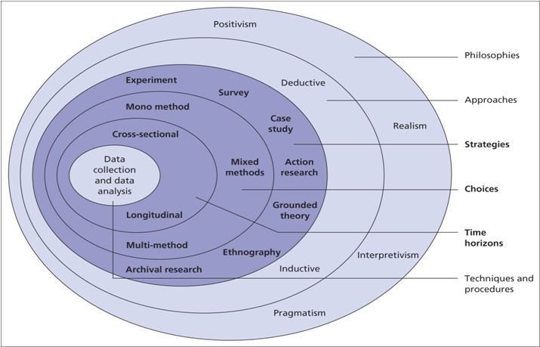
Fig 3. Diagram of Research Onion (All Assignment Help UK, 2017)

Research Philosophy
There are three different Philosophies that hold significance when planning and carrying out research. These are Ontology, Epistemology and Axiology. For this study, the researcher will use the epistemology philosophy. Epistemology is the theory of knowledge. It is concerned with the minds relation to reality.
Each philosophy is made up of philosophical instances. It is these philosophies that provide structure and guidance while carrying out research. The philosophical approach for this study will be ‘Interpretivism’. However, ‘Interpretivism’ is closely linked to ‘Realism’ and ‘Positivism’ as they can all fall under the Epistemology philosophy. ‘Interpretivism’ allows individuals to understand how they and others think and behave. According to Bryman (2016), using the interpretive approach can help in gaining a better understanding of a culture and provide explanations as to why things happen.

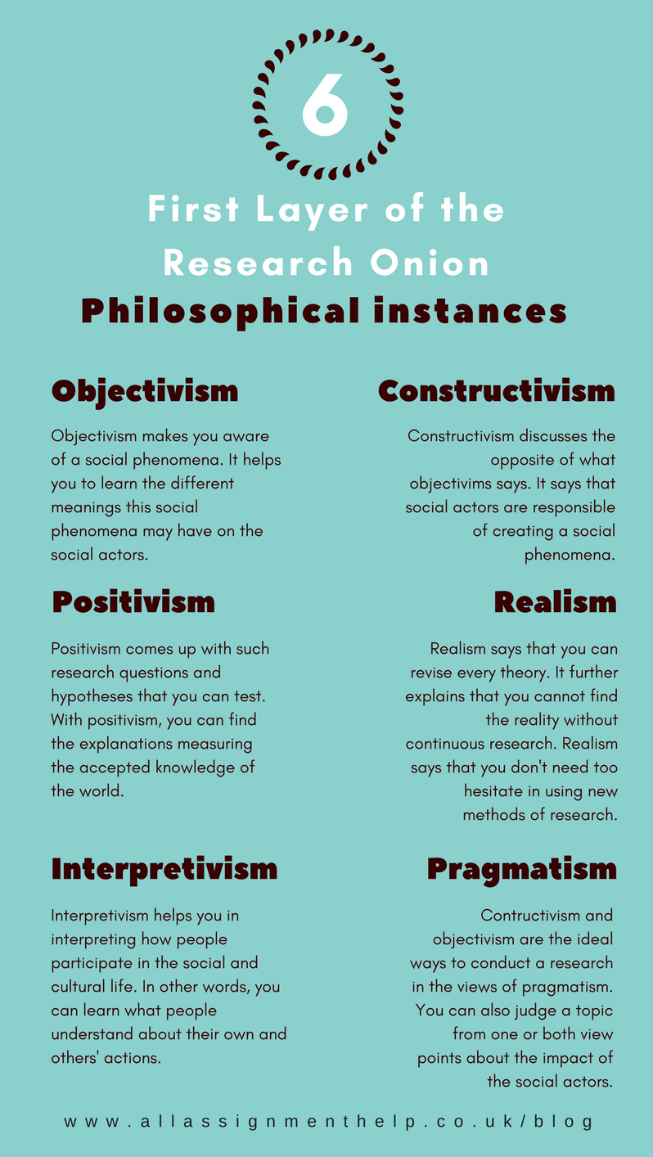
Fig 4. First layer of the Research Onion (All Assignment Help, 2017)

Research Approach
According to Saunders et al. (2016), two types of research approaches are commonly used in academic writing: the Deductive method and Inductive method. A deductive method goes from theories to data, whereas an inductive method goes from data to theory. To put it simply, a deductive process begins with a theory and proceeds to acquire data or evidence that may prove or disprove that theory. An inductive approach is one in which a researcher examines the outcome or action and sets out to collect data to account for the potential reasons as to why a phenomena exists.
This research uses the ‘Deductive’ approach with the aim of collecting data to help prove or disprove the many theories that have already been identified in earlier chapters of this dissertation (surrounding the issues male victims face when attempting to report abuse).
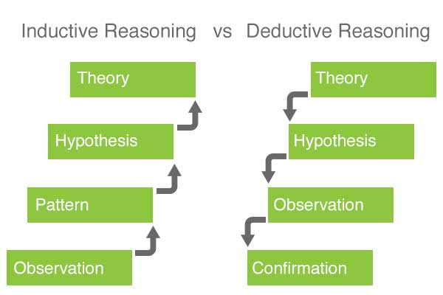
Fig 5. Inductive and Deductive Approaches (Elmansy, 2016)

Ethical Considerations
This study will not include any victims of domestic violence due to the delicate nature of this subject matter. Participation is entirely voluntary, and all participants will be fully informed of the nature of the study and will have the right to withdraw at any time. All information submitted will be anonymised, with all personal data eliminated, ensuring that no personal information will be collected or retained, guaranteeing that no persons or places will be recognised.

Research Strategy and Choice
The researchers chosen strategy is to create a questionnaire using Google documents which will then be available online via hyperlinks and social media websites. This approach acknowledges that this is a sensitive subject and participants may be put off if it was conducted face to face (Lelkes et al., 2011). By doing it this way, total anonymity will hopefully encourage individuals to participate who may normally be put off.
Furthermore, this method is the most straightforward and efficient way to conduct a survey. It is cost effective and due to the volume of quantitative data required, this method is the easiest way to ensure that there are enough participants. By achieving high participant numbers, enough quantitative data will be gathered to determine the outcome, and the reliability and validity of this research will be strengthened.
The only disadvantage envisaged will be that the results from the questionnaire will take a lot of time and energy to gather and display the quantitative data found.
Time Horizon
Two different types of time horizons: Longitudinal and Cross sectional. A Longitude study is a method that allows you to analyse and compare behaviours and events over a longer period. A Cross-sectional study design is a type of observational study which allows the researcher to analyse data from participants from a specific point in time, such as surveys/questionnaires (Setia, 2016).
For this research project, the cross-sectional method will be used as this method is the most efficient model when conducting population-based surveys. This method is also the most appropriate as the research is over a short period of time.

Techniques: Data, Collection and Analysis
Due to several factors, such as, the nature of the subject, COVID restrictions, and sheer volume of anticipated participants, the survey will be conducted online by utilising Google forms. This will be disseminated to willing participants who can complete in their own time and return.
The aim is to collect between 50 and 100 completed surveys to collate data from. The quantitative data will be analysed and displayed into various graphs and charts show the findings and to see if any patterns or recommendations can be identified.

Sample
A sample is a small section of a larger population (Bryman, 2016). When carrying out research, it is necessary to sample a small section of the population, as the general population would be too large to allow for comparison (Ghauri et al, 2020).
However, sample sizes of less than 25 tend to produce results that are distorted by individual respondents. In such cases, the larger the sample size, the more reliable the findings will be (Flick, 2011). This is especially true for quantitative research.
Quantitative research requires a higher volume of participants to determine the reliability of the study’s findings. The sample characteristics are also important in qualitative research, but much smaller samples are typically used, as it is more personal and less reliant on volume data from many sources.
The researcher aims to target between 50-100 respondents consisting of police officers and members of the general public. This will provide the researcher with the opportunity to observe individual’s perceptions of the issues that male
Victim’s face when reporting domestic abuse. This sample size is ideal as the research will use the primary data from the results of the questionnaire to undertake quantitative research.

Reliability and Validity
When evaluating any measuring approach for data collection in a successful study, reliability and validity are two of the most important and fundamental variables to consider.
Although the terms validity and reliability are frequently used interchangeably, they have significant differences. Reliability demonstrates consistency, while validity demonstrates whether the tests effectively measure what they are intended to measure (Drost, 2011).
Questionnaires are regarded as a valid and dependable method of data collection because they provide a large amount of information outlining the participants’ point of view (Akinci and Saunders, 2015).
When conducting this study, the reliability and validity of the results will be strengthened by adhering to a predetermined structure contained within the research onion.

Limitations
As with every study, there are always constraints or possible problems that are outside the control of the researcher. When it comes to research methodology and data analysis, there is no “gold standard”. Most approaches cannot be properly duplicated and, as a result, cannot be confirmed. Due to the imposed constraint of 10,000 words, it is anticipated that the scope of this study would be constrained. Time constraints/deadlines may also have an influence on participation rates and study outcomes. Furthermore, there are simply not enough studies/papers pertaining to male victims of domestic abuse, making spotting patterns problematic. Furthermore, because male victims of domestic violence cannot be included in the study, ethical difficulties will have an influence on the genuine reasons why they do not disclose domestic violence. However, because males will be included in the study, but not as victims, the explanations will not be a real portrayal, but rather an indicator of why. All of the aforementioned factors may have an influence on results, and it is critical to recognise them.

Conclusion
This chapter has identified and described all the various aspects of this research methodology. The goal of the following chapter will be to compile, analyse, and present the findings from the data collection methods identified in this chapter.

1,574 Words

Bibliography

Saunders, M., Lewis, P. & Thornhill, A. (2016). Research Methods for business students. 7th ed. Essex: Pearson Education Limited.

Bryman, A. (2016). Social Research Methods. 5th ed. Oxford: Oxford University Press.

Flick, U., 2011. A beginner’s guide to doing a research project. Introducing Research.

Ghauri, P., Gronhaug, K. and Strange, R. (2020) Research Methods in Business Studies. Cambridge University Press.

All Assignment Help UK, (2017)
Available at: http://www.allassignmenthelp.uk/blog/research-onion-made-easy-to-understand-and-follow (Accessed 25th February 2022)

Setia, M. (2016) ‘Methodology Series Module 3: Cross Sectional Studies’, Indian Journal of Dermatology, 61(3), pp. 261-264.

Elmansy, R (2016)
Available at: http://www.designorate.com/inductive-reasoning-in-user-experience-research/ (Accessed 25th February 2022).

Lelkes, Y., Krosnick, J., Marx, D., Judd, C. and Park, B. (2011) Complete Anonymity comprises the accuracy of self-reports. Available at: http://pprg.stanford.edu/wp-content/uploads/Anonymity-JESP-FINAL-June-2012.pdf (Accessed 25th February 2022).

Akinci, C. and Saunders, M. (2015) Using questionnaire surveys for within-organisation HRD research: In handbook of research methods on human resource development. London: Edward Elgar Publishing.

Drost, E. A., 2011. Validity and reliability in social science research. Education Research and perspectives, 38(1), pp. 105-123.

