University of Wales Trinity Saint David
Motorsport
Assignment 2
Alexandros Griffiths
2403677
Motorsport Engineering BEng
02/04/25
Engineering Design
1608 Words
Contents
Introduction 1
Key legislation considerations 2
Specifications 2
Time plan 3
Research 3
Annotated sketches 3
Scissor Jack 3
Geared wheel 4
Hydraulic actuator 5
CAD Model of Final Design 6
Fully dimensioned technical drawings 8
Manufacturing 13
Justification 13
Conclusion 14
References 14

Introduction
The design task is to address a health and safety concern regarding the heavy stainless-steel lid used in an anodization tank in an automotive OEM factory. The current 5mm thick lid is a two-person lift, which poses ergonomic risks and operational inefficiencies. The objective is to redesign the lid so that it may be handled by one person with safety, compatibility with existing tank size, and sufficient overhead clearance for handling parts. This report will trace the design process from research through to final proposal, justifying decisions by analysis and prototyping.

Key legislation considerations
The new anodization tank lid will have to adhere to main UK health and safety law to eliminate manual handling hazards and chemical exposure risks. The Health and Safety at Work Act 1974 gives a duty of care by employers for employee safety, and this includes the elimination of unnecessary physical effort within the new design (HSE, 2023). Employers are, under the Manual Handling Operations Regulations (1992), to prevent hazardous manual handling where feasible; where not, mechanical aids or ergonomic adjustments must be implemented (HSE, 2021). The Provision and Use of Work Equipment Regulations (PUWER 1998) further demand that any equipment, such as tank covers, be safe to operate, adequately maintained, and appropriate for its purpose (Legislation.gov.uk, 1998). Adherence to these standards guarantees that the new lid reduces the risk of injury and enhances operational effectiveness.
Chemical safety law also impacts design specification. The Control of Substances Hazardous to Health (COSHH 2002) calls for the prevention of exposure to sulphuric acid, implying the cover should be able to give a good seal and also be resistant to corrosion (HSE, 2022). Minimisation of hazards in machine design is headed by global standards such as BS EN ISO 12100:2010 without introducing any new hazards (BSI, 2010). Any additional materials used are made safe under control and kind to the environment by REACH compliance (EC 1907/2006) (European Chemicals Agency, 2024). By these legislations being followed, the cover will assist in ensuring workplace safety within the provisions of the law.

Specifications
The new tank lid will put safety, ergonomics, and performance at the highest level and will meet all relevant rules and regulations. The highest priorities are facilitating safe single-person operation by either a composite material-based, lightweight lid or an assisting lifting system (e.g., counterbalanced hinges or gas struts). It must be able to form a good vapor seal to contain the sulfuric acid fumes inside, have comfortable handling points, and provide sufficient clearance for loading and unloading of parts It must be compatible with existing tank sizes, rugged enough for industrial use, and cost-effective. All components must adhere to PUWER, COSHH, and ISO 12100 standards.

Time plan
I’ll spend the first two weeks finalizing design specifications and researching lightweight materials like stainless-steel composites and assisted-lifting mechanisms. Weeks 3-4 will focus on prototyping the selected design (likely a scissor-jack assisted stainless-steel lid ), followed by rigorous testing in week 5 for acid resistance, ergonomics, and safety compliance. After refining the design in week 6 based on test results, I’ll spend weeks 7-8 preparing manufacturing documentation and sourcing suppliers, then produce the first batch of 20-30 lids in week 9 for final validation before full-scale production begins in week 10. Throughout the process, I’ll maintain close collaboration with your health and safety team to ensure all operational requirements are met.

Research
Industry research shows that it has been possible for the majority of chemical plants to transition from stainless steel covers to lightweight composite covers without issues. Fiberglass-reinforced plastic is now a popular material due to its high corrosion resistance and significantly reduced weight compared to metal (Chemical Processing Magazine, 2023). Case studies in automobile manufacturing factories indicate that polypropylene covers can be strong structurally in sulfuric acid conditions and save weight by over 50%, making them practical for one-person use (Industrial Equipment News, 2023). Such material solutions provide the necessary strength without addressing the primary ergonomic concerns of the current design.
Current industrial equipment research reveals several effective techniques for improving tank cover usability. The most efficient designs incorporate assisted-opening devices such as gas springs or counterbalanced hinges, reducing the lifting force required by as much as 80% (Plant Services Magazine, 2023). Proper positioning of the handle and distribution of weight have been shown to lower operators' strain significantly, with optimal designs maintaining the overall weight at less than 15kg for one-man operation safety. These ergonomic improvements have been applied across the board in similar industrial applications with successful results in preventing on-site accidents.
Effective tank covers must provide easy access as well as reliable vapor retention. Contemporary industry practice prioritizes secure sealing devices these days, and EPDM rubber gaskets and magnetic closure systems prove most effective to prevent acid fume leaks (Process Safety Progress, 2022). The research concurs that well-designed covers can deliver all necessary safety features while being radically easier to handle, provided they are executed with proper sealing, corrosion-resistant, and ergonomic handling in mind. All this provides a firm template for constructing an improved cover that will support all performance requirements.

Annotated sketches

Scissor Jack

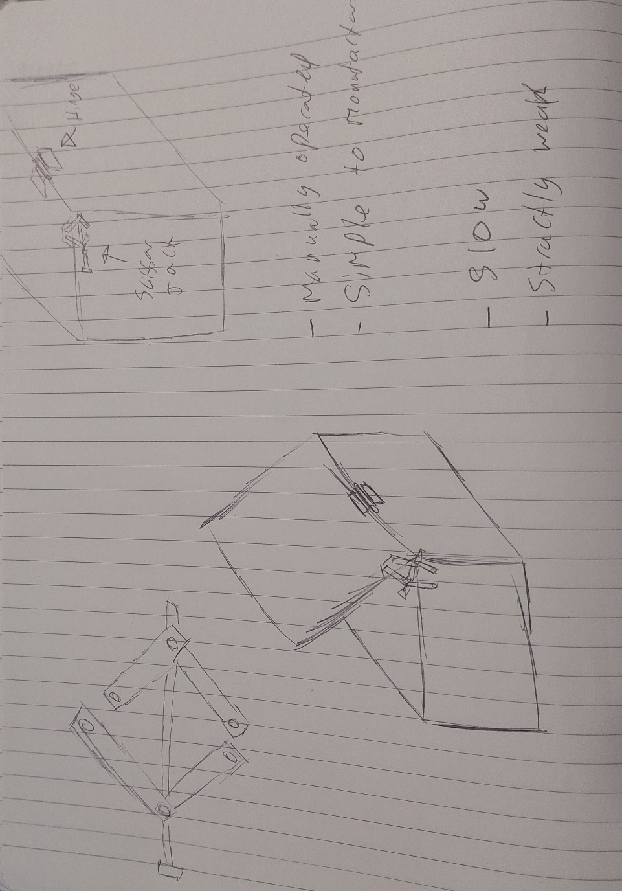

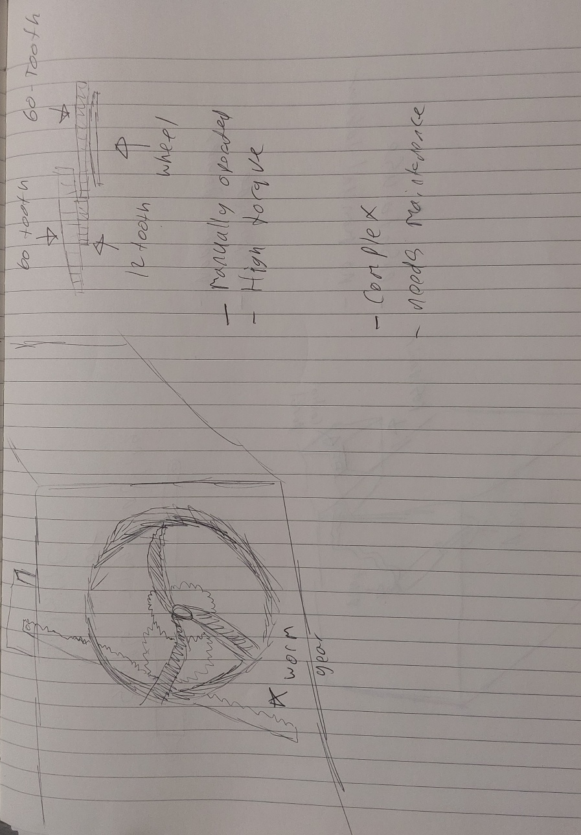

Geared wheel

Hydraulic actuator

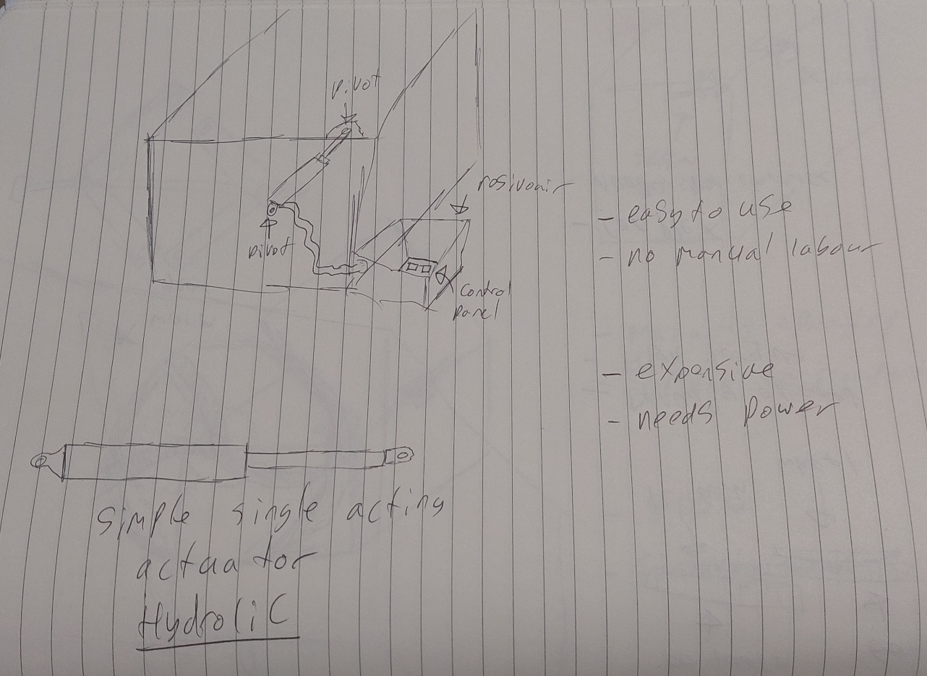

CAD Model of Final Design
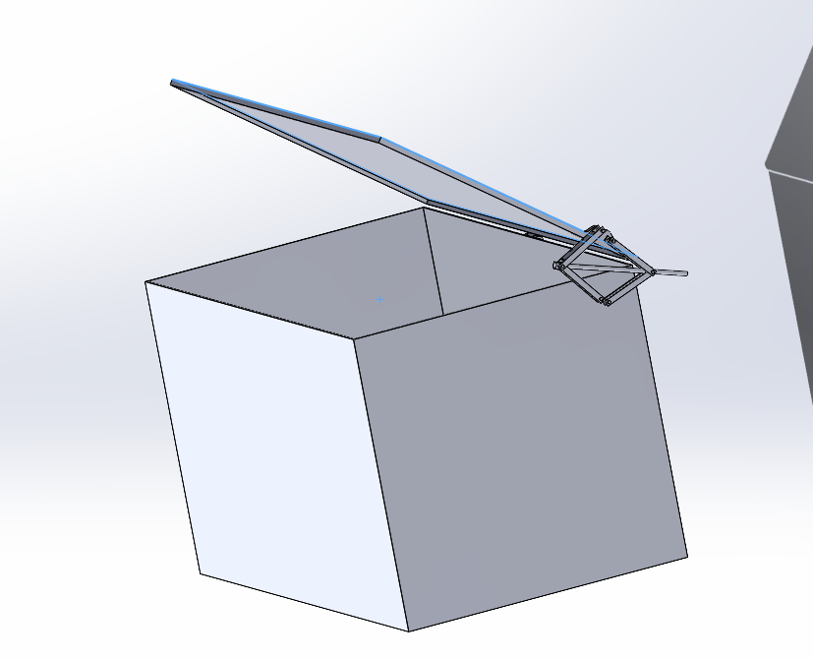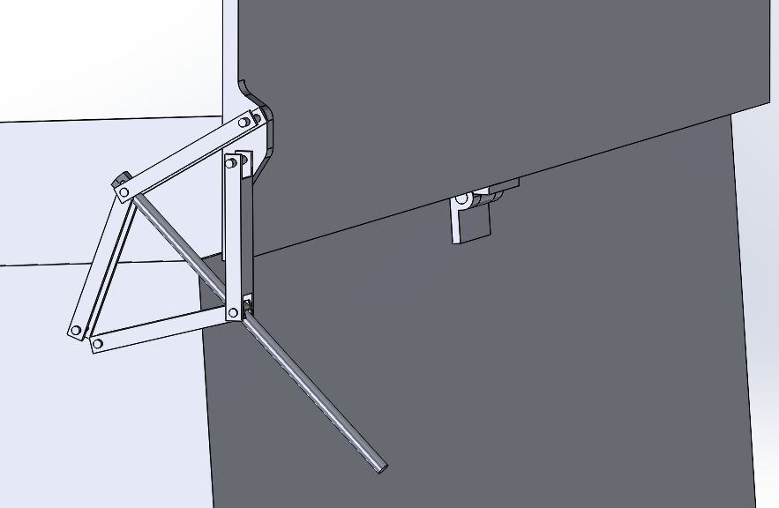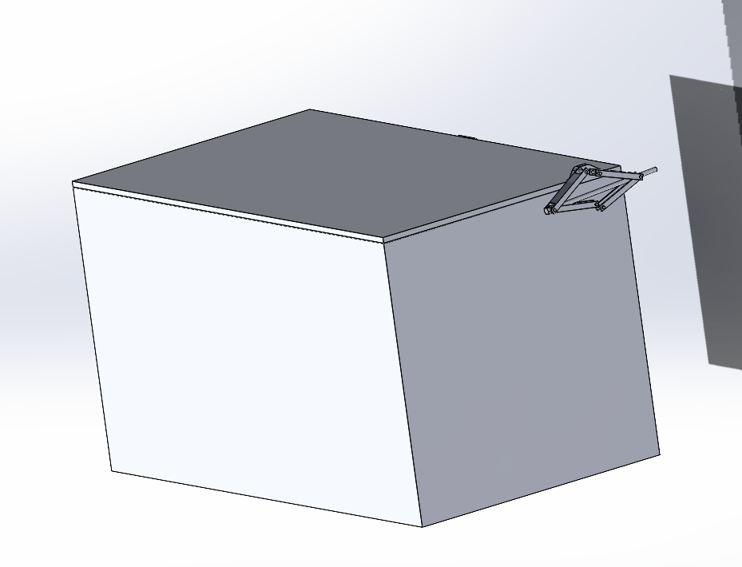

Fully dimensioned technical drawings

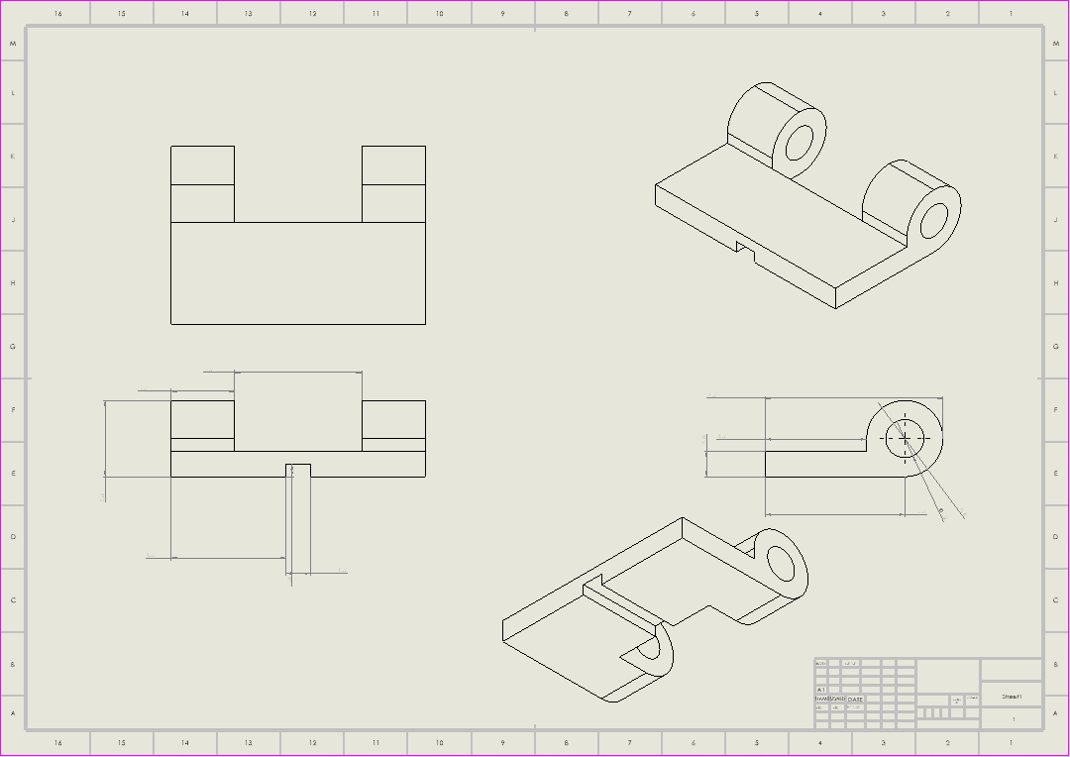

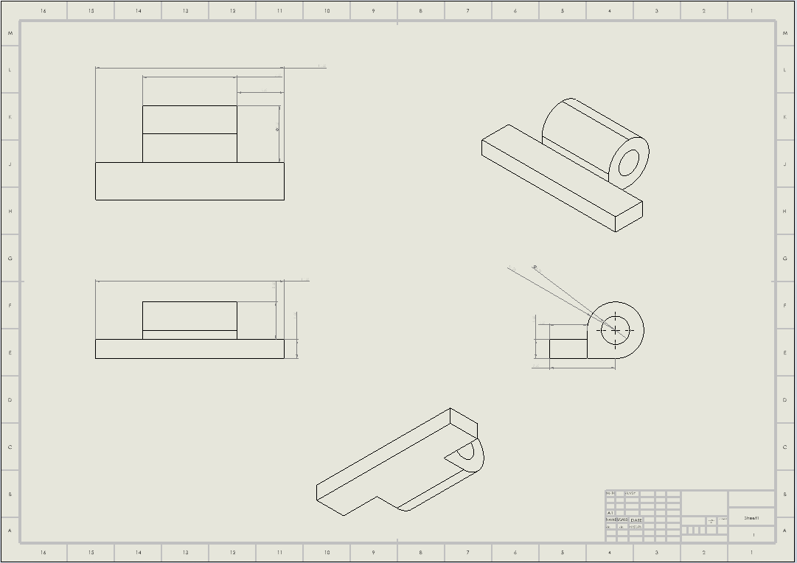
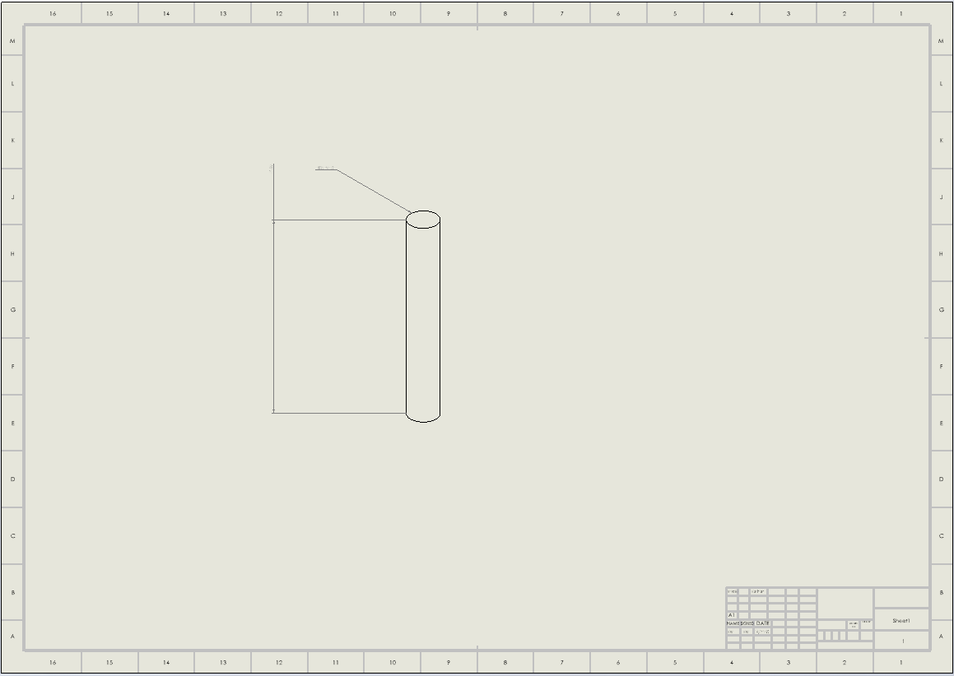

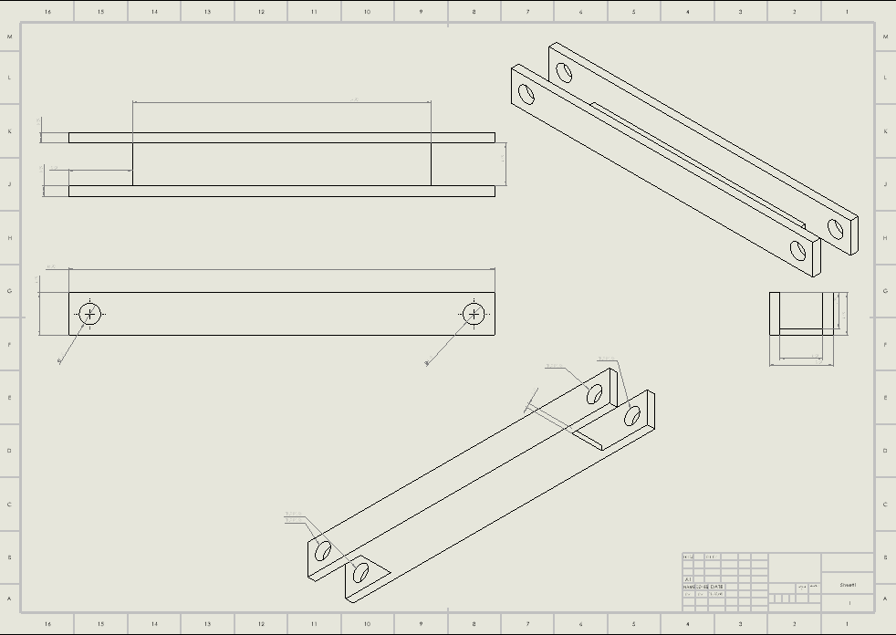
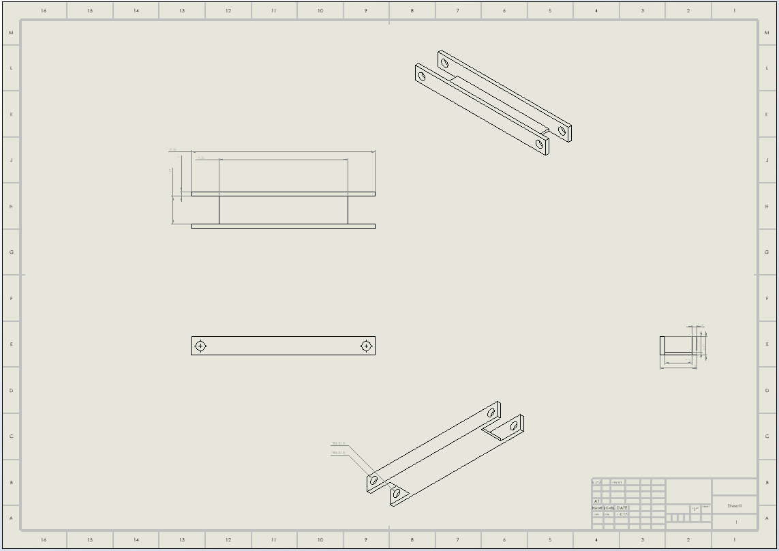
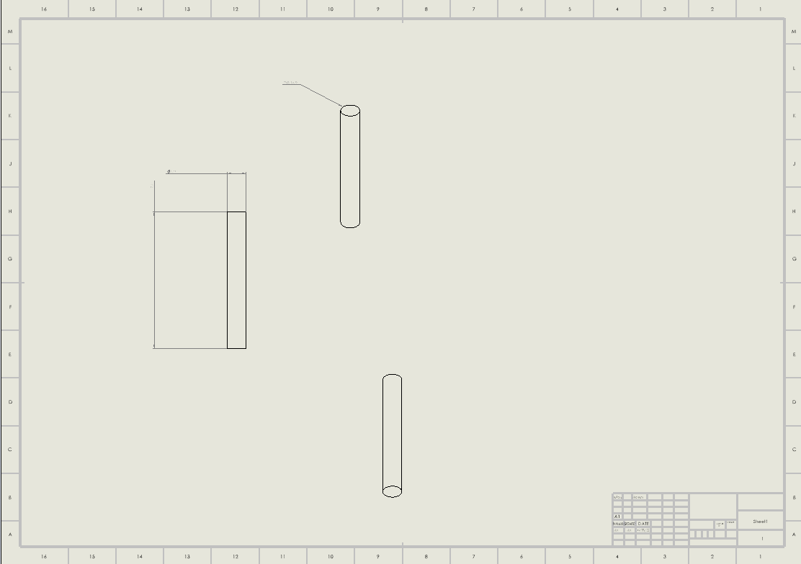

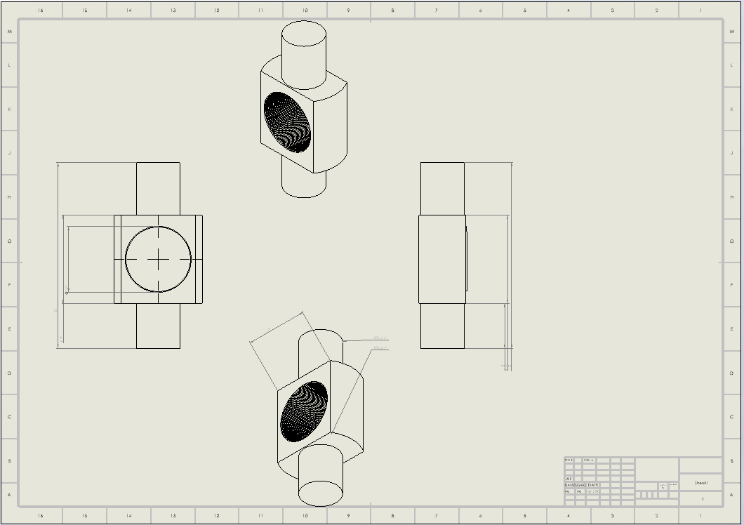

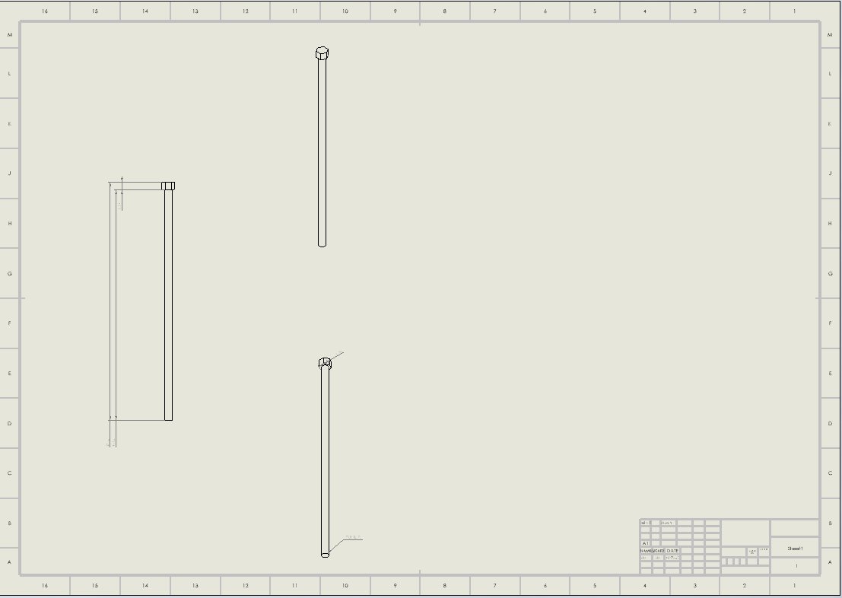

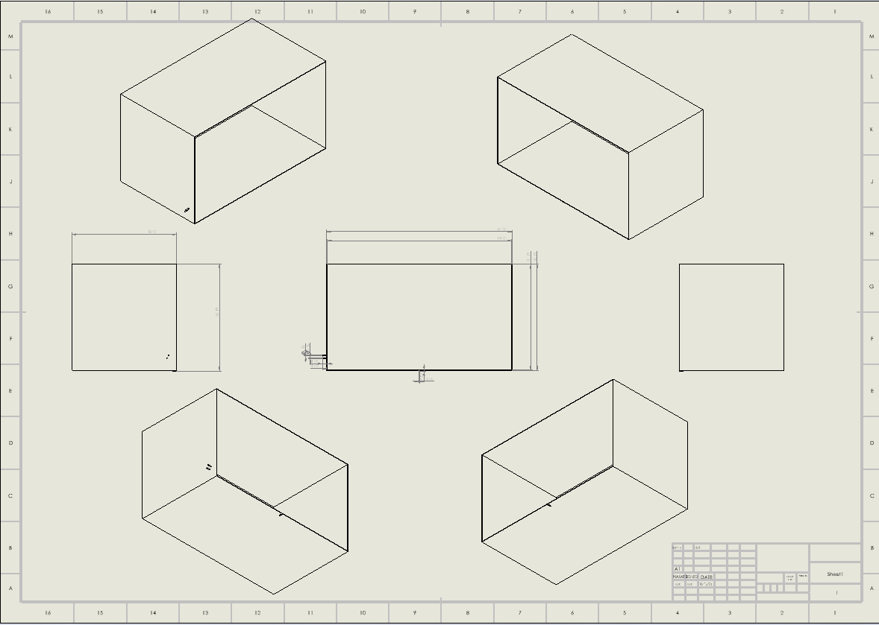

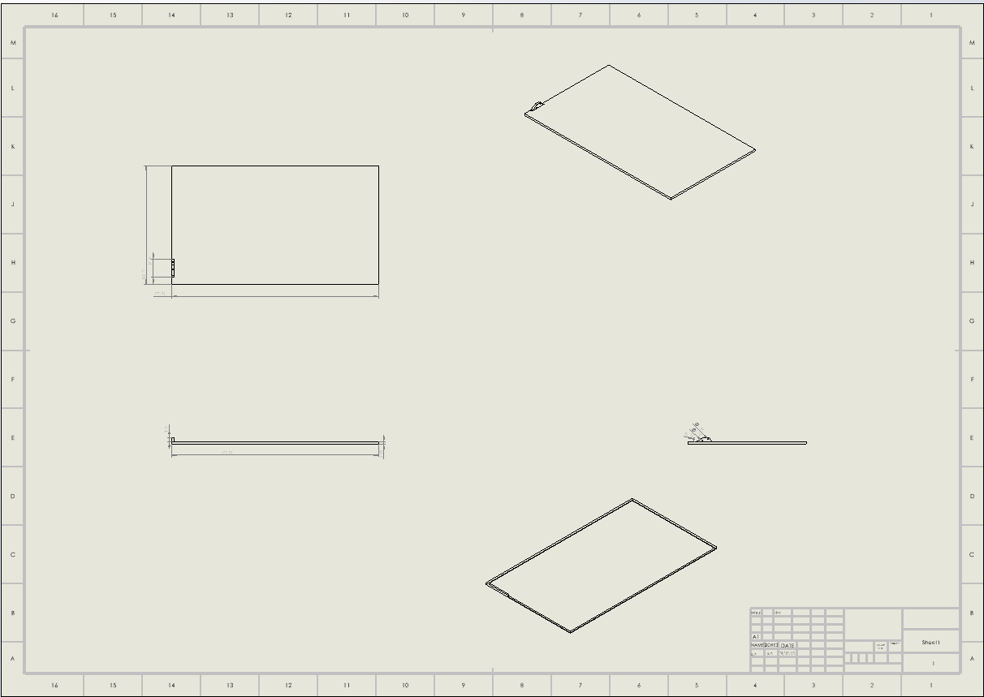
Everything made from stainless-steel for corrosion resistance, all tolerances are withing +-0.05mm.

Manufacturing
The folded stainless-steel lid and screw jack can be manufactured by combining laser cutting and press brake forming. The first step would be laser-cutting 2-3mm stainless steel sheets to the required sizes with precision-cut handle holes and hinge mounting positions (with BS 8888 tolerances being met). The flat pattern would then be formed on a CNC press brake to create the lid's flanged edges and the screw jacks arm, with tooling selected to provide consistent bend radii. For protection against corrosion, the resulting lid and arms can be electropolished or powder-coated after manufacturing. Contracting out the operation to a sheet metal fabrication plant that is ISO 9001 certified, such as precision engineering firms catering to the automotive or food processing sector (where resistance to chemicals is a must), can be taken into account. Economies of scale in establishing the tools will advantage batch manufacture of 200-500 pieces.

Justification
The screw jack system is the ideal lift for this use based on its improved safety, reliability, and compatibility with the corrosive environment. Compared to hydraulic actuators that can leak fluid and require extensive service maintenance, the mechanical-only construction of the screw jack resists acid exposure with little loss of functionality while providing fail-safe operation through its self-locking thread system. Compared to worm gear solutions, screw jacks offer greater control to achieve accurate lid positioning and greater force multiplication for expected increases in lid weight, in a simpler, lower-cost design for volume production. The deliberate, slow movement of the system eliminates sudden falls or pinching hazard, and modularity allows rapid replacement of parts if needed - important advantages to offering long-term protection for workers from hazardous chemicals while satisfying the one-person operation requirement.

Conclusion
This project successfully resolved the health and safety problem of the existing anodization tank lid by providing a single-managed, light solution. I determined, via ergonomic design and material evaluation, that an stainless-steel alloy cover with screw jack lifting system is the optimal compromise among corrosion resistance, lightness, and usability safety. The proposed design meets all conditions needed—chemical compatibility, safe one-man operation, and necessary part-loading clearance—under the framework of applicable industry standards' (COSHH, PUWER, and ISO 12100) guidelines. By eliminating two-man lifting and improving sealing integrity, this design significantly reduces workplace injury hazards and working efficiency in most production facilities.

To finalize and implement this solution, various potential further steps could be taken into account. First, prototyping and field testing would validate screw jack longevity in sustained acid exposure, with modification of material coatings or thread lubricant as needed. Second, addition of sensor technology (e.g., position indicators or seal integrity alarms) would further enhance safety by providing visual assurance of correct closure. In addition, low-voltage motor automation of the screw jack would reduce manpower but preserve fail-safe mechanical advantages. Finally, the design would be adapted to be used on other chemical tanks across the plant, adapting as needed for varying sizes or more aggressive chemistries. These modifications would perpetuate the benefit of the project in the long term and address compliance with evolving safety standards.

References

- British Standards Institution (BSI) (2010) BS EN ISO 12100:2010 - Safety of machinery. London: BSI.
- European Chemicals Agency (2024) REACH Regulation (EC) No 1907/2006. Available at: https://echa.europa.eu.
- Health and Safety Executive (HSE) (2021) Manual Handling Operations Regulations 1992 (as amended). Available at: https://www.hse.gov.uk.
- Health and Safety Executive (HSE) (2022) COSHH: Control of Substances Hazardous to Health Regulations 2002. Available at: https://www.hse.gov.uk.
- Health and Safety Executive (HSE) (2023) Health and Safety at Work etc. Act 1974. Available at: https://www.hse.gov.uk.
- Legislation.gov.uk (1998) The Provision and Use of Work Equipment Regulations 1998. Available at: https://www.legislation.gov.uk.
- Chemical Processing Magazine (2023) 'Lightweight alternatives to metal tank covers', vol. 86, no. 4, pp. 32–35.
- Industrial Equipment News (2023) 'Polypropylene covers in automotive acid treatment systems', 15 June, Available at: www.industrialequipmentnews.com/polypropylene-covers.
- Plant Services Magazine (2023) 'Ergonomic solutions for industrial tank access', vol. 44, no. 8, pp. 18–21.
- Process Safety Progress (2022) 'Containment strategies for acid tank systems', vol. 41, no. 2, pp. 112–118.

