

LOCATION: Swansea | LLEOLIAD: abertawe
LEVEL 6 | LEFEL 6
EXAMINATION PERIOD | CYFNOD ARHOLIADAU
MAY 2020 | MAI 2020

MODULE CODE: M6X02209
ALTERNATIVE POWERTRAIN TECHOLOGY
TIME: 2 HOURS

answer TWO quESTIONS out of tHREE

Equipment or materials required – None (Calculators may be used)
Adnoddau neu ddefnyddiau sydd eu hangen – Dim

ANSWER TWO QUESTIONS out of THREE

QUESTION 1

Fig 1 Internal Combustion Engine (ICE) Brake Specific Fuel Consumption (BSFC)

A vehicle has the following characteristics.
Mass 1500kg
Frontal area 3m²
Coefficient of drag (CD) 0.5
Density of air = 1.2 kg/m³
Density of Gasoline = 0.755 kg/litre
The rolling resistance of a tyre on asphalt RF = 0.013N per applied N of vertical force.
The powertrain drives through a constant velocity transmission (CVT) with an efficiency of 80% in each direction.

Flywheel
Driving wheels
Transmission efficiency 90%
Transmission efficiency 80%
Internal Combustion Engine 55Kw

- Assume the vehicle is being driven at a constant speed of 70 Kph along a level road. What is the tractive power required to maintain this speed?
(3 marks)

- The above vehicle slows to a new speed, at this new speed 5kw of tractive power is required to maintain the vehicle speed. From the above BSFC graph it can be seen that the fuel consumption will be 700 g/kWh. Allowing for transmission losses, what volume of fuel will be used in one hour?
(3 marks)

To improve the fuel usage of the vehicle it has been fitted with an additional flywheel.
The flywheel has a capacity of 1.2 Mjoules.
The flywheel is charged and discharged with an efficiency of 90% in each direction.
The flywheel drives the vehicle through the CVT (efficiency 80%)
In this hybrid power mode the internal combustion engine will operate at its most efficient operating point, producing 55Kw with a fuel consumption of 255 g/kWh. See fig 2 below.
Fig 2

During the first phase (P1) the ICE will propel the vehicle and charge the flywheel at the same time until the flywheel has reached maximum capacity. The ICE will then switch off and (in the second phase (P2)) the flywheel will continue to propel the vehicle until it is empty. Then the ICE will start up and the cycle will repeat.

- How much power is used to charge the flywheel?
(2 marks)

- How many seconds will it take to charge the flywheel (first phase)?
(2 marks)

- How many seconds will the vehicle run on flywheel power (second phase)?
(3 marks)
- How many whole cycles (first and second phases) are completed in one hour?
(2 marks)
- What volume of fuel will be used per hour in the flywheel hybrid mode?
(Assume the ICE uses 1 gram of fuel to restart)
(3 marks)

- Discuss the driver experience of using such a system. (2 marks)

QUESTION 2

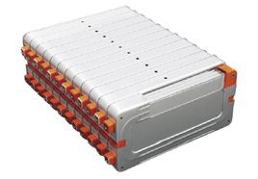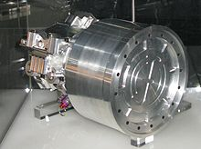

Alternative energy storage technologies have the following characteristics:

Technology | Energy Density  wh/kg | Power Density  w/kg
Lithium based batteries | 130 | 1000
High speed flywheel | 60 | 3000

Calculate the required storage mass for each technology for:

- 24hr endurance racing 60kw and 400 kj Kinetic Energy Recovery System
(4marks)

- Electric road car 125kw max power and 19kwh storage capacity
(4marks)

- Select a suitable energy storage solution for the endurance racing car and the electric road car. You have calculated the basic storage mass. Now analyse additional features and characteristics of the selected technologies that should be considered for a realistic installation.
(12 marks)

QUESTION 3

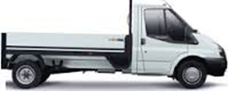

The City and County of Swansea have a fleet of flat bed and tipper vans used by the parks department. The vans are kept overnight in a secure location and then used in the day to transport lawn mowers etc to the various parks within the City and County of Swansea. They will remain within a 15 mile radius of Swansea. They hope to gain the following improvements:
Reduced fuel consumption
Lower emissions
Lower running costs
A greener image
Use diagrams, graphs and basic calculations to support your answers. State any assumptions made where information is missing.
Typical mass: Kerb weight 1600kg, GVW 2600kg. Tow limit 900kg

- Analyse alternative electric, hybrid and fuel cell vehicle architectures
(4 marks)
- Investigate and contrast alternative technologies for

- Energy storage
- Re-fuelling
- Drive / electrical machines
(9 marks)
- Develop a brief typical drive cycle and discuss typical vehicle requirements.
(3 marks)
- Recommend a Flat Bed Van electric/hybrid solution and demonstrate how it may meet their requirements.
(4 marks)

Equations

Potential Energy = mass x gravity x height PE = m.g.h

Moment of Inertia = mass x (radius of gyration) ² I = mk²

For a plain disc : radius of gyration k = outer radius x 0.707

Aero dynamic resistance = 0.5 x area x cd x density of air (1.2 kg/m²) x velocity²
Rolling resistance = mass x gravity x coefficient of rolling resistance.
Gradient resistance = mass x gravity x (sin) angle of slope = m.g.sinƟ

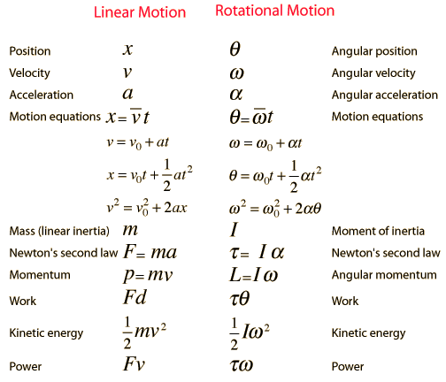

Diwedd/End

