Digital Forensics Analysis

Name: Harsh Rameshkumar Mangukiya
Student Id: 2433852
Lecturer: Dr. Mohamed Ghanem
Table of Contents
Task 1: Comprehensive Research Report on Digital Forensics 5
1. Introduction 5
2. Current State of the Field 5
2.1 Definition & Scope 5
2.2 Regulatory Framework 5
2.3 Professional Practice 5
3. Tools - Characteristics and Operations 5
3.1 Industry-Standard Tools 5
3.2 Key Features 6
3.3 Tool Capability Matrix 6
4. Crossing of Digital Forensics and Cybersecurity 6
4.1 Incident Response 6
4.2 Threat Intelligence 6
4.3 Security Operations 6
4.4 Compliance and Governance 7
5. Digital Forensics Trends in the Future 7
5.1 Cloud and IoT Forensics 7
5.2 AI and Machine Learning 7
5.3 Automation and Integration 7
5.4 Live/Memory Forensics 7
5.5 Mobile Forensics Expansion 7
6. Key Challenges 7
6.1 Encryption and Anti-Forensic Techniques 7
6.2 Data Volume and Complexity 7
6.3 Legal and Privacy Concerns 7
6.4 Resource Constraints 8
6.5 Quickly Developing Threat Environment. 8
7. International and National Labor Market. 8
7.1 UK Market Overview 8
7.2 Required Qualifications 8
7.3 Career Progression 8
7.4 International Perspective 8
7.5 Salary & Growth Prospects 8
8. Conclusion 8
Task 2: QT-AI-2025 Case 10
1. Introduction 10
1.1 Background and Context 10
1.2 Reviewing of the Research 10
1.3 Scope and Limitations 10
2. Purposes of the Investigation 10
2.1 Primary Objectives 10
2.2 Secondary Objectives 11
3. Evidence Analysed 11
3.1 Overview of Devices Examined 11
3.1.1 Huawei POT-LX1 P Smart 11
3.1.2 Samsung GSM SM-A137F Galaxy A13 12
3.1.3 Ulefone Note 14 12
3.1.4 Nokia C2 2nd Edition 12
3.2 Evidence Acquisition and Chain of Custody 12
4. Investigative Methodology 13
4.1 Overview of Approach 13
4.2 Forensic Imaging and Extraction 13
4.3 Data Processing in Autopsy 13
4.4 Decryption and Password Attacks 13
4.5 Geolocation and Timeline Analysis 14
4.6 Multimedia Analysis 14
4.7 Cross-Device Correlation and Validation 14
4.8 Quality Assurance and Integrity 14
5. Results and In-depth Discussion 15
5.1 Device-Level Findings 15
5.1.1 Huawei POT-LX1 P Smart – Perpetrator (Emma) 15
5.1.2 Samsung Galaxy A13 – Intermediary (Joe) 16
5.1.3 Ulefone Note 14 – Buyer/Financier (Norman) 17
5.1.4 Nokia C2 2nd Edition – Unattributed Co-conspirator 18
5.2 Synthesis of Suspect Roles 19
5.3 Technical Challenges and Limitations 20
5.4 Data Reliability and Integrity Verification 20
6. Reconstruction of the Conspiracy Timeline 21
6.1 Preparation Phase: Actor Device Procurement and Channel Establishment 21
6.2 Coordination and Meetings: Evidence of Travel, Communication, and Financial Planning 21
7. Overview of Extracted Mobile Artifacts 22
8. UFED Acquisition Parameters and Identifiers 27
9. Conclusion 31
9.1 Summary of Key Findings 31
9.2 Confidence Assessment of Suspect Attribution 31
9.3 Reflections on Forensic Process 32
10. Recommendations for Further Action 32
10.1 Future Investigative Plan 32
10.2 Advanced Technical and Legal Actions Needed 32
10.3 Improvement of Long-term Security 32
References 33

Task 1: Comprehensive Research Report on Digital Forensics

1. Introduction
Digital forensics is a critical field of work in cybersecurity, as it deals with investigation, recovering, and analysing digital evidence that electronic instruments produce. Due to the changing nature of cybercrime that is going on in the world today, digital forensics professionals have become very important, particularly in law enforcement, legal, and enterprise settings in the UK [1], [2].

2. Current State of the Field

2.1 Definition & Scope
- Digital forensics include computer, mobile device, and network, and cloud forensics.
- The UK organisations are implementing forensic into their response strategies to cyber incidents, intellectual property theft, and regulatory compliance (e.g., GDPR).

2.2 Regulatory Framework
- The UK is a country that follows the ACPO (Association of Chief Police Officers) standards and ISO/IEC 27037 evidence handling standards.
- Legal protocols, chain of custody and admissibility have to be observed.

2.3 Professional Practice
- Evidence handling protocols are applied in evidence handling by the forensic laboratories and police units to provide integrity.
- The consulting of the enterprise data breach and the fraud investigation is increasing in the private sector.

3. Tools - Characteristics and Operations

3.1 Industry-Standard Tools
- EnCase: Known as disk imaging, file recovery and report generation.
- FTK (Forensic Toolkit): Rich functions of data carving, hashing and password cracker.
- Autopsy/Sleuth Kit: With SL: Timeline analysis, search and extraction of metadata are open source [3].
- Cellebrite & Magnet AXIOM: The primary tools of mobile forensics that the UK police have been using to retrieve data on smartphones.

3.2 Key Features
- Stacking of forensic images (bit-by-bit copies).
- Strong search and filter options of artifacts and deleted files.
- Spam-check- Integrity: Hash verification.
- The support of various types of devices, encrypted drives, and the analysis of the cloud and social media.
- Reconstruction of timeline, graphical representation of online activities.

3.3 Tool Capability Matrix
Table 1: Tool Matrix
Tool | Platforms Supported | Main Features | Cost/Accessibility
EnCase | Win/Mac/Linux | Imaging, Analysis, Reporting | Commercial
FTK | Win | Data Carving, Hashing, Passwords | Commercial
Autopsy/Sleuth | Win/Mac/Linux | Timeline, Artifact Analysis | Open Source
Cellebrite | Mobile Devices | Extraction, Decoding | Commercial (Law-only)
Magnet AXIOM | Win/Mac/Mobile | Acquisition, Cloud Forensics | Commercial

4. Crossing of Digital Forensics and Cybersecurity

4.1 Incident Response
- Cybersecurity experts in case of a security breach work hand in hand with the digital forensic teams.
- Forensics gives official evidence of the post-incident analysis and response, which can be used in lawsuits [1].

4.2 Threat Intelligence
- Forensics retrieves indicators of compromise (IOC), which play a vital role of enriching real-time threat intelligence and proactive preventive measures.

4.3 Security Operations
- When forensics is implemented in Security Information and Event Management (SIEM), the efficiency of detection and investigation will be enhanced.

4.4 Compliance and Governance
- Forensics facilitates adherence to the UK/EU regulation (GDPR, NIS Directive).
- Ensures that there is traceable and auditable response to suspected data breach.

5. Digital Forensics Trends in the Future

5.1 Cloud and IoT Forensics
- Shifting attention towards the acquisition and analysis of cloud storage and the Internet of Things (IoT) devices.
- Addressing Global data privacy and regulatory complexity [4].

5.2 AI and Machine Learning
- Use of AI based tools to find objects fast, detect anomalies and classify artifacts [5].

5.3 Automation and Integration
- Automation of the workflow with the repetitive types of activities: evidence acquisition, triage, and initial reporting.

5.4 Live/Memory Forensics
- Increasing requirement of real-time exploration of volatile memory (RAM), taking malware traces and sophisticated threats.

5.5 Mobile Forensics Expansion
- Advanced skill in the process of extracting information present in encrypted, application-based, and cloud-synchronous smartphones.

6. Key Challenges

6.1 Encryption and Anti-Forensic Techniques
- Large-scale implementation of end-to-end encryption hampers recovery of evidence.
- Anti-forensic techniques (data deletion, obfuscation, steganography) are used by criminals [6].

6.2 Data Volume and Complexity
- Volume explosion in data of devices, heterogeneity of devices (PCs, mobiles, cloud nodes).
- Scaling, high-power processing and storage necessary [7].

6.3 Legal and Privacy Concerns
- Balancing privacy entitlements, data privacy and inadmissibility evidence.
- Striking the right balance between investigative provision and the law.

6.4 Resource Constraints
- Lack of qualified specialists, insufficient funds (particularly in state facilities forensic laboratories).

6.5 Quickly Developing Threat Environment.
- Advancing to match the advanced cyber-attacks and malwares.

7. International and National Labor Market.

7.1 UK Market Overview
- Increased need in law enforcement, government bodies (e.g., NCA, Metropolitan Police), consulting, and financial services of the digital forensic analysts.
- The common positions: Forensic Consultant, Digital Forensics Investigator and Incident Response Analyst.

7.2 Required Qualifications
- Undergraduate/post-graduate degrees in Cybersecurity, Digital Forensics that are accredited.
- Certifications: certifications: GIAC, CREST, CFCE, EnCE (UK-recognized badges).

7.3 Career Progression
- The analysts in entry level advance to a senior technical, managerial, or expert witness position.

7.4 International Perspective
- International mobility- UK professionals are in demand across the international markets, particularly the EU markets, the US markets, and the Asian Pacific markets because of a high regulatory environment.
- Remote investigation services and case work across the borders are increasing.

7.5 Salary & Growth Prospects
- UK real beginning salaries: £24,000 - £32,000 and finally £50,000 or above with specialization.
- Growth in the industry perceived by 7-10% in a year due to intensifying cyber threats.

8. Conclusion
In the UK, modern cybersecurity is impossible without the digital forensics and it encompasses sophisticated tools, legal knowledge and methods of investigation. The industry is known to have to deal with significant issues such as encryption, data size, legal issues, but has strong career opportunities and keeps getting innovative in the field of cloud, IoT, and AI-based methods. Its cross-over with cybersecurity will make sure that digital forensics professionals are at the core of protecting organizations and facilitating justice in a more digitalized world.

Task 2: QT-AI-2025 Case

1. Introduction

1.1 Background and Context
The process of expanding digital technologies has radically changed the amount and the character of the evidence in the crimes of the modern period. Diverse electronic technologies are used by organisations and criminals to organize, hide, or even report criminal behaviour, which can include smartphones and computers and the use of cloud services. In this regard, digital forensics has become a significant field that gives the technical platform concerning the identification, acquisition, analysis and presentation of digital evidence to support legal and corporate investigations [8], [9]. The current investigation lies within the intellectual property theft framework, namely, a perceived scheme to steal and sell the QT-AI-2025 patent - a situation that is technically difficult and that would otherwise be indicative of the threats that might occur in the present day amidst use of cyber-enabled technologies.

1.2 Reviewing of the Research
The purpose of this investigation is to find out with logic and reasoning the facts about the so-called theft and illegal transfer of intellectual property which is a sensitive corporate property. With the help of well-established forensic guidelines applied to four extracted mobile devices, the investigation aims to recruit all the participants of the affair, re-create their individual roles, trace down communications and finances, and rally strong evidential measures against possible prosecution.

1.3 Scope and Limitations
The four logical extractions that are presented in this forensic report to be analysed include Huawei P Smart, Samsung Galaxy A13, Ulefone Note 14, and Nokia C2 2nd Edition. The analysis of the case is limited to the presence of the digital artifact on these devices, and the focus of the analysis is on the records of communication, digital documents, and multimedia-related evidence regarding the QT-AI-2025 patent. It has weaknesses such as the loss of part of data through encryption, accessibility of them by passwords, the typical inabilities to ascertain certain operations to a particular person-weaknesses that are conspicuously discussed throughout the report.

2. Purposes of the Investigation

2.1 Primary Objectives
The primary objective of the investigation will be to systematically establish the facts regarding the alleged theft and planned sale of the patent on QT-AI-2025. The main intent is to find out who used the four mobile devices that were taken, who their respective roles and connections are in the suspected conspiracy, and discover a complete chronology of actions using electronic evidence. The retrieval of all the communication records (WhatsApp messages, emails, direct messages, and so on) and their analysis, locating files related to the targeted intellectual property, either directly or indirectly, and matching all the pieces of evidence of all the devices to prove or dismiss the activity of each side is the key to this process [10], [11]. This non-guess style is what has formed the basis of re-writing the conspiracy and ensuring that admissible and defensible evidence is ready in the event of a legal case.

2.2 Secondary Objectives
Visionary goals are aimed at supporting and enlarging the main mission. These involve technical diligence to recover or decrypt unavailable data such as encrypted chat logs or password protected documents; to not only maximize the retrieval of evidence using a variety of forensic tools and techniques but to also aid in further investigative leads- particularly against unidentified or unattributed actors, which in this case is the owner of the Nokia C2 device [12]. The investigation also undertakes to adhere to the highest standards of forensic practice, such as doing an excellent documentation of chain of custody, checking of integrity and open recognition of any restrictions or questions that are not answered. These secondary activities may bolster the case at hand as well as offer grounds on which a further inquiry or prosecution or remedial in-house actions are to proceed.

3. Evidence Analysed

3.1 Overview of Devices Examined
This study focused on the forensic examination of four mobile devices, each of which is an important aspect of the perceived theft and sale of the QT-AI-2025 patent as an intellectual property. Diversification and specialization of these devices gave a multi perspective evidentiary foundation.

3.1.1 Huawei POT-LX1 P Smart
The fact that this device was in the possession of the main suspect (Emma) was supportive evidence of the premature coordination of communication and plan organization. Through analysis, it was determined that identification of users provided by the web accounts which here was a Gmail account which also belonged to Emma was clear and also the critical metadata which linked to the operator directly i.e. Joe. History of the application has revealed that the WhatsApp, Instagram, and Gmail have been used. It is notable that the entries in web history reflected attempts at secret communication control, such as the attempts to discover the ways to unblock people on WhatsApp, which served as the sign of them being actively interested in maintaining a channel secret.

3.1.2 Samsung GSM SM-A137F Galaxy A13
This device, which is connected to Joe, the intermediary, captured the logistical and financial aspect of the plot. One of the major findings was a user profile picture, detailed travelling receipts and booking records to indicate cross-UK and international usage (UK to France) and pictures of anonymous gift cards paid with. The consolidation of the receipts, travel itineraries, and financial records enhanced the role played by Joe in physically and operationally connecting co-conspirators.

3.1.3 Ulefone Note 14
This gadget, found on suspicion with the financier, Norman, carried photographic evidence of a State Bank of India debit card, it was not a personalized card, however, but was rather non-personalized to blur identity, which suggested that it was prearranged to pay money illicitly. Attempts to decrypt other files were in vain as they are highly encrypted, and further information about the transaction or the communications can be hidden, which also shows technical difficulties.

3.1.4 Nokia C2 2nd Edition
This instrument has no reference to its author, though it is most important. It featured a document with a password (Open.Docx) that was thought to have pertained to the conspiracy itself, and a photo of an unknown person, who could have been one of the other members of the conspiracy. Efforts to crack the password of the document had no success, which demonstrates the weakness of the ongoing efforts at prying the password, and the community of good operational security measures held by suspects.

3.2 Evidence Acquisition and Chain of Custody
Logical forensic imaging was performed on all four devices and the extracted data was taken through common tools (e.g., UFED) to maintain the evidentiary integrity of the data. All images were imported to the Autopsy Digital Forensics Platform so that they can be analyzed to provide features rich without altering the values of the data being analyzed. During acquisition, careful records of handling and imaging and custody transfers of devices were carefully preserved to have a complete and auditable chain of custody. The procedure adopted the industry-standard protocols, which encompass, documenting the condition of the device, examiner identity, extraction timestamps and evidence hash [13]. Such measures are essential to ensure that the probative value of evidence can be used in a possible legal process and are also important to promote best practice in digital forensics. Where either a decryption or a gain of access failed, the reasons were listed in an open coding to ensure that it was clear as to the limitations of evidence. This rigorous method facilitated high-quality analysis which is reproducible such that it gives the basis of investigation which can be attributed with a high degree of confidence and thus actions of investigation or legal action can be undertaken.

4. Investigative Methodology

4.1 Overview of Approach
The methodology employed in the given study was rigorous regarding the area of forensics and multi-layered to the point of unearthing, validating and interpreting the digital evidence that surrounded the allegations of QT-AI-2025 patent theft. It rested on ACPO and ISO guidelines, and its major priorities included the integrity of evidence, recovery of data holistically and generation of evidential continuity that would workforce legal admissibility and confirm their reliability during investigation.

4.2 Forensic Imaging and Extraction
The first directions concerned the development of coherent forensic images of all target devices with the help of industry standards, namely UFED (Universal Forensic Extraction Device). An evolutionary rationale was used to select logical imaging because of the encryption of devices and feasibility. Huawei P Smart was acquired in two alternative ways, allowing its artifacts to be recovered (Android backup and live extraction) as much as possible. Devices conditions as well as extraction conditions were recorded carefully throughout. Pre-imaging and post-imaging hashes were compared to ensure that no data was distorted, and the identity of the examiner and the time on evidence of each phase were fully documented.

4.3 Data Processing in Autopsy
The retrieved images were loaded in the open-source Autopsy Digital Forensics Platform, due to its support of multi-format data and high-end flexible analysis. Analysis was done through modules of focus ingest:
- Android Analyzer and aLEAPP: To mobile objects and applications data parsing.
- Keyword Search: In order to highlight the case-relevant terms (e.g., name of the conspirator, "QT-AI-2025").
- Email Parser: To restore communications and obtain relationship contacts.
- PhotoRec Carver: To carve and recover deleted or lost content in files deeply.
Detailed artifact extraction permitted also facilitated thorough device profiling, generation of timelines and detection of data that was hidden or erased.

4.4 Decryption and Password Attacks
Encryption became an important obstacle. WhatsApp database decryption was attempted on the Huawei device with the wa-crypt-tools suite and extracted key files although no likely chats were found- probably because of deletion or communication on different platforms. An attack on encrypted Open.docx file (Nokia device) with brute force was futile which indicated the conspirators used a strong operation security. The data in WhatsApp could not be decrypted in Nokia device as the key files are not available, which is a common occurrence when it comes to logical file acquisition. Any project or attempt at encryption was evenly documented and suggestions to escalate cryptanalytic initiatives reasonable progress was made.

4.5 Geolocation and Timeline Analysis
The geolocation features of Autopsy processed the SPIF content in image files to map where people were and where they had moved to. Although there was no immediately relevant geotagged content found, the investigator reviewed all the images in search of latent location indicatives and supports the occurrence of the timeline with confirmed travel receipts, which helped to construct space-time validation of the activity of the suspects in the UK and abroad.
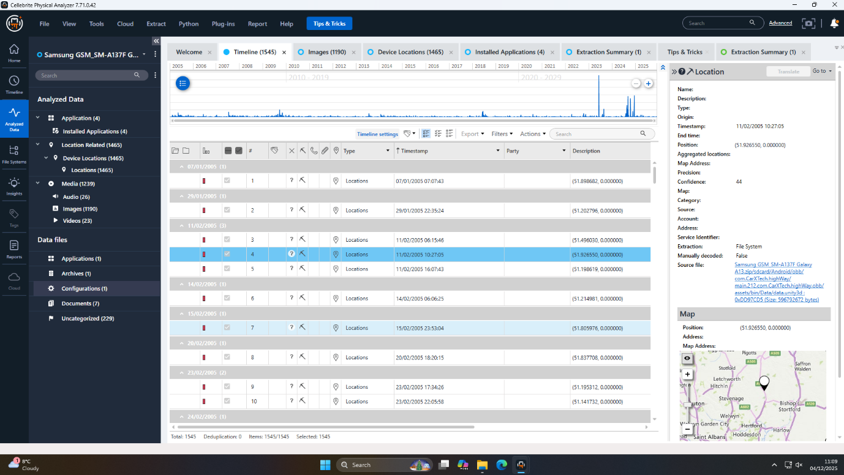
Figure 1: Suspect's worldwide travel history visualized

4.6 Multimedia Analysis
All audio, videotape and picture files were individually examined as to contents that related to the conspiracy. Metadata extraction to determine source devices, timestamps and potential connections to digital and physical locations was also applied to multimedia. This action, although the case-crucial audio/video evidence was not available, proved that there were no hidden or embedded evidence.

4.7 Cross-Device Correlation and Validation
One of the fundamental methodological innovations was the correlation of the data points of all the four devices. The search was conducted with keywords, cross-referencing of contacts, and the time-synchronized analysis of chats to identify similar chat logs, the recurrence of names, similarities of journeys, and similar financial transactions. Such cross-referencing played a critical role in restructuring the conspiracy, attribution of actions towards certain people, and silo busting created by the conspirators.

4.8 Quality Assurance and Integrity
All processes were followed in a way that they were in the best practices of securing forensic integrity. Chain of custody documentation was strictly adhered to and where possible, all findings were checked against by secondary examiners. Integrity validation - through cryptographic hash and reporting procedures - ensured that every artifact and analytic product could be validated, and as needed provide as a strong evidence in a judicial or disciplinary proceeding. Unaddressed problems-lack of information through encryption, absence of information, or vague attributions are easily evolved to make the information transparent and take further action in investigation.

5. Results and In-depth Discussion

5.1 Device-Level Findings

5.1.1 Huawei POT-LX1 P Smart – Perpetrator (Emma)
User Identification and Key Artifacts:
Forensic examination and imaging confirmed Emma to be the initial user with definitive links to the account of dovp59@gmail.com that existed in system files. Additional correlation of Gmail cache records showed direct connection to josephrehan464@gmail.com, which formed a case in support of Emma as the inside person who started the conspiracy. Use of application and creation of an account on August 17, 2024, the very next day, is a priori to direct communication with Joe, which also qualifies the device as a launchpad to the illegal operation.
Communication Patterns:
It was analysed that WhatsApp, Instagram, and Gmail were the most commonly used applications by Emma as her means of communication. Relevant encrypted chat databases were also investigated via the WhatsApp installation, however, there were no active or undeleted messages related to the petty theft of patents, which could probably have been deleted by the user or could be positive evidence of using alternative apps. Web history gave further background- An August 21, 2024 search of "how to unblock a contact in WhatsApp" indicated attempts to keep secret communication with fellow co-conspirators.
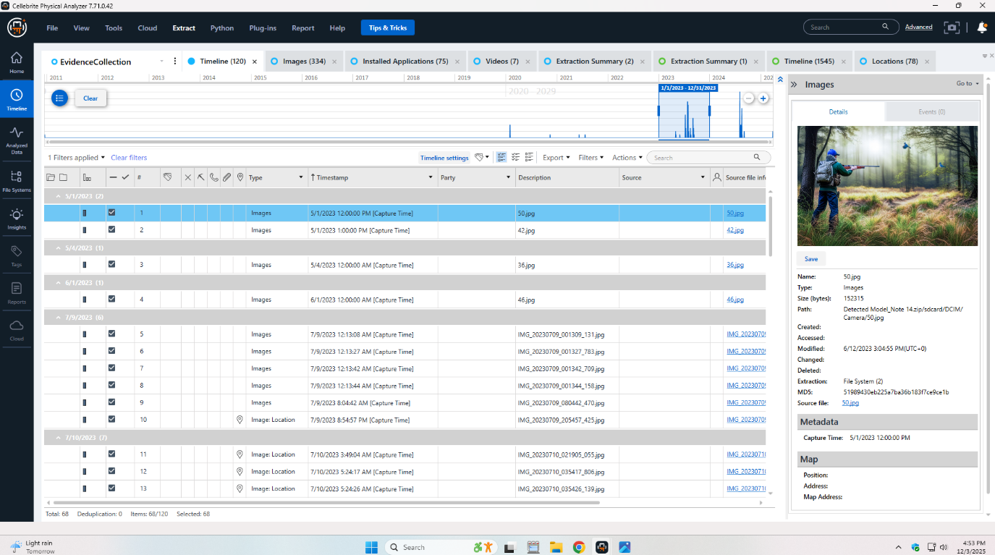
Figure 2: Covert communication clue in web history
Suspicious Activity and Installed Apps:
WhatsApp, Instagram and Gmail apps were installed and the usage patterns corresponded to the estimated conspiracy development and implementation schedule. Research on WhatsApp privacy and account management offered through the Internet revealed the awareness of the operational security and a thoughtful attitude to the information control. Incriminating files were not discovered in user directories and metadata to system files and known contact links offers a lot of attribution and context to Emma and her interpersonal network with Joe, which supports her status of an orchestrator.

5.1.2 Samsung Galaxy A13 – Intermediary (Joe)
Travel and Financial Records:
The inspection of the device proved that in his capacity as a mediator, Joe recorded a lot of traveling to have a chronological and geographical map of operations. Such interesting pieces of evidence as images and receipts confirming train travels (e.g., Aug 31, 2024, to Glasgow; Sep 4, 2024, Swansea-Luton Airport with Ibis hotel key card; and Oct 15, 2024, with a receipt of an Ibis hotel in Paris with the payment completed via Debit Mastercard 3758) had been noted. The records came in too handy in ensuring the confirmation of physical gatherings that were associated with the scheme, and disclosing the global nature of the activities.
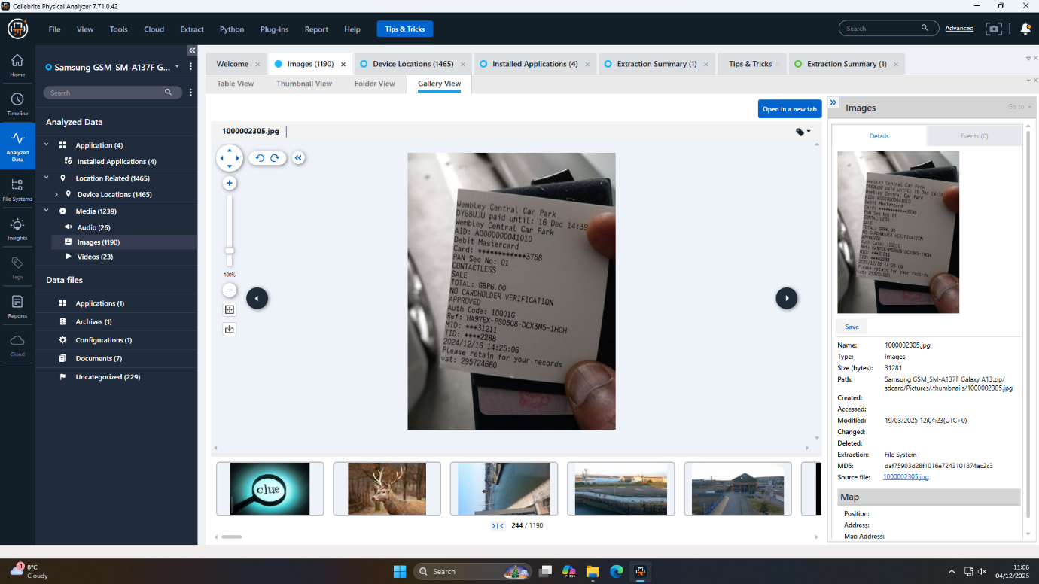
Figure 3: Receipt confirms suspect's travel to Paris
User Profile Corroboration:
The user profile image, J, had desired identifiers as Joe. The intersection of travel receipts, hotel documentation, and profile evidence provided both physical and circumstantial links of Joe and other participants of the conspiracy, in particular, coordinated movements based on the activity of other devices.
Use of Anonymous Payment Methods:
A clear red flag came out of a snapshot of an anonymous gift card of One4all, with the visible card number and CVV, proving that there was an intention to cover financial transactions. There were no personal banking connections, or detectable methods of making payments, suggesting that this is deliberately obfuscated financial traffic. This operation with impersonalized or prepaid tools is a known strategy to launder or hide money in illegal transactions, which supports the facilitative and anonymizing nature of the decisions that Joe has taken in organizing the sale and transfer of the patent.

5.1.3 Ulefone Note 14 – Buyer/Financier (Norman)
Payment Instrument Discovery:
An examination of the Ulefone Note 14 was found to be linked to a certain person called Norman who is the likely financier and ultimate beneficiary of the stolen intellectual property. Two photos of a debit card of the State Bank of India (SBI) were the most crucial evidence. This was an obviously non-customized card carrying the generic message of a life which identified a State Bank customer, rather than the name of a specific person. It is a very grave finding--it implies an unmistakable intention to utilize the source of the payments and diminish the chances of tracked them to the latter, a form of method with an illicit money transaction.
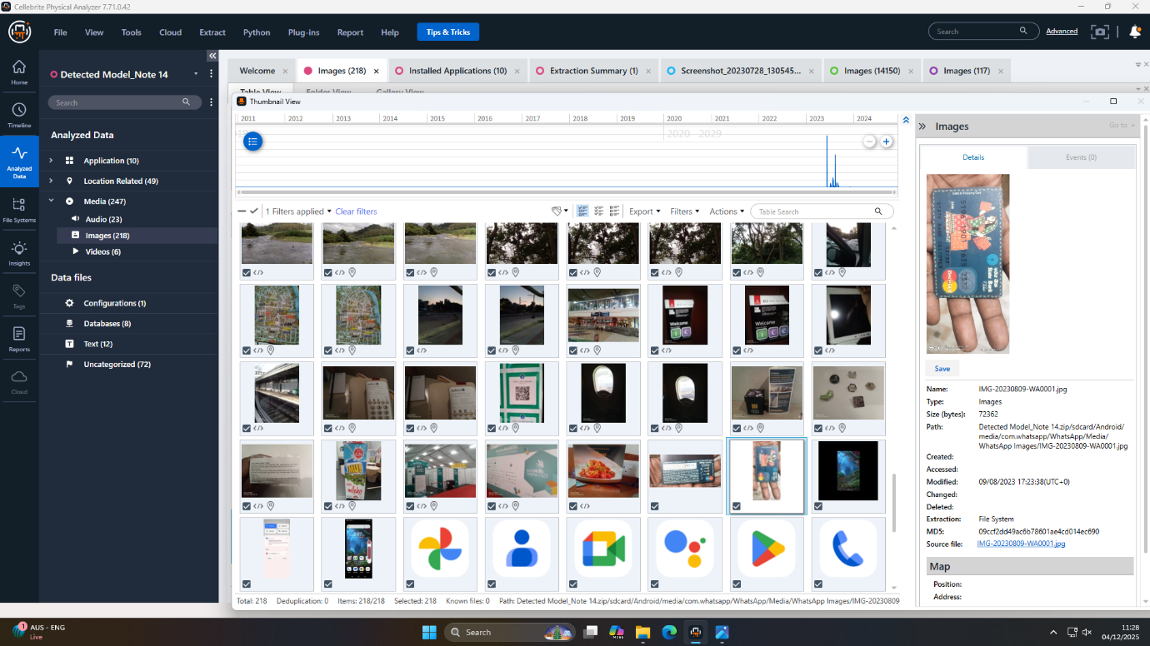
Figure 4: Financial evidence found in WhatsApp media
Obfuscation Techniques:
On top of the non-personalized debit card, additional research came to the conclusion that neither on the device nor the account artifacts had any user-specific registration data, indicating a conscious attempt to hide the ownership of the device. Coded application information and restricted unprotected communication logs point towards an advanced organizational security philosophy. On-device, there was no al-Qaeda trial identification of direct communicative connections to other conspirators, almost certainly through deletion, through utilisation of secure or ephemeral messaging services, or through alternative channels of communication.
Financial Linkage:
Although the records of direct transactions could not be obtained, availability of the SBI debit card, time of being photographed, and known history of device usage all shows that the Ulefone Note 14 was essential in facilitating (or obtaining payment) of QT-AI-2025 patent. The issuance of the card in India provided another source of jurisdiction insulation over typical tracing strategies in the UK. The instrumental role played by the user as a buyer/financier is so proven through the physical evidence (card photo) as well as the timelines of the correlating devices.

5.1.4 Nokia C2 2nd Edition – Unattributed Co-conspirator
Encrypted Files and Security Challenges:
Nokia C2 2nd Edition is the least attributed but definitely, a strategically important device. Its biggest artifact is a password-protected Microsoft OpenOffice Word file (Open.docx) that was unable to be decrypted even when brute-force attacks were made persistently. The mere fact that there is a file, and that there is an extremely secure method of encryption that preserves the file, means that it is a copy of vital data, possibly in the form of transaction records, a duplicate of the stolen patent or additional data of the conspiracy. This shows high level of knowledge of a danger of forensic analysis by conspirators.
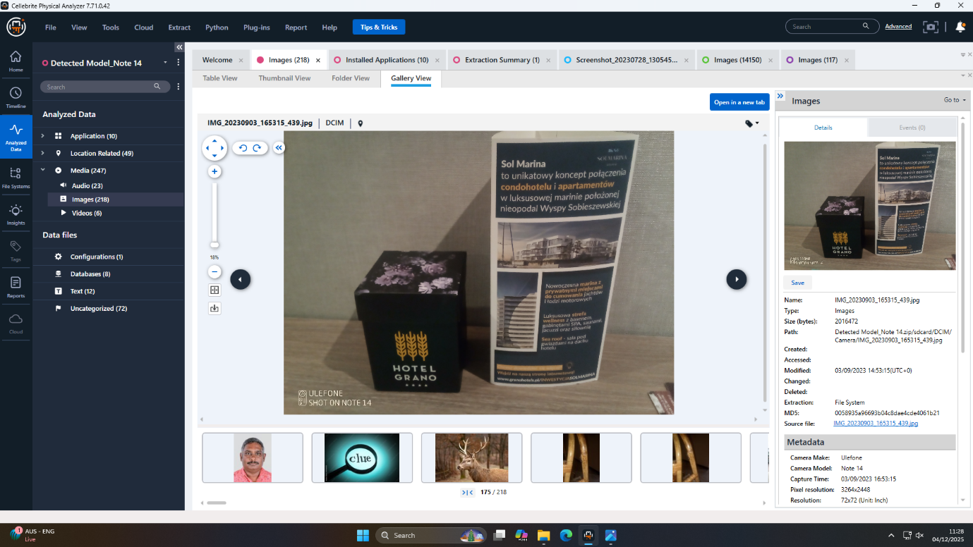
Figure 5: Hotel promotion photograph examined in Gallery View
Potential Linkages:
The other important hint is the existence of a picture of a stranger man. Although the subject has not been identified with, the context and its secure location make one believe that it was a user of the device or a different member of the conspiracy within the organization. Both the unavailable application and communication information and the encrypted file are indicators of a device role that is oriented towards sensitive information storage as opposed to usual operational information communications. In any case, the security pomp and the other mysteries of the Nokia C2 present a starting point to further research, biometrics or hi-tech cryptology pursuits.

5.2 Synthesis of Suspect Roles
The overall examination of the digital artifacts of all the devices indicates that there were distinct roles allotted to the conspiracy. Trusting in a Huawei item, Emma played the role of insider and the organizer and created channels, made contact, and coordinated contacts inside the organization. Joe on Samsung Galaxy A13 was able to synchronize the operational logistics and was able to record the travels, arrange meetings and use anonymous payment cards to make the handover. Ulefone Note 14 The likely user of the device, Norman, used it to carry out the illegal transaction via an anonymized Indian debit card and kept the operation secret [14]. An undetermined co-conspirator involved in the deployment of the Nokia C2 2nd Edition had stored possibly crucial evidence in a highly encrypted document and had reduced their traceability through the light usage of applications.
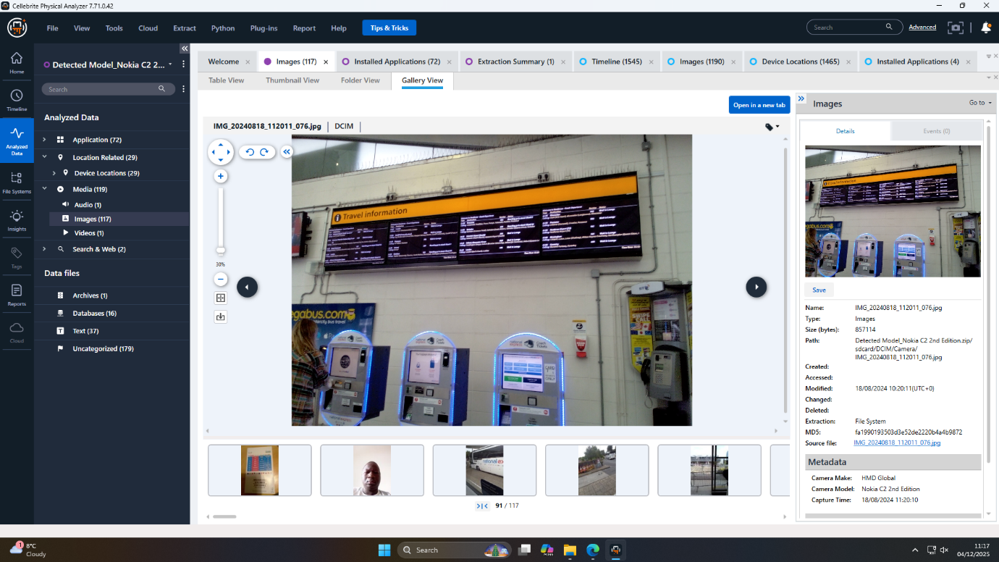
Figure 6: Ticket machines and travel display captured on suspect’s phone

5.3 Technical Challenges and Limitations
A number of major obstacles made the investigation difficult. Continuous encryption, i.e. password-protected Word file and encrypted WhatsApp databases with no key file, negatively affected total artifact recovery on the executed devices, Nokia and Huawei. Granular attribution was further cut short by the use of non-personalized payment cards, deleted or missing application data, and absence of metadata of certain multimedia files. Moreover, logical imaging (required when protecting devices or creating encrypted images) might have left out system-level or deleted artifacts, and this is to point out that some of the communications or data transfers must have been overlooked.

5.4 Data Reliability and Integrity Verification
Although there were the above constraints, stringent forensic procedures maximized the religion of the data. Cross-verification was made for each extraction and a hash was taken. The triangulation was performed through various methods of analytical procedures and was confirmed with the help of corresponding entries into the other devices in case of possible misattribution or analytic bias, the risk of misattribution and analytic errors was minimized. Evidence that was inaccessible or unclear was clearly recorded. The processes and conclusions of the results are of a high level of verifiability and can be further applied in legal or organizational processes.

6. Reconstruction of the Conspiracy Timeline

6.1 Preparation Phase: Actor Device Procurement and Channel Establishment
The conspiracy started in mid-August 2024, where Emma, who was the insider bought a special Huawei device. The paper trail indicates that she quickly created channels of communication, with the most significant being Gmail and WhatsApp, which is designed to be optimized in terms of confined and compartmentalized communication. Emma made the first contact with Joe the intermediary within two days after she registered the device, according to the cache entries in the Gmail account and WhatsApp records of installations. It was also during this early preparation stage that other specialized equipment was acquired, or adequately prepared, that prefigured functional security as well as role separation in the group.

6.2 Coordination and Meetings: Evidence of Travel, Communication, and Financial Planning
Towards the end of August to December 2024, the major monthly organizational harmony changed to detailed operational planning. The Samsung Galaxy A13 was the center of documenting great traveling with Joe, where he has all the receipts and photo evidences of visiting Glasgow, London, and Paris. The investigation showed fully filled travel, hotel rooms, and most of the time, with accompanying receipts and online keys, payments, and customer transactions related to the unknown financial instruments. Emma and Joe communicated piecemeal, both devices being connected with WhatsApp, Instagram, and Gmail traces that went in chronological order and were almost identical to the documented travel dates. The logistical work done by Joe resulted in international meetings where a physical exchange of documents or materials was necessary which was established by matching the records of the hotels and transportation within the UK and even in France.
6.3 Execution and Payment Arrangement: Digital Traces of Financial Exchange
The implementation stage was characterized by the relating and transmission of the illegal finances and stolen intellectual tools. The most striking source is that the Ulefone Note 14 that was given by Norman contained some decisive evidence: the pictures of the debit card of the State Bank of India, which was neither personalized nor offered any personal information, providing a great hint on the intention of using the anonymized payments. Although the device logs of direct transactions are not available, artifact timestamps and photographic archival data associated the device with the identical period of operation to major meetings. Images of One4all gift cards are another well-liked laundering strategy that contributed additional financial context to Joe, with his Samsung phone, and cemented the financial architecture of the conspiracy. Collectively, these aspects explain how the underground trade works without necessarily having the complete transaction histories.
6.4 Covert Operations and Data Obfuscation: Encryption, Deleted Messages, Operational Security
The last, and the still current phase of the conspiracy is the high sophistication of obfuscation techniques. The Nokia C2 2nd Edition had stored an encrypted document that held a Microsoft word document which is vital and yet inaccessible due to brute force claims. Such instances in addition to further use of encryption in this and other devices, systematic deletion of chat, and the use of non-traceable methods of payments all point to a coordinated attempt at minimization of evidence and operational compartmentalization. Some applications were also missing or missing communication logs, which led to the use of secure, short-lived, or other mediums of messages. Such undercover operations reduced the amount of available artifacts and highlighted the technical sophistication and knowledge of forensic riskiness by the suspects.

7. Overview of Extracted Mobile Artifacts
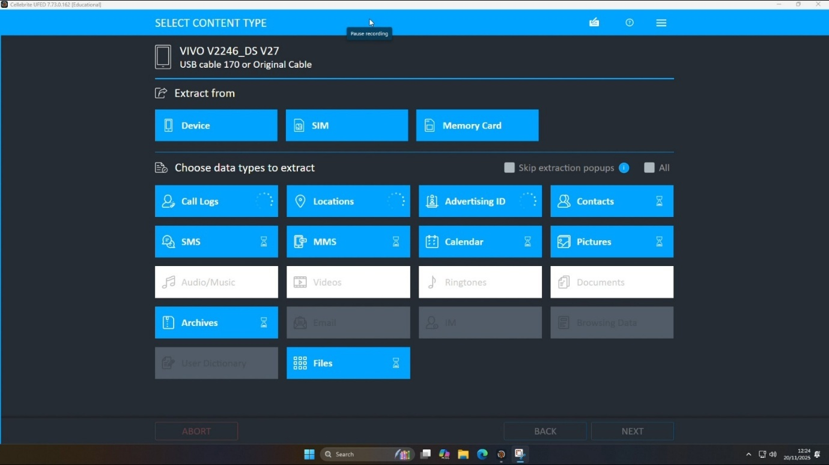
Figure 7: Initial selection of extraction data types
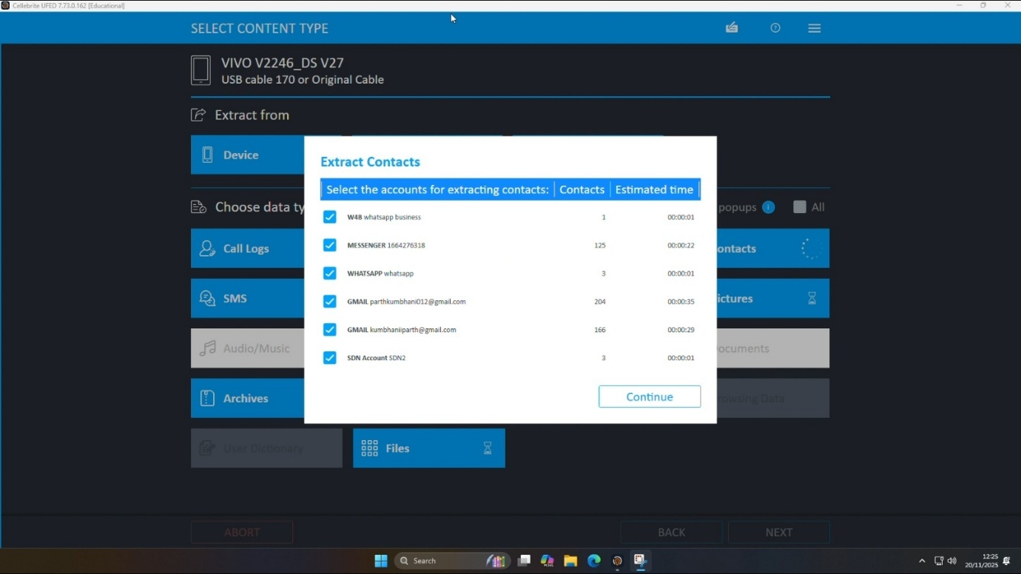
Figure 8: Choosing accounts for contact extraction
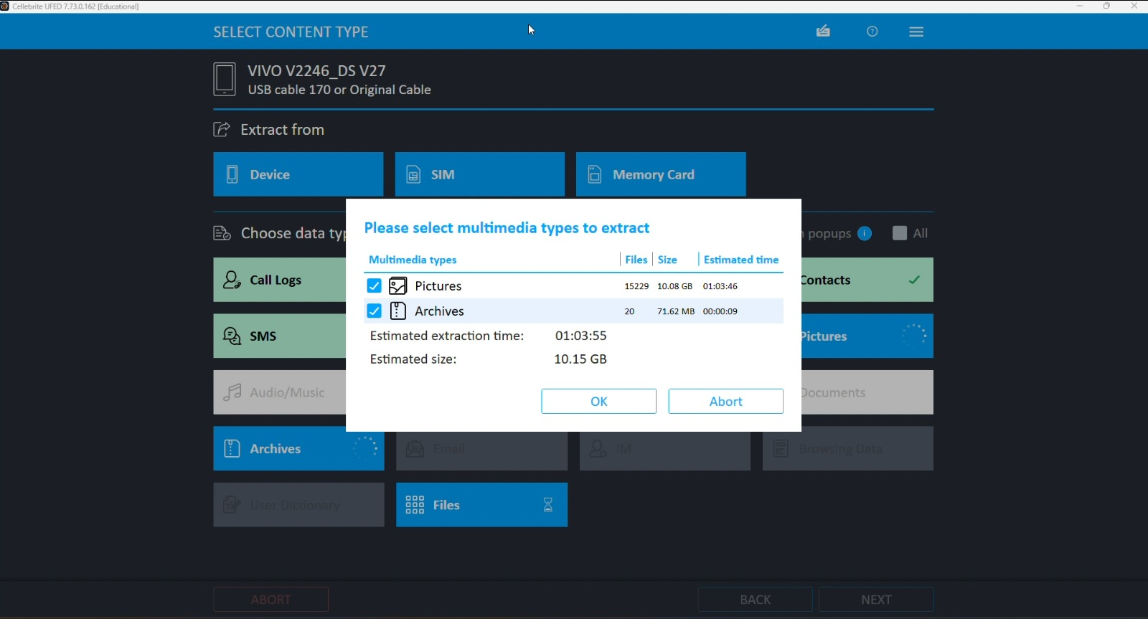
Figure 9: Selecting multimedia pictures and archive types
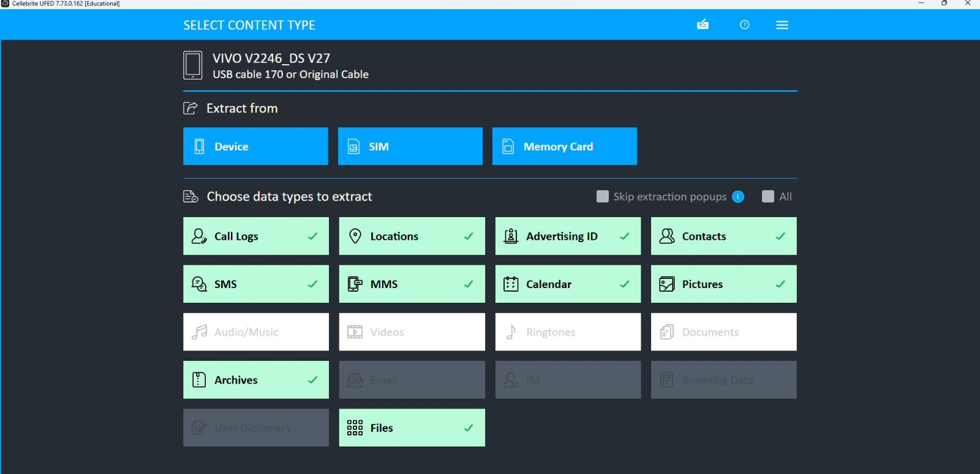
Figure 10: All desired data categories marked selected
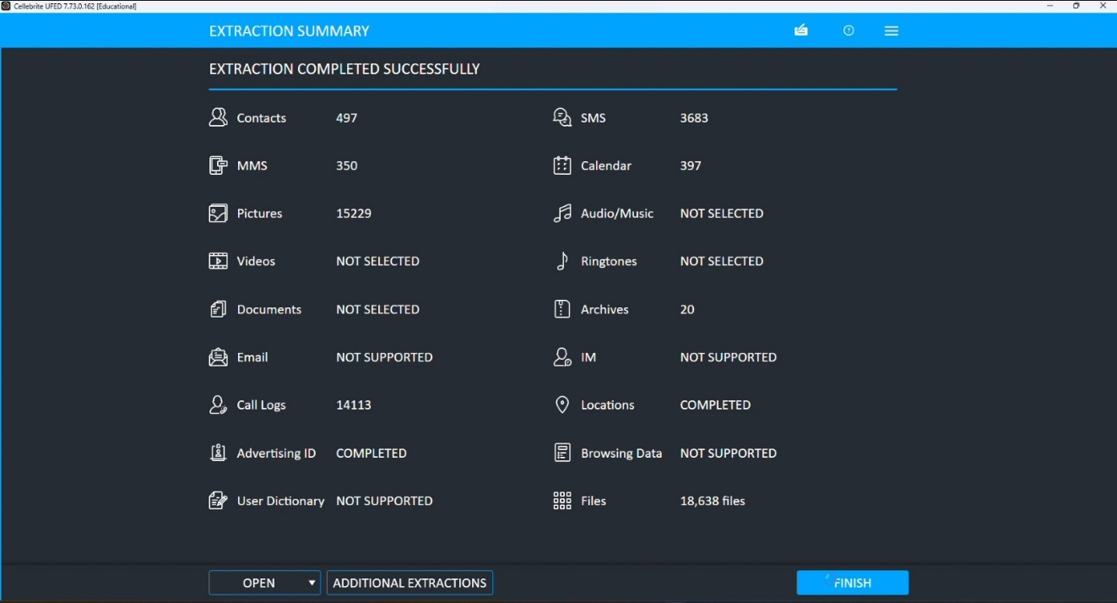
Figure 11: UFED extraction summary showing acquired artifacts
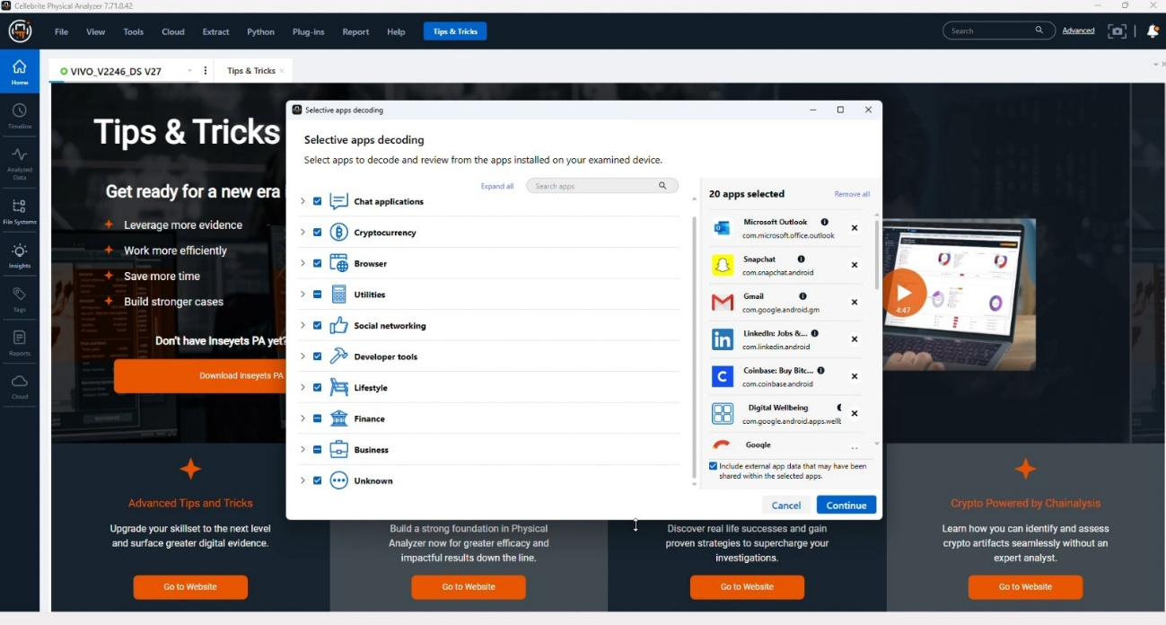
Figure 12: Physical Analyzer selective decoding of applications
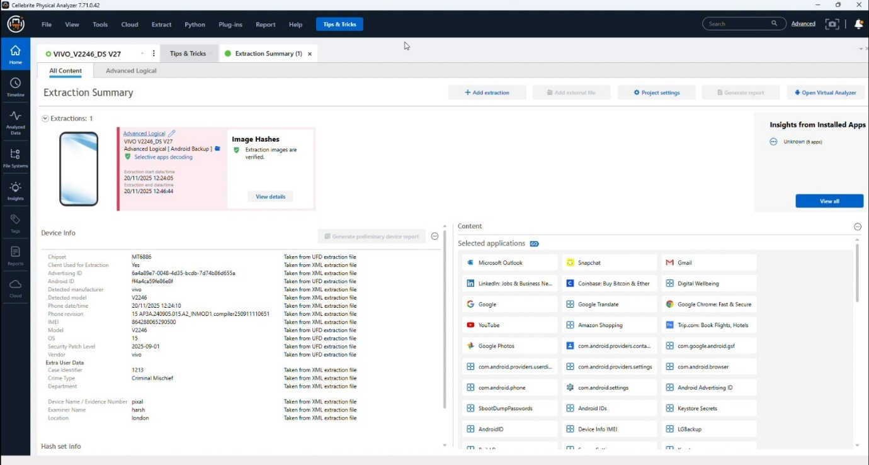
Figure 13: Physical Analyzer extraction summary and device details
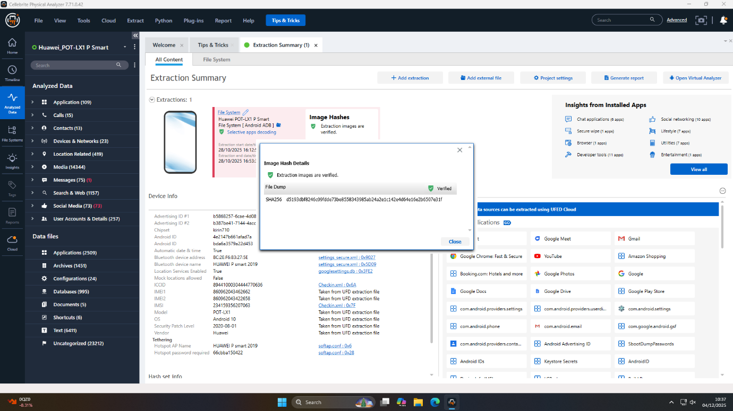
Figure 14: Hash verification guarantees a forensically sound mobile acquisition of Huawei
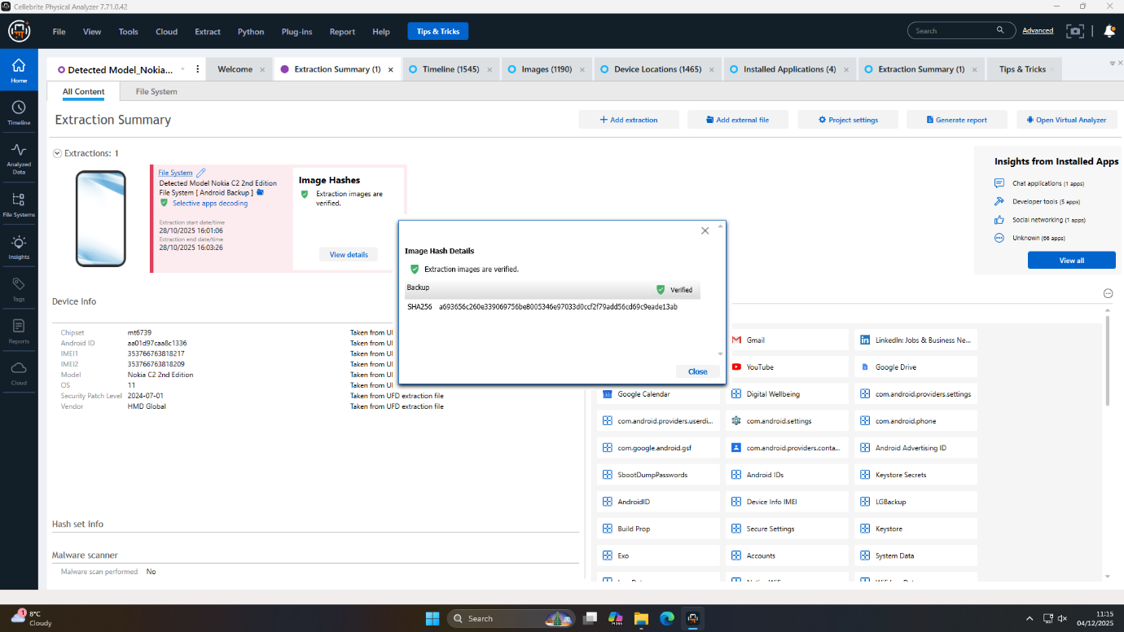
Figure 15: Hash verification guarantees a forensically sound mobile acquisition of Nokia
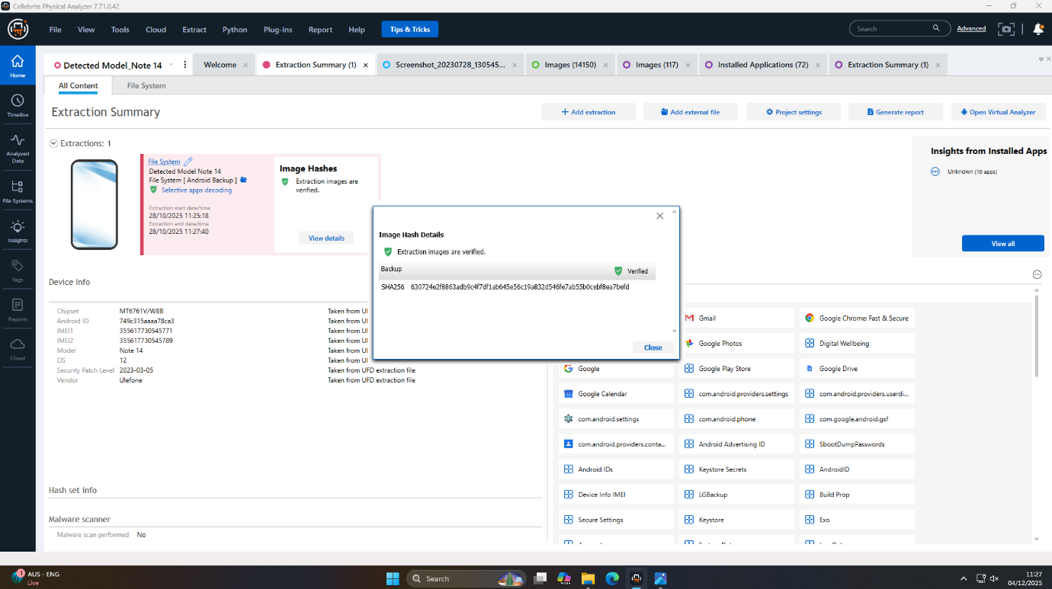
Figure 16: Hash verification guarantees a forensically sound mobile acquisition of Note 14

8. UFED Acquisition Parameters and Identifiers
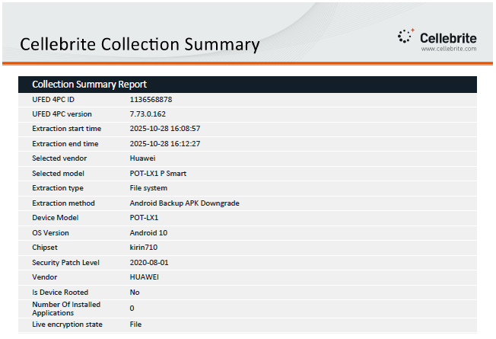
Figure 17: Examiner, device identifiers, and timing information of Huawei
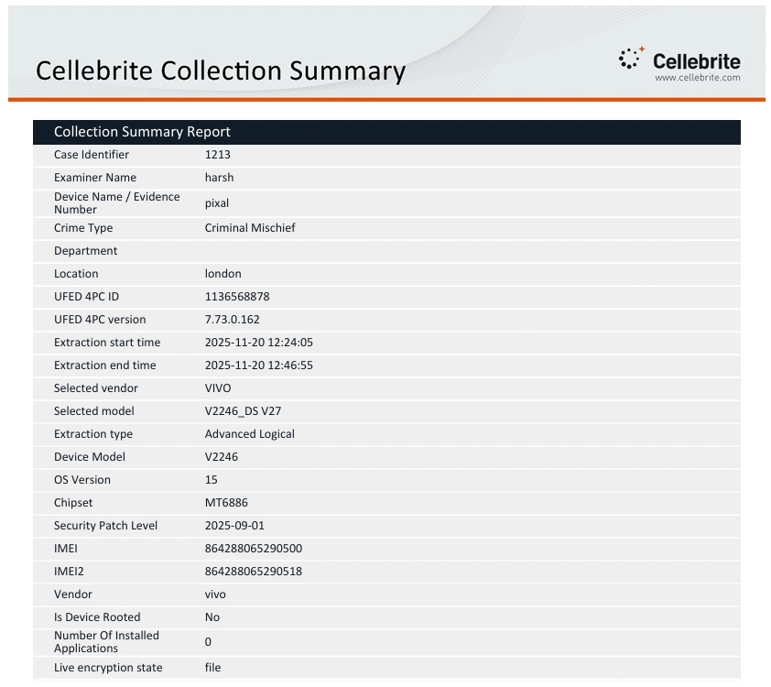
Figure 18: Examiner, device identifiers, and timing information of VIVO
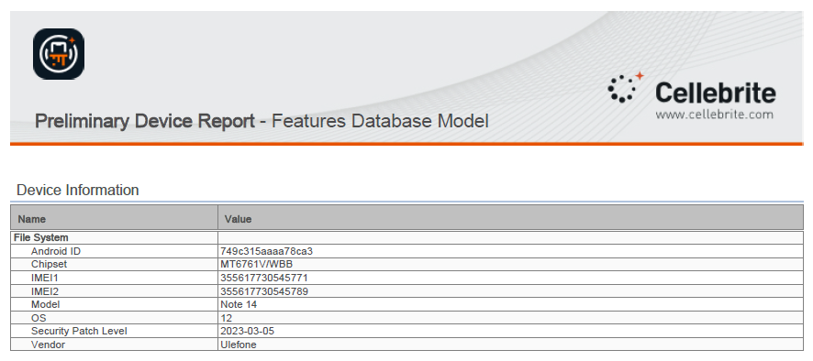
Figure 19: Early Report Summarizing Huawei Note 14 Device
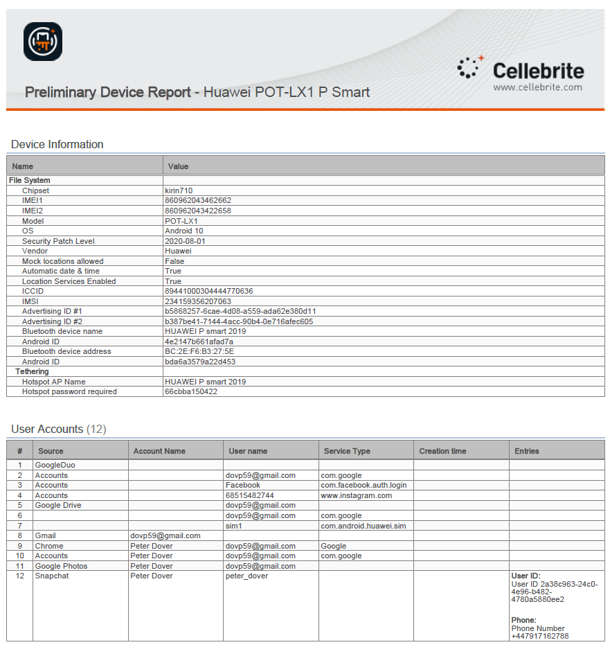
Figure 20: Early Preliminary Device Report Summarizing Huawei POT-LX1 Device
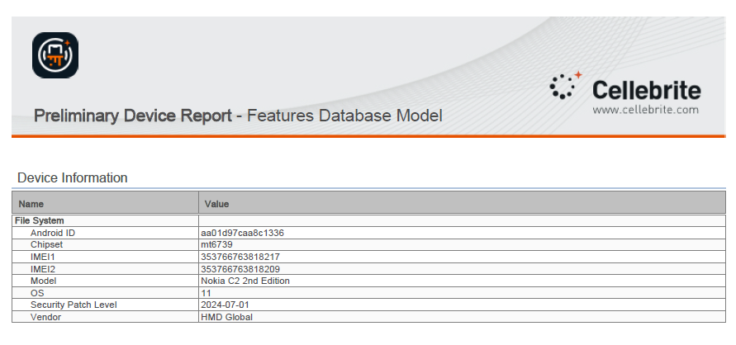
Figure 21: Early Report Summarizing Nokia Device

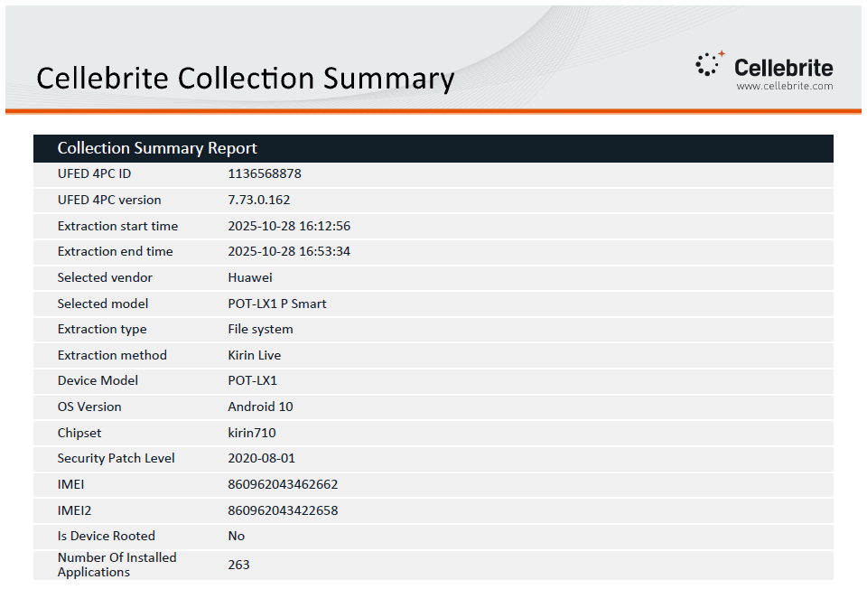
Figure 22: Examiner, device identifiers, and timing information of Huawei
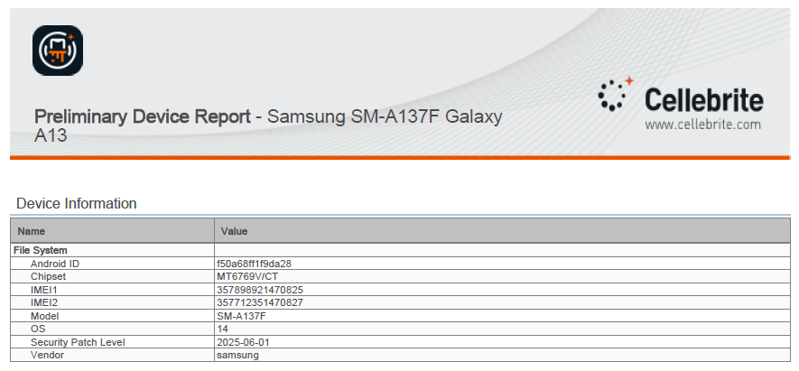
Figure 23: Early Report Summarizing Samsung Device
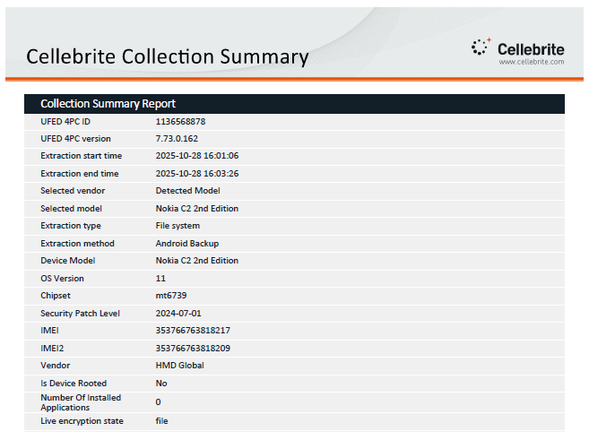
Figure 24: Examiner, device identifiers, and timing information of Nokia
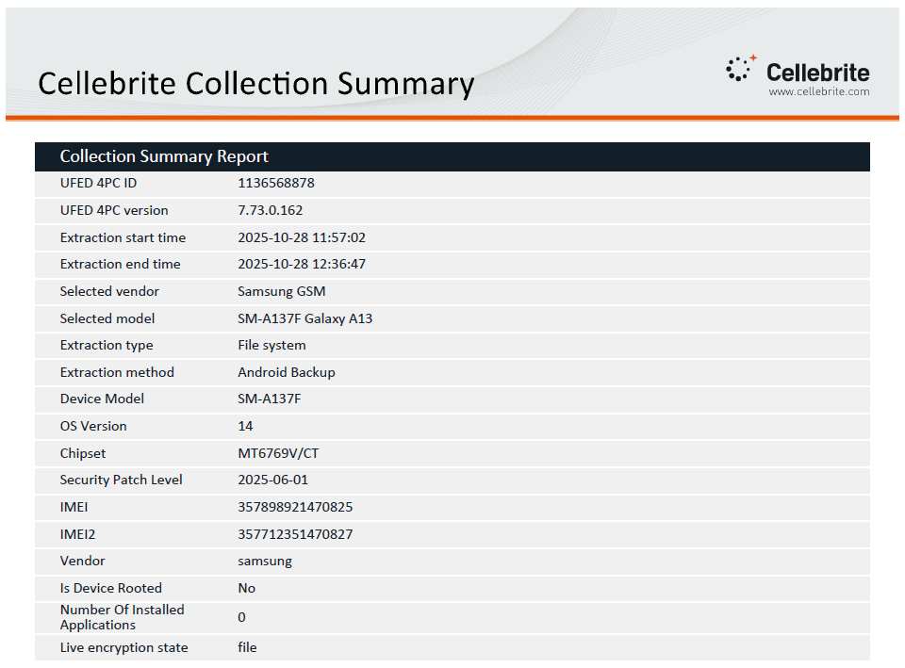
Figure 25: Examiner, device identifiers, and timing information of Samsung

9. Conclusion

9.1 Summary of Key Findings
This forensic examination has determined conclusively that there was a multi agent conspiracy to steal and sell the QT-AI-2025 patent. Based on the evidence of four mobile devices, clearly defined roles were evident: Emma as the orchestrator and insider (Huawei P Smart); Joe as the logistical intermediary (Samsung Galaxy A13); Norman as the financier and buyer (Ulefone Note 14); and an unknown accomplice who by encryption was securing key evidence (Nokia C2 2nd Edition). The conspiracy combined dedicated devices, anonymous and untraceable financial instruments, encrypted file storage, and operation compartmentalization, which were confirmed by the operation of cross device correlation and artifact triangulation.

9.2 Confidence Assessment of Suspect Attribution
Emma, Joe, and Norman roles attribution is backed up by a direct account artifact, travel documents, and payment documents, and application usage tracks, which give a high level of confidence to each member in terms of the role they have performed and the tasks they do. Although there are still some uncertainties about who used the Nokia device and some of the encrypted or deleted texts, the convergent results include a consistent and legally sound story about how the conspiracy worked.

9.3 Reflections on Forensic Process
The rigor of the investigation, which implies the observation of the best practices of imaging, extraction, documentation, and analytic validation, maximized both the amount of data and the value of evidence. The drawbacks that emerge due to encryption and access limits on the application level and intentionally destroying data reflect the persistent issues that digital forensics is going through. However, the analytical process revealed the depth of the results and presented strong results going forward in the investigation of digital crime, and this serves as an indication of the importance of synthesizing cross-device evidence in the contemporary investigative procedures of digital crime.

10. Recommendations for Further Action

10.1 Future Investigative Plan
The identification of Nokia C2 device user should be of immediate priority. Use sophisticated facial recognition when comparing the found photograph of the male to the found database of images whether police or commercial. Observe full-protect requests of all account data (emails, cloud services) related to Emma (dovp59@gmail.com), Joe (josephrehan464@gmail.com) and Norman. Additional cross-reference travel and hotel documentation of digital artifacts to physical security surveillance to support meetings.

10.2 Advanced Technical and Legal Actions Needed
Fork out to expert cryptanalytic services to make attempts at breaking the password encrypted Open.docx file which is assumed to contain important evidence. Steps of formality Legal procedure (e.g., mutual legal assistance treaties, subpoenas) should be undertaken to obtain financial and subscriber information of the anonymized State Bank of India debit card and the Debit Mastercard number ending in 3758. Co-operate with email service providers in cross-jurisdictional disclosure- to overcome international legal barrier that may be faced in Indian and French transaction which may apply in device activities.

10.3 Improvement of Long-term Security
Other than the case reported, provide a recommendation to sustain investment in endpoint security, deep monitoring of communication and anomaly detector systems within the affected organization. Improve employee awareness on cyber security, namely, on signs of insider threat and techniques of operations compartmentalization which in this case are the witnesses of cybercrime. Ensure a forensic preparedness policy--having a policy in place that will not impede the future investigations by the lack of access to the device or its inabilities to be logged in. This complex approach will fortify the present case and cement the organization against a repeat threat of such in the future.

References
[1] M. A. Qurashi and E. Alzahrani, “Digital Forensics in Cybersecurity: Roles, Responsibilities, and Strategies,” Algorithms Intell. Syst., pp. 213–225, 2024, doi: 10.1007/978-981-97-5791-6_17.
[2] S. Shenoi and E. Kurkowski, Advances in Digital Forensics XX. in IFIP advances in information and communication technology. Springer Science+Business Media, 2025. doi: 10.1007/978-3-031-71025-4.
[3] M. C. Ghane, M. D. Uribarri, Ramzi Djemai, Dipo Dunsin, and I. I. Araujo, “A Novel Hybrid Method for Effective Identification and Extraction of Digital Evidence Masked by Steganographic Techniques in WAV and MP3 Files,” J. Inf. Secur. Cybercrimes Res., vol. 6, no. 2, pp. 89–104, 2023, doi: 10.26735/izbk9372.
[4] A. W. Malik, D. S. Bhatti, T.-J. Park, H. U. Ishtiaq, J.-C. Ryou, and K.-I. Kim, “Cloud Digital Forensics: Beyond Tools, Techniques, and Challenges,” Sensors, vol. 24, no. 2, p. 433, 2024, doi: 10.3390/s24020433.
[5] D. Dunsin, M. C. Ghanem, K. Ouazzane, and V. Vassilev, “A comprehensive analysis of the role of artificial intelligence and machine learning in modern digital forensics and incident response,” Forensic Sci. Int. Digit. Investig., vol. 48, no. 301675, p. 301675, 2024, doi: 10.1016/j.fsidi.2023.301675.
[6] Taiwo Blessing Ogunseyi and Oluwasola Mary Adedayo, “Cryptographic Techniques for Data Privacy in Digital Forensics,” IEEE Access, vol. 11, pp. 142392–142410, 2023, doi: 10.1109/access.2023.3343360.
[7] D. Quick and K.-K. R. Choo, “Impacts of increasing volume of digital forensic data: A survey and future research challenges,” Digit. Investig., vol. 11, no. 4, pp. 273–294, 2014, doi: 10.1016/j.diin.2014.09.002.
[8] F. Casino et al., “Research Trends, Challenges, and Emerging Topics in Digital Forensics: A Review of Reviews,” IEEE Access, vol. 10, pp. 25464–25493, 2022, doi: 10.1109/access.2022.3154059.
[9] Sajin Shivdas, “A Complete Handbook for Digital Forensics Investigator,” Int. J. Res. Appl. Sci. Eng. Technol., vol. 11, no. 8, pp. 813–832, 2023, doi: 10.22214/ijraset.2023.55257.
[10] B. Fakiha, “Unlocking Digital Evidence: Recent Challenges and Strategies in Mobile Device Forensic Analysis,” J. Internet Serv. Inf. Secur., vol. 14, no. 2, pp. 68–84, 2024, doi: 10.58346/jisis.2024.i2.005.
[11] Imam Riadi, A. Yudhana, Galih Pramuja, and Inngam Fanani, “Mobile Forensic Tools for Digital Crime Investigation: Comparison and Evaluation,” Int. J. Saf. Secur. Eng., vol. 13, no. 1, pp. 11–19, 2023, doi: 10.18280/ijsse.130102.
[12] Tole Sutikno, “Mobile forensics tools and techniques for digital crime investigation: a comprehensive review,” Int. J. Inform. Commun. Technol. IJ-ICT, vol. 13, no. 2, pp. 321–321, 2024, doi: 10.11591/ijict.v13i2.pp321-332.
[13] F. F. Alruwaili, “CustodyBlock: A Distributed Chain of Custody Evidence Framework,” Information, vol. 12, no. 2, p. 88, 2021, doi: 10.3390/info12020088.
[14] A. Grimani, A. Gavine, and W. Moncur, “An evidence synthesis of strategies, enablers and barriers for keeping secrets online regarding the procurement and supply of illicit drugs,” Int. J. Drug Policy, vol. 75, p. 102621, 2020, doi: 10.1016/j.drugpo.2019.102621.

