

Leading and Implementing Workplace Change

Module Code: BMSW6103
Student Name: Silviu Marius Tanasa
Student ID: 2028900
Lecturer: Nadeem Mirza

Table of Contents
Introduction 1
1. Company Overview 2
2. Relationship with Nike, Inc. 5
3. Current Change Initiative 6
4. External Environmental Analysis 8
5. Analysis of Recent Organisational History 10
6. Evaluation of Change Management Models 13
7. Impact of Organisational Culture on Change Management 16
8. Development of Change Management Plan 19
Conclusion 20
Reference 21

List of Figures
Figure 1: Nike's approach to marketing: 4
Figure 2: Nike's recent financial performance 5
Figure 3: Move to zero campaign Nike inc. 11
Figure 4: Lewin's Change Management Model 14
Figure 5: Kotter's Eight-Step Model 15
Figure 6: Identification of Strengths in the Existing Culture 18
Figure 7: Identification of Weaknesses in the Existing Culture 19

Introduction
Businesses today have to deal with problems that have never been seen before. These problems are caused by changes in the environment, like the COVID-19 pandemic, digital disruption, and economic uncertainty (Vanini, 2019). Nike, Inc. is a global leader in athletic shoes and clothing. This report looks at how the company has changed in response to these powerful forces and how it has handled the challenges of change management. My work with Nike has given me the chance to see and be a part of this ongoing change, which has helped me think critically about the company's current state and recent efforts to make changes. The purpose of this report is to break down the complicated relationship between outside factors and Nike's strategic responses, looking at how these responses have changed the company's organisational skills, leadership styles, and cultural dynamics. This report looks into the history of the company in order to find insights that can be used to create a forward-looking change management plan. This will help make sure that Nike is strong, flexible, and ready for the challenges that lie ahead.

1. Company Overview
A Quick Look at ‘The Present Situation of Nike, Inc.: Nike, a global leader in athletic shoes, clothes, and accessories, dominates the sports and lifestyle market. Today, the company's strategic positioning adapts to business's many challenges. Nike's focus on new ideas, brand building, and customers has helped it solve problems and maintain market share.
The company now sells products for running, basketball, soccer and golf. Nike's sustainability and social responsibility efforts have improved the brand's image, which appeals to customers who are more aware of questionable business practices. Nike can better adapt to changing consumer tastes and trends since it started using digital marketing and sales.
An Overview at Nike's Place in the Market: Nike's innovation and strategic partnerships maintain its market dominance. The Swoosh logo, which symbolises performance and style, gives the brand a broad market presence. The company leads the global market with a large retail footprint and strong online presence.
Nike's partnerships with athletes, celebrities, and fashion designers have improved its image and expanded its audience. Nike sets trends because it blends fashion and athletic performance without looking awkward. Customers have something to aim for.
Nike always leads the market. Innovative designs and technology in their sportswear keep them ahead of the competition. In a changing market, the company's ability to anticipate customer needs and stay ahead of trends shows its strength.
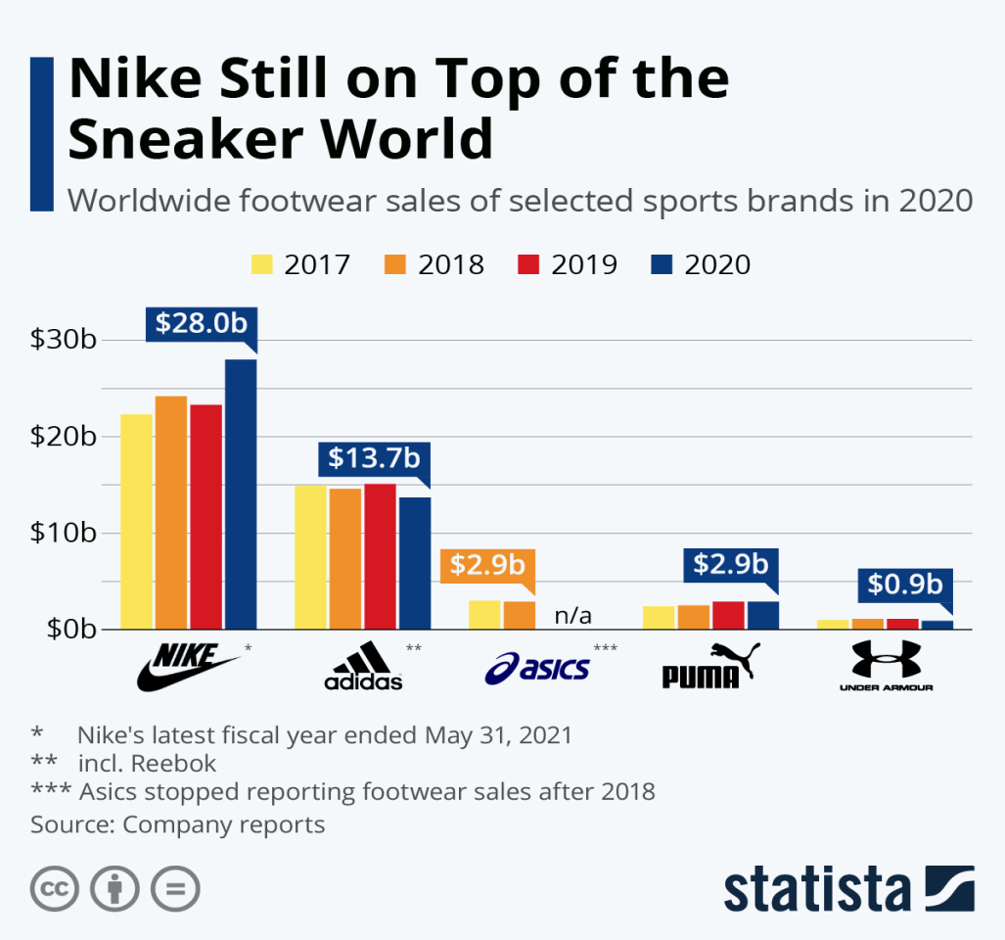
Figure 1: Nike's approach to marketing:
Source: (Google.com, 2023)
Important Financial and Operational Points: Nike's recent financial performance shows how stable and flexible the company is. The company's income streams have been strong even when the economy has been uncertain. Strong money management and smart investments in marketing and technology have helped the economy grow steadily.
Operational highlights show that Nike is committed to making its supply chain more efficient and environmentally friendly. The company's efforts to reduce its impact on the environment are shown by its investments in smart manufacturing and ethical sourcing. Even though the COVID-19 pandemic caused problems, Nike was able to quickly adjust, making sure that its supply chain stayed up and running and those customers were happy.
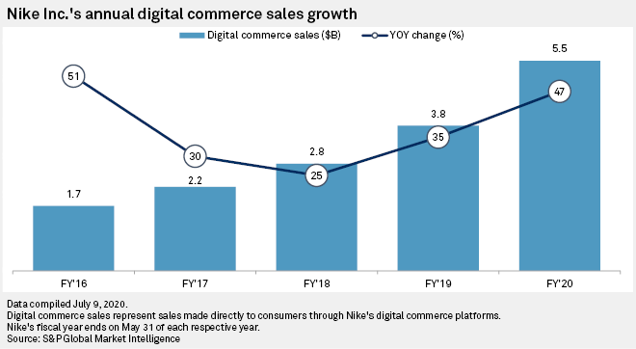
Figure 2: Nike's recent financial performance
Source: (PREBLE, 2020)

2. Relationship with Nike, Inc.
Role or Connection with the Company: As a Senior Marketing Analyst at an outside consulting firm hired by Nike, Inc., it's my job to look at all of Nike's marketing strategies, how they engage customers, and how they position themselves in the market. As an important member of the team, I work closely with Nike's leadership and marketing teams to learn about the company's plans, challenges, and goals. The position I'm in gives me a unique view of and opportunity to contribute to Nike's complex operational landscape.
What view and participation mean to the analysis: As a Senior Marketing Analyst at Nike, I can really get to know the company's marketing ecosystem and learn about things like consumer behaviour, market trends, and how competitors work. I regularly interact with Nike's internal teams, which helps me understand the company's strategic goals and the difficulties it faces in a market that is always changing.
Being close to Nike's internal workings affects my analysis by giving me a more nuanced view of how the company makes decisions and the factors that went into recent changes or initiatives. As part of my job, I'm able to connect what people outside the organisation see with their own plans. This lets us look more closely at how outside factors like the COVID-19 pandemic and digital disruption are seen and dealt with inside the company.
For example, I recently worked with Nike on a project to look at how the pandemic changed the buying habits and preferences of people in the sportswear industry. This meant looking at information about how people's online shopping habits changed, how much demand there was for certain types of products, and how well Nike's communication strategies worked during this time. Collaborations like these help us understand how Nike deals with problems from the outside and help us figure out how to best manage change.
Also, my participation makes it possible to evaluate both the quantitative and qualitative parts of Nike's business in a fair way. In addition to financial metrics, my interactions with the leadership and marketing teams teach me about how the organization's culture and values affect decisions. This complex point of view is very important for comprehending how organisational culture and change management connect, which is a main topic of this report.

3. Current Change Initiative
Outline of a Current Change Initiative within Nike, Inc.: Nike, Inc. has started a major change initiative to show its dedication to sustainability and make sure its business is in line with what customers want. On December 22, 2022, this project began as a strategic move towards a more sustainable and environmentally friendly business model. Nike wants to incorporate sustainability into every step of its value chain, from product design to distribution to disposal.
The "Move to Zero" campaign is crucial to this plan. This campaign aims to make Nike's products and business more environmentally friendly as part of its larger environmental efforts. Stopping climate change and protecting the environment are priorities of the initiative. Nike is also portrayed as a responsible, impactful company.
Objectives and Goals of the Change Initiative:
Carbon Neutrality: One of the main goals of the project is to have all of Nike's owned and run buildings zero carbon by a certain year. To do this, the company needs to carefully study its carbon footprint and take steps to balance out and lower its emissions (Fama and Jensen, 2019).
Sustainable Materials: The project's goal is to get Nike to make its products with more eco-friendly materials. From now until 2025, a lot of Nike's items will be made from recycled or natural materials. This will lessen the damage that making and using Nike products does to the environment.
Circular Economy: From 2026 on, Nike wants to move towards an economy that uses materials in a circle. In other words, it means making things that can be recycled and exploring new ways to get old things back and recycle them.
Water Stewardship: As part of the plan to make things different, the way water is used in manufacturing will be studied more closely (Hamilton, 2019). Targets have been set by Nike to cut down on the amount of freshwater used in its supply chain. This will help protect water resources.
Community Engagement: Nike wants people all over the world to care about the environment and do things that help it. Programmes that teach and raise awareness are part of the initiative and are meant to get consumers, suppliers, and partners to join the movement towards a more sustainable future.
Key Stakeholders Involved in the Change Process:
Leadership Team: To make the change happen, it's very important that the CEO and other top leaders at Nike support it. They have to set the project's goals, explain why sustainability is important, and decide how to use resources to make the project happen.
Employees: Every Nike employee is invested in this change.Every worker is important to the initiative's success, from designers who use eco-friendly materials to manufacturing teams who use eco-friendly methods.
Supply Chain Partners: Nike works with a lot of different suppliers and manufacturers as part of its global supply chain. To reach the initiative's goals, it is essential to get these partners involved in sustainable practices (Shore and Venkatachalam, 2023). To do this, there needs to be clear communication, support, and sometimes investment in the skills of the supplier.
Consumers: Nike knows that customers have a lot of power over market trends. A big part of the initiative is getting people to think about and learn about sustainable choices and how their purchases affect the environment. Nike wants to build a customer base that values and wants environmentally friendly products.
Regulatory Bodies and Advocacy Groups: Because Nike does business all over the world, it is important that it follows environmental laws and works with advocacy groups. Nike works closely with the right authorities and environmental groups to make sure they follow the rules and standards set by the industry.

4. External Environmental Analysis
Impact of the COVID-19 Pandemic on Nike, Inc.:
When the COVID-19 pandemic started, it caused problems for businesses all over the world that had never been seen before. Nike, Inc. was no exception. Nike had to deal with a lot of problems, like stores closing down, supply chains getting messed up, and changes in how people behave. When lockdowns happened, physical stores had to close, which had a big effect on Nike's traditional sales channels. The company proved its strength by quickly adapting to digital life and using its e-commerce platform to offset store losses.
The pandemic also accelerated consumer tastes, making health and wellness more important (Zhang and Wang, 2022). Nike benefited from focusing on athletic and casual wear when comfort and utility were crucial. The company used virtual events and interactive online content to keep customers engaged and attract new fitness customers during lockdowns. Nike's ability to adapt to consumer needs and change direction during crises shows its speed.

Table 1: Impact of the COVID-19 Pandemic on Nike, Inc. profit
Source: (GlobalData UK Ltd, 2021)
There were big changes in Nike's financial performance over the three years. After falling by 35.10% in 2020, profits rose by 17.30% in 2021 and by a huge 302.20% in 2022, showing that the company was resilient and growing strategically.
Influence of Digital Disruption on the Company's Operations:
Nike understood the importance of adopting new technologies in a digital world. From supply chain management to marketing and sales, digital disruption has changed the business. Nike connected with customers more directly and personally through its e-commerce platform and DTC strategy. People used the internet to sell things, socialise, and have fun. Nike fans could customise their shoes, participate in virtual events, and chat in real time.
Technology also improved Nike's supply chain. Advanced analytics and data-driven insights improved demand forecasting. Too much or too little stock was reduced. Technology made things run more smoothly and helped the environment by making inventory tracking and waste reduction easier.
Nike was open to digital innovations like 3D printing and augmented reality when it came to designing products. These new ideas not only made prototyping faster and easier, but they also made the customer experience better by letting them "try on" clothes virtually and making changes to the way they look. Nike's commitment to staying ahead in a world of changing technologies is shown by how well digital tools are integrated into different parts of the company's operations.
Examination of Ongoing Economic Uncertainty and its Effects on Nike:
The unstable economy, marked by changes in currency exchange rates, trade tensions, and global economic downturns, has made things interesting for Nike. Because the company does business all over the world, it faces economic problems in many different markets. Changes in currencies can affect the cost of making things and the profit margins, especially in places where Nike buys materials or makes products.
Trade disputes and geopolitical unpredictability can mess up supply chains (Kitzmueller and Shimshack, 2022). Nike has changed its sourcing strategy and added suppliers to reduce risk. Strong finances and proactive risk management have helped the company absorb shocks and stay stable during economic uncertainty.
Nike also uses strategic pricing to balance high-end products with affordable prices in response to economic issues. This strategy helps Nike maintain its high-end status while appealing to a wide audience.

5. Analysis of Recent Organisational History
Assessing Nike's Recent Changes:
There have been big changes at Nike, Inc. lately. These changes are due to changes in how business is done. That the company is now focusing on being more eco-friendly is a big change. This is what led to the "Move to Zero" campaign. This is a big change from how things have always been done: Nike says it will lower its environmental impact over the whole lifecycle of a product. Nike is making a big change by using eco-friendly ways to design, make, and use materials. This is what they're doing because more and more people want brands that care about the earth.
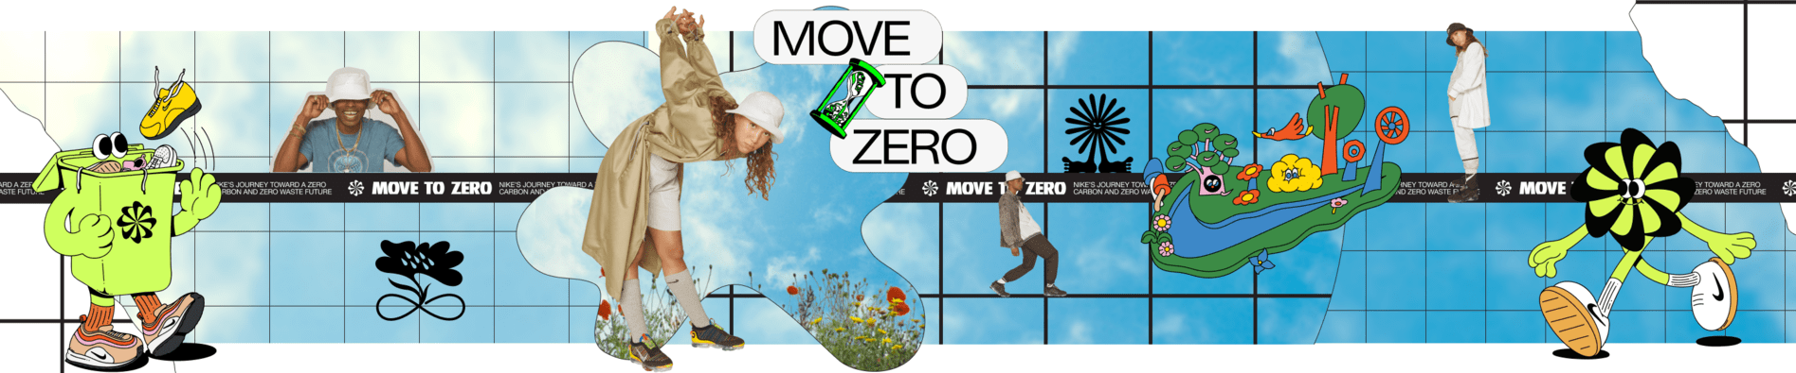
Figure 3: Move to zero campaign Nike inc.
Source: (Nike, 2023)
Moving faster towards digital transformation is another big change in Nike's recent past. Nike knows how important it is to talk to customers directly, so it has put a lot of money into its e-commerce platform and other smart projects. A more balanced approach with a stronger focus on the direct-to-consumer (DTC) channel has been taken by the business, which used to focus mostly on wholesale (Stevens, 2022). This change will help Nike learn more about its customers, gather information that can be used for personalised marketing, and make the whole experience better for its customers.
In the past few years, Nike has also put a lot of effort into being socially responsible and welcoming. Nike's commitment to making a positive social impact and support of social causes show that it knows what customers who care about social issues want and is changing to meet those needs.
Evaluation of the Company's Response to External Challenges:
Nike's responses to external issues are swift and strong. Due to the COVID-19 pandemic, traditional retail channels slowed and stores closed. Nike, on the other hand, quickly changed with the times. The company sped up its digital efforts and used e-commerce to lessen the effect of closing stores. Nike did well in the new consumer landscape that the pandemic created by focusing on health and wellness products, holding virtual events, and making online content that people could interact with.
It has been proactive and thorough for Nike to deal with digital disruption. The company knows what's going on in the industry and wants to stay ahead by using technology in marketing, supply chain management, and product design. By using data analytics, 3D printing, and augmented reality, Nike not only improved operational efficiency but also the customer experience. This solidified Nike's position as a leader in the sportswear industry when it comes to technology.
When it comes to the economy, Nike has handled trade tensions and economic downturns with strategy. The business's global sourcing plans, risk management methods, and pricing strategies show that it has a deep understanding of how the economy works. Nike's ability to deal with economic problems while keeping up the image of a high-end brand shows how smart and flexible it is with money.
Lessons Learned from Past Change Initiatives:
Nike's history of making changes can teach the company and the industry as a whole important lessons. To begin, the successful implementation of sustainability practices shows how important it is for business strategies to be in line with larger environmental and social issues. The "Move to Zero" campaign shows businesses how to make sustainability a part of their everyday work. These businesses know that doing the right thing is not only the right thing to do, but also good for business.
Nike's quickness in responding to outside problems, especially the COVID-19 pandemic, shows how important it is to be ready for digital challenges. Being able to switch to online channels, interact with customers virtually, and change marketing strategies based on how customers act shows how resilient a well-executed digital transformation is.
Nike's focus on social responsibility and acceptance can also teach us how to position a brand. By supporting diverse groups and social causes, Nike not only adapts to changing consumer values but also builds a brand identity that goes beyond its products. This method builds brand loyalty and makes the company more relevant in today's world.

6. Evaluation of Change Management Models
Overview of Different Change Management Models
Transformational organisations can organise their work using change management models. Lewin's Change Management Model and Kotter's Eight-Step Model are popular models.
Lewin's Change Management Model: The model by Lewin is made up of three parts: unfreezing, changing, and refreezing. Part of unfreezing is getting people ready for change and aware of it. Getting the change that is wanted to happen is what the changing stage is all about. The refreezing stage is all about making sure that the change becomes part of the organization's culture. Starting new habits is very important, and this model shows how important it is to break old ones.
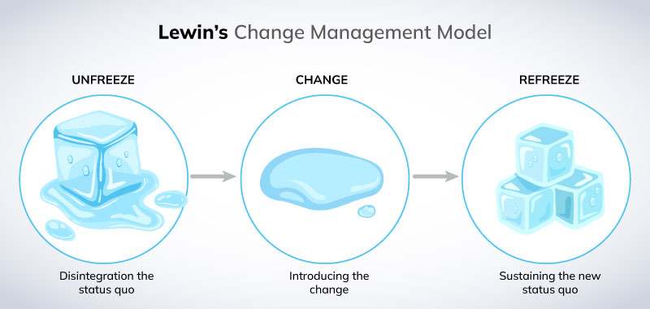
Figure 4: Lewin's Change Management Model
Source: (W Warner Burke, 2018)
Kotter's Eight-Step Model: In order to make people feel like they need to act quickly, build a guiding coalition, come up with a vision and strategy, share the change vision, give employees the power to act on a large scale, get quick wins, keep gains, and make sure that the new ways of doing things become part of the culture, this model was created by John Kotter. Kotter's model is based on the idea of keeping change going and building momentum.
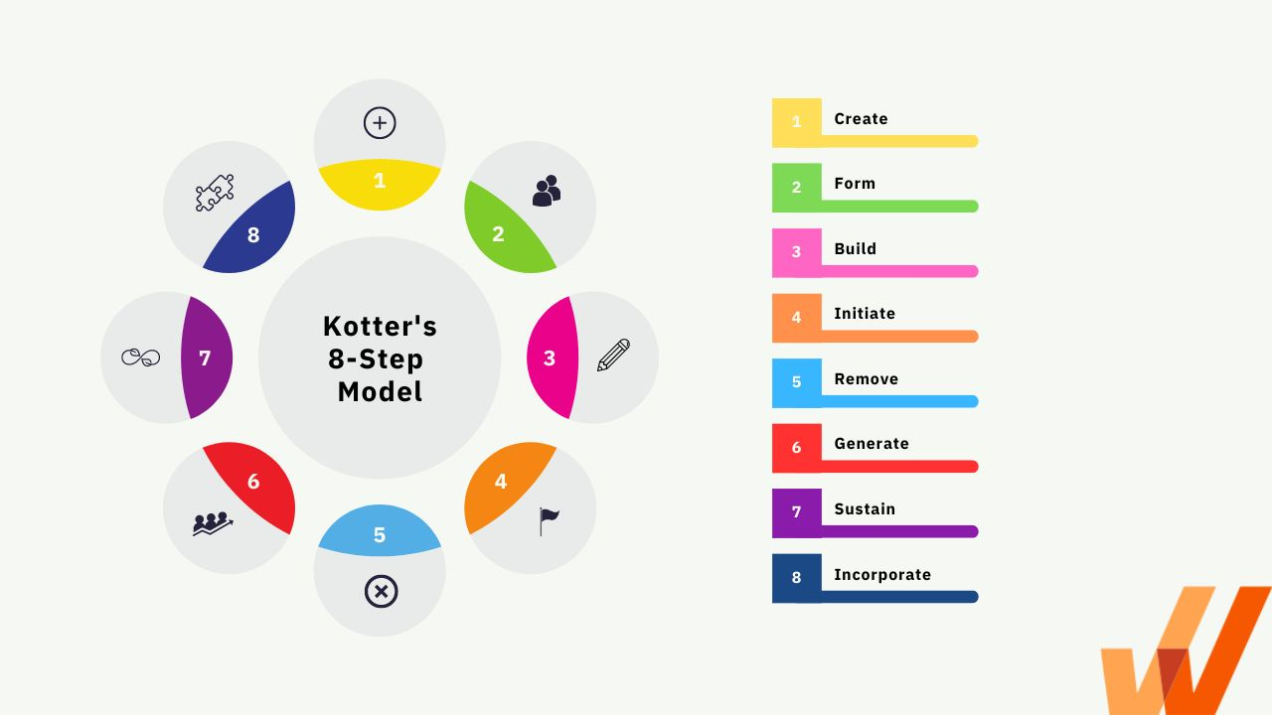
Figure 5: Kotter's Eight-Step Model
Source: (SQ et al., 2018)
Application of Selected Models to Nike's Change Initiative:
Lewin's and Kotter's models aid Nike's "Move to Zero" sustainability plan. Unfreezing represents Nike's realisation that things must change. It's aware of how its operations affect the environment and how important it is to address sustainability issues right away. During this stage, sustainability practices are being put in place across the value chain, with a focus on using eco-friendly materials and cutting down on carbon emissions. In the refreezing stage, these environmentally friendly practices are ingrained in Nike's organisational culture. This ensures that the company will remain environmentally responsible in the long term.
The strategic parts of Nike's change initiative fit with Kotter's Eight-Step Model. The global imperative for sustainability is to create a sense of urgency. To form a guiding coalition, you need to put together a group of people whose sole purpose is to drive the sustainability agenda. Nike is committed to a circular economy and carbon neutrality, which is why they are making a vision and strategy. To share this vision, Nike needs to involve both internal and external stakeholders, so that everyone can understand the company's sustainability goals. Short-term wins could include the successful launch of long-lasting product lines, which would build on past successes and speed up the process of making more changes.
Integration of Strategic Change, Management, and Leadership Issues:
Strategic Change: Nike's plan for change includes a shift in strategy towards being more environmentally friendly. The chosen models support this strategy by stressing how important it is to have a strong vision, involve important stakeholders, and make changes that are in line with the organization's long-term goals. The focus on a circular economy, a smaller carbon footprint, and long-lasting materials shows that the company's goals are in line with the world's environmental concerns.
Management Approach: Nike uses both participative and transformational leadership to help people deal with change. Employees, supply chain partners, and customers are all being included in the sustainability journey through collaborative efforts, which show the participative aspect. With transformational leadership, the company is committed to a vision that goes beyond traditional business metrics and makes social and environmental issues part of its core values (Anderson, 2019).
Leadership Styles: During this change initiative, Nike's leaders are both long-term and hands-on. Visionary leadership is shown by the dedication to a sustainable future, and empowering leadership is seen in the work to involve employees and stakeholders at different levels. Nike's leadership styles are in line with the chosen change management models because they encourage a shared vision and give everyone the tools they need to help reach the sustainability goals.

7. Impact of Organisational Culture on Change Management
Analysis of Nike's Organizational Culture:
Nike's unique organisational culture has helped it succeed. The company values innovation, performance, and authenticity. This lifestyle, called "Nike Culture," combines athleticism, creativity, and pushing boundaries. Nike values employee autonomy and encourages them to try new things and take risks. This culture gives employees pride and belonging, making the workplace lively and collaborative.
Evaluation of How Cultural Aspects Influenced the Change Initiative:
Nike's "Move to Zero" sustainability initiative was shaped by its culture. Sustainable operations were easy for Nike due to its culture of innovation and performance. Due to the focus on pushing boundaries and questioning the status quo, employees saw the change initiative as an opportunity to solve problems creatively.
The sustainability initiative also worked because of the cultural aspect of being real. Nike's real connection to sports, athletes, and active lifestyles fit in well with the growing awareness around the world about protecting the environment. People not only agreed with this, but it also inspired employees who saw the real commitment to a purpose other than making money.
But cultural differences also made things hard. While putting a lot of emphasis on performance and results can help spark new ideas, it could also make people unwilling to change, especially if they think that sustainability goals are at odds with traditional business metrics. To get around this problem, Nike had to communicate better and change its culture so that sustainability became an important part of the company's performance-focused identity.
Identification of Strengths and Weaknesses in the Existing Culture:
Strengths:
Innovation and Creativity: Nike's culture of coming up with new ideas and being creative is one of its strengths in the change initiative. It helps people come up with long-lasting materials, eco-friendly ways to make things, and creative ways to lessen their impact on the environment (Caniëls and Rietzschel, 2019).
Employee Empowerment: Giving employees the freedom to take risks and contribute to the success of the company creates a sense of ownership in the sustainability initiative. Employees are encouraged to take an active role in the change process, which leads to new ideas and commitment.
Brand Loyalty: The loyal employees at Nike are helped by the company's strong organisational culture. If employees agree with the company's values, they are more likely to support and promote efforts to be more environmentally friendly. This will help the change initiative succeed.

Figure 6: Identification of Strengths in the Existing Culture
Source: (Grant, 2019)
Weaknesses:
Resistance to Change: The emphasis on performance and traditional success metrics may create resistance to changes that are not immediately aligned with these metrics. Convincing employees to adopt sustainability goals may require a cultural shift and reevaluation of success criteria.
Potential for Soloed Thinking: Competitive and individualistic cultures can lead to thinking alone, making it harder for departments to collaborate on sustainability practices. We need to promote collaboration to solve this issue.
Balancing Innovation and Tradition: Nike values new ideas, but it may be difficult to balance them with traditional values and practices. It's difficult to integrate sustainability into existing processes without hindering innovation.

Figure 7: Identification of Weaknesses in the Existing Culture
Source: (ALARCÓN, 2019)

8. Development of Change Management Plan
Nike, Inc. is putting in a lot of work to bring ideas from the circular economy into its daily business with an eye towards the future. Putting together a closed-loop system is the main goal of this project, which focuses on recycling and reusing things. Because of this change, Nike products will have less of an effect on the environment. More and more customers want products with responsible lifecycles, and the company's promise to be eco-friendly fits with the plan for a circular economy.
We need a solid plan for training and developing our staff if we want this change to last. Nike is empowering its employees to adapt to changes. Participants will understand how tasks are related through training modules on the circular economy, advanced recycling technologies, and cross-departmental collaboration. Skills-building programmes on creativity, innovation, and sustainability leadership allow company employees to participate in the circular economy initiative.
Good communication is crucial to this change management plan (Cook, 2018). Nike's communication strategy is to be honest and open about the circular economy initiative's vision and goals. A stakeholder is anyone with an interest in the project, regardless of company affiliation. They should receive regular project updates and feedback. The communication plan also emphasises how staff training and development programmes can help people advance in their careers and help sustainability projects succeed.
If you want to know how well the initiative worked in the circular economy, you will need a good evaluation plan. Key performance indicators are set up so that the goals of the initiative can be tracked and judged (Kowalczyk, 2018). For example, work is being done to make trash collection better and to use recycled materials more often. To fully understand how the project turned out, it's important to look at how involved and responsive the employees were, how the project affected the supply chain, how customers felt about it, and the financial indicators. The fact that Nike uses an evaluation method that is both measurable and iterative shows that the company cares about the environment and works to make sure things keep getting better.

Conclusion
It is great that Nike is committed to a circular economy. This is a big step towards sustainability. The proposed plan for managing change, which includes training staff, good communication, and a full evaluation, fits in perfectly with the company's culture of coming up with new ideas. By using circular principles, Nike not only cares about the environment but also sets an example for how to run a responsible business. The all-around method makes sure that workers are given the tools they need, that all parties involved are involved, and that it is clear how well the sustainability project is doing. Nike's move towards a circular economy not only moves the company forward, but it also sets an example for the rest of the industry. It shows how purpose-driven change can have a big effect on the quest for a more resilient and sustainable future.

Reference
ALARCÓN, R.D. (2019). Culture, cultural factors and psychiatric diagnosis: review and projections. World Psychiatry, [online] 8(3), pp.131–139. doi:https://doi.org/10.1002/j.2051-5545.2009.tb00233.x.
Anderson, D.R. (2019). An introduction to management science : quantitative approaches to decision making. Boston, Ma: Cengage.
Caniëls, M.C.J. and Rietzschel, E.F. (2019). A Special Issue of Creativity and Innovation Management: Organizing Creativity: Creativity and Innovation under Constraints. Creativity and Innovation Management, 22(1), pp.100–102. doi:https://doi.org/10.1111/caim.12010.
Cook, S. (2018). Good communication is key to good care. BMJ, p.k1704. doi:https://doi.org/10.1136/bmj.k1704.
Fama, E.F. and Jensen, M.C. (2019). Agency Problems and Residual Claims. The Journal of Law and Economics, 26(2), pp.327–349.
GlobalData UK Ltd (2021). COVID-19 Impact on Nike Inc. and its future prospects. [online] Market Research Reports & Consulting | GlobalData UK Ltd. Available at: https://www.globaldata.com/store/report/covid-19-impact-on-nike-inc-and-its-future-prospects/.
Google.com. (2023). Redirect Notice. [online] Available at: https://www.google.com/url?sa=i&url=https%3A%2F%2Fhashtagpaid.com%2Fbanknotes%2Fnikes-approach-to-marketing-then-and-now&psig=AOvVaw213f2JxGPCqqDOQZK-wTP1&ust=1703078789775000&source=images&cd=vfe&opi=89978449&ved=0CBQQjhxqFwoTCJjd3YfNm4MDFQAAAAAdAAAAABAD [Accessed 19 Dec. 2023].
Grant, R.M. (2019). The Resource-Based Theory of Competitive Advantage: Implications for Strategy Formulation. California Management Review, 33(3), pp.114–135.
Hamilton, R. (2019). From Water Management to Water Stewardship—A Policy Maker’s Opinion on the Progress of the Mining Sector. Water, 11(3), p.438. doi:https://doi.org/10.3390/w11030438.
Kitzmueller, M. and Shimshack, J. (2022). Economic Perspectives on Corporate Social Responsibility. Journal of Economic Literature, 50(1), pp.51–84.
Kowalczyk, M. (2018). KEY PERFORMANCE INDICATORS IN LOCAL GOVERNMENT IN POLAND. Prace Naukowe Uniwersytetu Ekonomicznego we Wrocławiu, (503), pp.236–245. doi:https://doi.org/10.15611/pn.2018.503.21.
Nike (2023). Nike Sustainability. Move to Zero. [online] Nike.com. Available at: https://www.nike.com/sustainability.
PREBLE, J.F. (2020). Toward a Comprehensive Model of Stakeholder Management. Business and Society Review, 110(4), pp.407–431. doi:https://doi.org/10.1111/j.0045-3609.2005.00023.x.
Shore, B. and Venkatachalam, A.R. (2023). Evaluating the information sharing capabilities of supply chain partners. International Journal of Physical Distribution & Logistics Management, 33(9), pp.804–824. doi:https://doi.org/10.1108/09600030310503343.
SQ, T., WW, L., SL, L., WLJ, P. and TY, T. (2018). Kotter’s Eight-Step Change Model: One Centre’s Experience for Transition to the GnRH Antagonist Protocol. Journal of Womens Health, Issues and Care, 5(5). doi:https://doi.org/10.4172/2325-9795.1000246.
Stevens, M. (2022). The Direct to Consumer Playbook The Stories and Strategies of the Brands That Wrote the DTC Rules. London: Kogan Page, Limited.
Vanini, P. (2019). Digital Disruption. SSRN Electronic Journal . doi:https://doi.org/10.2139/ssrn.2988962.
W Warner Burke (2018). Organization change : theory and practice. Los Angeles: Sage.
Zhang, J. (Mandy) and Wang, Y. (Jasmine) (2022). Effectiveness of corporate social responsibility activities in the COVID-19 pandemic. Journal of Product & Brand Management. doi:https://doi.org/10.1108/jpbm-07-2021-3551.

