PRACTITIONERS HANDBOOK
TRANSITIONS

Javaria Rehman
Student ID: 2128580
ECEY4001 Human Development
Image Source: (Nursery Resources, 2019).
Contents Page

Introduction……………………………………………………………………….…………...……3
What are Transitions?……………………………………………………….…………………….3
Communication…………………………………………………………………………………….5
The Needs of the Child……………………………………………………………………………5
Maslow’s Hierarchy of Needs…………………………………………………………………….5
Bowlby’s Attachment Theory……………………………………………………………………..6
A Unique Child……………………………………………………………………………………..7
Positive Relations………………………………………………………………………………….7
Enabling Environments……………………………………………………………………………7
Learning and Development……………………………………………………………………....7
The Role of the Adult………………………………………………………………………..…….8
Partnerships…………………………………………………………………………………….....8
Interventions……………………………………………………………………………………….9
Proposed Outcomes……………………………………………………………………...……..11
References……………………………………………………………………………………… 12-13

Introduction
The purpose of this Handbook is to provide good practice guidance for practitioners within our setting and to increase awareness of how crucial good communication is to young children's learning and development during transitions, and to support effective transition arrangements in the early years.
This Handbook will focus on children making the transition from home or pre-school to nursery and how to support them to make the transition go as smooth as possible.
What are Transitions?
Image Source: (Confident parent’s confident kids, 2014)
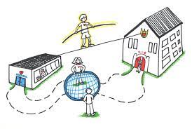

As stated on Birth to 5 Matters (n.d), transitioning is a process.
Transitions involve more than just moving "horizontally" from one room to another within the same setting or going from one place to another in a linear fashion. They can also involve movements to an organised time of day, that include lunch, or traveling from home to a setting and back home again in the same day.
Children will feel positive about the numerous transitions they will encounter throughout their life, if transitions throughout their early years are handled with empathy (Birth To 5 Matters, n.d).

Also stated on Birth To 5 Matters (n.d), Transitions have opportunities for professional discussions where the key members establish crucial links.
Good transitions understand how important it is to feel "known”. Maintaining consistency among family, key individuals, and settings is vital for providing high-quality experiences to every child.
Children in today's world might have a variety of experiences, including childcare, toddler groups, and many nurseries. While many children adapt easily, not all handle frequent transitions well (Birth To 5 Matters, n.d).
As stated on Early Years Matters (2023), transitions are significant milestones that can have a real impact on children’s development. These are undoubtedly exciting times of change, as well as times for each child to grow and have new opportunities. There may be times where there is uncertainty and where the surroundings are different, including the expectations and procedures. For every child, a smooth transition is essential, and it should be seen as a process rather than an event involving parents, practitioners, and children (Early Years Matters, 2023).
As stated by Devon County Council (2022), early childhood transition is a pivotal developmental stage for children and their caregivers, which involves significant events such as entering early education settings, starting school, or moving from the foundation year to key stage 1. It can be difficult for children and stressful for parents or carers, especially if the child has a disability or there are specific needs that the child requires that calls for extra help and understanding during these transitions (Devon County Council, 2022).
As stated by The Educator Magazine (2017), according to research, transitions are crucial to a child's development and emotional welfare, how these early transitions are managed can have a huge impact on how well the child is able to cope with a change in the future. The whole family can feel anxious, and emotions can run high when their child leaves their home environment for the first time. Therefore, this transition should be managed with sensitivity as it is the first time the child is moving from home to a nursery (The Educator Magazine, 2017).
The Early Years Foundation Stage also incorporates the concepts of well organised transitions and the collaboration with parents to ensure that children's needs are met. Children, practitioners, and parents all need to communicate and participate during the transition process (The Educator Magazine, 2017).
Policies and procedures to ensure successful transitions include:
- All communication given to new parents should be clear and welcoming.
- The settling in policy should be given to parents.
- Parents should receive welcome packs with photos of the staff and the provision.
- Have drop-in sessions so new families can familiarise themselves with the setting.
- Home visits should be organised so key workers are introduced.
- Offer staggered starts.
- Parents can be invited to stay with their child during the early stage.
- Children can be encouraged to bring items of their choice from home such as a teddy or a blanket.
- All information on individual children must be read carefully.
- All staff should be aware of children who may have special needs or may be vulnerable.
- Communicate with other professionals such as health visitors, social services who could be involved with any child.
- Update parents and key workers and assess how the children are settling in daily and communicate this information to parents or carers and key workers.
- Parents may have anxieties, and these should be dealt with sensitively.
- Parents who struggle with speaking English will need additional support to clarify information provided to them.
- Children's home life and culture can be celebrated by providing experiences which reflect this.
- Policies and procedures regarding transitions should be reviewed and updated as needed (The Educator Magazine, 2017).
A child may occasionally need to transfer to a new nursery because their circumstances have changed. This transition should be supported by practitioners, ensuring that there is effective communication and information exchange with the family and the new setting (The Educator Magazine, 2017).
Extra planning involving parents and other professionals may be required for a child with special educational needs (SEN), this could include extra training for staff as well as resources or necessary adaptations, for a good transition from the start (The Educator Magazine, 2017).
Communication
To ensure successful transitions, it is vital for practitioners to have effective communication between parents and other parties involved. Children may talk about any worries they have at home. Positive relationships between staff and parents are necessary for ensuring that this information is communicated, and that appropriate support is provided by the setting. Parents should be involved in any planning as they have vital information about their child that professionals can use appropriately (Lochrie, 2023).
When communication between all parties concerned goes well, then transitions are a success (Public Health England, 2014).
The Needs of the Child
Every child deserves an education which meets high standards, is tailored to their needs, and ensures they achieve their full potential (UNICEF, n.d).
As stated by Department for Education (n.d) when getting to know your children, this will reveal that they all learn at varying speeds, with some finding tasks more challenging than their peers. This is all part of normal childhood development and may simply be a sign that good progress can be made with slight modifications to the teaching strategies or the provision of modest amounts of support, encouragement, and extra assistance.
It is critical that any early delays or challenges result in the appropriate support and are not always seen as an indication of a long-term special education need or disability. Although some needs may not be long term, it is crucial to arrange the curriculum and activities in a way that will support the children who may raise concerns early on (Department for Education, n.d).
An example could be a child who was raised in a household where the adults did not routinely have conversations with their children. This could indicate that the child has not yet learnt eye contact, turn-taking and other conversational skills. Additionally, the child may not know as many words compared to the other children around the same age. Although this does not imply that they have SEND, they will require assistance, encouragement, and support in order to expand their vocabulary and early language skills. By reading to the children frequently, they will be exposed to new words daily and by modelling turn-taking in conversations with other children or adults, you will support them to develop their language and communication skills. With careful assistance and strong collaborative relationships with parents and carers, they will quickly return to making good development (Department for Education, n.d).
Maslow’s Hierarchy of Needs
Abraham Maslow, an American psychologist, and humanist first introduced the idea of a hierarchy of needs in 1943 (Pathak, 2021).
As stated by Mcleod (2023), there are five levels of Maslow’s hierarchy of needs. These are as follows, starting from the bottom: physiological (clothes and food), safety (work security), love and belonging (friendship), esteem, and self-actualisation. Maslow claimed that higher-level needs, such as social needs, would start to drive behaviour if basic needs, like food, drink, and shelter, were satisfied.
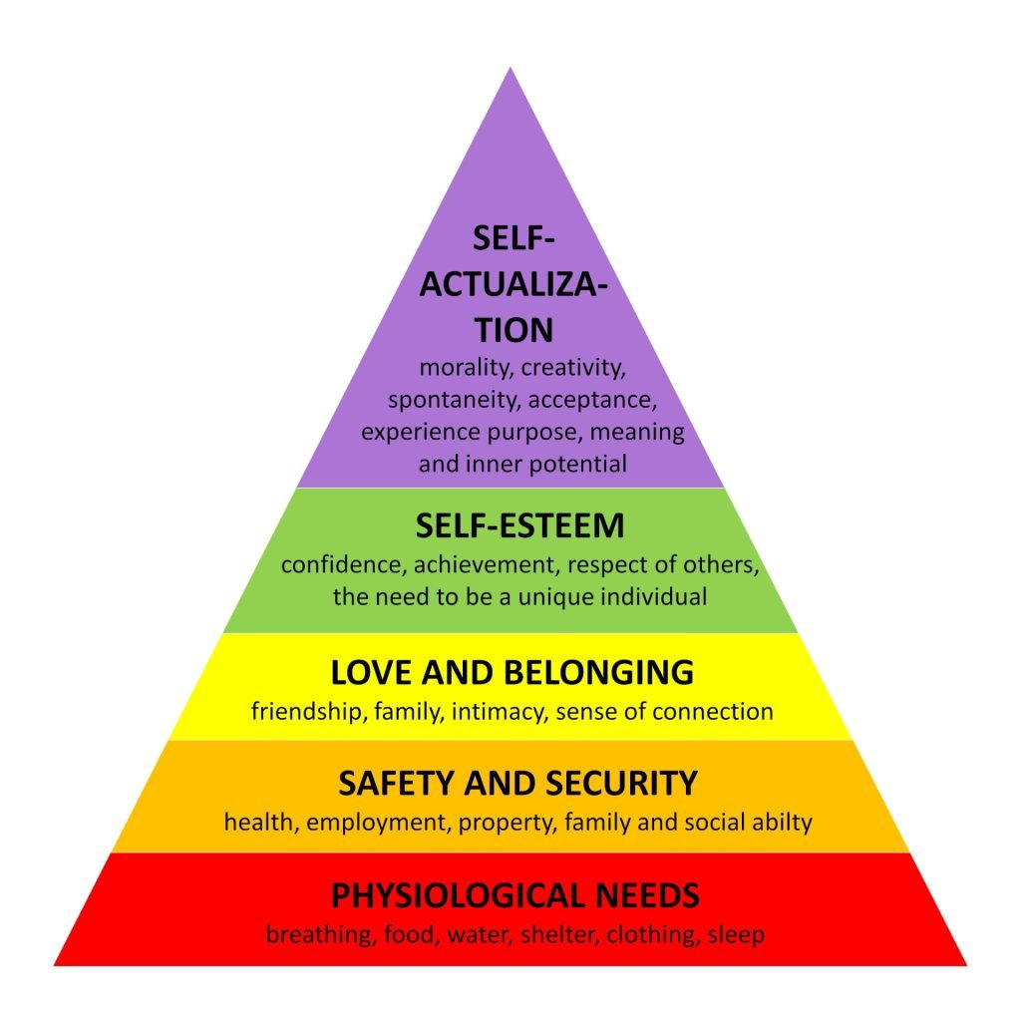
Image Source: (Mcleod, 2023).
Maslow suggested that when the physiological needs are met, individuals seek security and safety (Mcleod, 2023).
Transitions can make children feel anxious (Martinelli, 2023).
Children need support to feel safe which contributes to their emotional well-being, enabling them to form relationships and settle in a new environment (Hunter, 2023).
Bowlby’s Attachment Theory
As stated by Sheperd (2015), Bowlby’s attachment theory is based on the idea that secure attachments will enable children to have the confidence to face any situation and to effectively handle them or ask for assistance. Having secure attachments will also ensure children a more responsive and have traits of loveable people. Children will feel confident to explore their surroundings if they have an attachment figure that they can rely on when they feel anxious about their environment. For successful transitions, it is vital for children to build secure attachments with their key person (Sheperd, 2015).
A Unique Child
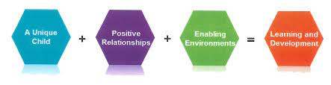
Image Source: (Playtime Day Nurseries, n.d.).
Every child is unique, as the early years foundation stage legislative framework makes clear. This implies that while some children will adjust to times of transition without any problems, others can find it difficult. It is imperative that the practitioner evaluates each child's needs in order to determine the best way to facilitate their transition. This means that transitions must be given enough time and necessitate adaptable approaches (twinkl, n.d).
Positive Relations
For children to feel safe within the setting, they will need to form relationships that are positive with the adults there. Children can receive support from a key worker during the period of transition (twinkl, n.d).
Enabling Environments
By understanding the children’s motivation and what interests them, practitioners can then support them with their learning and development. Building positive relationships with parents and carers during this time is essential. This is important as it ensures key workers have all the information about the children in their care from the parents or carers. When the period of transition starts, practitioners can then focus on any concerns raised by the parents or carers (twinkl, n.d).
Learning and Development
As stated on twinkl (n.d), the final principle of the EYFS which combines all the previous ones is crucially the learning and development of young children. Children who have special educational needs and disabilities are also included in this. This element is key as it links back to the unique child theme where it states that every child develops at a different rate to others. Before the transition stage begins, also throughout the transition period and after the initial transition period, it is vital that the practitioner understands the child's learning needs. Communication in this area will also be important, as practitioners will need to communicate with the parents and carers about their child's learning and development and with other departments, such as a special needs co-ordinator or other members of staff about the child before he or she transitions to the next year.
It is important when supporting learning and development to have clear understandings of what children can achieve within the EYFS learning areas. This can be done during the time of transition by simply talking to the child and spending time with them whilst they are playing.
Getting to know the children will help with successful transitions (twinkl, n.d).
The Role of the Adult
As stated by Essex County Council (2023), it is important for practitioners to respond to the needs and interests of each child in their care. In order to guide children's development, interactions should be warm and positive, ensuring that the provisions on offer reflect and support all the children.
Individual needs of the children should be considered, these include the interests and stages of development of each child. This vital information can then be used to plan a challenging and enjoyable experience for every child in all developmental and learning stages.
Essex County Council (2023) also states that adults must possess a solid, comprehensive understanding of child development. Practice should be based on an understanding of children's learning and development phases. this should underpin all high quality EYFS practice. In order to promote learning, it is crucial that adults set the pace for the activities and organise a variety of engaging new experiences.
The things to remember are:
Always consider the unique ways that different children learn, play, and interact.
Children's learning must continue as they transition from their homes to settings, to support this process, practitioners should gather from parents and professionals, information, and match teaching strategies to the needs of individual children.
To respect children as independent learners who need opportunities to practice, choose and own their learning (Essex County Council, 2023).
The word "teaching" encompasses a wide range of methods by which teachers assist children in learning. It includes engaging with children during planned and child-initiated activities: language modelling, demonstration; exploration; motivation; asking questions; recalling; storytelling; facilitation and posing challenges. It considers the equipment they supply, the care given to the physical surroundings, the daily schedule and structure that set expectations. Planning the next steps in learning and tracking children’s development requires practitioners to assess what the children know, comprehend, and are capable of, as well as to consider their learning styles (Essex County Council, 2023).
Young children need to be able to rely on a familiar and trustworthy key person in the setting, this is when a key person is crucial, so the child is able to cope with the transition. A child will feel safe if they are able to develop a close relationship with a key person who is there for them. In addition to planning activities and keeping track of each child's developmental progress, key persons also have a variety of other responsibilities. The primary objective of the key person is to establish a warm and caring relationship with the child by getting to know them as an individual through these activities. An important element of this is to respond to their nonverbal and verbal cues (Anna Freud, 2023).
Partnerships
A key component of the EYFS is collaborating with parents or carers. By talking to them about the early experiences of their children, practitioners can better prepare the environment for learning to occur there and assist parents in fostering their children's learning at home.
Encouraging parents to contribute is beneficial as they can understand what their child is learning, this can be done by helping during sessions, and sharing interests or cultural knowledge (Early Years Alliance, 2019).
As stated by Department for Education (n.d), research shows that by getting parents or carers involved, children can succeed in their education. An important aspect of the early year’s foundation stage is collaborating with parents and carers. The relationship may start with them visiting the setting, this will assist in determining how to settle the child into the setting.
The other ways that parents can get involved include:
- Allowing time for the child to settle in.
- Watching recordings of their child to extend learning at home.
- Attending workshops on various subjects.
- Accompanying their child on any trips.
- Home visits by staff members.
- Volunteering at the setting.
- Community initiatives for example fundraising.
- Sharing their unique life experiences.
- Getting involved by becoming parent governors (Department for Education, n.d).

Interventions
Interventions can be used to support children starting nursery for the first time. With effective communication and planning carefully, the right support can be given to children and their families (Nursery Story, 2021).
As stated on Nursery Story (2021), a child's transition to a nursery should be managed gradually. To get to know the child and learn about their routine, it is ideal to have the initial meeting with them at home. To help children settle in gradually, they can be accompanied with or without their parents for some sessions. It is also helpful to present the family with a picture of the child's primary worker during discussions about the nursery. When parents leave their children, they can become upset. By creating a 'goodbye routine" with their favourite toy can be beneficial.
Make sure the child is aware of where everything is, for example the toilets, their favourite games, and the play area. By knowing the new environment, it will alleviate any anxieties. Involving parents and communicating effectively with them may help with a smooth transition (Nursery Story, 2021).
Early Intervention Foundation (2023), states that it is important to identify any child who is at risk of a poor outcome. Early interventions mean that practitioners can identify and provide early support to avoid this from happening.
It also aids in the development of a child's personal strengths and abilities that get them ready for adulthood. Early intervention can take many different forms, such as school-based initiatives or home visits to enhance children' social and emotional development. There is evidence which shows the effectiveness of interventions can raise children's opportunities for success in life at any stage of childhood and adolescence.
Early intervention aims to strengthen a child's protective factors and decrease their risk factors. Intervention strategies focus on enhancing a child’s physical, cognitive, behavioural, social, and emotional growth for maximum impact (Early Intervention Foundation, 2023).
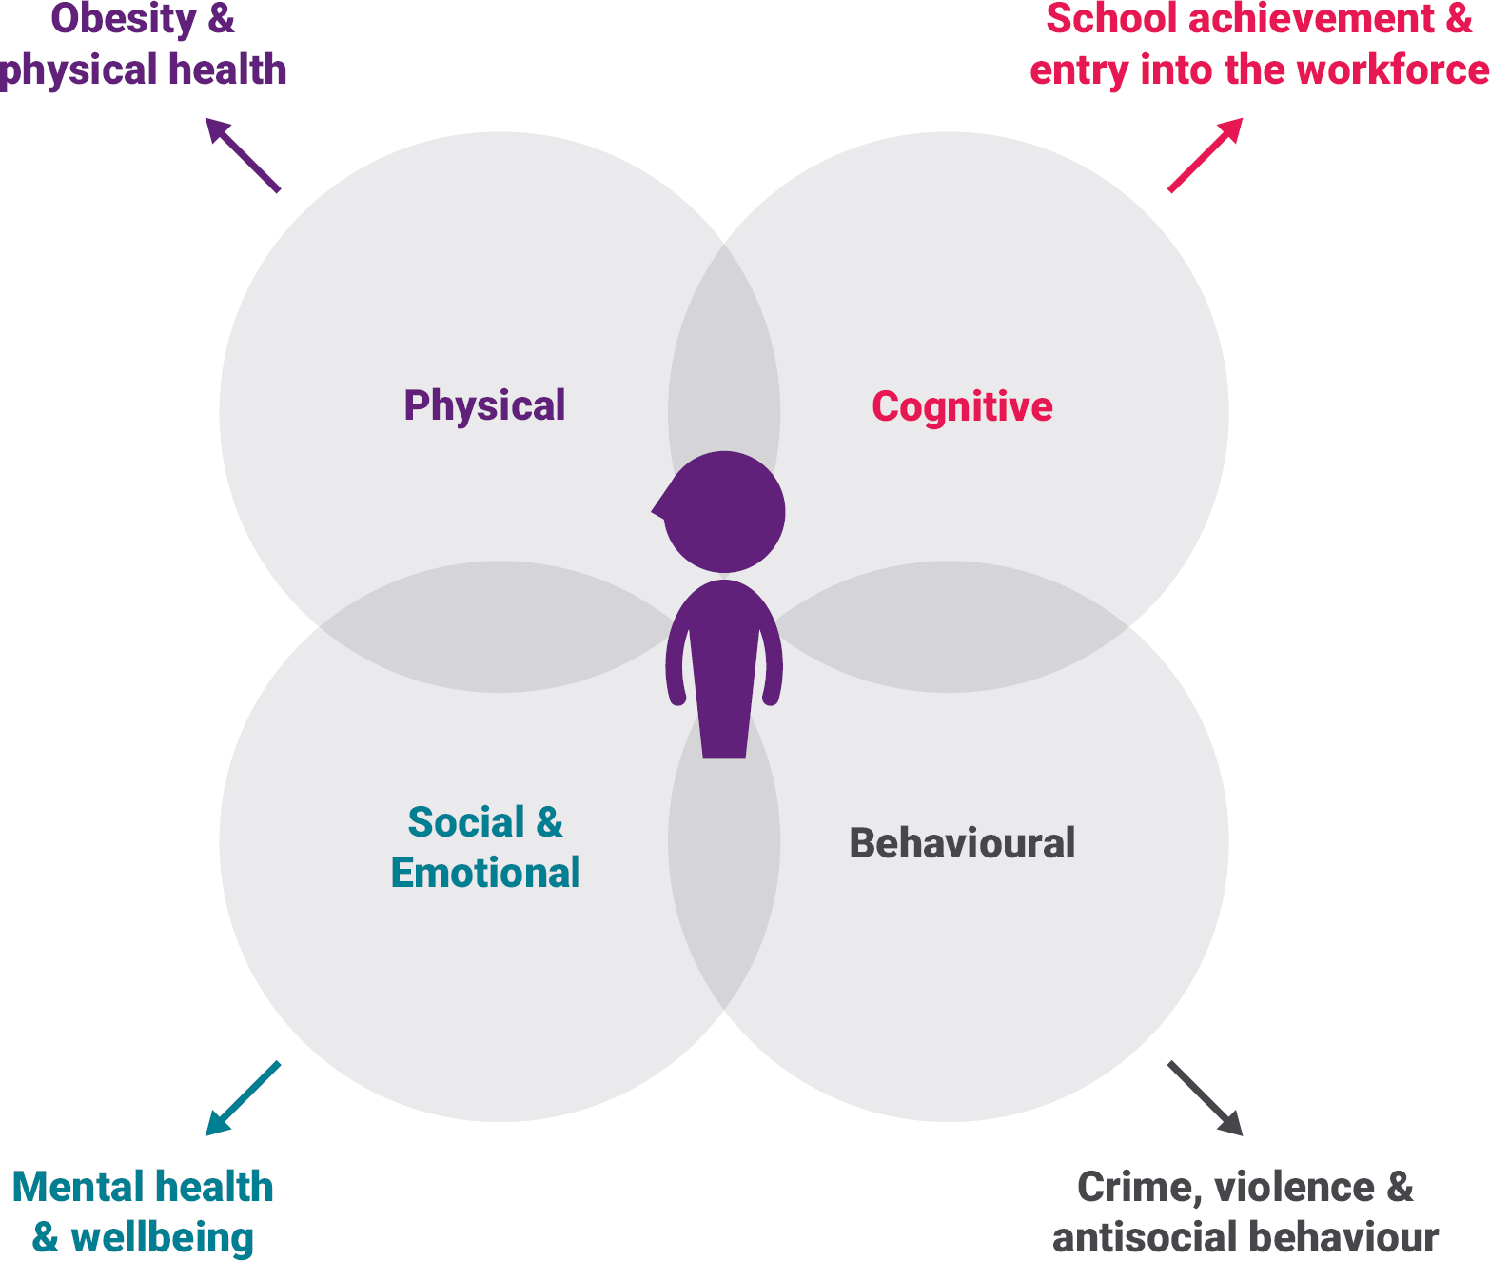

Image Source: Early Intervention Foundation, (2023).

Risk factors may impede a child's development, restrict their access to future social and economic possibilities, and raise their chances of experiencing mental and physical health issues, getting involved in crime, drug abuse, or being exploited or abused in the future. These elements interact in different ways at several levels in the child's environment, including the individual, family, community, and society levels (Early Intervention Foundation, 2023).
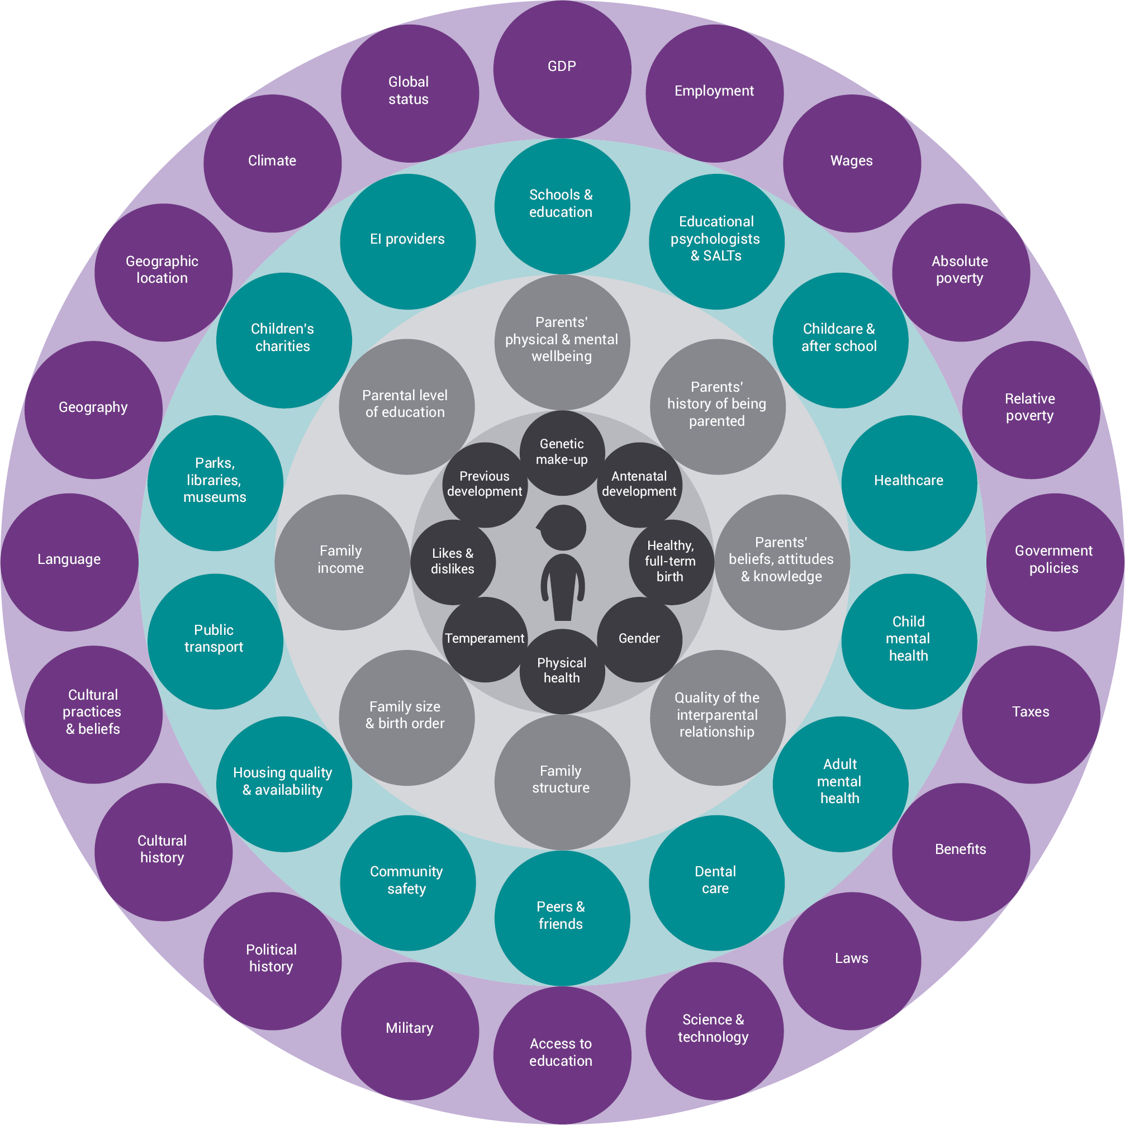

Image Source: (Early Intervention Foundation, 2023).

The risk factors do not show which children may need help; however, they can assist in identifying the children who may be vulnerable and need extra support (Early Intervention Foundation, 2023). Also stated by Nursery Story (2021), children who build a strong attachment with their key person may find transitions less stressful.
Transitions may be more difficult for some children than for others, and they may require extra support. Practitioners should give these children enough notice when something is going to change, whether it consists of moving to a new room or to a new activity. Communication can be aided by visual cues like a storyboard or transitional object (Nursery Story, 2021).
The Proposed Outcomes
There is a certain amount of flexibility within our setting during transitions based on each individual child, such as a staggered start or parents accompanying their child at the beginning of a session for a while. In our setting parents or carers can speak with their child’s key person in the morning before the session starts or when they come to collect their children at the end of the day. We also have three parent’s evenings a year to discuss the children’s progress with their parents.
The proposed outcomes for children transitioning from home to nursery for the first time include successful transitions when the needs of the child are met. Collaborating between parent’s practitioners and other professionals is crucial to establish the best possible outcome for the child. The EYFS framework emphasises the role of the key person in working in partnership with others to support these transitions. The use of effective interventions that are tailored to the individual needs and developmental stage of each child is crucial. When these factors are combined, meeting individual needs, effective communication, partnership working and appropriate interventions, a smooth and positive transition from home to nursery is facilitated, fostering the child’s well-being and . developmental progress.

References
Anna Freud (2023) Relationship with a key person. Available at: https://www.annafreud.org/resources/under-fives-wellbeing/common-difficulties/relationship-with-the-key-person-in-a-childcare-setting/ (Accessed: 3 December 2023).
Birth To 5 Matters (n.d) Transitions. Available at: https://birthto5matters.org.uk/transitions/#:~:text=Transitions%20include%20not%20just%20movements,in%20the%20course%20of%20the (Accessed: 25 November 2023).
Confident Parents Confident Kids (2014) New Early Childhood Transitions Support [Drawing]. Available at: https://confidentparentsconfidentkids.org/2014/03/06/new-early-childhood-transitions-support/ (Accessed: 26 November 2023).
Department for Education (n.d) Meeting the needs of all children. Available at: https://help-for-early-years-providers.education.gov.uk/get-help-to-improve-your-practice/meeting-the-needs-of-all-children (Accessed: 15 November 2023).
Department for Education (n.d) Working in partnership with parents and carers. Available at: https://help-for-early-years-providers.education.gov.uk/get-help-to-improve-your-practice/working-in-partnership-with-parents-and-carers#:~:text=It's%20about%20working%20together%20to,best%20to%20support%20their%20learning. (Accessed: 23 November 2023).
Devon County Council (2022) Transition in the early years: Guidance for schools and settings. Available at: https://www.devon.gov.uk/support-schools-settings/inclusion/transition/transition-in-the-early-years/ (Accessed: 15 November 2023).
Early Intervention Foundation (2023) What is early intervention?. Available at: https://www.eif.org.uk/why-it-matters/what-is-early-intervention (Accessed: 1 December 2023.
Early Years Alliance (2019) Involving parents in their children's learning. Available at: https://www.eyalliance.org.uk/involving-parents-their-children%E2%80%99s-learning#:~:text=Working%20in%20partnership%20with%20parents,children's%20learning%20development%20at%20home. (Accessed: 24 November 2023).
Early Years Matters (2023) Transitions. Available at: https://www.earlyyearsmatters.co.uk/eyfs/positive-relationships/transitions/ (Accessed: 19 November 2023).
Essex County Council (2023) Role of the adult. Available at: https://eycp.essex.gov.uk/the-early-years-foundation-stage/how-do-i-become-an-outstanding-practitioner/role-of-the-adult/#:~:text=Support%20and%20facilitate%20learning,children%20learn%2C%20play%20and%20interact. (Accessed: 20 November 2023).
Hunter, C. (2023) Examples of nurturing – How to create a supportive environment in Early Years. Available at: https://www.teachearlyyears.com/learning-and-development/view/nurturing-environments. (Accessed: 5 December 2023).
Lochrie, P. (2023) Smooth Transitions in the Early Years: A Good Practice Guide. Available at: https://www.oxfordshire.gov.uk/sites/default/files/file/childrens-social-care/EYTransitionPack.pdf (Accessed: 4 December 2023).
Martinelli, K. (2023) Why Do Kids Have Trouble with Transitions. Available at: https://childmind.org/article/why-do-kids-have-trouble-with-transitions/#:~:text=If%20they've%20had%20an,child%20lash%20out%20in%20anger. (Accessed: 5 December 2023).
Mcleod, S. (2023) Maslow's Hierarchy of Needs. Available at: https://www.simplypsychology.org/maslow.html#:~:text=There%20are%20five%20levels%20in,esteem%2C%20and%20self%2Dactualization. (Accessed: 4 December 2023).
Nursery Story (2021) Supporting Children and Parents with Transitions. Available at: https://nurserystory.co.uk/resource-centre/supporting-children-and-parents-with-transitions/ (Accessed: 2 December 2023.
Pathak, R. (2021) Examples of nurturing – How to create a supportive environment in Early Years. Available at: https://htschool.hindustantimes.com/editorsdesk/knowledge-vine/maslows-hierarchy-of-needs-here-is-what-parents-need-to-know (Accessed: 5 December 2023).
Playtime Day Nurseries (n.d) EYFS Summary. Available at: https://playtimedaynurseries.co.uk/curriculum-eyfs (Accessed: 20 November 2023).
Public Health England (2014) Improving the home to school transition. Available at: https://assets.publishing.service.gov.uk/media/5a7ed72140f0b6230268bde8/Briefing1b_Home_to_school_health_inequalities.pdf (Accessed: 10 December 2023).
Sheperd, C. (2015) Pacey. Available at: https://www.pacey.org.uk/Pacey/media/Website-files/school%20ready/PG10-transitions-and-settling-in.pdf (Accessed: 8 December 2023).
The Educator Magazine (2017) Managing Transitions in Early Years. Available at: https://www.the-educator.org/managing-transitions-early-years/(Accessed: 28 November 2023).
twinkl (n.d) Why is Transition Important in Early Years. Available at: https://www.twinkl.co.uk/blog/why-is-transition-important-in-early-years (Accessed: 23 November 2023).
UNICEF (n.d) The Convention on the Rights of the Child: The children’s version. Available at: https://www.unicef.org/child-rights-convention/convention-text-childrens-version (Accessed: 3 December 2023).

