JIAYING HE
2208747
Strategic Analysis and Sustainable Strategy Development
An Strategic Analysis of Unilever

Executive Summary
This report provides an in-depth study of the strategic position of global FMCG giant Unilever. Through PESTEL analysis, external factors present challenges such as political instability, economic pressures and legal regulations, but also show the potential opportunities in technological and environmental areas. The more micro analysis about Porter's Five Forces theory reveals intense competition and strong bargaining power of buyers, a moderate threat of substitutes and suppliers, and a weak risk from new entrants.
From the internal factors, Unilever has sustainable competitive advantages in terms of brand equity and R&D. However, it also faces weaknesses such as raw material price volatility and over-reliance on third-party logistics in certain regions.
Strategically, Unilever uses a hybrid strategy that combines cost leadership, differentiation and regional focus for growth, and its recent M&A activity has focused on high-growth areas, aligning with its strategic goals.
Sustainability is a key focus of its growth, and the company has taken various initiatives on the environmental and social areas. However, it also faces challenges such as rising costs and the risk of 'greenwashing', needing further tactics.
The conclusion is that Unilever is in a relatively positive strategic position but with both opportunities and risks. Thus, strategic management is critical for its growth. To thrive, Unilever should expand its sustainability-driven markets, embrace agility and compatibility while promoting sustainable product innovation.
Table of Contents
Executive Summary 1
1. Introduction 3
2. External Factors 4
3. Internal Factors 9
4. Strategy Formulation & Competitive Positioning 13
5. Sustainability & Strategic Recommendations 14
6. Conclusion 18
References 19
Appendices 29

- Introduction
Unilever is a one of the world's largest multi-national FMCG company based in the UK and the Netherland, with more than 400 brands from different sectors. As a global leader in the FMCG industry, Unilever sells its products across 190 countries, impacting the lives of more than 2.5 billion consumers every day through its extensive a global reach (Cheng, 2021).
Strategic analysis of Unilever is critical because the global FMCG industry requires it to respond agilely to changing market trends, consumer preferences and macroeconomic challenges (Kpoku, 2021). In addition, under the increasing sustainable development requirements and the wave of digital transformation (Korada, 2024), Unilever needs to continuously optimize its strategy to ensure market competitiveness.
Currently, Unilever is facing challenges including rising costs led by global inflation and supply chain crises (Basu, 2023), fierce market competition from major competitors such as P&G and Nestle, and sustainable development pressure including new regulations and consumers concerns (Hu and Zeng, 2024). Thus, it is necessary to adopt an in-depth analysis within today’s global context. This report is going to analyse the external and internal environment of Unilever and to better understand the gaps and strengths of its current strategy, and further explore the path to the strategic and sustainable growth in the future based on various models, dedicating to provide helpful takeaways for stakeholders.

- External Factors
It is important to study the external environment of the firm because uncontrollable factors can affect organizational behaviour and its direction (Buye, 2021). The PESTEL model is an effective tool used to analyse the external environment. The purpose is to examine what is happening in the wider business environment, helping organizations to consider all the important factors that could affect business strategies (Effendi and Putro, 2023). The PESTEL analysis for Unilever is as follows.
Table 1
To summarize, based on the six factors above, the challenges Unilever face is mainly including political uncertainty, economic pressures, tightening regulations, and environmental sustainability requirements, which may affect its costs on supply chain and market competitiveness (Unilever PLC, 2024). However, technological factors and social trends like health-conscious and sustainable products present opportunities. The key is to flexibly respond to changes in the external environment through optimizing cost structures and brand differentiation, as well as leveraging technology to increase market penetration for long-term growth.
Although PESTLE can provide a macro view of the external environment in a multidimensional way, some scholars like Buye (2021), argue that it lacks an in-depth analysis of an enterprise's internal resources and capabilities, which cannot directly generate a competitive advantage analysis. Thus, a more micro perspective should also be incorporated. Porter's Five Forces model is a suitable framework, which is strategic planning tool widely used in company analysis to assess the competitive structure of their industry (Burra & Ushadevi, 2022). The micro-market is closer to us and offers more controllable elements containing many external stakeholder groups including competitors, suppliers, customers, etc., The analysis of them will help the company understand the strengths and weaknesses of its current and future competitive position.

Table 2
The analysis of Unilever's five forces suggests that Unilever faces fierce competition (TBH, 2024), and bargaining power of buyers (BPB) is also high as consumers have access to substitutes and online price comparison. The study from Olubukola (2024) confirms the positive correlation between BPB and FMCG innovation, where in a competitive market and under the pressure of consumer empowerment, companies must innovate to stand out. This dynamic validates the need for Unilever to prioritize brand differentiation and customer retention strategies. Essentially, increased BPB is both a market pressure and a catalyst for innovation, resulting in a strategic cycle where consumer bargaining power drives product upgrades to remain competitive.
Other factors like the threat of substitutes and new entrants are moderate because Unilever's brand loyalty limits significant change, which is an established fact for industry giants. Supplier power is also moderate with potential challenges, but Unilever reduces risk through integration and long-term contracts (Lieu et al., 2021). Therefore, Unilever need to strategically prioritize competition and the bargaining power of buyers, as well as to maintain a stable supplier relationship and market position.
As a static model, Porter's five forces model provides a snapshot of the industry at a given time. This is useful for developing short-term strategies, which is convinced by mass applications, but researchers including Beattie (2022) have questioned that its applicability has narrowed due to the rapid evolution of external factors. Therefore, continuous updates and other models’ aids are needed for its immediacy.

- Internal Factors
By the context external analysis provides for strategic growth, internal analysis really focuses on the core of the business. Internal factors include everything within the company’s control, which can affect how a company meets its objectives. The resource-based view (RBV) is a model that see resources are the key to business performance, which are categorized as tangible and intangible resources. If a resource shows VRIO (Valuable, Rare, Inimitable, Organized) attributes, then this resource enables a firm to gain and maintain a sustained competitive advantage (Mahdi & Nassar, 2021). However, the limitation of this model is that the criterion of is difficult to quantify, causing inaccuracy. Although scholars Murcia et al. (2022) have provided theoretical framework to quantify VRIO model, its application is complex with multiple parameters, so this report will only apply basic mechanism in Picture 1.
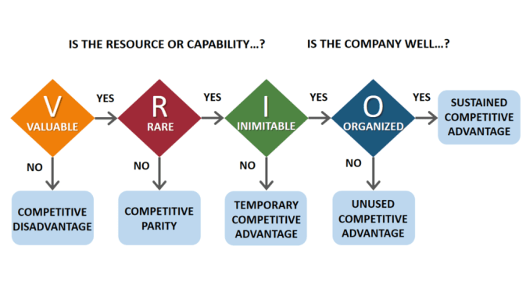
Picture 1
Table 3

Unilever's sustainable competitive advantage lies in brand equity and R&D innovation, as these are deeply rooted in its market positioning and are difficult for competitors to replicate. This is also the explanation of the weak threats of substitutes and new entrants in Five Forces analysis, demonstrating the interactive effect of internal competitiveness and external factors.
Global distribution and sustainable supply chains provide temporary advantages, but they are increasingly being imitated by industry rivals. Digital marketing, while essential, does not offer a unique advantage due to its widespread adoption. Blockchain tracking system is an emerging strategy, which could be a strength in the future if integrated effectively (Natarajan et al., 2021). These selected internal factors are actually summarized from another tool called Value Chain Analysis, which presents the whole process of business operation. It is argued to be a useful tool to assess the company's competitive advantages (Stobierski, 2020), but during practical applications, it did not present more information outside the fundamental workflow of production. Thus, the report uses it as a base for VRIO analysis rather than detailed analysis, which is proved to be effective in driving useful information.
In order to integrate the internal and external analysis, a phased summary is necessary. SWOT can be a useful tool, which is a framework used to help a company identify the strengths, weaknesses, opportunities and threats associated with business competition (Benzaghta et al., 2021). The TOWS Matrix, as a further step, can be seen as an extension of the SWOT process, shaping the actions to be taken of key areas, which often be shown as a more comprehensive presentation of business situations (Đalić et al., 2021). Therefore, the report adopts TOWS to analyse Unilever as follows.
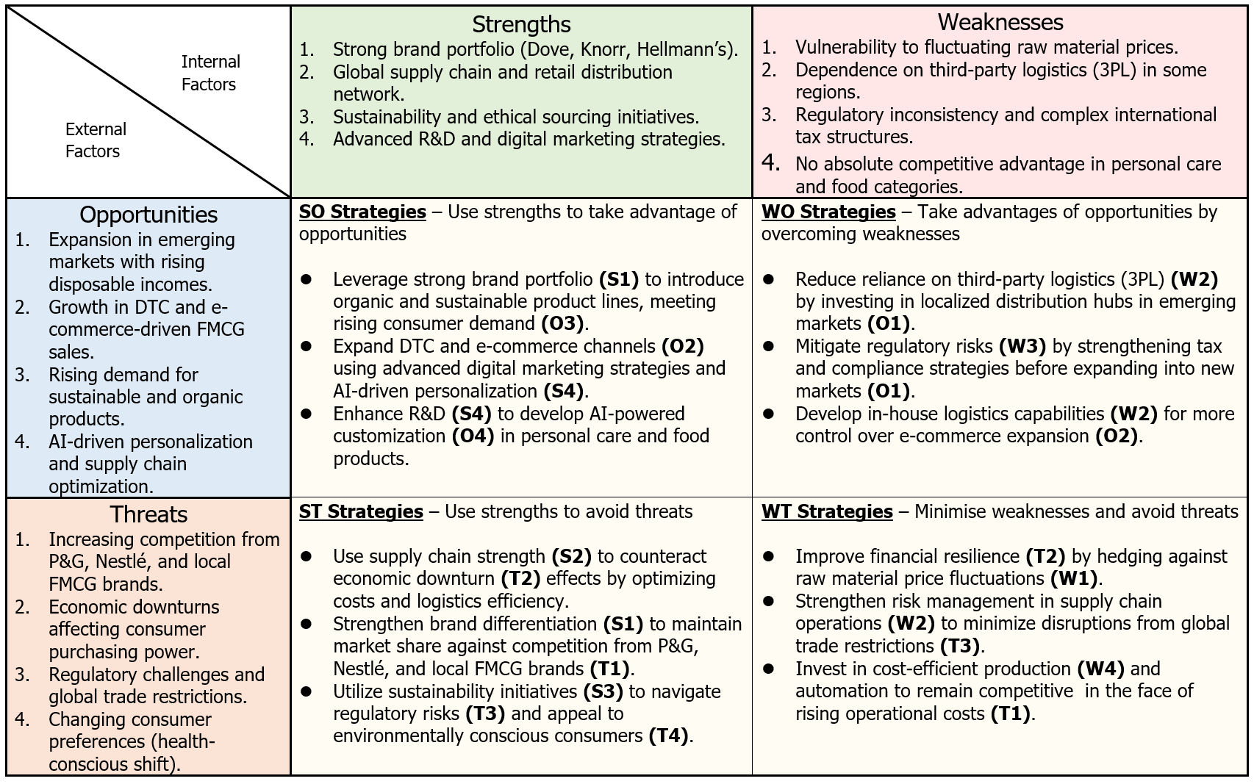
Table 4
Unilever's TOWS analysis reveals a strategic approach that builds on its strengths while addressing internal weaknesses and external threats. By leveraging its strong brand portfolio and digital marketing expertise, Unilever can enhance its strengths and catch emerging opportunities driven by technology advancement. However, its reliance on third-party logistics and vulnerability to raw material price fluctuations require it to strengthen supply chain control and financial resilience. Investments in cost-effective production and automation will also help mitigate global economic uncertainty and maintain long-term competitive advantage (Aithal, 2023).
Overall, the situation Unilever faces are complex and multifaceted, requiring comprehensive strategic considerations including cost and differentiation, and given the high weight of sustainability in the TOWS analysis, subsequent analysis process also should incorporate related factors.
- Strategy Formulation & Competitive Positioning
During planning further strategy development, it is necessary to review the current strategy situation and market positioning. Porter's generic strategy is a strategic framework that identifies three core approaches that firms can use to gain competitive advantage.
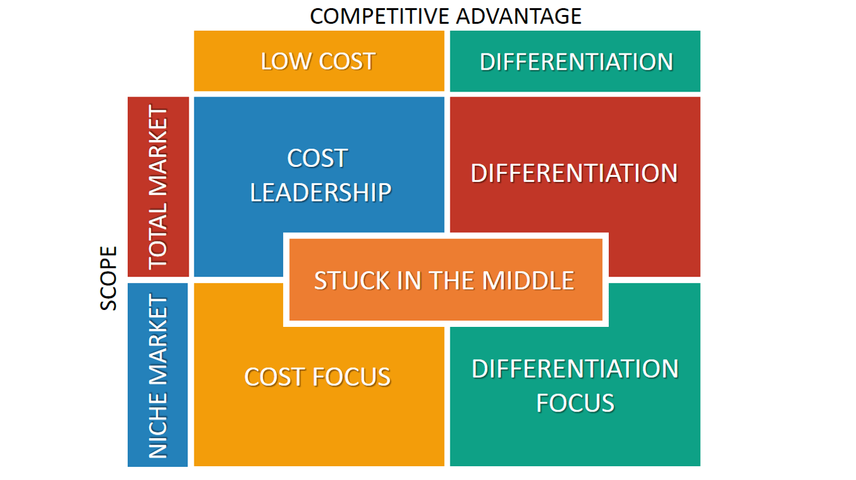
Picture 2
These strategies help firms to position themselves in the market based on cost, differentiation and focus on specific market segments (Ateljević et al., 2023), but sometimes more complex strategy can be adopted in real world, especially for international FMCG giants like Unilever, so it is just a simplified model for references.
For most of the studies, Unilever is classified as Differentiation strategy user including Lieu et al. (2021), with Alhosseiny (2023) proving that Differentiation strategy achieved the highest market share. However, when combining ideas from Ismaeel and Alsariera (2023), a hybrid strategy is a better description that balances Cost Leadership with an emphasis on promoting brand innovation and sustainable differentiation (Table 6). This combination ensures broad consumer appeal, market resilience and long-term competitive advantage. In addition, it has selectively adopted the Focus Strategy in localized areas to expand market coverage (Unilever PLC, 2025).
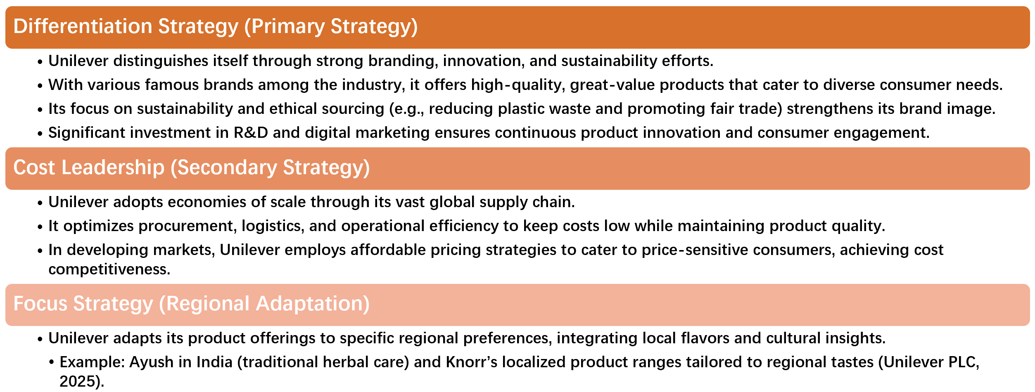
Table 5
Additionally, Unilever's M&A activities also reflect its hybrid growth strategy:
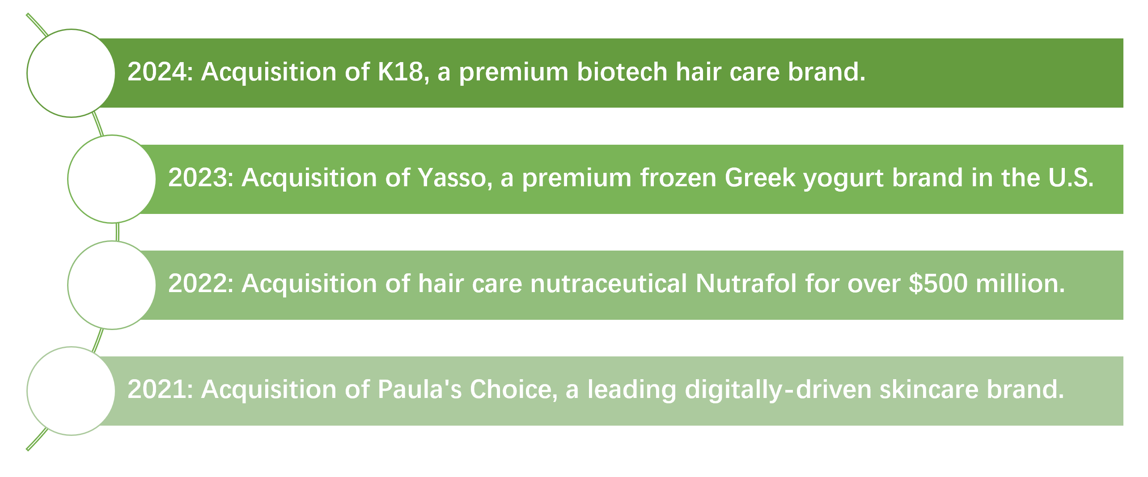
Table 6
The core of its strategy is to acquire established brands through acquisitions, on the one hand, to focus its resources on high-margin markets, such as beauty, health food and high-end ice cream, to efficiently differentiate itself from traditional FMCG. On the other hand, avoiding the capital to innovate from scratch (Bradt and Pritchett, 2022) facilitates the creation of a price advantage under cost leadership strategy.
Similarly, in the Ansoff Matrix, Unilever has adopted a hybrid strategy that includes expansion in both existing and new markets & products (Evatt, 2023), resulting in an ambiguous positioning, so no more discussions here, but turn to the more worthwhile sustainability section.
- Sustainability & Strategic Recommendations
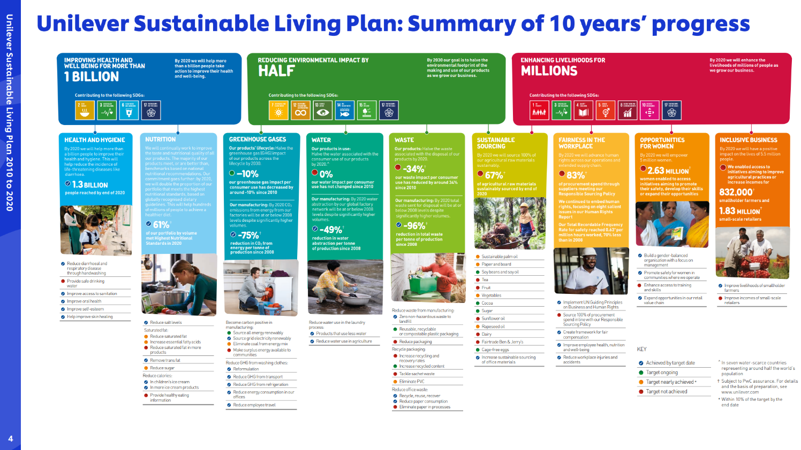
Unilever has always been at the forefront of sustainable development with its Sustainable Living Programme (USLP) (2010-2020) and Compass Strategy (2021 to present). Its progress in recent years can be found in the Unilever Sustainable Living Plan: Summary of 10 years' progress, published on the official website 2021.
Picture 3
Its key initiatives in recent years can be divided into two parts. Environmentally, it strives to halve virgin plastic use by 2025 and net-zero emissions along the entire value chain by 2039 (Segal, 2024), and has achieved 97.5% deforestation-free in its sourcing of key commodities (McMillan, 2024). Socially, it puts efforts on fair living wage and employee well-being, and also stands as a benchmark for age, gender and ethnicity diversity with 50% of managerial roles represented by women after 2018 (Savoy, 2021).
The Unilever Sustainability Initiative is strategically significant. For consumers, ethical appeal strengthens brand loyalty (Kotler & Keller, 2022). For investors, sustainable brand excellence enhances ESG investment attractiveness. For competitors, Unilever also differentiates itself through sustainable product innovation.
While sustainability is a competitive advantage, it also poses financial and operational challenges: In terms of cost pressures, green supply chain and ESG programmes increase operating costs due to ethical sourcing, renewable energy investments and packaging innovations. Mitigating these risks will require Unilever to offset higher costs by investing in sustainable productivity and leveraging economies of scale. Secondly, reliance on third party suppliers creates sustainability compliance risks. Unilever can manage this risk through rigorous supplier audits, blockchain transparency programmes and long-term sourcing partnerships. Regulatory risks posed by evolving global sustainability laws also require proactive policy engagement and adaptation by Unilever. Lastly, if sustainability claims are not substantiated, there is a risk of being accused of “greenwashing” by consumers (Shanor & Light, 2022), which further emphasises the importance of supply chain transparency.
To address the above risks and help Unilever improve its strategic positioning in line with environmental and social sustainability, this report makes the following recommendations.

Table 7
From the previous analysis, the external PESTLE and Porter's Five Forces analyses help to identify the impact of the general environment and industry dynamics on the sustainability strategy, and the recommendations on green product innovation and digital transformation are based on the internal VRIO resource analysis. Combined with the strategy analysis, Unilever should stick to its current strategy, while considering the use of sustainable planning for market expansion and adopt actions in the TOWS to work on transforming sustainable advantages into competitiveness.

- Conclusion
In summary, this report provides an overall strategic analysis of global FMCG giant Unilever. The external analysis through PESTEL reveals challenges such as political and economic uncertainty, but also opportunities presented by technology and changing consumer trends. The Porter's Five Forces analysis shows intense competition and strong buyer power, but new entrants face high barriers. Internally, Unilever has sustainable competitive advantages in brand equity and R&D, with other key advantages needing optimization, with TOWS linking internal strengths and weaknesses to external opportunities and threats. Strategically, Unilever employs a mix of cost leadership, differentiation and focus strategies with balanced growth of targeted M&A. Sustainability is the core of its strategic focus. Despite leading in both environmental and social initiatives, potential risks need addressing by adaptation and tactics.
Overall, strategic management is critical for Unilever to navigate the sustainable business environment, which requires external agility, internal compatibility and a focus on sustainability to remain competitive (2172 words).

References
Abir, M. M. (2024). From Strategy to Execution: Optimizing Territory’s Sales Effectively at Unilever Pureit Bangladesh.
Ahmed, M. (2024). The Impact of Workforce Diversity on Organizational Performance: A Case Study of Unilever. iRAPA International Journal of Business Studies, 1(1), pp. 18-33.
Aithal, P. S. (2023). Enhancing Industrial Automation through Efficient Technology Management in Society. International Journal of Applied Engineering and Management Letters (IJAEML), 7(4), pp. 184-215.
Alhosseiny, H. (2023). How Do Porter’s Business-Level Strategies Affect Competitive Advantage in the Food and Beverage Industries?. Journal of Entrepreneurship Education.
Allied Market Research (2024) Anti Aging Products Market Size & Share, trends: Forecast 2033, Allied Market Research. Available at: https://www.alliedmarketresearch.com/anti-aging-products-market-A06331 (Accessed: 05 March 2025).
Altuntas Vural, C., Balci, G., Surucu Balci, E., & Gocer, A. (2024). Looking inside the panarchy: reorganisation capabilities for food supply chain resilience against geopolitical crises. Supply Chain Management: An International Journal, 30(7), pp. 1-19.
Ateljević, J., Kulović, D., Đoković, F., & Bavčić, M. (2023). Business strategy and competitive advantage: A reinterpretation of Michael Porter’s work. Routledge.
Bahadur, A. (2025) The rise of D2C (direct-to-consumer) in FMCG, LinkedIn. Available at: https://www.linkedin.com/pulse/rise-d2c-direct-to-consumer-fmcg-atharva-bahadur-x0gsc/ (Accessed: 06 March 2025).
Baragiola, G., & Mauri, M. (2021). SDGs and the private sector: Unilever and P&G case studies.
Basu, R. (2023). Managing Global Supply Chains: Contemporary Global Challenges in Supply Chain Management (3rd ed.). Routledge. https://doi.org/10.4324/9781003341352
Beattie, A. (2022) The pitfalls of Porter’s Five forces, Investopedia. Available at: https://www.investopedia.com/articles/investing/103116/pitfalls-porters-5-forces.asp (Accessed: 19 March 2025).
Benzaghta, M. A., Elwalda, A., Mousa, M. M., Erkan, I., & Rahman, M. (2021). SWOT analysis applications: An integrative literature review. Journal of Global Business Insights, 6(1), pp. 54-72.
Bradt, G. B., & Pritchett, J. P. (2022). The Merger & Acquisition Leader's Playbook: A Practical Guide to Integrating Organizations, Executing Strategy, and Driving New Growth After M&A Or Private Equity Deals. John Wiley & Sons.
Brennan, T. et al. (2023) Building Food and Agriculture Businesses for a green future, McKinsey & Company. Available at: https://www.mckinsey.com/industries/agriculture/our-insights/building-food-and-agriculture-businesses-for-a-green-future (Accessed: 09 March 2025).
Burra, N. J., & Ushadevi, K. N. (2022). Porter’s Five Forces Analysis of Zanzibar’s Seaweed Industry. Asian Journal of Agricultural Extension, Economics & Sociology, 40(11), pp. 185-196.
Buye, R. (2021). Critical examination of the PESTEL Analysis Model. Project: Action Research for Development.
Cheng, Y. (2021). Analysis on the Opportunities and Challenges of Unilever’s Differentiated Competition by Using SWOT and PEST. In 6th International Conference on Economics, Management, Law and Education (EMLE 2020) (pp. 280-284). Atlantis Press.
Chepkorir, G. (2023). Cultural Adaptation Strategies in the Market Penetration by Unilever Kenya Ltd (Doctoral dissertation, University of Nairobi).
cHow Unilever is building a diverse & inclusive culture, Savoy. Available at: https://savoynetwork.com/how-unilever-is-building-a-diverse-inclusive-culture/ (Accessed: 09 March 2025).
Đalić, I., Stević, Ž., Ateljević, J., Turskis, Z., Zavadskas, E. K., & Mardani, A. (2021). A novel integrated MCDM-SWOT-TOWS model for the strategic decision analysis in transportation company. Facta Universitatis, Series: Mechanical Engineering, 19(3), pp. 401-422.
Dang Khanh, G. (2024). Integrating Environmental, Social and Governance Factors into Strategic Management: A Comparative Case Study of Unilever and Neste.
Dekimpe, M. G., & van Heerde, H. J. (2023). Retailing in times of soaring inflation: What we know, what we don't know, and a research agenda. Journal of Retailing, 99(3), pp. 322-336.
Effendi, M., & Putro, U. S. (2023). Enhancing Adaro’s Transformation Strategy for Business Diversification: The Aluminium Smelter Project. European Journal of Business and Management Research, 8(5), pp. 37-47.
Evatt, M. (2023) Unilever goes cloud-only with Accenture and Microsoft, ERP Today. Available at: https://erp.today/unilever-goes-cloud-only-with-accenture-and-microsoft/ (Accessed: 08 March 2025).
Fair Wage Network (2021) Unilever case study, Fair Wage Network. Available at: https://fair-wage.com/case-study-unilever-2/ (Accessed: 09 March 2025).
FSA (2023) Packaging and labelling, Food Standards Agency - Packaging and labelling. Available at: https://www.food.gov.uk/business-guidance/packaging-and-labelling (Accessed: 05 March 2025).
Ganepola, T. (2022). A Comprehensive Literature Review on Global and Local Marketing Strategies Adopted by Various Industries. Available at SSRN 4307736.
Govindarajan, V., & Venkatraman, V. (2024). Fusion Strategy: How Real-time Data and AI Will Power the Industrial Future. Harvard Business Press.
Hu, Y., & Zeng, Y. (2024). Achieving Sustainable Operations: Challenges, Countermeasures, and the Case of Unilever. In SHS Web of Conferences (Vol. 181, p. 01036). EDP Sciences. https://doi.org/10.1051/shsconf/202418101036
Hufnagel, G., Schwaiger, M., & Weritz, L. (2022). Seeking the perfect price: Consumer responses to personalized price discrimination in e-commerce. Journal of Business Research, 143, pp. 346-365.
Ismaeel, B., & Alsariera, W. (2023). The Effect of Marketing Effectiveness, and Consumer Behaviour on Consumer Purchase Preference for Unilever Products in Jordan. International Journal of Academic Research in Business and Social Sciences, 13(7), 1014-1032.
Keller, K. L., & Kotler, P. (2022). Branding in B2B firms. In Handbook of business-to-business marketing (pp. 205-224). Edward Elgar Publishing.
Khan, M. R., Khan, M. R., & Nallaluthan, K. (2023). Blockchain Supply Chain Management and Supply Chain Sustainability. In Blockchain Driven Supply Chain Management: A Multi-dimensional Perspective (pp. 155-180). Singapore: Springer Nature Singapore.
Kissinger, D. (2024) Unilever Five Forces Analysis & Recommendations (Porter Model), Panmore Institute. Available at: https://panmore.com/unilever-five-forces-analysis-porters-model-recommendations (Accessed: 06 March 2025).
Kopnina, H., Padfield, R., & Mylan, J. (2023). Environmental challenges. In Sustainable Business (pp. 55-79). Routledge.
Korada, L. (2024). Digital Transformation Balanced with Sustainability Goals. Journal of Engineering and Applied Sciences Technology. SRC/JEAST-E106. DOI: doi. org/10.47363/JEAST/2024 (6) E106 J Eng App Sci Technol, 6(5), pp. 2-7.
Kpoku, O. K. (2021). Positive and negative influence of globalization on international business actors’ activity (on materials of Unilever Group) (Doctoral dissertation).
Kpoku, O. K. (2021). Positive and negative influence of globalization on international business actors’ activity (on materials of Unilever Group) (Doctoral dissertation).
Küster, S. C. (2022). Strategic Business Models: Analysis of Vertically Integrated Quick Commerce Business Models Operating in the Grocery Retail Industry in Europe: Introduction of Revenue Models Through Surcharges, Assortment, and Subscription and the Analysis of the Cost Structure and Revenue Stream in the Business Model Canvas (Master's thesis, Universidade NOVA de Lisboa (Portugal)).
Lieu, P. T. H., Arunjit, N., Buapradabkul, S., & Nathaniel, D. (2021). Unilever Company Strategic Business Analysis.
Mahdi, O. R., & Nassar, I. A. (2021). The business model of sustainable competitive advantage through strategic leadership capabilities and knowledge management processes to overcome covid-19 pandemic. Sustainability, 13(17), pp. 9891.
Maione, G. (2024). Convergence of Artificial Intelligence and Sustainable Innovation Reporting. In Sustainable Innovation Reporting and Emerging Technologies (pp. 29-48). Emerald Publishing Limited.
Mason, T., & Jarvis, S. (2023). Omnichannel retail: How to build winning stores in a digital world. Kogan Page Publishers.
McMillan, A. (2024) How Unilever is using its supply chain to protect nature, Procurement Magazine. Available at: https://procurementmag.com/sustainability/how-unilever-is-using-its-supply-chain-to-protect-nature (Accessed: 09 March 2025).
Moskal, A. (2022). Digital markets act (DMA): a consumer protection perspective. European Papers, 7(3), pp. 1113-1119.
Murcia, N. N., Ferreira, F. A., & Ferreira, J. J. (2022). Enhancing strategic management using a “quantified VRIO”: Adding value with the MCDA approach. Technological Forecasting and Social Change, 174, 121251.
Narcin, S. B. (2022). Biomaterials in cosmetics and personal care industry: a comprehensive literature review and case studies.
Natarajan, G., Ng, E., & Katina, P. (2021). Blockchain Technology and digital supply chains: towards revolutionizing the industry of the future. In Proceedings of the International Annual Conference of the American Society for Engineering Management.
Natarajan, G., Ng, E., & Katina, P. (2021). Blockchain Technology and digital supply chains: towards revolutionizing the industry of the future. In Proceedings of the International Annual Conference of the American Society for Engineering Management.
Nygaard, A. (2024). Green promotion and marketing communication. In Green Marketing and Entrepreneurship (pp. 63-81). Cham: Springer International Publishing.
Olubukola, O. J. (2024) “THE INFLUENCE OF BUYER BARGAINING POWER AND COST LEADERSHIP STRATEGY ON INNOVATION WITHIN NIGERIA'S CONSUMER GOODS INDUSTRY,” International Journal of Management Science and Business Analysis Research Published by Cambridge Research and Publications IJMSBAR: E-ISSN 3027-1711 P-ISSN 3026-81681Vol. 3 No. 7.
Patel, K. R. (2023). Harmonizing sustainability, functionality, and cost: navigating responsible packaging innovations in modern supply chains. American Journal of Economic and Management Business (AJEMB), 2(8), pp. 287-300.
Phelan, A. A., Meissner, K., Humphrey, J., & Ross, H. (2022). Plastic pollution and packaging: Corporate commitments and actions from the food and beverage sector. Journal of Cleaner Production, 331, pp. 129827.
PwC (2023) 69% of consumers hold back on non-essential spend as cost of living rises; 90% adopt cost-saving behaviours: PWC consumer insights survey, PwC’s February 2023 Global Consumer Insights Pulse Survey. Available at: https://www.pwc.com/gx/en/news-room/press-releases/2023/global-consumer-insights-pulse-survey-february-2023.html (Accessed: 05 March 2025).
Qavami, H. (2023). Evaluating the Effect of Value Added Tax on the Performance of Enterprises (Case Study: Manufacturing and Service Industries in the Khorasan Provinces). Journal of Business and Economic Policy, p. 9.
Segal, M. (2024) Unilever sets new goals to cut value chain emissions by 2030, ESG Today. Available at: https://www.esgtoday.com/unilever-sets-new-goals-to-cut-value-chain-emissions-by-2030/ (Accessed: 09 March 2025).
Selvarajan, G. P. (2021). Harnessing AI-Driven Data Mining for Predictive Insights: A Framework for Enhancing Decision-Making in Dynamic Data Environments. International Journal of Creative Research Thoughts, 9(2), pp. 5476-5486.
Shanor, A., & Light, S. E. (2022). Greenwashing and the first amendment. Columbia Law Review, 122(7), pp. 2033-2118.
Statista (2021) Largest global advertisers 2021 | statista, Statista. Available at: https://www.statista.com/statistics/286448/largest-global-advertisers/ (Accessed: 07 March 2025).
Stobierski, T. (2020) What is a value chain analysis? 3 steps: HBS Online, Harvard Business School Onlin - Business Insights Blog. Available at: https://online.hbs.edu/blog/post/what-is-value-chain-analysis (Accessed: 07 March 2025).
Stockdale, O., Prabhala, P. and Brennan, T. (2024) Revitalizing fields and balance sheets through regenerative farming, McKinsey & Company. Available at: https://www.mckinsey.com/industries/agriculture/our-insights/revitalizing-fields-and-balance-sheets-through-regenerative-farming (Accessed: 09 March 2025).
Tazvivinga, K., & Pooe, D. (2024). Supply chain disruptions in the fast-moving consumer goods industry. Journal of Transport and Supply Chain Management, 18, pp. 1-9.
TBH (2024) Top 9 Unilever competitors in 2024: A market analysis, The Brand Hopper. Available at: https://thebrandhopper.com/2024/08/19/top-9-unilever-competitors-in-2024-a-market-analysis/ (Accessed: 06 March 2025).
Tuten, T. L. (2022). Principles of marketing for a digital age. Sage Publications
UK Parliament (2025) Employment rights bill 2024-25: Progress of the bill, House of Commons Library. Available at: https://commonslibrary.parliament.uk/research-briefings/cbp-10174 (Accessed: 05 March 2025).
Unilever PLC (2023) Unilever Global, Unilever. Available at: https://www.unilever.com/ (Accessed: 05 March 2025).
Unilever PLC (2024) Working with suppliers to beat the clock on climate change, Unilever. Available at: https://www.unilever.com/news/news-search/2021/working-with-suppliers-to-beat-the-clock-on-climate-change/ (Accessed: 06 March 2025).
Unilever PLC (2025) Innovation in Unilever, Unilever. Available at: https://www.hul.co.in/our-company/rd-innovation/innovation-in-unilever/ (Accessed: 07 March 2025).
Vyshnavi, P. and Bajj, A. (2024) Magnum Ice Cream Marketing Strategy, StartupTalky. Available at: https://startuptalky.com/magnum-marketing-strategy/ (Accessed: 08 March 2025).
XPDEL (2024) How FMCG companies are improving operations with 3PL services, XPDEL. Available at: https://xpdel.com/blog/how-fmcg-companies-are-improving-operations-with-3pl-services/ (Accessed: 06 March 2025).
Yen, J. T., & Blome, C. Glocal sourcing: How to Combine Global and Local Sourcing.
Zugay, B., & Zakaria, R. (2023). Ansoff matrix. SAGE Publications, Inc.

Appendices
Table 1 PESTLE Analysis of Unilever 5
Table 2 Porter’s Five Forces Analysis of Unilever 7
Table 3 VRIO Analysis of Unilever 10
Table 5 SWOT Analysis of Unilever 12
Table 6 Porter's Generic Strategy of Unilever 14
Table 8 Unilever M&A in the last 5 years 14
Table 9 Recommendations on Strategic Planning 17

Picture 1 VRIO Illustration 9
Picture 2 Porter’s Generic Strategy Illustration 13
Picture 3 Unilever Sustainable Living Plan: Summary of 10 years' progress 15

