LCHS4001 Referencing Activity - Journal Articles
Look at the first part of this journal article and answer the questions below:
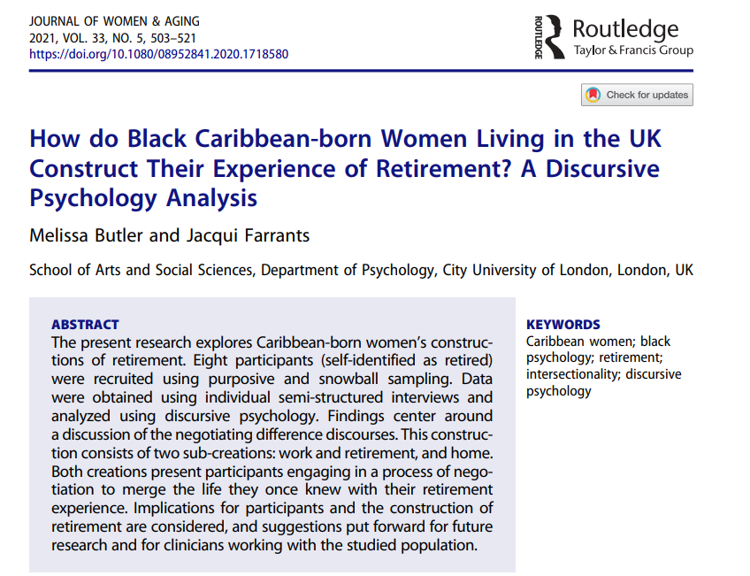
Who are the authors of the journal article?
When was the article published?
What is the title of the journal article?

What is the title of the journal?
What is the issue information i.e. what is the number of the volume and the issue (part).
What are the page numbers of this article?

Here is a reference for another article in UWTSD Harvard format. Can you answer the same questions, below:
Femi-Ajao, O., Kendal, S. and Lovell, K. (2020) ‘A qualitative systematic review of published work on disclosure and help-seeking for domestic violence and abuse among women from ethnic minority populations in the UK’, Ethnicity & health, 25(5), pp. 732–746. Available at: https://doi.org/10.1080/13557858.2018.1447652.
Who are the authors of the journal article?
When was the article published?
What is the title of the journal article?

What is the title of the journal?
What is the issue information i.e. what is the number of the volume and the issue (part).
What are the page numbers of this article?

Here is the UWTSD Harvard format for a journal article (from CiteThemRightOnline). Write out the reference for the article on the previous page. Follow the format exactly, including all the commas, dots, inverted commas etc.

Surname, Initial. (Year of publication) 'Title of article', Title of Journal, Issue information, Page reference. Available at: DOI.

