
APPENDIX GA36c

LEVEL 6 ASSESSMENT SPECIFICATION

Student name: | David Jordan | Student ID number:
Programme:
Module: | Usability Engineering
Module code: | ACCB6017 | Contribution to Overall Module Assessment (%): | 50%
Lecturer: | Pauline Greenaway | Internal Verifier: | Gaynor Thomas
Assignment Title: | Prototyping & Testing | Word count (or equivalent): | 3000
Submission deadline: | 24/3/23 | Return date of provisional marks & written feedback: | TBA
Submission method: | All written assessments, where practical and possible, must be submitted via Turnitin unless otherwise instructed by the Lecturer. (Please DO NOT put this assessment specification into Turnitin or it will match many similarities with other students’ submissions.)  Alternative submission method (if applicable):  Late submission of the assessment will result in a late penalty mark. Penalties for late submission: Up to one week late, maximum mark of 40%. Over one week late, 0%. Only the Extenuating Circumstances Panel may approve a change to submission dates.
Academic honesty / referencing: | Academic honesty is required. In the main body of your submission you must give credit to authors on whose research and ideas your work is based. Append to your submission a reference list that indicates the books, articles, etc. that you have used, cited or quoted in order to complete this assessment.
Module Learning Outcomes
(from module syllabus)
Upon the successful completion of this module, the student should be able to:
- Research and evaluate cognitive and social information processing
- Select, apply and analyse critically techniques of interface evaluation
- Synthesize a solution to a complex design problem from the concepts and principles of usability engineering and software development
- Critically analyse, individually and as part of a team exercise, input and output hardware appropriate for specialised applications, for example for use by disabled people, and for three-dimensional modelling applications

TASK DESCRIPTION

Task 1
Twitter (2006) and Mastodon (2016) are two short-form messaging applications. On both systems, users can publish short messages (which may include images) to their followers, who may in turn “like” them, forward them to their own followers, or message the original author. Due to the recent changes at Twitter many users have decided to delete their accounts and move to Mastodon instead.

After downloading and using these applications, write a short report that discusses the following issues:

- How do the applications use psychology, usability, and design to engage and maintain user interest in the conversation space?
- What user experience lessons has Mastodon learned from Twitter and how does it make itself appealing to its target audience?
- How do the differences between the applications provide different social experiences for their users?
The report should include appropriate illustrations and references to research literature (8-10 references are sufficient, and at least two thirds of these should be books/journal papers).

Your submission should be presented in the form of a report that includes the following sections:
- (15%) A (very!) brief description of the applications, including similarities and differences in their mechanics and interfaces.
- (15%) Consideration of the target user groups for the applications. Is there any overlap or potential to encourage users of one application to migrate to the other?
- (40%) What elements of psychology, usability, design and copyrighting are significant and how these interact to provide an emotionally satisfying user experience?
- (20%) Are there any elements that don’t work? If a user of one application decides to try the other application then what elements are likely to feel comfortable or uncomfortable? Are there any features that might be missed?

The final 10% will be awarded for document presentation and appropriate references to the research literature.

The report should be submitted through Turnitin. Do not submit the assignment brief document with this.

Task 2

The boardgame CLUEDO is familiar to many as one that requires players to move their pieces around a board that represents a country mansion, finding clues that will help them solve the murder of Dr Black.
You are to design a UWTSD version of this as a computer game.

“Oh no! The Vice-Chancellor has been murdered! Who did it?”

You may set the game on any or all of the university campuses, and may include up to 8 players who should represent different parts of the university. This task represents your initial user research and design ideas for the game interface. In the next assignment you will develop your ideas further into a full colour design.

You should submit a report containing the following:
- A set of four detailed personas with associated scenarios and an indication of the main user and experience requirements relating to each persona;
- An appropriate information architecture for your game with justification for its structure;
- An initial set of wireframe storyboards;
- A description of the process used to collect feedback on your storyboard prototypes and a summary of the positive and negative feedback elicited.
The report should include appropriate illustrations and references to research literature (at least two thirds of these should be books/journal papers).

Your submission should be presented in the form of a report that includes the following sections:
- (20%) Who are your test personas? What are their user and experience requirements? Remember that students are not all able-bodied 18-21 year olds living in the Swansea area.
- (20%) How did you gather information to support the design of your personas? Discuss the results of any focus groups you held to elicit this information. Lists of user and experience requirements, categorised using the MoSCoW criteria, should be provided in an appendix.
- (20%) What information is necessary for the game to be a success? How does this need to be structured to make it easy to use? What information is location-sensitive, and how does this fit into the app?
- (20%) Storyboards should be wireframe only, rather than full colour design. They should show all of the major functionality of the app at a size appropriate for a mobile phone, and should take all of the usual aspects of interaction design theory into account in the design. The complete set of storyboards should be presented in an appendix but significant elements such as the main screen designs should be discussed in the main body of the report. These can be created using any suitable software; Adobe XD is a good choice for this, but other packages are fine provided that you remember to show not only the screens but how the user moves between the screens.
- (10%) How did you collect feedback on your prototypes? How did you ensure that your test subjects covered the range of personas you defined earlier? What feedback did you get, both in terms of usability and of emotional response? Were these what you expected and, if not, why not?

The final 10% will be awarded for document presentation and appropriate references to the research literature.

The report should be submitted through Turnitin. Do not submit the assignment brief document with this.

GUIDANCE FOR Students IN THE COMPLETION OF TASKS

NOTE: The guidance offered below is linked to the five generic assessment criteria overleaf.

- Engagement with Literature Skills
Your work must be informed and supported by scholarly material that is relevant to and focused on the task(s) set; you should make use of scholarly reviews and primary sources, where appropriate (for example, refereed research articles and/or original materials appropriate to the discipline). You should provide evidence that you have accessed a wide range of sources, which may be academic, governmental and industrial; these sources may include academic journal articles, textbooks, current news articles, organisational documents, and websites. You should consider the credibility of your sources; academic journals are normally highly credible sources while websites require careful consideration/selection and should be used sparingly. Any sources you use should be current and up-to-date, mostly published within the last five years or so, though seminal/important works in the field may be older. You must provide evidence of your research/own reading throughout your work, using a suitable referencing system, including in-text citations in the main body of your work and a reference list at the end of your work.

Guidance specific to this assessment: Task 1: Remember that although you should present your opinions of the user interface, you should justify those opinions with reference to the relevant areas of the literature. Task 2: Remember to justify your choices for the design with reference to research literature.

- Knowledge and Understanding Skills
At level 6, you should be able to demonstrate coherent and detailed knowledge and a systematic understanding of the subject area, at least some of which is informed by the latest research and/or advanced scholarship within the discipline. You should be aware of the uncertainty, ambiguity and limits of knowledge. Your work must demonstrate the growing extent of your knowledge and systematic understanding of concepts and underlying principles associated with the subject area. Knowledge relates to the facts, information and skills you have acquired through your learning. You demonstrate your understanding by interpreting the meaning of the facts and information (knowledge). This means that you need to select and include in your work the concepts, techniques, models, theories, etc. appropriate to the task(s) set. You should be able to explain the theories, concepts, etc. meaningfully to show your understanding. Your mark/grade will also depend upon the extent to which you demonstrate your knowledge and understanding; ideally each should be complete and detailed, with comprehensive coverage.

Guidance specific to this assessment: Task 1: Consider the elements of the interfaces and of the gameplay – what works, what doesn’t work, and why? Task 2: Not applicable.

- Cognitive and Intellectual Skills
You should be able to: critically evaluate evidence, arguments, assumptions, abstract concepts and data some of which are at the forefront of a discipline (and that may be incomplete) to devise and sustain arguments, to make judgements and/or solve problems; describe and comment upon particular aspects of current research, or equivalent advanced scholarship, in the discipline Your work must contain evidence of logical, analytical thinking, evaluation and synthesis. For example, to examine and break information down into parts, make inferences, compile, compare and contrast information. This means not just describing what! But also justifying: Why? How? When? Who? Where? At what cost? At all times, you must provide justification for your arguments and judgements. Evidence that you have reflected upon the ideas of others within the subject area is crucial to you providing a reasoned and informed debate within your work. Furthermore, you should provide evidence that you are able to make sound judgements and convincing arguments using data and concepts. Sound, valid conclusions are necessary and must be derived from the content of your work. Where relevant, alternative solutions and recommendations may be proposed.

Guidance specific to this assessment: Task 1: How transferrable are skills learned between the two games? Task 2: You should produce appropriately detailed personas and use these to help guide your information architecture design.

- Practical Skills
At level 6, you should be able to apply the methods and techniques that you have learned to review, consolidate, extend and apply your knowledge and understanding, and to initiate and carry out projects. You will deploy accurately established techniques of analysis and enquiry relevant to the discipline, and apply them in complex and unpredictable contexts, to devise and sustain arguments and/or to solve problems. You should be able to frame appropriate questions to achieve a solution - or identify a range of solutions. You should be able to demonstrate how the subject-related concepts and ideas relate to real world situations and/or a particular context. How do they work in practice? You will deploy models, methods, techniques, and/or theories, in that context or circumstances, to assess current situations, perhaps to formulate plans or solutions to solve problems, or to create artefacts, some of which may be innovative and creative. This is likely to involve, for instance, the use of real world artefacts, examples and cases, the application of a model within an organisation and/or benchmarking one theory or organisation against others based on stated criteria. You should show awareness of the limitations of concepts and theories when applied in particular contexts.

Guidance specific to this assessment: Task 1: Not applicable. Task 2: You should produce a full interface for this prototype design, using an appropriate workplace tool. This should be tested with real users rather than simply relying upon designer tests. Remember that you can perform user tests via Zoom or Teams.

- Transferable Skills for Life and Professional Practice
Your work must provide evidence of the qualities and transferable skills necessary for graduate-level employment requiring the exercise of initiative and personal responsibility and decision-making in complex and unpredictable circumstances. This includes demonstrating: the learning ability for professional development to advance existing skills and acquire new competences of a professional nature that will enable you to assume significant responsibility within organisations; that you can initiate and complete tasks and procedures, whether individually and/or collaboratively; that you can use appropriate media to effectively communicate information, arguments and analysis in a variety of forms to specialist and non-specialist audiences; fluency of expression; clarity and effectiveness in presentation and organisation. Work should be coherent and well-structured in presentation and organisation.

Guidance specific to this assessment: Tasks 1 and 2: This is a report, not a paper, so no abstract is needed. Ensure that your report looks professional. You should show how you’re using common professional techniques like task analysis effectively. Remember to write the report in an academic manner with numerical referencing, correct captioning of illustrations, appropriate technical English.

Student FEEDBACK FORM

This section details the extent to which the assessment criteria are demonstrated by you, which in turn determines your mark. The marks available for each category of skill are shown. Lecturers will use the space provided to comment on the achievement of the task(s), including those areas in which you have performed well and areas that would benefit from development/improvement.

Generic Assessment Criteria | Marks available | Marks  awarded
1. Engagement with Literature Skills
.
Brief description of Twitter and Mastadon provided with inclusion of consideration of target user groups. Reference made to relevant literature in most areas of your discussion with the exception of user satisfaction. However, this discussion could have been more detailed. Relevant psychological, usability and design concepts applied in relating to both platforms. Application of usability design rules relating to Dix have been included as a framework with some synthesis of those relating to other theorists such as Shneiderman, Nielsen and Norman into the discussion, highlighting similarities and differences although this could have been more extensive. More extensive reference should have been made to usability design rules/principles in your explanations of the main wireframe screens. |  | 18
 | 30 | 18
2. Knowledge and Understanding Skills

 | 0
3. Cognitive and Intellectual Skills

 | 0
4. Practical Application Skills

As instructed, four test personas have been developed resulting from your focus group feedback with MOSCOW criteria applied in relation to user expectations. Wireframes have been produced using Adobe XD, with navigation clearly applied. Designs are comprehensive in nature although you should have proofread them carefully to ensure no typographical errors are included. Heuristic evaluation applied using relevant user personas, however, you state earlier in your report that cognitive walkthrough applied, but no evidence of this. Key issues from the feedback have been identified. |  | 37
 | 50 | 37
5. Transferable Skills for Life and Professional Practice

Front page and table of contents included but no introductory/concluding paragraphs.  Detailed flow chart provided outlining the processes and decisions required to complete the game successfully. No HTA nor sitemap provided. |  | 11
 | 20 | 11

Assessment Mark (Assessment marks are subject to ratification at the Exam Board. These comments and marks are to give feedback on module work and are for guidance only until they are confirmed. ) | Late Submission Penalties (tick if appropriate) |  | 66%
 | Up to 1 week late (40% Max) |  | 66%
 | Over 1 week late (0%) |  | 66%

GENERIC ASSESSMENT CRITERIA

Level 6
In accordance with the Framework for Higher Education Qualifications, at the end of Level 6 students should have coherent and detailed knowledge and a systematic understanding of their subject area, at least some of which is informed by the latest research and/or advanced scholarship within the discipline. They will be able to accurately deploy established techniques of analysis and enquiry within a discipline, using their conceptual understanding to devise and sustain arguments and/or to solve problems. They should be aware of the uncertainty, ambiguity and limits of knowledge. They should be able to critically evaluate evidence, arguments, assumptions, abstract concepts and data (that may be incomplete), to make judgements, and to frame appropriate questions to achieve a solution - or identify a range of solutions. They will apply the methods and techniques that they have learned to review, consolidate, extend and apply their knowledge and understanding, and to initiate and carry out projects. They will have the ability to manage their own learning, and to make use of scholarly reviews and primary sources (for example, refereed research articles and/or original materials appropriate to the discipline). They will demonstrate the qualities and transferable skills necessary for employment requiring: the exercise of initiative and personal responsibility; decision-making in complex and unpredictable contexts; the learning ability needed to undertake appropriate further training of a professional or equivalent nature.

Level 6 | FAIL | MARGINAL FAIL | SATISFACTORY  (3rd / Pass) | GOOD  (2.2 / Pass) | VERY GOOD  (2.1 / Merit) | EXCELLENT  (1st / Distinction) | EXCEPTIONAL  (1st / Distinction)
Category | 0-29% | 30-39% | 40-49% | 50-59% | 60-69% | 70-84% | 85-100%
Engagement with literature (including reading, referencing,  academic conventions and  academic honesty) | Little or no evidence of reading and/or reliance on inappropriate sources.  Views and findings mostly unsupported and non-authoritative.  Referencing conventions used incoherently or largely absent. | Poor engagement with essential reading. No evidence of wider reading. Reliance on inappropriate sources, and/or indiscriminate use of sources. Heavily reliant on information gained through class contact. Inconsistent and weak use of referencing. | Engagement with a limited range of mostly relevant and credible sources. Some omissions and minor errors.  Referencing conventions evident though not always applied accurately or consistently. | Engagement with an appropriate range of research-informed literature, including sources retrieved independently. Some over-reliance on texts. Referencing may show minor inaccuracies or inconsistencies. | Engagement with a wide range of research-informed literature, including sources retrieved independently.  Selection of relevant and credible sources. Very good use of referencing, with no/very few inaccuracies or inconsistencies. | Engagement with an extensive range of relevant and credible literature, informed by the latest research. Consistently accurate application of referencing. | Exceptional engagement with an extensive range of relevant and credible literature, informed by the latest research. High-level referencing skills consistently and professionally applied.
Knowledge and understanding (Coherent and detailed knowledge and systematic understanding of the subject area, at least some of which is informed by the latest research and/or advanced scholarship within the discipline.) | Major gaps in knowledge and systematic understanding of the subject matter. Substantial inaccuracies. No awareness of knowledge of the latest research and/or advanced scholarship within the discipline. | Gaps in knowledge, with only superficial systematic understanding. Some significant inaccuracies and/or irrelevant material. No awareness of knowledge of the latest research and/or advanced scholarship within the discipline. | Limited knowledge and systematic understanding of the relevant concepts and principles within the subject area which to some limited extent, is informed by current research and scholarship. | Knowledge is reasonably detailed, accurate with a good systematic understanding of the field of study and to some extent, current research and scholarship. | Knowledge is reasonably extensive coherent and detailed. Exhibits very good understanding of the breadth and depth of established views, and the work is, at least in part, well-informed by current research and scholarship. | Excellent coherent and detailed knowledge and systematic understanding of the principles and theories of current research and scholarship. Clear awareness of challenges to established views and the limitations of the knowledge base. | Exceptionally coherent and detailed knowledge and systematic understanding of the principles and theories of the subject, well-informed by current research and scholarship. A critical, sophisticated and nuanced awareness of the ambiguities and limitations of knowledge.
Cognitive and intellectual skills  (Conceptual and critical thinking, analysis, synthesis and evaluation of research, assumptions, abstract concepts and data (that may be incomplete); logic, argument and judgement.) | Wholly or almost wholly descriptive work. Little or no analysis, synthesis or evaluation.  Failure to develop arguments, leading to illogical or invalid judgements. Unsubstantiated generalisations, made without use of any credible evidence. | Largely descriptive work, with superficial use of critical evaluation. Weak development of arguments and judgements. Information accepted uncritically, uses generalised statements made with scant evidence and unsubstantiated opinions. Ideas sometimes illogical and contradictory. | Limited attempt at critical thinking, analysis, synthesis and evaluation, tending towards description.  Some evidence to support emerging arguments and judgements but these may be underdeveloped or with a little inconsistency / mis-interpretation.  Asserts rather than argues a case. | Some critical thinking, analysis, synthesis and evaluation. Can analyse new and/or abstract concepts and data without guidance.  An emerging awareness of different stances and ability to use evidence (that may be incomplete) to support the argument.  Mostly valid arguments and logical judgements. Some tendency to assert/state opinion rather than argue on the basis of reason and evidence. | Sound critical thinking, analysis, synthesis and evaluation demonstrating critical thinking. Ability to devise and sustain persuasive arguments, and to review the reliability, validity and significance of evidence (that may be incomplete) to make mostly appropriate and valid judgements. | Excellent critical thinking, analysis, synthesis and evaluation. Ability to investigate contradictory or incomplete information and make strong, persuasive, arguments and sophisticated judgements. Some evidence of independent thought and ability to ‘see beyond the question’, suggesting a grasp of the broader field and wider concepts. | Exceptional critical thinking, analysis, synthesis and evaluation based on judiciously selected evidence.  Ability to investigate contradictory or incomplete information and make strong, persuasive, arguments and sophisticated, nuanced, judgements. Evidence of independent thought and ability to ‘see beyond the question’, suggesting an outstanding grasp of the broader field and wider concepts.
Practical skills  (Apply/deploy accurately established tools and techniques; initiate and carry out projects; formulate solutions to solve problems in complex and unpredictable contexts.) | Limited or no use of methods, materials, tools and/or techniques.  Little or no appreciation of the context of the application.  Limited understanding of the application of theory to practice or making appropriate links between the two.  Very weak problem-solving skills in complex and unpredictable contexts. | Rudimentary application of methods, materials, tools and/or techniques but without consideration and competence. Flawed appreciation of the context of the application.  Weak understanding of the application of theory to practice, with only occasional evidence of making appropriate links between the two. Weak problem-solving skills in complex and unpredictable contexts. | An adequate awareness and mostly appropriate application of well-established methods, materials, tools and/or techniques.  Basic appreciation of the context of the application. Theoretical knowledge and understanding applied in practice, but not always making logical links between the two.  Can identify problems and propose basic solutions in complex and unpredictable contexts without fully appreciating the complexity. | A good and appropriate application of standard methods, materials, tools and/or techniques.  Clear appreciation of the context of the application. Mainly consistent, accurate and logical application of theory to practice, making appropriate links between the two  Can identify problems and propose mostly appropriate solutions in complex and unpredictable contexts. | A very good application of a range of methods, materials, tools and/or techniques.  Very good consideration of the context of the application, with perceptive insights. Can identify problems and propose appropriate solutions in complex and unpredictable contexts.  Evidence of some innovation and creativity. | An advanced application of a range of methods, materials, tools and/or techniques.  The context of the application is well considered, and insightful.  Application and deployment extend beyond established conventions. Can identify complex problems and propose excellent solutions. Innovation and creativity evident. | Exceptional levels of application and deployment skills in unpredictable, practical contexts, drawing skilfully on the latest research within the discipline. Can identify complex problems and propose sophisticated solutions. Assimilation and development of cutting edge processes and techniques.
Transferable skills for life and professional practice  (Exercise of initiative and personal responsibility; professional development; initiate and complete tasks and procedures: individually and/or collaboratively; use appropriate media to communicate effectively; fluency of expression; clarity and effectiveness in presentation and organisation.) | Communication medium is inappropriate or misapplied.  Work is poorly structured, disorganised and/or confusingly expressed. Very weak use of language and/or very inappropriate style. Little or no evidence of autonomy (or collaboration, where relevant) in the completion of tasks. Little or no evidence of the skills required in graduate employment. | Communication medium is poorly designed and/or not suitable for the audience.  Work is poorly presented in a disjointed manner. It is loosely, and at times incoherently, structured, with information and ideas often poorly expressed. Weak use of language and/or inappropriate style. Weak independent initiative (or collaboration, if relevant). Limited evidence of the skills required in graduate employment. | Can communicate in a suitable medium but with some room for improvement.  Mostly ordered presentation and structure in which relevant ideas / concepts are reasonably expressed. Work may lack coherence in places. Can work as part of a team, but with limited involvement in group activities.  Demonstrates the basic skills required in graduate employment, with some areas of minor weakness. | Can communicate effectively in a suitable format, but may have minor errors.  Mostly coherent, organised work, in a suitable structure and is for the most part clearly expressed. Can work effectively independently and/or as part of a team, with clear contribution to group activities.  Demonstrates the skills required in graduate employment, with some areas of strength and some of minor weakness. | Can communicate well, confidently and consistently in a suitable format.  Work is coherent, fluent, well-structured and organised. Can work very well autonomously and/or as part of a team, with very good contribution to group activities.  Demonstrates very good graduate employment skills, with just occasional minor weakness. | Can communicate professionally confidently and consistently in a suitable format.  Work is coherent, very fluent and is presented professionally. Can work autonomously with initiative. Where relevant can work professionally within a team, showing leadership skills as appropriate, managing conflict and meeting obligations. Demonstrates excellent graduate employment skills and an appetite for further development. | Can communicate with an exceptionally high level of professionalism.  Work is exceptionally coherent, very fluent and is presented professionally. Can work exceptionally well and professionally within a team, showing advanced leadership skills. Demonstrates exceptional graduate employment skills and an appetite for further development.

THIS DOCUMENT IS ALSO AVAILABLE IN WELSH

fad-lc
S.I.H.E.
GA36c Level 6

Contents
Brief description of the applications 2
Target User Groups 3
Psychology, Usability and Design 3
Learnability 4
Flexibility 4
Robustness 4
User Satisfaction 5
Test Personas 6
Application Concepts 7
Cognitive walkthrough and Flow chart 7
Design 8
Start and Main Menu 9
Rules 9
Player Select 10
Game board 10
Clues 11
Intrigue 11
Mystery 12
Conclusion 12
Feedback 13
References 14
Appendix 15
Flow Chart for a Cluedo Game 16
Storyboard 17
Heuristic evaluations 17

Brief description of the applications

Twitter (1) and Mastodon (2) are microblogging social media sites allowing individuals to interact with a global community. Twitter was founded in 2006, and Mastodon in 2016 and initially appeared to be very similar applications, but before twitters change in leadership, Mastodon was seldom spoken of. At a glance, both sites follow a similar layout as shown in figures one and two; both have logging options, search functions and menus for accessibility. In addition, the mastodon page layout almost mirrors its predecessor with a centralised main feed and menu panels to the left and right with similar enfaces on the use of negative space.

The fundamental difference between the 2 is their implementation, where Twitter follows a centralised model, and Mastodon implements a decentralised model. Where Twitter is managed by a central hub which can control and censor data and its distribution, such as advertisements and trending threads, Mastodon users create individual server groups called instances, which that user manages. This implies that the user is responsible for their instance. Unlike Twitter, any users who are unhappy or offended by the server's content must ignore it rather than request the moderators remove it (3&4).

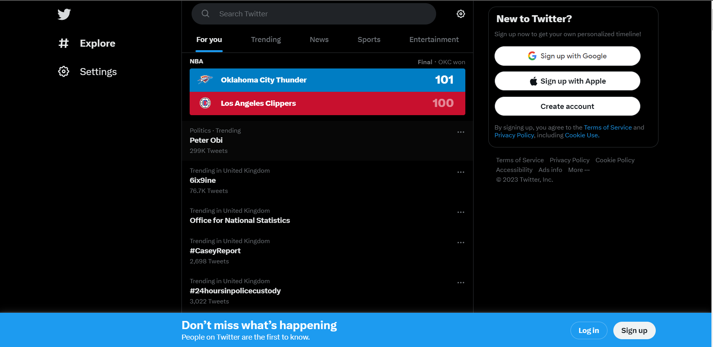

Figure1 Twitter explore page (1)

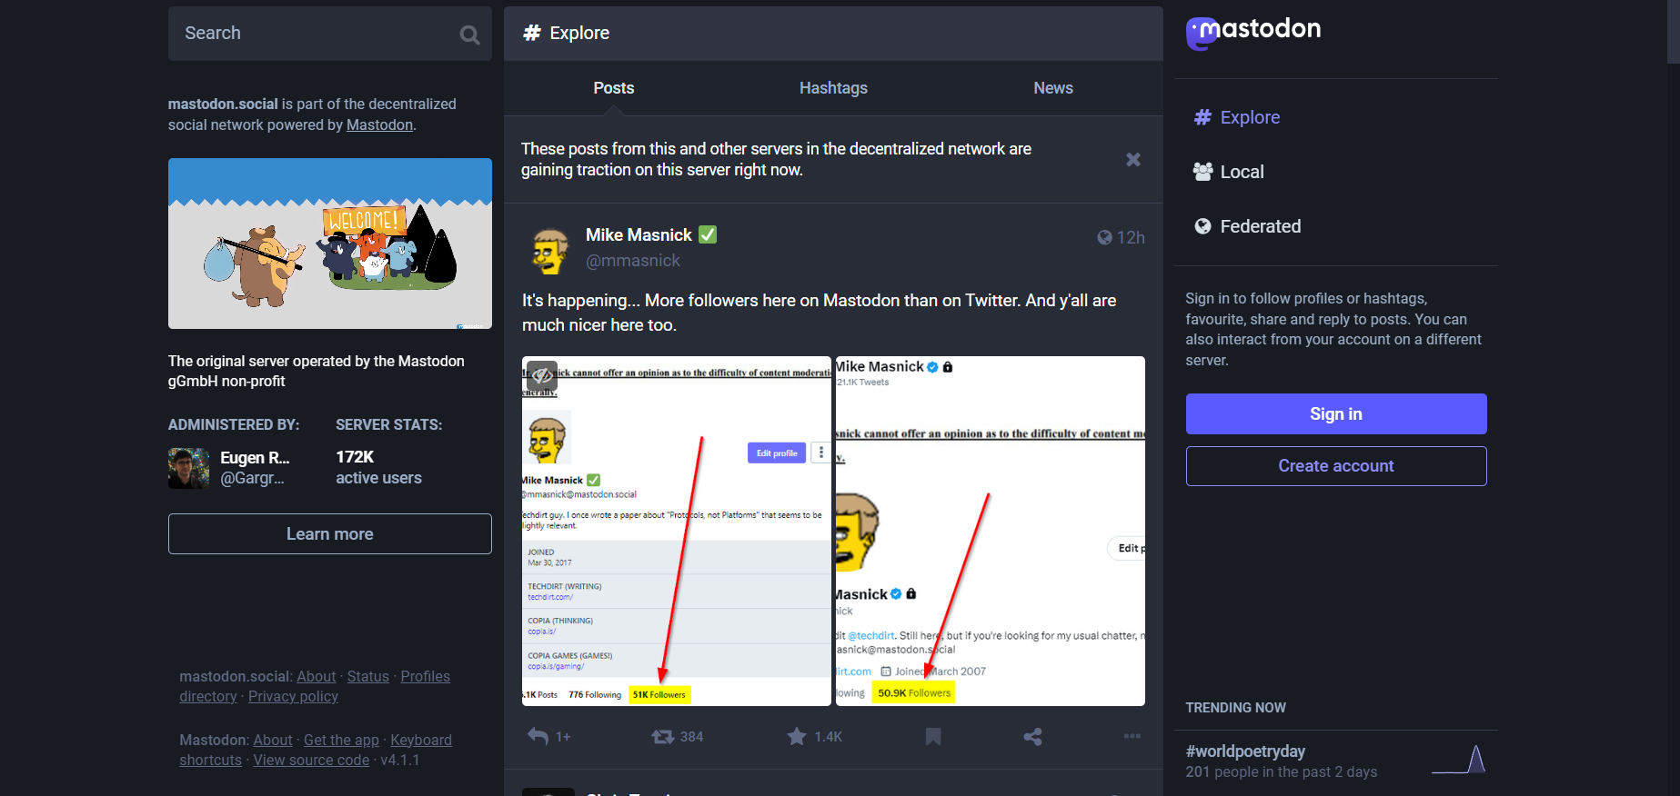

Figure 2 Mastodon explore page (2)

Target User Groups

The migration from Twitter to other social media platforms has been caused by a change in owners and their views about the platform. As Mastodon uses a decentralised model using individual servers managed by its users, this reduces the risk of sweeping changes in policy if a new owner takes over. If this is an issue for Twitter users, this may be a feature that mastodon offers to persuade new users to join.

Twitter offers a sizeable global community which uses algorithms to display trending tweets and hashtags. Conversely, Mastodon implements smaller instances in more specialised subjects managed by users and toots shown chronologically. This may offer closer nit groups that follow a specific interest which may encourage new users to remain. In essence, Mastodon provides a similar experience to Twitter, which is reflected in the migration and coverage of where Twitter leavers went, although it is not identical and has a learning curve due to its model and decentralised nature. For example, where Twitter builds an algorithm to show the user what they would find interesting across the whole of the site, Mastodon instances remain isolated until the user sees and follows them, incurring more manual tuning (5).

Psychology, Usability and Design

As Twitter is the progenitor, it will be used to compare features and designs with Mastodon and examine if it provides a similar overall experience. When the explore screens in Figures one and two are examined, it is visible that Mastodon mirrors the Twitter layout. Although there are some differences, it lends a feeling of familiarity and recognisability. Gestalt theory (6) suggests that this allows users to adapt, as Mastodon uses the 3 central panel design implemented by Twitter, which may feel familiar as a whole as a microblogging site. This also lends toward cognitive psychology (9), which states that users will have learned responses through repetition and, once again, if the site feels familiar, allowing them to adapt quickly to the new environment.

There are many different theorists when considering the usability and design of the two sites, such as Dix (8), Shneiderman (9), Nielsen (10) and Norman (11&12), that have their own rules and principles for designing an application. Dix’s principles will be used to examine the design, and the other theorist’s rules and principles will be used to compare their views on the applications and find if they conform.

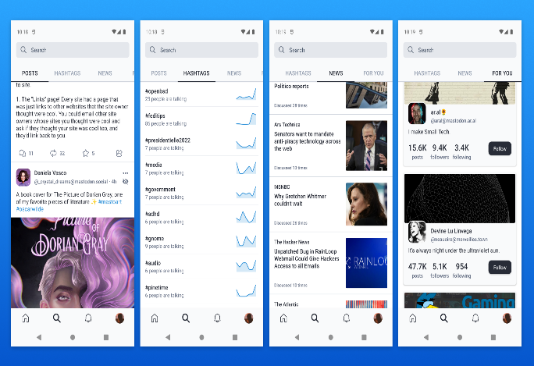
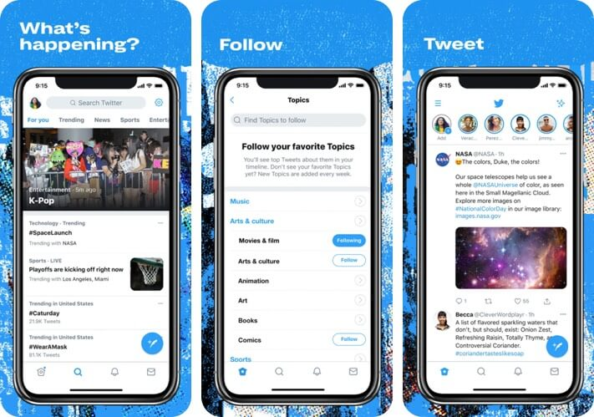

Figure3 Twitter application (1) Figure 4 Mastodon Application (2)

Learnability

Dix defines learnability as a system allowing new users to understand its use and the road to gaining proficiency(8 p261). Twitter allows its users to make microblogs or tweets, which can be assigned a new or pre-existing hashtag (#), shown in their timeline to get engagement through likes and retweets. This illustrates the predictability and synthesizability of what a user would expect to occur when using Twitter. From an application standpoint, Mastodon emulates these functions, which would give the user a sense of familiarity with the layout and further enforce the generalizability of the application in comparison. Similarly, it appears consistent with what the user has learnt from their interactions with Twitter which is supported by Shneiderman’s first 2 golden rules of design, which are “striving for consistency” and “seeking universal usability” (9). This shows the crossover between these principles and how they are similar

Flexibility

Dix believes that flexibility is the multiple ways in which the end user and the application exchange information (8 p268). As both these sites are microblogging sites, the dialogue initiative would be restricted by the characters, which is 500 for Mastodon toots and varying for Twitter tweets from the free 280 to the membership 3000. The sites also allow the user to show images and text-based messages, allowing for a level of substitutivity and flexibility of expression. As Twitter uses algorithms to show the user trending tweets and hashtags, it limits the customise ability of their feeds, whereas Mastodon requires more work, but the feeds will be more in line with what the user believes they want to see. These are also defined by Neilson (10) with the flexibility and efficiency of use, showing that inexperienced users can grow into proficient users and are given more freedom on the Mastodons platform. These rules also share similarities which may indicate how the authors have intersecting views.

Robustness

As Dix (8 p270) outlined, Robustness is the engagement between the application and the users to achieve a set goal. The applications for both companies offer a robust browsability to view the feeds of the users, their following, trends and timelines and, with the instance of phone applications, allow for text resizing for better observability for near-sighted individuals. Both sites and applications have the delete message function to remove any errors created, but it should always be considered that if something is put on the internet, it is there forever. Once a goal is achieved with the application, such as a message posted, the user requires prompt feedback to confirm that it has been done; this is shown by a new message appearing in your thread after you post it on both sites. This is also supported by the Normans design rule (11) for feedback, as the user expects it instantly, as any delay leaves the user with a feeling of dissatisfaction and questions whether the app is working correctly. The speed that a user expect feedback has increased over time further support their views.

User Satisfaction

Mastodon and Twitter, although similar, work with different principles in mind. Both are microblogging websites, but Twitter is centralised and controlled by an organization, and Mastodon is decentralised and managed by its users, which is where some of the fundamental differences occur. Users who move to Mastodon expect the exact Twitter experience and will be left disappointed; the algorithm that populates their feed is gone, and the user must do more work to seek out what they desire. The moderation changes from instance to instance rather than a global constant, which may mean leaving and blocking an instance they do not find to their tastes. The feed of messages in Mastodon falls in a chronological order which may be disconcerting to some new users, and the customizability does not allow for any changes. Ultimately, for an exact Twitter experience, the only site to use is Twitter; while Mastodon imitates and learns from it, it still has its own experience with its own learning curves. While many may go back to the comfort of Twitter, others have embraced different social media options and found new communities to interact with.

Test Personas

The test persons were devised through a focus group to represent the potential users of the Cluedo application. A variety of potential demographics and age groups were discussed, and the persona that was adopted is below:

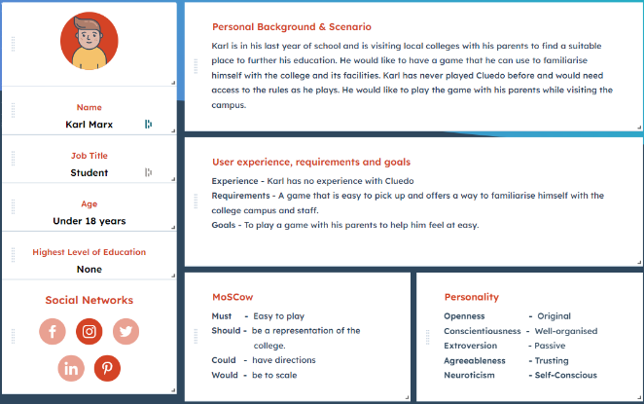
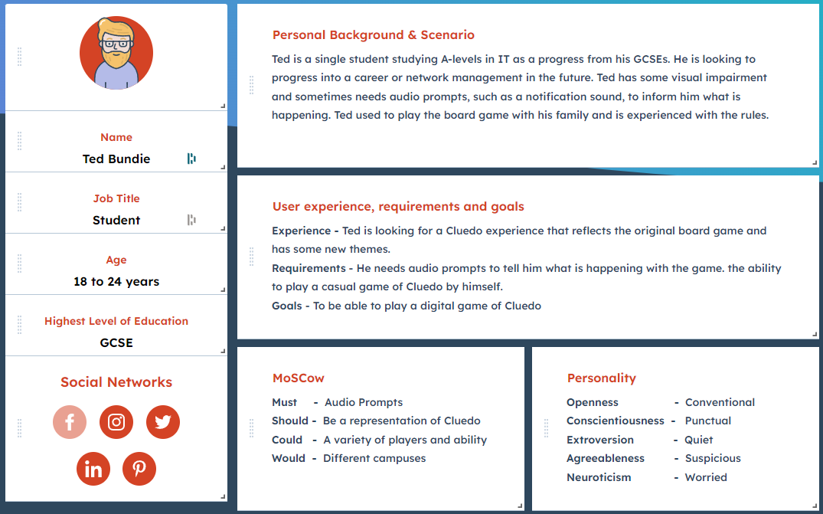

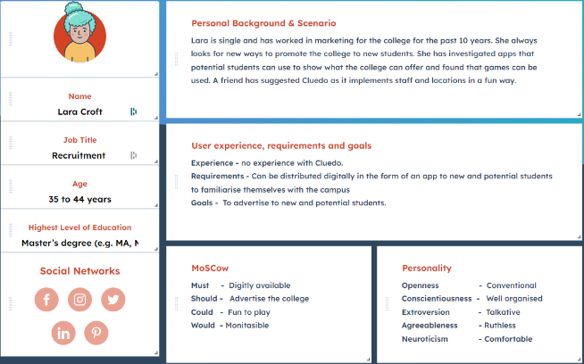
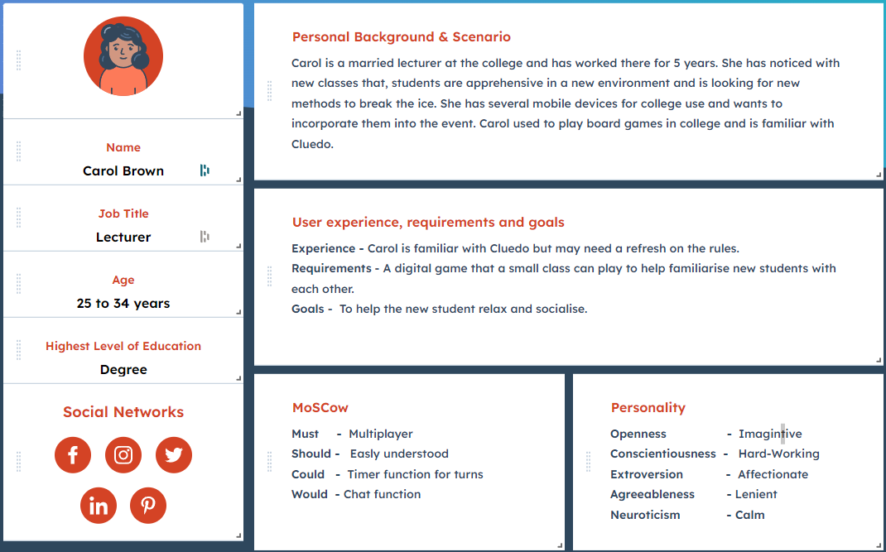

The focus group engaged in a game of Cluedo to ensure they understood the concepts and rules of the game. They were then asked questions about building a game around the neath college campus. This helped outline the demographics and motives of the persona, and then a background and scenario were built. This is available in the Appendix.

The 4 personas represent some of the potential users that will use the application for different purposes. This follows a current student with a visual impairment who wishes to enjoy a themed game of Cluedo and a potential student who wants to learn about the college in a fun way. Moving into professional personas, the lecturer that wants to break the ice with new students, and the recruitment leader that wants a way to advertise the college to potential students. Using the MoSCoW method to outline the need for the application’s important functions, the personas were assigned:

- Must have
  - Audio prompts
  - Multiplayer
  - Digitally available
  - Easy to play

- Should have
  - easy to understand.
  - Fidelity to the college
  - Fidelity to the Cluedo
  - Advertise the college.

- Could have
  - Timed functions on turns
  - variety of different players and abilities.
  - Directions
  - Fun to play

- Would have
  - different campuses
  - chat function,
  - be to scale.
  - Monetizable

A personality was generated for the persona that matches their scenario and background for future testing and feedback for the application.

Application Concepts

The application for Cluedo requires plan to design and build it to ensure that it matches the needs of the personas. There are different methods to accomplish this; a cognitive walkthrough accompanied by a flow chart will be used to demonstrate the flow of the Cluedo application.

Cognitive walkthrough and Flow chart

- Start Game
- Select the number of players.
  - Single
  - Multiplayer
- Select your character.
- Receive 3 Clue cards.
- Roll for the first go.
  - Wait for turn.
  - Take turn.
- Roll for the move.
- Event?
  - No
  - Room
    - Guess the player & weapon.
    - Wait for confirmation.
    - Record clues
  - Card
    - Intrigue
    - Clock
  - Centre room
    - Guess murder, weapon and room.
- Repeat until player guesses correctly.
This demonstrates a rough outline of how the application should react to a user initiating a new game. This is further expanded on in the flow chart in the appendix. This outlines the usability story for the design and how it will react when used; the feedback given from the application will follow this principle, giving quick feedback in line with the user’s goal. There will also be instances that allow the user to correct some of their decisions in line with Shneiderman 6th golden rule (9).

Design

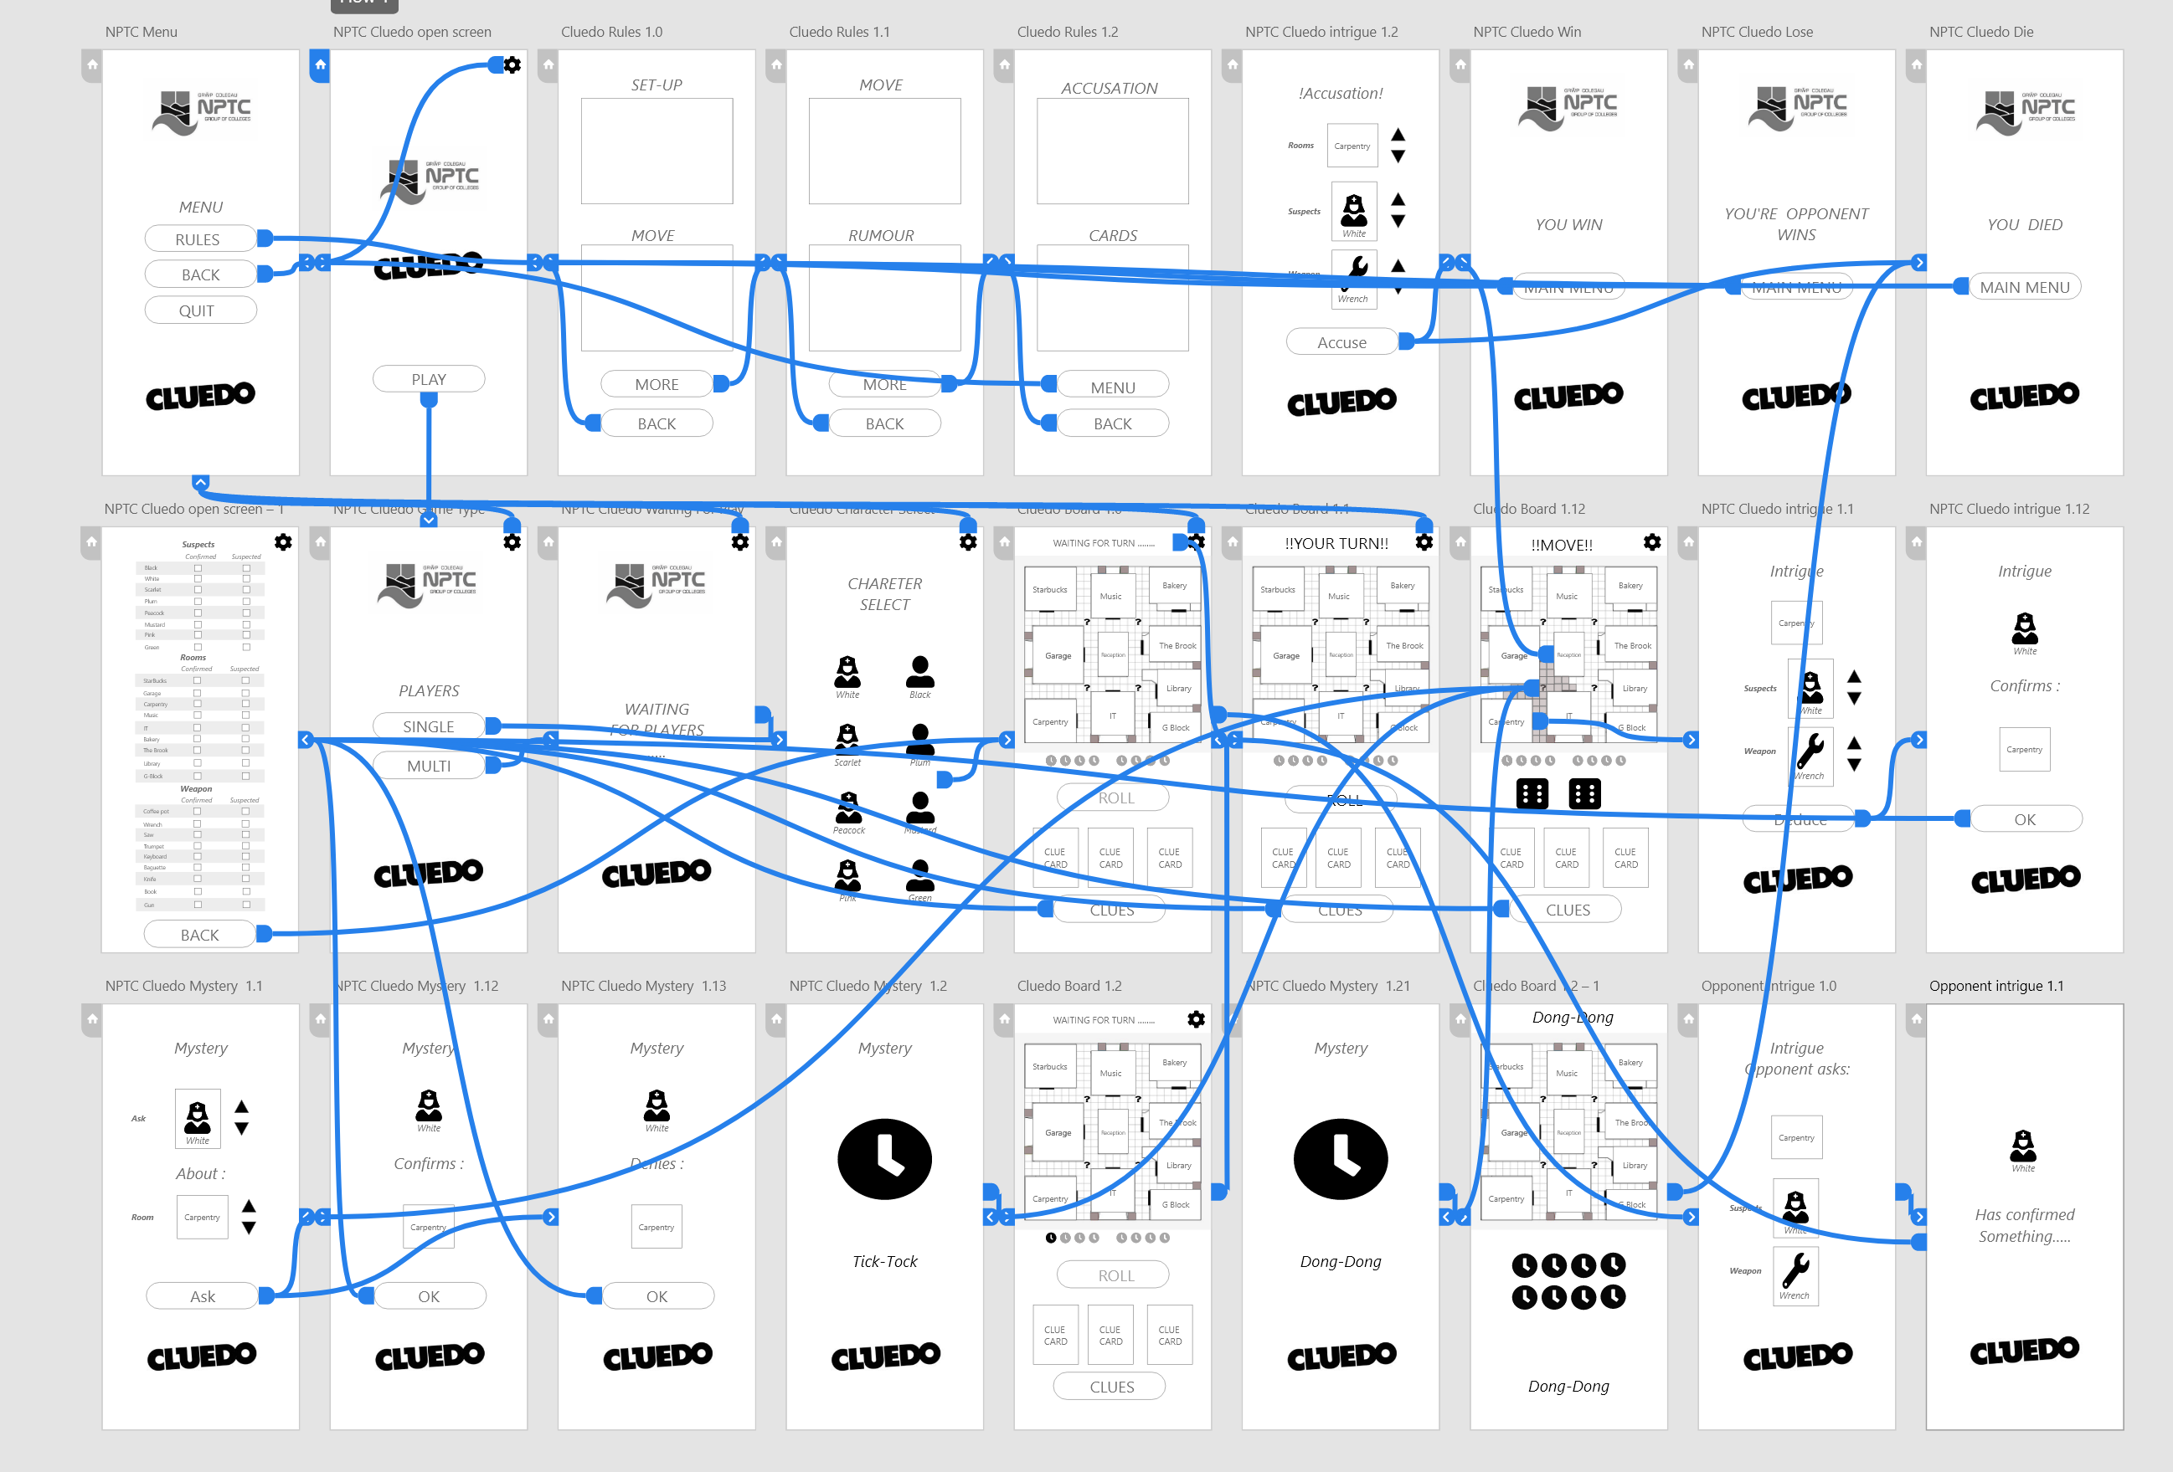

Cluedo Wireframe

As a plan for the design has been completed, a storyboard wireframe was built in Adobe XD. Above is the wireframe with active connections, and the appendix has an example without the visible connection. The application was designed simply and used learned experiences and common design principles so all users could navigate the menu and game. Each screen will be explained and thoughts and principles behind it as well as how it aligns with the person’s goals.

Start and Main Menu

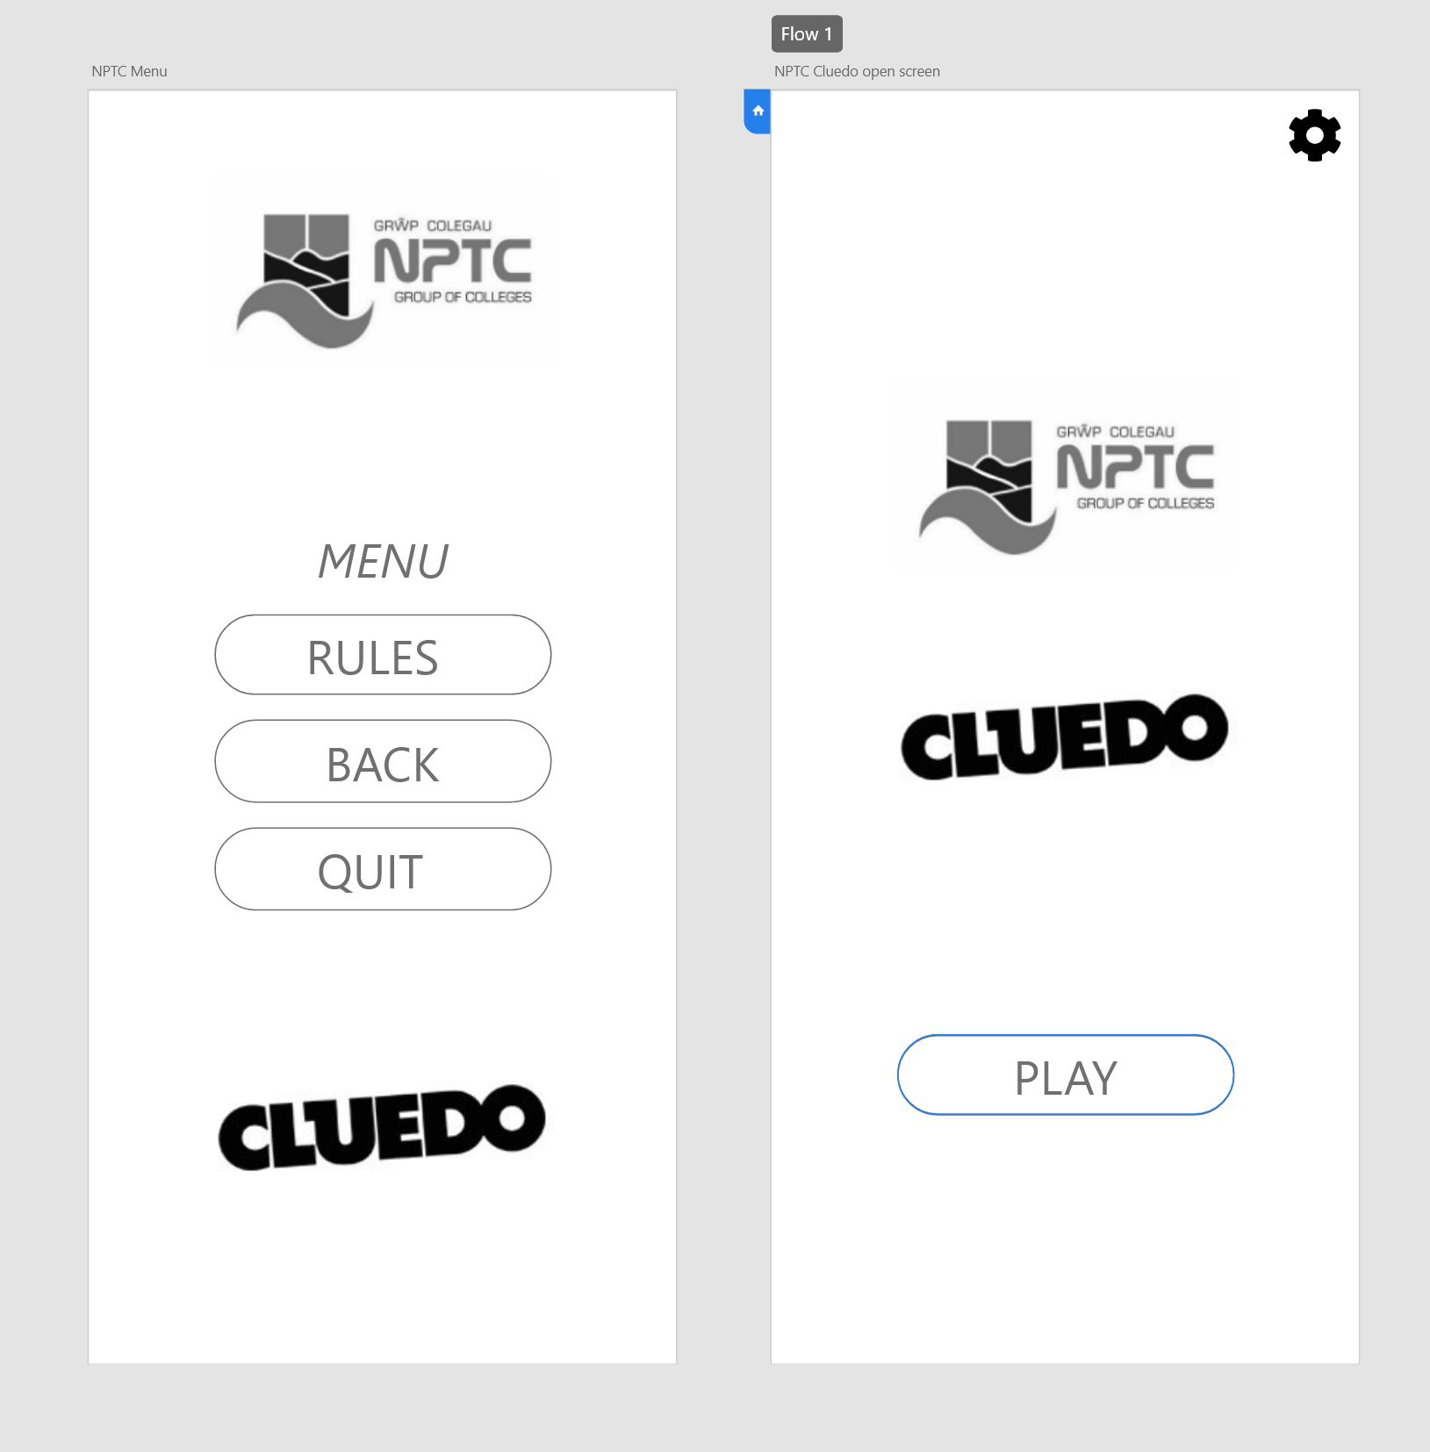

For the start menu (Right), the use of negative space is used to draw the user’s eyes to the centre of the screen, where a single button with a simple instruction is placed. For new users with experience with applications, this would indicate that this is how the game started. As this application is designed for mobile devices, the cog symbol located in the top right would indicate a settings menu; this takes advantage of the user’s learned experience. A similar design is used with the main menu as the start menu, with large buttons with simple instructions with expected outcomes. This follows Dix’s rules on learnability with familiarity focal point (8 p261). This also sets the theme of the consistent application applying both Shnidermans first golden rule (9) and Neilson’s 4th rule.

Rules

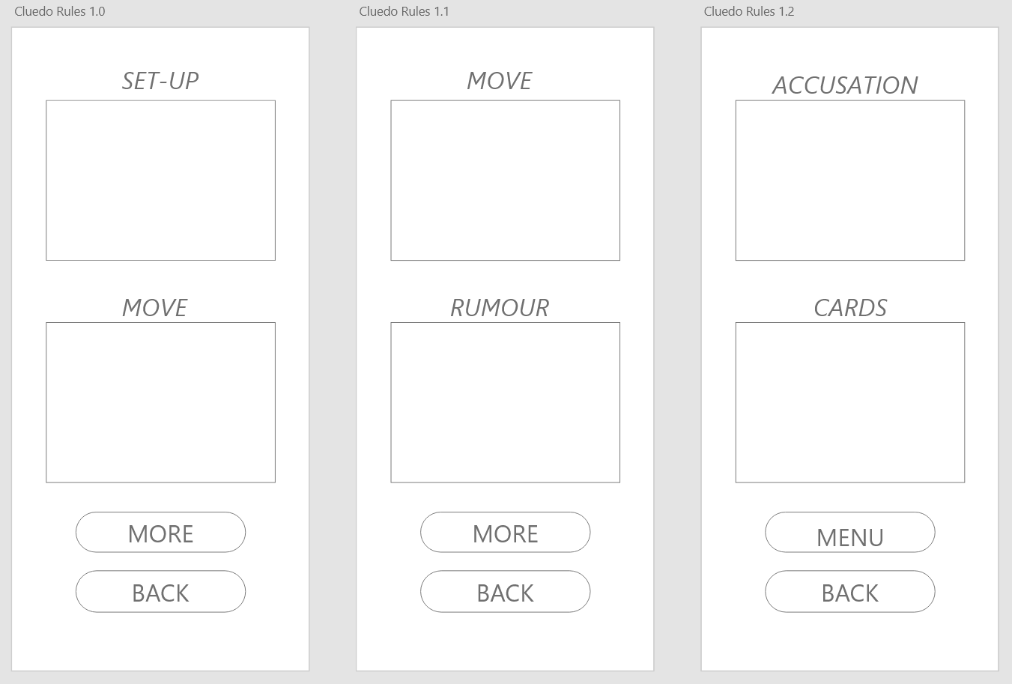

Placeholders have been used in the wireframe for the rules, and the logos are not present due to the potential content. Once again, the only interactive elements are the buttons which are clearly labelled. This page would be considered to have a high affordance following Norman’s rules for design; it is clear what can and can’t be done (12).

Player Select

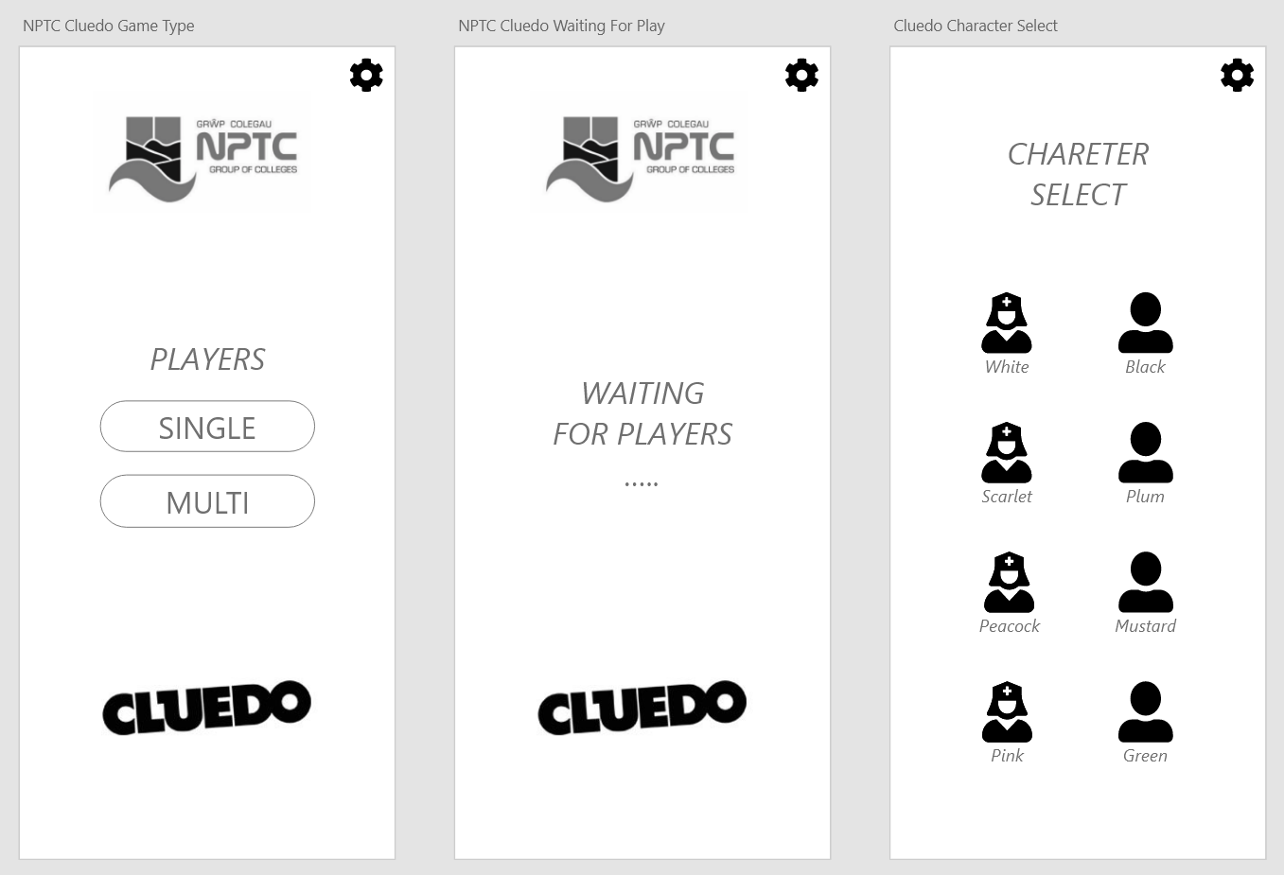

These are the menus that follow the play option from the start menu. The logo and main menu option continue the theme and consistency of the application. The player is offered a single-player option that takes them directly to the character select or a multiplayer option that then waits for additional players before they start. This aligns with some of the persona’s goals for the application. This offers informative feedback that is suggested in both Shnidermans (9) and Normans (11) rules of design.

Game board

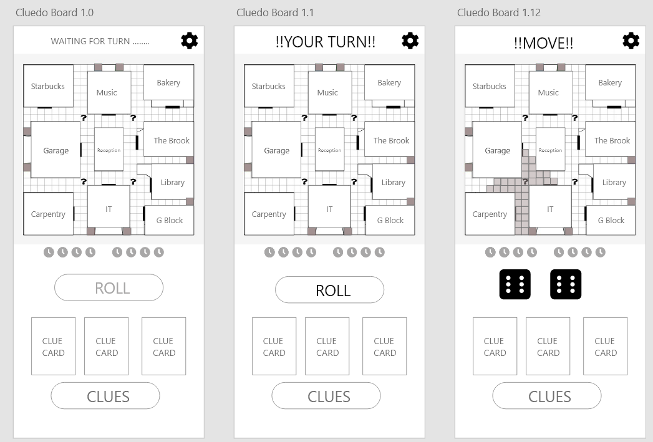

Following the character selection, the first player is chosen randomly and then moved to the main game board. Both Neilson and Norman imply that system status visibility is important in design (10&11), and as such, the turn status is displayed prominently on the top screen. The menu theme remains, constantly allowing the user to view the rules or end the game. The roll option also has a distinct signifier, only becoming active on the player’s turn. The clues the player initially receives are shown with the option of viewing the discovered clue menu beneath it. The clock mechanism will be explained in the rules and further in the explanation. Once a roll has been made, the potential moves are highlighted on the board, ready for the player’s decision.

Clues

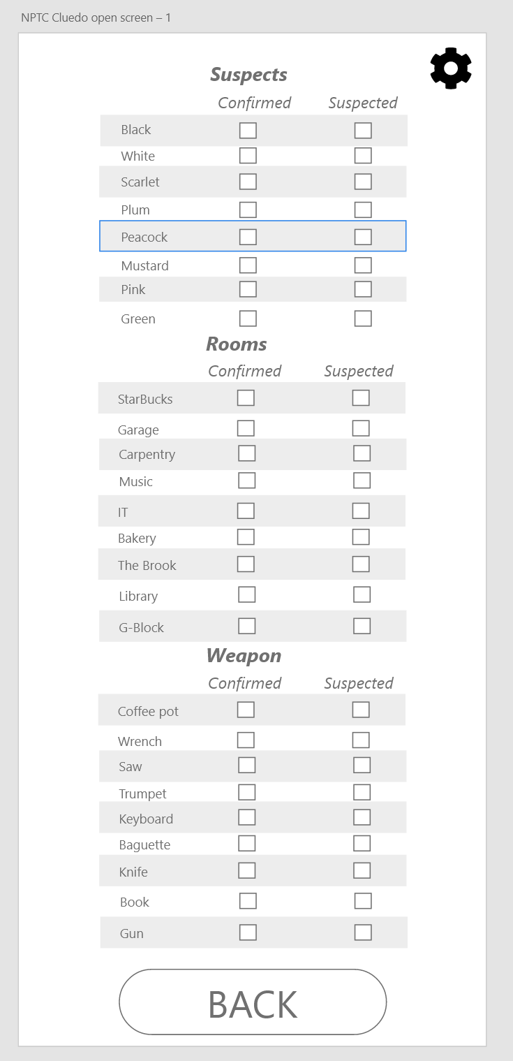

The clues menu displays the current know clues as confirmed and what the player suspect are potential. Any confirmed clue will be auto-filled while the player can fill the suspected column offering some fidelity to the original game. The weapons align with the room themes outlined by the focus group and the college layout. The suspects are currently placeholder colours until the appropriate suspect are assigned.

Intrigue

v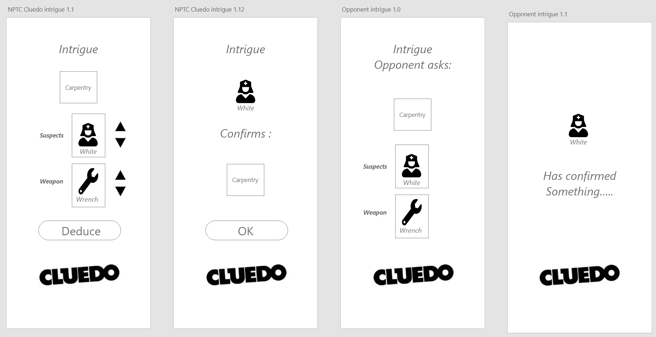

Intrigue occurs when a player enters a room and investigates. The room is fixed to the location the player landed in, and then it is up to them to enquire about a suspect and weapon. These can be changed with the arrow function that follows the familiarity principle of Dix (8 p261), as most users instinctively know that an up arrow moves choice in that direction and vice versa. Once the decisions are made, the deduce button is pressed to ask each player about the clues sequentially, and they must confirm one of the three if they have that clue; if not, it continues until unanswered, and conclusions can be drawn. Conversely, when an opponent asks if another player has a clue, the player that confirms it is visible, but the clue is not. This aligns with the persona’s desire for an authentic Cluedo game.

Mystery

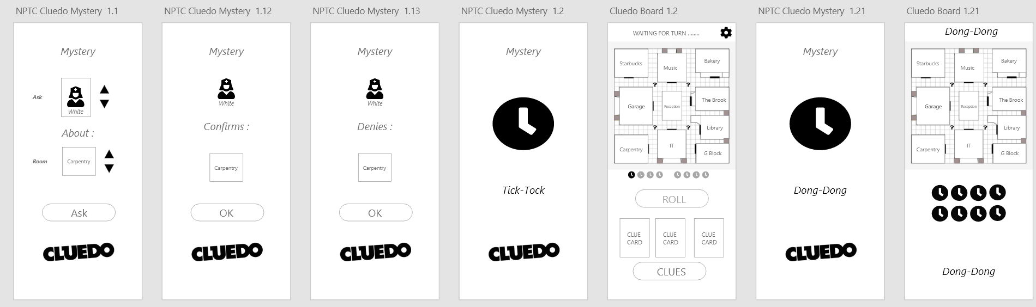

If a player lands on a mystery square (?), several options can be chosen randomly. Some potential outcomes are that a player can directly ask another player directly about a room, weapon or suspect directly, and they can confirm or deny it, as shown in the display above. The other option is the clock mechanic, which will add a clock; once the count reaches 8 the player who draws it dies, and the game is over for them, and their clues are shown on the board. This aligns with Cluedo’s newer rules and supports the persona’s needs.

Conclusion

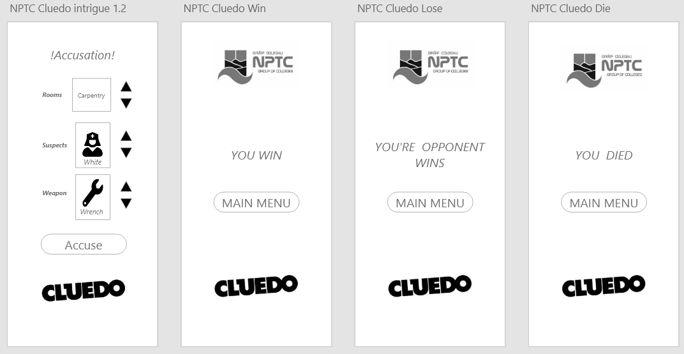

What is shown above is the conclusion screens of the game; as with all other parts of the application, it follows the theme allowing the players to easily recognise and progress through the game. The accusation screen is accessed in the centre of the board, and a guess can be made about the killer, weapon and room. If correct, the player wins; if incorrect, the player dies, and all cards are shown; finial, if an opponent guesses correctly, the opponent win screen is shown. All outcomes let the player return to the start menu if they wish to play another game.

Feedback

A heuristic feedback questionnaire was generated for the personas to reflect on the wireframe design and outline any potential violations in the design. One of the recurring main recurring problems is the lack of multiplayer selection and player numbers; this was rated as a high violation by several users. The lack of sound control for the visually impaired user was also highlighted, which was a must-have feature. The personas saw no issues with the aesthetic of the minimalist design. Some additional error detection and notification also feature the users’ desire.

The full questionaries answers are available in the appendix. The design, for the most part, has met expectations but has some room for growth. The user expressed their concerns with missing key feature and outlined what they believe will improve their user experience.

References

- Twitter. Twitter; [cited 2023Mar10]. Available from: https://twitter.com/?lang=en
- Mastodon [Internet]. Mastodon hosted on mastodon.social. [cited 2023Mar10]. Available from: https://mastodon.social/explore
- Davies H, Ryles G. Twitter vs mastodon: Which social media site is better? [Internet]. Trusted Reviews. Trusted Reviews; 2022 [cited 2023Mar10]. Available from: https://www.trustedreviews.com/versus/twitter-vs-mastodon-4289276
- Zignani M, Gaito S, Rossi GP. Follow the “mastodon”: Structure and evolution of a decentralized online social network. Proceedings of the International AAAI Conference on Web and Social Media. 2018;12(1):541–50.
- Zia HB, He J, Raman A, Castro I, Sastry N, Tyson G. Flocking to Mastodon: Tracking the Great Twitter Migration. arXiv preprint arXiv:2302.14294. 2023 Feb 28.
- Köhler Wolfgang. Gestalt psychology: An introduction to new concepts in modern psychology. New York, NY: Liveright; 1992.
- De Houwer J, Barnes-Holmes D, Barnes-Holmes Y. What is cognition? A functional-cognitive perspective. Core Processes of Cognitive Behavioral Therapies. Oakland, CA: New Harbinger. 2018 Jan 2.
- Dix A, Finlay J, Abowd GD, Beale R. Human-Computer Interaction. 3rd ed. Harlow, Essex: Pearson Prentice-Hall; 2004.
- Shneiderman B. The Eight Golden Rules of Interface Design [Internet]. Ben Shneiderman. University of Maryland; [cited 2023Mar12]. Available from: https://www.cs.umd.edu/users/ben/goldenrules.html
- Nielsen J. 10 usability heuristics for user interface design [Internet]. Nielsen Norman Group. Nielsen Norman Group; 2020 [cited 2023Mar12]. Available from: https://www.nngroup.com/articles/ten-usability-heuristics/
- What are Norman's design principles? [Internet]. Educative. Educative; 2023 [cited 2023Mar12]. Available from: https://www.educative.io/answers/what-are-normans-design-principles
- Norman DA. The design of everyday things. New York, NY: Basic Books; 2021.
- Miranda E. Moscow rules: A quantitative exposé. InAgile Processes in Software Engineering and Extreme Programming: 23rd International Conference on Agile Software Development, XP 2022, Copenhagen, Denmark, June 13–17, 2022, Proceedings 2022 Jun 9 (pp. 19-34). Cham: Springer International Publishing.

Appendix

Focus Group Questions
What demographic do you think would be interested in a college cluedo game? | Students, teachers, management, potential students and parents, Marketing
What kind of motive would they have for using/playing the app? | Fun, education, information, to relax, advertise and socialise.
Regarding the campus, what areas do you feel will be informative to the interested parties? | The Brook, Starbucks, the bakery, G-block, IT Department, Music department, Machine shop,  Sports field, car park, student services, financial services, the canteen, and reception.
What do you feel are the important aspects of designing a Cluedo game for the college? | Fun to play, easy to understand, Single and multiplayer modes, recognisability, funny, pretty and fair.
What do you believe are the “must-have” features? | Fun, audio prompts, game fidelity, easy to understand.
What do you believe are the “should have” features? | easy to understand, access to the rules, and fidelity to the college.
What do you believe are the “could have” features? | Timed functions on turns, variety of different players and abilities.
What do you believe are the “would have” features? | High graphics, music, different campuses, chat function, be to scale.

Flow Chart for a Cluedo Game

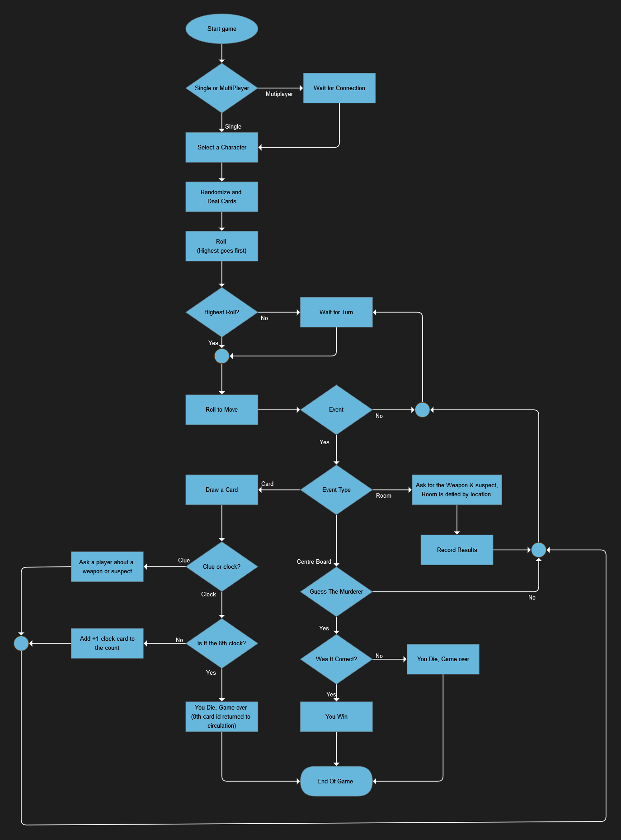

Storyboard

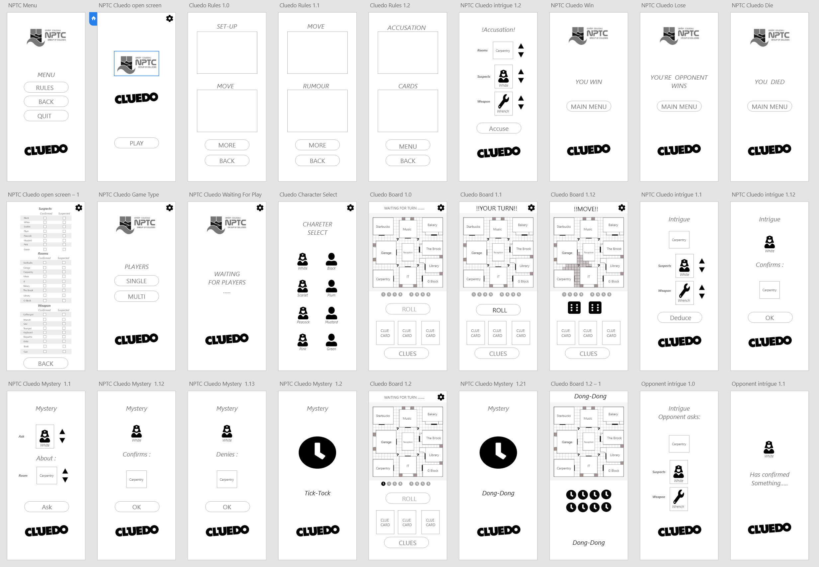

Heuristic evaluations

1st persona

Nielsen’s | Violation severity (1-5) | Comment
Visibility of system status | 2 | There are no error prompts when things go wrong.
Match between system and real world | 1 | Player board is different to the board game
User control and freedom | 3 | No volume control
Consistency and standards | 0 | Theme is consistent
Error prevention | 1 | It’s always possible to get back to where you were.
Recognition rather than recall | 1 | The menus are intuitive but seem to simple
Flexibility and efficiency of use | 3 | Can’t choose the number of players
Aesthetic and minimalist design | 0 | N/a
Help users recognise, diagnose, and recover from errors | 2 | If the game crashes there is no recovery
Help and documentation | 0 | Rules are easily accessed

2nd persona

Nielsen’s | Violation severity (1-5) | Comment
Visibility of system status | 0 | N/a
Match between system and real world | 1 | Not much experience with Real Cluedo
User control and freedom | 2 | Choosing the number of players
Consistency and standards | 0 | N/a
Error prevention | 2 | No way to revers mistaken move
Recognition rather than recall | 1 | Controls are basic
Flexibility and efficiency of use | 4 | Can’t select the players you are up against.
Aesthetic and minimalist design | 0 | N/a
Help users recognise, diagnose, and recover from errors | 3 | If the game crashes, there is no recovery
Help and documentation | 3 | An active tutorial for new players with signposts.

3rd persona

Nielsen’s | Violation severity (1-5) | Comment
Visibility of system status | 1 | Can see what’s happening
Match between system and real world | 0 | N/a
User control and freedom | 2 | Choosing the number of players
Consistency and standards | 0 | N/a
Error prevention | 2 | The game is lost if one player goes back to menu
Recognition rather than recall | 0 | N/a
Flexibility and efficiency of use | 3 | Can’t select the players you are up against.
Aesthetic and minimalist design | 0 | N/a
Help users recognise, diagnose, and recover from errors | 2 | The game is lost if one player goes back to menu
Help and documentation | 1 | Rules are easy to access

4th persona

Nielsen’s | Violation severity (1-5) | Comment
Visibility of system status | 0 | N/a
Match between system and real world | 0 | N/a
User control and freedom | 1 | Choosing the number of players
Consistency and standards | 0 | N/a
Error prevention | 2 | The game is lost if one player goes back to the menu
Recognition rather than recall | 0 | N/a
Flexibility and efficiency of use | 3 | Can’t select the players you are up against.
Aesthetic and minimalist design | 0 | N/a
Help users recognise, diagnose, and recover from errors | 1 | In line with design
Help and documentation | 1 | Rules are easy to access

