Title:
Design of an Unsigned Two Number Uneven Parallel Multiplier and the Design of a FSM in Hardware and VHDL

Module: Electronics ll ACDA6001

Course: BEng (Hons) Electronics and Electrical Engineering

University of Wales Trinity St David

By: Nick Regan
Student No: 1803871
Date: 4.5.21



Contents
Subject Page

Abstract 1
1. Multipliers 2
1.1 Introduction 2
1.2 What are Multipliers? 2
1.2.1 Serial Multiplier 3
1.2.2 Parallel Multiplier 3
1.2.3 Serial Parallel Multiplier 4
1.3 Block Diagram of Multipliers 5
1.4 Parallel Array Multipliers and Examples 6
1.4.1 Booth Multiplier 6
1.4.2 Braun Multiplier 7
1.4.3 Baugh Woolley Multiplier 7
1.5 Parallel Tree Multiplier and Examples 8
1.5.1 Wallace Tree Multiplier 8
1.5.2 Dadda Tree Multiplier 9
1.6 Vedic Multiplier 9
1.7 Comparison Table 1 10
1.8 Comparison Table 2 11

2. Design of a 12 bit x 4 bit Unsigned Number Multiplier Based upon a
Simple Braun Multiplier using Xilinx DesignSoftware 13
2.1 Introduction 13
2.2 Proteus 13
2.3 VHDL 14
2.4 Simulation 16
2.5 Conclusion 27
3. Design of an FSM in both VHDL and Discrete Gate Solution 28
3.1 Introduction 28
3.2 Discrete Gate Solution 29
3.3 VHDL 34
3.4 Conclusion 38

List of References 39
Bibliography 40
List of Tables 41
List of Figures 41

Abstract
Multipliers are a necessary and important part of the architecture of digital processors because multiplication is a major requirement. There are a number of different types of multiplier each having their own advantages and disadvantages. These are discussed in the first section of the report with a comparison table.
In the second section of this assignment is the author’s design, simulation and synthesis of a 12 bit x 4 bit unsigned number multiplier based upon a simple Braun multiplier, using Xilinx design software.
Following this in the third section is the author’s design, simulation and synthesis of an FSM described in a given diagram as both a VHDL and discrete gate solution.

Multipliers
1.1 Introduction
Multipliers are an important architectural part of processors which perform an arithmetical function, and multiplication especially plays a large and necessary part of the process. Digital technology is progressing at a fast rate which means processors are required to perform faster and more efficiently than previously. Since multipliers are an important part of this, the performance of the processor will depend on the performance of the multipliers.
In this section different types of multipliers will be looked at to understand their differences, and discuss their advantages and disadvantages. A comparison table is used to illustrate these results.
1.2 What are Multipliers?
Adhikari et al describe a multiplier as “An electronic circuit used in digital electronics to multiply two binary numbers. It is built using binary adders” (1).The adders consist of full adders and half adders. In their opinion multipliers are “indispensable in modern electronic systems where high speed calculations are required such as FIR filters, digital signal processing and micro processing.” (1). Prabhu et al state that “In the majority of digital signalling processing applications the critical operations are the multiplication,” (2) and that 70% of the instructions in algorithms are to perform addition and multiplication. (2).
Multiplication is the largest and most fundamental operation in processing (1,2,3,4,5,6). Because of this the performance of the processor will depend on the performance of the multipliers.(1,2,3,4,5,6,7).
So it is important for the multiplier to perform well. In the majority of research articles on this subject the authors (1,2,3,4,5,6,7,8), agree that the attributes necessary in the design of any multiplier are:
- Speed
- Delay
- Power consumptiom
- Performance accuracy
- Hardware, floor and memory space
In the present day technology has increased demands to deal with information and tasks at a faster rate. Siridhara et al point out “Nowadays multimedia applications are demanding high speed computing architecture.” (3). Prasannakumar adds that processors are expected to do the tasks at high speed, less memory usage and less power consumption.” (6). In the opinion of Kiran and Prashar (7) speed is the most important factor of a multiplier as “multiplication is usually the slowest part in the system and the main part of the process.” (7).
It is unlikely that there is a multiplier that fulfils good results in all these areas. Some areas have to be compromised and it may depend on the application. Various methods of Architecture and algorithms have been researched and invented to try and improve all of these areas. For example, Prabhu suggests that in order to reduce power consumption and increase speed and lessen delay, the number of operations must be reduced. (2 Agarwal agrees, saying out of all the components in a processor, multipliers are the slowest blocks. Writing for Elporocus in a website tutorial, Agarwal says that the speed of a multiplier depends on the architecture. (8).
Multipliers can be put into three groups.

1.2.1 Serial Multiplier
A serial multiplier uses serial (or sequential) circuits with feedbacks (3). The multiplication is divided into a sequence of steps. Each partial product is generated and added to the accumulator sum, then shifted to the next step. So each partial product is generated in sequence and each newly generated one is added to the previous one. This add shift process is slow as it is done serially. (1,6,8,9), but the advantage is less area of hardware and floor space and low power consumption. (1).
1.2.2 Parallel Multiplier
In parallel multipliers the structural layout is done differently. The multiplier and multiplicand are fed in parallel. The multiplicand is multiplied with each bit of the multiplier to generate partial product, then to generate a resultant partial product, these generated partial products are added together in parallel. (3).
- Partial product formation
- Partial product accumulation after shift of successive partial products to one bit left from previous partial products.
Parallel multipliers are faster than serial multipliers as the tasks are not being done serially but in parallel and the adders are fast. (6,9,10).. Although the number of partial products to be added can affect the delay of parallel multipliers. (1,3).
The disadvantage of parallel multipliers is that they need a large area.
1.2.3 Serial Parallel Multipliers (SPM)
This multiplier is a combination of serial and parallel to attempt to achieve the best of each type. Works on each bit of a multiplication serially but uses a parallel adder for the partial product accumulation. (1). Multiplicand multiplies one bit of multiplier to form partial product, each time and sends the temporary result to the right. Works on each bit of a multiplication serially but uses a parallel adder for the partial product accumulation.
Therefore, the serial multiplier is accurate, low on power consumption, takes a small amount of space, has a regular layout but is slow.The parallel multiplier is accurate, uses a lot of power, takes up a lot of space, has a complex and irregular layout but is fast.
The SPM is a compromise of serial and parallel multipliers. And is half way between both. They are faster than a serial but slower than a parallel. Also they take up more area than a serial but less than a parallel.
The SPM is therefore moderate in comparison with serial and parallel.

1.3 Block Diagram of Multipliers
Multipliers
Vedic
unsigned

Parallel
Serial
Serial Parallel

Parallel Array
Parallel Tree

Wallace Tree
Dadda
Tree

Baugh Woolley
Signed only
Booth
Unsigned & signed
Braun
Unsigned only

Figure 1: Block Diagram of Multipliers (by Author)
As shown above in the block diagram, parallel multipliers are divided into array types and tree types.

1.4 Parallel Array Multiplier and Examples
Array types of multiplier are based on repeated add and shift algorithm. They are easy, simple and regular structure, using small amount of space. (5). The multiplication operation between the multiplicand and one multiplier bit will generate the partial product output in every stage. The consecutive stages are shifted and added to produce the end result. Koppala et al explain: “It works on each bit of a multiplication serially but uses a parallel adder for the partial product accumulation. Multiplicand multiplies one bit of multiplier equals partial product, each time and sends the temporary result to the right. (5).
It is simple layout with good speed but can have a delay (due to the fact it occupies more gates.) (5) Also uses more power. (5,6,8) and has complex hardware (5).

1.4.1 Booth Multiplier
With the Booths multiplier, unsigned and signed binary number multiplication can be multiplied. The ‘two’s complement’ method is used. It treats positive and negative numbers the same. Shing et al explain, Booth algorithm consists of a Booth encoder and a Booth decoder and a multiple bit partial product adder. The encoder reduces the number of partial products by encoding three bits of multiplier into one bit. The Booth decoder generates the partial product for each encoded bit. (11.)
Compared to the shift and add array it will reduce the number of multiplicand multiples. The partial product generations are reduced by half and the area is minimised. (5). In shift add array each multiplier bit generates one multiple of the multiplicand to be added to the partial product. If lots of additions requires, the delay will be long. According to Jagadeeswara Rao et al,Booth can deal with more than one bit in each cycle because it uses high radix multiplication. (12).
There is a modification of the Booth algorithm brought about in 2000 by Chang Yeh and Chein Wei in which a triplet of bits are scanned instead of two bits. (5, 12).There are two steps, encoding, (scanning the triplet of bits) and selection. (5). This modification increased the speed of the Booth multiplier by 25%. (12).
In a study carried out by Siridhara et al it was concluded that the Booth multiplier had less delay when compared to a Wallace Tree and Dadda multiplier. (3).

1.4.2 Braun Multiplier
The Braun multiplier is also known as a carry save array multiplier. It will only accept multiplication of two unsigned numbers. Each partial product is generated in parallel with AND gates. Each partial product can be added with the sum of partial product which has previously been produced, by adders. Prakash et al explain that the carry signals are shifted one bit to the left and then added to the sum of the first adder and the new partial product, This is then passed diagonally downward to the next adder stage. (13).
but architecture causes high power consumption and hardware cost. (Sab)
.
1.4.3 Baugh Wooley Multiplier
The Baugh Wooley algorithm uses signed numbers and uses ‘two’s complement’ multiplication method. It uses parallel products to complement multiplication and adjusts the partial products to maximise the regularity of multiplication array. Numbers are presented in ‘two’s complement’ form and the sign is embedded in the multiplier. The algorithm ensures that the sign of partial product bits is always positive so that array additions can happen. (7).
In a study by Kiran and Prashar, the Baugh Wooley algorithm was found to be fast and cost effective. (7).

1.5 Parallel Tree Multipliers and Examples
Compared to array multipliers, ,tree multipliers are more power efficient, take up less area and are faster. (4). They are also known as column compression multipliers. (3).
1.5.1 Wallace Tree Multiplier
In 1964 Wallace invented a new method of the process known as the Wallace Tree, a partial product reduction tree which was a reduction by rows using carry save adders in parallel. (4) “Adding the partial products bits in parallel by using carry save adders as a tree.” (3).
The Wallace tree multiplier consists of three stages:
- The partial product is formed by n2 AND gates
- The partial product is reduced to the height of two by adding
- These two rows are combined using an adder
The first step is to produce the partial product array of the n2 bits. Secondly, groups each with three adjacent rows. Each of these groups of three rows is reduced by using full adders and half adders. Full adders are used in each column where there are three bits whereas half adders are used in each column where there are two bits. Any single bit is passed to the next stage in the same column without processing. This reduction process is repeated in each successive stage until only two rows remain. In the final step, the remaining two rows are added using a carry save adder. (10 )
The partial products are reduced using carry save addition. This will allow successive addition in one global step (3)
This is a fast multiplier as it does not have the serial stages of adding, it is high speed, medium complexity, but has an irregular inefficient layout and occupies large area of hardware (3,6).
Adhikara et al and Jagadeeswara Rao et al point out that many improvements have been made to the Wallace Tree in 1998, 2010, and 2011improving the delay and speed (1,12) especially but also reduced power consumption by 11%. (1,12). Mishra and Nayak agree by stating there is less delay and less power consumption than in array type multipliers. (4).

1.5.2 Dadda Tree Multiplier
Dadda followed shortly after in 1965 with another reduction tree, except a reduction in columns instead of rows. The method uses the minimum reduction necessary at each stage instead of Wallace’s method of reduction as soon as possible. (9 )
Less compressors in the partial production stage and a larger carry propagate adder, similar but refined. (3).
Siridhara et al explain Dadda advanced this method by placement plan of compressors that resulted in fewer compressors required in partial product reduction stage (3)

1.6 Vedic Multiplier
The Vedic multiplier is a different concept., based on ancient mathematic techniques originating from India, multiplication is done crosswise and vertically. Due to this technique the vedic multiplier is faster. The calculation steps are reduced. Eg. Array types have 16 AND gates, 8 full adders, 4 half adders. Vedic has 16 AND gates, and 3 adder circuits, therefore less hardware. The partial product and sum are added in parallel. Vedic multipliers use different adders in the architecture such as carry Save adder, carry look ahead. Prasannakumar states they are efficient in low power, less delay and less area. (6) In his opinion their performance is very good. Adhikari et al in their study conclude that the Vedicis best in speed and best all round. (1) Also both Prabhu et al (2) and Thomas et al (14) agree stating their studies have shown the Vedic multiplier is the best in relation to power consumption, speed and area and that it is better than the Wallace Tree multiplier. (2).

Comparison Table of Multipliers Groups

Multiplier Type | Speed | Delay | Power  consumption | Accuracy | Layout | Area | Comments
Serial | Slow Slower than Parallel (3,12) | Long (2,5) | Low (12) | High | Regular (2,5)  Reduced wire length (12) | Small (6, 12) less hardware (6) | Simple and easy process (6)
Parallel | Fast ( faster than Serial) (3) |  | High | High | Complex (2,5) | Large as lots of gates (2,12) | More options than Serial (2)
Serial Parallel SPM | Medium than parallel (3) |  | Low (5) |  |  | Larger area than Parallel Ps but less hardware (6) | Best trade off between Serial (slow) and parallel (large area) (6)

Table 1: Comparison Table of Multiplier Groups

Comparison Table of Multiplier Types
Multiplier | Speed | Delay | Power consumption | Accuracy | Layout | Area
Braun (Array) | Fast |  | High |  | Regular | High cost hardware | Carry save adders used  Unsigned numbers only
Booth (Array) | Fast | Low | Low |  | Complex |  | Signed and unsigned  Number of partial products reduced by half  Modified in 2000 to increase speed 25% (12)
Baugh Wooley (Array) | Fast |  | Low |  | Regular |  | 2’s complement method used  Cost effective
Vedic | Fast  Faster than array | Minimal | Low | High | Efficient | Small | In studies it was best for area, efficiency performance, speed and power (1, 2 14) Best in delay and area (5) Lower delay than Wallace  Tree (12)
Wallace Tree  (Tree) | Fast  Faster than array | Minimal | Medium (higher than array) | Good | Complex  Irregular wires  (Improved in 2000 onwards) | Small but large amount of hardware | Economical for large operations (2)  Better in speed, power consumption and delay than array types. (12)  Better than array for delay and power consumption than array (4)
Dadda (Tree) | Fast | Minimal | Low | High | Complex |  | Refined version of Wallace Tree Multiplier
Table 2: Comparison Table of Multiplier Types
2. Design of a 12 bit x 4 bit Unsigned Number Multiplier Based upon a Simple Braun Multiplier, using Xilinx Design Software.
2.1 Introduction
The author has designed, simulated and synthesized a 12 bit x 4 bit unsigned number multiplier, based upon a simple parallel Braun multiplier. This consists of 12 inputs (A1 – A12) and 4 multipliers (B1 – B3).
2.2 Proteus
The first step was to design the first line of the multiplier which will be the inputs (A1 – A12) x B0. This task was done using software called ISE Design Suite. This first line will be called line 0. However before this it was necessary to build the multiplier in Proteus as it would make it easier to recognize the inputs, signals and outputs.

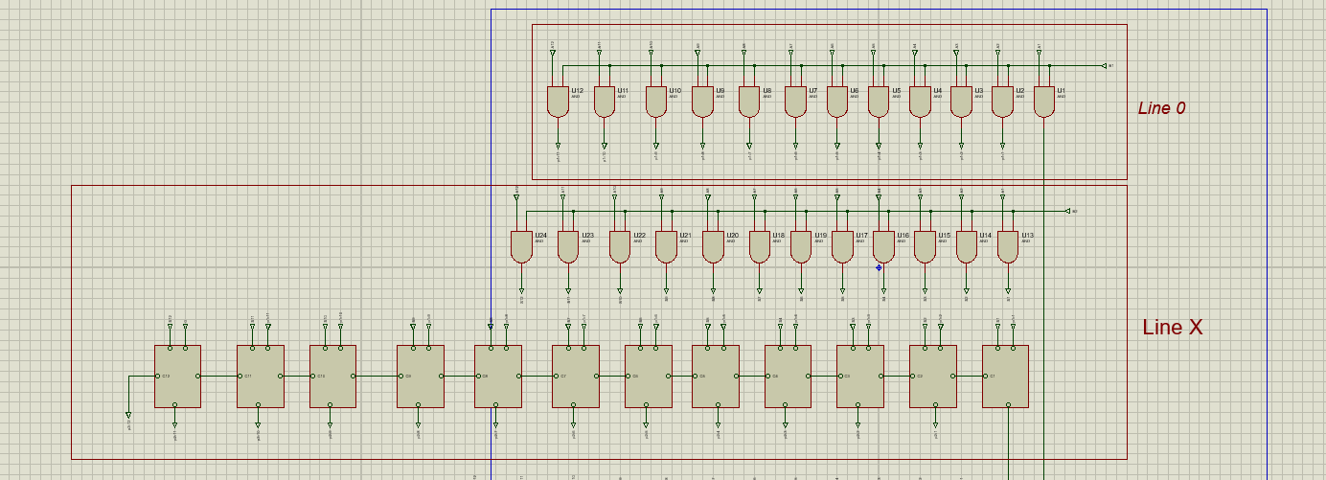
Figure 2 :Proteus Line 0 and Line x

As shown above in figure 2, line 0 consists of Q0 which is the first output and p1-1 – p2-11 which are the signals. Line x consists of signals S1 – S12. The signals from line 0 and line x were added together using half adder and full adders. As there are 11 previous signals, a 0 is used on the final adder. This then produced output signals for the next sequence including Q1.

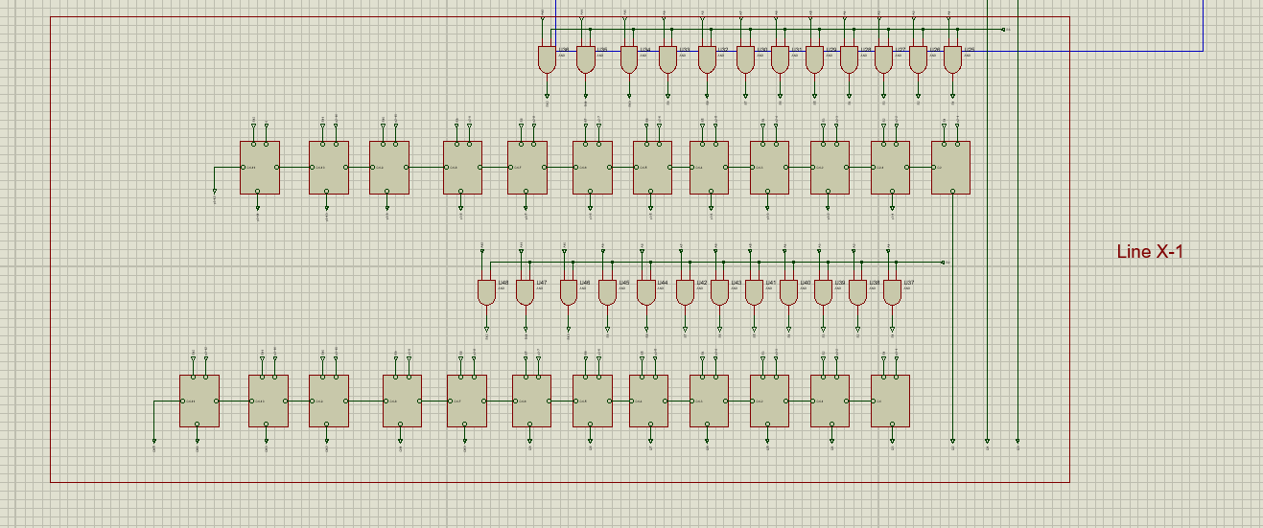
Figure 3: Proteus Line x-1

Line X-1 consisted of two parts. The first part was to add the outputs signals from line 0 and line x which are p2-1 – p2-12 to the new signals S1 – S12. This then gave new output signals which were p3-1 – p3-12 and Q2. These signals were then added to new signals again using adders, giving outputs Q3 – Q15. See figure 3.
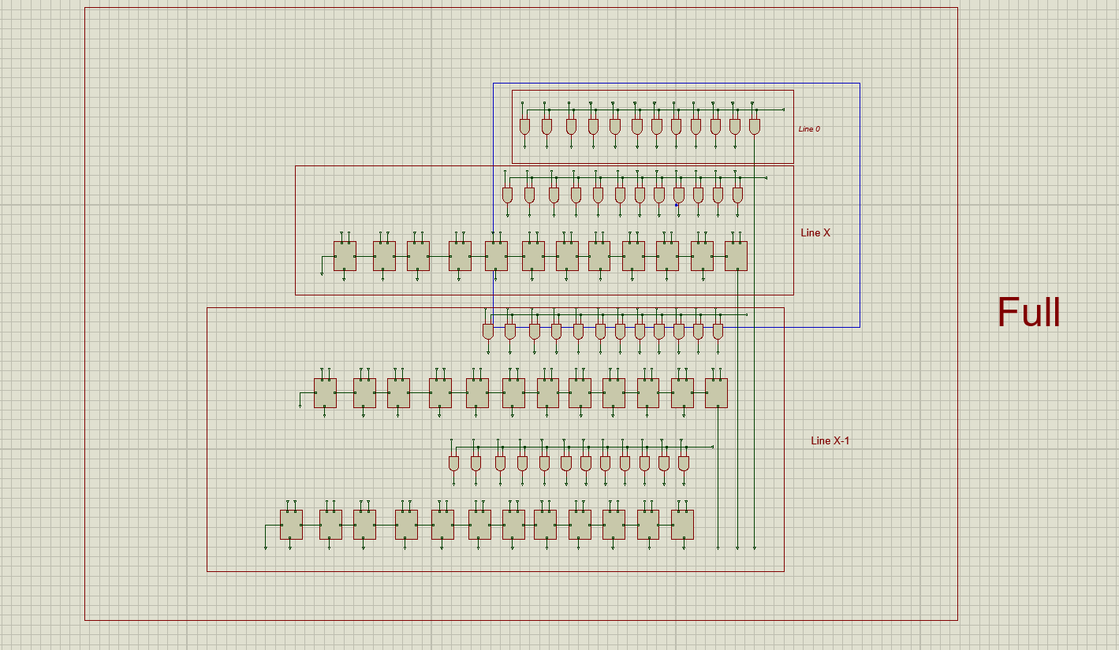
Figure 4: Proteus Full
When put together in full in figure 4, the outputs were Q1 – Q15.
2.3 VHDL Design

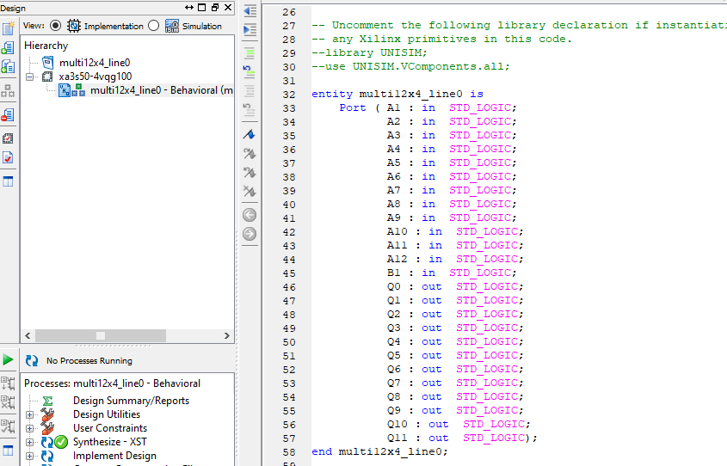
Figure 5: Line 0 Component
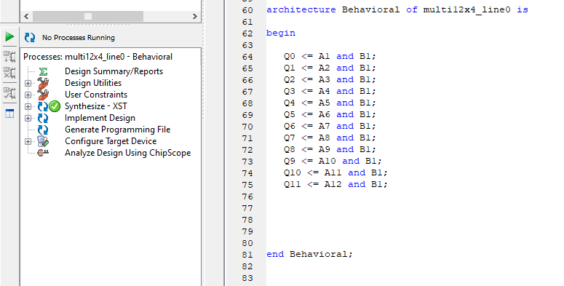
Figure 6: Line 0
The implementation for Line 0 is shown in the two screenshots above in figures 5 and 6. A1 – A12 and B1 are the inputs and Q0 – Q11 are the outputs. The outputs were given using an ‘and gate’ as shown in figure 6 above. Once the code had been written it could be checked by running. The result of this was issue free and therefore a green tick appeared as shown on the left side of Figures 5 and 6 above.

2.4 Simulation
The next step was to build the stimulation process by using the test bench source.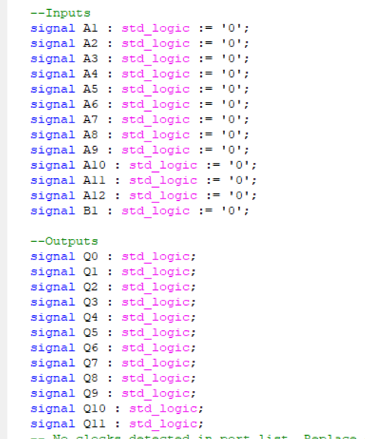

Figure 7:Line 0 Inputs and Outputs
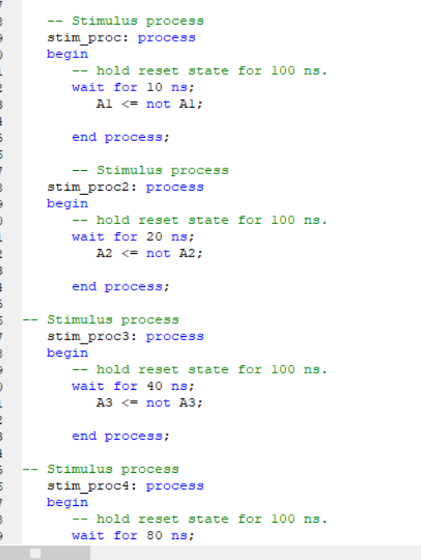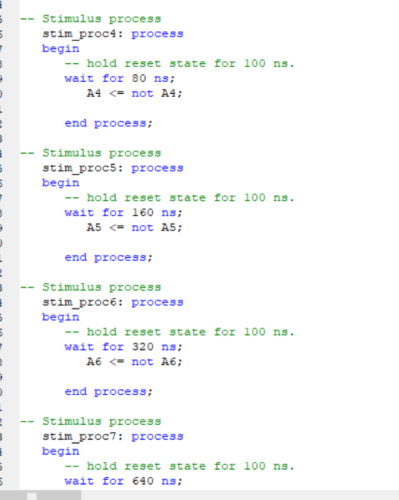
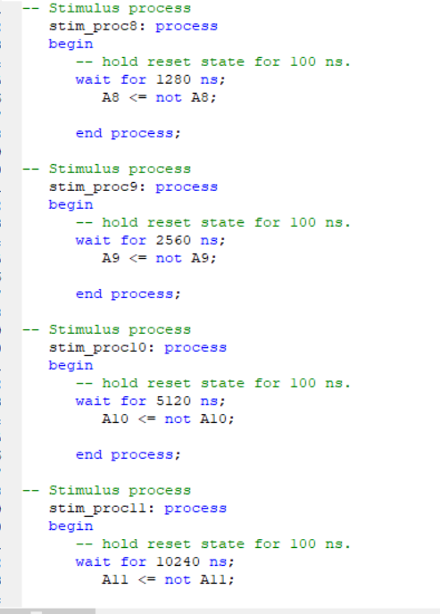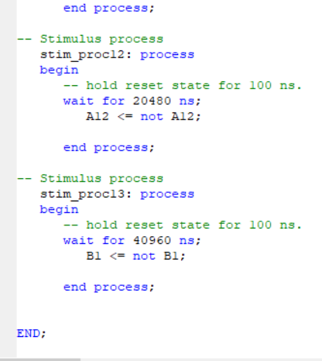
Figure 8: Line 0 Stim Process
As shown above in figure 7, all inputs started at 0 and all inputs were exercised by doubling the time for each one as shown in figure 8. Therefore, every 10 ns, A1 would flip between 0 and 1 likewise for A2 every 20 ns, A3 every 40 ns and so on. This allowed all the outputs for each input to be shown.
Again when the code has been built it can be checked by running and if it is correct a green tick will appear. The results can then be checked by simulation.

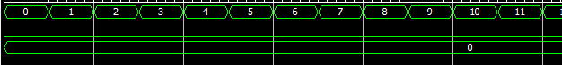

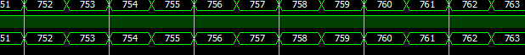
Figure 9: Line 0 (1)

As shown in the results in figure 9 when the inputs are multiplied by 0 the output is 0 and when the inputs are multiplied by one, the output is the same which is what should be happening.
This process was followed for the completion of line x however, this now involved adders because there was a multiplication between line 0 and line X. As well as A1 – A12 and B1 which are the inputs, now there is P1 – P12 which are the signals from the line before. These will be added to the input using half adders and full adders as shown below in figure 10.

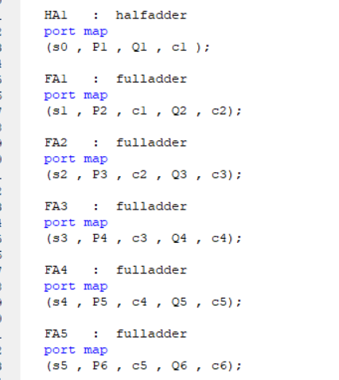
.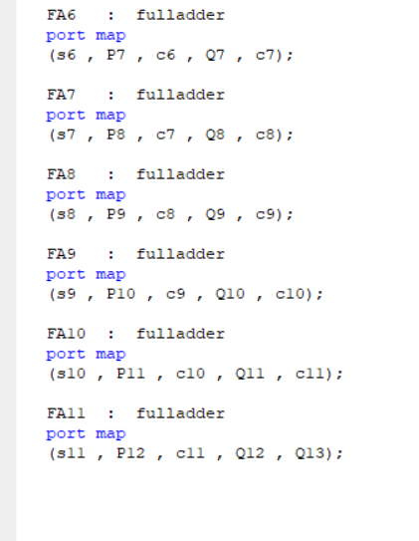
Figure 10 Line x Code

The signal S0 – S11 was added to P1 – P12 to give the outputs Q1 – Q13 in respect of the half adder, because it’s always the first adder that is used as it only has a carry in. The full adders have a carry in and carry out C1 – C12, however, the last full adder will only have a carry in and the carry out will become an output.

Again the same process was carried out for the simulation however the only difference was the signals from line 0 were added as P1 – P12. See figure 11 below.
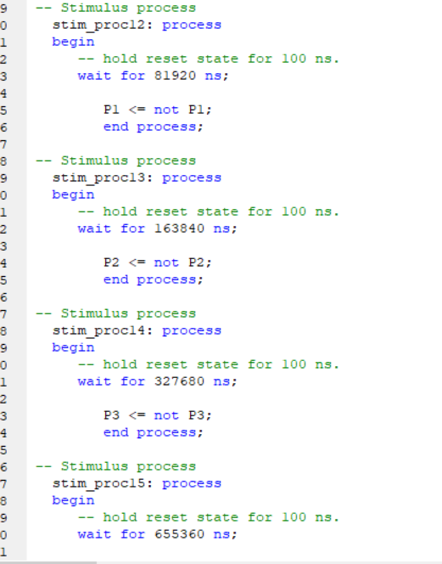
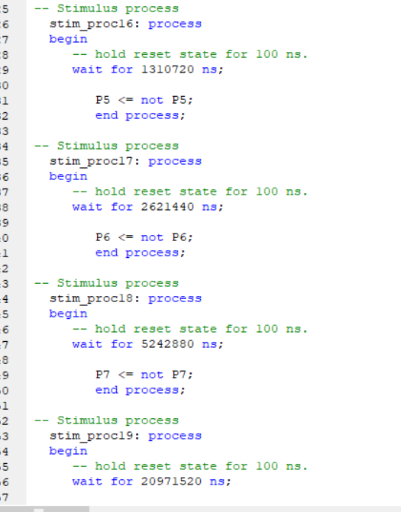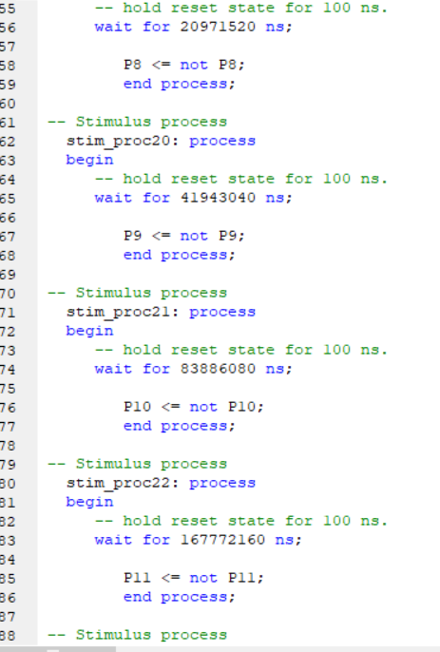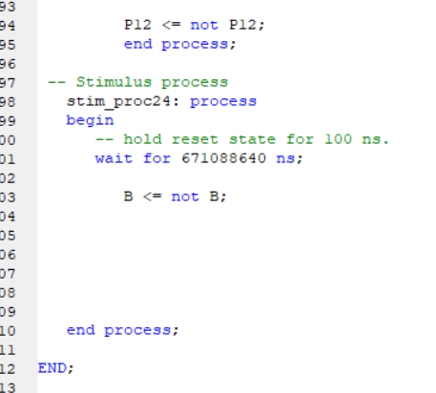
Figure 11: Line x Stim Process

The results for Line x are shown below in Figures 12 and 13.
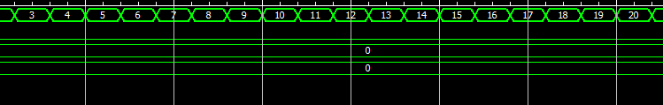
Figure 12:Line x (0)
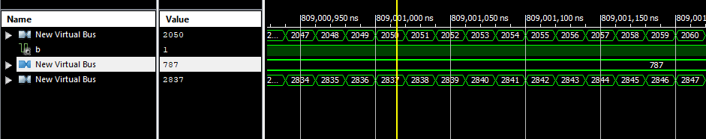
Figure 13: Line x (1)

When B was 0, both P and Q were the same. However when B was 1 then the output was the sum of both A and P which were the two signals coming in. This showed evidence that everything was working.
The next line then was line x-1 which would be the third multiplier line. This was the same process as line x and the results were as follows in Figures 14 and 15.
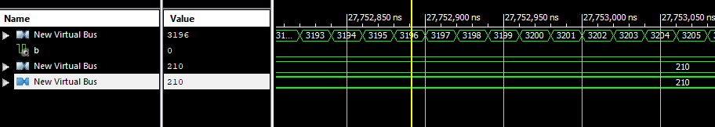
Figure 14:Line x-1 (0)
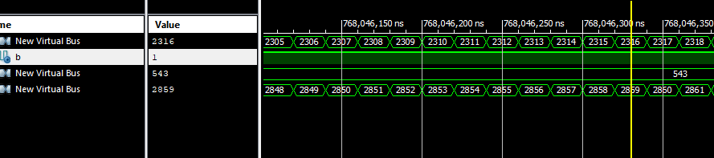
Figure 15: Line x-1 (1)
As before, the line x when B is 0, both P which is the signal from the line before and Q which is the output are the same. However when B is 1 then the output is the sum of the input and signal from the last line which again shows that this is correctly working.
Now all the lines have been completed, the last step of the multiplier is to put it all together.
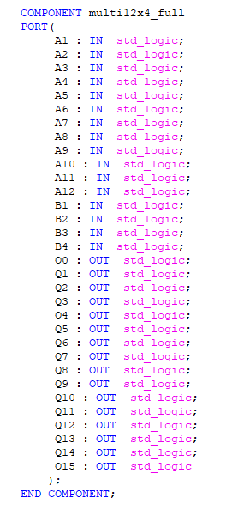
Figure 16:Component 12x4 full
As shown in figure16 above, this was done by firstly declaring the 12 x 4 multiplier as a full, with all the inputs and all the outputs, then by adding in the other component lines.
Following this the author had to declare all the signal from each line as shown in Figure 17 below.
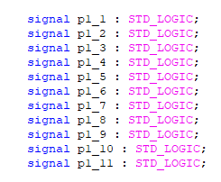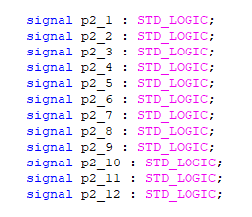
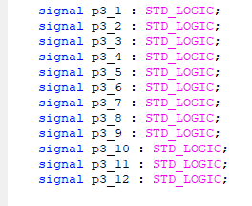
Figure 17: Signals 12x4 full

At this stage the code can be written beginning with line 1, using line 0.
Figure 18: Line 1 12x4 full

A1 – A12 are the inputs which are multiplied by B1. This gave one output Q0 and the first lot of signals that were added to the next line. Line 2 was started then using line x. See Figure 19.
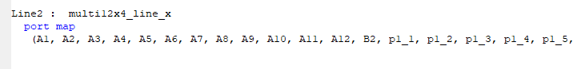
Figure 19: Line 2 12x4 full

As before, A1 – A12 were multiplied by B2 and added to the signal from the line before which gave a carry ‘0’ which became P12 on the next line and another output Q1. Line 3 was begun using line x1.

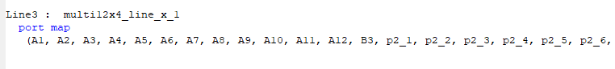
Figure 20: Line 3 12x4 full
In Figure 21 below, A1 – A12 were multiplied by B3 this time which gave the output Q2 and the signals to add to the next line. The next line would be the final line which was line 4 using line x1 again.
Figure 21: Line 4 12x4 full
As this was the last line A1 – A12 were multiplied to B4 and this gave the remainder of the outputs. Now the simulation for the full multiplier could be built using test bench as before. This was carried out using the same process however only the inputs were needed.
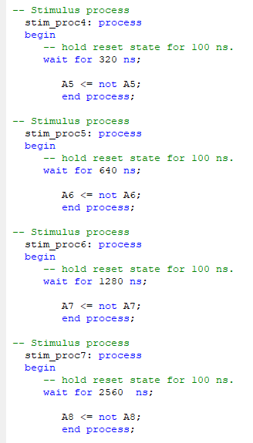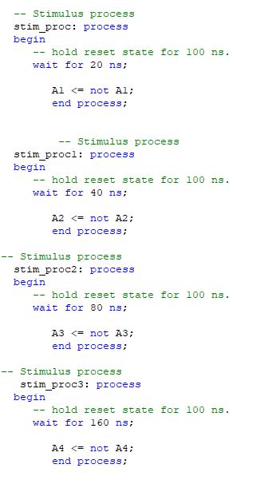

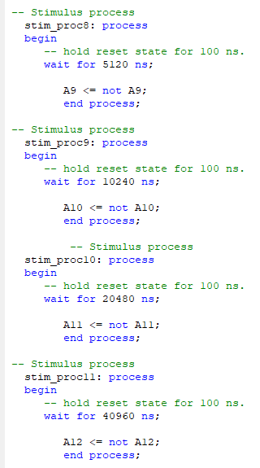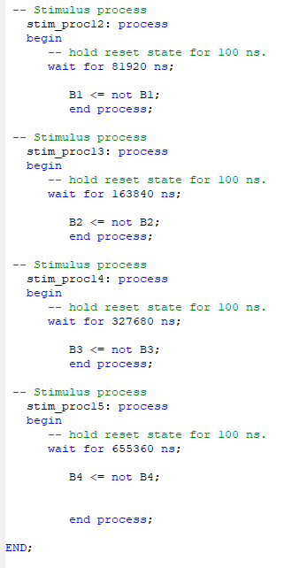
Figure 22: Stim process 12x4 full

The results are as shown below.
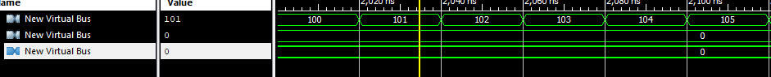
Figure 23: Multiplying by 0
When the numbers multiplied by zero the answer was zero as it should be.
Figure 24: Multiplying by 1

When the numbers are multiplied by 1 the outputs are the same which is correct.

Figure 25: Multiplying by 2 (problem)

Now when multiplying by two a problem arose, and this was that two inputs gave the same outputs. The author was not sure why this was happening. However this problem only occurred up until the input was at 2048 and then it went back to normal and multiplied by two as it should be therefore this could have been an internal problem.

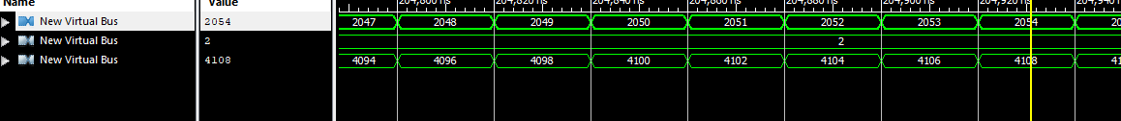
Figure 26: Multiplying by 2

There were no other issues found and the multiplier worked correctly.

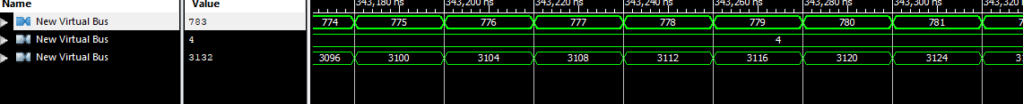
Figure 27: Multiplying by 4

Figure 28: Multiplying by 11

Figure 29: Multiplying by 8
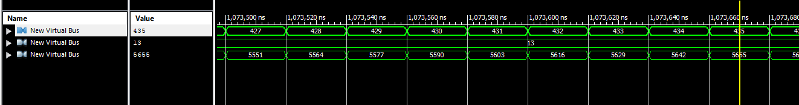
Figure 30: Multiplying by 13

2.5 Conclusion
In conclusion the author recommends using software to multiply binary as it is far more simple and straightforward and takes less time. However if the issue found by the author when multiplying by tow is an internal error then this could lead problems and could mean that multiplying by hardware is more accurate. Therefore the reason for this setback should be investigated further first.

3. Design of an FSM as both VHDL and Discrete Gate Solution
3.1 Introduction
The purpose of this task was to design, simulate and synthesise the FSM described by the state diagram below as both a VHDL and discrete gate solution.
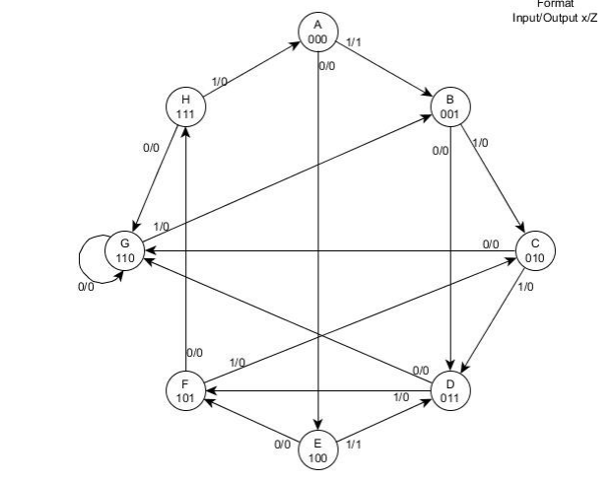
Figure 31: State Diagram

3.2 Discrete Gate Solution
The first part of this exercise was to design the discrete gate solution and this was done by firstly designing a state table. This will help in tabulating the next state code. The state table designed by the author is below in figure 32.
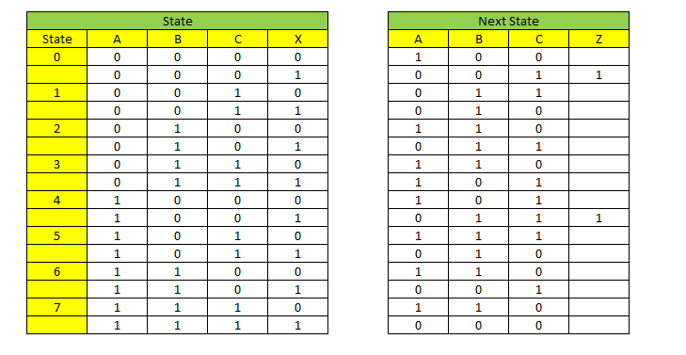
Figure 32: State Table
As shown in the state diagram there are 9 states with an input (x) and an output (z). The input x always changes between a 0 and a 1, this will decide which state is next as shown in the next state diagram in Figure 32 above. As shown the true next state is always the next state. Also shown in the state table, when in state 0 or 4 with a 1 then the output z will be a 1.
The Karnaugh maps could then be designed using this state table as shown below in figures 33-35. These were used to calculate the functions used in each state A, B and C which were referred to as Da, Db and Dc.
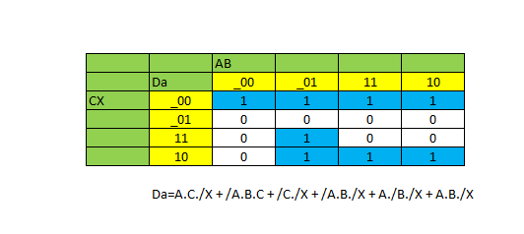
Figure 33: Karrnaugh Map Da
As shown in map Da there are 8 functions covered by 6 signals. The signals come from the loops of the functions which can be done in groups of 1, 2, 4 etc. loops can be done in adjacent.

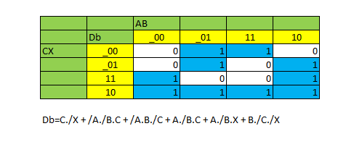
Figure 34: Karrnaugh Map Db
This map Db shows 10 functions with 6 signals

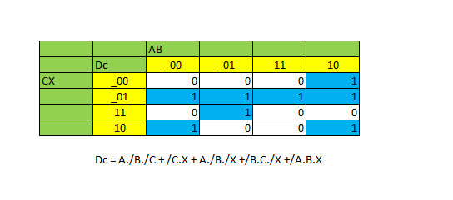
Figure 35: Karrnaugh Map Dc
This map Dc shows 9 functions with 5 signals.
The next step for the author now is the design the circuit using proteus as shown below.
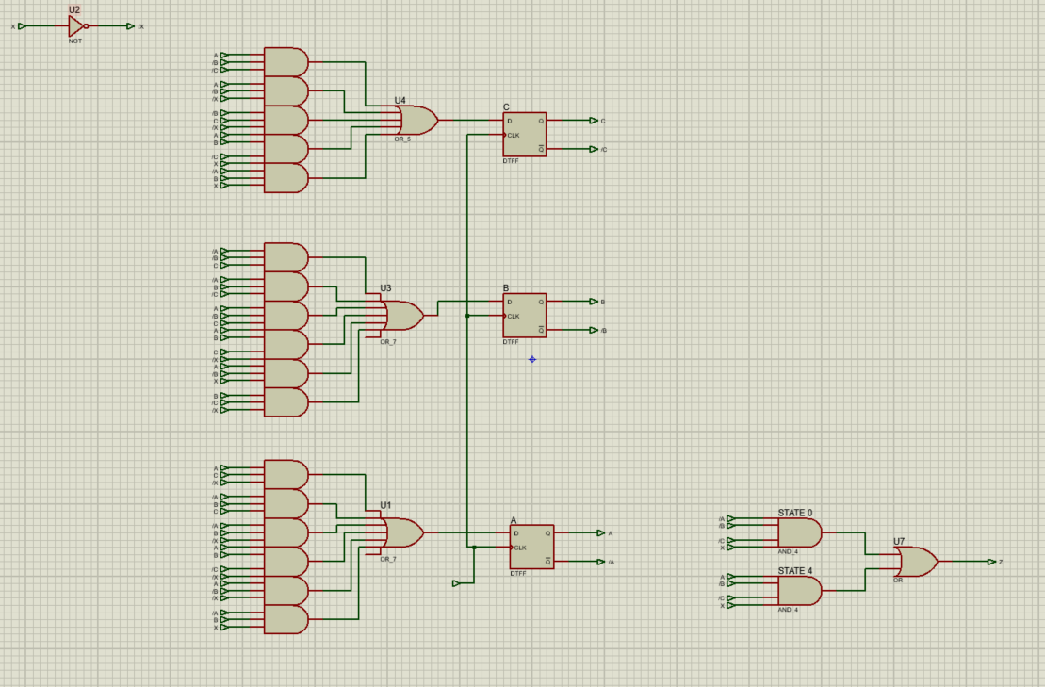
Figure 36: Full Circuit in Proteus
This is the full design including Da, Db, Dc the input and the output.
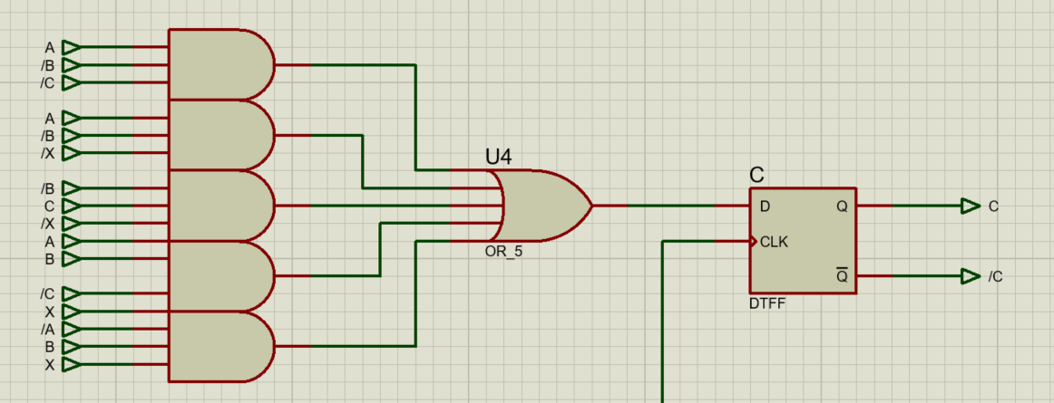

Figure 37: Circuit diagram Dc
Shown In figure 37 is the circuit for Dc which consists of four And Gates with 3 inputs, one And Gate with 4 inputs and an OR Gate with 5 inputs and a D type flip flop.

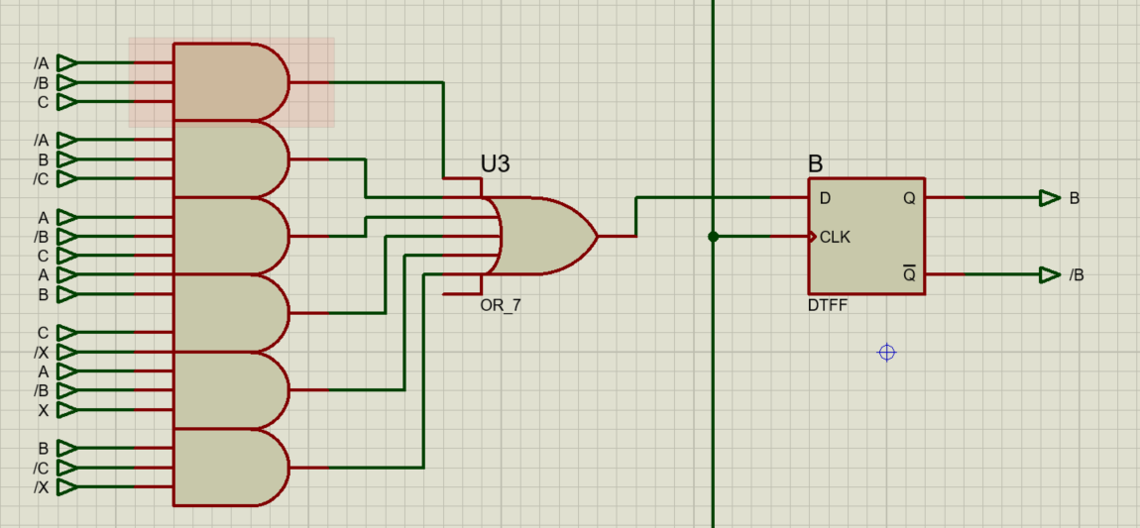

Figure 38: Circuit Diagram Db
Shown in Figure 38 the circuit diagram Db consisting of five And Gates with 3 inputs and one And Gate with 4 inputs and an OR Gate with 7 inputs however only 6 inputs were, the author could not find an OR Gate with 6 inputs.

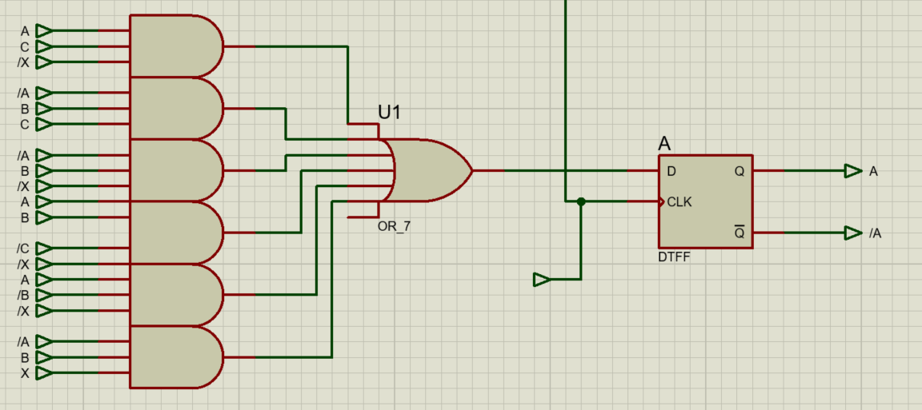

Figure 39: Circuit Diagram Da
Shown above in Figure 39 circuit diagram Da consisting of the same as Db.

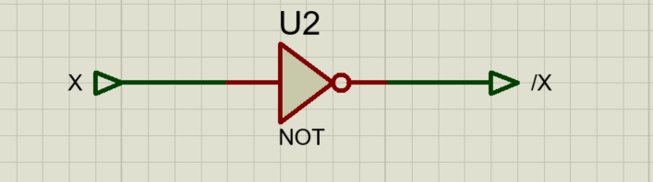
Figure 40: Input Circuit
Figure 40 shows the NOT Gate used for the input.

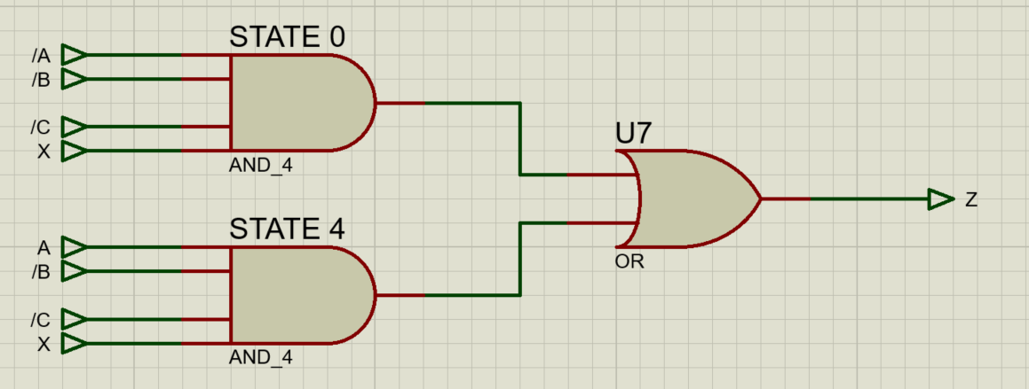
Figure 41:Output circuit
The output circuit shown above in Figure 41 consists of two And Gates with 4 inputs and an OR Gate.

3.3 VHDL
Now the author can design it in VHDL. This was done using the same process as in the first Chapter 2. with the multipliers.
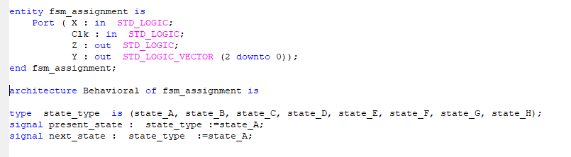

Figure 42: Implementation Code 1
The first step of this exercise was to declare the inputs and outputs. As shown in Figure 42 above, X and Z are the inputs and outputs. However the author also used a Clock as an input and Y as an output. The Y output was a bus three bits wide and this will show the user what state it is in.
The state type was then defined which was a new type and these were all the states used in the diagram. The author then defined to signals present state and next state and these were both initially set to state A.
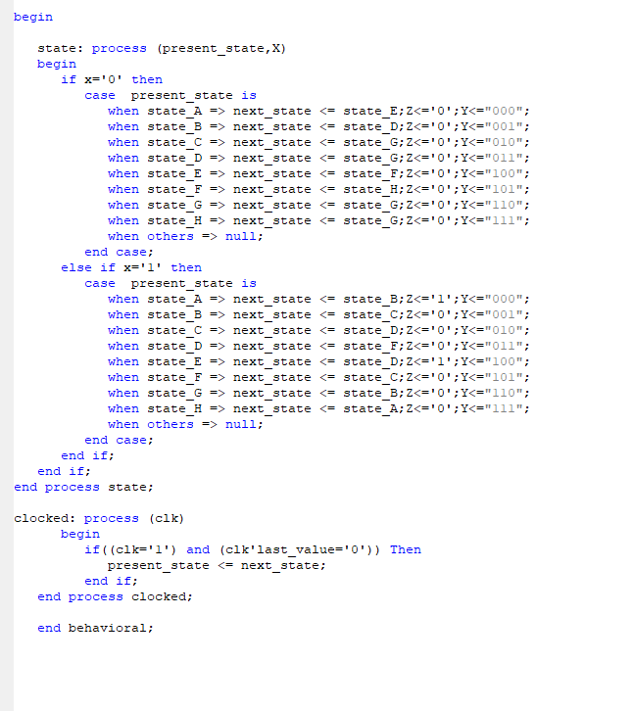

Figure 43: Implementation code 2

The next stage was to begin the code for the process of the states when x is equal to 0 and x is equal to 1. The author also included the outputs at each state and the statement when other => NULL which means when there is anything else then do nothing.
The author also used a clocked statement and this means the process is dependent on the clock. The process works when clock is equal to a 1 and the last value the clock looked at was a 0, then the present state equates to next state. This will give the leading edge of a pulse.
The next step is the simulation process. The author decided on a sequence for the simulation. The sequence is shown below in Figure 44.
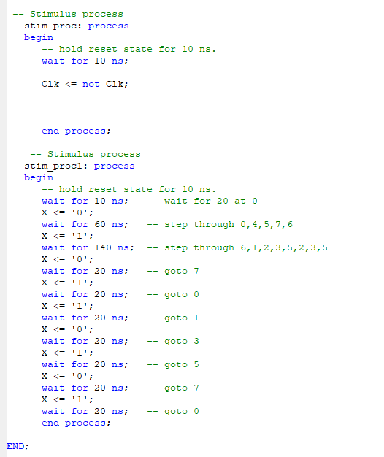
Figure 44: Sequence Process
As shown above the author decided firstly to step through 0, 4, 5 7, 6, as this is the direction of the state when x is equal to 0. Every step through takes 10 ns which is why 60 ns was chosen. This then stopped at state 6 as when x is equal to 1, it stayed in state 6.
The author then decided to step through 6,1,2,3,5,2,3,5 which was the direction of the state when x is equal to 1. The author ended the sequence at 5 as when x is equal to 1 it will keep stepping through 2,3, and 5. This is done by setting the wait time to 140ns.
The author then chose a sequence stepping through 7, 0, 1, 3, 5, 7 and 0. This was done by flipping the input between 1 to 0 to set the direction of the state diagram to follow this sequence.
The reason this sequence was chosen was because it is a recurring pattern in the state diagram.by the author.
The code was then simulated to see the results.
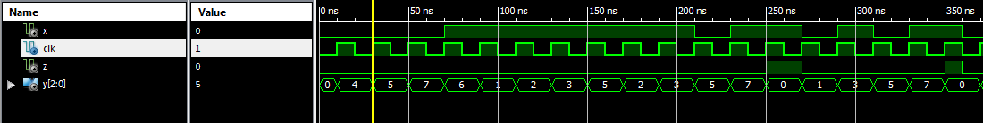
Figure 45: Results of Code Simulation
The results in figure 45 above clearly showed that the design has worked. As shown when x is equal to 0 it steps through 0,4,,5 and 7. Then x changes to 1 and steps through 6,1,2,3,5,2,3 and 5.
Following on from this the sequence the author chose stepping through 7, 0, ,1 3, 5, ,7 and 0. Also the results show that the clock process works as every time the state changes it is on the leading edge as indicated by the yellow marker line in figure 45.
3.4 Conclusion
In conclusion after this exercise, it is in the author’s opinion that the VHDL is a more efficient method of designing an FSM. It is simpler and quicker than discrete gate solution method and there were no issues internally or externally with the VHDL.
List of References
1. M.Adhikari, R.M.Mishra, S.Pine, Artile Title: Performance Evaluation and Implementation of Parallel Multipliers, Written for International Journal of VLSI VLSI System Design and Communication Systems Vol 5, Issue 3, March 2017 pp 0272-0278 found online at: http://www.ijvdcs.org/uploads/132564IJVDCS14069-51.pdf Accessed 14.3.21
2. T. Prabhu, V.Madhubala, M. Mahalakshmi, Article Title: Survey of VLSI Multipliers, written for International Journal of Advance Research in Scienece and Engineering Vol 06 Issue 10, October 2017, found online at: http://www.ijarse.com/images/fullpdf/1508765456_3054_ijarse.pdf Accessed 14.3.21
3. A.L.Sindhara, M.Vucha, T.Ravinder Article Title: Performance Evaluation of Parallel Multipliers, written for Journal of Engineering and Applied Sciences. 12(20): 5186-5189, 2017, found online at: http://docsdrive.com/pdfs/medwelljournals/jeasci/2017/5186-5189.pdf Accessed 14.3.21
4.P.Mishra, S.Nayak, Article Title: A Study of Wallace Tree Multiplier, published April 2018, found online at: https://www.researchgate.net/publication/327209221_A_study_on_Wallace_tree_multiplier Accessed 17.3.21
5. N. Koppala, R. Sreerama, , P. Satish, Article Title: written for International Journal of Computer Applications in Engineering Sciences [VOL II, ISSUE II, JUNE 2012] found online at: https://citeseerx.ist.psu.edu/viewdoc/download?doi=10.1.1.261.3138&rep=rep1&type=pdf Accessed 18.3.21
6. R.Prasannakumar, Article Title: A Review-Performance Analysis of Various Multipliers for Digital Processors, published July 2018, found online at: https://www.researchgate.net/publication/336825387_A_Review_-Performance_analysis_of_various_Multipliers_for_the_design_of_digital_processors Accessed 15.3.21
7. A.Kiran, N.Prashar Article Title: FPGA Implementation of High Speed BaughWooley Multiplier using Decomposition Logic found online at: https://arxiv.org/ftp/arxiv/papers/1509/1509.03575.pdf Accessed 16.3.21
8.T.Agarwal Article Title: What is a 4x4 Array Multiplier and it’s Workings? March 2020, written for Elprocus website, found online at https://www.elprocus.com/4x4-array-multiplier-and-its-working/ Accessed 15.3.21
9.S.T. Oskuii , Dissertation title: Design of Low-Power Reduction-Trees in Parallel Multipliers, Dissertation for Department of Electronics and Telecommunications Norwegian University of Science and Technology Trondheim, Norway, unknown date, found online at: https://core.ac.uk/download/pdf/52104064.pdf Accessed 14.3.21
10. H.Bansal, K.G.Sharma, T.Sharma, Article Title: Wallace Tree Multiplier Designs: A Performance Comparison Review, written for Innovative Systems design and Engineering Vol 5, No5, 2004, found online at: https://core.ac.uk/download/pdf/234643291.pdf Accessed 15.3.21
11. L Z Shinga,R Hussin, A Kamarudin, S N Mohyar, S Taking, M H A Aziz and N Ahmad, Article Title: 16X16 Fast Signed Multiplier Using Booth and Vedic Architecture, published 6.12.18 AIP Conference Proceedings 2045, 020085 (2018); found online at: https://doi.org/10.1063/1.5080898 Accessed 20.3.21
12. E.Jagadeeswara Rao et al, Article Title: A systematic Jurmal of Multipliers Accuracy and Performance, written for International Journal Engineering and Advanced Technology Vol 8, Issue 6S August 2019, found online at: https://www.ijeat.org/wp-content/uploads/papers/v8i6S/F11840886S19.pdf Accessed 15.3.21
13. S.P.Prakash. R.S. Valarmathi. M.Abdhullah, S.Kirubakaran , Article Title: Design and Analysis of Low Power Braun Multiplier Architecture ,written for International Journal of Pure and Applied Mathematics Volume 119 No. 16 2018, 4357-4363, published 2018, found online at: https://acadpubl.eu/hub/2018-119-16/2/454.pdf Accessed 21.3.21
14. A.Thomas, A.Jacob, S.Shibu,S.Sudhakaran, Article title: Comparison of Vedic Multiplier with Conventional Array and Wallace Tree Multiplier, 206, written for International Journal of VLSI System Design and Communication System ISSN 2322-0929 Vol 04, Issue 04, April 2016 pp02444-0248 found online at: http://www.ijvdcs.org/uploads/235146IJVDCS9274-48.pdf Accessed 22.3.21
14. R. Subalakshmi , Article Title: Analysis of low Power Parallel and Serial Array Multiplier, written for International journal of Engineering Research and Technology 24.4.18, found online at: https://www.ijert.org/analysis-of-low-power-parallel-and-serial-array-multiplier Accessed 14.3.21

Bibliography
P.J. Ashenden, Digital Design- an Embedded Systems Approach using VHDL, New Delhi, India, Elsevier Publications, 2007

List of Tables
Page

Table 1 Comparison of Multipliers 10
Table 2 Comparison of Parallel Multiplier Types 11

List of Figures
Page
Figure 1 Block Diagram of Multipliers 5
Figure 2 Proteus Line 0 and Line x 12
Figure 3 Proteus Line x-1 13
Figure 4 Proteus Full 13
Figure 5 Line 0 Component 14
Figure 6 Line 0 14
Figure 7 Line 0 Inputs and Outputs 16
Figure 8 Line 0 Stim Process 17
Figure 9 Line 0(1) 18
Figure 10 Line x Code 19
Figure 11 Line and Stim Process 20
Figure 12 Line x (0) 21
Figure 13 Line x (1) 21
Figure 14 Line x -1 (0) 21
Figure 15 Line x-1 (1) 21
Figure 16 Component 12x4 Full 22
Figure 17 Signals 12x4 Full 23
Figure 18 Line 1 12x4 Full 23
Figure 19 Line 2 12x4 Full 24
Figure 20 Line 3 12x4 Full 24
Figure 21 Line 4 12x4 Full 24
Figure 22 Stim Process 12x4 Full 25
Figure 23 Multiplying by 0 26
Figure 24 Multiplying by 1 26
Figure 25 Multiplying by 2 Problem 26
Figure 26 Multiplying by 2 26
Figure 27 Multiplying by 4 27
Figure 28 Multiplying by 11 27
Figure 29 Multiplying by 8 27
Figure 30 Multiplying by 13 27
Figure 31 State Diagram 38
Figure 32 State Table 29
Figure 33 Kamaugh Map Da 30
Figure 34 Kamaugh Map Db 30
Figure 35 Kamaugh Map Dc 31
Figure 36 Full Circuit in Proteus 31
Figure 37 Circuit Diagram Dc 32
Figure 38 Circuit Diagram Db 32
Figure 39 Circuit Diagram Da 33
Figure 40 Input Circuit 33
Figure 41 Output Circuit 34
Figure 42 Implementation Code 1 34
Figure 43 Implementation Code 2 35
Figure 44 Sequence Process 36
Figure 45 Results of Code Simulation 37

