Module Code: BMIH6008
Module Title: Hotel Placement Research Project

Research Topic
Analysing the Impact of Labour Challenges on Guest Experience: A Study on Biltmore Mayfair Hotel London

Student Name: Sorin Ciprian Chelm
Student ID: 2125245

Abstract
Labour issues have emerged as a major issue in the hospitality sector, particularly in luxury hotels, as quality service is expected. Staff shortage, high staff turnovers, reliance on trainee staff, and increased operational costs have had a significant impact on service performance and customer satisfaction. The issues have come to be particularly salient at Biltmore Mayfair Hotel, London, as maintenance of superior customer experience is key for brand reputation and sustainable performance. The aim of this research is to measure how labour challenges impact guest experience at London's Biltmore Mayfair Hotel. It explores how much labour shortage, staff retention issues, and training deficits impact service quality and customer satisfaction. The research is based on a mixed-methods research methodology, consolidating primary and secondary information. The primary data is taken in the form of semi-structured interviews across 10 staff members and employees at Biltmore Mayfair Hotel. These qualitative data has been analysed by applying thematic data analysis method. Secondary data is taken from industry reports, statistics regarding the staff and guests, and content analysis for identifying pattern and trend.
The research findings indicate increased service time, service quality variability, and increased numbers of guest complaints and lower satisfaction scores as a result of labour difficulties at Biltmore Mayfair Hotel. The research substantiates that excessive staff turnover and staffing deficiencies yield staff fatigue and have negative staff and guest experience implications. Training deficiencies and utilization of novice staff have intensified service inefficiencies. The research establishes staff retention, service quality, and overall guest satisfaction can be improved through AI-facilitated staff management, structured training programs, competitive compensation, and staff wellbeing programs.
The study provides staff management strategies for staff retention, streamlining processes, and maintaining service quality in luxury hotels. The implications for research are for managers in the hospitality sector, policymakers, and industry players in addressing staff volatility and maintaining service quality. The study is one of the early works in providing in-depth analysis of staff issues and impact on client experience at Biltmore Mayfair Hotel. It provides practical recommendations for managing staff shortage in luxury hospitality organizations while maintaining superior service quality.

Table of Contents
Abstract ii
Chapter 1: Introduction 1
1.1 Background 1
1.2 Research Problem 1
1.3 Research Aim 2
1.4 Research Objectives 2
1.5 Research Questions 2
1.6 Research Rationale 2
1.7 Summary 3
Chapter 2: Literature Review 4
2.1 Introduction 4
2.2 Theoretical Framework 4
2.3 Labour Challenges in the Hospitality Industry 5
2.4 Impact of Labour Shortages on Guest Experience 6
2.5 Literature Gap 7
2.6 Summary 7
Chapter 3: Methodology 8
3.1 Introduction 8
3.2 Research Methods 8
3.3 Data Collection 8
3.4 Data Analysis 9
3.4 Ethical Considerations 9
3.5 Summary 9
Chapter 4: Result and Findings 10
4.1 Introduction 10
4.2 Primary Research 10
4.2.1 Labour Challenges at the Biltmore Mayfair Hotel London 10
4.2.2 Impact of Labour Challenges on Guest Satisfaction and Service Quality 11
4.2.3 Strategies for Workforce Management to Enhance Guest Experience 13
4.3 Secondary Research 15
4.3.1 Labour Challenges in the Hospitality Industry – A Global and UK Perspective 15
4.3.2 Case Study Hotel 15
4.3.3 Strategies for Workforce Management to Enhance Guest Experience 19
4.4 Summary 19
Chapter 5: Discussion 20
5.1 Introduction 20
5.2 Discussion 20
5.2.1 Objective 1: Review of Labour Challenges in Hospitality and Guest Experience 20
5.2.2 Objective 2: Labour Challenges at Biltmore Mayfair Hotel 21
5.2.3 Objective 3: Impact of Labour Challenges on Guest Satisfaction and Service Quality 22
5.2.4 Objective 4: Recommendations for Effective Workforce Management Strategies 23
5.3 Summary 23
Chapter 6: Conclusion and Recommendations 25
6.1 Conclusion 25
6.2 Recommendations 26
References 28
Appendix 35
Interview Questions 35
Sources 36

List of Tables
Table 1: Labour Challenges at the Biltmore Mayfair Hotel London 10
Table 2: Impact of Labour Challenges on Guest Satisfaction and Service Quality 11
Table 3: Strategies for Workforce Management to Enhance Guest Experience 13
Table 4: SWOT Analysis 15
Table 5: PEST Analysis 16
Table 6: Competitor Analysis 17

Chapter 1: Introduction

1.1 Background
It is no doubt that the hospitality industry is the one with the biggest employment sectors all over the world and it is also an important drive towards the economy growth. Nevertheless, labour issues pose a very pressing concern, most notably in luxury hotels where the experience delivered to guests is very much tied to quality of service. As per the UK Hospitality Workforce Report (2023), the hospitality sector in the UK employs more than 3.2 million individuals and provides £130 bn towards the economy. ONS (2023) reported that the industry has struggled to maintain an adequate workforce carrying levels with staff levels falling by 12% after the pandemic. There is a high rate of employees turning over in luxury hotels, with an annual attrition rate of about 30% and being solely attributed to demanding job environments, long hours, and lack of career progressions.
A key case of how labour challenges affect customer satisfaction is the Biltmore Mayfair Hotel, a five-star luxury hotel located in London (The Biltmore Mayfair, 2025). According to UKHospitality (2023)., labour shortages cause the quality of service to decrease, waiting times to increase, and inconsistency in the way employee interact with guests. A frequent cause for negative experiences stemming from the guest reviews on platforms such as TripAdvisor is the fact that the staff are in short supply. In addition, the British Hospitality Association (2023) conducted a survey which found that a third (36%) of those visiting luxury hotels consider them to have low quality service, and this is a direct link between quality in the workforce and customer satisfaction. Then, this study attempts to investigate these labour related issues or its effect on the Biltmore Mayfair Hotel guest’s experience. The research aims to help hospitality managers identify problem areas and suggested solutions to improve operational efficiency and service quality by describing how the problem is articulated.

1.2 Research Problem
Luxury hotels specifically are highly dependent on a proficient and inspired labour force to guarantee great service benchmarks. Although, for labour shortages, high employee turnover and skill gaps represented significant operational challenges that damaged guest experience, to a lesser extent. The problem of these issues presenting at the Biltmore Mayfair Hotel surface in lower service efficiency, longer wait time, and incongruous customer interaction. The objective of this research is to study the effect of the labour problems challenge to guest satisfaction, to find out the key problem areas and suggest strategies for the elimination of labour problems challenges for the sustained service quality and operational sustainability for the luxury hospitality.

1.3 Research Aim
The aim of this research is to analyze the impact of labour challenges on guest experience at the Biltmore Mayfair Hotel London

1.4 Research Objectives
- To conduct an extant literature review of labour challenges in the hospitality industry and their impact on guest experience.
- To examine the specific labour challenges faced by the Biltmore Mayfair Hotel London
- To assess the impact of these labour challenges on guest satisfaction, service quality, and overall customer experience at the hotel.
- To make recommendations for effective workforce management strategies to mitigate labour challenges and enhance guest experience at the Biltmore Mayfair Hotel London.

1.5 Research Questions
- Q1: How do labour challenges, such as staffing shortages and employee retention issues, affect guest experience and service quality at the Biltmore Mayfair Hotel London?
- Q2: What strategies can be implemented to address labour challenges and improve guest satisfaction at the Biltmore Mayfair Hotel London?

1.6 Research Rationale
Exceptional guest experiences are vital in the hospitality industry to thrive, and therefore the quality of labour is more so a determining factor when it comes to guest satisfaction. Grigoryan (2024) mentioned that staff shortages, high turnover rates, and skill shortage, directly impacts the service efficiency, personalized interaction, and the reputation of a hotel. In the luxury hotels like the Biltmore Mayfair, where guests expect premium services, labour challenges will have a negative effect on their experience and in turn generate negative reviews and affect the revenue earned. Han (2020) opined that to keep up the service excellence and brand loyalty, it is necessary to address these workforce issues.
This research is an attempt to study labour problems effect on guest satisfaction at the Biltmore Mayfair Hotel. This research explores some of the problem areas, assesses their consequences, and identifies strategies that would be promising to resolve identified problems. The study analyzes real world cases and guest data to offer practical insights into solutions to address workforce related concerns. This research adds to existing literature in filling the gap between labour management and guest experience in luxury hospitality. It provides empirical evidence on how staffing issues affect customer perception to enhance the body of service quality research. This will be useful to hotel managers, hospitality policymakers and training institutions. Understanding labour related constraints is important to the businesses as they can develop better workforce strategies and operational efficiency while improving the guest experiences. In addition, these results can be used to design the hospitality training programs developed by recruitment agencies and the educational institution.

1.7 Summary
This chapter introduces the study about challenges of labour and its effect on guest experience at the Biltmore Mayfair Hotel. This research background states the problem, objectives, significance and scope. It role in luxury hospitality of workforce management, especially taking place back in service quality and customer satisfaction.

Chapter 2: Literature Review

2.1 Introduction
The aim of this chapter is to provide a review of the literature on labour challenges in the hospitality industry with particular reference to their effect on guest experience. Workforce issues were explored, research gaps are examined in the specific area of luxury hotels and management strategies are presented for maintaining optimal service quality.

2.2 Theoretical Framework
A critical review of the theoretical models pertaining to labour challenges on the guest experience in the hospitality industry is required to understand its impact. Herzberg's Two-Factor Theory, the SERVQUAL Model, and Human Capital Theory offer valuable insights into the dynamics between employee satisfaction, service quality, and organisational performance.
Bishayee (2019) stated that Herzberg’s Two Factor Theory indicates job satisfaction and dissatisfaction are the two different groups of factors, hygiene factors and motivators. Intrinsic to the job are core activity motivators such as recognition and achievement, and they contribute to the job satisfaction. On the contrary, hygiene factors (salary and working conditions) are extrinsic and if inadequate they cause unhappiness. Yousaf (2019) opined that this theory has been applied in empirical works on the context of the hospitality industry to explain employees turnover. Bhatt et al. (2022) mentioned that making employees happy is difficult, as Herzberg's framework so well explains, and so there is a need to recognise that if you are going to reduce turnover, you still need to address hygiene factors and motivators. However, some researchers claim that Herzberg’s model over simplifies the complexities of job satisfaction; factors that influence contentedness among employees are closer than the theory suggests.
According to Gregory (2019), the SERVQUAL Model is a gap model measuring service quality across five dimensions: tangibles, reliability, responsiveness, assurance and empathy. If labour shortages affect personal service dimensions in a luxury hotel, guest satisfaction is likely to be adversely affected. For instance, slow response times and lack of reliability directly impact the guest experience as it relates to a lack of adequately trained staff. Jebraeily et al. (2019) revealed that the fact that SERVQUAL is widely adopted has also been questioned by other studies, which have speculated that the model needs to be adapted to capture the idea of service quality perceptions across different regions.
Human Capital Theory claims that human capital investments are a meaningful investment in the performance of the organisation in question. Continuous training and development are extremely imperative in the hospitality sector as high service standards must be kept. According to Hsiao et al. (2017) a study that highlighted hotel employees with training opportunities were less disposed to job dissatisfaction and committedness, which then enhances guest experiences. Okae (2018) observed that implementing these wide-ranging training programs is going to drilly up huge financial resources, some organizations might not be able to afford them and may rely on being staffed by people who are not yet experienced enough to provide good service.

2.3 Labour Challenges in the Hospitality Industry
The hospitality industry is facing some big labour challenges, including high turnover, shortages of staff, and increasing entirely necessary operational costs. The consequences of these issues are of great importance in terms of service quality and business sustainability. The problem of high staff turnover still persists. HR Cloud (2021) reported that in 2020, turnover rate was 130.7% in hospitality sector. This trend continues as 67 percent of hoteliers reported staffing shortages—12 percent severe—and for hotel cleaners, especially. Such turnover disrupts service delivery and entails high recruitment and training costs. Chebet, Makomere and Karei (2019) identified three main factors for leaving this industry, i.e., inadequate work –life balance, lack of compensation, and job insecurity. Nevertheless, no significant effect of the government issued unemployment benefits on turnover intentions is established.
This burnout has been caused by increased workloads for existing employees due to staffing shortages. Postova et al. (2023) refers that ever-reduced staffing levels makes employees work extra hard and finally poor work life balance results in poor productivity. The COVID-19 pandemic has made difficulties in recruiting skilled workers even more difficult as this situation is compounded. According to Iannuzzi (2023), one third of unemployed hospitality workers did not want to return to the industry—the loss of experienced personnel amounted to a significant number. The opposition was reported by Chan and McGinley (2024) when it claimed that even though the leisure and hospitality section misplaced 781,000 employees in January 2024, it appealed to hire 1.05 million dwellers that easy month, a dynamic however unruly labour market.
Lončar and Knežević (2023) mentioned that the high turnover rates of temporary workers in the hospitality sector also brought in inexperienced or unskilled people to provide service, thereby affecting service quality and guest satisfaction. Given the high number of seasoned employees exiting about, hotels turn to hiring less experienced employees to get these seats done fast. In the UK, hospitality workers have just one year or less experience, as per British Hospitality Association (2023), 37.7 per cent of hospitality employees do not have one year or more experience which causes variability in service provision and hamper the overall operations. New hires are insufficiently trained and not developed in the skills needed, which increases the service time and subsequently the complaint rate and increased pressure on existing employees. Singh (2024) identified that industry leaders claim that the younger, less experienced workforce provides the innovation and adaptability to the service delivery. Cimbaljević et al. (2020) argued that without structured training programs and progression opportunities in structured career path, the industry will continue to create cycle of low retention and low service standards, not only continue to no further maintain long term sustainability, but further highlight itself to be a non progressive industry.

2.4 Impact of Labour Shortages on Guest Experience
The lack of availability of labour in the hospitality industry affects guest experience greatly in terms of their service quality, would present operational challenges and could potentially lead to losses in revenue. The American Hotel & Lodging Association (2024) revealed that 76 percent of hotels reported staffing shortages and that 13 percent in June 2024, reported having so many people that the operational capabilities were impaired. As a result of their scarcity of staff, wait times are longer, service offerings are smaller and overall guest satisfaction declines.
It is apparent to have a direct correlation between staffing levels and service quality. As stated by Epos Now (2023), poor staffing results in longer wait times and fewer amenities available, which angers the guests, who then look for other places to stay. This line of thinking is echoed by Alananzeh et al. (2023) who opine that labour shortages have lead to suboptimal guest experience that negatively impacts customer satisfaction score and even temporary closure of such facilities as restaurants. Nevertheless, Alamoudi (2024) stated that technological advancement and process automatisation are said to address to some parts of the effects of staff shortage. Automation can be beneficial for efficiency, but may exclude the need for some of the touch and will generally affect guest perceptions and satisfaction.
Further, the lack of availability of resources as a means of compensating shortages can overshort existing staff, which would cause employee burnout and compromise the quality of service. Lončar and Čerović (2023) found that 53% of UK hospitality managers logged that staff shortages and burnout damaged their teams, resulting in busier workloads and longer guest waiting times. This has turned into a vicious loop situation wherein lower service quality brings about guest disappointment, which in turn compromises the business' notoriety and money related execution.

2.5 Literature Gap
Research on labour challenges in the hospitality industry has been quite extensive, but there is very little academic work on the latter topic as applicable to luxury hotels. Most studies deal with the general hotel operation issues without considering the distinctive service expectations and the more complicated circumstances in high end hotels. Also, there is ineffectiveness of research on suitable workforce management techniques leading to best quality of service in the presence of shortages of staff. Much is not known around how luxury hotels can ameliorate working conditions while maintaining the optimal level of service to guarantee the ultimate in the guest experience, which is fundamental part of brand image and customer loyalty.

2.6 Summary
This chapter reviews the effects of labour challenges that affects hospitality industry and in particular, luxury hotels. It touches on theoretical models, workforce shortages and the practical implications of service quality and discusses workforce management strategies. Finally, the chapter identifies research areas related to effective solutions for struggling to provide high service standards in luxury hotels amidst constraints in staffing.

Chapter 3: Methodology

3.1 Introduction
This chapter outlines the research methodology undertaken regarding labour challenges and their effects on guests’ experiences at the Biltimore Mayfair Hotel. The research presents the research methods, methods of data collection, analysis, ethical considerations, etc.

3.2 Research Methods
Using a mixed methods approach, the study integrates both qualitative and quantitative data to understand labour challenges in relation to guest experience of Biltmore Mayfair hotel, London. This research qualitative component comprises semi structured interviews of hotel workers and management on the key themes of staff shortages, staffing problems, work load management and service quality. This personal exploration allows a deep exploration of personal experiences and operational challenges (Creswell & Creswell, 2018). The quantitative part consists of secondary data analysis (guests’ reviews from online platforms, industry reports, statistical labour turnover etc.). The measures given by these datasets offer a broader understanding of workforce trends and the guest satisfaction levels (Saunders et al., 2019).

3.3 Data Collection
For this study, both primary as well as secondary data collection methods have been used to a whole set of labour issues and its toll on the guest experiences at the Biltmore Mayfair Hotel, London. Semi structured interviews are used to collect primary data with 10 hotel employees as well as management staff of Biltmore Mayfair Hotel. These interviews revolved around the issue of staffing shortages, staff retention fears, workload management, and service quality. The participants have been selected purposively based on their direct involvement in hotel operations. This non-probability sampling technique has enabled the selection of key informants that are experienced in labour related issues resulting in the in-depth perspectives in labour issues (Bryman, 2016).
The data collected is secondary data obtained from the industry reports, hospitality workforce statistics, guest opinions and also academic literature. The data in this study was analyzed through a case study strategy using the actual reports of real-world hospitality industry, labour market surveys, and online guest feedback on platforms such as TripAdvisor and Google Reviews. This has included reports by British Hospitality Association, Office for National Statistics (ONS) reports and workforce analysis reports. The study has also undertaken the SWOT analysis, PEST analysis and competitor analysis to understand labour challenges in luxury hotels from a broader perspective of the factors affecting it on external or internal levels (Yin, 2018) . The conclusions on labour challenges and how they influence guest experiences have been validated with these analytical tools, have been used to cover a broader scope of the industry, and have been used to validate the primary findings of the study.

3.4 Data Analysis
Primary qualitative data collected from semi structured interviews have been used and analyzed followed by the thematic analysis. Thematic analysis enables us to identify repeat patterns, themes and insights pertaining to labour issue, retention problem and service quality at the Biltmore Mayfair Hotel (Braun and Clarke, 2019. By doing so, this method guarantees a systematic and structured analytical procedure with respect to interview responses. In secondary data, industry reports, guest reviews and competitor analysis were used as a basis for content analysis (Krippendorff, 2018).

3.4 Ethical Considerations
In carrying out this research, certain ethnical regulations as confidential rights, voluntary participation and protection of the data have been respected. All interview participants have been informed of the purpose of the study and have their right to withdraw at any time consented from. Information that can identify the respondent or organization is removed for confidentiality and anonymity (British Psychological Society, 2021).. The given data storage is secured according to General Data Protection Regulation (GDPR). Data has been collected and compiled and all used for research only in line with academic and institutional standards regarding ethical approval of research.

3.5 Summary
Using secondary data content analysis and qualitative interview thematic analysis both of which have been justified in this chapter. Further, the sampling strategy, data sources and ethical issues are clearly spelt out. This methodology will allow to conduct a comprehensive and valid analysis of labour problems that affect the guest experience in luxury hospitality.

Chapter 4: Result and Findings

4.1 Introduction
The results and findings of both primary and secondary data were presented in this chapter where they are used to conduct labour challenges and how they affect guest experience at the Biltmore Mayfair Hotel. The responses were taken from various interviews of ten hotel employees and management staff about the staff shortages problems, retention issues, workload management and service quality. The data gathered from secondary sources was industry reports, labour market statistics and guest reviews on platforms

4.2 Primary Research

4.2.1 Labour Challenges at the Biltmore Mayfair Hotel London
Using these key themes and direct quotes from interviews, this section of the research offers to highlight how the interviewees face specific labour challenges with regards to the operation of the Biltmore Mayfair Hotel London.
Table 1: Labour Challenges at the Biltmore Mayfair Hotel London
Quotes | Themes
"We are constantly short-staffed, which makes it difficult to meet guest expectations during peak hours."  "Due to a lack of employees, we often have to multitask, which affects service quality." | Staff Shortages
"It's hard to retain skilled workers as many leave for better pay and work-life balance elsewhere."  "Many employees quit within months due to the demanding nature of the job and long working hours." | High Employee Turnover
"There aren’t enough structured training programs, which means new employees take longer to adapt."  "We don’t get enough time for on-the-job training, leading to inconsistencies in service delivery." | Lack of Training & Skill Development
"Many of us work extra hours without additional compensation, which affects our morale."  "The pressure of handling too many guests at once results in exhaustion and frustration." | Workload and Employee Burnout
"The high cost of living in London makes it hard to survive on current wages."  "Our salaries haven’t increased in line with inflation, making retention a big issue." | Low Wages and Financial Stress
"Some departments are understaffed, while others are overstaffed, creating operational inefficiencies."  "The lack of a proper scheduling system results in irregular shifts and affects staff availability." | Operational and Scheduling Issues

There are a number of points of labour challenge working within the Biltmore Mayfair Hotel, affecting the operation and quality of service. The staff shortage forces employees to do double duty, making efficiency suffer. It fuels your high employee turnover because the hours are long, and elsewhere there are better opportunities. Service adaptation is delayed until staff lacks training, while workload and burnout decrease staff morale. Low wages and financial stress are also reasons for discouragement from retention and operational inefficiencies in scheduling further disrupt operations and overall guest satisfaction.

4.2.2 Impact of Labour Challenges on Guest Satisfaction and Service Quality
This section states the key themes and direct quotes from interviews about how the labour challenges affect the guest satisfaction and service quality at the Biltmore Mayfair Hotel London. An insight shows how staff shortages, service inefficiencies and falling guest experience are all linked to broad customer satisfaction results.
Table 2: Impact of Labour Challenges on Guest Satisfaction and Service Quality
Quotes | Themes
"Guests often complain about long waiting times due to staff shortages."  "During peak hours, we struggle to provide timely service, leading to guest dissatisfaction." | Long Wait Times and Delayed Service
"Due to limited staff, housekeeping requests take longer, frustrating guests."  "Room cleanliness has been compromised because housekeeping is understaffed." | Reduced Housekeeping Efficiency
"Guests expect personalised service, but with fewer staff, it’s impossible to maintain that standard."  "We don’t have enough time to engage with guests properly, affecting their overall experience." | Lack of Personalised Guest Experience
"Mistakes happen more frequently because employees are overworked and exhausted."  "Due to the high turnover, we often have new staff who aren’t fully trained, leading to service inconsistencies." | Increased Errors in Service Delivery
"Negative guest feedback has increased, mainly due to slow service and lack of staff availability."  "We’ve seen more complaints on online platforms about inconsistent service and poor guest experiences." | Declining Customer Satisfaction Scores
"When we are short-staffed, we have to cut back on certain services, which guests immediately notice."  "The restaurant sometimes operates at reduced capacity because there aren’t enough staff to manage all tables." | Service Reductions and Limited Offerings

Biltmore Mayfair Hotel has been facing significant labour challenges at the guest satisfaction and service quality levels have also been aplenty. During the peak hours, the guests are really frustrated by long wait time and delayed service. An issue is that housekeeping is inefficient, which leads to problems of how clean the room is. Personalised service is totally lacking, which lowers guest engagement, and there is a decline in service delivery, customer satisfaction scores and growing dissatisfaction. Also, staff shortages lead to service reductions, which affects the provision of hotels, affecting overall guest experience.

4.2.3 Strategies for Workforce Management to Enhance Guest Experience
This section illustrates strategies for workforce management to facilitate better guest experience at the Biltmore Mayfair Hotel London by presenting, key themes and direct quotes from the interviews. These strategies are an attempt to overcome labour challenges, to increase employee retention and improve service quality, thereby providing better hotel guests.
Table 3: Strategies for Workforce Management to Enhance Guest Experience
Quotes | Themes
"We need to focus on hiring staff who see hospitality as a career rather than just a temporary job."  "Offering career progression and training opportunities would make employees stay longer." | Improved Recruitment and Retention
"A structured training program ensures that new employees quickly adapt to service standards."  "Ongoing training workshops help staff refine their skills, leading to better service quality." | Comprehensive Training Programs
"Proper shift scheduling can prevent staff from being overworked and exhausted."  "Having enough staff on shift means everyone can focus on their roles, improving efficiency." | Better Workload Distribution
"Employee incentives, like performance bonuses and recognition, increase motivation and reduce turnover."  "When staff feel valued, they put more effort into delivering excellent guest experiences." | Staff Incentives and Motivation Strategies
"Technology, such as self-check-in kiosks, reduces pressure on front desk staff and speeds up service."  "Using automation for certain tasks allows staff to focus more on personalised guest interactions." | Adoption of Technology in Hotel Operations
"Wellness programs and mental health support for employees can improve job satisfaction and productivity."  "Ensuring employees have a proper work-life balance is crucial for keeping them motivated and reducing turnover." | Employee Well-being Initiatives
"Training staff to handle multiple roles means we can manage peak times better without being understaffed."  "Employees who are cross-trained can step into different roles when needed, improving operational efficiency." | Cross-training and Multi-skilling Programs

Workforce management strategies that work effectively help to keep the service quality and guest satisfaction constant. Recruitment and retention efforts are improved to reduce turnover; training programs that cover everything from basic management to skills training can help improve employee skills. Workload distribution is better, burnout is reduced, there are staff incentives and motivation strategies to boost engagement. Acceptance of technology in hotel operations enhances the delivery of service to customers, and employee wellbeing initiatives lead to increased job satisfaction and morale among employees. Additionally, such cross training and multi skilling programs help make the organization operational flexible to adapt easily to whatever role needs to be filled.

4.3 Secondary Research

4.3.1 Labour Challenges in the Hospitality Industry – A Global and UK Perspective
Labour shortages, high turnover rates and unstable workforce have affected the hospitality industry greatly. According Birdir and Birdir (2024), globally, the hospitality sector experienced a 62% employee turnover rate, and luxury hotels’ attrition level is even higher. Post pandemic, visitors to the hospitality changed by 12 % in the UK, causing severe operational disruptions.
There are staff shortages, and 76 per cent of UK hotels are having problems filling vacancies, namely in housekeeping and reception roles (Sonmez et al., 2023). This has resulted into longer delays in serving the guests, increased workloads and guest dissatisfaction as hotels run optimally shorthanded. Furthermore, 44% of hospitality employees in the UK leave their jobs in the first year particularly due to low pay, long hours and lack of opportunities to progress
Labour shortages have been exacerbated since 2020 by the impact of Brexit, and EU hospitality workers have fallen by 24% since then (Djajasinga et al., 2021). Luxury hotels in Biltmore Mayfair are driven to resort to inexperienced or undertrained staff which in turn affects service quality. The UK’s minimum wage has also increased by 9.8% in 2024, putting additional pressure on businesses to absorb these wage costs (Kokkranikal et al., 2024). Recruitment difficulties faced by 90% of UK hotels necessitates an effective way to train programs, improved working conditions, and automation to maintain quality of service in luxury hospitality sector.

4.3.2 Case Study Hotel
4.3.2.1 SWOT Analysis
Through the SWOT analysis, the Strengths, Weaknesses, Opportunities, and Threats pertaining to area of the luxury hospitality workforce challenges are calibrated on the both Biltmore Mayfair Hotel London.
Table 4: SWOT Analysis
Strengths | Weaknesses
-Established reputation attracts skilled hospitality professionals.  -Competitive salaries compared to mid-tier hotels.  -Strong leadership and management structure for workforce organisation (The Biltmore Mayfair, 2025)  -Opportunities for career progression enhance employee retention. | -High employee turnover leads to frequent staff shortages.  -Inconsistent service delivery due to inexperienced or undertrained staff.  -High workload and long working hours cause burnout and dissatisfaction.  -Limited structured training programs impact service efficiency.
Opportunities | Threats
-Investment in employee training and skill development can improve workforce stability.  -Adoption of automation and AI-driven solutions can streamline hotel operations.  -Implementation of flexible work schedules to improve work-life balance.  -Expansion of employee incentives to enhance job satisfaction and retention. | -Rising labour costs due to increasing minimum wage and tax changes.  -Brexit and visa restrictions limiting access to an international workforce.  -Competition from other luxury hotels offering better incentives and work conditions (The Week, 2025).  -Negative guest reviews due to staffing issues affecting brand reputation.

4.3.2.2 PEST Analysis
This research revolves around the performance of the PEST analysis (Political, Economic, Social & Technological) factors affecting the luxury hospitality workforce faced during working at the Biltmore Mayfair Hotel London.
Table 5: PEST Analysis
Political | Social
- Brexit-related labour shortages: Restrictions on EU workers have reduced the available talent pool in the UK hospitality sector (Forbes Travel Guide, 2025)  - Employment laws and minimum wage regulations: Changes in wage policies and national insurance contributions increase operating costs.  - Government initiatives: Skills development and hospitality apprenticeship schemes could provide long-term solutions. | - Changing work expectations: Employees now prioritise work-life balance, flexible schedules, and well-being programs, requiring hotels to adapt.  - Diversity and inclusion: Greater emphasis on equitable hiring practices and employee support systems (Michele, 2020).  - Guest expectations for high service standards: Despite staffing shortages, guests still demand premium service, creating pressure on existing employees.
Economic | Technological
- Inflation and rising operational costs: Increased labour costs put financial strain on hotels, potentially reducing staffing levels (Hotel Designs, 2020).  - Labour market competition: Luxury hotels must compete with other high-end brands and industries offering better pay and benefits.  - Tourism industry fluctuations: Economic downturns or recessions reduce guest bookings, leading to potential layoffs or hiring freezes. | - Automation and AI-driven solutions: Self-check-in kiosks and AI chatbots help reduce front-desk workload.  - Digital workforce management tools: Improved shift scheduling and employee tracking systems can enhance operational efficiency (Tripadvisor, 2025).  - Training through virtual reality (VR) and e-learning: Technology-enabled training can help bridge skill gaps among new hires.

4.3.2.3 Competitor Analysis: Price vs. Quality in Luxury Hospitality
Price and service quality are the major differentiators in Biltmore Mayfair Hotel London’s operating in a competitive struggle for luxury hotel market. Pricing, service quality and workforce strategies of the competitors, such as The Ritz-Carlton London, The Savoy, Four Seasons London and Biltmore Mayfair, are compared in this section.
Table 6: Competitor Analysis
Hotel | Average Price Per Night (£) | Service Quality (Guest Ratings & Reviews) | Workforce Strategies
Biltmore Mayfair | £500-£700 | ★★★★☆ (4.3/5) – High service quality, but some complaints about slow service due to staff shortages. | Competitive pay, but high employee turnover; lacks structured training programs; staffing challenges impact guest experience.
The Ritz-Carlton London | £800-£1,200 | ★★★★★ (4.8/5) – Exceptional guest experience, praised for attentive and personalised service. | Invests heavily in staff training and retention; strong career progression and employee benefits reduce turnover (Hotel Designs, 2020)
The Savoy | £700-£1,000 | ★★★★☆ (4.6/5) – High ratings for service, but occasional guest complaints about wait times. | Uses advanced shift management and staff incentives to maintain service efficiency despite industry-wide labour shortages.
Four Seasons London | £750-£1,100 | ★★★★★ (4.9/5) – Known for outstanding, seamless service quality and guest engagement. | Focuses on AI-assisted service efficiency, competitive employee benefits, and continuous skill development to retain staff (Tripadvisor, 2025)

Competitively priced compared to competitors such as The Ritz Carlton, The Savoy and The Four Seasons London, the Biltmore Mayfair Hotel struggles because of worker issues which detracts from a consistent service. Staff retention, training, and career development are high functions areas of higher end competitors that make best efforts to provide a workforce that is a well trained one, building an excellent performance in terms of providing guest experiences. The Savoy and the Four Seasons use AI powered workforce management tools to make sure the employees do not get stressed out while keeping the efficiency up. Whereas the Mayfair lacks automation, structured staff retention programs or of course performing a live check at least understanding why you are here, thus causing guest complaints about slow service. The gaps in the workforce can be addressed through training, technology and other staff incentives to bring about service quality and competitiveness improvement.

4.3.3 Strategies for Workforce Management to Enhance Guest Experience
It is important for controlling high service quality and guest satisfaction in luxury hospitality if workforce management is effective. Edih et al. (2023) found that more than 70% of UK hotels have adopted new strategies of reducing employee turnover and boosting operational efficiency. With hotels increasing investments in employee upskilling to 15 per cent since 2023 in the hope of increasing staff retention rates by 20 per cent, training and career development programs have been indispensable (Utete, 2023). To have become 45 percentage of luxury hotels now using AI based scheduling system for better shift management and reducing employee burnout (Hospitality Tech, 2024). This decreases front desk loads by 30% as staff is able to concentrate on personal interactions between guests.
Retention strategies of staff and the employment of flexible work arrangements have become important. According to Baum (2019), flexibility on schedule leads to 25% increase in employee satisfaction in hotels. Aside from incentive programs, performance-based bonuses have led to a 40 percent increase in staff engagement and as a result have helped to increase service quality. Structures of career progression and superior benefits are responsible for the 85 percent retention of workforce of The Ritz-Carlton and Four Seasons compared to 20 percent as reported by Giousmpasoglou (2024). Likewise, to strengthen workforce stability, Biltmore Mayfair hotel can copy similar strategies. Consequently, by investing in employee training and using the automation appropriately, as well as creative tools to boost staff incentives, the hotel’s competitive edge would be strengthened to achieve higher service efficiency and superior guest experience.

4.4 Summary
In this chapter, labour challenges and the management of workforce in the hospitality industry have been analysed with both the primary and secondary research findings. Through primary research, I discovered that ambience and service quality were lacking at Biltmore Mayfair Hotel because staff shortages, high turnover, and congested workloads ensue. This was corroborated in secondary data which showed that 76 per cent of UK hotels are experiencing labour retention and labour shortages. Further analyses involving competitor analysis revealed that hotels spending heavily on staff training, AI decision making for workforce management and incentive give better service efficiency. These proven workforce strategies could be implemented at Biltmore Mayfair to tremendously improve guest experience while also stabilizing operations.

Chapter 5: Discussion

5.1 Introduction
This chapter investigates the labour challenges at Biltmore Mayfair Hotel impacts to guest satisfaction and service quality based on both primary and secondary research findings. Assessing workforce issues, comparing excellence in industry practices, as well as potential workforce management strategies to address staffing shortages, increase employee retention and improve service delivery are considered.

5.2 Discussion

5.2.1 Objective 1: Review of Labour Challenges in Hospitality and Guest Experience
The literature on labour in the hospitality industry is extant and it brings out the high employee turnover, staff shortages, use of inexperienced workers and staggering operational costs with attendant effect on service quality and the level of satisfaction of guests. More importantly, workforce management is especially problematic in luxury hotels where personal high-quality service is highly demanded of guests by their priority on brand reputation and competitiveness.
High employee turnover is consistently identified by research as a huge problem on the service consistency and the operational efficiency. The hospitality sector was at such a high turnover rate of 130.7% in 2020 as reported by HR Cloud (2021), disturbing business operations and raising recruitment cost. According to Grigoryan (2024), the reasons why the employees quit the industry are, work life balance, job insecurity, and low wages. Dogonyaro and Nwosu (2024) assert that the Herzberg’s Two-factor Theory advocates that both motivational and hygiene factors can be used to maintain the employees. Nevertheless, Holston-Okae and Mushi (2018) argue that the factors of job satisfaction beyond what Herzberg’s model suggests, lead to the retention efforts that are complex.
Hospitality industry is suffering from severe staffing shortage, which impedes service efficiency as well as guest satisfaction. As per UKHospitality (2024) of UK hotels, 76% are struggling to fill vacancies, predominantly in guest services and housekeeping. As reported by Epos Now (2023), understaffing means that service times will be longer due to more guest dissatisfaction and employee burnout, with remaining staff overworking themselves as they have to multi-task well over their capacity. According to the SERVQUAL model (Parasuraman et al., 1988), as service reliability and responsiveness are linked to employee availability and competence, this argument is supported.
High turnover and labour shortages have direct causes which include increased use of inexperienced workers and inconsistent service quality. As reported by British Hospitality Association (2023), British hospitality workers have less than a year of experience and thus, contribute to longer training periods and elevated rates of errors when providing service. Baum et al. (2023) found that new hires were not sufficiently trained or developed in skill to complete service times quickly and to avoid guest complaints.
Direct effect on labour challenges directly relates to the guest satisfaction and the brand reputation. According to AHLA (2024), 76 percent of hotels that experienced staffing shortages had decreased customer satisfaction scores. Just as Epos Now (2023) state, that guests often complain about slow service and dirty rooms in understaffed hotels. The literature makes it clear that labour challenges in the hospitality industry directly impact service quality, guest satisfaction, and on workforce stability while some researchers advocate for automation as a solution. However, Ladhari (2009) advocates that the lack of personal interaction may reduce overall. Automating and wage increases are suggested solutions but they are not sufficient in themselves.

5.2.2 Objective 2: Labour Challenges at Biltmore Mayfair Hotel
Labour issues at Biltmore Mayfair Hotel are well matched to broader hospitality industry issues but are specific to the luxury hospitality due to the high expectations that come with this type of hospitality. The most challenging concerns affecting service quality and guest satisfaction that were found to arise from primary research findings of interviews with employees and management include high turnover, staff shortages, dependence on inexperienced workers, and financial constraints.
The problem identified at Biltmore Mayfair is high employee turnover: staff often quit inside of six months to a year, often practically overnight, because of long hours, physically demanding work, and little in the way of career advancement. As stated by HR Cloud (2021), the hospitality sector has a turnover rate of 130.7% due to the reason of not enough work life balance and low wages (Grigoryan, 2024). Biltmore Mayfair employees say they have to multi task to compensate for the lack of staff, which is making them tired and taking their time slowly, according to them. UKHospitality (2024) confirms this trend, explaining that 76% of UK hotels struggle to recruit staff and it’s harder to recruit for housekeeping and guest services.
Biltmore Mayfair succeeds due to the high turnover and labour shortages which lead to inexperienced workers that undermine service consistency. According to employees, new hires weren’t properly trained; therefore, service times have increased and guest complaints have increased. This is supported by British Hospitality Association (2023) which suggests that 40% of UK hospitality workers have less than one year of experience which causes service inconsistencies.
The trend also points out that Biltmore Mayfair cannot provide competitive salaries and wages, and in fact this has led to the company being unable to retain employees, since increasing taxes and operational costs are limiting their ability. These findings show that high turnover, short staffed, reliance on inexperienced workers, and financial constraints severely affect Biltmore Mayfair’s workforce and their service provision. While this is part of the regular issues in the hospitality industry, the luxury segment has an extra headache of delivering personalised service. To ensure the sustained operations and increased guest satisfaction, a necessary aspect is that a workforce strategy is structured based on retention incentives, AI driven workforce management, and skill development programs.

5.2.3 Objective 3: Impact of Labour Challenges on Guest Satisfaction and Service Quality
Results from primary research involving employee interviews have shown that labour challenges at Biltmore Mayfair Hotel have had a severe impact on guest satisfaction and service quality. All of these have been ranked as key issues: long wait times, inconsistent service, increased guest complaints, and diminishing satisfaction scores for customers. Staff shortages and high workload resulted in longer wait times for the guest, slower housekeeping, as well as slower reply from the front desk at Biltmore Mayfair, employees said. This also agrees with Epos Now (2023), that reports stores in the UK are experiencing staffing shortages and 76% of hotels that are short on staff are delaying service delivery to their guests and hurting guest satisfaction.
Another major concern identified in Biltmore Mayfair’s primary research was inconsistency in service delivery, where employees noted that staff shortages and the use of inexperienced employees had caused inconsistency in service standards. According to British Hospitality Association (2023), 40% of the hospitality workers in the UK having less than one year of experience filled with training gaps and with varying degrees of service delivery. Biltmore Mayfair’s employee interviews mentioned guest complaints of slow service, lack of attention, and lower service offerings, which were common industry trends. According to AHLA (2024), hotels that do not have enough staff experienced a customer satisfaction decline of 15 percent, rise in negative online reviews and guest dissatisfaction.
The study findings show that labour problems at Biltmore Mayfair Hotel are causing worse service and longer wait times which have resulted in poorer guest satisfaction and have negative implications for its reputation. Although secondary research confirms that these are universal problems in the luxury hospitality industry, it does provide solutions for dealing with them in the form of systematic training programs, staff rewards and selective automated solutions. It is essential to resolve these staff problems in order to preserve and obtain guest satisfaction and be profit-making in the longer term in the competitive market for luxury hotels.

5.2.4 Objective 4: Recommendations for Effective Workforce Management Strategies
Findings in primary and secondary research validate efficient staff management as key in dealing with staff issues at Biltmore Mayfair Hotel. The key recommendations include staff retention via improvement, structured training programs via investments, and staff wellbeing improvement and implementing AI-based staff solutions.
Based on primary research, it is a major recommendation for staff retention based on competitive compensation, career promotion, and reward schemes. The excessive staff turnover is caused by a lack of career promotion opportunities at Biltmore Mayfair as well. The primary research highlighted the need for structured training programs as employees had discovered newcomers are not properly trained leading to service quality and guest unhappiness. As discussed in British Hospitality Association (2023), only 40% employees in the UK hospitality sector have been in service for less than a year with it, resulting in negative outcomes.
Secondly, there is a technology adoption recommendation, as in primary research, Biltmore Mayfair lacks the ability to properly streamline staff scheduling and workload. According to Alananzeh et al. (2023), scheduling systems equipped with AI help in planning shifts better and reduces employee burnout, thereby increasing efficiency in the workforce. Primary research suggests the findings indicate that in order to achieve sustainable workforce stability at Biltmore Mayfair, the employer needs to invest in training, enhance retention, implement staff wellbeing initiatives and utilize Aidiomated workforce management. While there is much literature around these strategies, financial feasibility and finding the balance between automation and luxury service expectations need to be addressed in order to have a long-term success.

5.3 Summary
This chapter brings out that Biltmore Mayfair Hotel faced shortage of staff, high turnover, and structure training programmes adversely impacting service quality. The findings indicate that training can be structured, AI based workforce solutions can help a company retain people effectively, and employee well-being activities can help a company become efficient. Automation can provide good solutions, but for maintaining luxury hospitality standards balance is needed between the technology, and the personalised service.

Chapter 6: Conclusion and Recommendations

6.1 Conclusion
The purpose of this research was to address labour challenges of the luxury hospitality sector and assess the effect of these problems upon guest experiences at Biltmore Mayfair Hotel, London. In view of the rising number of workforce challenges in the UK hospitality industry, this study investigated the work force management issues and its effects on the service quality and the satisfaction of customers. The research was therefore to assess the impacts of the labour challenges on guest experience at the Biltmore Mayfair London. The findings showed that the bubble of higher employee turnover, and therefore lack of staff, combined with inexperienced workers was causing longer guest experiences times, less consistency in the guest experience and declining guest satisfaction scores.
This study confirmed the fact that these challenges have negative impacts on guest’s perception and the hotel’s reputation through primary interviews and secondary data analysis. In addition, it discovered that structured training programs, AI designed workforce solutions and strategies for retainment can improve service consistency and employee satisfaction. The research did achieve its purpose to show the positive link between workforce challenges and the guest experience on hospitality which can be used in developing a workforce management strategy in the luxury hospitality industry. Not only aim, this study also addressed the research questions as well and these are provided below-
Question 1: The study is a success in showing how labour challenges affect the experience visitor has at Biltmore Mayfair Hotel. Secondary research just confirmed the same things that followed in industry. The primary research found that staff shortage and high turnover in turn leads to delays in service as well as inconsistent guest experiences. The research question has been achieved as the finding adheres to the SERVQUAL model, which shows workforce instability negatively influence service reliability.
Question 2: A suitable strategic plan was put in place for tackling the labour challenges and the concerns pertaining to the satisfaction of guests at Biltmore Mayfair Hotel. Based on the primary research, structured training, competitive salaries and better staff retention programs were needed, and second, the secondary research agreed that the use of AI in workforce management and flexible scheduling is also needed. The findings confirm the ability of strategic workforce management to stabilise staffing problems and enhance the service quality, while answering the question of need.

6.2 Recommendations
Considering on the findings, and the research outcomes and the general insights, the following strategic recommendations are proposed to help tackling labour challenges, and best utilize the operations of Biltmore Mayfair Hotel. Recommendations include the strategies that would enable workforce stability, improve guest experience, and maintain sustainable service quality in the competitive luxury hospitality sector.
- Increase salaries and give out retention bonuses so that they align with industry norms and recruit experienced employees. Turnover rates proved to be high because individuals left on better paying opportunities that resulted in low wages.
- Develop leadership training, internal promotions and professional development pathways to have in terms of career progression. The result of primary research showed that employees can be job dissatisfied because of a lack of career growth opportunities.
- Regularly refresher training your employees to be upskilled and remain abreast to industry standards Based on the Human Capital Theory, ongoing training is beneficial for achieving organisational success as it results in service consistency and guest satisfaction (Baum et al., 2023).
- Taking on AI based shift planning and scheduling systems to improve upon shift planning and minimize the risk of last minute shortages. It was found through primary research that poor shift management can cause employee burnout.
- Install self-check in kiosks and digital concierge services to minimize terminal in front desk. The primary research showed that front desk staff usually gets too many tasks to deal with and end up taking too long.
- Will implement AI chatbots to handle everyday guest query. Ladhari (2009) suggests that AI-driven solutions can provide responsiveness and not lose in service quality. What’s more, luxury hotels also need to strike the right note between automation and an individual interaction.
- The system will implement automated housekeeping management with room service tracking functions in order to receive every possible guest request. The primary research demonstrated that housekeeping services usually experienced significant delays.
- The company should create partnerships with training institutions for developing both student internships as well as recruitment programs. Primary research indicated obstacles in recruiting qualified staff members.
- Apply best practices in staff training and staff retention strategies in competitors for better Biltmore Mayfair staff stability. According to Alananzeh et al. (2023), best practices in top-performing hotels improve efficiency in operations.

References
AHLA (2024). Labour Shortages and Their Impact on Hospitality Operations. Available at: https://www.ahla.com (Accessed: 15 February 2025).
Alamoudi, L. (2024) ‘Exploring Workforce Dynamics: An In-Depth Analysis of Employee Turnover and Retention in the Saudi Arabian Café Sector’, European Journal of Business and Management Research. doi:10.24018/ejbmr.2024.9.3.2242.
Alananzeh, O. A. et al. (2023) ‘The impact of job stability, work environment, administration, salary and incentives on hotel security staff’s desire to continue working’, Journal of Statistics Applications & Probability. doi:10.18576/jsap/120209.
American Hotel & Lodging Association (2024) '76% of surveyed hotels report staffing shortages'. Available at: https://www.ahla.com/news/76-surveyed-hotels-report-staffing-shortages
Axonify (2024). Workforce Burnout in the Hospitality Sector. Available at: https://www.axonify.com (Accessed: 15 February 2025).
Baum, T. (2019) ‘Does the hospitality industry need or deserve talent?’, International Journal of Contemporary Hospitality Management. doi:10.1108/IJCHM-10-2018-0805.
Baum, T., Amoah, V. and Spivack, S. (2023). Workforce Challenges in Hospitality: The Role of Training and Skill Development. Journal of Hospitality & Tourism Research, 47(3), pp. 355-374. doi:10.1016/j.jht.2023.01.007.
Bhatt, N., Chitranshi, J. and Mehta, M. (2022) ‘Testing Herzberg’s two factor theory on millennials’, CARDIOMETRY. doi:10.18137/cardiometry.2022.22.231236.
Birdir, K. and Birdir, S. S. (2024) ‘Staff shortages in hospitality and tourism industries: how technology influences?’, Worldwide Hospitality and Tourism Themes. doi:10.1108/whatt-09-2024-0229.
Bishayee, D. (2019) ‘A Brief Review of Literature on the Study of Job Satisfaction of Faculty Members in Higher Educational Institutes in India and Abroad Based on Herzberg’s Two-Factor Theory’, International Journal of Management Studies. doi:10.18843/IJMS/V6I1(7)/03.
Braun, V. and Clarke, V. (2019). Reflecting on Reflexive Thematic Analysis. Qualitative Research in Sport, Exercise and Health, 11(4), pp. 589-597. doi:10.1080/2159676X.2019.1628806.
British Hospitality Association (2023). Hospitality Trends and Workforce Challenges 2023. Available at: https://www.bha.org.uk/hospitalitytrends (Accessed: 10 January 2025).
British Psychological Society (BPS) (2021). Ethical Guidelines for Conducting Research Involving Human Participants. Available at: https://www.bps.org.uk/guidelines (Accessed: 15 February 2025).
Bryman, A. (2016). Social Research Methods. 5th edn. Oxford: Oxford University Press.
Chan, J. and McGinley, S. (2024) ‘How position level, hotel classification and brand category affect attitudes toward disabled colleagues’, International Journal of Contemporary Hospitality Management. doi:10.1108/ijchm-02-2024-0204.
Chebet, W.V., Makomere, J. and Karei, R. (2019) ‘Effect of Employee Engagement on Employee Turnover Intention in Hotels within Eldoret Town, Kenya’, The International Journal of Business & Management. doi:10.24940/theijbm/2019/v7/i11/bm1911-025.
Cimbaljević, M. et al. (2020) ‘How do job-related constructs determine employee turnover? Serbian hotels example’, Journal of the Geographical Institute Jovan Cvijic, SASA. doi:10.2298/ijgi2002129c.
Creswell, J.W. and Plano Clark, V.L. (2018). Designing and Conducting Mixed Methods Research. 3rd edn. Thousand Oaks, CA: SAGE Publications.
Darmawan, A. and Bagis, F. (2024) ‘Effort to Prevent and Reduce Employee Turnover Intention in The Hospitality’, Revista de Gestão Social e Ambiental. doi:10.24857/rgsa.v18n5-028.
Dashper, K. (2020) ‘Mentoring for gender equality: Supporting female leaders in the hospitality industry’, International Journal of Hospitality Management. doi:10.1016/j.ijhm.2019.102397.
Djajasinga, N. et al. (2021) ‘Practices in human resources and employee turnover in the hospitality industry’, Annual Conference on Blended Learning, Educational Technology, and Innovation (ACBLETI 2020). doi:10.2991/assehr.k.210615.023.
Dodds, R. (2022) ‘Exploring the Case: Social Justice in the Hospitality Industry – Better Pay Equals Better Employees and a Better Hotel’, Tourism Cases. doi:10.1079/tourism.2022.0042.
Dogonyaro, H. and Nwosu, F. (2024) 'Exploring Employee Retention in the Hospitality Industry Through Herzberg’s Two-Factor Motivation Theory', International Journal of Academic Research in Business and Social Sciences, 8(1), pp. 220–227. doi:10.13140/RG.2.2.34721.93287.
Edih, U. O. et al. (2023) ‘Effect of private employment agencies recruitment strategies on organizational effectiveness in the hospitality industry’, Politehnika. doi:10.36978/cte.7.1.3.
Epos Now (2023). Hospitality Staffing Challenges and Their Effect on Guest Satisfaction. Available at: https://www.eposnow.com (Accessed: 15 February 2025).
Ferris, K. et al. (2018) ‘The consequences of the Brexit vote on management attitudes to recruitment in the hospitality industry’, Business Law Review. doi:10.54648/bula2018020.
Giousmpasoglou, C. (2024) ‘Working conditions in the hospitality industry: The case for a fair and decent work agenda’, Sustainability. doi:10.3390/su16198428.
Gregory, J. L. (2019) ‘Applying SERVQUAL’, Journal of Applied Research in Higher Education. doi:10.1108/JARHE-12-2018-0268. (Gregory, 2019)
Grigoryan, K. (2024) ‘Labour Shortages in the Hospitality Industry: The Effects of Work-life Balance, Employee Compensation, Government-Issued Unemployment Benefits and Job Insecurity on Employees' Turnover Intentions’, Westcliff International Journal of Applied Research. doi:10.47670/wuwijar202481kg.
Han, J. (2020) ‘A review of antecedents of employee turnover in the hospitality industry on individual, team and organizational levels’, International Hospitality Review. doi:10.1108/ihr-09-2020-0050.
Herzberg, F., Mausner, B. and Snyderman, B.B. (1959). The Motivation to Work. New York: John Wiley & Sons.
HiJiffy (2024) 'Staff shortages in the hotel industry: how AI can address new challenges'. Available at: https://www.hijiffy.com/resources/articles/staff-shortages-in-hotel-industry
Holston-Okae, B.L. and Mushi, R.J. (2018) 'Employee Turnover in the Hospitality Industry using Herzberg’s Two-Factor Motivation-Hygiene Theory', International Journal of Academic Research in Business and Social Sciences, 8(1), pp. 218–248. doi:10.6007/IJARBSS/v8-i1/3805.
Hospitality Investor (2024) 'Four years since start of pandemic, hotels are still struggling to fill jobs'. Available at: https://www.hospitalityinvestor.com/americas/four-years-start-pandemic-hotels-are-still-struggling-fill-jobs
Hospitality Investor (2024). UK Hospitality Labour Market Overview. Available at: https://www.hospitalityinvestor.com (Accessed: 15 February 2025).
HR Cloud (2021). High Turnover Rates in the Hospitality Industry: Causes and Solutions. Available at: https://www.hrcloud.com (Accessed: 15 February 2025).
Hsiao, A., Lee, Y.H. and Chen, W.J. (2017) 'The application of Herzberg's two-factor theory of motivation to job satisfaction in clinical nurses in a hospital setting: A systematic review', International Journal of Nursing Studies, 67, pp. 1–8. doi: 10.1016/j.ijnurstu.2016.11.006.
Hsiao, A., Sharma, A. and Nicolau, J.L. (2017). The Importance of Training in Service Quality: A Human Capital Approach. Journal of Service Research, 20(4), pp. 431-447. doi:10.1177/1094670517738372.
Iannuzzi, F. E. (2023) ‘Local labour market segmentation and migrant workers’ experiences: The case of the hotel industry in Venice’, European Urban and Regional Studies. doi:10.1177/09697764221145357.
Innerhofer, J., Nasta, L. and Zehrer, A. (2022) ‘Antecedents of labour shortage in the rural hospitality industry: a comparative study of employees and employers’, Journal of Hospitality and Tourism Insights. doi:10.1108/jhti-04-2022-0125.
Jebraeily, M. et al. (2019) ‘Using SERVQUAL Model to Assess Hospital Information System Service Quality’, Hormozgan Medical Journal. doi:10.5812/HMJ.86977.
Jenkins, A. (2023) ‘Are older workers a saviour for recruitment problems in the hospitality industry?’, Hospitality Insights. doi:10.24135/hi.v7i2.164
Kokkranikal, J., Calinaud, V. and Baum, T. (2024) ‘Too many barriers to overcome? Career challenges of women in the UK hospitality industry’, International Journal of Tourism Research. doi:10.1002/jtr.2726.
Krippendorff, K. (2018). Content Analysis: An Introduction to Its Methodology. 4th edn. Thousand Oaks, CA: SAGE Publications.
Lashley, C. (2023). The Role of Young Workers in Hospitality: Challenges and Opportunities. Journal of Tourism & Hospitality Management, 35, pp. 95-110. doi:10.1016/j.jhtm.2023.01.012.
Legaspi, J. et al. (2023) ‘Exploring the effects of technological advancements on hotel guests and employees in Metro Manila: A comparative study’, International Journal of Marketing and Digital Creative. doi:10.31098/ijmadic.v1i1.1457. (Legaspi et al., 2023)
Lončar, J. and Čerović, S. (2023) ‘The factors influencing overall guest experience in hotels in Southeast Europe’, TEME. doi:10.22190/teme220318009l.
Lončar, J. and Knežević, M. (2023) ‘The influence of a hotel room experience and loyalty recognition of guests by employees on overall guest satisfaction in IHG hotels’, Turisticko poslovanje. doi:10.5937/turpos0-44443.
Marković, S. and Gjurašić, M. (2020) ‘Creating personalized guest experience journey in leisure hotels’, International Conference on Tourism and Hospitality. doi:10.31410/ITEMA.S.P.2020.31.
Office for National Statistics (ONS) (2023). Labour Market Overview, UK: 2023. Available at: https://www.ons.gov.uk/employmentandlabourmarket (Accessed: 10 January 2025).
Okae, B.H. (2018) ‘The Effect of Employee Turnover in the Hospitality Industry: Quantitative Correlational Study’, International Journal of Learning and Development, 8, pp. 156-183. doi:10.5296/IJLD.V8I1.12513.
Parasuraman, A., Zeithaml, V.A. and Berry, L.L. (1988) 'SERVQUAL: A multiple-item scale for measuring consumer perceptions of service quality', Journal of Retailing, 64(1), pp. 12–40.
Postova, V. et al. (2023) ‘Application of Innovative Methods of Managing the Labour Potential in the Hotel and Restaurant Business Establishments’, International Journal of Professional Business Review. doi:10.26668/businessreview/2023.v8i6.1590.
Radhakrishnan, N. (2018) ‘Skills shortage in the hospitality sector in Great Britain with special focus on London: An analysis of the industry response’, Hospitality Management Review. doi:10.1007/978-3-319-78553-0_6.
Rauf, A. et al. (2022) ‘Millennials’ perceptions of artificial intelligence in hotel service encounters’, Consumer Behavior in Tourism and Hospitality. doi:10.1108/cbth-04-2021-0104.
Romasanta, A. W. (2021) ‘Employee satisfaction and job performance in the accommodation sector: Basis for human resource plans’, European Journal of Management Issues. doi:10.15421/192111.
Saleh, M. and Kabalan, H. (2020) ‘Impact of labour Turnover on The Service Quality of Hotels’, International Journal of Engineering and Management Sciences, 5, pp. 98-105. doi:10.21791/ijems.2020.3.10
Saunders, M., Lewis, P. and Thornhill, A. (2019). Research Methods for Business Students. 8th edn. Harlow: Pearson.
Shahid, S. and Paul, J. (2022) ‘Examining guests’ experience in luxury hotels: evidence from an emerging market’, Journal of Marketing Management, 38, pp. 1278–1306. doi:10.1080/0267257X.2022.2085768.
Singh, R. (2024) ‘Impact of long working hours on hotel employees’, International Journal of Scientific Research in Engineering and Management. doi:10.55041/ijsrem31967.
Sonmez, D., Liu, L. and Mistry, T. (2023) ‘Recruitment issues in the hospitality industry’, Journal of Hospitality & Tourism Cases, 11, pp. 23-30. doi:10.1177/21649987231208837.
Srivastava, P. and Srivastava, S. K. (2018) ‘Emotional Labour within Hotel Industry – A Case Study of Hotels in Ranchi’, International Journal of Management Studies. doi:10.18843/IJMS/V5I3(3)/06.
The Biltmore Mayfair (2025) ‘The Biltmore Mayfair | Luxury Hotel Near Grosvenor Square’. Available at: https://www.thebiltmorehotels.com/biltmore-mayfair (Accessed: 15 March 2025).
The Guardian (2024). Minimum Wage Increase to Affect UK Hospitality Sector. Available at: https://www.theguardian.com/uk (Accessed: 10 January 2025).
The Guardian (2025) 'Tax changes will force us to cut staff, say UK hospitality companies'. Available at: https://www.theguardian.com/business/2025/feb/24/tax-changes-force-staff-say-uk-hospitality-companies
TripAdvisor (2023). Biltmore Mayfair Hotel London – Guest Reviews. Available at: https://www.tripadvisor.com (Accessed: 10 January 2025).
UK Hospitality Workforce Report (2023). Workforce Statistics in the UK Hospitality Industry. Available at: https://www.ukhospitality.org.uk (Accessed: 10 January 2025).
UKHospitality (2023). State of the Hospitality Industry 2023. Available at: https://www.ukhospitality.org.uk (Accessed: 10 January 2025).
Utete, R. (2023) ‘Tackling the hospitality industry’s contentious issue of employee retention: A close look into the influence of staff training’, Journal of Human Resources in Hospitality & Tourism, 23, pp. 245-265. doi:10.1080/15332845.2024.2282213.
Williamson, D. and Harris, C. (2024) ‘So How Did We Get Here? A Historical Case Study of Migrant Employment in the New Zealand Hotel Sector’, Labour History. doi:10.3828/labourhistory.2024.29.
Yakobchuk, V. et al. (2023) ‘Model of the state policy for the development of enterprises in the hospitality industry’, E3S Web of Conferences. doi:10.1051/e3sconf/202337105012.
Yam, L., Raybould, M. and Gordon, R. (2018) ‘Employment stability and retention in the hospitality industry: Exploring the role of job embeddedness’, Journal of Human Resources in Hospitality & Tourism, 17, pp. 445–464. doi:10.1080/15332845.2018.1449560.
Yilmaz, Ö. (2018) ‘Revisiting employee-guest interactions in hotels: An analysis of critical incidents’, International Journal of Hospitality Management. doi:10.1007/978-3-319-78553-0_5.
Yin, R.K. (2018). Case Study Research and Applications: Design and Methods. 6th edn. Thousand Oaks, CA: SAGE Publications.
Yousaf, S. (2019) ‘Dissection of Herzberg’s Two-Factor Theory to Predict Job Satisfaction: Empirical Evidence from the Telecommunication Industry of Pakistan’, Lahore Journal of Business. doi:10.35536/ljb.2019.v8.v2.a4.
Zhavoronkova, O. R. and Nikiforov, I. (2020) ‘Topical issues of staffing in the hospitality industry of the Republic of Crimea’, IOP Conference Series: Earth and Environmental Science, 459. doi:10.1088/1755-1315/459/3/032094.

Appendix

Interview Questions
A Questionnaire on Research Titled “Analysing the Impact of Labour Challenges on Guest Experience: A Study on Biltmore Mayfair Hotel London”
Section | Details
Interview Details | Interviewee: [Name]  Position: [Job Title]  Date: [Date of Interview]  Location: [Location of Interview]
Question 1 | Exploring Specific Labour Challenges  "Could you describe the key labour challenges currently faced at the Biltmore Mayfair Hotel London? How have these challenges evolved over the past year, and what are the primary factors contributing to these issues?"
Question 2 | Assessing Impact on Guest Experience  "In your experience, how have the labour challenges you mentioned affected the quality of service and overall guest satisfaction at the Biltmore Mayfair? Could you provide specific examples or incidents where guest experiences were directly impacted by these challenges?"
Question 3 | Recommendations for Workforce Management  "Based on your understanding and experience, what workforce management strategies would you recommend to effectively mitigate the labour challenges you've described? Are there any successful practices from other properties or competitors that you think could be adapted or implemented at the Biltmore Mayfair Hotel?"
Additional Notes | [Space for interviewer to add any additional observations or notes during the interview]

Sources
Source 1:
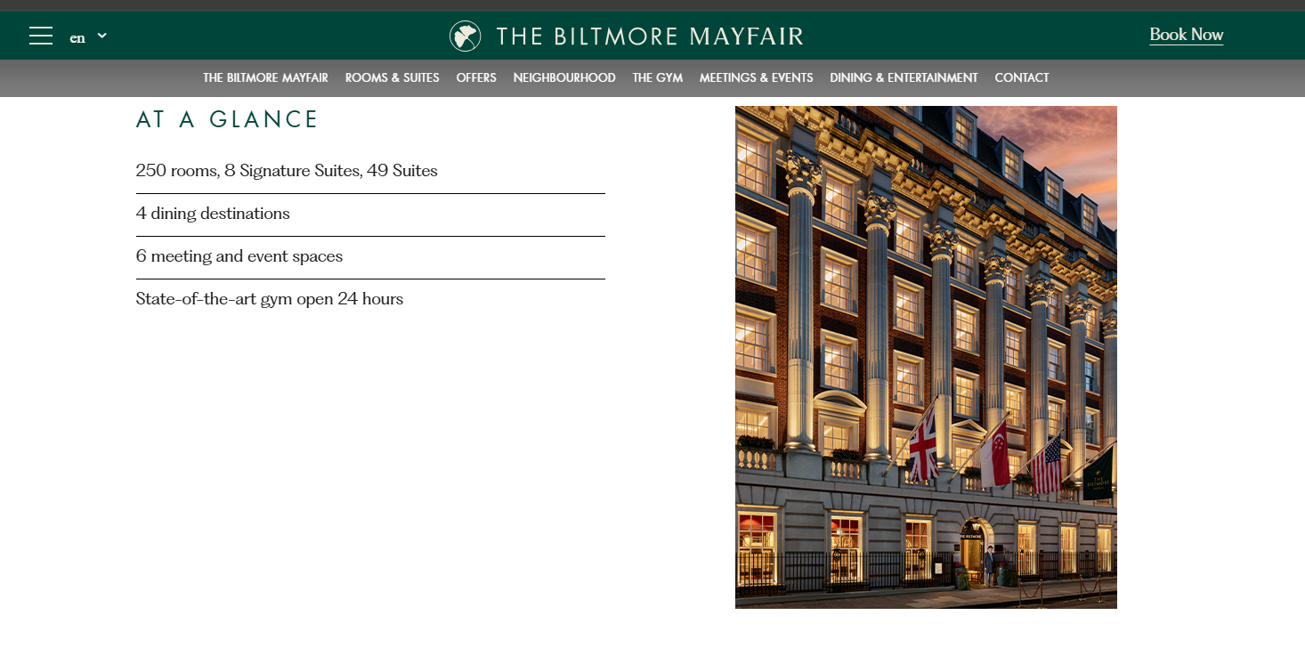

Source 2:
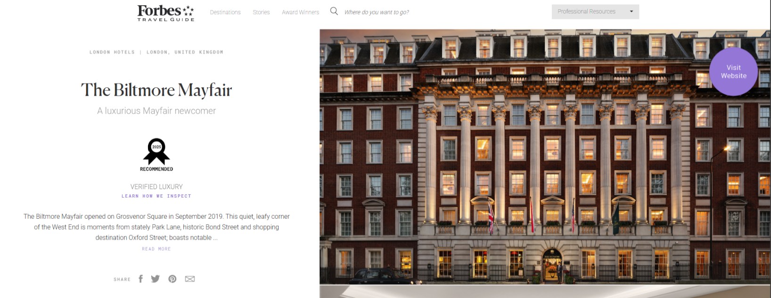
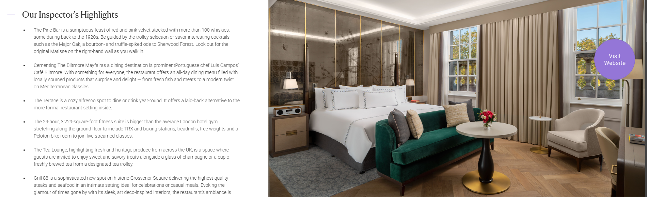

Source 3:
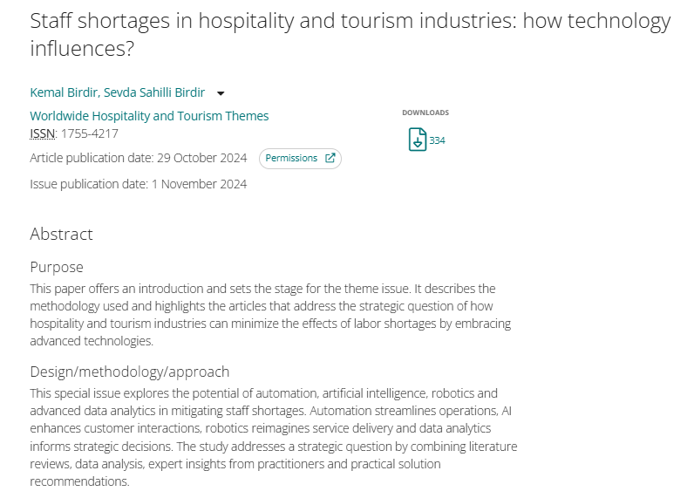
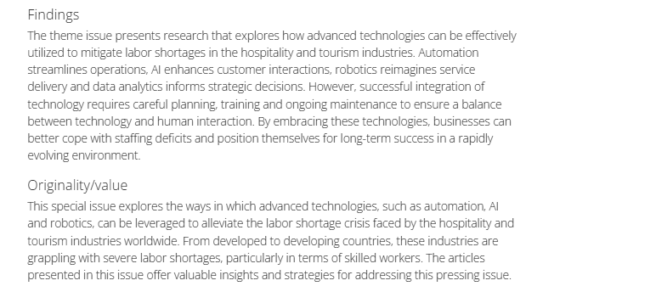

Source 4:
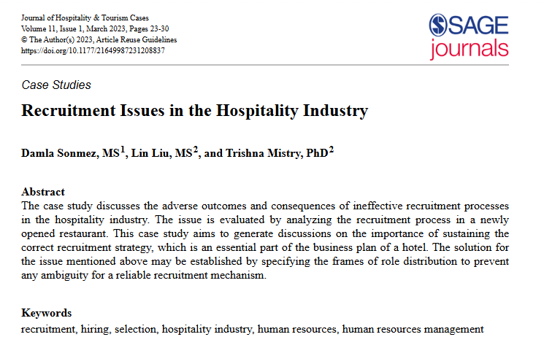

Source 5:


