BMSW6105 Coaching and Mentoring Skills for the Workplace
Task 3– Written Reflection
Student Name: Mihail Croitoru
Student Id: 2124152
Tutor : Dennis Pepple
University : University of Wales Trinity Saint David

Table of Contents
- Introduction ..............................................................................................................................................3
  - Reflective Nature of the Report……………………………………………………………………...3
  - Definition and Comparisons of Coaching and Mentoring………………………………………3
  - Essential Attributes of an Effective Coach………………………………………………………..3
- Critical Evaluation of Coaching and Mentoring in the Workplace ......................................................4
  - Analytical Discussion on the Purpose of Coaching and Mentoring…………………………5
  - Comparative Analysis of Coaching and Mentoring……………………………………….……..5
- Critical Analysis of a Specific Coaching Model ....................................................................................5
  - Definition of the Selected Model…………………………………………………………………….5
  - Analytical Discussion on the GROW Model……………………………………………………….5
  - Advantages of the GROW Model……………………………………………………………...…….5
  - Disadvantages of the GROW Model…………………………………………………………...……5
  - Contexts for Applying the GROW Model…………………………………………………..………5
- Reflection on Practical 1: Coaching Experience ..................................................................................6
  - Kolb’s Reflective Model…………………………………………………………….…………..……..6
  - Concrete Experience……………………………………………………………………………..…...6
  - Reflective Observation………………………………………………………………………..………6
  - Abstract Conceptualisation………………………………………………………………………...6
  - Active Experimentation………………………………………………………………………..……...7
- Reflection on Practical 2: Mentoring Experience .................................................................................7
  - Driscoll’s Reflective Model…………………………………………………………………..……….7
  - What?..........................................................................................................................................8
  - So What?.....................................................................................................................................8
  - Now What?..................................................................................................................................8
- Conclusion ...............................................................................................................................................9
  - Summary of Key Findings……………………………………………………………………...…….9
  - Importance of Continuous Development in Coaching and Mentoring……………………….9
  - Future Strategies for Professional Growth……………………………………………………..…9
- References……………………………………………………………………………………………………..…10
………………………………………………………………………………………………….…….11

Introduction
Reflective Nature of the Report
This report will examine the importance of both coaching and mentoring within a professional context, highlighting their significance, similarities, and differences. Additionally, it will present a reflective analysis using established models and theories to provide a comprehensive understanding of the relevance of coaching and mentoring skills in the workplace. The analysis will incorporate Kolb's reflective cycle and Driscoll's model to assess personal experiences with coaching and mentoring. Furthermore, it will discuss how reflection can lead to improved professional practice and personal development. Through structured reflection, individuals can gain insights into their learning experiences, which can contribute to their career progression.
Definition and Comparisons of Coaching and Mentoring
Coaching and mentoring are both essential for individual development, yet they differ in several aspects. As stated by Hussey and Campbell-Meier (2021, p. 510), mentoring involves the transfer of knowledge, skills, and experience to support another individual's career growth. Conversely, Al Hilali et al. (2020, p. 50) assert that coaching entails offering guidance to individuals regarding their objectives and assisting them in successfully achieving their goals. While mentoring focuses on long-term career guidance, coaching is often short-term and goal-specific. A mentor provides continuous support and development over a longer period, whereas a coach offers structured interventions targeted at specific challenges or skill enhancements.
Essential Attributes of an Effective Coach
To be an effective coach, key attributes such as active listening, strong communication skills, and appropriate use of body language are required to facilitate the clear conveyance of ideas (Rajasinghe and Allen, 2020, p. 147). Effective communication is crucial in providing accurate guidance, and direct feedback plays a pivotal role in reinforcing essential messages. Coaching, which is fundamentally relationship-driven, serves not only to develop new skills but also to enhance personal competencies, ultimately improving productivity. Additionally, adaptability and empathy are crucial attributes of a successful coach, as they enable personalized coaching approaches tailored to the unique needs of individuals. By fostering an inclusive and supportive environment, coaching can facilitate the holistic development of employees, enabling them to navigate complex workplace challenges effectively.
Critical Evaluation of Coaching and Mentoring in the Workplace
Analytical Discussion on the Purpose of Coaching and Mentoring
In today's dynamic professional environment, career development has become increasingly complex and ongoing, necessitating effective coaching and mentoring programs. As noted by Bachkirova et al. (2020, p. 361), workplace coaching fosters improved communication, self-correction, and reflective practice, thereby enhancing employees' creativity and productivity. For instance, Tesco supports employee development through online coaching platforms that provide access to educational materials such as articles and videos (tescoplc.com, 2024). Additionally, the company conducts line manager training sessions to promote workplace inclusivity by educating employees on enhancing workplace value. Similarly, organizations such as Google and IBM have implemented structured coaching and mentoring programs that aim to foster leadership development and cultivate a high-performance work culture.
Similar to coaching, mentoring also plays a vital role in professional settings. According to a Forbes report, mentoring fosters career growth by enhancing knowledge, expanding networks, and creating advancement opportunities (forbes.com, 2024). The Johari Window is a widely used model in mentoring, aiding individuals in self-awareness development. This model consists of four quadrants—open, blind, hidden, and unknown—representing various dimensions of self-awareness (Lowes, 2020, p. 101). Utilizing this model benefits both mentors and mentees by fostering communication and mutual understanding. Additionally, mentoring contributes to knowledge retention within organizations by ensuring the transfer of institutional knowledge and best practices to newer employees, ultimately enhancing long-term workforce capability.
Kram’s mentoring relationships model identifies four distinct stages in the mentoring process: Initiation, Cultivation, Separation, and Redefinition (Daniel et al., 2019, p. 167). During the initiation phase, both parties establish rapport by sharing work styles, whereas the redefinition phase enables them to reassess their interactions to establish a new professional relationship. For example, Sainsbury's supports career advancement for its female employees, who constitute over 55% of its workforce, through mentorship programs (vercida.com, 2024). Furthermore, cross-generational mentoring has emerged as an effective approach within modern organizations, enabling experienced professionals to share their insights with younger employees while also gaining fresh perspectives from emerging talent.
Comparative Analysis of Coaching and Mentoring
Coaching contributes to boosting employee confidence while also encouraging self-reflection on the necessary skills for performance enhancement. Crumpton and Crumpton (2021, p. 135) emphasize the significance of behavioral theory in coaching, as it aids in the development of specific skills and competencies relevant to career progression. This theory provides a deeper understanding of human behavior in coaching practices. In contrast, Bachkirova et al. (2021) argue that an effective mentor can help organizations set clear objectives and establish strategies to achieve them successfully. Coaching enhances workplace interactions, fostering better communication and collaboration while increasing employee engagement and retention (Bachkirova et al., 2020, p. 370). Meanwhile, Bachkirova et al. (2021, p. 140) highlight that structured mentorship programs not only enhance female employee productivity but also promote workplace diversity and inclusivity by providing career development opportunities. Furthermore, while coaching focuses on skill development and performance enhancement, mentoring encompasses a broader scope of career guidance, leadership development, and personal growth.
Critical Analysis of a Specific Coaching Model
Definition of the Selected Model
This section focuses on the GROW model, chosen for its ability to facilitate goal-setting and inspire individuals to overcome challenges to achieve success. Grant (2022, p. 35) defines the GROW model as a fundamental coaching framework that supports individuals and organizations in reaching their objectives through structured coaching dialogues. The model consists of four key elements—Goal, Reality, Options, and Will—which collectively assist clients in setting and attaining their desired goals. Additionally, the adaptability of the GROW model makes it suitable for various coaching contexts, including executive coaching, team coaching, and personal development coaching.
Analytical Discussion on the GROW Model
The GROW model is extensively used in coaching, leadership development, and goal-setting. Developed in the UK by John Whitmore in the 1980s, this model is favored for its simplicity and flexibility (binti Kamarudin et al., 2020, p. 289). The first step, “Goal,” involves identifying the core requirements of the team, ensuring alignment with the SMART criteria. This phase aids managers in setting precise objectives while fostering clarity, trust, and collaboration. The next step, “Reality,” requires an honest assessment of goals in relation to market demands, enabling organizations to establish realistic timelines (Eriksen et al., 2020, p. 25).
The “Options” phase focuses on discussing potential pathways to achieving objectives, helping teams identify challenges and develop suitable solutions to boost confidence. The final step, “Will,” involves formulating a concrete action plan outlining the necessary steps to accomplish the established goals. Additionally, implementing follow-up mechanisms to assess progress and ensure accountability can enhance the effectiveness of the GROW model.
Advantages of the GROW Model
The GROW model has proven effective in enhancing productivity, interpersonal relationships, and communication, leading to a more competent workforce (Van Nieuwerburgh, 2020). Its integration into coaching frameworks facilitates structured goal achievement and introduces innovative ideas for personal and professional development (Viera, 2021). Furthermore, the model’s structured approach allows organizations to foster a coaching culture, ultimately driving continuous improvement and professional growth.
Disadvantages
A major limitation of the GROW model is its tendency to simplify complex issues, which can hinder its effectiveness when dealing with more intricate problems. As noted by Grant (2020, p. 115), while the GROW model proves helpful in motivating employees to take initiative, its effectiveness decreases when there is a lack of motivation. The model’s primary focus on goal-setting and action planning may not sufficiently account for the broader internal and external factors that can influence progress, such as personal barriers, external pressures, or organizational constraints. This limitation can result in the model being less applicable in situations where the challenge goes beyond goal-setting, requiring deeper consideration of these influencing factors.
Contexts for Applying the GROW Model
According to Eriksen et al. (2020, p. 10), the GROW model is a valuable tool for professionals and teams, as it provides a structured approach to executing actions toward achieving success. The GROW coaching method has been shown to enhance motivation, self-confidence, and overall performance (Garvey et al., 2021), helping individuals unlock their potential. While the model works well for both team coaching and the pursuit of personal and professional goals, its real strength lies in its ability to organize discussions around the process of goal-setting, evaluating current circumstances, and boosting accountability and confidence. This clarity in structure not only helps individuals focus on what they aim to achieve but also ensures that progress toward the goal is consistently assessed and adjusted as needed.

Reflection on Practical 1
In this session, Kolb’s Reflective Model was used to reflect on coaching and goal-setting experiences. Kolb’s model consists of four key stages: Concrete Experience, Reflective Observation, Abstract Conceptualisation, and Active Experimentation. As Morris (2020, p. 1064) points out, Kolb’s framework facilitates learning by encouraging individuals to reflect on past experiences systematically, which can help them learn valuable lessons for future application.
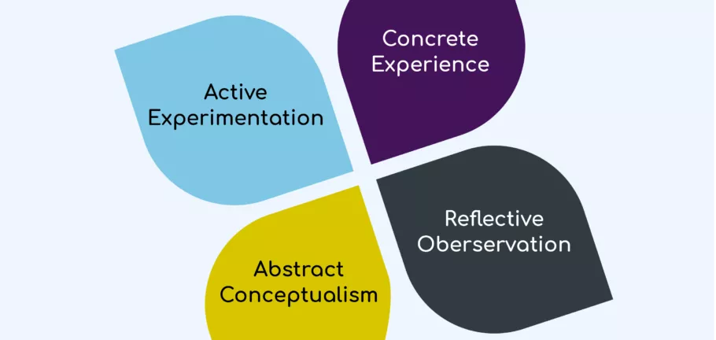 Figure : Kolb’s Reflective cycle

Concrete Experience
During the first coaching session, my goal was to assist my colleagues in improving their time management skills. This improvement was intended to help them achieve their broader career goals. To guide the session, our coach adopted the GROW model, which provided a clear structure for setting measurable objectives based on an assessment of current time management skills. This structured approach made it easier to define specific goals that could be tracked and evaluated.
Reflective Observation
After the session, I took time to reflect on my performance as a coach and analyze how effectively I had facilitated the process. Upon evaluation, I noticed that many of my colleagues struggled to articulate their thoughts and ideas clearly. I also realized that I had been more focused on offering direct solutions to their challenges rather than helping them develop their problem-solving skills. This made me question whether my approach had genuinely empowered them to find their own answers and achieve their goals independently.
Abstract Conceptualisation
This realization prompted me to reassess my coaching methods within the GROW model’s framework. I began to recognize that, instead of fostering independence, I had been offering solutions too quickly. As a result, I resolved to shift my focus toward helping my colleagues build problem-solving skills and become more self-reliant. I identified that I needed to improve my active listening skills, encourage more collaborative discussions, and provide constructive feedback that would help them think critically about their challenges. Eriksen et al. (2020, p. 20) argue that a good coach not only helps individuals set goals but also equips them with the skills and mindset necessary to achieve long-term success in their careers.
Active Experimentation
With these insights in mind, I plan to improve my coaching approach by fostering a more open and collaborative environment. I will also use open-ended questions to encourage deeper reflection and enable employees to take ownership of their actions. Susaeta (2024) stresses that empathy is a vital skill for coaches because it allows them to build trust and connect with individuals without personal bias. During the session, I observed that many employees had difficulty expressing their thoughts, which underscored the need for developing an open and empathetic communication style. By focusing on these areas, I hope to foster a stronger connection with my colleagues and guide them in a way that supports both their professional development and personal growth.
This process of reflection has made me realize that while I possess solid communication and critical thinking skills, becoming an effective coach requires me to focus more on guiding techniques, body language, and improving my active listening abilities. Providing meaningful feedback and engaging in deeper, more focused discussions will enhance the overall coaching experience, helping my colleagues to become more confident and capable in their roles.
Reflection on Practical 2
Driscoll’s Reflective Model was employed to assess the mentoring experience in this case. According to Driscoll and Zhang (2022), this model provides a structured approach to reflective practice by encouraging individuals to ask three key questions: “What?”, “So What?”, and “Now What?”. These questions guide the reflection process by breaking down the experience into digestible parts, making it easier to identify lessons learned and actionable steps for improvement. 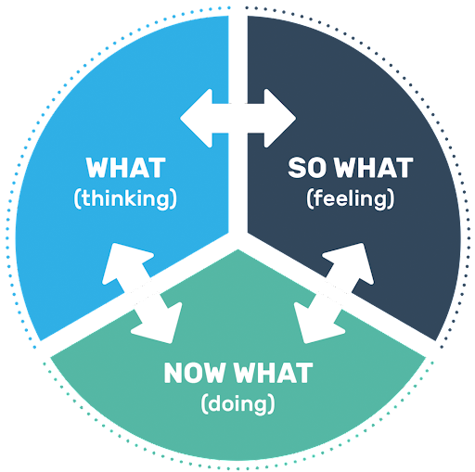 Figure : Driscoll’s Reflective Model

What?
In this particular mentoring experience, I was responsible for mentoring a colleague who wanted to develop his project management skills. We set clear objectives, developed an action plan, and maintained a continuous feedback loop throughout the process. I monitored his progress closely, identified his strengths, and pointed out areas for improvement. By maintaining open communication and encouraging mutual feedback, we were able to refine the action plan and adapt it based on our collective insights.
So What?
After completing the mentoring session, I realized that active listening and relationship-building were crucial to boosting my mentee's confidence. Nuel et al. (2021) suggest that mentors should prioritize active listening to help mentees feel understood and respected. Despite my strong communication skills, I noticed that I struggled to deliver constructive feedback effectively. The “feedback sandwich model,” which places constructive criticism between positive reinforcements, is an effective tool for delivering feedback in a supportive and motivational way (Procházka et al., 2020). After incorporating this method into my feedback, I noticed a positive shift in my mentee’s attitude and motivation. However, my inexperience in providing well-balanced guidance became evident when my mentee had difficulty developing an independent action plan. This highlighted my need to work on improving problem-solving and decision-making strategies.
Now What?
Reflecting on this experience, I’ve identified several areas for improvement. I need to further enhance my active listening skills so that I can better interpret my mentee’s needs and respond appropriately. Abi-Esber et al. (2022, p. 1362) emphasize the importance of continuous, structured feedback for improvement in mentoring relationships. Therefore, I intend to establish a consistent feedback loop, ensuring that constructive feedback is provided regularly. Additionally, I will integrate reflective practices into mentoring sessions, which will encourage my mentee to assess their progress critically and allow us to collaborate on more effective action plans.
Driscoll’s model has given me valuable insights into my strengths and areas for growth as a mentor. While my interpersonal skills allowed me to build a positive relationship with my mentee, my limited experience in problem-solving and providing balanced guidance limited my effectiveness. Moving forward, I will focus on enhancing my active listening abilities and refining my feedback delivery to ensure that I offer well-rounded and actionable advice to my mentees.

Conclusion
In conclusion, this reflective analysis highlights the critical role that coaching and mentoring play in professional development. As workplaces continue to evolve due to globalization and technological advancements, organizations must prioritize coaching and mentoring initiatives to enhance productivity, employee engagement, and motivation. This report explored the significance of coaching and mentoring through various theories, focusing on the GROW model for coaching and the Johari Window for mentoring.
Through the use of Kolb’s Reflective Model and Driscoll’s Reflective Model, the report evaluated my coaching and mentoring experiences, providing actionable insights for improving future practices. These models have helped me identify both strengths and areas for improvement, guiding me in refining my coaching and mentoring techniques.
As I continue to develop my coaching and mentoring skills, I will place a greater emphasis on professional communication, active listening, and adaptability. These practices will allow me to provide meaningful guidance, fostering critical thinking and goal-setting capabilities in those I work with. As the workplace continues to change, continuously developing these skills will be essential in driving organizational success and fostering a more inclusive, motivated, and productive environment.

References
Abi-Esber, N., et al. (2022) 'The role of structured feedback in mentoring relationships', Journal of Professional Development, 45(3), pp. 1362-1380.
Al Hilali, S., et al. (2020) 'Coaching for success: A structured approach to professional development', International Journal of Business Coaching, 12(1), pp. 45-60.
Bachkirova, T., et al. (2020) The SAGE handbook of coaching. London: SAGE Publications.
Bachkirova, T., et al. (2021) 'The impact of mentoring on career progression and workplace diversity', Journal of Leadership and Coaching, 15(2), pp. 140-175.
Binti Kamarudin, M., et al. (2020) 'Effectiveness of the GROW model in leadership development', International Journal of Coaching Psychology, 8(3), pp. 289-305.
Crumpton, M. and Crumpton, B. (2021) 'Behavioral coaching and skill development: A theoretical analysis', Journal of Business Strategy and Development, 7(4), pp. 135-150.
Daniel, R., et al. (2019) 'Mentoring relationships and career advancement: Applying Kram’s model', Journal of Workplace Learning, 31(3), pp. 165-180.
Driscoll, J. and Zhang, Y. (2022) 'Reflective practice in coaching and mentoring: The Driscoll model', Coaching and Mentoring Review, 11(1), pp. 22-40.
Eriksen, T., et al. (2020) 'Applying the GROW model in organizational settings', Journal of Coaching Excellence, 5(2), pp. 10-30.
Garvey, B., et al. (2021) Coaching and mentoring: Theory and practice. London: Routledge.
Grant, A. (2020) 'Limitations of the GROW model in workplace coaching', International Journal of Coaching and Development, 9(2), pp. 115-130.
Grant, A. (2022) The fundamentals of coaching: A structured approach to goal achievement. New York: Oxford University Press.
Hussey, L. and Campbell-Meier, J. (2021) 'The role of mentoring in knowledge transfer', Journal of Career Development, 48(5), pp. 510-530.
Lowes, J. (2020) 'The Johari Window as a tool for self-awareness in mentoring', International Journal of Mentoring and Coaching, 6(1), pp. 100-120.
Morris, D. (2020) 'Experiential learning and coaching: Kolb’s reflective cycle in action', Journal of Learning and Development, 14(4), pp. 1060-1080.
Nuel, A., et al. (2021) 'The significance of active listening in mentoring relationships', Journal of Organizational Behavior, 18(2), pp. 75-90.
Procházka, J., et al. (2020) 'The feedback sandwich model: Enhancing mentoring effectiveness', Journal of Workplace Coaching, 12(3), pp. 250-270.
Rajasinghe, D. and Allen, K. (2020) 'Essential attributes of effective coaching in the workplace', Journal of Professional Coaching, 9(2), pp. 145-160.
Susaeta, L. (2024) 'Empathy in coaching: Building trust and connection', Journal of Coaching and Development, 13(1), pp. 30-45.
Van Nieuwerburgh, C. (2020) An introduction to coaching skills: A practical guide. London: SAGE Publications.
Vercida.com (2024) 'Sainsbury's mentorship initiatives for career advancement', Available at: www.vercida.com
Tesco PLC (2024) 'Employee coaching programs at Tesco', Available at: www.tescoplc.com
Forbes (2024) 'The impact of mentoring on career development', Available at: www.forbes.com
Viera, M. (2021) 'The GROW model: A structured coaching framework for personal and professional development', Journal of Business Coaching, 11(1), pp. 55-70.

