Context page
Part 1-page 1 to 4
Part 2- page 4 to 6
Part 3 – page 7 to 10
Basic Acknowledgement of AI Tool Use
I acknowledge the use of Microsoft 365 Copilot to support the proofreading of this assignment.
I used the AI tool to:
- Check punctuation.
- Identify minor grammar and spelling errors.
I confirm that I have not presented any AI-generated text as my own work.

Word count -2785

Part 1-
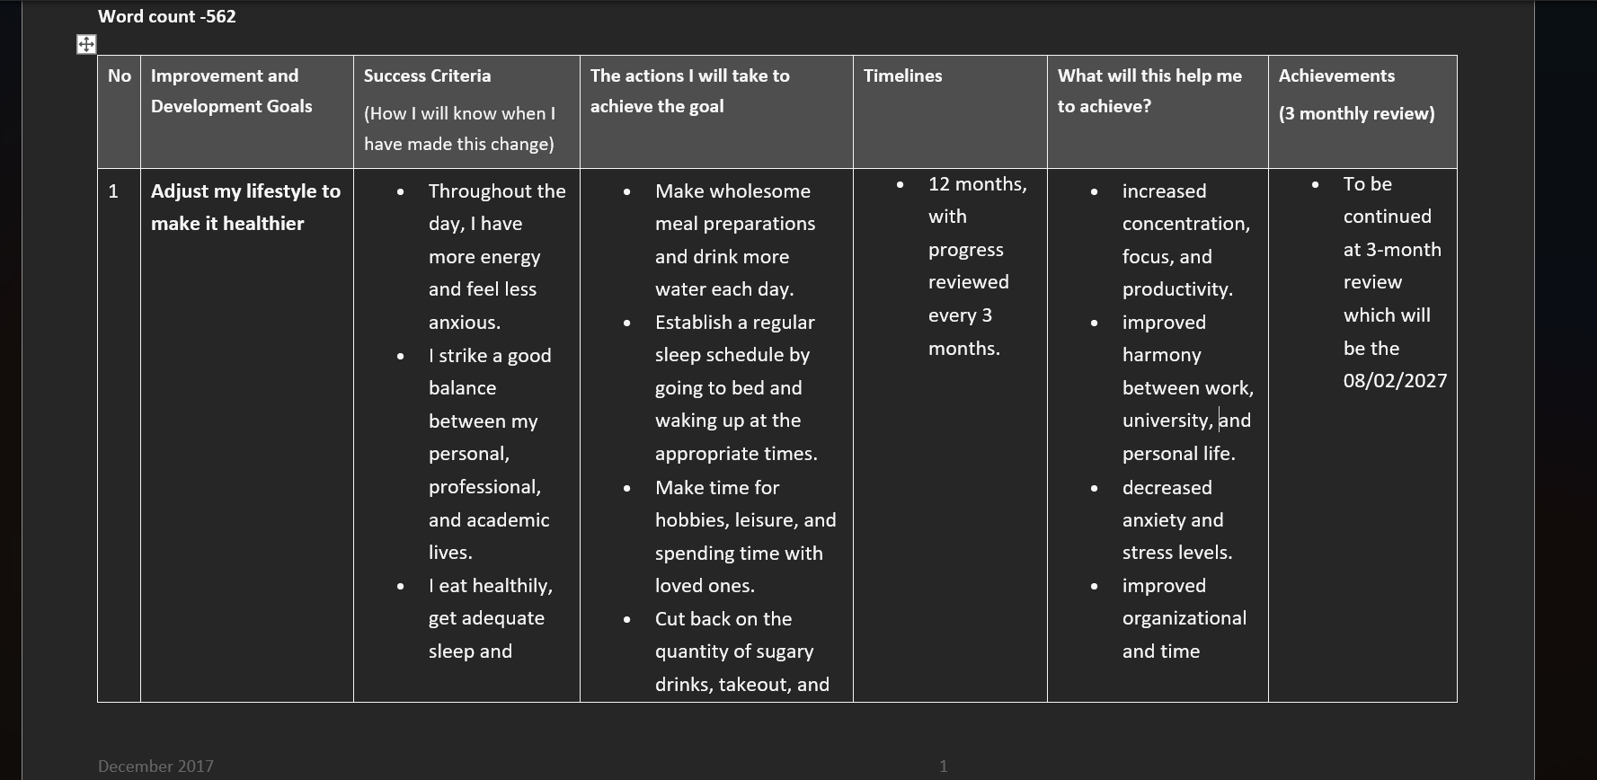

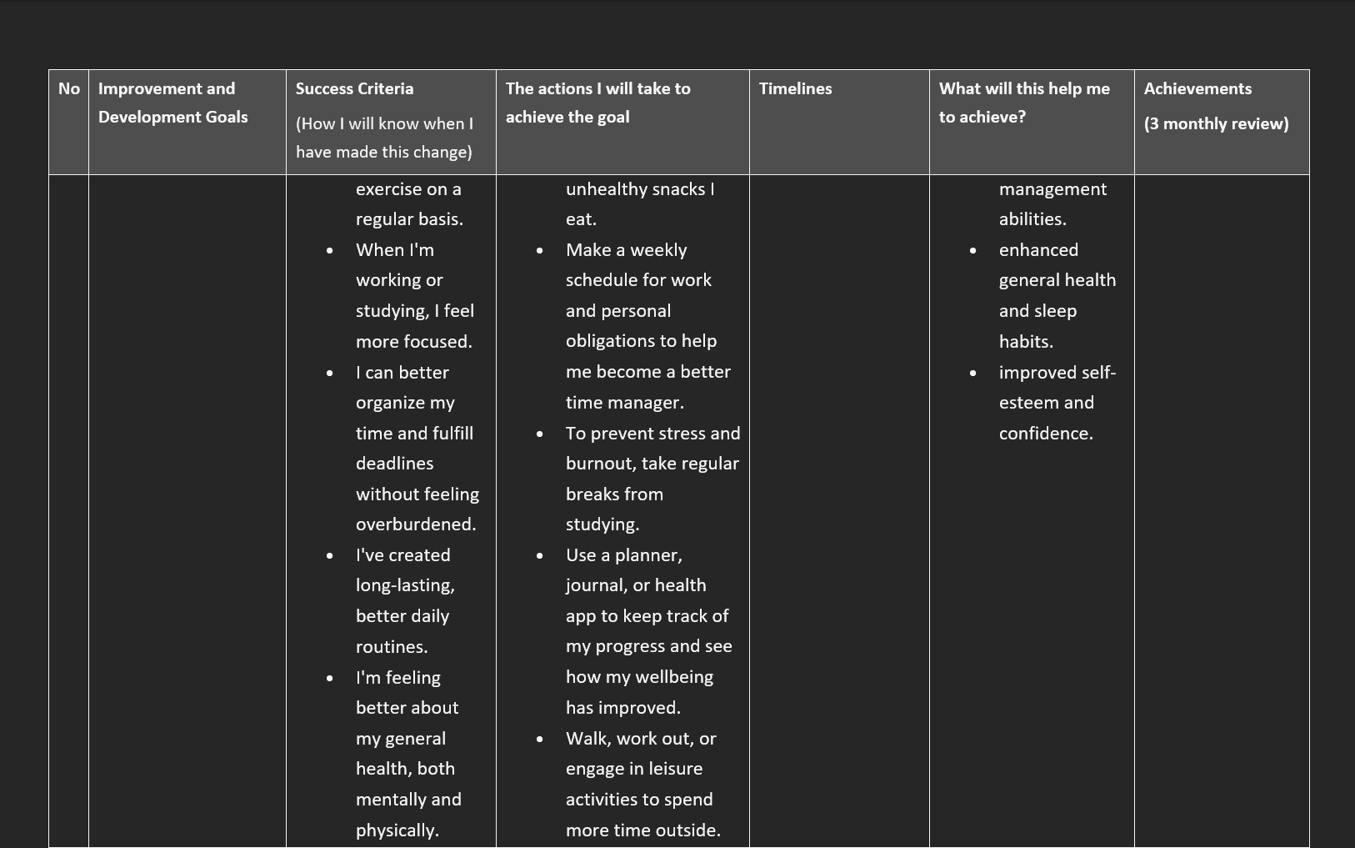
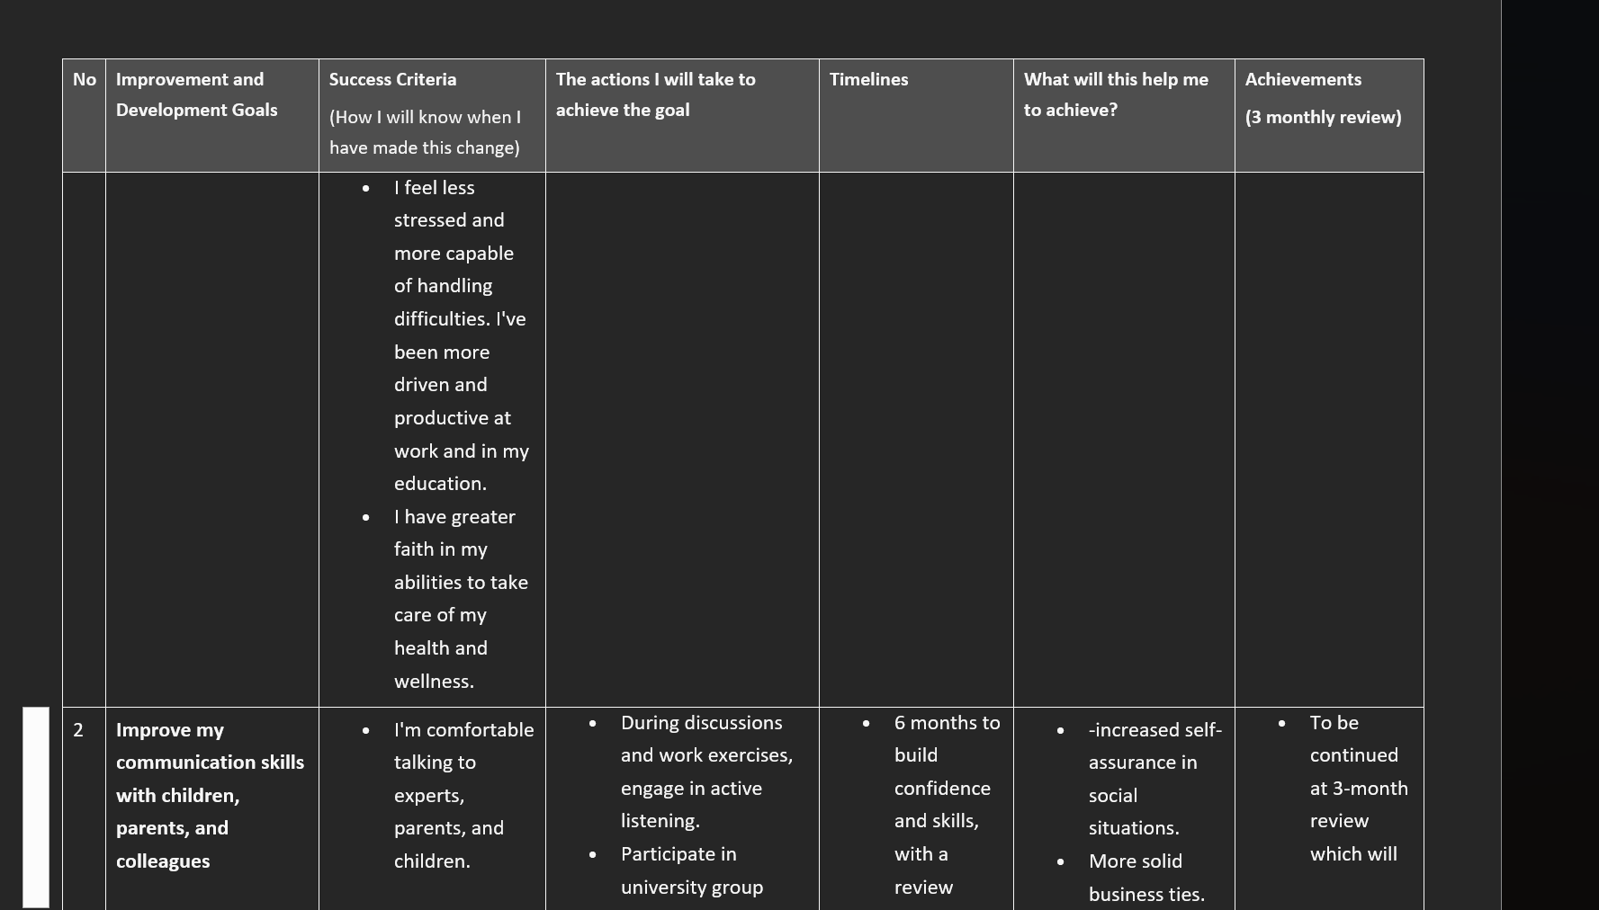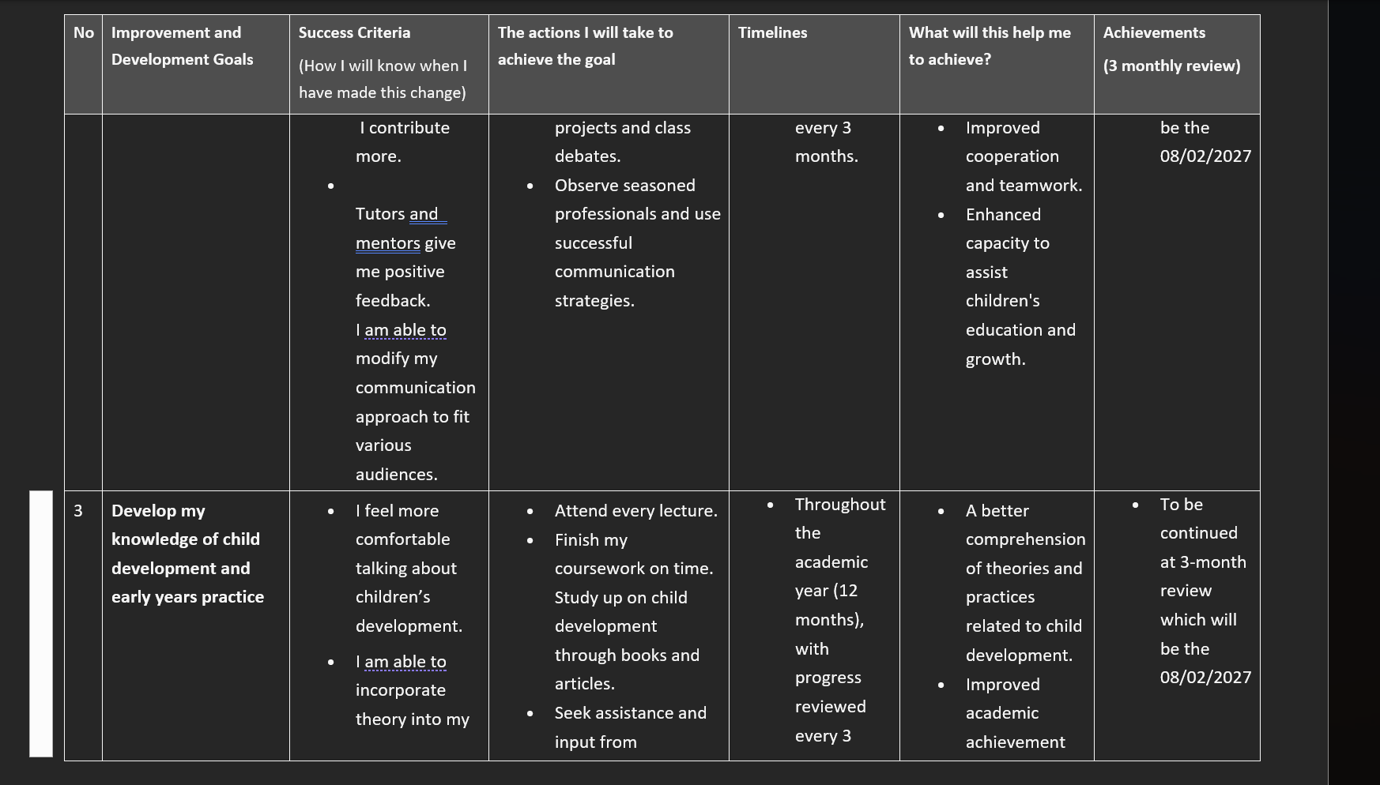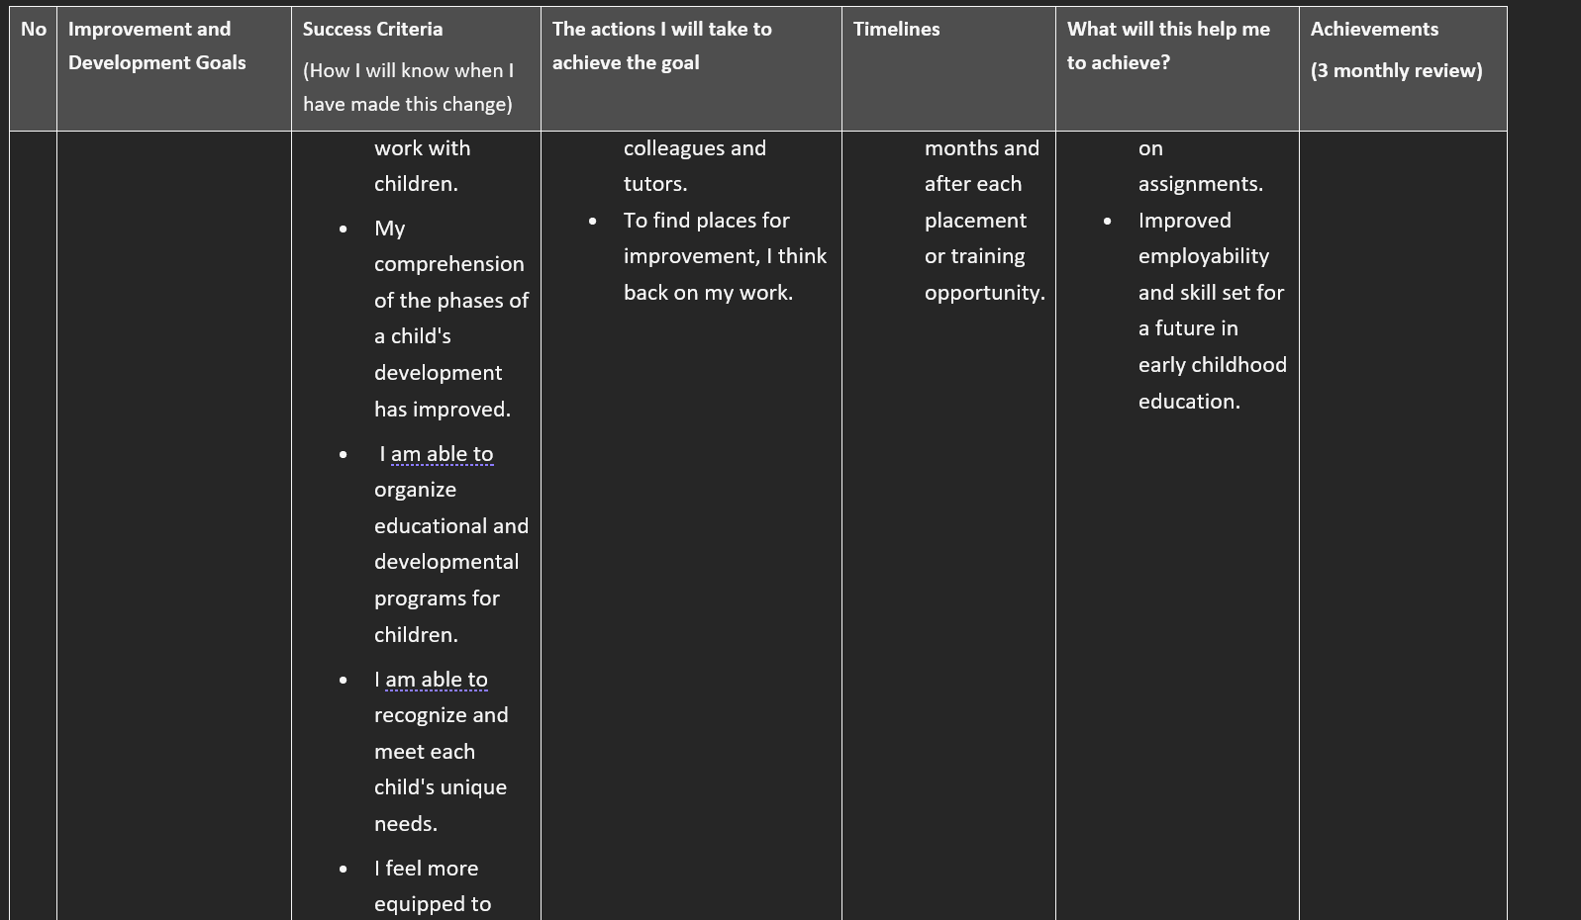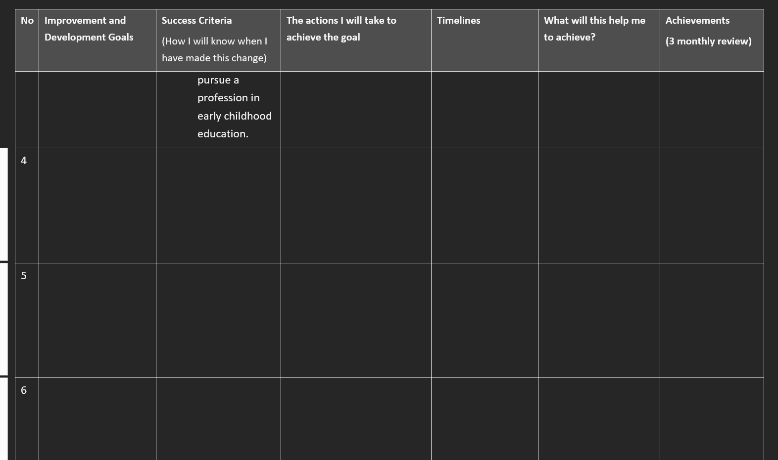

Part 2-
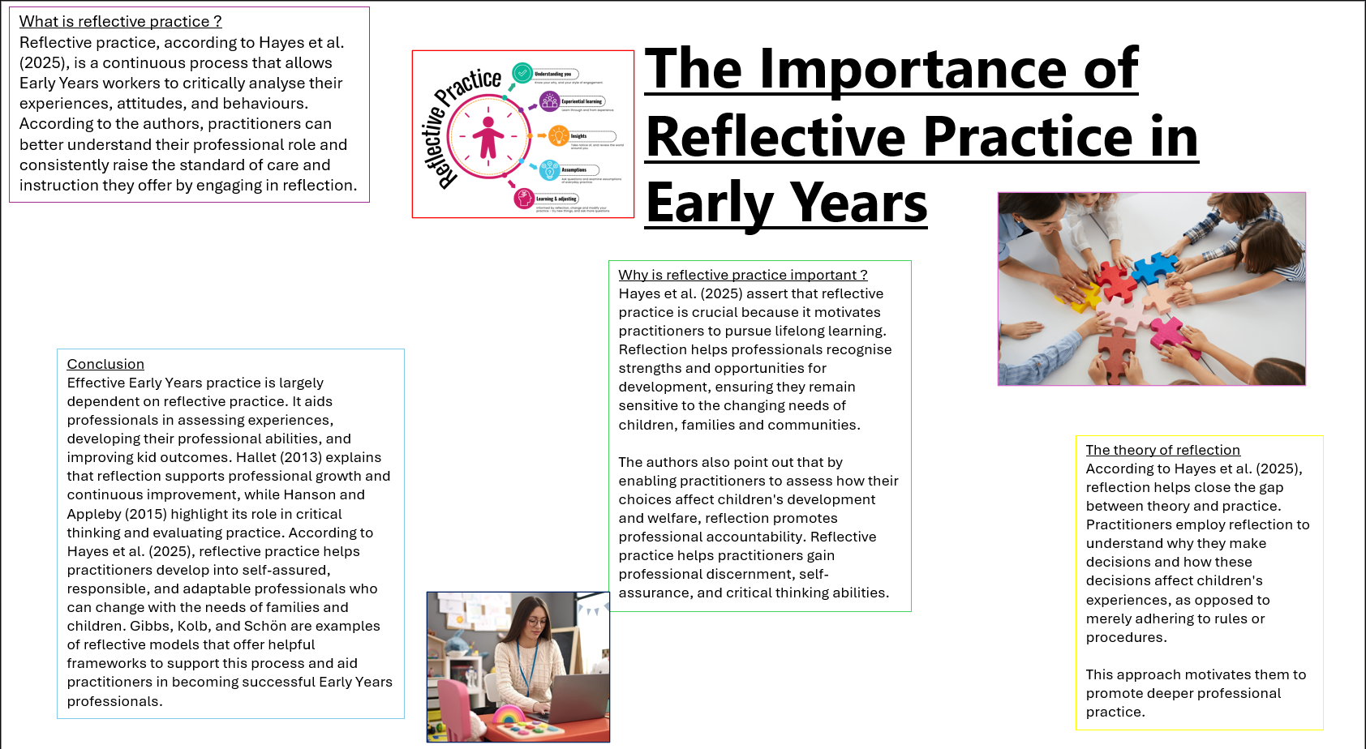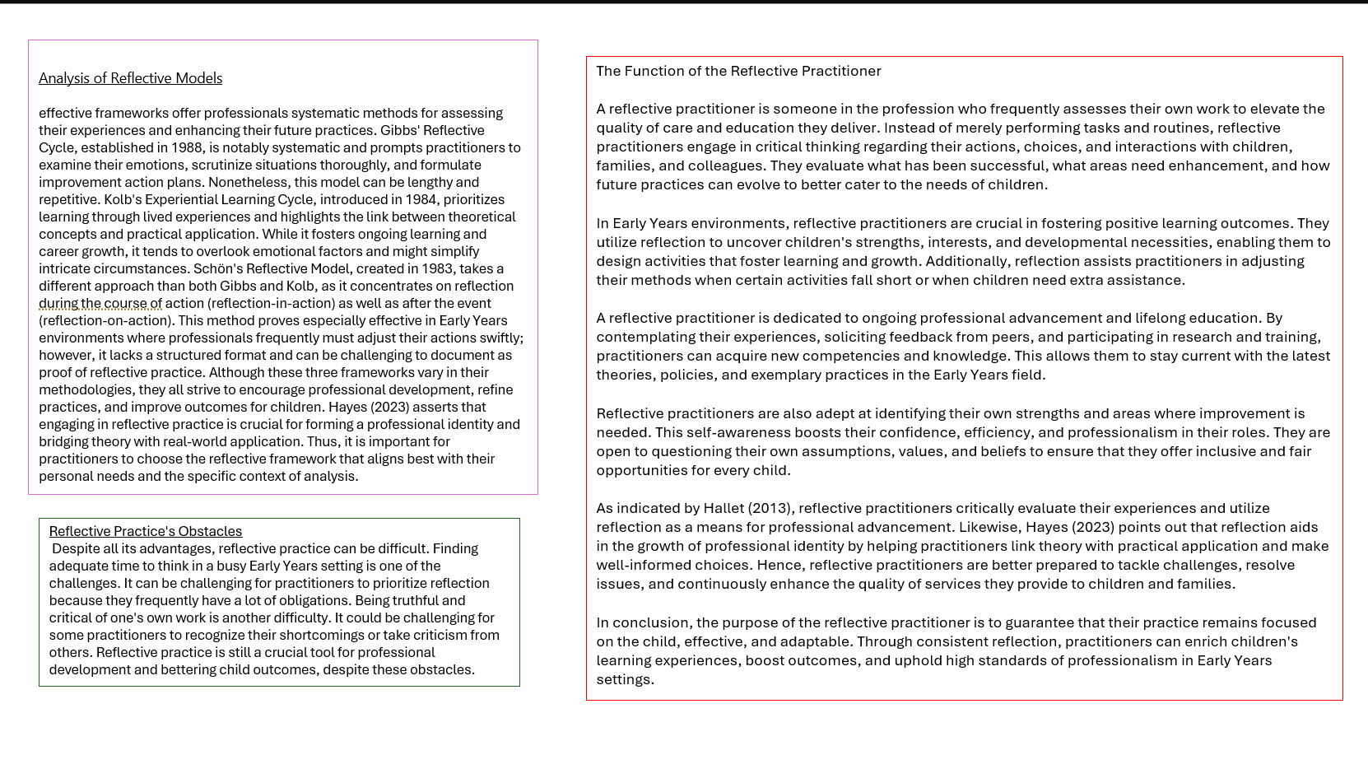
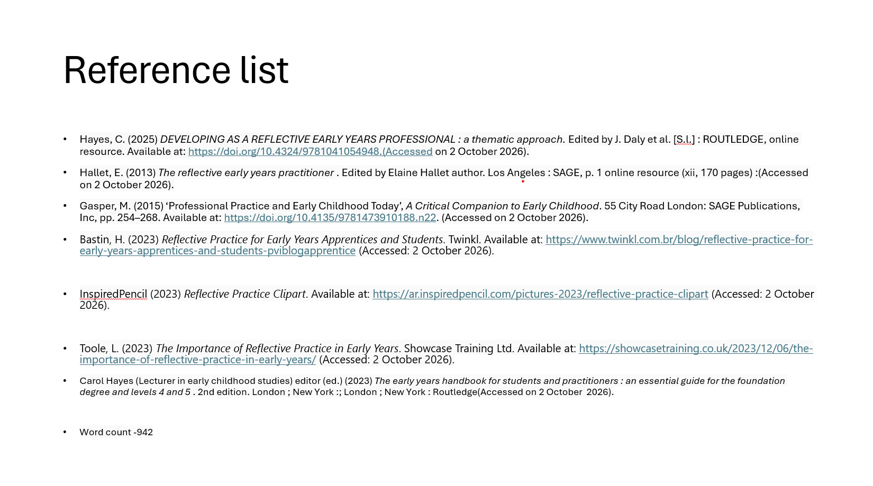

Part 3-
An essential component of working in the early years is professional practice. It is the duty of practitioners to promote children's education, growth, safety, and well-being. They must show professional ideals, communicate effectively, collaborate with other professionals, conduct observations, organise suitable activities, and comprehend children's rights in order to accomplish this successfully. These areas support practitioners in addressing children's unique needs while advancing equality and inclusivity.
Effective early childhood practice is centred on professional values. Respect, integrity, equality, privacy, and inclusivity are some of these ideals. Every child should be treated as an individual by practitioners, who should also acknowledge that every child grows differently. It is crucial that practitioners appreciate and value diversity because children come from a variety of backgrounds, ethnicities, and family situations. Professional values assist practitioners in establishing a secure and friendly setting where children feel appreciated and accepted. Meeting children's needs and upholding high standards are the fundamental goals of professional practice, according to Gasper (2015). Children are more likely to gain self-assurance and a sense of community when practitioners show positive values.
Another crucial component of professional work is communication. Positive relationships with children, families, and coworkers are facilitated by effective communication. Parents must have precise knowledge about their child's development and well-being, and children must feel heard and understood. Effective communication enables professionals to recognise issues and promptly address children's needs. Additionally, it fosters trust between families and practitioners. Positive relationships and understanding people are important, according to Rogers (1995). Children receive more constant assistance at home and in the classroom when there is excellent communication between the parent and the setting.
Because families and children may require assistance from several specialists, multi-agency collaboration is crucial. In multi-agency working, practitioners collaborate with experts including educational psychologists, social workers, health visitors, and speech and language therapists. Professionals can give children the best help possible by cooperating and exchanging knowledge. According to McMahon and Dyer (2018), teamwork is a crucial component of professional practice. Children with additional learning challenges benefit most from this strategy since it makes it easier to plan and provide support.
In early childhood settings, observations are crucial. Observations are used by practitioners to track children's growth, interests, and accomplishments. Practitioners can better grasp children's abilities and pinpoint areas that could require assistance by using observations. Because every child learns differently, observations enable practitioners to create activities that are tailored to each child's requirements. Additionally, observations assist practitioners in tracking advancement over time. It would be challenging to offer learning opportunities that are appropriate for every child without observations.
Observations and planning are strongly related. Practitioners can create activities that promote learning and growth if they are aware of a child's interests and developmental stage. Planning well ensures that the activities are fun, interesting, and suitable for every child within early years. Children's needs and interests can change; therefore, planning should be adaptable. All children, regardless of ability or background, can participate thanks to inclusive planning. This is significant because it encourages equally opportunities and enables each child to reach their full potential.
Another crucial part of professional activity is reflective practice. Reflective practice entails considering what has worked and what needs improvement. According to Hanson and Appleby (2015), reflection aids practitioners in honing their work and raising the standard of their work. Practitioners can find methods to better support children and make learning settings more accessible by thinking back on their work. In addition to helping practitioners deliver high-quality treatment and instruction, reflection promotes ongoing professional development.
Another crucial component of professional practice is the United Nations Convention on the Rights of the Child (UNCRC). In addition to outlining each child's rights, the UNCRC seeks to guaranty that children are respected, safeguarded, and given the chance to take part in choices that impact them. It is the duty of practitioners to support and protect these rights in early childhood settings. Children, for instance, are entitled to an education, the freedom to voice their opinions, and protection from harm. Comprehending the UNCRC enables professionals to guaranty that children receive equitable treatment and that their opinions are acknowledged(UNICEF,2016).
Inclusion and the UNCRC are closely related. Ensuring that every child has an equal chance to engage and thrive is known as inclusive practice. Children's unique requirements must be taken into account by practitioners, and obstacles that would keep them from taking advantage of educational opportunities must be removed. Children who may be vulnerable, have disabilities, or have specific learning needs should pay special attention to this. Practitioners may assist all children feel appreciated and supported by advocating for children's rights and offering inclusive experiences.
To sum up, professional practice is essential to addressing children's unique and inclusive needs. High-quality early years practice is influenced by professional values, communication, multi-agency collaboration, planning, observations, reflective practice, and the UNCRC. These elements support professionals in establishing welcoming, constructive settings where children can grow, learn, and flourish. Early childhood educators can guaranty that every child gets the help they require to realize their full potential by working professionally and reflecting on their job.
Making sure children feel valued, safe, and supported in the classroom is a crucial component of professional practice. Practitioners need to build strong bonds with children and provide them the chance to voice their opinions. Children are more likely to grow up to be self-assured, independent, and to have positive attitudes toward learning when they feel appreciated and included. Practitioners can offer individualized support that fosters growth and health by acknowledging each child's distinct abilities, interests, and needs. This contributes to the development of an inclusive setting where children of all backgrounds and skill levels can succeed and advance.
Safeguarded to successfully learn and grow. When appropriate, practitioners must collaborate with other experts, raise concerns, and adhere to safeguarding protocols. The welfare of children is always given first priority, and any issues are dealt with in a timely and suitable manner thanks to good professional practice.
Maintaining confidentiality and preserving records are crucial components of professional work. Information regarding the growth, health, and welfare of children is routinely gathered by practitioners. Only the right people should have access to this data, and it must be stored safely. Confidentiality guaranties the protection of personal data and fosters confidence between practitioners and families. Keeping thorough records also makes it easier for professionals to track children' development and spot any extra aid that might be needed.
Because professionals serve as role models for children, professional conduct is crucial. This entails being dependable, courteous, well-organized, and upholding professional limits. Professional conduct guaranties that children receive top-notch care and support while fostering strong relationships with coworkers and families. Professionals that act professionally show dedication to their work and foster a supportive environment.
To guaranty that children are helped and kept safe, practitioners must adhere to policies and procedures. Policies offer direction on behaviour management, inclusivity, health and safety, and safeguarding. Adhering to these protocols’ guaranties uniformity and aids practitioners in fulfilling their legal and professional obligations.
Promoting children's physical, emotional, and social wellness is the duty of professionals. The success of children's learning and development is directly related to their well-being. By fostering strong interactions, establishing a secure atmosphere, and making sure each child's unique needs are satisfied, practitioners can promote wellness. Children are more likely to participate in learning and gain confidence when they feel safe and supported. Therefore, delivering high-quality Early Years practice requires improving wellbeing.
In general, professional practice involves a combination of ideals, knowledge, cooperation, and communication rather than a single skill. When these elements come together, practitioners are better able to address each child's unique needs, encourage inclusivity, and deliver excellent Early Years experiences.

Word count 1281
Reference list
Gasper, M. (2015) ‘Professional practice and early childhood today’, in A Critical Companion to Early Childhood. London: SAGE Publications Ltd, pp. 254-268(Accused on 19/10/2026).
Hanson, K. and Appleby, K. (2015) ‘Reflective practice’, in A Critical Companion to Early Childhood. London: SAGE Publications Ltd, pp. 24-35. (Accused on 19/10/2026).
McMahon, S. and Dyer, M. (eds.) (2018) Advanced Work-based Practice in the Early Years: A Guide for Students. 1st edn. Boca Raton, FL: Routledge. (Accused on 19/10/2026).
Rogers, C.R. (1995) A Way of Being. Boston: Houghton Mifflin Company. (Accused on 19/10/2026).

