MANAGING ENTERPRISE IN THE 21ST CENTURY: A BUSINESS PLAN FOR AA SECURITY
DANIELA CRISTIANA ONOLEATA (2022553)
LECTURER: NADEEM HOPKINS

Table of Contents
Introduction 2
Business environment Analysis 2
Porter’s 5 forces analysis 2
PESTLE analysis 5
SWOT analysis 7
Competitor Analysis 9
Competitor Profile 9
Competitor Intelligence Mapping 9
Conclusion 10
References 11

Introduction
Modern enterprises experience highly aggressive competition due to the advancement of the technologies and also due to the adverse effect of the Covid outbreak. The pandemic of the coronavirus caused the businesses to drive effective strategies to develop and recover the loss faced by them during the pandemic situation. In this concern, it is significant for the new entrants to analyze the market environment of the UK before entering the marketplace. Analyzing the business environment allows the new entrants to strategize the business operations and also foster high organizational growth at a quick pace. In regards, AA security being an innovative business in the UK marketplace can gather a huge consumer base by considering and analyzing the market environment of the UK marketplace. Moreover, competitor analysis also plays an important role in opening a business where organizations analyze the potential competitors and also analyze their key strategies and offerings. Hence, this particular report showcased and described the business environment and potential competitors of AA security to assist the business in entering the UK marketplace.

Business environment Analysis

Porter’s 5 forces analysis
As per Bruijl (2018), analyzing the competition level of a marketplace is a significant factor for new businesses while entering the marketplace. In regards, the competition level for AA security is analyzed through Porter's 5 forces analysis approach. This framework is effective in deriving five forces for determining the competitive intensity as shown in the below figure.
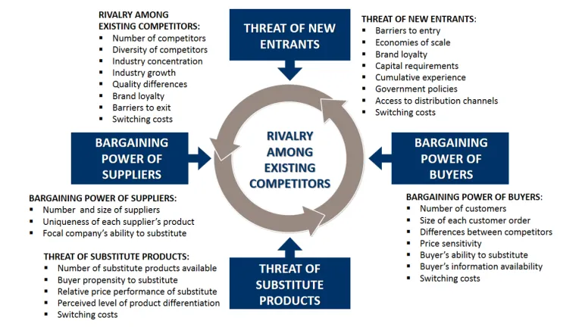
Figure 1: Significance of Porter’s five forces analysis framework
(Source: Moreno-Izquierdo et al. 2016)
Forces | Severity Level | Impact
The threat of new entrants | Low | New entrants enter the market with similar sized shoes and hence, the threat of new entrants for AA security is low as the majority of shoe businesses enter the marketplace with regular sized shoes or footwear
Threat of Substitute | Moderate | There is a wide range of substitute products of shoes like sandals, athletic footwear and boots (Zhao et al. 2016). This makes the threat of substitutes moderate because AA security is planning to enter the marketplace by launching shoes of irregular sizes.
Rivalry among the businesses | High | The footwear industry of the UK comprises reputed shoe brands like Grenson, Church's, George Cleverly and many more (Fashionbeans, 2021). Therefore, tackling such a competitive marketplace will be a great challenge for AA security.
Bargaining Power of Suppliers | High | With increasing GDP growth of the UK makes the demand of the suppliers high and hence, buying raw materials from the suppliers at a high price can negate the business revenue margin for AA security.
Bargaining Power of Buyers | Low | AA security will promote its products on its website and multiple social media platforms and hence, the bargaining power of buyers will be low as they need to pay the displayed prices for the footwear.
Table 1: Porter’s 5 forces analysis of UK footwear market
(Source: Created by the Learner)
From the above table, it can be stated that AA security will easily attract the market audiences of the UK as the threat of new entrants for the concerned business is low as footwear businesses often enter the market with regular-sized footwear. Moreover, it has been identified that the UK footwear industry comprises multiple reputed footwear brands like Grenson, Church's, George Cleverly and many more and hence, AA security can face highly aggressive competition while entering the UK marketplace. As per Varelas and Georgopoulos (2017), new entrants face huge complexities while operating in a competitive marketplace. In addition, the GDP growth rate of the UK can be analyzed through the below-mentioned figure.
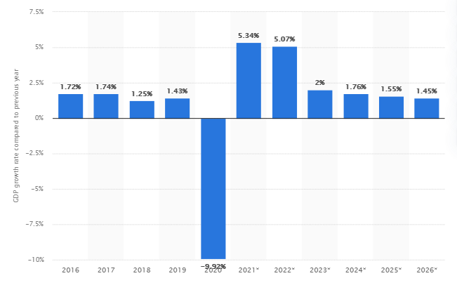
Figure 2: GDP growth rate of UK
(Source: Statista, 2021)
The high GDP growth rate of the UK implies that the bargaining power of the suppliers increases with passing days. Therefore, the high demands of the suppliers can negate the revenue margin of AA security. Knego and Delić (2017), denoted that social media marketing in modern days has become a trending business strategy used by multiple organizations. In regard, the business I will be using its website and multiple social media platforms like Facebook, Instagram and many more for launching and promoting the products. Therefore, the buyers will have to pay the displayed price for the footwear and hence, the bargaining power of the buyers is low for AA security.

PESTLE analysis
One of the reputed frameworks used to analyze the business environment is the PESTEL analysis approach. As per Sijabat (2019), this approach is effective in analyzing the factors that can affect the business functioning in a marketplace. In regards, this approach considers six different factors of the business environment which are shown in the below-mentioned figure. Hence, the PESTEL analysis approach is used here to analyze the competitive marketplace of the UK footwear industry.
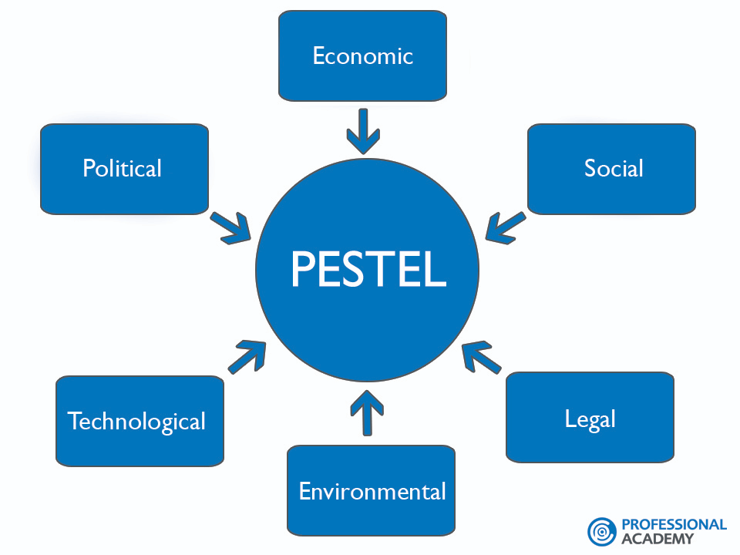
Figure 3: PESTLE analysis framework
(Source: Sijabat, 2019)
In this concern, the PESTEL analysis approach has been used to analyze the footwear industry in the UK.

Political Factors | - Presence of a highly active and stable governing body  - Brexit can help AA security to hire highly skilled employees  - Brexit enables the UK to trade in non-EU territories  - Presence of adaptable and stable taxation policies
Economic Factors | - UK has a stable GDP growth rate and the nation recorded a growth rate of 5.92% in 2021 (Statista, 2021)  - Foreign Direct Investment (FDI) cash net flows as recorded in 2019 was 1498.23 billion GBP (Statista, 2019).  - The footwear industry of the UK comprises a revenue margin of 12,807 million US dollars as recorded in 2021 (Statista, 2021)  - It is expected that within the fiscal year 2021, 86% of the footwear revenue will be attributable to non-luxury goods
Social Factors | - Market demand is high as AA security is going to enter the market by launching multi-seized shoes which are available rarely in the UK footwear marketplace.  - The literacy rate of the UK as recorded in 2018 was 96% and hence, people can judge and take efficient decisions regarding the purchase of shoes of AA security (Macrotrends, 2021)  - The death cases of Covid 19 resulted in a decline in the population size of the nation.
Technological Factors | - The use of modern tools and technologies can help AA security in influencing its business performance and efficiency.  - AA security needs to recruit highly skilled technicians to handle technical operations like social media marketing, handling software like CRM and others  - The availability of IT skilled candidates in the UK is high
Legal Factors | - The governing policies and laws are effective in protecting the employees operating in the UK businesses  - AA security can use the equality act 2010 to avoid discriminatory actions in the working environment (Tsvirko, 2020)  - Welfare programs should also be used to increase the employees' value and also to retain skilled employees.
Environmental factors | - AA security should focus on minimization of waste generation  - Utilization of natural resources can be an effective strategy for AA security  - Consumption of resources should be controlled to avoid mass waste generation.
Table 2: PESTLE analysis of the UK footwear market
(Source: Created by the Learner)
Therefore, from the above table, it can be stated that AA security can gather huge business opportunities as the GDP growth rate of the UK is remarkable. Moreover, high FDI cast net flows can help the business in gaining a high revenue margin. Moreover, the revenue margin can also be benefited by the stabilized taxation policies of the UK government. Moreover, as AA security is planning to enter the UK by launching multisized shoes which are rarely available in the UK marketplace and hence, the consumer demand is high and can provide huge opportunities for the concerned business to gain a high revenue margin.
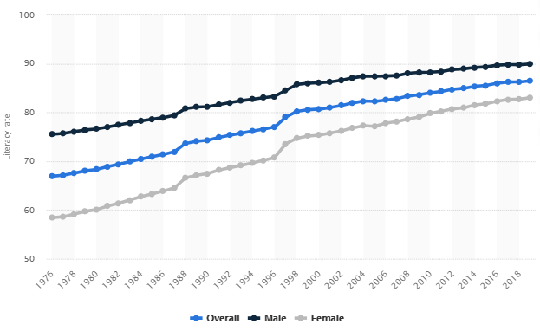
Figure 4: Literacy rate of UK
(Source: Statista, 2019)
In addition, it has been observed that the footwear industry of the UK plays an important role in the UK economy and generate a revenue of 12,807 million US dollars in 2021. Moreover, it has been identified that the use of modern technologies and tools can help AA security in increasing its efficiency and productivity margin. Moreover, following the legal implications of the UK can help the business to enrich its reputation and can be benefited by acquiring a huge consumer base. As per García and Prieto (2019), new entrants need to consider environmental factors like pollution, waste generation and many more. In regards, AA security needs to control the resources for lowering the waste generation volume.

SWOT analysis
As per Potter and Urquhart (2017), new entrants should also analyze the micro environmental factors to determine the opportunities. In this aspect, the SWOT analysis approach is effective in analyzing the internal business environment and also in determining the potential opportunities that can be gained by the business while operating in the marketplace as shown in the below figure.
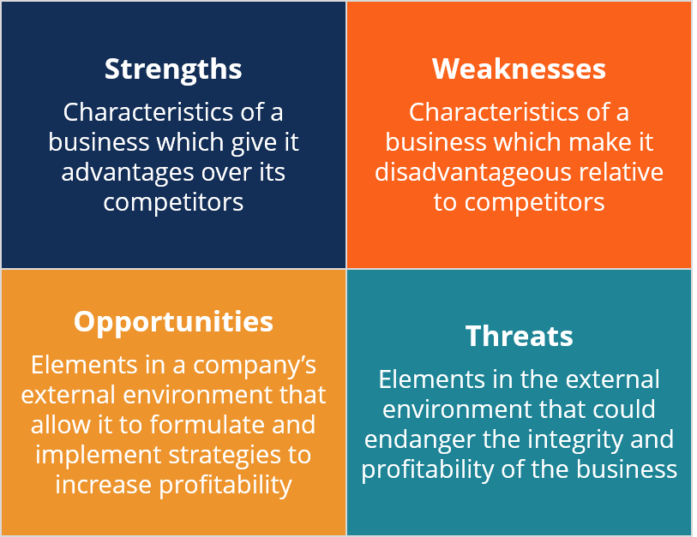
Figure 5: SWOT analysis approach
(Source: Potter and Urquhart, 2017)
Hence, this model has been used to analyze the opportunities for AA security as stated in the below-mentioned table:

Strengths  - Customized sizes of shoes can attract the market audiences  - Promote social activities and also assesses multiple CSR activities  - Supports the workforce and promotes active participation in the social programs | Weaknesses  - Being a new business in the UK marketplace can lead to low brand awareness and hence the business can be disabled to attain a huge consumer base  - High competition in the UK footwear industry can disallow AA security is gaining a highly competitive edge (Hodgetts et al. 2016)  - Inefficiency in using advanced technologies can disallow the business in influencing its efficiency and productivity margin
Opportunities  - Multi-size customized shoes can attract the market audiences and can benefit AA security to attain a huge consumer base at a quick pace.  - The use of modern technologies can increase the business productivity and efficiency margin and the availability of highly skilled employees in the UK can help the business to recruit technical staff (Bradshaw et al. 2019) | Threats  - Low brand awareness can disallow the business to engage the market audiences  - Providing shoes at the base price can negate the profit margin of the business
Table 3: SWOT analysis of AA security
(Source: Created by the Learner)

Competitor Analysis

Competitor Profile
Competitor Profile is an effective framework used to analyze the competitors of a business and help them to analyze their key offerings. Hence, this framework is used in this case to strategize the business operations of AA security. However, the key competitors for the concerned business are Grenson, Church’s, George Cleverly and many more (Fashionbeans, 2021). The reputed footwear brands operating in the UK marketplace hold a strong market reputation and in this concern, competing with such competitors will be a great challenge for AA security. However, as stated by Roukova et al. (2016), footwear businesses often provide shoes of regular sizes and hence, it can be expected that A security can attract the market audiences as this business is going to launch shoes for the people who rarely find their shoes in the footwear stores of UK. Hence, it is expected that AA security can easily attract the market audiences and can help such people in attaining the shoes which are rarely available in the marketplace. The concord business will focus on delivering shoes that are rare in terms of sizes. Hence, the business will focus on delivering superior quality shoes to the market audiences and also on gaining feedback from the consumers.

Competitor Intelligence Mapping
Competitor intelligence mapping is a modern visualization tool that is used by organizations for analyzing their respective competitors. In this concern, the competitor mapping visualization of A security is shown in the below figure.
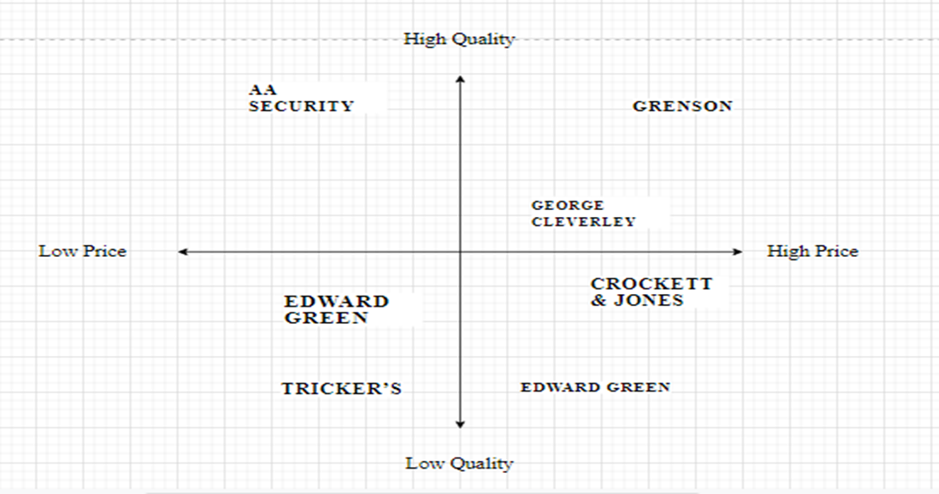
Figure 6: Competitor Intelligence Mapping
(Source: Created by the Learner)
As the above figure depicts, the market offerings of the key competitors are high. For example, as can be observed from the above figure, Grenson provides footwear of high quality but the prices of the products are high. Hence, being a new entrant, AA security will focus on delivering superior quality shoes to the market audience at low prices which can help the business to develop a huge consumer base at a quick pace.

Conclusion
Therefore, from the above discussion, it can be concluded that AA security has huge business opportunities while entering the UK marketplace with its customized sized shoes for the market audiences who rarely find their shoes at the footwear stores in the UK. It has been identified that market stabilization and the GDP growth rate of the UK can help businesses gain a huge revenue margin. Moreover, it has been identified that AA security should focus on delivering superior quality shoes to the market audience at low prices which can help the business in developing a huge consumer base.

References
Bradshaw, C.D., Hemming, D., Baker, R., Everatt, M., Eyre, D. and Korycinska, A., 2019. A novel approach for exploring climatic factors limiting current pest distributions: A case study of Bemisia tabaci in north-west Europe and assessment of potential future establishment in the United Kingdom under climate change. Plos one, 14(8), p.e0221057.
Bruijl, G.H.T., 2018. The relevance of Porter's five forces in today's innovative and changing business environment. Available at SSRN 3192207.
Dunn, M., Marzano, M., Forster, J. and Gill, R.M., 2018. Public attitudes towards “pest” management: Perceptions on squirrel management strategies in the UK. Biological Conservation, 222, pp.52-63.
Fashionbeans, 2021. The best made in britain shoe brands. Available at: https://www.fashionbeans.com/article/best-british-shoe-brands/ [Accessed on: 21st August 2021].
García, C. and Prieto, M.A., 2019. Bacterial cellulose as a potential bioleather substitute for the footwear industry. Microbial Biotechnology, 12(4), p.582.
Hodgetts, J., Ostojá-Starzewski, J.C., Prior, T., Lawson, R., Hall, J. and Boonham, N., 2016. DNA barcoding for biosecurity: case studies from the UK plant protection program. Genome, 59(11), pp.1033-1048.
Knego, N. and Delić, M., 2017. Footwear market in the Visegrad Group countries and the Republic of Croatia. International Entrepreneurship Review, 3(1), pp.153-173.
Macrotrends, 2021. U.K. Literacy Rate 2021. Available at: https://www.macrotrends.net/countries/GBR/united-kingdom/literacy-rate#:~:text=Adult%20literacy%20rate%20is%20the,%2C%20a%200%25%20increase%20from%20. [Accessed on: 21st August 2021].
Moreno-Izquierdo, L., Ramón-Rodríguez, A.B. and Perles-Ribes, J.F., 2016. Pricing strategies of the European low-cost carriers explained using Porter's Five Forces Model. Tourism Economics, 22(2), pp.293-310.
Potter, C. and Urquhart, J., 2017. Tree disease and pest epidemics in the Anthropocene: A review of the drivers, impacts and policy responses in the UK. Forest Policy and Economics, 79, pp.61-68.
Roukova, P., Keremidchiev, S. and Ilieva, M., 2016. Footwear Industry: Delocalization and Europeanization. In The Moving Frontier (pp. 227-250). Routledge.
Sijabat, R., 2019. Macro-environment analysis of the tourism industry in Indonesia: findings from the PEST analysis. Innovative issues and approaches in social sciences, 12(3), pp.96-118.
Statista, 2019. Global adult literacy rate aged 15 years and older from 1976 to 2019 by gender. Available at: https://www.statista.com/statistics/997360/global-adult-and-youth-literacy/ [Accessed on: 21st August 2021].
Statista, 2019. Global foreign direct investment (FDI) position of the United Kingdom (UK) from 2004 to 2019. Available at: https://www.statista.com/statistics/284847/uk-global-foreign-direct-investment-fdi-position/ [Accessed on: 21st August 2021].
Statista, 2021. Footwear. Available at: https://www.statista.com/outlook/cmo/footwear/united-kingdom [Accessed on: 21st August 2021].
Statista, 2021. United Kingdom: Real gross domestic product (GDP) growth rate from 2015 to 2025. Available at: https://www.statista.com/statistics/263613/gross-domestic-product-gdp-growth-rate-in-the-united-kingdom/ [Accessed on: 21st August 2021].
Tsvirko, S., 2020, May. Crowdfunding as a Source of Financing in Russia: PEST Analysis. In International Conference on Integrated Science (pp. 154-163). Springer, Cham.
Varelas, S. and Georgopoulos, N., 2017. Porter’s competitive forces in the modern globalized hospitality sector–the case of a Greek tourism destination. J Tour Res, 18, pp.121-131.
Zhao, Z.Y., Zuo, J., Wu, P.H., Yan, H. and Zillante, G., 2016. Competitiveness assessment of the biomass power generation industry in China: A five forces model study. Renewable Energy, 89, pp.144-153.

