Donna Kennett
Student number 1908067
ACCB4013
13/01/2020

This is the context diagram
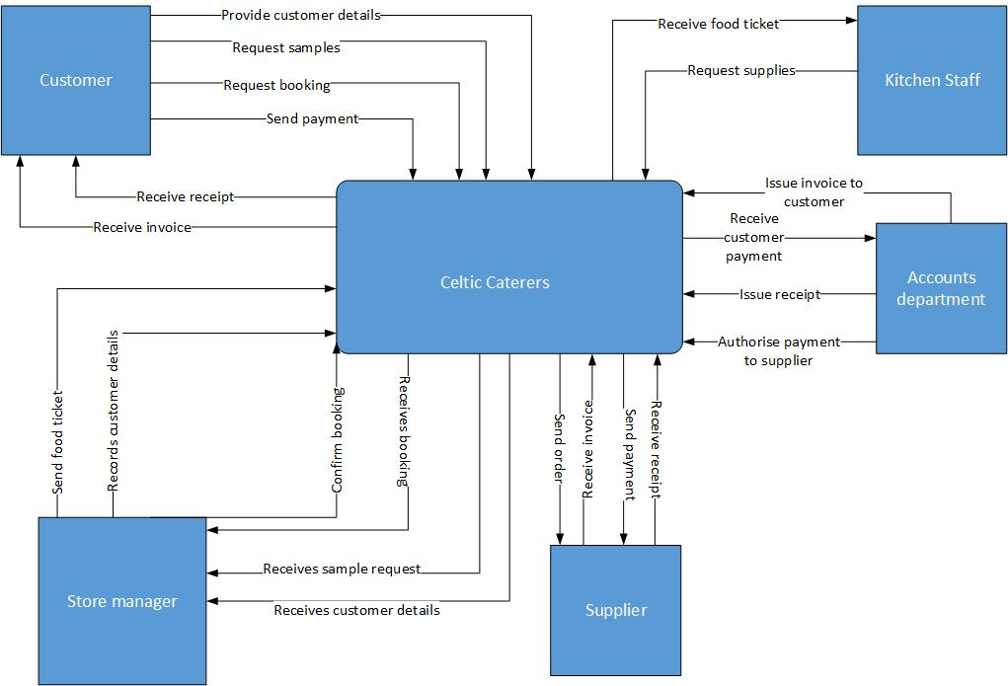

This is a Level 0 diagram

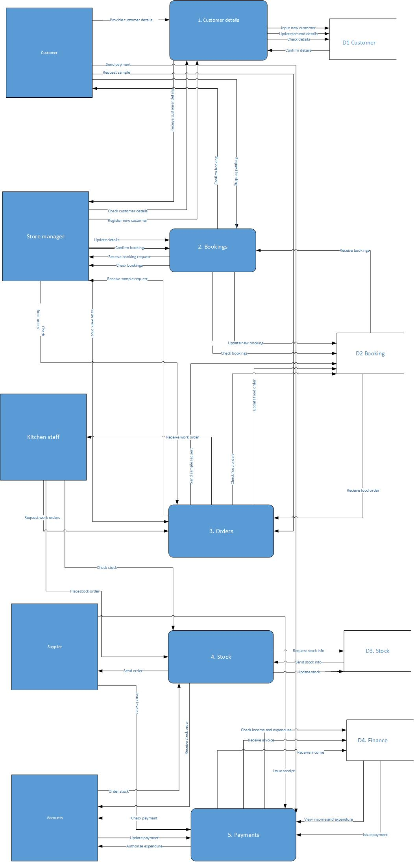
This is a Level 1 diagram:
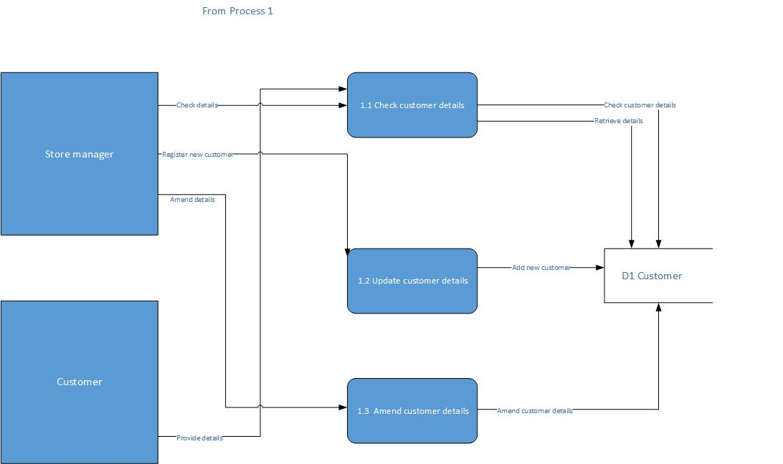

This is the ERD:

