Student Name: | Renee kennedy
Student Number: | 2010989
Module No: | BMSK4006
Module Title: | Managing enterprise in the 21st century

The Personalised Project

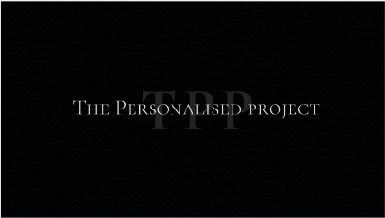

Business Plan

Contact: Renee kennedy
Email: reneekennedy2621@gmail.com
Tel: 07853034383

Table of Contents
Table of Contents 1
Executive Summary 1
Business Overview 1
Markets and Competition 1
Target Markets 1
Competition 1
Sales and Marketing 1
Product Positioning 1
Marketing 1
Sales 1
Management 1
Key Personnel 1
Advisors and support services 1
Operations 1
Premises and Equipment 1
Employees 1
Suppliers 1
Financial Forecast 1
Sales 1
Cashflow 1
Profitability 2
Financing 2
Executive Summary 3
Business Overview 4
Markets and Competition 5
Target Markets 5
Competition 5
Sales and Marketing 6
Product Positioning 6
Marketing 6
Sales 6
Management 7
Key Personnel 7
Advisors and support services 7
Operations 8
Premises and Equipment 8
Employees 8
Suppliers 8
Financial Forecast 9
Sales 9
Cashflow 9
Profitability 9
Financing 10

Executive Summary

My name is Renee Kennedy. I am 37 years of age and I have made the decision to start my own business.

I have no children so feel like this is the right time to take this step.

I am setting up a business for personalised merchandise. Firstly, I am going to focus on personalised business t-shirts this will allow businesses to have their logo on the uniforms.

I will eventually expand to company merchandise like personalised mugs, pens, notepads.

Then in years to come I have the idea to expand even further more variety of gifts etc.

I will target local businesses from all sectors offering a loyalty benefit for regular customers.

I will market my business using social media to enhance my sales. I have a lot of family and friends who can also share my business on their own social media platforms to spread my business even further.

My business will be run by myself as a sole trader.

I undertook a cost analysis and found that in this industry of t-shirt printing if you can get the t-shirts at a very low cost the printing does not cost much so it’s an effective way to make 100% profit.

I did a swot analysis that I found that this my strong point that will help me massively in starting my own business if that I have had over 10 years of customer service experience. One of my weaknesses is that I do not have any experience in running my own business as a sole trader but I am looking to learnt a lot through the process and on the job.

The good thing about my business is it isn't going to cost a lot of money to start up and once the profit starts coming in It will then enable me to expand.

I will be using my own savings to start my business so it’s a good start to not owe anything out before I even start bringing money in.

Business Overview

My business idea has been developed through a hobby. I decided that one day I need a hobby and I decided I was going to personalise products.

I am a fan of a personalised gift for friends and family so I thought what better way to save money and enjoy something and do it myself.

From there all these ideas come into my head and every time I think of something I jot it down in my notepad for when I expand.

There is so much option out there you can personalise almost anything.

It seems to be a trend at the moment where people are enjoying having their names on a different varierty of things .

Personalising gifts are a great sentimental gift to buy for a loved one.

My plan is that in 5 years' time I will have a website that consists of so many different options for my customers.

I have a notepad full of ideas that range from personalised t-shirts to children's reading books.

I have folders full of ideas ready for when I get started so this business plan has come at the right time and it has taught me a lot already.

I have the machinery ready to use which is a great start. And I already have my first customer that is a good starting point for me as we all must start somewhere.

The key feature of my business is selling. I will keep up with all the latest trends to make my business succeed. I have nieces and nephews that when I expand into things like children's wear and personalised school bags and pencil cases etc they can help promote my products by using them and their friends seeing them and wanted to also buy from me.

All the profit that I make in the first year will allow me to expand my ideas into the second year and so on.

There is a risk this may not go to plan especially the way the economy is at the moment but I am willing to take a risk and work hard for it.

This is all very new to me so there is a risk I could face several things starting up a new business.

The first thing we all pray for is a good reputation. With this must come a good service so it is nerve racking thinking you may mess it up but i must take risks to find out or i will never get to run my own business.

I am confident that this is the time for me to start and I am fully aware that it's not going to succeed without hard work.

Markets and Competition

Target Markets

My target customers are businesses that have a company logo that require the brand to be on their staff uniform.

One of the most important things of small business is addressing your target market –the people that’s are more likely going to buy your products.

My Target audience could be any business ranging from builders to beauticians. I will target all ages whether it be a business owner age 20 or age 50 if they require my product and services then I will there it provide it .

Competition

“Safewear” is one of my competitors which offer printing and embroidery services. They have been trading since 2009 and are a limited company.

They mainly target the workplace so eventually my business will differ from them as I plan to expand into the world of personalised gifts etc also.

I have a vision of where I want my business to be in the next 5 years which involves personalised party packages like plates and serviettes and party bags. Personalised beach bags, towels and swimwear. The list is endless but this is my starting point.

Their advantages are that they have already been trading on companies' house for 12 years and may have been trading as a small business prior to this as it was formed in 1980 so they have at least 12 years' experience. They advertise over Facebook, Instagram and twitter so have a wide following.

They also aim to deliver products within 48hrs of order.

There disadvantages that they are closed on a Saturday and a Sunday and bank holidays.

For my business I will open 6 days a week Monday through to Saturday and close on a Sunday. I will open reduced hours on a bank holiday 9am until 1pm. I have asked 20 family and friends' what day of the what day of the week they are most likely to sit down, and online shop and they majority of people have said a Saturday. (See Appendix A) .

From this data I worked out the mode which is 1, The median which is 1 and the mean which is 3.

“Safewear” is 4.5 miles from my home and takes 11 minutes in a car.

I feel I can have a faster turnaround at home as I can work outside my advertised hours to meet customers' needs if needs be. Especially in the first 2 years to get my business off the ground whilst still maintaining a healthy WorkLife balance.

If im at home out of working hours and im not busy I won't mind doing a little bit of extra work to satisfy my customers.

Happy customers lead to a successful business.

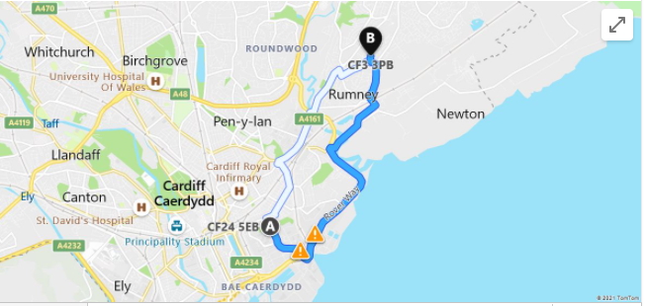

Another competitor is “Industry Ink” They are a little bit further away at 6.2 miles minutes in a car.

The travel time is 19 minutes.

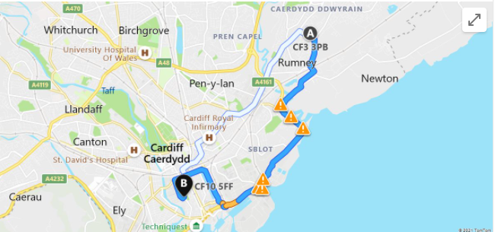
Industry Ink started in 2013 so they have over 8 years' experience in the business world.
They are a limited company and consist of 3 directors. The difference with these is they also design the prints.
This could be a disadvantage to them and an advantage to me being so close in the same industry as company's tend to already have their Logos designed before they contact you for the prints.
Their location could also come as a disadvantage as its not on a main bus route so if you didn’t drive and didn’t live close it would be a bit inconvenient to get to.

They also print bags which is something I would be doing for my own business in the future.
The advantage that they have is they offer pick up or delivery of orders so if you lived close you could avoid the delivery cost and collect your order instead.
They also open 7 days a week Monday-Sunday which is a huge advantage and a good unique selling point for them.
Our of these 3 competitors Industry Ink has the most followers on Instagram which could confirm that their audience is from 18-40 yr olds based on my knowledge of family and friends and who uses Instagram.

I have researched this and found that the average age of Instagram users (33.8%) is between 25 and 34 years old.

Cardiff Embroidery is also a competitor based 8.7n miles away from my business and 18 minutes driving.

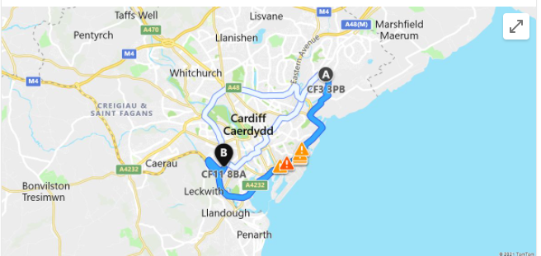
A disadvantage of this company like safe wear is that they close all weekend they are only trading Monday to Friday. So this makes my opening hours a good selling point for customers around this area.

Cardiff Embroidery have “More Than 30 Years' Expertise” .

There advantage is that they have numerous agreements with businesses in that area already to provide the personalised prints for example schools in the area.

They also advertise over twitter Instagram and Facebook

Sales and Marketing

Guidance Notes:
This section shows how you will reach customers — how you attract their attention and how you make sales.

Product Positioning
My business is Goin to offer price match which makes my business very appealing. All the competitors that I have researched do not advertise that they offer price match.
When i see that a company price matches it automatically draws me to them thinking they must be confident that their prices are already lower.
Convenience attracts customers no one wants hassle when buying products, they want a nice easy simple experience so that is what my customers will get. My advertising accounts on social media will easy to use and straight forward.

Marketing
Explain how you will promote your business — for example, through advertising, direct mail or online. How can you be sure that your promotions will reach your target customers and convince them to act?

At this stage I will promote my business through free advertising channels like social media by setting up a business profile. I will make business cards myself (see appendix B) and delivery them to businesses to make sure that it reaches my target audiences which will come at a small cost as I will print the business cards myself using card and my own colour printer. I have a large group of family and friends so my business will also be promoted through word of mouth and by them using my products also.

My Unique Selling Point is that I will price match if a customer finds my product cheaper with another local company. If this means more regular business then I can afford to break even on this occasion to get this customer to stick with me as their sole supplier.

I undertook a PESTLE and SWOT analysis (see appendix C)

The Pestle is a few points of what I need to take into consideration whilst starting my own business. It explains the bigger picture of the climate we are currently in.

Doing this pestle as a new business owner has helped me look deeper into the industry and helped my planning and way of thinking.

This is all new to me so I need to analyse every aspect in order to make decisions that could make or break my business in the long run.

By doing a SWOT it brings to the surface what I do well what I struggle with and what I can work on to make things better. Already I have more knowledge on finance spreadsheets and running my own business that what I did at the start of this business plan so it's a step in the right direction in making my weaknesses into strengths.

Sales

“Most people do not realize how important selling is—unless your pay check depends on it! great salespeople are made, not born, and no one achieves success in life without knowing how to sell.

The first thing you are selling is yourself.
Forget about the product or service. If whoever you are selling to does not like you, they are not going to listen to you. Make sure you know the product and present yourself well. Be the salesperson you would buy something from.

Listen more than you talk.
Bad salespeople cannot get over how amazing their product is—they go on and on about it! But good salespeople listen to what their clients are saying. They pay attention to the clients’ needs from the start and present accordingly.

Explain what you will do in terms of actively selling — for example, phoning or meeting customers. How will you identify the right customers to call? How difficult will it be to convince new customers and how long will it take? Do you have any existing customers or hot prospects, and will you get repeat sales?

Management

I will be trading as a ole trader so I will be the management. I will be doing the buying of the stock the selling the managing and overall, the running of the business.

As it is my business I am ready for all this responsibility to fall on me solely.

“For many, setting up as a sole trader is the best way to start up a new business. When compared against setting up as a limited company, it may seem like an easier and more convenient option. However, like all important decisions in life, it is best to weigh up the good against the bad before making that important leap. “

The pros are I get to run the business how I want to and I do not have anyone to report to. I also keep all the profit.

I can work whatever hours I want and as I will be working from home I can wear and look like how I want whilst working.

The disadvantages of being a sole trader is that all debt lies on you.

Weather the business works or does not rely solely on you.

You are working alone all day everyday with no one to interact with so that could affect me socially.

I do enjoy my company so that is a good start and will go in my favour.

Guidance Notes:
This section convinces the reader that you have the right team to make your business a success.

Key Personnel

This business is run me so I am responsible for everything from running the business, dealing with stock, assisting customers etc. I am very committed to starting this business and have invested all my time and money into it.

My skills involve
- I am a people's person and able to effectively communicate at all levels.
- I have Effective time management within the workplace.
- I excel in Customer Service based roles.
- Ive had Previous in-house Customer Service, Leadership and Management training.

These are the skills I have picked up in my current job which will benefit me greatly in my new business. I have attached my Cv to show my transferable skills (see Appendix D )

The people supporting me at the beginning will be friends and family that have experience and knowledge in sunning a business until I am financially able to start outsourcing for example my accounts to and accountant.

It's all going to take time to get right.

Operations

Guidance Notes:
This section shows that you are on top of all the practical aspects of running your business.

Premises and Equipment

I will be running my business from home I have a spare room in my house that will be purely to run my business from.

I have the heat press machine and the embroidery machine and all the equipment I need to start.

I will be looking in the future when I expand to rent a premises when the room in my house no longer serves its purpose.
Explain what premises you have (or are looking for). Is there anything special about the location?
What equipment and machinery do you have or need?

Employees
For now, I do not need any employees but as I expand, I will be taking people on. The key skill they will need is excellent customer service skills. They will also be able to deal with complaints and work well under pressure.
They will need to have Excellent time management and be well organised.

Suppliers
My key supplier to start off with is Ebay they are cheap and reliable but as my business grows, I will investigate wholesalers that are a bit more reliable.
Ebay is generally small business so wholesalers are usually bigger and more established which means the guarantee is a bit more set in stone to continuously provide my business and meet my needs on a long-term basis.

Who are your key suppliers and are they reliable? Do they offer you credit? How will you cope if a particular supplier increases its prices or goes out of business?

Financial Forecast

In order to break even I need to sell 1150 t-shirts at £10 each.

The ideal number of products I require to sell to make a comfortable living would be 250 t-shirts a month this would bring me in a profit of £1250 a month.

Heat pressing will take around 5 mins per t-shirt and embroidery will take a maximum of 15 mins per t-shirt depending on the logo size and detail.

The minimum amount of t-shirt prints per day is 32 based on all being embroidered. The maximum amount is 84. The minimum would be embroidered t-shirts and the maximum would be heat pressed based on an 8hr working day.

The heat press amount is also taking into consideration a 1hr lunch break where are the embroidery machine does hand to be hand driven its automatic so you can step away from it whilst it is still working.

Guidance Notes:
This section outlines how you expect your business to perform in financial terms. The main business plan highlights the key figures, with more detailed figures included in the appendix. The forecasts must be convincing: include any key assumptions or evidence that supports your expectations (including historical data if you are already trading). If there is a lot of uncertainty, it may be worth providing a range of forecasts: for example, a ‘most likely’, ‘optimistic’ and ‘pessimistic’ cases.

Sales

I have a friend who is already interested in my personalised business t-shirts as he has just started his own business VSS Vale Site Services. He has emailed me over his logo and he will be my first customer.

These t-shirts will be for the construction industry in which his office is based around other Contruction companies that he will promote my products to.

My aim is to sell 3000 t shirts in the first year to make a decent profit.

I would have to sell 1500 to be at a loss so I will always aim higher.

What total sales do you expect over the next year and further ahead? Provide a more detailed breakdown if this is useful: for example, by types of customer or different product ranges.

Cashflow
“When you are running a business, you are in a continuous cycle of spending and making money. Cash flow refers to the amount of money that is moving in and out of your business in a given period.

Cash flow can be positive or negative. A business that has positive cash flow has more money coming in than going out”.

I have added a spreadsheet showing my cashflow for 1 year see (Appendix E ).

My business will run on the basis that payment will be due before the product is made to avoid personalising t-shirts that a customer does not pay for that have to go to waste as they will be no good to another customer.

This will ensure I keep my losses as low as possible.

Every time I make an outgoing payment weather that be for a stamp or for some stationary this must be counted in my outgoing to get a true reflection of what money I am making as a profit.
What is your cashflow forecast over coming months and years? Make sure you are realistic about how quickly you expect customer to pay you. Will your business have enough cash to survive?

Profitability

I am confident that my business will be profitable in the first year the reason being is its small and my product is 100% profitable so once I break even on the outgoings, I have made then everything after that is profit.

In order to ensure it is profitable I will track my time so I will know what I am going to be achieving for the next day and how many orders I must completed by the end of the day.

I will analyse my finances regularly to keep track of what is going out and what is coming in and have a monthly review so at first, I will do my accounts myself.

I will make buying for my customers easy so my social medica account will be simple to make a purchase and complete an order as I know myself if the experience to purchase a product is difficult my customers will more than likely go to another supplier.

How profitable will the business be over the next year? What about further ahead? If the business is initially loss-making, when do you expect to reach break-even?

Financing

I will be using my own savings to finance this business at the start up (see Appendix F) for products and start up costs.

Appendix A
What Day of the week are you most likely to make an online order ?
 | Monday | Tuesday | Wednesday | Thursday | Friday | Saturday | Sunday
Person 1 |  |  |  |  |  | 1
2 |  |  |  |  |  | 1
3 |  |  |  |  |  |  | 1
4 |  |  |  |  |  | 1
5 |  |  |  | 1
6
7 |  | 1 |  |  |  | 1
8 |  |  |  |  | 1
9 | 1
10 |  |  |  |  |  | 1
11 |  |  |  |  |  |  | 1
12 |  |  |  |  |  | 1
13 |  |  |  |  |  | 1
14 |  | 1
15 |  |  | 1 |  |  | 1
16
17 |  |  |  |  |  |  | 1
18 |  |  |  |  |  | 1
19 |  |  |  |  |  | 1
20 |  |  |  |  |  | 1

Appendix B
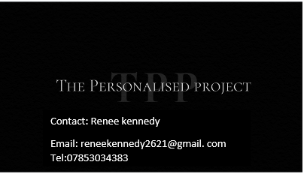

Appendix C

P  Political | E  Economic | S  Sociological | T  Technological | L  Legal | E  Environmental
Government stability is important as not only will this affect me as a business, but it can affect other business which will have a knock-on effect.  For example, if I cannot get stock from a supplier then my business can't run.  Corruption is something that could have a huge effect on my small business. If I messed up a customer's order, they could bribe me with giving them free merchandise for them to not slate my business over social media. Although I would not want to agree to the bribery social media is immensely powerful. Bad feedback would travel very quickly.  “As a sole trader, personal liability is unlimited.  sole traders are taxed under the self-assessment system.  Corporation tax would be charged to the company at rates of: 20 per cent up to profits of pound(s)300,000;  27.5 per cent on profits of pound(s)300,000-pound(s)1.5m; and 26 per cent on profits above pound(s)1.5m.  This is a lot less than the 40 or 50 per cent charged to individuals. As a sole trader, your net  profits are liable to income tax at these rates as well as national insurance.”  As my business grows, I will be looking into changing my legal entity to partnership so that every responsibility isn't just on myself. | The stage my business is at is the start ready to write a business plan and put all my ideas together.  Now the economy has been hit hard due to coronavirus, but this has not necessarily had a negative effect on all businesses. Especially the ones that trade online.  The impact of globalisation has now become negative as it's hard to ship products from overseas due to the pandemic or the shipping time has tripled.  Being a sole trader is going to involve a small cash flow to begin with so I may need to take out a loan at some point. Interest rates are going to be play a big part of this as I will need to ensure that I am able to make the payments of the loan back and on time.  Failure to do so could result in poor credit which will then mean I will be unable to take out further loans is needs be which could result in my business crashing.  At first, I will be starting my business off as just myself taking on all work but eventually when I get it up and running, I will need to employ at least one member of staff to help with the labour. This comes with another outgoing payment that I will need to take into consideration to ensure I can afford to take staff on. | My business is aimed to cover all ages over different varieties of personalised products e.g baby grows to teacups.  It we will be an online business which is not going to suit everyone as not everyone has access to online. More the older generation.  “One of the biggest workforce trends this year, will be the ongoing evolution of technology”.  I will keep up to date with the latest trends to grow my business and keep up with the ever-expanding market.  My attitude towards this business is positive as this is going to be my career. The reason I get up in the morning positive ready to cease the day and run my own business. | There is room for development in my business it will grow with the latest fashion.  I will need to have a backup if my machine has a fault and stops me from producing customer orders.  I will constantly be researching new products and services to develop my business and meet my customer's needs.  I will focus my time on building my business as well as running it. For me you can't run a business that you're not also building in the background. | As I will be running my business from home, I will not need to follow health and safety for customers as they will not enter my workspace. I will need to follow it for myself as a sole trader as I will be using hot machinery.  I will need to investigate tax and how it will change for me going from employed too self-employed.  Copyright laws will automatically cover me for any original work I produce in the future which is good to know that I haven't go to apply for it it automatically stands | I will investigate using environmentally friendly packaging, but this also must be beneficial to my income.  I already work in customer service and have done for 10 years so I have come across every attitude you can think of. I have learnt in my 10 years' experience how to turn a customer around from an angry customer to a satisfied customer so I will be transferring these skills into my own business.  I will ensure that my business is registered and insured before I start trading.

SWOT

STRENGTHS  - I am a people's person and able to effectively communicate at all levels.  - Effective time management within the workplace.  - I excel in Customer Service based roles.  - Previous inhouse Customer Service, Leadership and Management training.  - Ability to identify people's strengths and development areas. | WEAKNESSES  - I need to ensure I take time out for myself and focus on improving the balance of family/work/studying.  - I dont know much about finance  - I am not the best at spreadsheets  - I lack experience in running my own business.
OPPORTUNITIES  - I am currently undertaking the Higher Education, Skills for the Workplace course. By obtaining the ILM qualification, I will be in a much better position, as this will open further career opportunities.  - I will be undertaking a computer course this year to enhance my computer knowledge, which is all part of my personal development.  - I will liase with family and friends' business owners to engage mor knowledge on how to run a business. | THREATS  - COVID-19 has had a significant impact on businesses and have changed the way that people spend money which could effect my sales.  - By not excelling in strong time management of balancing work/family/studying, there is the possibility of failure.

Appendix D
CURRICULUM VITAE
Renee Kennedy
28 Penrhos Cresent
Rumney
Cardiff
CF3 3PB

PERSONAL PROFILE
A dedicated, proactive and focused team player who possesses extensive skills and pride in delivering first class customer service. A naturally organised individual who has a flair for solving problems and leading others to meet and exceed goals and deadlines.

KEY SKILLS
Problem Solving: A strong ability to resolve existing and predict foreseeable problems through a pragmatic and practical approach with a keen focus on attention to detail.
Customer Service: Experienced in handling difficult conversations with an influential approach to exceeding customer expectations. Proven ability to earn respect and credibility amongst customers and staff of all levels.
Communication: A high standard of verbal and written skills. A strong ability to invest attention in others and the use of effective communication in seeking the right combination of words, body language and voice tone.
Team Building: A core team player who develops others through leading by example. Unafraid to work at the bottom line to encourage team members to perform at their best. An influential character who motivates and guides with a compassionate and humanistic approach.
Motivation: An energetic self-starter who motivates others through a positive attitude and dedication to delivering a first class service at all times.

KEY ACHIEVEMENTS
Joined management team and now holds responsibility to supervise and manage a team of 10. Leads team meetings and reviews performance of staff, targets and practices, implements and manages change.
Through management efforts of coaching and mentoring of staff both in groups and individual meetings, lead team to exceed business target by 60% during last quarter.
As a lead for testing for implementing a new SAP system into the business my duties involved using my extensive knowledge of the electricity industry to carry out system testing to ensure a smooth roll out across the business. As i played a key part in the delivery of the new SAP system into the department i regularly liaised with stakeholders throughout other parts of the business including Leicester where i was based for 3 months. I carried out regular Testing and reported any issues and risks to the business . I also liaised with the learning and development department to ensure all training material was accurate from my knowledge of testing the new system.

EDUCATION AND QUALIFICATIONS
Rumney High School- GCSE’s:
Mathematics C
English C
Science C
Media Studies B
Physical Education B
WORK EXPERIENCE
British Gas- Customer sales executive - February 2010 to Present
The nation’s largest energy provider: Employed within the Connections & Metering team which focuses on the metering needs of business customers from SMEs up to large industrial and commercial organisations.
§ Manages a portfolio of over a hundred customers for the duration of the enquiry life cycle, covering various business customers from long standing relationships to new accounts.
§ Supports line manager and other team members in responding to complex queries, complaints, work processes and training.
§ Arranges quotations for various aspects of metering work and contracts.
§ Educates customers on the energy industry to ensure a clear and transparent approach to account management.
§ Guides customers through processes with clear instructions and through being available to respond to queries and offer regular updates.
§ Handles incoming sales calls, including business overflow.
§ Verifies contracts, ensuring complete records with accurate data are obtained at all times.
§ Liaises with customers to develop and maintain effective working relationships.
§ Obtains payments from clients.

Appendix E

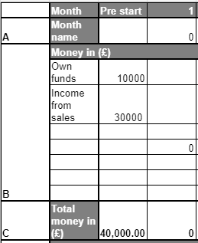
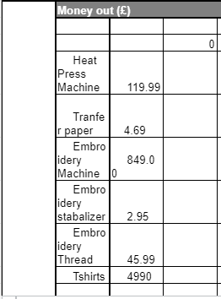
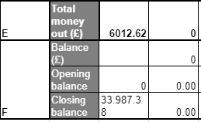

Appendix F
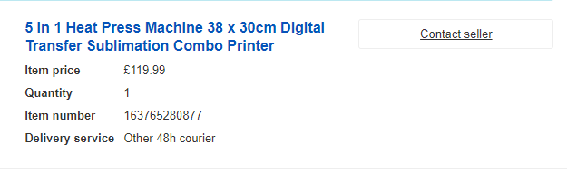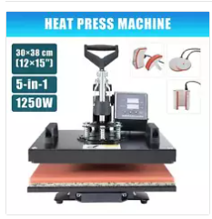

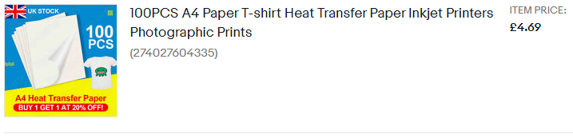

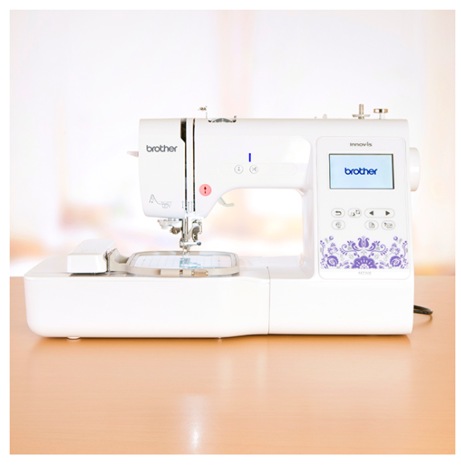
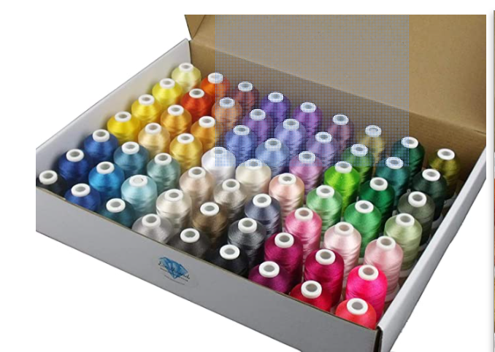
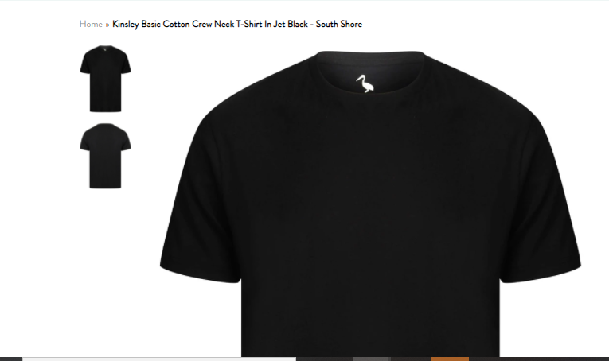

References

Strategic Planning Through PEST Analysis. (2021) (n.d.). Lucid Content Team Web Site. Retrieved July 5th 2021 from https://www.lucidchart.com/blog/pest-analysis

FT.com. (2012) ‘Top-rate tax forces sole traders to think again’
Business and Economics (7th Edition)

The Top 8 Workforce Trends of 2019 [PREDICTIONS] (2019) Industry Insights & Trends

Available at: https://www.cxcglobal.com/top-8-workforce-trends-2019 [Accessed:05 July 2021].

Logo Maker (2019) Design your business logo Available at:
https://www.wix.com/createlogo6/brand-logo?utm_source=bing&utm_medium=cpc&utm_campaign=ms_logo_uk_e_July19^company_logo_x&experiment_id=how%20to%20make%20a%20company%20logo^be^79302425145053^create%20a%20business%20logo&msclkid=d5b9c86c3f4214164b36a8b4adc405ed
[Accessed: 23rd June 2021].

Safewear Available at : https://www.tshirtprintingcardiff.co.uk/contact
[Accessed: 25th June 2021]

Industry Ink Available at: https://industryink.co.uk/
[Accessed 25th June 2021}

Cardiff Embroidery Available at cardiffembroidery.co.uk
Accessed: 25th 1th June

Ebay Heat press machine Available at: https://www.ebay.co.uk/itm/163765280877
[Accessed 2nd July 2021]

Ebay 100PCS A4 Paper T-shirt Heat Transfer Paper Inkjet Printers Photographic Prints Available at https://www.ebay.co.uk/itm/274027604335 [Accessed 2nd July 2021]

Create and craft Brother Embroidery Machine Available at https://www.createandcraft.com/gb/pp/brother-innovis-m230e-embroidery-machine-with-3-year-warranty-440591?v=000~000&msclkid=418064162bf018e5e1a204f92656907a&utm_source=bing&utm_medium=cpc&utm_campaign=Finch%20Shopping%3A%20Create%20and%20Craft%2091866%20(GB)%203&utm_term=4580977767248964&utm_content=440591.000.000%3A%20Brother%20Innov-is%20M230E%20Embroidery%20Machine%20with%203%20Year%20Warranty
[Accessed on 2nd July 2021]

Amazon Embroidery thread Available at https://www.amazon.co.uk/dp/B01CAOC3AI/ref=redir_mobile_desktop?_encoding=UTF8&aaxitk=690fdbdbc91cf73bb566eef58a99be46&hsa_cr_id=3136778640602&pd_rd_plhdr=t&pd_rd_r=2f7241be-a805-439e-9107-4e1b04f97aa8&pd_rd_w=g1V9K&pd_rd_wg=km8pT&ref_=sbx_be_s_sparkle_mcd_asin_1_title
[Accessed on 2nd July 2021]

Pilon, A. (2018) Small Business Trends. Available at: https://smallbiztrends.com/2018/03/make-more-profit-small-business.html [Accessed 14 July 2021]

Berry, T. (2019) How to define your target market. Available at: https://articles.bplans.com/how-to-define-your-target-market/
[Accessed 14th July 2021]

Crothers, G. (2017) kash Flow Blog. Available at: https://www.kashflow.com/blog/the-pros-and-cons-of-being-a-sole-trader/ [Accessed 14th |July 2021]

Herjavec, R. (2017) My 5 Essential Tips for Selling Anything to Anyone
Available at: https://robertherjavec.com/5-essential-tips-selling/
[Accessed 14th July 2021]

Nwokike, F. (n.d) How to Manage Cash Flow as a New Business Available at: https://thetotalentrepreneurs.com/how-to-manage-cash-flow-as-a-new-business/[Accessed 14th July 2021]

