
Mustafa Alsaady
Student ID:2326285
MODULE COURSE: DIGITAL SKILLS
MODULE NUMBER: LCLM4002
MODULE TEACHER: Dr Hoang Nguyen
Safeguarding Your Digital World
It's critical to safeguard your online privacy in this highly technologically advanced era. Understanding the foundations of digital safety, from appropriate online behaviour to the security of personal data, is essential. This poster provides a comprehensive method for safeguarding your internet environment.

Crucial Advice for Online Safety!
3. privacy settings
Privacy Settings: To keep track of the data you publish on social media, examine and alter your privacy settings on a regular basis. Furthermore, emphasise the importance of regularly managing privacy settings to protect personal information and avoid privacy risks linked with online social interactions. (Vitak, Shilton, & Ashktorab, 2016).


2. Double-Factor Authentication (2FA):
Include verification with two factors (2FA). Due to this, users are unable to access some systems or accounts without presenting two different forms of identity. This typically entails merging an individual's possessions—like a tablet or smartphone—with their knowledge—like a security code. (University of Birmingham Young)
1.Use Strong Passwords
Strong Passwords: Strong passwords are created by combining complicated characters that are difficult for hackers to guess or crack using tactics such as brute-force attacks and credential stuffing. Strong passwords prevent unauthorised access, data breaches, financial fraud, and identity theft. Research by (Shay et al2010)
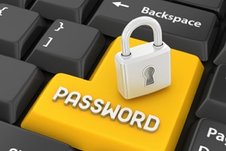

4. Cyber threats that you should be cautious of!
Phishing Operations: Phishing tactics create serious cyber threats. According to Sheng, Holbrook, Kumaraguru, and Cranor (2010), phishing assaults remain some of the most prominent methods by which cybercriminals gain personal information.
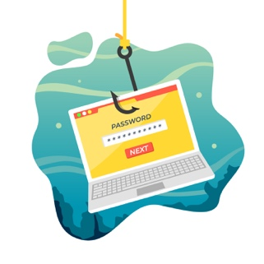
6. online scams
Precautionary Note: take precautions when it comes to online social networking scams that seek to trick users into revealing personal information, spread of online discussion through Facebook. (Dr Richard Frank)

5. Data encryptions
Data encryption is vital for protecting confidential information from unauthorised access. According to studies they Underline how important encryption methods are. (Seth,2020)


Digital safety is a shared responsibility. By being proactive and staying informed about emerging risks, people may navigate the digital world with confidence. Remember that having a secure online presence is the cornerstone of a safer browsing experience.
Refences:
1.Shay, R., Komanduri, S., Gage, P., Leon, P., Mazurek, M., Bauer, L., Christin, N. and Cranor, L. (2010). Encountering Stronger Password Requirements: User Attitudes and Behaviors. [online] Available at: https://cups.cs.cmu.edu/soups/2010/proceedings/a2_shay.pdf.
2.Reese, K., Smith, T., Dutson, J., Armknecht, J., Cameron, J. and Seamons, K. (2019). A Usability Study of Five Two-Factor Authentication Methods This paper is included in the Proceedings of the Fifteenth Symposium on Usable Privacy and Security. A Usability Study of Five Two-Factor Authentication Methods. [online] Available at: https://www.usenix.org/system/files/soups2019-reese.pdf.
3.Vitak, J., Shilton, K. and Ashktorab, Z. (2016). Beyond the Belmont Principles: Ethical Challenges, Practices, and Beliefs in the Online Data Research Community. Proceedings of the 19th ACM Conference on Computer-Supported Cooperative Work & Social Computing - CSCW ’16. doi:https://doi.org/10.1145/2818048.2820078.
4.Sheng, S., Holbrook, M., Kumaraguru, P., Cranor, L. and Downs, J. (2010). Who Falls for Phish? A Demographic Analysis of Phishing Susceptibility and Effectiveness of Interventions. [online] Available at: https://lorrie.cranor.org/pubs/pap1162-sheng.pdf.
5.Seth, B., Dalal, S., Jaglan, V., Le, D., Mohan, S. and Srivastava, G. (2020). Integrating encryption techniques for secure data storage in the cloud. Transactions on Emerging Telecommunications Technologies.
doi:https://doi.org/10.1002/ett.4108.
6. epe.lac-bac.gc.ca. (n.d.). Disclaimer - Electronic Collection. [online] Available at: https://epe.lac-bac.gc.ca/100/201/301/weekly_checklist/2012/internet/w12-05-U-E.html/collections/collection_2012/sp-ps/PS14-5-2011-eng.pdf.

