12/13/2019
Fundamentals of Construction Technology
Site InvestigationCase Study
Lynsey Davies
Student ID Number 1911295

Contents
Front Cover
Table of Contents……………………………………………………………………………….1
Introduction………………………………………………………………………………………2
Task 1 ……………...…………………………………………………………………………3-10
Task 2 …………………………………………………………………………………………11
Task 3 & 4………………………………………………………………………………………12
References………………………………………………………………………………………13

Site Investigation
Introduction:
City & County of Swansea have chosen to enter into a joint agreement with Marriot Hotels to create a new restaurant and ice-cream parlour with manager’s apartments, on Swansea foreshore. The building will share parts of the existing adjacent buildings car park facilities at the Marriot Hotel and Swansea Council Civic Centre.
The building is to contain the restaurant, café bar, ice-cream parlour, kitchen, and food -stores. At second floor level, there is to be a self-contained manager’s apartment and staff welfare facilities. The GIA (gross internal floor area) at ground level of 300 square meters. The project is procured via a Design and build contract.
Proposed development
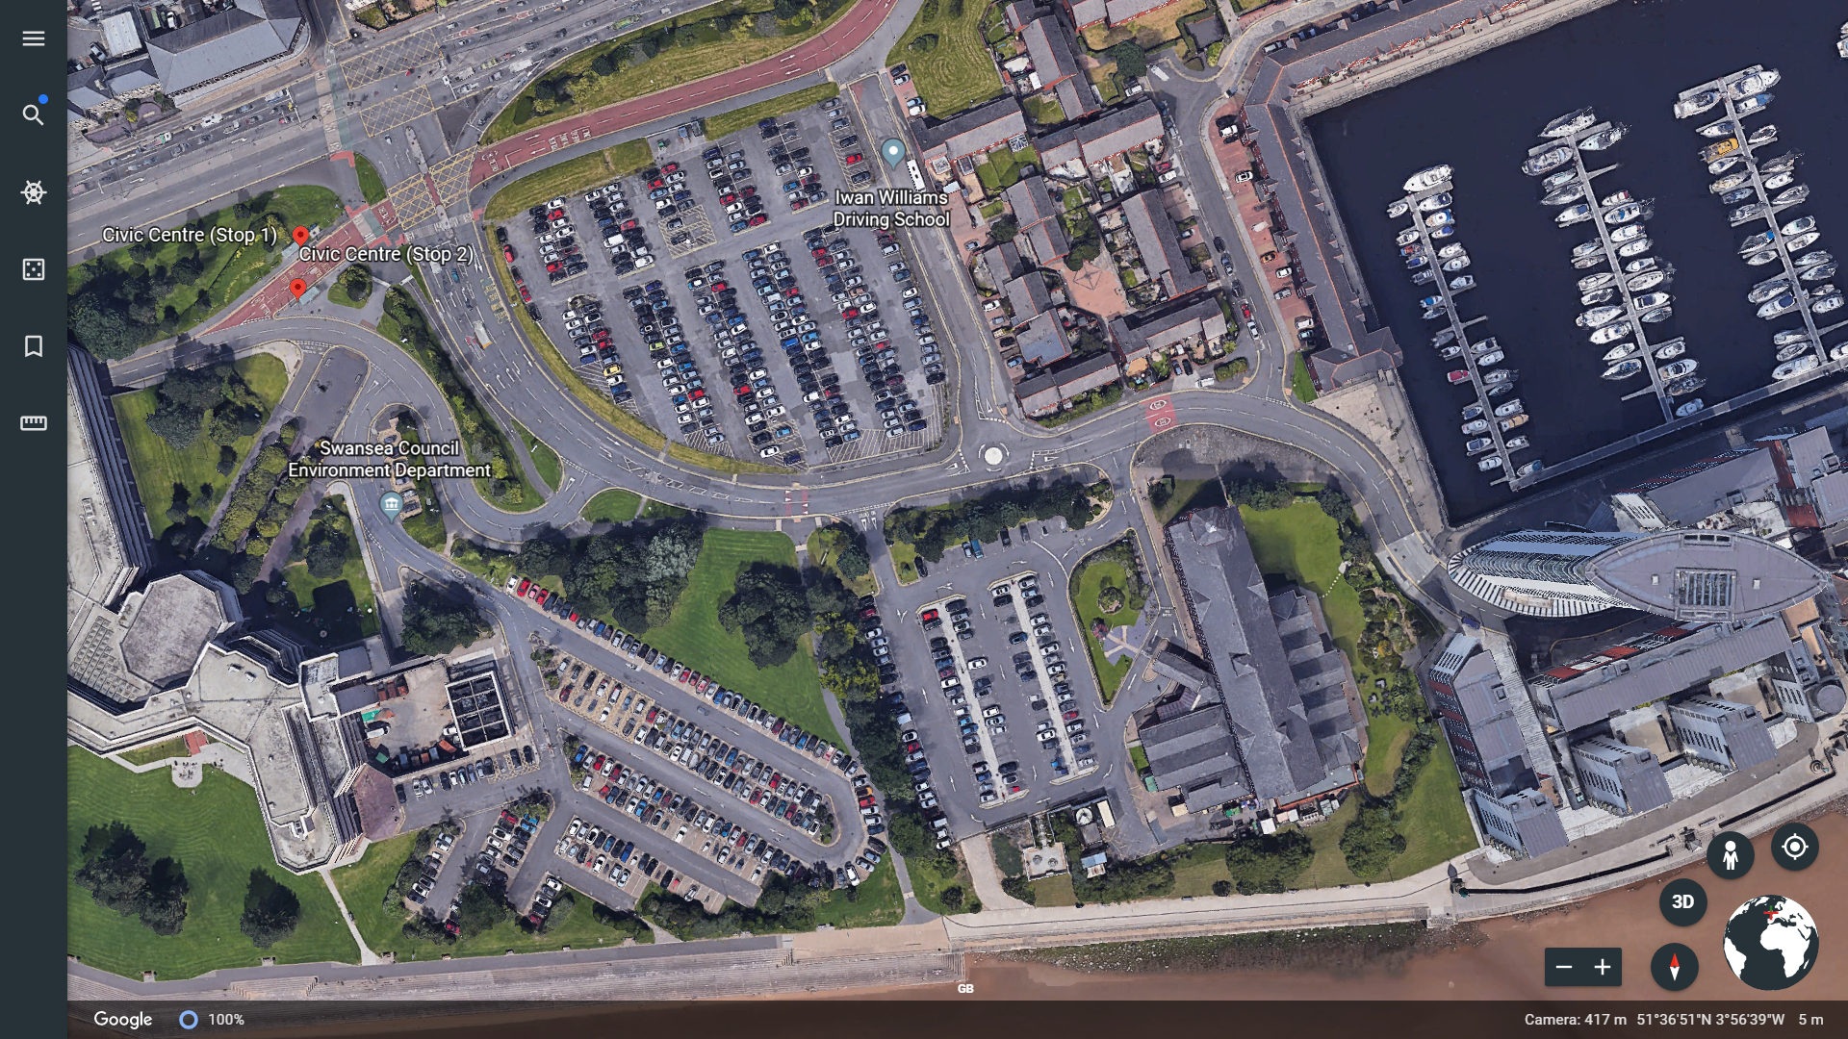
Image 1, Google (Earth) The Proposed Development
As a junior Quantity Surveyor for L.D Contractors I am to initiate a full desktop study of this proposed development in order to present my findings to the Architects for the design element of the contact.
The vision for this area is to redevelop the existing buildings into a mixed retail leisure facility, which will connect to Swansea sea front in order to create a unique profile for Swansea as a waterfront city with spectacular views.
Below are photos showing the existing man-made ground, situated above the sea bank.
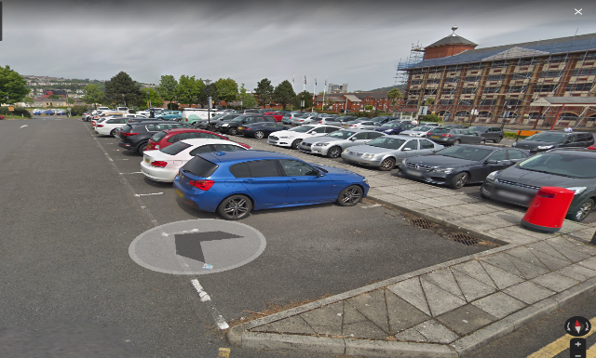
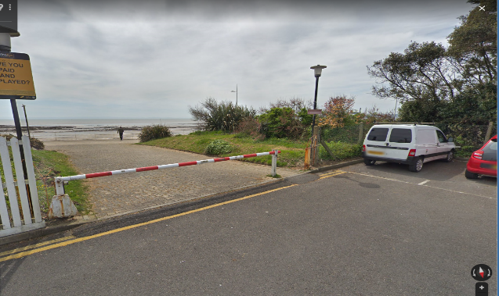
(google images , 2019)
Feasibility study
My aim is to gain an initial understanding of the characteristics of the area and to identify any potential risks involved in order to effectively manage these areas with regards to safety and cost of the proposed development.
From my findings I will have an indication on what needs to be undertaken within a detailed site investigation, which will be carried out by a local contractor.
As part of my research I will be looking at the historical background of the proposed development; which will help me understand what studies I will need to procure to enable us to proceed with the contract.

Phase 1 Desktop study – Research the historical background and site walkover.
Historical Background
It is believed that Swansea was founded by a Norseman who built a fort on the island around 1000 AD. Swansea was once called Sweins eg or ey, which means Swains Island. He was believed to have been raiding the welsh coast.
Through the century’s Swansea has grown and flourished with many industries deriving from wool, leather and cheese factories, then developing into copper and metals industry. In the 17th and 18th century coal and iron was discovered, and Swansea’s trade boomed. Shipments were exported daily from the port and Swansea became a busy trade and market town with a population of around 3000 people. In the 21st century Swansea is still flourishing, today the population of Swansea is 241,000.

In 1941 this thriving town was bombed for 3 nights causing significant damage “…there was only rubble. I couldn’t find anyone. The town was all flat”. This was the reaction of one Swansea fireman’s wife following the Three Nights’ Blitz, 19th-21st February 1941. (Lambert, n.d.)
The images below are ordinance survey maps which provides evidence that the area was heavily attacked, especially around the Swansea foreshore.
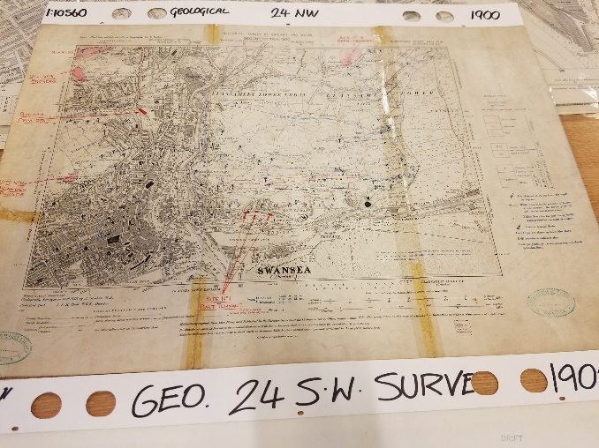
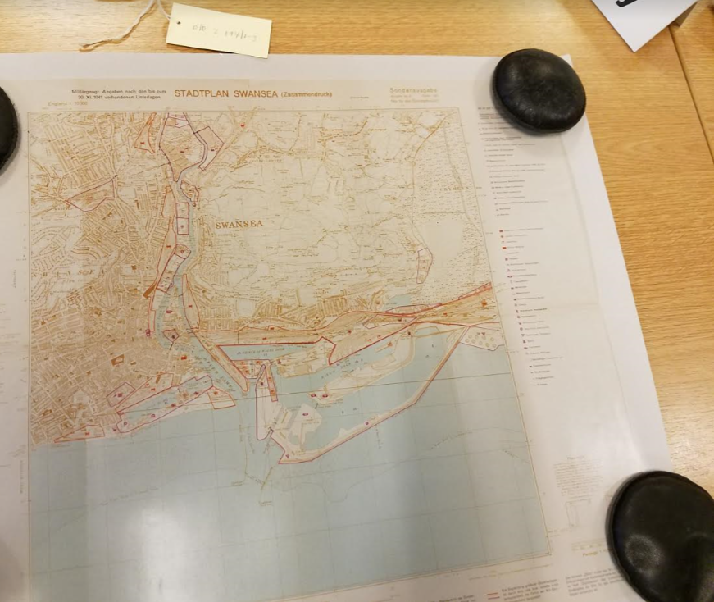
(Uxo Survey, 1900) (Survey, Geological, 1900)
The Pictures below were derived from the book ‘The Three Night Blitz’ which illustrate the damage that was caused at Swansea Docks, January 1941. From these pictures there is also evidence of a railway track which run along the sea front.
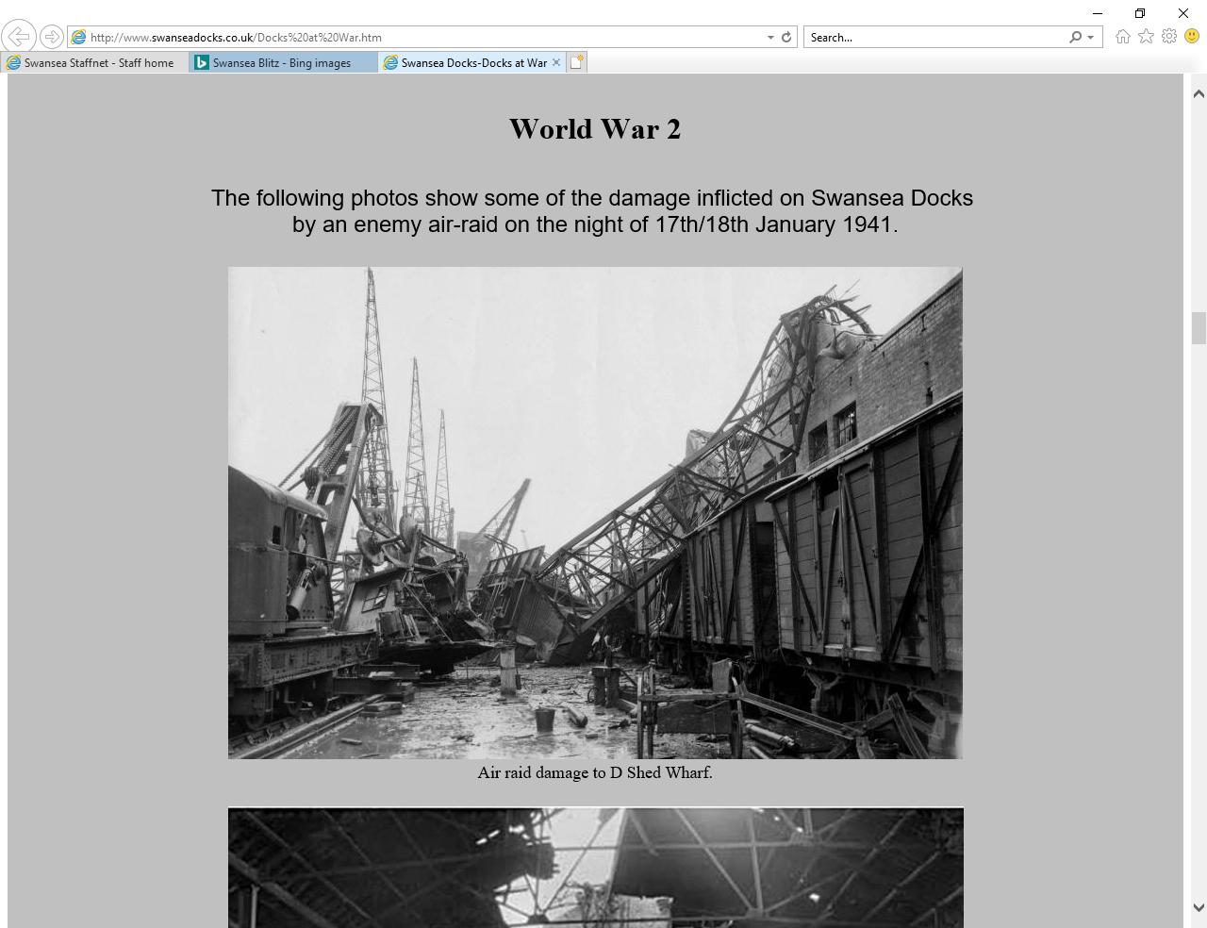
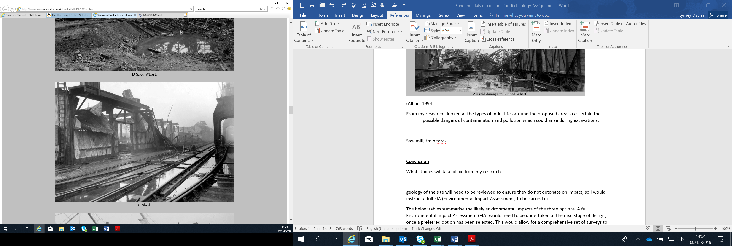
“On 3rd September of that year, Prime Minister Neville Chamberlain announced solemnly on radio that Britain was at war with Germany. However, rather than entering the conflict from a period of relative prosperity, the “Big Four” railway companies – the LMS, LNER, GWR and Southern Railway” https://www.bkrailway.co.uk/wp-content/uploads/2016/10/World-War-II-Mini-Pack.pdf

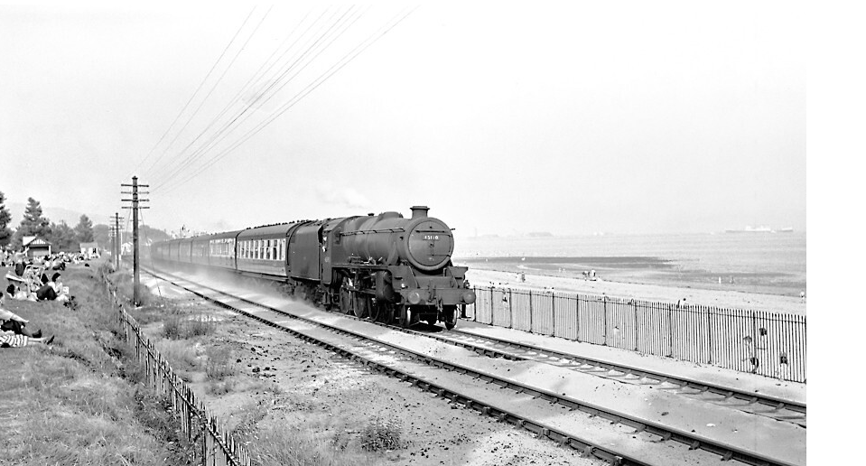
( LMS Shrewsbury Train along Swansea Bay , 1900)

From my research I looked at the types of industries and infrastructure around the proposed area to ascertain the possible dangers of contamination and pollution which could arise during excavations, due to toxicity of the metals.
Pictured below is a Survey Maps of ‘Swansea Bay’ detailing the types of industry in the area over the past 100 years.
The types of materials derived from these Companies:
- Gregors Timber Merchants, wood, Arsenic.
- Arsenic works, Arsenic.
- Old Coal Pit, Coal.
- English Spelter Crown Works, copper and zinc.
- Train Track.
These Companies put Swansea on the map and produced many jobs for the locals in the production and exporting business.
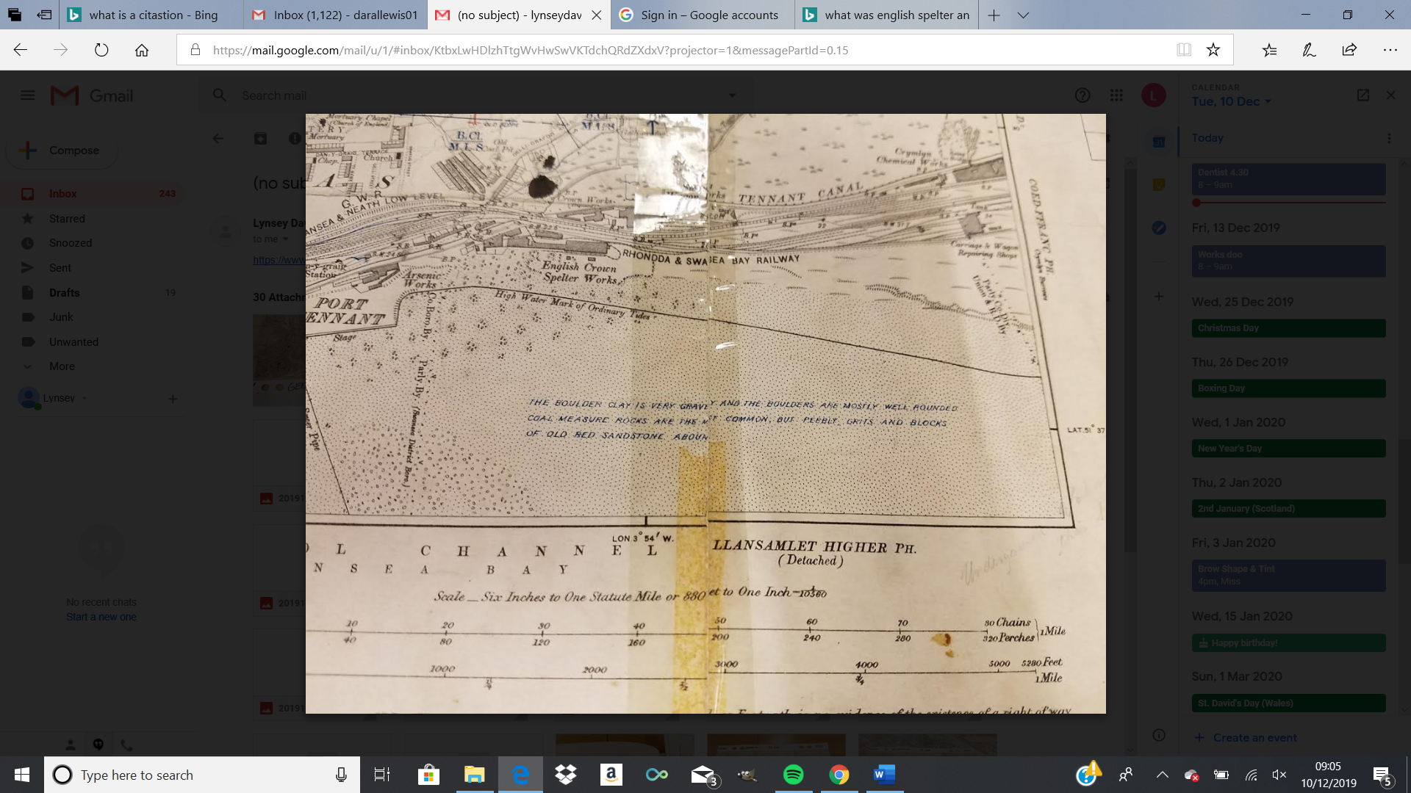
(Ordinance Survey Map , 1900)
Also, in the Survey Maps it clearly states the type of ground, which will help us tremendously in this investigation.
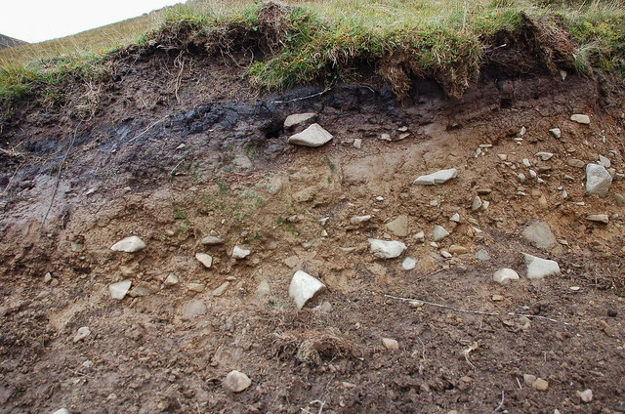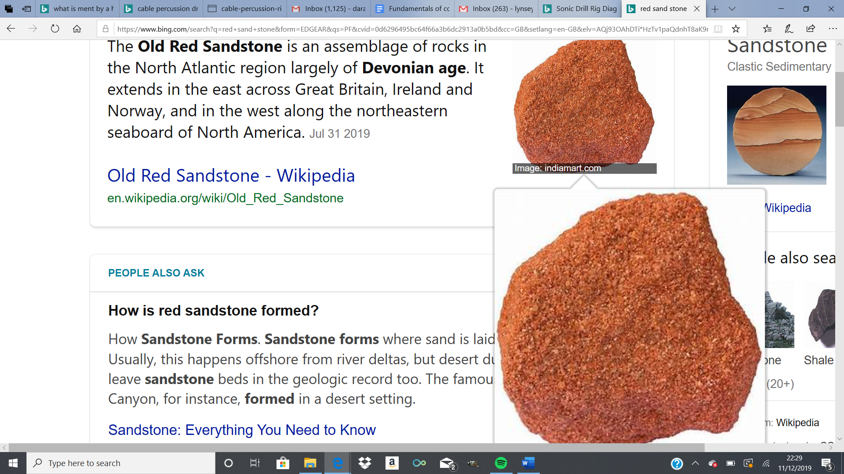
(google, n.d.)
Soil Strata
The ground is made up of Boulder Clays, which is very gravely well-rounded boulders, coal measure rocks and blocks of old red sandstone.
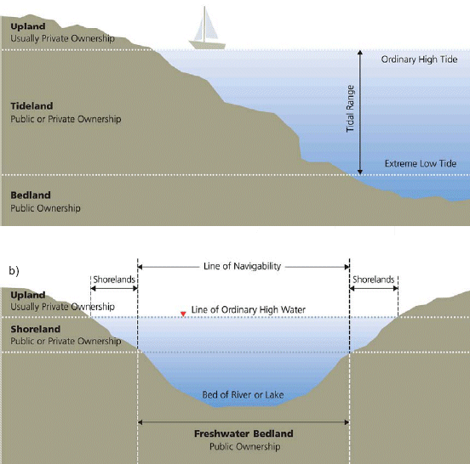
On the map you can see a high-water mark of ordinary Tide, a mark that will be found by examining the bed and banks and ascertaining where the presence and action of common or usual waters rest.
The ground is man-made which is evidenced in the above pictures of the car parks of the existing site.
It is very rare that ground investigations do not identify some depth of man-made ground. It will be used usually for fill materials, reworked or importing. Man-made ground may present harmful and a risk to our health and environment, so the ground investigations are a vital aspect in order for us to establish the possible effects (google image , n.d.)

Phase 2- intrusive investigation.
Giving my recommendations I must avoid undertaking unnecessary, expensive or intrusive investigations which may have significant effects on the environment. Completing these investigations will allow the Engineer to design the foundation intelligently and determine,
- The nature and sequence of strata;
- The ground water conditions;
- The physical properties of soil and rock underlying the site;
- The mechanical properties, such as strength and compressibility of different soil or rock.

Techniques used for soil sampling.
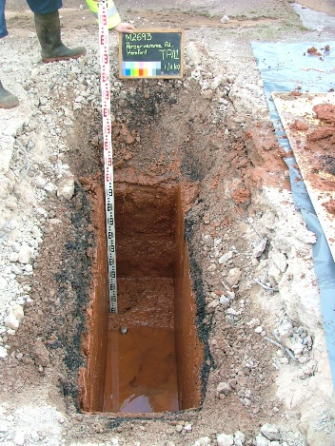
The types of techniques that can be used to undertake soil sampling are;
Trial Pits
These are carried out to recover large samples of the grounds soil, up to 1.2m. This enables us to gain a good understanding of the ground’s strata, which is the examined. Usually no supports are required to carry out this test, if required shoring will need to take place. This type of test has its advantages by the need for machinery, resulting in a lower expense.

Cable percussion Drilling
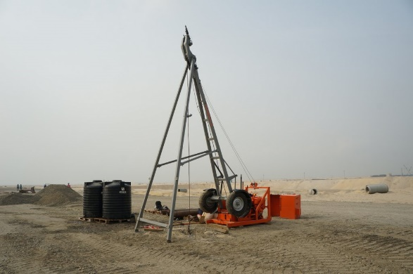
Depending on access, cable drilling (auger and Shell) is the most used technique for geotechnical sites, reaching depths of up to 60m. When investigating different soils, the borehole will be formed using various tools, depending on the type of ground in order to successfully collect the samples of disturbed and undisturbed. (RSA Geotechnics Ltd , n.d.)

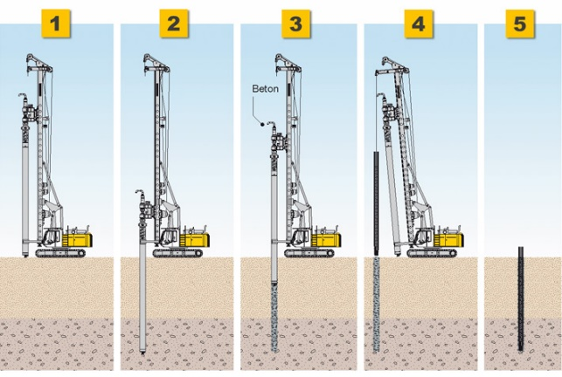
Rotary drilling;
Rotary drilling is used where the ground formation is dense, made up of rock, gravels and other geological formations. Depths of up to 100m can be achieved for bedrock samples to be taken for laboratory examination. Rotary drilling is a core barrel lowered into the ground where there are voids and then flushed with circulated air/mist or water.

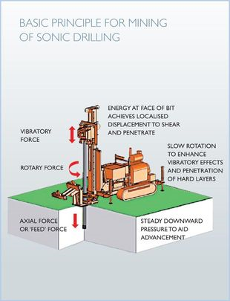
Sonic drilling;
A sonic Drill is a mechanical drill which uses high frequency mechanical oscillations down the drill string to the bit. The vibrations fluidise soil particles at the face of the bit allowing easy penetration. It is often used where other techniques are less successful in varied strata.

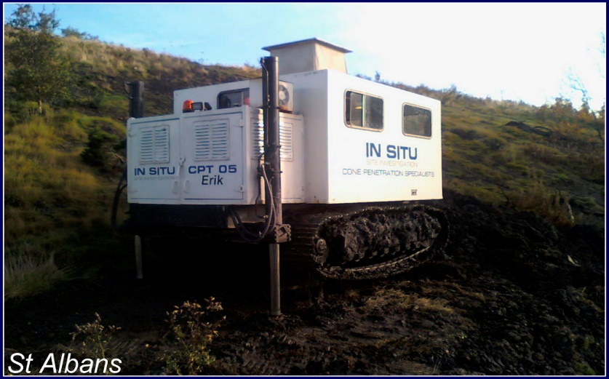
CPT Rigs (Cone Penetration Testing)
Cone rigs are used in depths up to 100m. It involves using a 4 -6 wheeled drive truck orsemi tracked trawler. The cone is pushed into the ground at a constant rate of 20mm per second, causing a causing friction against the shaft. Recordings are measured using an electric current and the frequencies of the readings are presented in a graphical graph.
Advantages of CPT testing over conventional is that the samples have minimal disturbance in order to determine the sub-surface stratigraphy.

Building Regulations 2010, Site Preparation and Resistance to Contaminants and moisture, Section C1.
Due to my historical investigation results I believe there is a need for further site investigation tests to be carried out under the Building Regulations Approved Document C1 site preparation and resistance to contaminants,
Sections 1- Clearance or Treatment of unsuitable Material;
Section 2- Resistance to Contaminants.
- Preliminary UXO risk assessment;
- Detailed UXO risk assessment;
- Ground Gas monitoring;
- Coal Mining risk Assessment;
- Ground water monitoring;
- EIA (Environmental Risk Assessment);
- Biodiversity Test;
- Heavy Metals Assessment.

Phase 3- Remediation Strategy and Phase 4- Validation
To be carried out by the selective company chosen to complete the survey from my investigations of phases 1 & 2.

Foundation Design- Building Regulations 2010, Structure, Approved Document A
From the results of the desktop study the type of foundation chosen for this development will be a piled Cap foundation.
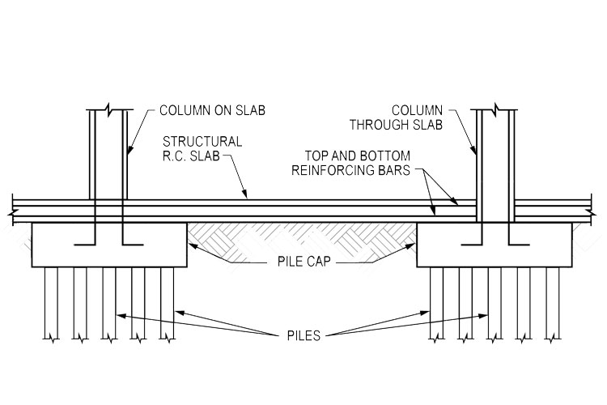
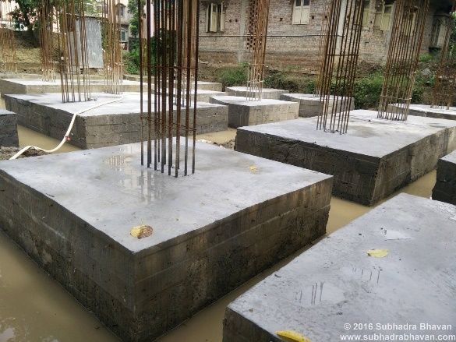
Piled Cap Foundation
Piled cap foundations are used when the strata below is a mix of soil and rocks. The weight of the structure can be distributed evenly using single or grouped piles. Areas that will affect the use of this type of foundation can be:
- Soil Condition
- Types of Loads acting on the foundation
- The bottom layers of the soil
- The site conditions
- Operational Conditions.
From our soil investigation results, we have decided to go for a piled Foundation due to the results from the upper layers of soil and rock formation. Settlement issues would be common so in order for safety and security and due to this being built of the seafront the building would be confronted with high winds.
The building will be constructed of steel and 2 storeys high, again another reason why piling would be the best option. The piles are used to take the vertical weight off the structure and transfer it into the deep layer of the soil.
(https://theconstructor.org/geotechnical/foundations/need-functions-of-pile-foundation/1785/)

References
(n.d.). Retrieved from https://www.bkrailway.co.uk/wp-content/uploads/2016/10/World-War-II-Mini-Pack.pdf
(n.d.). Retrieved from world war 11 and the railways.
(n.d.). Retrieved from Global security.org .
(n.d.). Retrieved from RSA Geotechnics Ltd : (https://www.rsa-geotechnics.co.uk/site-investigation/cable-percussion-drilling/)
(n.d.). Retrieved from https://theconstructor.org/geotechnical/foundations/need-functions-of-pile-foundation/1785/.
LMS Shrewsbury Train along Swansea Bay . (1900).
(Global security.org , n.d.). (n.d.).
(2014). Retrieved from https://www.bkrailway.co.uk/wp-content/uploads/2016/10/World-War-II.
Earth, G. (n.d.). Swansea .
Geological ordinance Surevy Map . (1900). Swansea : Swansea Archives .
google image . (n.d.).
google Image . (n.d.).
google images . (2019).
http://a2environmental.co.uk/index.php?option=com_content&view=article&id=3&Itemid=429. (n.d.).
http://wessonenvironmental.co.uk/services/intrusive-investigations/. (n.d.).
Image. (1900). Geoglogical Survey. Swansea: Swansea Archives.
Image 4, A. J. (1994). The Three Night Blitz. Swansea: City Of Swansea.
Lambert, T. (n.d.). A Breif History of Swansea. Retrieved from (http://www.localhistories.org/swansea.html).
Ordinace Geological Survey Maps . (1900). Swansea .
Ordinance Survey Map . (1900). Swansea : Archives, City & County Of Swansea .
Survey, Geological. (1900). Swansea, Swansea: Archives .
Uxo Survey. (1900). Geological Ordinance Surevy Map. Swansea, Swansea: Archives.
(http://wessonenvironmental.co.uk/services/intrusive-investigations/, n.d.)

