Title page
BSc health and social care
Introduction to physiology
BMHP5003_BIRM
Assessment 2 – Health assessment report
Poppy Wagstaffe – 2026246
Gillian Weaver

Introduction

In this assessment report I will be identifying multiple health issues by using a questionnaire-based system to help create an understanding of varied factors such as: dietary, age-related factors, daily routines, and height/weight identification. When carrying out such elements like calculating Dean’s BMI, his alcohol assumption, and smoking habits to help pinpoint any existing health risk or problems. After calculating the causes and risk factors for Dean within a chart format, the aim is to then spot the unerring results to then provide an Assessment report in depth regarding all components gathered to allow a feedback and recommendation providing both solutions and coping mechanisms when identifying all health issues from the case study and person in question, meaning Dean. Concluding with a light summarisation giving the highlighted factors and results regarding Dean (person in question) with a finishing approach to the case study.

Case study
Key points of the health questionnaire Additional information/comments
Age - 52 years
Occupation -Truck driver
Smoking status -A smoker (has been since the age of 20)
Height -5ft 9 inches (average height for male)
BMI -31.1
Blood pressure -Unknown -

Alcohol - Known to consume a bottle of Whiskey at Night occasionally (at home), Cause for concern of an early indication of alcohol abuse.

Diet - Poor diet, consists of food on the go and fizzy drinks (coca cola). Can cook but has lost the passion for it.
Marital status - stated to be divorced (has been for over 5years) no indication of new relationship assumed single.
Family/friends - Has a 27year old daughter who has 2 of her own children (2 grandchildren) daughter is married has her own family, Dean is Separated from wife and no other family or friends mentioned apart from brother, mother and father who passed away 10 years ago.
Sleep patterns - not ideal (aided by alcohol) possible insomnia would need further investigation.
Daily routine/exercises - Truck driver and brief period at home, no exercise routine noted.
interests - non-recorded - used to like family quizzes and to cook (no longer interested)
Health issues - Type 2 Diabetes (poor diet), COPD (linked with continuous smoking over 20years) and rheumatoid arthritis.

Main points within the case study table

Smoker
Dean is said to have smoked since the age of 20, Dean is now a 52-year-old male meaning he has had a sizeable consumption for years, causing continuous abuse to the lungs, Blood, and organs throughout the body. “Tobacco use harms every organ in your body. Smoking tobacco introduces not only nicotine but also more than 5,000 chemicals, including numerous carcinogens (cancer-causing chemicals), into your lungs, blood, and organs” (Cleveland clinic, 2019). When considering Dean’s years of smoking and taking his age into account he is likely to suffer or have suffered from health issues ranging from: increased blood pressure, heart attacks in the future or Lower oxygen to the heart and other tissues in the body (increasing risks for coronary artery disease, peripheral artery disease, and diabetes). All the above when considering Dean could lead him to be at a higher risk when considering key features such as his weight, diet, and age.

Weight (BMI)
Dean has a BMI which is on the higher spectrum meaning he is overweight when combining both height and weight. BMI is a combined calculation of age, height and weight, once they are all identified it is then calculated by “kg the metric formula is your weight in kilograms divided by your height in meters squared” (Ramsayhealth.co.uk, 2019). When referring to Dean he scored a 31 when his BMI was calculated as he weighs 210lbs, Obese falls under those who score a higher number then 202lbs meaning Dean falls into this category due to his height, weight, and age. A normal result for a male of his age and height would range from 125lb -169lb, Dean would need to lose the minimum of 41lb for him to be perceived as “normal weight” according to (NHS, 2018).

Dietary
Dean’s diet as noted briefly in the table consists of little nutrition and has miniscule structure, having a profession which is based on the road Bob has adopted the art of consuming only food on the go Meaning easy access foods such as fast food and has become fond of fizzy drinks (Coca Cola). A healthy balanced diet should be implemented not just for Dean but as a whole for those with or without potential health issues and risks factors. A healthy diet for an active 52-year-old male should include lots of vegetables, fruits, whole grains, low-fat dairy, lean meats, fish, eggs, and nuts. This can help reduce the risk of heart disease, diabetes, obesity, and cancer, and increase overall well-being. In addition, regular exercise should be added to the daily routine to improve muscle strength, balance, and flexibility (https://www.facebook.com/WebMD, n.d.) However, Dean’s questionnaire helps identify how he is not an active person his job is associated with travel and sitting whilst driving.

Assessment report

Dietary is a key element that is considered to accompt a healthy lifestyle when identified and carried out correctly researchers have suggested it encourages less health risks and life-threatening immune attacking deceases. Benefits of Healthy Eating for Adults
Picture of body identifying benefits of healthy eating for adults.
- May help you live longer
- Keeps skin, teeth, and eyes healthy
- Supports muscles
- Boosts immunity
- Strengthens bones
- Lowers risk of heart disease, type 2 diabetes, and some cancers
- Supports healthy pregnancies and breastfeeding
- Helps the digestive system function
- Helps achieve and maintain a healthy weight

(Centers for Disease Control and Prevention, 2021)
When referring to this particular case study in question Dean has adopted both poor and unhealthy habits that have caused him to develop lasting negative effects presently, he has type 2 diabetes and will have this until he chooses to reverse this with a balanced healthy diet and exercise for his future. Considering the highlighted area of diet Dean’s current situation in relation to the study and is he chooses to consume mostly food that he can receive ‘on the go’ which is likely to be fast food. In addition to his poor diet of fast food he also consumes many unhealthy drinks referred to as ‘fizzy drinks’ in Dean’s case study. Diet is not just the consumption of food and drink it also refers to other adopted habits some may inherit or develop such as alcoholism. “Alcohol causes damage to the organs involved in digesting, absorbing, and processing nutrients. The body also prioritises metabolising alcohol at the expense of other nutrients, this can lead to nutrient deficiencies in those who drink at high-risk levels” (Alcohol Think Again, n.d.). All the above can act as factors to his ongoing issues of sleep deprivation, lack of motivation, interest, and passion for simple things such as desiring to look after his body, health, and mind. Recommendations for those who have current alcohol misuses are to replace and recover with substitutes which consist of a healthier alternative such as:
- Flavoured water
- 100% juice drinks (for example orange or apple)
- Low fat milk
- Fruit smoothie
- Sparkling water
- Tomato juice
(Bettiker et al., 2009)
“Government dietary recommendations are underpinned by the latest scientific evidence, based on advice from the Scientific Advisory Committee on Nutrition (SACN). SACN’s remit is to assess the risks and benefits of nutrients, dietary patterns, food, or food components to health by evaluating the evidence base in its entirety and making dietary recommendations for the UK (United Kingdom) population (including vulnerable and diverse groups) based on its assessment” (GOV.UK, 2023). According to the direct government website when instructed on how to balance a healthy diet or recommendations on how to live a healthy lifestyle these are the results which I believe can be an informative guide to those who read, also a great map to those who need guidance on how to change their current situation meaning Dean in this case.

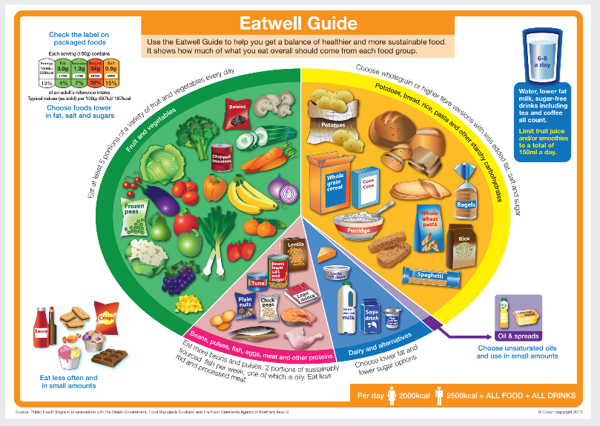
(Public Health England, 2016)

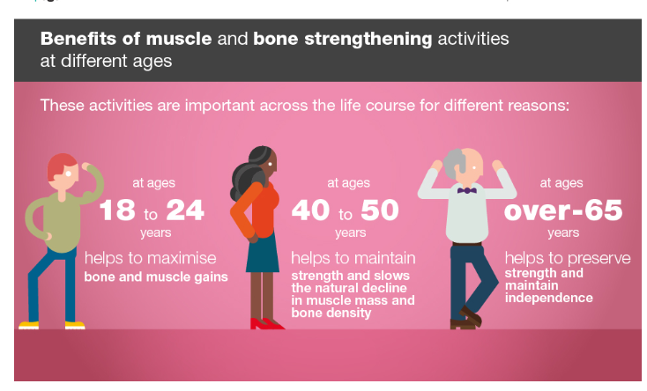
(Public Health England, 2020)

Physical activity and exercise are both significant factors when explored alone and implemented alongside a balanced healthy diet as stated in the above text. “Being physically active can improve your brain health, help manage weight, reduce the risk of disease, strengthen bones and muscles, and improve your ability to do everyday activities” (Centers for Disease Control and Prevention, 2022). Dean’s current state when considering his physical health and wellbeing is poor, he has a full-time job as a truck driver meaning a sizeable percentage of his time is spent stationary sat down inside of a truck taking long tedious journeys without any form of exercise. The lack of movement and positioning he has subjected himself each day has slowly formed and developed into serious physical impairments such as Rheumatoid arthurites. “Rheumatoid arthritis is a long-term condition that causes pain, swelling and stiffness in the joints. The condition usually affects the hands, feet, and wrists” (NHS, 2019). This particular condition can occur if a person has abused their body with substances such as alcohol and tobacco, so in Dean’s case that could be one root of why he has developed this condition however Dean has also been a truck driver for over 15 years and the impact alone on someone physical ability when taking into consideration that he sits in a stationary position 6 days a week and has bare minimum close to non-interaction or exercise throughout those days. Dean has also developed a form of respiratory disease which is called chronic obstructive pulmonary disease also known as COPD. “Chronic obstructive pulmonary disease (COPD) is a progressive and long-term inflammatory lung condition characterized by a persistent cough and shortness of breath” (Alto Pharmacy, 2021). This is likely to have been caused by the long-lasting effects of smoking for over 20 years but also consuming over 20 cigarettes each day, that alone can cause major respiratory issues, potential diseases such as cancer and physical changes like loss of limbs alongside poor circulation.
Recommendations
Recommendations when considering all the above is that Dean needs guidance and support when introducing new elements to his current lifestyle like gym, family activities and short to long walks around the park or other places he may like to explore. However, when providing help or suggestions for Dean many considerations must be factored such as his inability to perform vigorous activities due to his COPD or being careful when performing movements due to his arthurites. The idea of change and exercise can be daunting for anyone who has tasked themselves for a new change of lifestyle, Dean has already stated he has lost the ability to motivate himself to do simple task like cooking or spending time with family members. I would suggest that he should reach out for support and include others in his journey for self-clarification Aswell as motivation from others. Activities that a male over 50 with a BMI of 31.1 is recommended as follows:
- Water aerobics (minimal impact exercises)
- The stationary bike exercise (minimal impact exercises)
- Walking (short or long)

Recognize
“That living a healthy lifestyle is a skill and a habit, so approach your goals
for health and fitness like you would any other new skill you want to master.
You want to make positive changes to your lifestyle that will last indefinitely
and that may take some trial and error, as well as commitment” (Healthline, 2016).

Conclusion

After careful recognition of all Dean’s answers and observations when considering all things as a collective including: BMI, lifestyle, diet and health conditions. The ideal overall outcome would be a suggestion of aided support from outside organisations, a careful thought-out guide of what Dean should be consuming dietary wise as he is diabetic. In addition to that when considering all factors, a common consistency when identifying all Dean’s potential health risks they seem to be linked in with his profession as a truck driver, which can be a major subfactor that is worth investigating to determine if his current situation offers to much of a health risk as he has developed diabetes, Rheumatoid arthurites and depressed resulting in lack of motivation and self-care. The concept of importance when considering a healthy lifestyle and way of life can create a better feeling physically and mentally allowing methods such as exercise to keep a consistent lower BMI score as well as benefits such as saving money and preventing possible health issues in the future (SANE, 2015).

Reference list
Cleveland clinic (2019). Smoking & Disease | Cleveland Clinic. [online] Cleveland Clinic. Available at: https://my.clevelandclinic.org/health/articles/17488-smoking.
Ramsayhealth.co.uk. (2019). BMI Formula | How To Work Out BMI | Ramsay Health Care. [online] Available at: https://www.ramsayhealth.co.uk/weight-loss-surgery/bmi/bmi-formula.
NHS (2018). BMI Healthy Weight Calculator. [online] NHS. Available at: https://www.nhs.uk/live-well/healthy-weight/bmi-calculator.
https://www.facebook.com/WebMD (n.d.). Best Diets for Men Over 50. [online] WebMD. Available at: https://www.webmd.com/healthy-aging/best-diets-for-men-over-50 [Accessed 27 Jun. 2023].
Centers for Disease Control and Prevention (2021). Benefits of Healthy Eating. [online] Centers for Disease Control and Prevention. Available at: https://www.cdc.gov/nutrition/resources-publications/benefits-of-healthy-eating.html.
Alcohol Think Again. (n.d.). How Alcohol Affects Nutrition And Food Absorption. [online] Available at: https://alcoholthinkagain.com.au/alcohol-and-your-health/long-term-health-effects/alcohol-and-nutrition#:~:text=Alcohol%20and%20nutrient%20absorption [Accessed 10 Jul. 2023].
Bettiker, S., MS, RD and LDN (2009). Alcoholism and Nutrition. [online] Nutrition Care Systems. Available at: https://www.nutritioncaresystems.com/alcoholism-and-nutrition/.
GOV.UK (2023). Healthy eating: applying All Our Health. [online] GOV.UK. Available at: https://www.gov.uk/government/publications/healthy-eating-applying-all-our-health/healthy-eating-applying-all-our-health.
Public Health England (2016). Eatwell Guide. [online] gov.uk. Available at: https://assets.publishing.service.gov.uk/government/uploads/system/uploads/attachment_data/file/528193/Eatwell_guide_colour.pdf.
Centers for Disease Control and Prevention (2022). Benefits of Physical Activity. [online] Centers for Disease Control and Prevention. Available at: https://www.cdc.gov/physicalactivity/basics/pa-health/index.htm#:~:text=Being%20physically%20active%20can%20improve.
NHS (2019). Rheumatoid Arthritis. [online] NHS. Available at: https://www.nhs.uk/conditions/rheumatoid-arthritis/.
Alto Pharmacy (2021). What to Know about the Four Stages of COPD. [online] alto.com. Available at: https://alto.com/blog/post/the-four-stages-of-copd.
Public Health England (2020). Health matters: physical activity - prevention and management of long-term conditions. [online] GOV.UK. Available at: https://www.gov.uk/government/publications/health-matters-physical-activity/health-matters-physical-activity-prevention-and-management-of-long-term-conditions.
Healthline. (2016). Exercises for Obese People: Ease Into Working Out. [online] Available at: https://www.healthline.com/health/fitness-exercise/exercise-for-obese-people#Tips-For-Success.
SANE. (2015). Healthy living. [online] Available at: https://www.sane.org/information-and-resources/facts-and-guides/healthy-living#:~:text=Benefits%20of%20healthy%20living&text=feeling%20better%20mentally%20%E2%80%93%20regular%20exercise.

‌

