
Swansea Docks
Desk Study Report and Site Analysis

January 7, 2023
Liam Miles
2684 Words

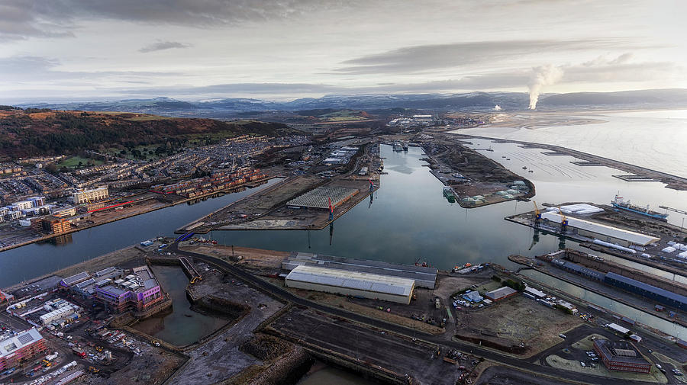
Contents
List of Figures 2
List of Tables 3
1.0 Introduction 4
1.1 Swansea Docks Background 4
1.2 Site History 5
1.3 Site History Overview 6
2.0 General Site Details 8
2.1 Site Location 8
2.2 Access & Traffic 8
3.0 Underlying Geology 10
3.1 Soil Conditions 11
3.2 Contamination 12
4.0 Hydrology 13
5.0 Additional Findings 14
5.1 Sites of Scientific Interest 14
5.2 Topography 15
5.3 Climate 16
6.0 Summary of Findings & Recommendations for Future Investigations. 17
7.0 Conceptual Model & Foundation Design 18
8.0 References 20
9.0 Appendix 22
9.1 Appendix A- Record of Trial Bores Prince of Wales Dock Swansea (BGS, 1880) 22
9.2 Appendix B- Proposed New County Hall Paxton Street Swansea Borehole Log (BGS, 1976) 23
9.3 Appendix C- CISM Borehole Log (AECOM, 2019) 26

List of Figures

Figure 1- SA1 Site Plan 5
Figure 2- OS Map 1888 (National Library of Scotland, 1888) 6
Figure 3- OS DigiMap 1940 (EDINA, 1940) 6
Figure 4- OS DigiMap 1980 (EDINA, 1980) 6
Figure 5-OS DigiMap 2023 (EDINA, 2023) 6
Figure 6- Site Location (Bing, 2023) 7
Figure 7- Traffic update during work rush hour on the 18th December (GoogleMaps, 2023) 8
Figure 8- Borehole Log positions in comparison to plot E9 (Adapted using Bing Maps, 2023) 9
Figure 9- Soil Texture (LandIs, 2023) 10
Figure 10- UXO Map (ZeticaUXO, 2023) 11
Figure 11- Radon potential of being above the action level (UK Gov, 2022) 11
Figure 12- Flood Risk (NRW, 2020) 12
Figure 13- Tidal Flood Risk (NRW, 2020) 12
Figure 14- Sites of Scientific Interest (NRW, 2023) 13
Figure 15- Swansea Topographical Map (TopographicMaps, 2023) 14
Figure 16- Wind Speed Average Map (Met Office, 2010) 15
Figure 17- Potential foundation type (rough sketch) 18
Figure 18- Reinforced Concrete Piles (rough sketch) 18

List of Tables

Table 1- Site History Overview (Adpated using relevant OS Maps) 6
Table 2- Desk Study Findings & Recommendations 16

1.0 Introduction

1.1 Swansea Docks Background
With significant history dating back to the 1700s, Swansea was widely famous for its maritime trade and industrial activities. Swansea’s direct access to the Bristol Channel led to trading links to Cornwall and Devon, which were sources of copper ore. During the 1800s copper smelting was so important that Swansea became known as ‘Copperopolis’ with 70% of the world's copper being processed in Swansea. Between the 1800s to 1900s due to the popularity, the docks expanded along with the industrial evolution leading to the success of the coal and copper industries. However, during the 1940s Swansea was hit massively in WWII affecting the city’s infrastructure causing a giant reconstruction and redevelopment of the targeted areas. This took place in the 1950s. Due to the polluted land, this was a struggle, however, the city persisted but has struggled in recent times with the reduction of coal use, export reduced and due to the increase in oil, this led to the North and South Dock closing in the 1900s (Swansea Museum, nd). Despite the heavy industry reductions, the docks remain open but are now mainly used to handle large vessels and cargo. With the docks being taken over by the Welsh Government in 2022 and with the recent SA1 waterfront developments, the future of the area looks promising (Mansfield, 2022).
This report will provide an overview of the site where future works are planned on the SA1 University of Trinity St David Swansea Campus featuring the E9 plot in Figure 1. The report will look at the site history, geology, hydrology, environmental factors, and more. Recommendations will be provided for key areas which may need addressing in a future investigation. A foundation choice will also be presented with an example model based on the details of the report.

1.2 Site History
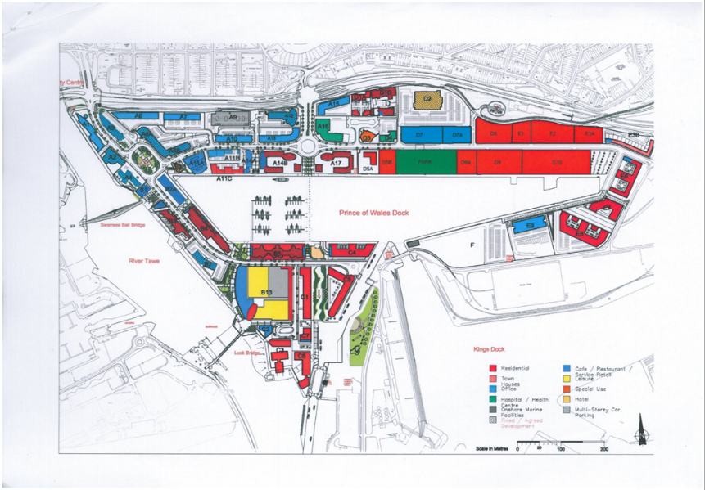
Using plot E9 as reference for the site location.

Figure 1- SA1 Site Plan
A study of historical Ordnance Survey maps has been undertaken to identify any former land uses at the site and surrounding areas that may have geotechnical or geo-environmental implications for the proposed development. These key findings are summarised in Table 1.

1.3 Site History Overview

Reference | Key Features (On Site) | Key Features (Off Site)
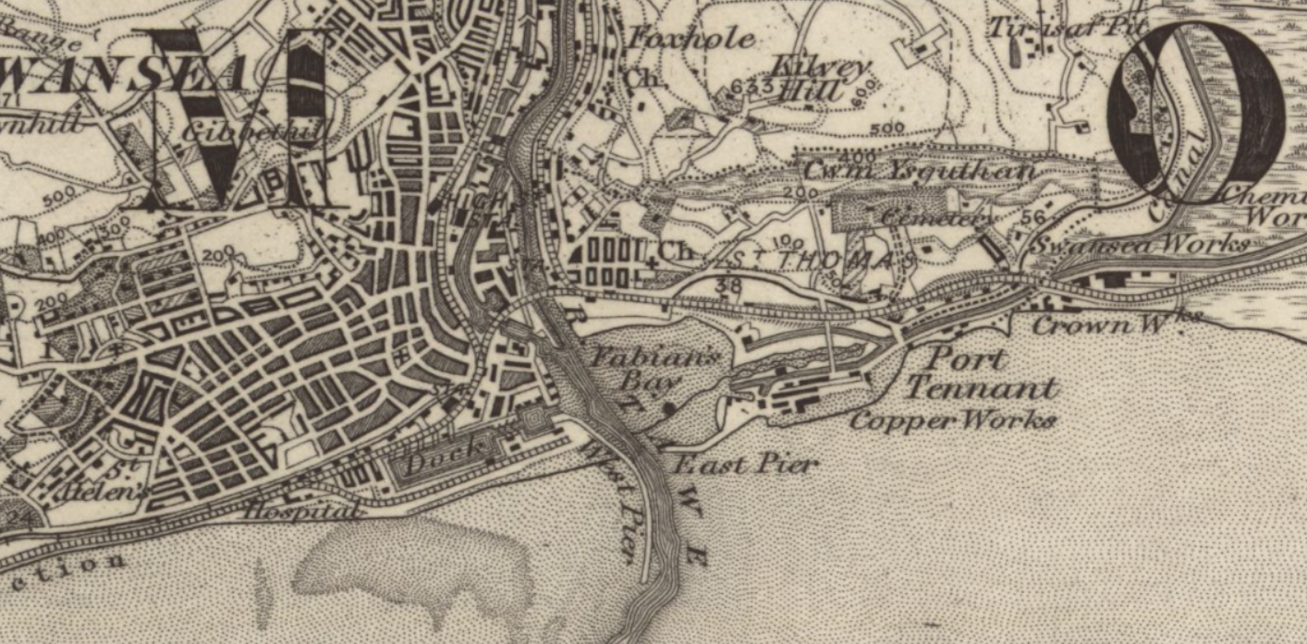  Figure 2- OS Map 1888 (National Library of Scotland, 1888) | Beginning of construction development of docks.  Pollutants nearby with proximity to copper and chemical works. | Access available via railway and road to St Thomas.
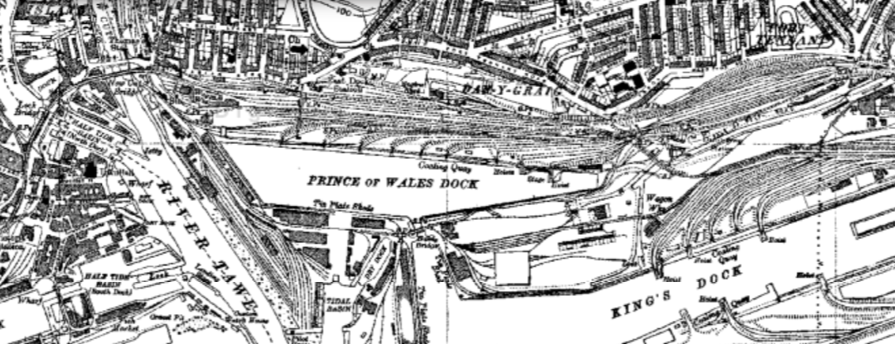  Figure 3- OS DigiMap 1940 (EDINA, 1940) | Construction of docks complete.  Improved access with construction of bridge to land of site. | Direct water flow near with the river Tawe.  Pollutants nearby with copper and chemical works still in motion.
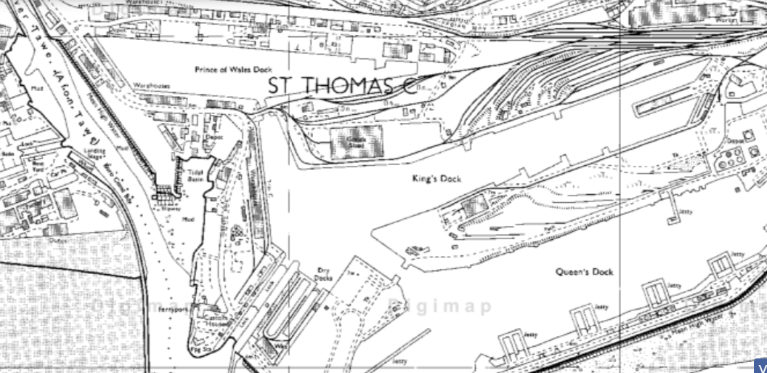  Figure 4- OS DigiMap 1980 (EDINA, 1980) | Redevelopment of docks complete due to the bombing in 1950. | No major developments- area of land in use as a Goods Shed.
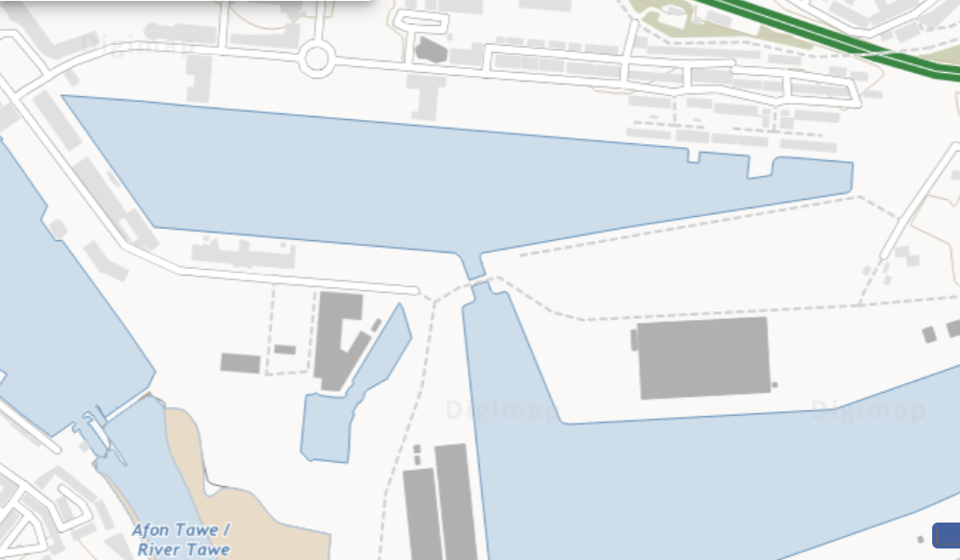  Figure 5-OS DigiMap 2023 (EDINA, 2023) | Area of land not in use. Expected environmental concerns with remedial works nearby. | Local developments of housing near site  Improved access with all link roads in use, but bridge between site and dock not in use.
Table 1- Site History Overview (Adapted using relevant OS Maps)

2.0 General Site Details
Plot E9

2.1 Site Location
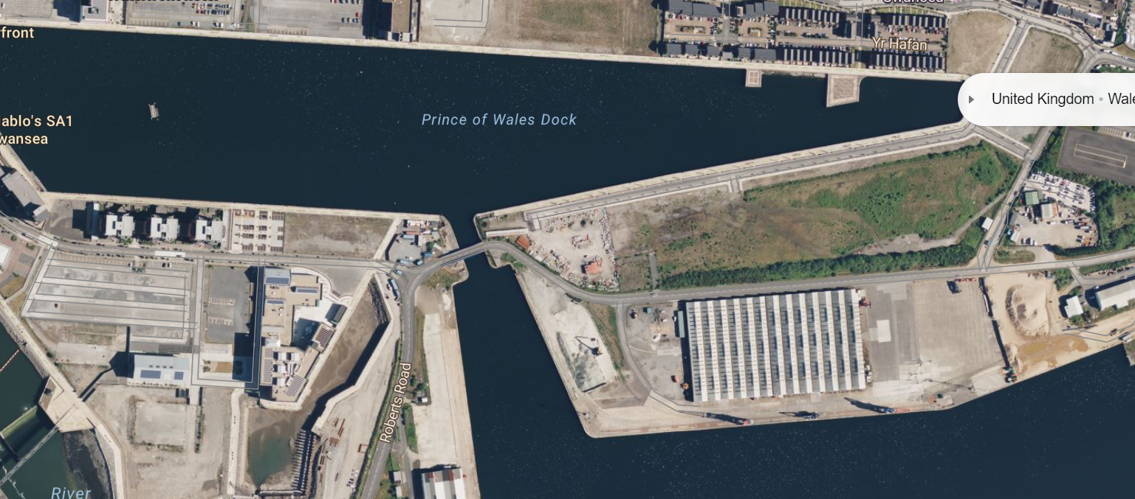
Figure 6- Site Location (Bing, 2023)
With the site not in current use, there is use slightly to the west of the site as a machinery storage facility (see Figure 6). To the south sits another storage facility which is in use. To the north of the site is a housing estate and further to the west sits the IQ building and main campus parking facility. With further housing being planned near the site (see figure 1) noise and disturbance would be an area to look at in further detail, however, it is recommended that construction of plot E9 commences first but special consideration should be given to the housing opposite and the nearby working facilities in order to comply with CCS1.2, “The Registered Activity providing a safe environment, preventing unnecessary disturbance, and reducing nuisance for the community from their activities” (Considerate Constructors Scheme, 2024).

2.2 Access & Traffic
Access is quite positive for the site. To the west of the site is the main University parking facility which is of use to students and staff members. Access to the site is possible via the west from this parking facility with the bridge being a link between Robert’s Road and the area of the site. To the east of the site is a road that has direct links to Fabian Way which has nearby connections to the M4. As parking may be an issue for works on site in the main campus with the business, further investigation could be looked at for the introduction of parking spaces nearer to the site with direct access via both the East and West.
In addition, there is a railway station to the northwest of the site just over a mile away. However, buses run close by with nearby stops to the intended site similar to the current campus, which is currently successful. Access would be recommended to the northeast of the site joining from Fabian Way with the increase of traffic as you further travel west on Fabian Way and get closer to Swansea centre (see figure 7).
Referring to Figure 7, with the site being in close proximity to the A483 which has close links to the M4, the connections are pretty good with traffic being fairly moderate. Although Swansea is a big city with some popularity as shown in figure 7, traffic is expected along sections of the road highlighted in amber, but generally not too extreme considering the area with large sections of blue indicating clear travel at the current period. Access would be recommended to the northeast of the site joining from Fabian Way with the increase of traffic as you further travel west on Fabian Way and get closer to Swansea centre (see figure 7). With local businesses, housing, and a driving test centre close to the site works planned mustn't cause significance to them. These factors combined will be important to comply with section CCS1.2 of the Considerate Constructors Scheme.
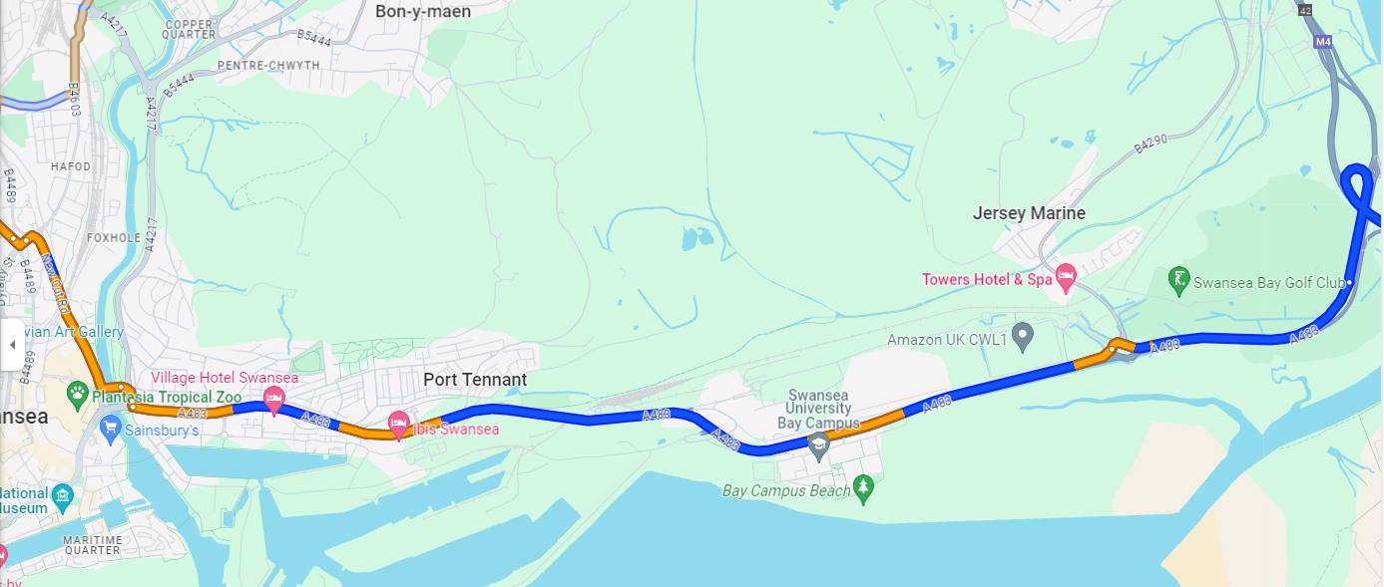
Figure 7- Traffic update during work rush hour on the 18th December (GoogleMaps, 2023)

3.0 Underlying Geology
With the aid of borehole logs and geological information on the BGS an anticipated geology of the site has been established. Using the BGS, there is a bedrock geology with the formation including mudstone, sandstone, and siltstone. With the land being on top of the sea, there are superficial deposits established in the form of shingles, sand, silt, or clay.
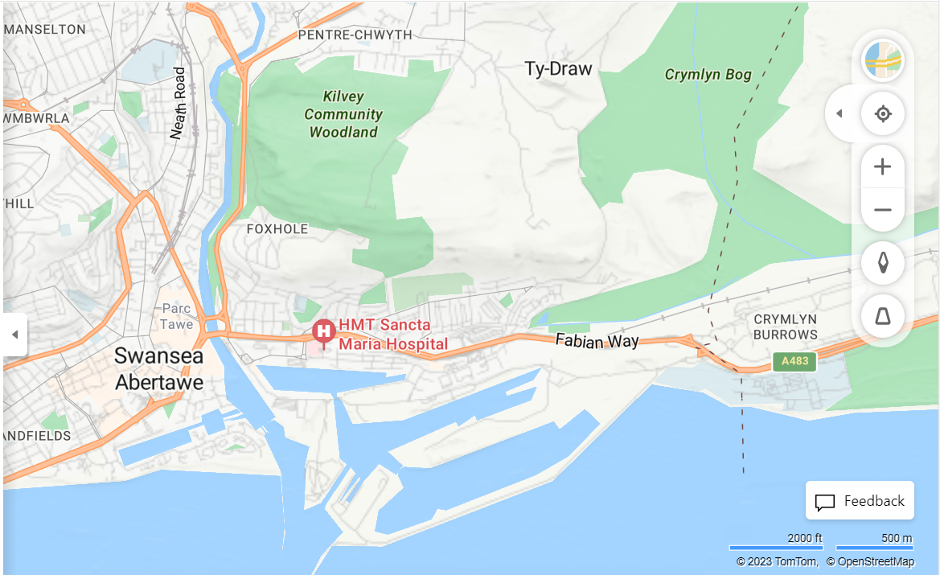
B
C
A
Figure 8- Borehole Log positions in comparison to plot E9 (Adapted using Bing Maps, 2023)
Despite not all of the borehole logs being in the exact position of the site, the similarities are clear. Please refer to the appendices for full borehole log information. Referring to Appendix A, at depths of around 4-6m gravel and stones were consistently found. At the greatest depth of 38m hard sandy clay was found with some stones. Moving on to Appendix B (section A in Figure 8), mudstone was found during the penetration test at a depth of just over 20m with thick gravelly clay found in large thicknesses. The N level which signifies the relative density and shear strength of the soil was found to be quite high at great depths. However, in Appendix C (section C of Figure 8) a similar report was found with dense gravelly clay found again at depths of around 15m, but extremely weak mudstone was found at depths of over 20m. This is an area that should be explored further in a future geotechnical study with the mudstone creating complications with its load-bearing capacity and permeability. It should also be noted that due to the recent remediations near the site, there could be potential contamination at depth (see Appendix C). Additionally, with the borehole logs used in this study being relative distance from the site it is recommended for exploratory holes to be trialled on plot E9. These trials should be in line with the GSHVBS Vertical Borehole Standard.

3.1 Soil Conditions
Figure 9 indicates the presence of loamy and clayey soils at the site with naturally wet drainage. Carbon in the soil is medium, with fertility being quite high, and drainage being naturally wet. Groundwater feeds into the river and this river creates a pollution risk. Thorough research into the percentages of loam/clay is recommended with too much clay potentially leading to poor drainage and potential foundation issues.

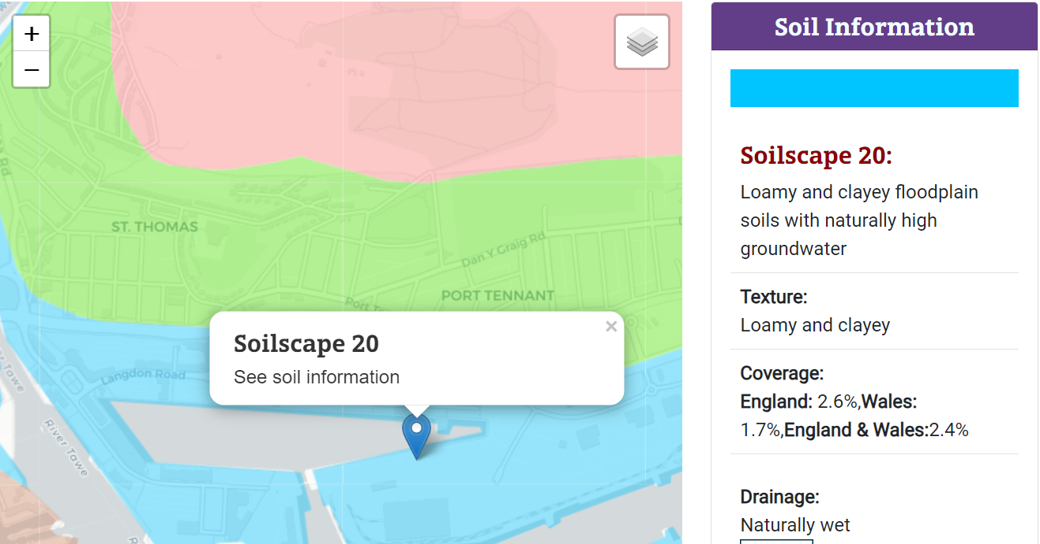
Figure 9- Soil Texture (LandIs, 2023)

3.2 Contamination
As discussed previously, there is a potential chance of contamination due to nearby remediation works (refer to Appendix C). With the previous history of bombings in the area in the 1950s there lies a potential contamination issue as well as potential for finding unexploded bombs. Using Zetica’s UXO map (see Figure 10) areas highlighted with an aeroplane highlight the Luftwaffe targets and therefore due to this, there lies a high risk of unexploded bombs in the area. To the north of the site lies UXO’s which have been found which are near the site. This map is advisory however in areas of high risk such as this it would be advised to have a more detailed UXO study. There are low percentages of radon expected in the site with there being a less than 1% chance of radon levels of over 200 becquerels per cubic metre (see Figure 11). These results are indicative and not definitive, and with there being expected higher levels of radon in the nearby area, this could be a consideration.
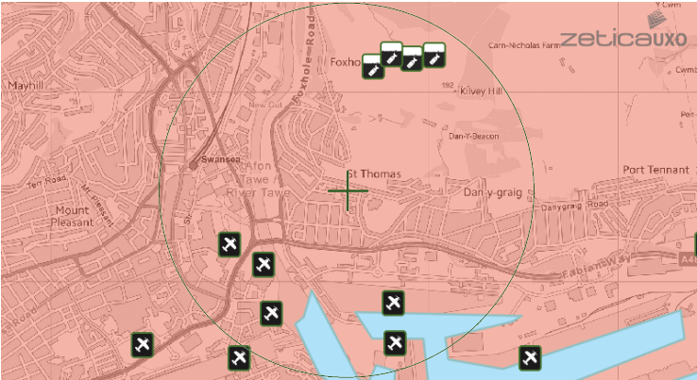
Figure 10- UXO Map (ZeticaUXO, 2023)

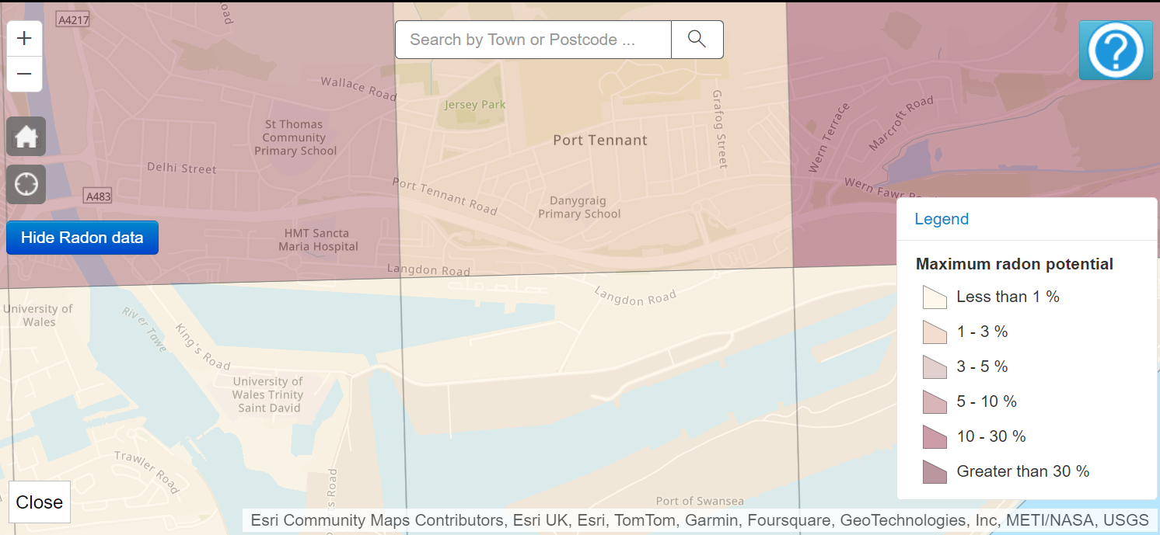
Figure 11- Radon potential of being above the action level (UK Gov, 2022)

4.0 Hydrology
Referring to Figures 12 and 13, there is a current medium risk in parts of the site area with a high risk in some parts of the site from surface water & small watercourses. This would be expected with the nature of the land and the fact that it is not used. This flood risk is an area that would need to be looked at in greater detail in future investigations. The potential for tidal flooding is low, however, with unlikely but possible drastic rise of sea levels and potential severe weather due to the proximity of the sea this could be a consideration in a more detailed investigation.
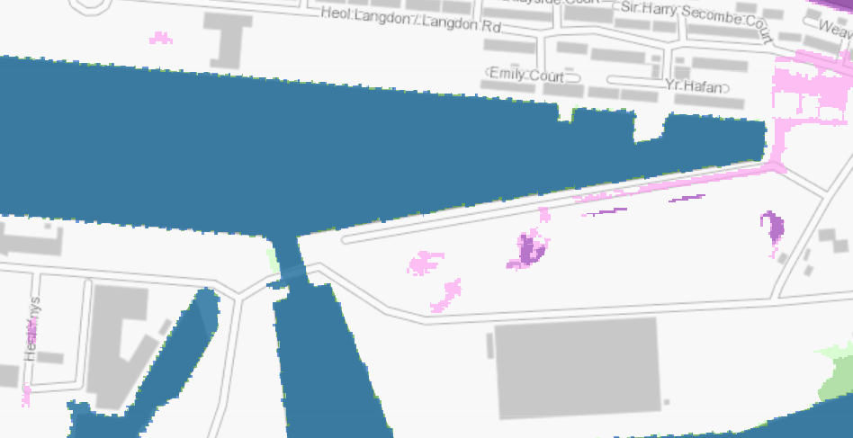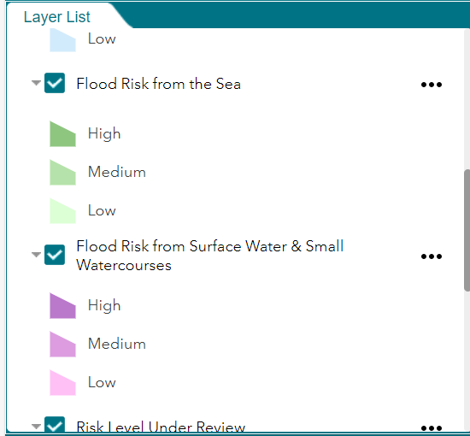
Figure 12- Flood Risk (NRW, 2020)
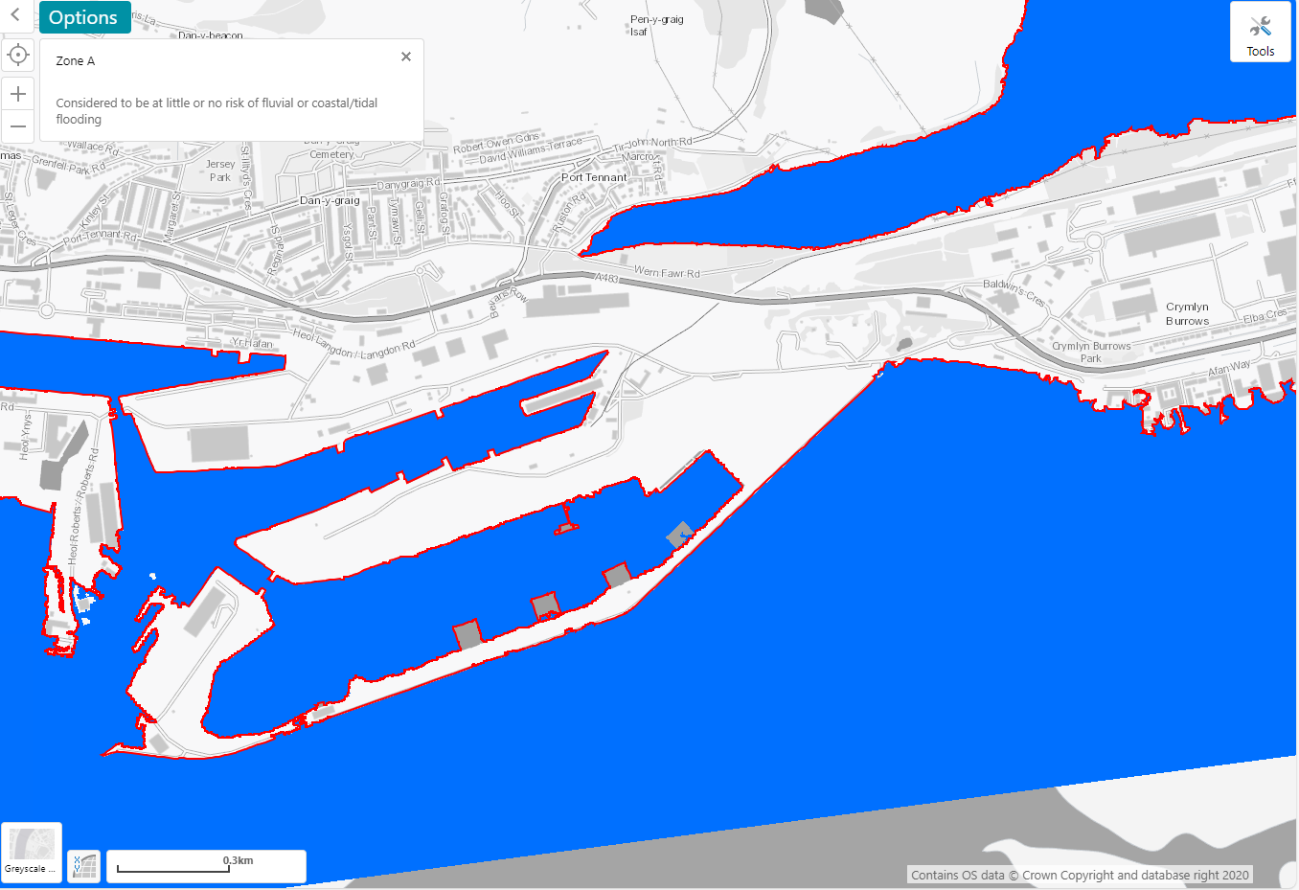
Figure 13- Tidal Flood Risk (NRW, 2020)

5.0 Additional Findings

5.1 Sites of Scientific Interest
There have been 3 sites of scientific interest found in the area (see Figure 14). These include Cors Crymlyn, Crymlyn Burrows, and Blackpill. Future investigations will need to be in place to minimise the risk of disrupting these areas with the nearby River Tawe and Swansea Bay Sea producing the ability of contamination through watercourses. Section CCS2.1.1 of the Considerate Constructors Scheme should be considered greatly and the potential risk of contamination or disruption of these areas should be considered further in the geotechnical study.

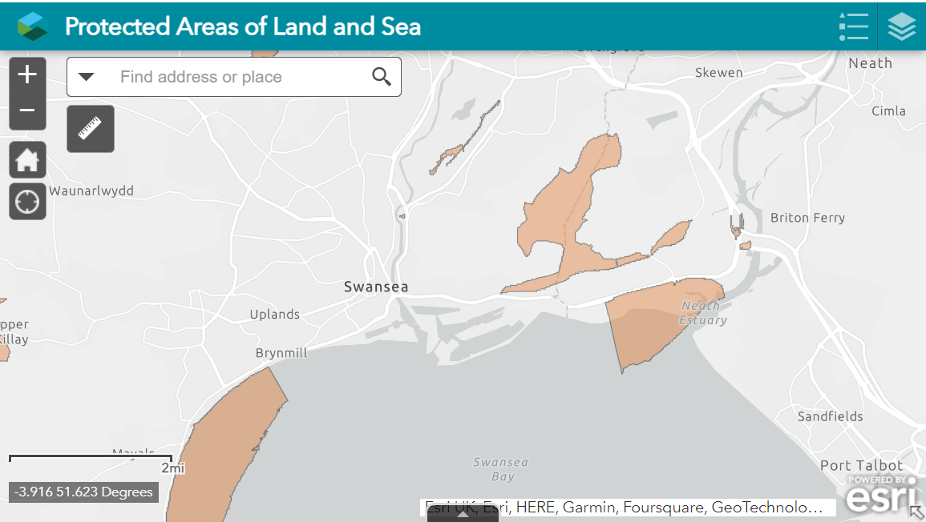
Figure 14- Sites of Scientific Interest (NRW, 2023)

5.2 Topography
Due to the nature of the area, with the area being a man-made structure, the elevation can be seen as consistent with the whole of the E9 plot being between 6-7m above sea level (see Figure 15). Thus, highlighting that the site is generally flat and terrain isn’t a major concern. However, there is some concern with Kilvey Hill in the background which poses a threat of potential soil erosion, stability issues, and possible landslide risks. This risk is unlikely but one to be a concern in a future geotechnical study to assess the stability and safety of the mountain.
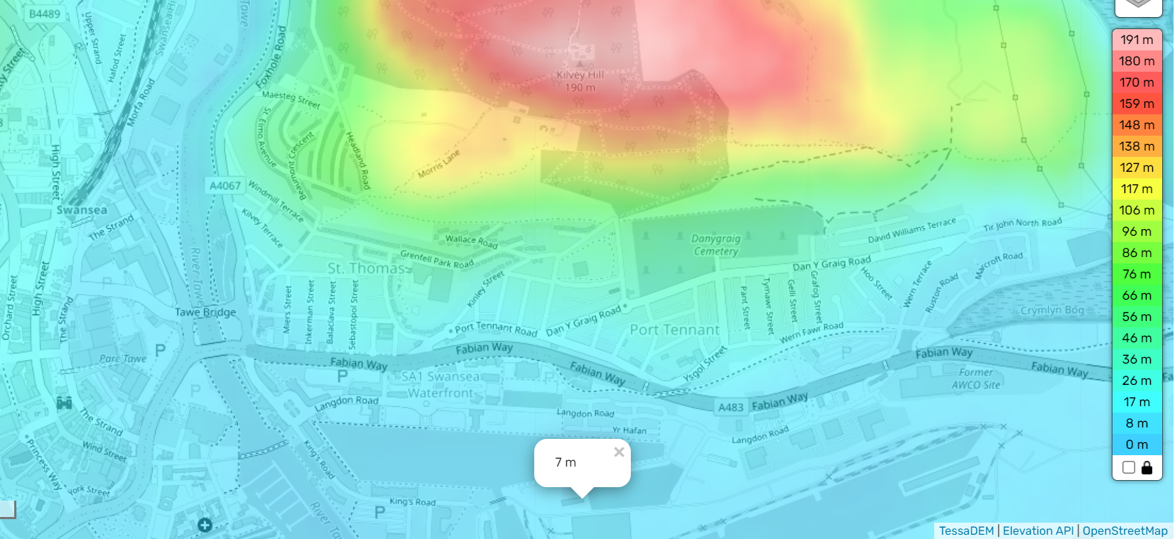
Figure 15- Swansea Topographical Map (TopographicMaps, 2023)

5.3 Climate
Due to the coastal location, wind can be a big factor. Please refer to Figure 14 for the wind speed average across the UK. As seen in the figure Swansea is an area with greater wind speeds. With the nature of the proposed building using steel frame and the height of the building it is likely that major craneage will be used. With this likelihood, a future assessment should address wind conditions and severity in more detail to construct safely and evaluate the best period of approach.
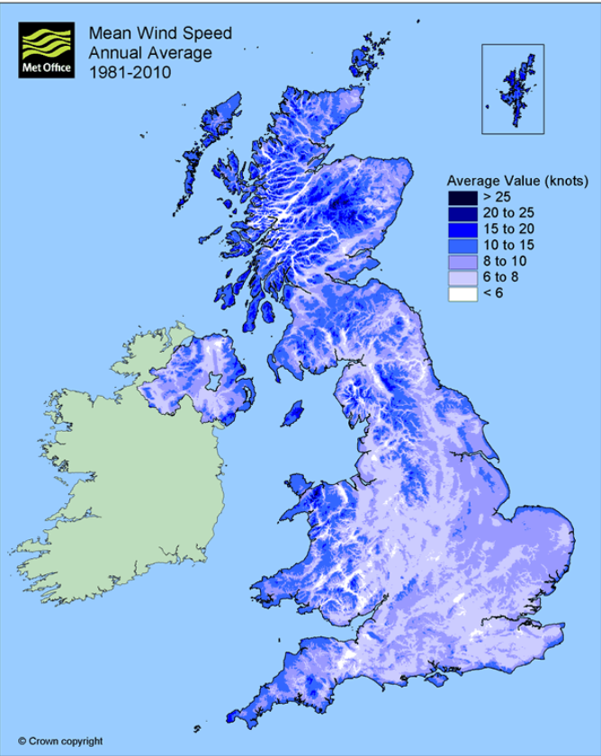
Figure 16- Wind Speed Average Map (Met Office, 2010)

6.0 Summary of Findings & Recommendations for Future Investigations.

Hazard | Desk study conclusion | Concern level | Considerate Constructors Consideration (CCSM Monitor Checklist) | Recommendation for future investigation
Access/Traffic | Positive access possibility, traffic manageable | Low | Refer to sections CCS1.1, CCS1.2 & CCS1.2.3. Potential concern with local housing disturbance, possible consultation with locals advised. | Address potential parking problems & disturbance levels.
Contamination | Possibility with background history of the site and area. Radon levels were found to be low. | Medium/High | Refer to sections CCS2.1, CCS2.1.2 & CSS2.1.3 | Future investigation is recommended into the exact site, radon levels, and UXO advisory map provided, and a more detailed map should be explored.
Climate | Significant wind were levels found in the area. | Medium | Refer to sections CCS3.2.2, CCS3.2.3 & CCS3.2 | Potential challenges to the foundations and superstructure approach, however, this is manageable.
Topography | Good topography found at the site with level terrain. Nearby Kilvey Hill is a concern. | Low/Medium | Refer to sections CCS2.3, CCS2.3.3 & CCS2.1 | Possibility of landslide/erosion. Further investigation of Kilvey Hill stability is recommended.
Ground instability | Extremely weak mudstone found, high potential for mudstone. The Strength of the mudstone at the exact site are not confirmed. Thick layers of strong gravelly clay found in nearby boreholes | Medium | Refer to sections (CCS2.1, CCS2.1.3 & CCS3.2.3) | Borehole logs and future consultation with the geotechnical engineer is recommended to determine exact ground stability.
SSI’s | Nearby SSIs found. Potential for disruption with local watercourses | Low/Medium | Refer to sections CCS2.1 & CCS2.1.3 | The likelihood of disruption should be further investigated.
Table 2- Desk Study Findings & Recommendations

7.0 Conceptual Model & Foundation Design
With the findings of this report, piling is recommended as a foundation choice. Piling has many advantages when dealing with low-bearing capacity soil at higher depths and soil with higher water content as expected at this site. Contamination is a possibility in the site and piling will mitigate this possibility and reduce the potential for spreading possible contaminants. With high wind levels expected at the site piling has additional benefits with lateral load resistance a benefit (Prasad, n.d.). Pre-cast-driven concrete piling would be recommended with several of the borehole logs used in nearby areas concluding findings of potential obstructions in the formation of cobbles and boulders (please refer to the Appendices and Section 3.0). This type of piling offers the ability to reinstall piles if an obstruction is found. In addition, in Appendix C this type of foundation choice was also concluded as the best foundation with ground conditions expected to be similar at this site.
A potential model sketch has been produced for the foundations of the site (please refer to Figures 17 & 18). Please note that with the full details of the site not being possible in this study, this model has been based on findings of nearby strata. Boreholes and further investigation into the specific E9 plot of land would be recommended before determining an exact foundation type.
With the high load-bearing pressure expected with the proposed 3-story framed building, reinforced concrete piling is advisory, and an example of this is displayed in Figure 18. Piling is currently advised to be based on top of thick expected hard gravelly clay which was found in thicknesses of over 7.5m, however, if potential mudstone is found to have a high soil-bearing capacity this would be recommended. Moisture content will need to be considered with high moisture content posing a threat.
High lateral loads are expected and hence reinforced concrete pile caps are advisory to strengthen the foundation, reduce the risk of settlement, and distribute the load evenly (UtilitiesOne, 2023). BS 8102:2009 and 2023 Building Regulations for future foundation design are advisory.

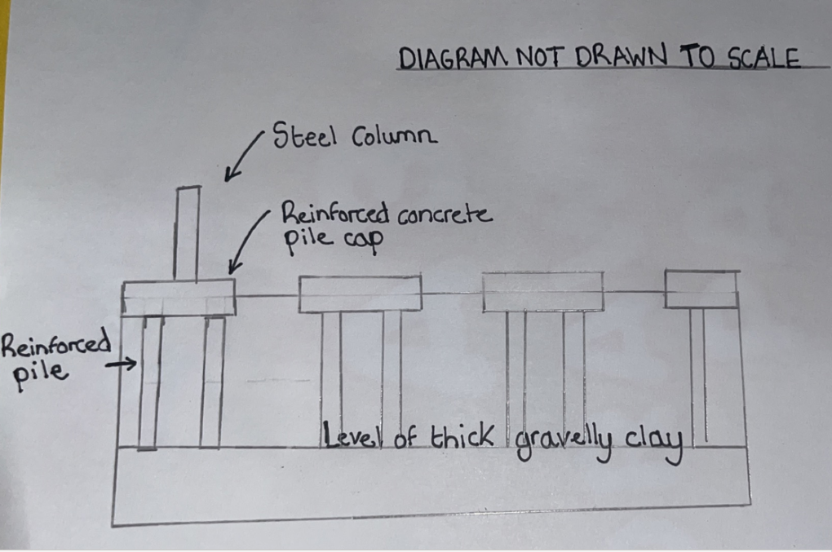
Figure 17- Potential foundation type (rough sketch)

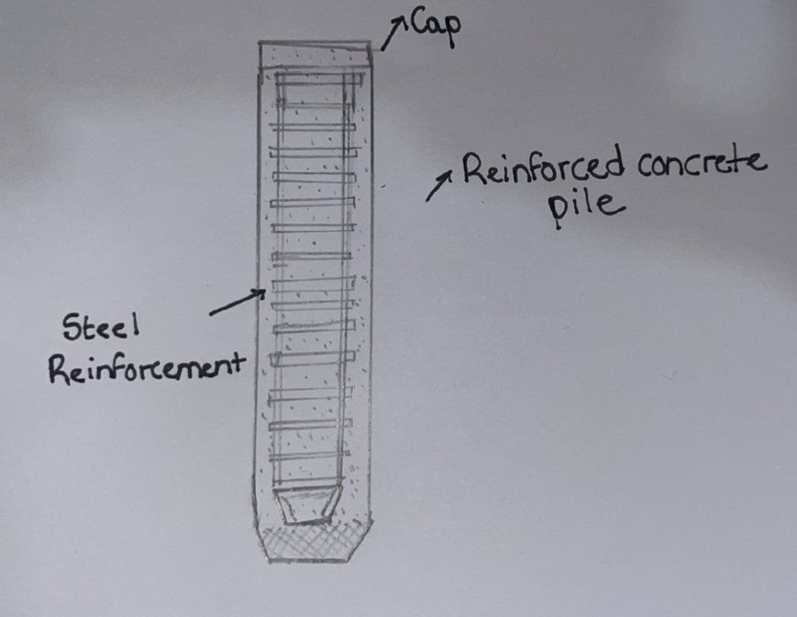
Figure 18- Reinforced Concrete Piles (rough sketch)

8.0 References

AECOM (2019) Summary of Ground Conditions. Available at https://www.swansea.ac.uk/media/CISM---Ground-Conditions.pdf. (Accessed 31st December 2023)
BGS (1880) Swansea Docks Borehole Logs. Available at http://scans.bgs.ac.uk/sobi_scans/boreholes/370199/images/10677848.html. (Accessed 30th December 2023)
BGS (1976). Proposed New County Hall Paxton Street Borehole Log. Available at https://api.bgs.ac.uk/sobi_scans/v1/borehole/scans/items/370215. (Accessed 30th December 2023).
Bing (2023). Bing Maps. Available at https://www.bing.com/maps/?cp=51.618254%7E-3.919843&lvl=16.9&style=h. (Accessed 29th December 2023)
Considerate Constructors (2024). CCS Monitor Checklist 2024. Available at https://www.ccscheme.org.uk/wp-content/uploads/2023/12/CCS-Monitor-Checklist-2024.pdf. (Accessed 1st January 2024)
EDINA (1940-2023). Historic Digi Maps. Available at https://digimap.edina.ac.uk/roam/map/historic. (Accessed 21st November 2023).
Google (2023). Google Maps. Available at https://www.google.co.uk/maps. (Accessed 23rd November 2023).
LandIS. (2023) Soilscapes Soil Types Viewer. Available at LandIS - Land Information System - Soilscapes soil types viewer. (Accessed 31st December 2023)
Mansfield, M. (2022) Welsh Government to take over Swansea’s prince of wales dock, Nation.Cymru. Available at: https://nation.cymru/news/welsh-government-to-take-over-swanseas-prince-of-wales-dock/ (Accessed: 20th November 2023).
Met Office (2010). Windiest place in the UK. Available at https://www.metoffice.gov.uk/weather/learn-about/weather/types-of-weather/wind/windiest-place-in-uk. (Accessed 2nd January 2024).
National Library of Scotland (1888). Ordnance Survey. Available at https://maps.nls.uk/view/239766367. (Accessed 21st November 2023)
NRW (2020). Flood Risk Map. Available at https://flood-risk-maps.naturalresources.wales/?locale=en. (Accessed 31st December 2023).
NRW (2023). Protected Areas of Land and Sea. Available at https://naturalresources.wales/guidance-and-advice/environmental-topics/wildlife-and-biodiversity/protected-areas-of-land-and-seas/find-protected-areas-of-land-and-sea/?lang=en. (Accessed 31st December 2023).
Prasad (n.d.) Types of pile foundations. Available at https://www.structuralguide.com/types-of-pile-foundations/. (Accessed 6th January 2024)
Swansea museum (n.d.) Swansea Museum, City and County of Swansea. Available at https://www.swanseamuseum.co.uk/. (Accessed: 20th November 2023).
Topographic Maps (2023). Swansea Topographic Map. Available at https://en-gb.topographic-map.com/map-733q/Swansea/?center=51.61787%2C-3.9222&zoom=16&base=5&popup=51.61807%2C-3.92008. (Accessed 31st December 2023).
UK Government (2022) UK Radon Map. Available at https://www.ukradon.org/information/ukmaps. (Accessed 2nd January 2024)
Utilities One (2023). What is a pile cap in construction? Available at https://utilitiesone.com/understanding-the-basics-what-is-a-pile-cap-in-construction. (Accessed 6th January 2024)

9.0 Appendix

9.1 Appendix A- Record of Trial Bores Prince of Wales Dock Swansea (BGS, 1880)

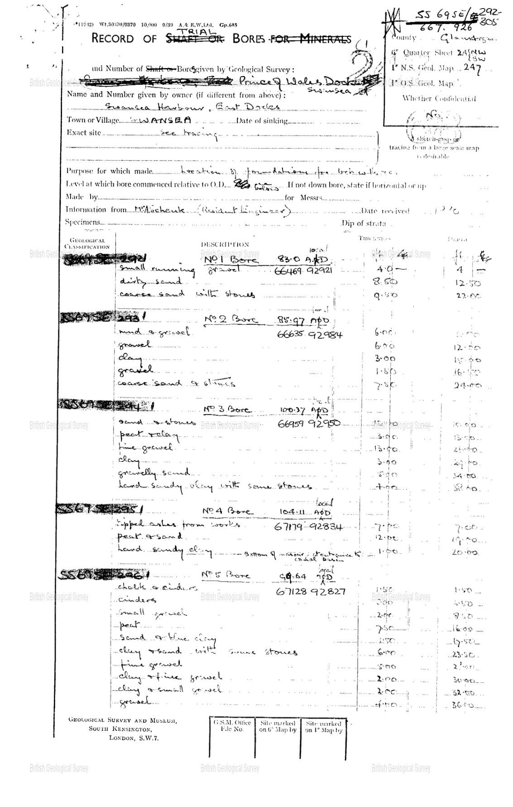

9.2 Appendix B- Proposed New County Hall Paxton Street Swansea Borehole Log (BGS, 1976)

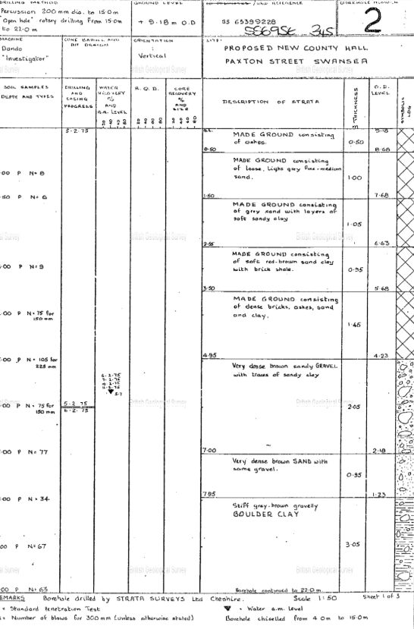

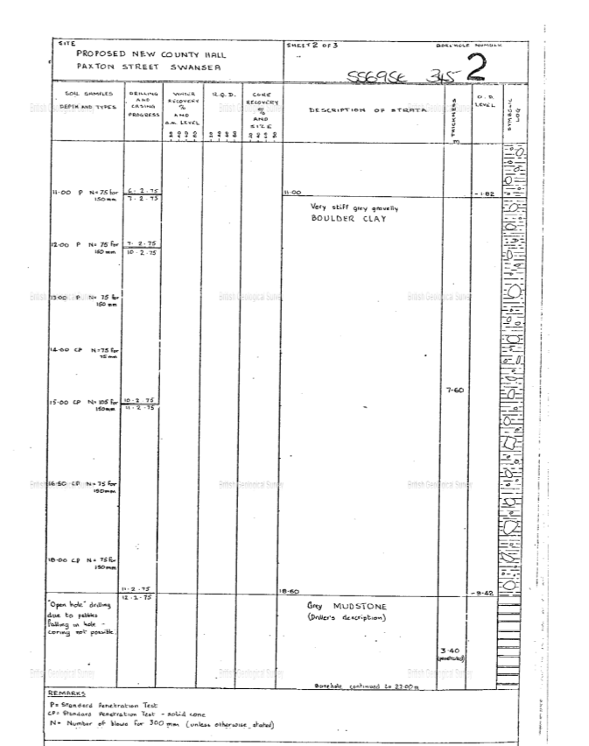

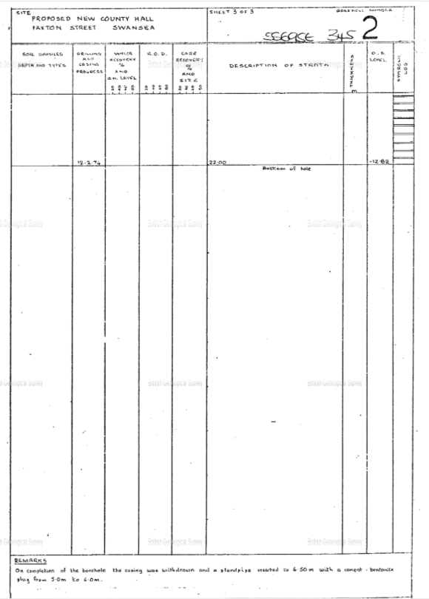

9.3 Appendix C- CISM Borehole Log (AECOM, 2019)
Borehole Log taken from AECOM’s ground conditions analysis for projected CISM building at Swansea Bay Campus.


