Emerging Network Technologies
To Design, Simulate and Evaluate a potential real-life Communication System.

Author – William Thomas
Organization – UWTSD
City - Swansea

Abstract – This paper will explore three modulation techniques which are ASK, PSK and QAM. The paper will outline the differences between them such as advantages, disadvantages and what they are typically used for. A simulation of the three modulation techniques will be provided against different levels of noise, to show the amount of information was lost. This paper will provide solutions on how to prevent crimes in farms, police stations and transport stations.

Introduction
This report will cover three types of digital modulation techniques, Amplitude Shift Keying (ASK), Phase Shift Keying (PSK) and Quadrature Amplitude Modulation (QAM). The report will compare these three modulation techniques using a series of simulations. Information will be gathered on when these modulation techniques would be used in a real-life scenario such as advantages and disadvantages. MATLAB, which contains SIMULINK will be used to conduct the simulations for the three modulation techniques. Three simulations will be done for each modulation techniques using different signal to noise radio (SNR). This report will also cover a simulation in-which is based on criminal activity and how to reduce the threat such as adding the necessary IoT equipment to help prevent that. There will be three locations which are farm, police station and transport station. Each will have their own characteristics on how to prevent crime. There will also be modulation techniques used.

Research Into Modulation

What is Modulation?
Modulation is a process in-which are made up of two signals known as the baseband signal and the high frequency signal. Modulation allows low frequencies to be shifted to high frequencies. Modulation helps with communication as it requires less of an output than without it. Modulation of a signal also requires de-modulation of the signal once it has been received. Since data signals cannot do direct transmissions, it is necessary to modulation the signal which would allow it to become possible for transmission.

Benefits of Modulation?
No Mixing of Signals –
- Modulation can allow multiple transmitters broadcasting on the same frequency by separating the baseband sound signal as it would use a different carrier also known as different slots on the frequency domain to avoid interference with the communication/signal.
- Multiple transmitters can broadcast on the same frequency without disruption.

Increases Range –
- Without modulation, a standard baseband frequency signal would fail if attempted to transmit a large distance since it’s a low frequency but with modulation it would convert the frequency into a high frequency which will allow it to travel a further distance.

Multiplexing –
- Multiplexing only works with modulation and it’s a process in-which it improves the channel bandwidth utilisation. An example of this is many signals can be transmitted over the same connection, which televisions perform, in-which cause no interface of the channels.

Reduction of the antenna height –
- Modulation reduces the amount of transmitted baseband of signal of frequency for example without modulation the antenna would have to be 7500metres to transmit the data but by using modulation to decrease the baseband the 7500metres antenna can become 75metres which is easier to install and requires less power operate.
Improves quality of reception –
- Frequency modulation and digital communications techniques allow the effect of noise to be reduced which produces a clearer output on the receiving end of the transmission.

Types of Modulation?
Analog Modulation –
- AM (Amplitude Modulation)
- FM (Frequency Modulation)
- PM (Phase Modulation)

Digital Modulation –
- ASK (Amplitude-Shift Keying)
- FSK (Frequency-Shift Keying)
- PSK (Phase-Shift Keying)
- QAM (Quadrature-Amplitude Modulation)

Research into computer network simulations

What is a Computer Network Simulation?
A Computer network simulation allows the creator to plan out and execute a computer network that they have created as if it was created in the real-word environment. Some software which performs such a task are NetSim and OPNET. The creator can create their own topology and configure the devices to create a real-world simulation to ensure that the network is stable, and no compilations are occurring. This saves money and time rather than buying all the equipment and setting it all up to realize there is a major problem down the line. The simulation can also be set-up to produce jitter and delay which can be adapted to other real-life environments

How does a communication system relate?
Computer networks use multiple communication protocols to communicate with other devices on the network to organize traffic and learn about the topology and size of the network which includes the devices on the network. The communication protocol can be used for digital media streaming, instant messaging and more. Resources are shared from and to the device via the network. The communication protocols support Ethernet and Wireless LAN (IEEE 802).

Research into three of the modulation types

Amplitude Shift Keying (ASK) – [1-3]
Amplitude Shift Keying (ASK) which is a type of Amplitude modulation produces a series of 0 and 1’s in binary data in-which forms variations in the amplitude of the signal. High input produces a 1 value whist Low input produces a 0 value.

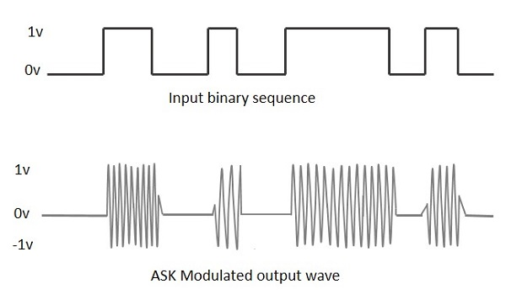[1] ASK requires an ASK modulator to convent the unmodulated signal into an ASK modulated signal, Once transmitted and received the ASK signal must be demodulated using an ASK demodulator which can demodulate the signal via two methods – [2]
- Asynchronous ASK Demodulation
- Synchronous ASK Demodulation

Amplitude Shift Keying (ASK) can offer a range of advantages such as –
- It’s a simple modulation and demodulation process.
- Low noise interference
- High efficiency
- Mainly used to transmit digital data signals via optical fibers.
- Requires less bandwidth than most other modulation techniques.

Amplitude Shift Keying (ASK) can offer a range of disadvantages such as –
- Low power efficiency.
- Atmospheric noise.
- Distortion.
- Requires excessive bandwidth.

Amplitude Shift Keying (ASK) can be found in a range of applications –
- Transmitting digital data over optical fiber.
- MORSE code communication

Amplitude Shift Keying (ASK) equation –
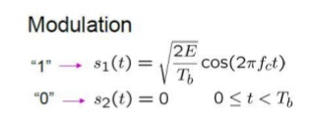[3]

Phase Shift Keying (PSK) – [4-6]
Phase Shift Keying (PSK) is a technique which phases the carrier signal is changed by varying the sine and cosine inputs. Phase Shift Keying (PSK) is widely used for bio-metric sensors, RFID readers, Bluetooth communication and Wireless communication.
Depending the way, the signal has been shifted, Binary Phase Shift Keying (BPSK) or Quadrature
Phase Shift Keying (QPSK) would have been performed. [4]
- Binary Phase Shift Keying (BPSK) is a technique which the sine wave carrier becomes a two-phase reversal which are 0 and 180.
- Quadrature Phase Shift Keying (QPSK) is a technique which the sine wave carrier becomes a four-phase reversal which are 0, 90, 180 and 270.

Phase Shift Keying (PSK) can offer a range of advantages such as –
- Wireless communication
- Less errors than ASK and QAM.
- Uses the same bandwidth to ASK.
- High data rate transmission can be achieved using QPSK.

Phase Shift Keying (PSK) can offer a range of disadvantages such as –
- Low power efficiency
- Recovery process
Phase Shift Keying (PSK) can be found in a range of applications –
- Wireless-LAN standard.
- Bluetooth communication
- Near-Field communication
- Multi-Channel WDM
- Optical communication

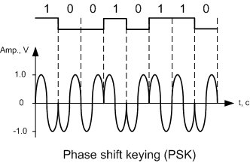[5]
Phase Shift Keying (PSK) equation –
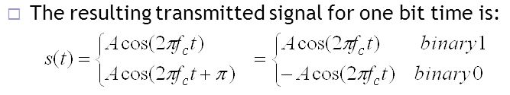[6]

Quadrature Amplitude Modulation (QAM)- [7-10]
Quadrature Amplitude Modulation (QAM) is a technique which utilizes both amplitude and phase components which provides a form of modulation can produce high levels of spectrum usage efficiency. It combines two amplitude modulated signals into a signal channel, this doubles the effective bandwidth. QAM has commonly been used in mobile phones and WI-FI as it allows these devices to execute high speed data communication. [7]

QAM uses the same frequency for the two carriers but differs in phase by 90 degrees. Both signals within QAM have a unique name which are I signal and Q signal. When dealing with the two signals multiple data can be gathered from both such as one signal can produce a sine wave whilst the other can produce cosine wave. Both signals are combined at the source of the transmission but once the data has been received at the receiver device the both signals are separated. QAM allows a higher data rate within the same bandwidth.

QAM has many types of formats which are 8-QAM, 16-QAM, 32-QAM, 64-QAM, 128-QAM and 256-QAM. 256-QAM is a high level of QAM which allows the high data rates to be achieved. This comes as a major advantage, but it also comes with a greater threat of having more noise produced in the signal. QAM has higher variations than 256-QAM. [10[

Quadrature Amplitude Modulation (QAM) can offer a range of advantages such as –
- Communications systems which can utilizing both amplitude and phase variations.
- Many different variants of QAM allow efficient usage of bandwidth.
- Radio communication.

Quadrature Amplitude Modulation (QAM) can offer a range of disadvantages such as –
- QAM is more susceptible to noise since the states are closer together.
- Uses more power.

Quadrature Amplitude Modulation (QAM) can be found in a range of applications –
- Radio communication systems
- LTE communication
- WiMAX
- Wi-Fi

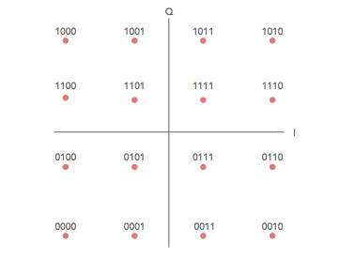[8]

Quadrature Amplitude Modulation (QAM) –
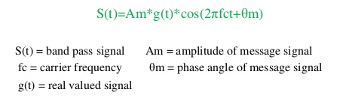[9]

Comparing the three modulation types – [11]
- PSK is less susceptible to errors than ASK.
- ASK has an easier recovery process than PSK.
- ASK is easier to setup than PSK and QAM as it’s less complex. [11]

Modulation | Bits Per Symbol | Symbol Rate
BPSK | 1 | 1x-bit rate
QPSK | 2 | 1/2-bit rate
8PSK | 3 | 1/3-bit rate
16-QAM | 4 | 1/4-bit rate
32-QAM | 5 | 1/5-bit rate
64-QAM | 6 | 1/6-bit rate

Modulation Software –
MATLAB, which contains a feature called Simulink is a communication system tool which allows simulations of many different variants of different scenarios of which can be configured. Some configuration that can be done but is not limited to is frequency (ASK,QAM and more), signal to noise ratio (To produce a small or large amount of noise on the signal to see how the signal adapts under a lot of disruption, modulation/de-modulation techniques and more.

Simulations of the modulation types
Each simulation will be run a total of two times. The first time the simulation is ran, it will be set to produce no signal to noise which allows the modulation and de-modulation signal to be produced perfectly. The second time the simulation is run, there will be a set amount of signal to noise ratio that would be set. This value will stay the same for all 3 modulation types to have a fair compression. The Signal to noise ratio will be set at -10

ASK and PSK will be displayed in scope format, the scope will display four rows of data. Each row will; contain the following data –
- 1st row – Connected to the Bernoulli Binary Generator to show the values that have been generated which will even be a value of 0 or 1.
- 2nd row – Connected after the modulation but before the signal to noise ratio has been added.
- 3rd row – Connected directly after the AGWN block. This shows that the signal has been modulated and signal to noise ratio has been added.
- 4th row –The de-modulated signal, which can be compared to the original signal, the top row. The signal should match the pattern of the 1st row of the scope but might contain some delay which is normal.

Display Block –
The display block is connected to the error rate calculation block, the error rate calculation block will forward the information to the display block, which are –
- The first text box – Percentage of packets lost during the simulation of the modulation.
- The second text box – The number of packets that were lost during the simulation of the modulation.
- The third text box – The number of packets sent during the simulation of the modulation.

Amplitude Shift Keying (ASK) –
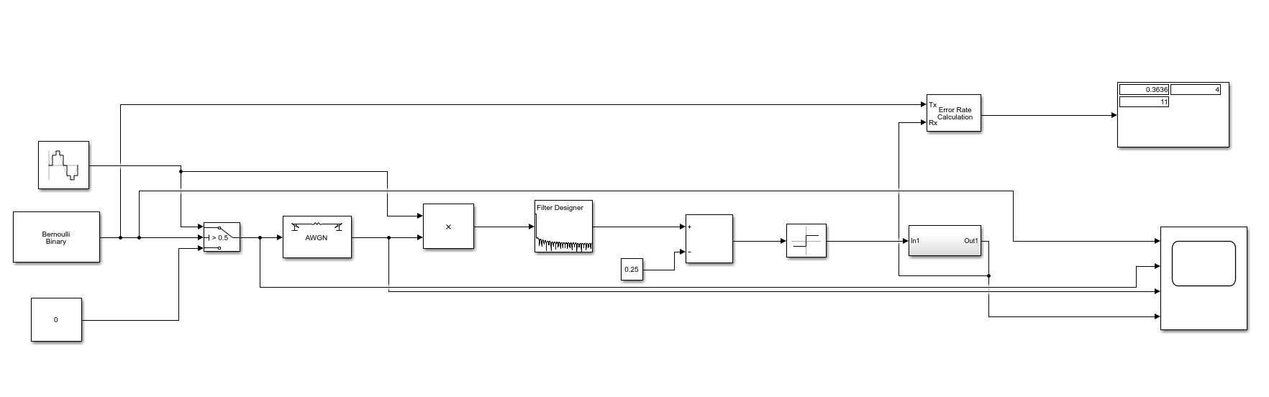
Image contents –
The image above is of a simulation of Amplitude Shift Keying (ASK) made in MATLAB/Simulink. The process above shows how Amplitude Shift Keying (ASK) can be simulated without using the built-in blocks. This shows how the signal has multiple processes to go through for the signal to be modulated and de-modulated.
The Amplitude Shift Keying (ASK) simulation used the following blocks –
- 1x Sine Wave
- 1x Bernoulli Binary Generator
- 2x Constant
- 1x Switch
- 1x AWGN Channel
- 1x Product
- 1x Filter Design
- 1x Add block
- 1x Sign Block
- 1x Error rate calculation
- 1x Display
- 1x Scope
- 1x Subsystem

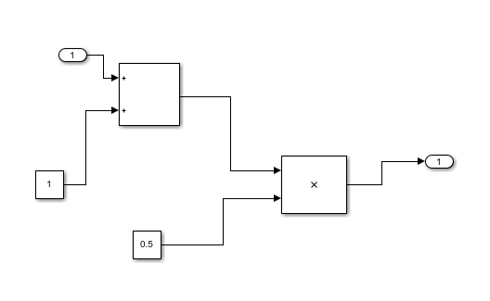
The Image above is inside the Subsystem block which contains more blocks, which are needed for the ASK de-modulation.
These blocks are –
- 2x Constant
- 1x Add block
- 1x Product

10 signal to noise ratio (ASK) (Scope) –
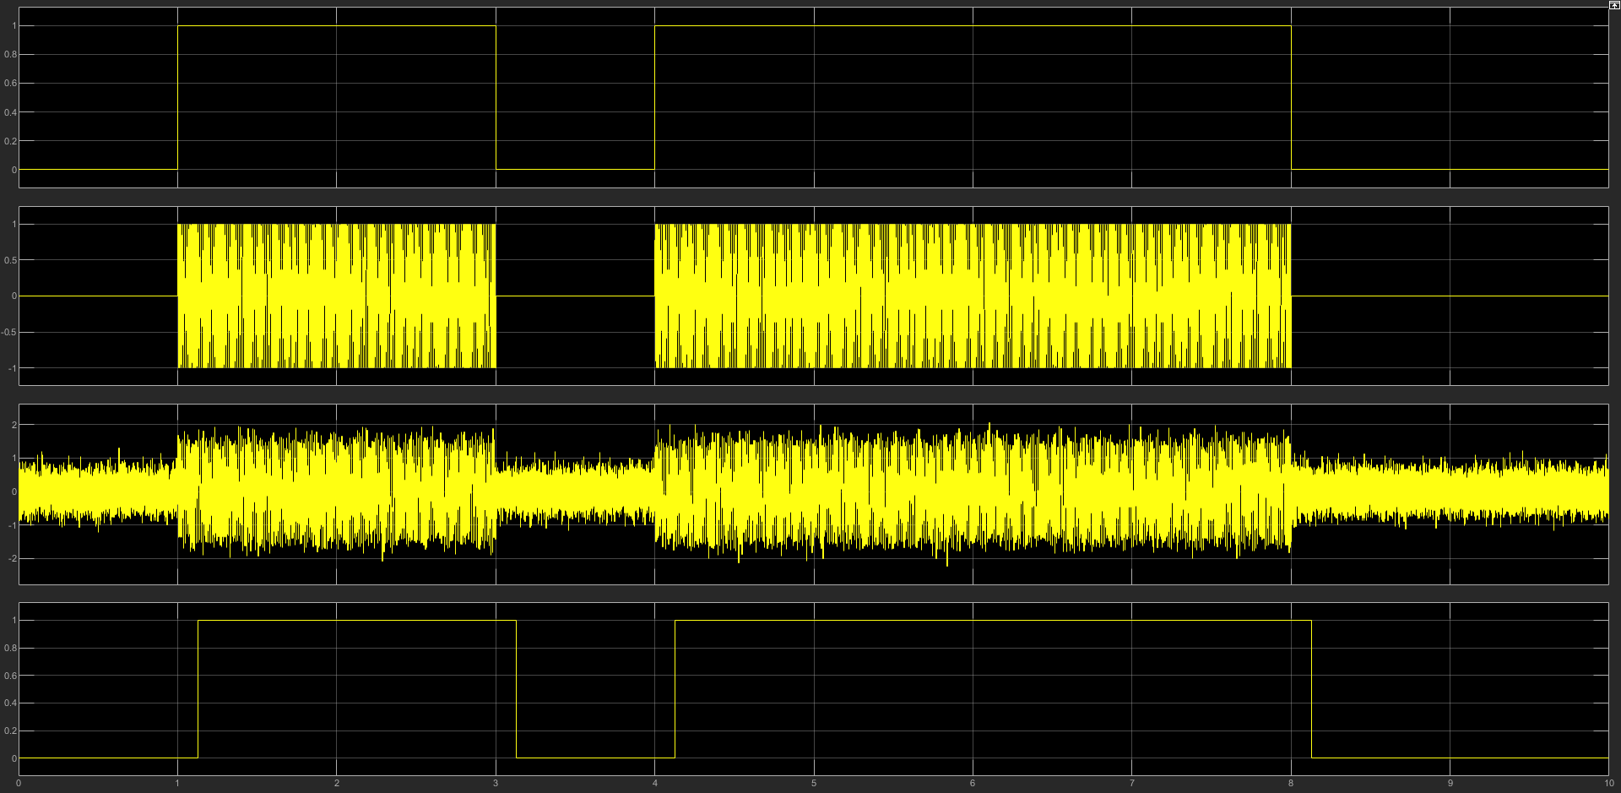
The image above is the ASK modulation set to 10 Signal to noise ratio (SNR). This produces more signal over noise.

10 signal to noise ratio (ASK) (Scope) (Zoomed in)–
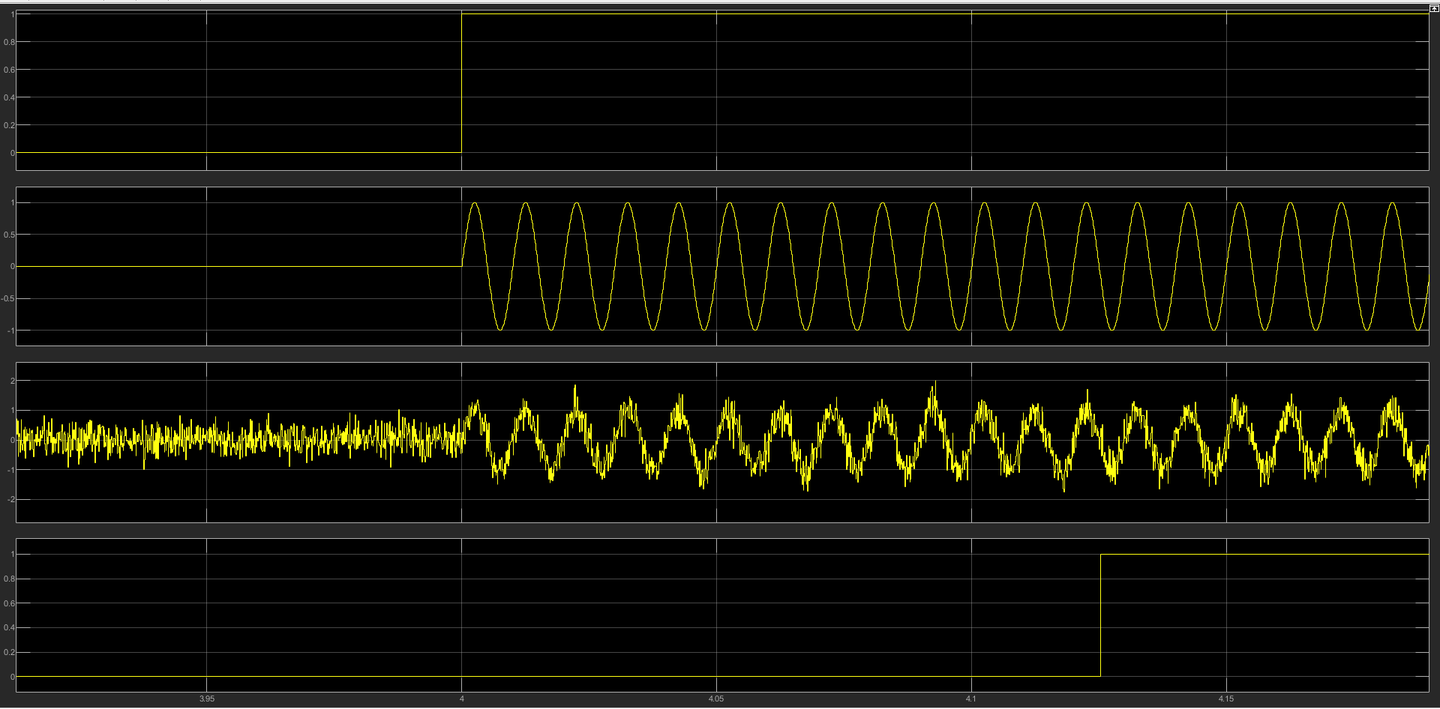
The image above is a zoomed in picture of the ASK modulation. The signal to noise ratio was set to 10 SNR.

Comparing the two images above, ASK is suitable when using 10 SNR, there is some slight delay on the modulation but looking at the process from which is started and ended, the modulation didn’t seem to have any major spikes or interference which could have produced some invalid data.

Display Block – ASK – SNR 10 –
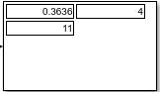
36% of packets during the simulation were lost, 4 out of 11 packets didn’t reach the destination.
Looking at the data from the 10 SNR ASK simulation, there wasn’t much interference and more than half of the data made it successfully to the destination which produced a mirror image to the original signal plus some delay.
-10 signal to noise ratio (ASK) (Scope) –
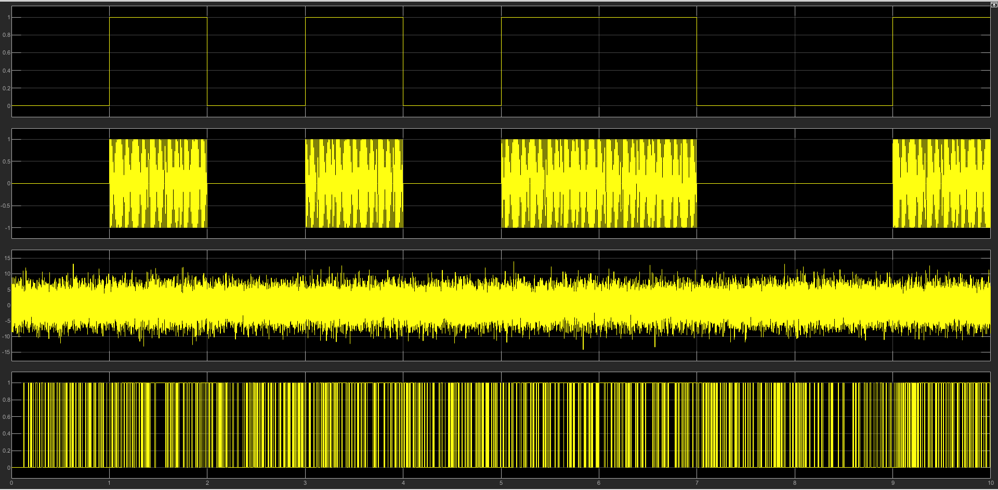
The 1st row doesn’t match the 4th row which means that the SNR was too much for the modulation type to handle.
-10 signal to noise ratio (ASK) (Scope) (Zoomed in)–
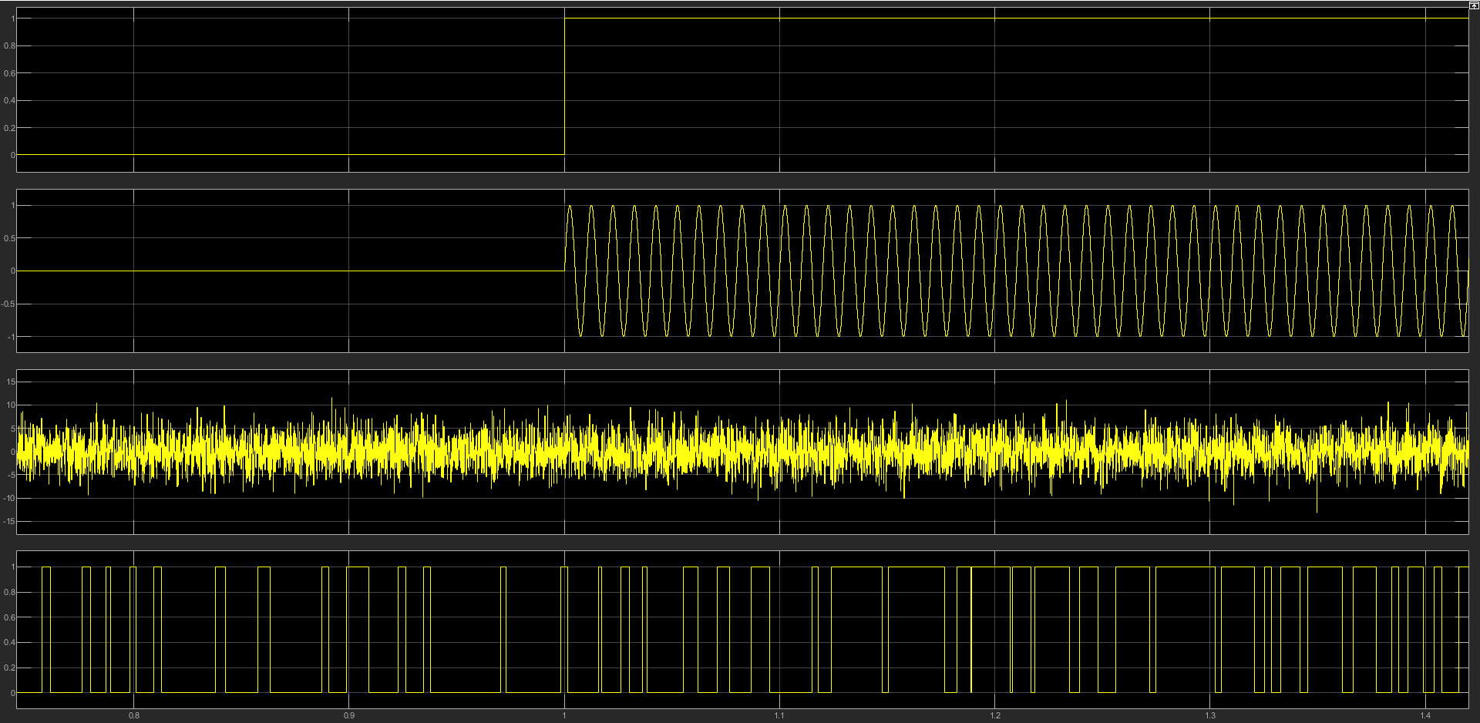
This shows that ASK against SNR -10 could not proude a good signal as too many errors have occurred. The 4th row is completely different from the 1st row which means that it’s receiving many errors.

Display Block – ASK – SNR -10 –
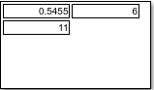
54% of packets during the simulation were lost, 6 out of 11 packets didn’t reach the destination.

-10 SNR was too much noise for the ASK modluation to handle. This means that ASK is very susceptile to a short amount of noise.

Phase Shift Keying (PSK) –
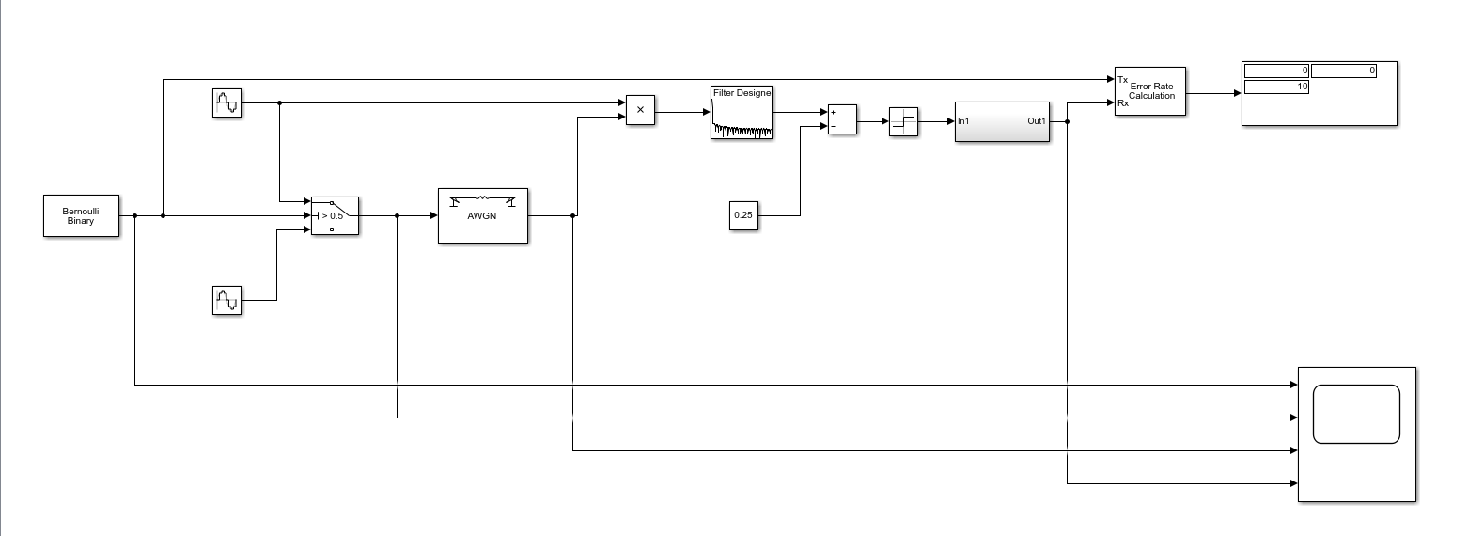
Phase Shift Keying (PSK) has been simulated in MATLAB/Simulink without using the PSK built-in blocks. This means that you can see the route of which PSK becomes modulated and de-modulated with the creation of the PSK signal.
The Phase Shift Keying (PSK) simulation uses the following blocks –
- 1x Bernoulli binary generator
- 2x Sine wave blocks
- 1x Switch
- 1x AWGN Channel
- 1x Product
- 1x Filter Design
- 1x Constant
- 1x Add block
- 1x Sign block
- 1x Subsystem block
- 1x Error rate calculation block
- 1x Display
- 1x Scope

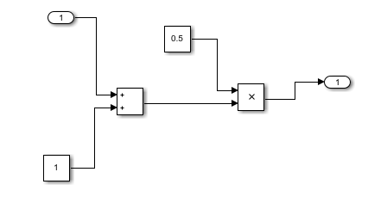
The image above, is inside the subsystem block. These blocks are needed for the de-modulation of PSK.
These blocks are –
- 2x Constant
- 1x Add block
- 1 Product

10 signal to noise ratio (PSK) (Scope) –
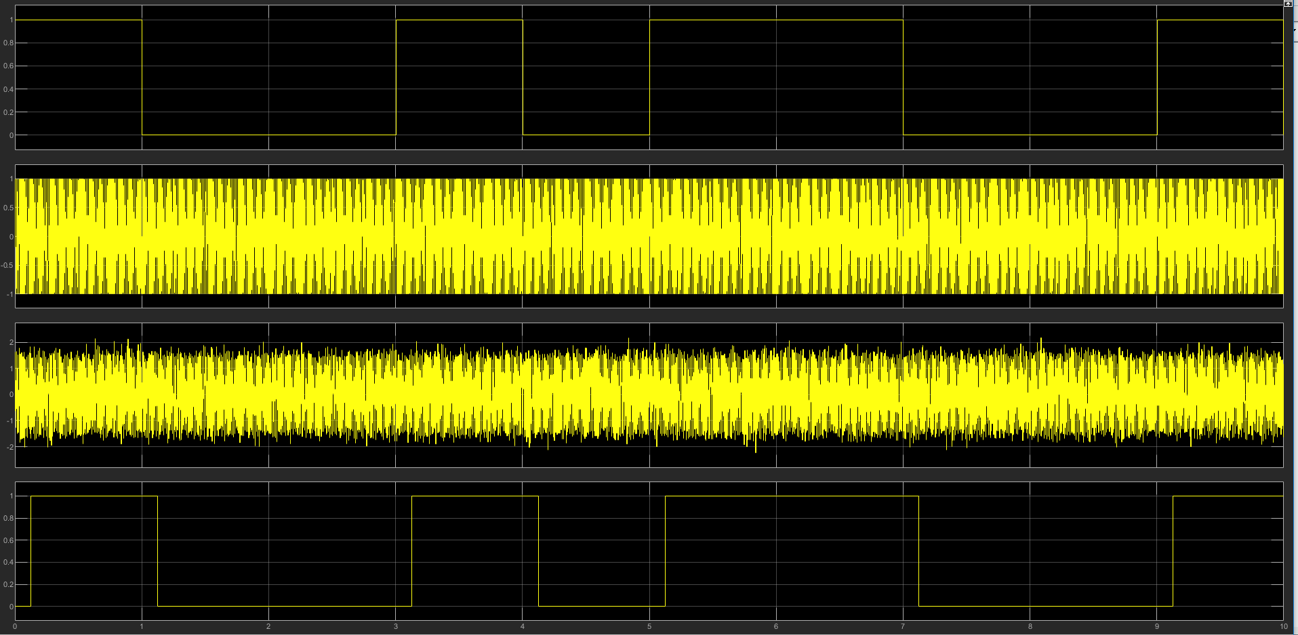
The signal was successful in modulating and de-modulating the signal.

10 signal to noise ratio (PSK) (Scope) (Zoomed in)–
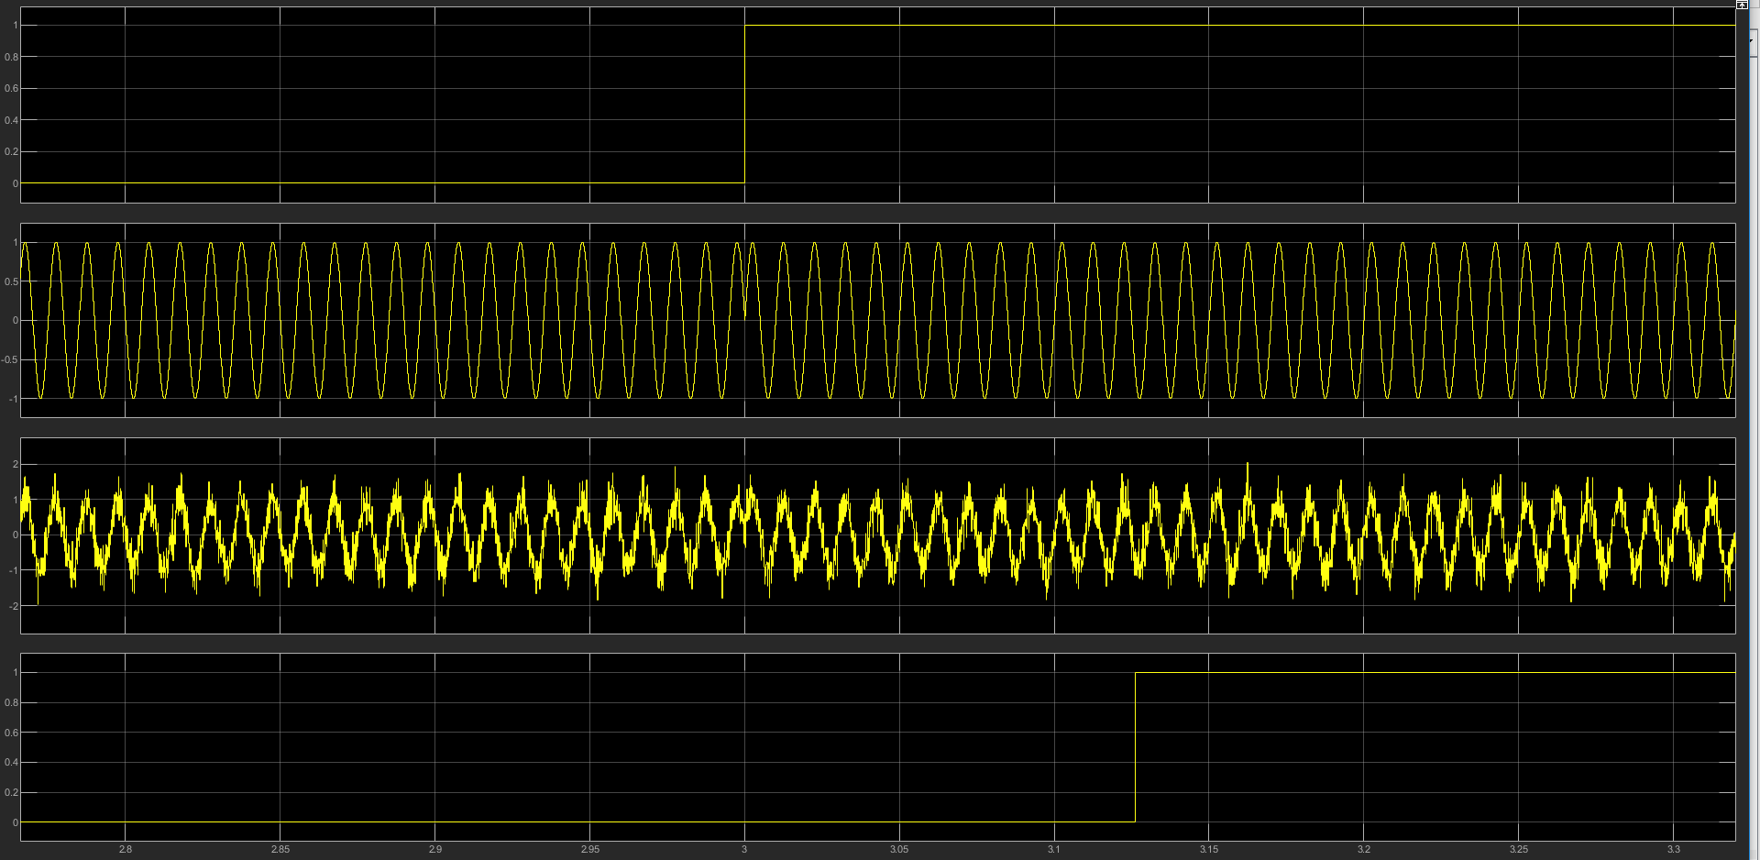
A closer look at the modulation and de-modulation of the signal and you can see that the correct result was produced but with some delay.

Display Block – PSK – SNR 10 –
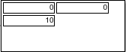
All the packets sent, were received so there were no errors for this simulation.

-10 signal to noise ratio (PSK) (Scope) –
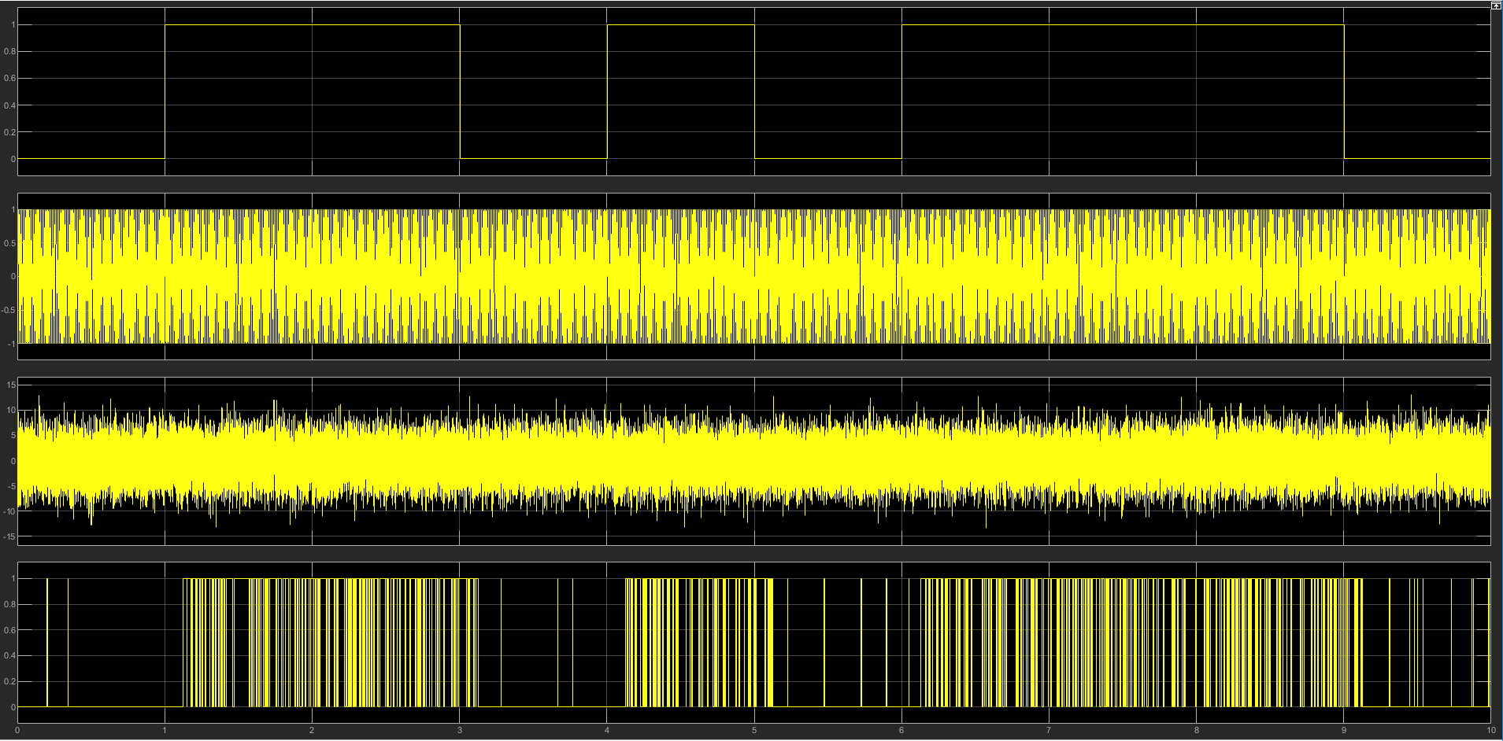
The signal produced some errors when comparing the 1st and 4th row but it looks quite stable since majority of the signal is correct.

-10 signal to noise ratio (PSK) (Scope) (Zoomed in)–
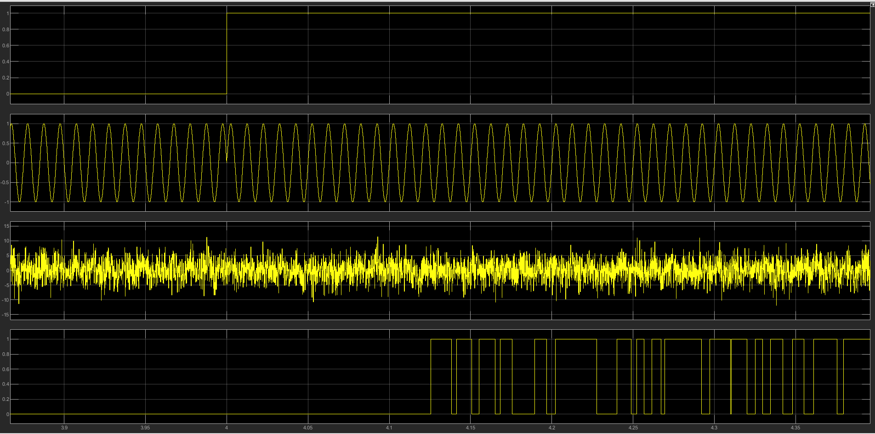
To further examine the data, the scope has been zoomed in. This allows us to see the number of spikes of errors the modulation had when receiving the data.
Display Block – PSK – SNR -10 –
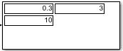
30% of packets during the simulation were lost, 3 out of 10 packets didn’t reach the destination.

Quadrature Amplitude Modulation (QAM) –

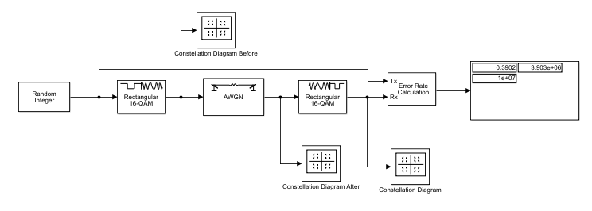
The above image is of the simulation created in MATLAB/Simulink of 16-QAM. This simulation used built-in blocks for the simulation as attempting to build it without the built-in blocks had many problems and weren’t producing the correct results so to ensure the results were correct, the built-in blocks were used.
Image contents –
- 1x Random Integer
- 2x Rectangular 16-QAM
- 1x AWGN channel block
- 1x Error rate calculation block
- 1x display
- 3x Constellation diagram blocks

The Constellation diagram’s Information –
There are three constellation diagrams for each of the 16-QAM simulations.
- The first diagram will show what 16-QAM should look like.
- The second diagram will be after the modulation has taken place and noise has been added.
- The third diagram should contain all 16 dots if the modulation process had no errors or small amount of errors. If some dots were missing, then the modulation type would have many errors.

10 signal to noise ratio (16-QAM) (Constellation Diagram) (First Diagram) –
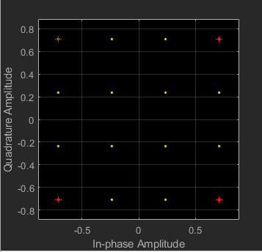

10 signal to noise ratio (16-QAM) (Constellation Diagram) (Second Diagram) –
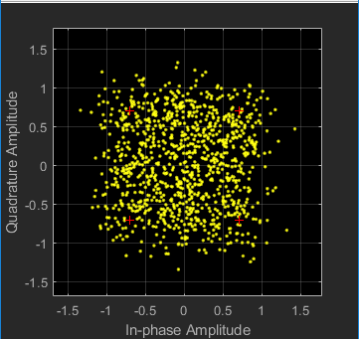

10 signal to noise ratio (16-QAM) (Constellation Diagram) (Third Diagram) –
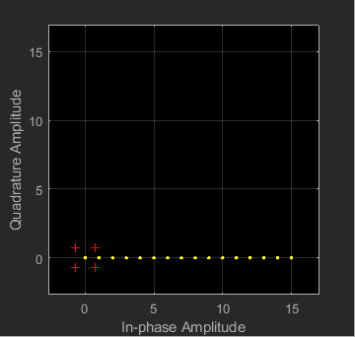
All the 16 constellation diagram dots were received, which means that there were no errors or that there wasn’t a large amount of errors to cause any serious loss of data.
Display Block – 16-QAM – SNR 10 –
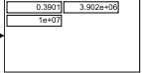
39% of packets during the simulation were lost, 3.902e+06 out of 1e+07 packets didn’t reach the destination.

-10 signal to noise ratio (16-QAM) (Constellation Diagram) (First Diagram) –
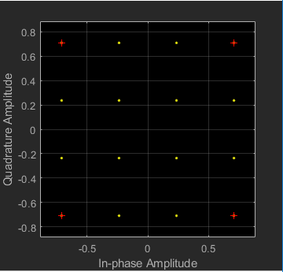

-10 signal to noise ratio (16-QAM) (Constellation Diagram) (Second Diagram) –
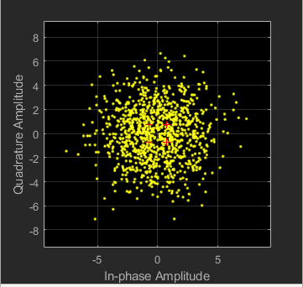

-10 signal to noise ratio (16-QAM) (Constellation Diagram) (Third Diagram) –
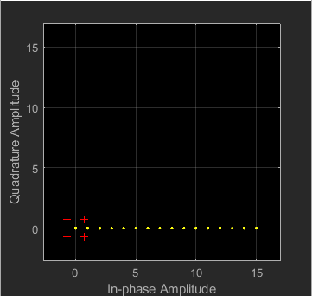
All the 16 constellation diagram dots were received, which means that there were no errors or that there wasn’t a large amount of errors to cause any serious loss of data.

Display Block – 16-QAM – SNR -10 –
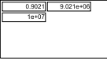
90% of packets during the simulation were lost, 9.021e+06 out of 1e+07 packets didn’t reach the destination.

-50 signal to noise ratio (16-QAM) (Constellation Diagram) (First Diagram) –
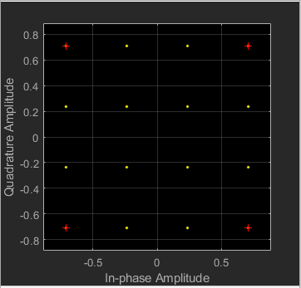

-50 signal to noise ratio (16-QAM) (Constellation Diagram) (Second Diagram) –
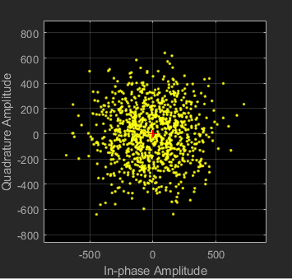

-50 signal to noise ratio (16-QAM) (Constellation Diagram) (Third Diagram) –
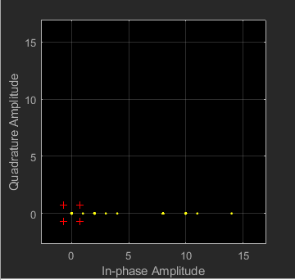
9 out of 16 constellation diagram dots were received, this means that -50 SNR caused some interference which caused some packets to not be received. -50 was tested to see how far 16-QAM could resist before major problems occurred.

Display Block – 16-QAM – SNR -50 –
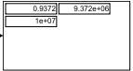
93% of packets during the simulation were lost, 9.372e+06 out of 1e+07 packets didn’t reach the destination. 16-QAM 10 and -10 SNR was stable until -50 SNR was used.

Comparing the Simulations
ASK was the weakest modulation type out of the three as it produced the wrong signal after adding some noise.
QAM was the second best as it provided a more stable signal than ASK with the same amount of noise added.
PSK was the best as it’s more resilient to noise than ASK and QAM.
ASK is great for when there is no noise and it’s a simple process to use.
QAM is used for when more bandwidth is required but it’s also massively susceptible to noise.
PSK should be used when there is a large amount of noise and bandwidth isn’t a requirement.

Comparing the Simulations to Research.
When comparing these three modulations to the research provided, PSK would be the best option to use since it’s less susceptible to noise and uses the same amount of bandwidth than ASK. QAM should be used when a large amount of bandwidth is required. PSK against noise or QAM for bandwidth.
ASK –
Comparing the ASK research diagram and simulation. You can see that the ASK modulation has taken place.
PSK –
Comparing the research PSK diagram and the simulation that was created. This shows that PSK was set up correctly and that you can see what happens when a value of 0 or 1 occurs.

QAM –
Comparing the QAM simulation and research. The QAM simulation constellation diagram matches the QAM diagram from the research.

Wireless network design

Research –
Direct Sequence Spread (DSSS) – [12]
- This is used in telecommunications, as it’s a modulation technique, which is used to reduce the overall signal interference by spreading the information bits. DSSS uses pseudo random binary sequence (PRBS).
- DSSS is used for IEEE802.11b which allows BPSK and QPSK modulation techniques.
- DSSS allows sharing of a single channel among multiple devices.
- DSSS is used for CDMA. [12]
- Has better range then VHT but cannot reach the high speeds that VHT perform.
- 2.4GHz WIFI.
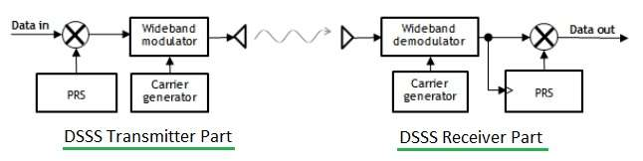

Very High Throughput (VHT) – [13]
- Can perform much higher data rate speeds than DSSS but has less of a range.
- Can perform Multi-User MIMO, which allows transmissions on the router to send and receive data signals from up to 8 devices connected at the same time. [13]
- VHT is newer technology than DSSS.
- 5GHz WIFI.
- VHT supports the following modulation types, BPSK, QPSK, 16-QAM, 64-QAM and 256-QAM.
- Supported in mobile phones, laptops and more.
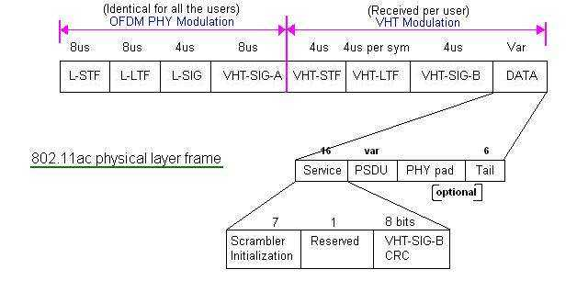

Simulation Programs used –
Packet Tracer –
This software was used for the initial design on how the network was going to be built such as adding the necessary devices to combat the tasks in-which had been given. The software is used for creating virtual simulations of a real-world network environment.

NetSim –
This software was used to produce the network simulation and gather the relevant information such as throughput, delay and packet loss for the proposed network.

Topology –
Packet Tracer –
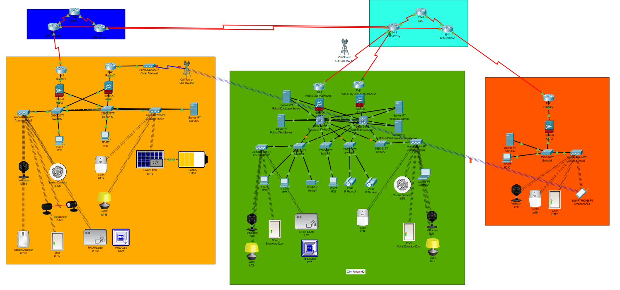

NetSim with application lines shown –
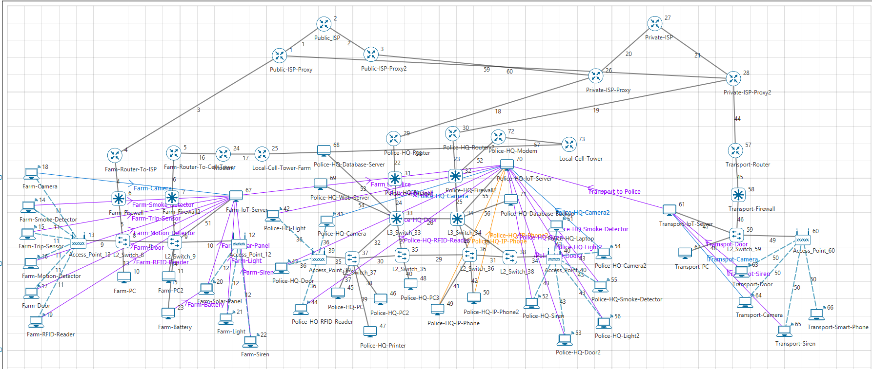

NetSim without application lines shown –
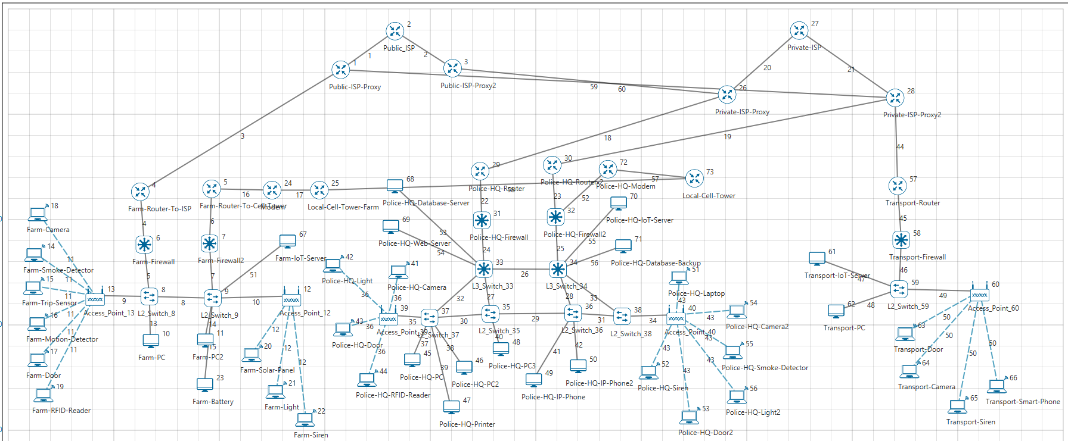
The wireless devices will be using CBR as the routing protocol. CBR means a constant bitrate which is mainly used for telecommunications when relating to quality of service. Some devices many differ such as cameras will be video and Ip phones will be voice.

Camera’s, Trip-Sensors and Motion detectors are the main security points for the farm, each of the devices connect to the on-site IoT which forwards the traffic to the Police-HQ if the devices detect movement during the conditions met such as time of day and two out of three devices were triggered.

IEEE802.11B – No Pathloss Results –
Network Metrics –
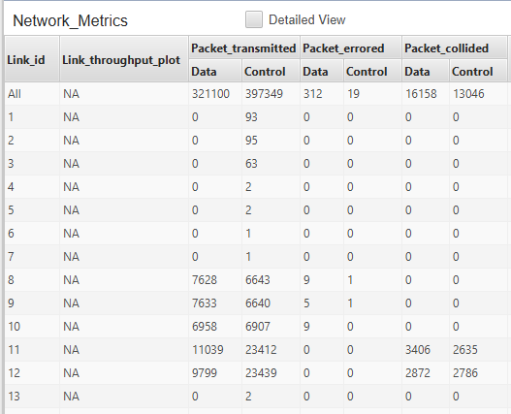
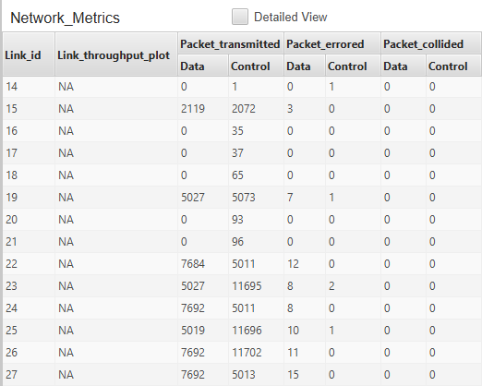
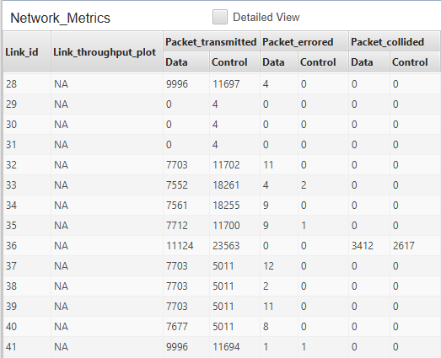
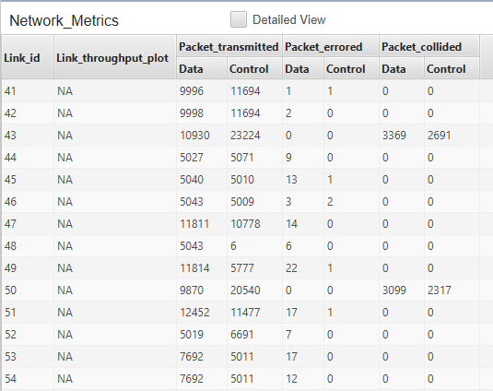
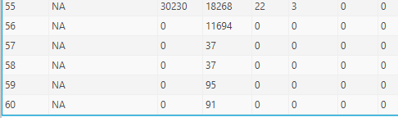

Application Metrics –
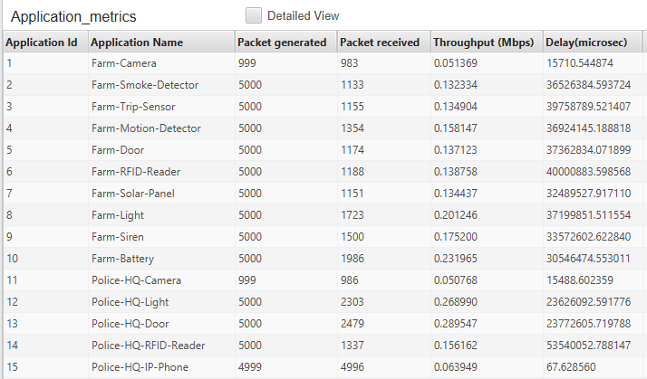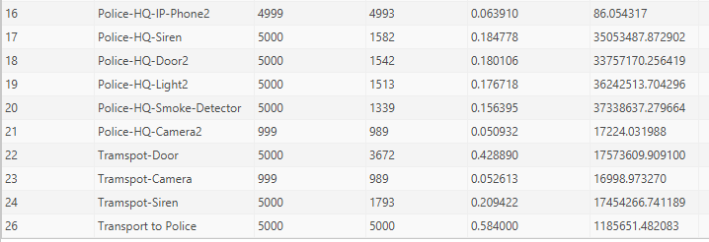

IEEE802.11B – Pathloss 10db Results –
Network Metrics –
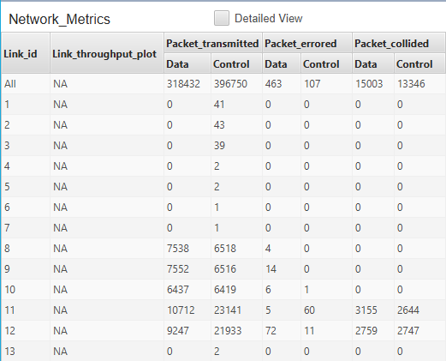
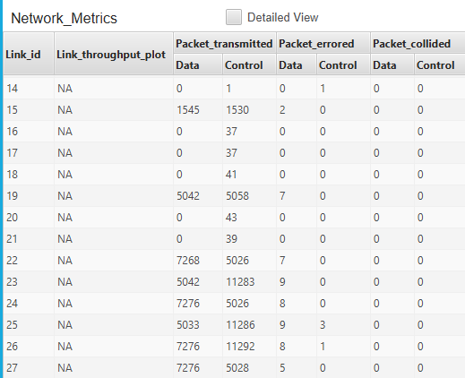
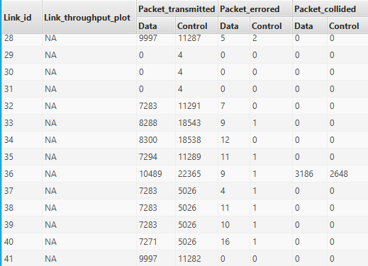

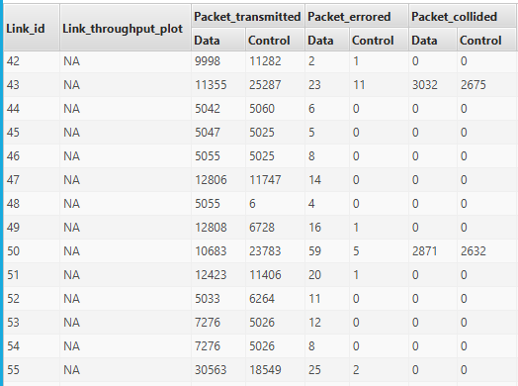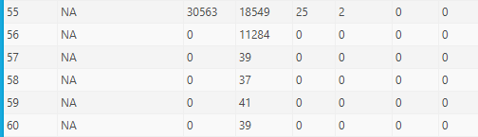

Application Metrics –
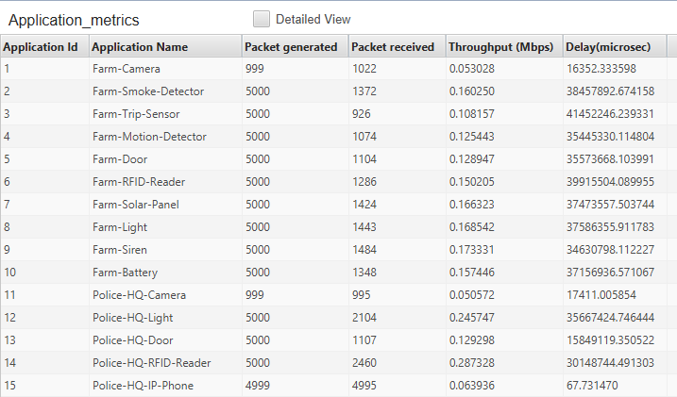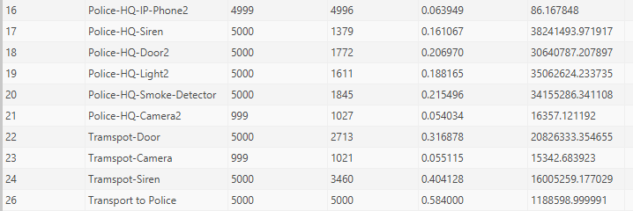

IEEE802.11AC – No Pathloss 0db Results –
Network Metrics –
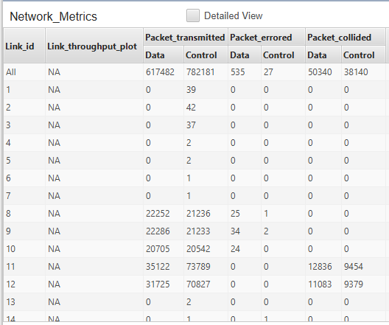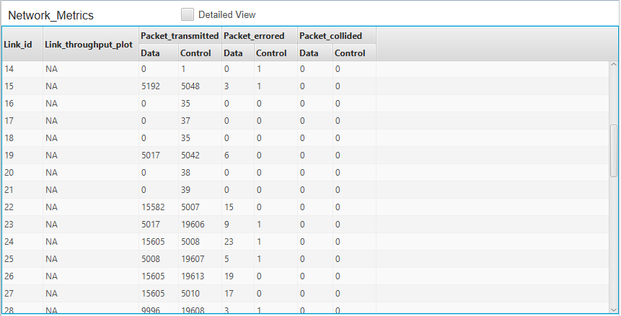
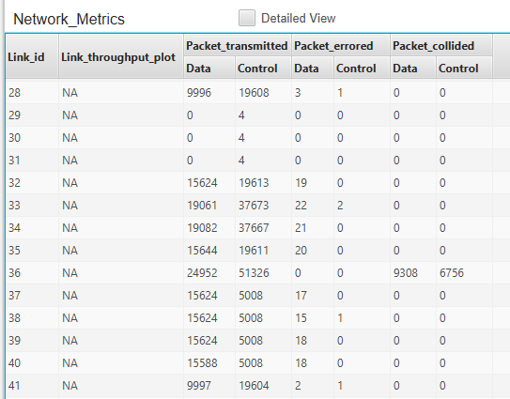
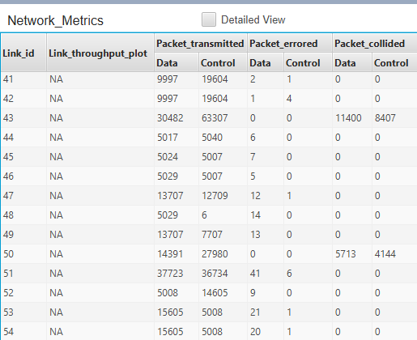
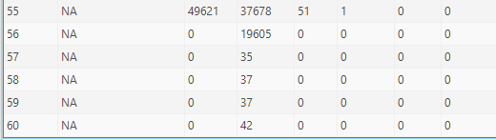

Application Metrics –
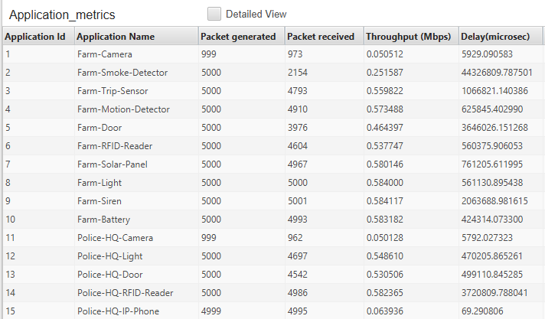
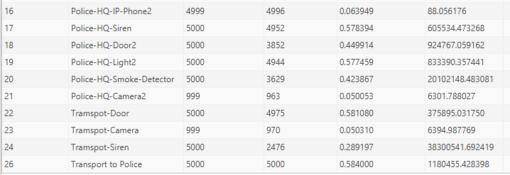

IEEE802.11AC – Pathloss 10db Results –
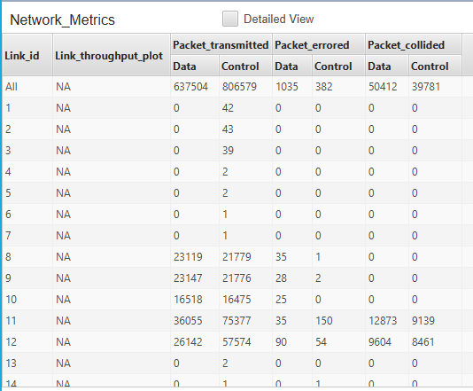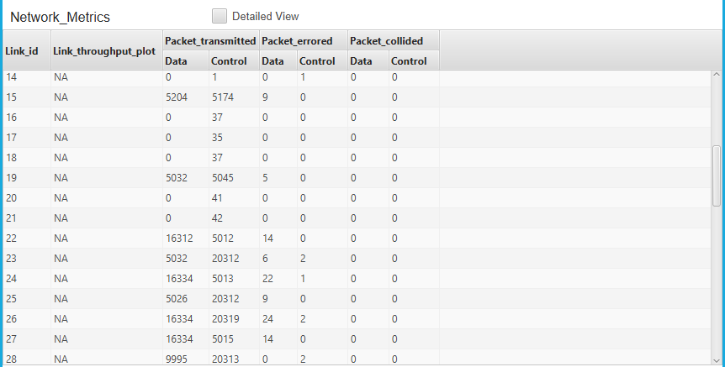
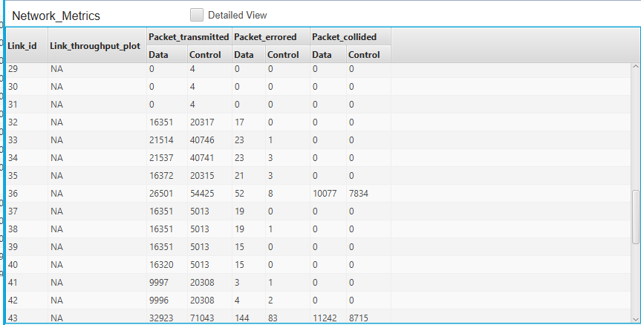

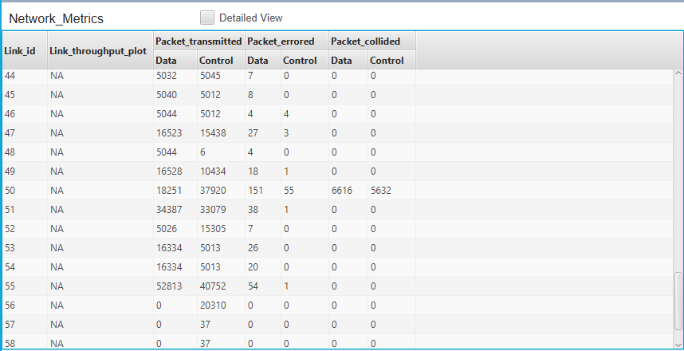

Application Metrics –
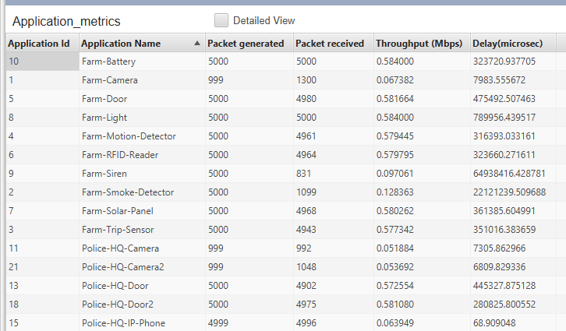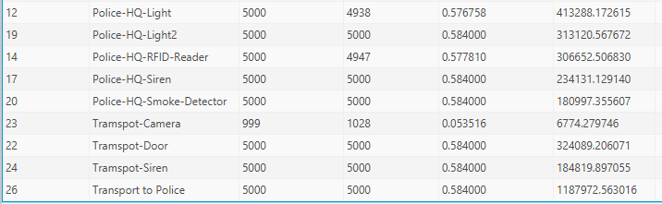

Information Shown from the images –
Network Metrics –
The network metrics show the number of packets transmitted. Errored and collided. This information is relevant, as it allows the administrator to de-bug the network if problems occur.

Application Metrics –
This shows each application that was setup on the network such as the camera’s produced video traffic and the IP phones produced voice traffic. This allows de-bugging to be simplified as it shows the number of packets each device has generated and received. It also contains information on the Throughput (Mbps) and delay.

Comparing IEEE802.11B and IEEE802.11AC –
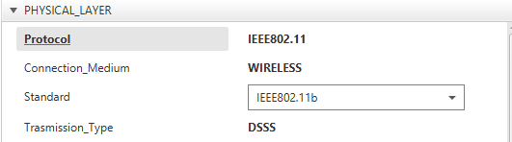
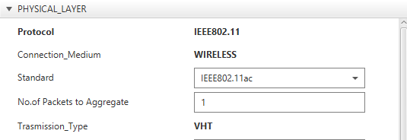
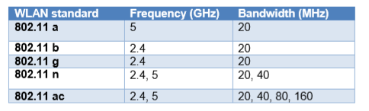
IEEE802.11b is the wireless standard for devices on NetSim. It performs a range of benefits such as range and compatibility but unlike IEEE802.11AC is lacks in speed.

IEEE802.11b was chosen as it uses 2.4GHz and it supports BPSK and QPSK.

IEEE802.11AC was chosen as it uses 5GHz and it supports 16-QAM.

Link Settings –
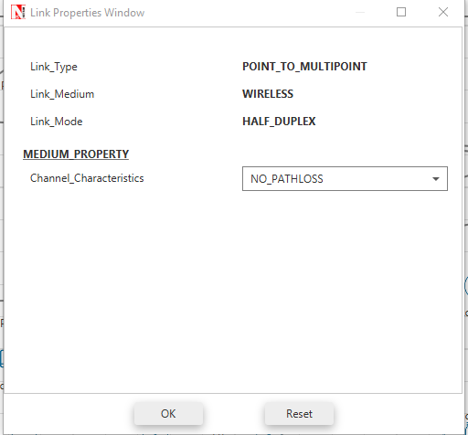
This allowed no pathloss to occur.

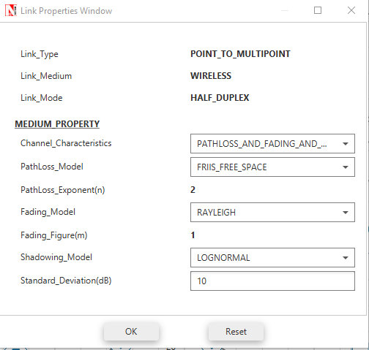
This added pathloss, fading and shadowing.

Limitations of Netsim –
Due to the lack of features that NetSim provides, choosing the Modulation type when IEEE802.11AC was select wasn’t an option so it is unsure that 16-QAM was used.
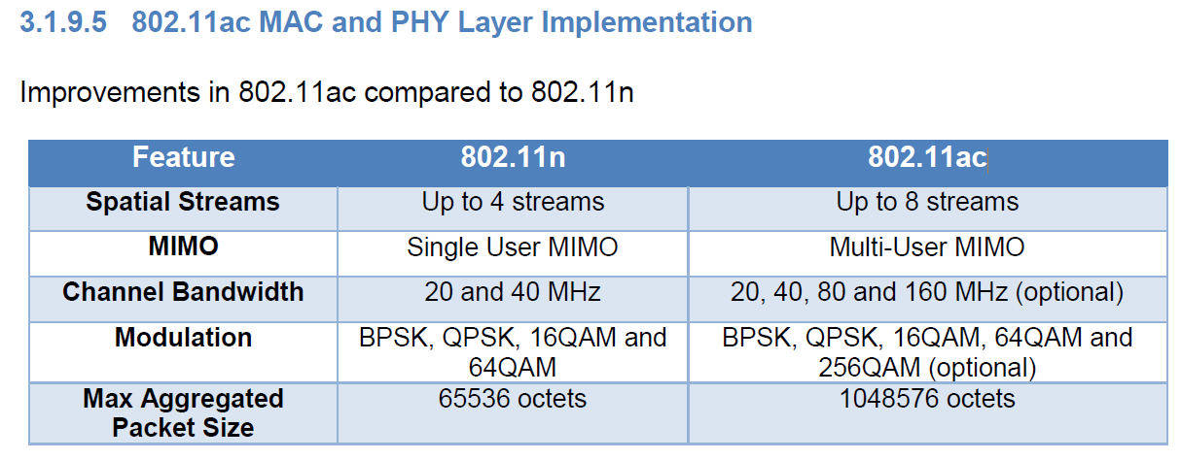

Conclusion
In conclusion of this report, ASK was the worst out of the three that was tested, since it has the same amount of bandwidth as PSK but more noise than QAM and PSK. ASK should be used for applications, in-which noise isn’t a problem since ASK is a simple process of producing. PSK would be a great option to use since it offers the best against noise unless you need more bandwidth than QAM is the option to go with. These three modulation techniques are still used today and offer a range of advantages against each other. This report shows how ASK and PSK are produced in MATLAB without using the built-in blocks so the process in-which the modulation and de-modulation can be shown. The second simulation was created to protect the farmers and transport station from crime. This was done by installing IoT devices to help combat crime.

References
- Tutorialspoint – ASK Image
https://www.tutorialspoint.com/digital_communication/images/ask_modulated_waveform.jpg
Time/Date Accessed – 16:10 04/03/2019
- Wei Li, Ming Li and Ning Hua Zhu, "All-optical generation of ASK, PSK, and FSK radio-frequency signals," 2016 Progress in Electromagnetic Research Symposium (PIERS), Shanghai, 2016, pp. 2362-2362.
https://ieeexplore-ieee-org.ezproxy.uwtsd.ac.uk/document/7734969/authors#authors
Time/Date Accessed – 12:25 06/03/2019
- Slideshare – ASK Image Modulation
https://image.slidesharecdn.com/ajay-130530113311-phpapp02/95/performance-analysis-of-different-digital-modulation-scheme-3-638.jpg?cb=1369914587
Time/Date Accessed – 12:40 06/03/2019
- M. T. Abuelma'atti, "New ASK/FSK/PSK/QAM wave generator using multiple-output operational transconductance amplifiers," in IEEE Transactions on Circuits and Systems I: Fundamental Theory and Applications, vol. 48, no. 4, pp. 487-490, April 2001.
https://ieeexplore-ieee-org.ezproxy.uwtsd.ac.uk/document/917985
Time/Date Accessed – 12:58 06/03/2019
- Tmatlantic – PSK – Image
https://www.tmatlantic.com/upload/images/keying_PSK.jpg
Time/Date Accessed – 13:04 06/03/2019
- Slideplayer – PSK - Image – Modulation
https://slideplayer.com/slide/4712204/15/images/33/Phase+Shift+Keying+%28PSK%29.jpg
Time/Date Accessed – 13:09 06/03/2019
- M. R. Mirarab and M. A. Sobhani, "Robust modulation classification for PSK /QAM/ASK using higher-order cumulants," 2007 6th International Conference on Information, Communications & Signal Processing, Singapore, 2007, pp. 1-4.
https://ieeexplore-ieee-org.ezproxy.uwtsd.ac.uk/document/4449591
Time/Date Accessed – 13:12 06/03/2019
- Electronics notes – QAM – Image
https://www.electronics-notes.com/images/quadrature-amplitude-modulation-16qam-constellation-01.jpg
Time/Date Accessed – 13:42 06/03/2019
- Slideshare – QAM – Image – equation
https://image.slidesharecdn.com/qudratureamplitudemodulation-141028144339-conversion-gate02/95/qudrature-amplitude-modulation-by-krishna-teja-sunil-11-638.jpg?cb=1414509236
Time/Date Accessed – 17:13 06/03/2019
- Chan Vee Chong and V. Tarokh, "Two constructions of 16-QAM Golay complementary sequences," Proceedings IEEE International Symposium on Information Theory,, Lausanne, 2002, pp. 240-.
https://ieeexplore-ieee-org.ezproxy.uwtsd.ac.uk/document/1023512
Time/Date Accessed – 17:34 06/03/2019
- A. Sharma, S. Majumdar, A. Naugarhiya, B. Acharya, S. Majumder and S. Verma, "VERILOG based simulation of ASK, FSK, PSK, QPSK digital modulation techniques," 2017 International Conference on I-SMAC (IoT in Social, Mobile, Analytics and Cloud) (I-SMAC), Palladam, 2017, pp. 403-408.
https://ieeexplore-ieee-org.ezproxy.uwtsd.ac.uk/document/8058380
Time/Date Accessed – 08:56 02/04/2019
- S. Hakak, S. A. Latif, F. Anwar, G. Gilkar and M. K. Alam, "Performance Analysis of DSR Protocol on the Basis of DSSS Rate," 2014 International Conference on Computer and Communication Engineering, Kuala Lumpur, 2014, pp. 48-51.
https://ieeexplore-ieee-org.ezproxy.uwtsd.ac.uk/document/7031597
Time/Date Accessed – 14:12 02/04/2019
- G. Z. Khan, R. Gonzalez, E. Park and X. Wu, "Analysis of very high throughput (VHT) at MAC and PHY layers under MIMO channel in IEEE 802.11ac WLAN," 2017 19th International Conference on Advanced Communication Technology (ICACT), Bongpyeong, 2017, pp. 877-888.
https://ieeexplore-ieee-org.ezproxy.uwtsd.ac.uk/document/7890239
Time/Date Accessed – 14:12 02/04/2019

