A literature review on the harbour porpoise in South Wales and beyond
Lucy Fairbrother

7 December 2020

Contents
1 Introduction 1
2 Population and distribution 2
2.1 Overall trends in population 2
2.2 Local estimates of population 2
2.3 Local habitat use 3
2.4 Conclusion 4
3 Threats 5
3.1 Introduction 5
3.2 Fishing 6
3.2.1 Bycatch 6
3.2.2 Food reduction 7
3.3 Climate change 7
3.4 Noise and disturbance 8
3.4.1 Vessels 8
3.4.2 Construction 8
3.5 Pollution 9
3.6 Bottlenose dolphin attack 10
4 Management 11
4.1 Protected status 11
4.2 Management solutions 12
4.2.1 Acoustic deterrents 12
4.2.2 Fishing restrictions 12
4.2.3 Reduction of pollutants 12
4.2.4 Vessel traffic management 12
4.3 Challenges to conservation 13
5 Conclusion 14
6 References 15

Tables and figures
Figure 2.1: Strandings and encounters by month (Jenkins, 2007; Penrose, 2003:2018) 3
Table 3.1: Cause of death of stranded harbour porpoises (Penrose, 2003:2018; (CSIP, 2002:2015)) 5
Figure 3.1: Annual reported strandings in Swansea and Gower (Penrose, 2003 to 2018) 6
Figure 4.1: Bristol Channel Approaches SAC boundary (shown in blue) 12

Introduction
While their diminutive size and wary nature (Roberts, et al., 2019) (Learmonth, et al., 2014) make them relatively hard to spot, harbour porpoises are the most common cetacean in the seas around the UK (Hammond, et al., 2017). Sightings data collected between 2002 and 2005 at four viewpoints in the Swansea and Gower area suggest that there is a resident population of harbour porpoise, and also that this group relies on specific local areas for breeding purposes (Jenkins, et al., 2009) . Consequently, human activities – including vessel traffic, fishing, industry and construction – around this partly-urbanised stretch of coastline are likely to have a significant impact on this species (JNCC, 2019a).
Globally, the conservation status of the harbour porpoise was assessed on 19 May 2020 as being of Least Concern (Braulik, et al., 2020). The justification for this assessment is that, while the species is subject to a number of pressures throughout its range, there is a lack of evidence that these pressures have led to a global decline in numbers, and the species maintains a wide range and relative abundance (Braulik, et al., 2020). However, it has been suggested that a global picture may mask pressures that are evident on a more local scale (Oakley, et al., 2016).
While there appears to be insufficient data to make definitive conclusions about the current size and trend of the population of harbour porpoise around the Swansea and Gower area, meta-analysis of surveys conducted since [2004] has concluded that numbers are declining in UK waters (NAMMCO, 2019). The key pressures that have contributed to this decline include bycatch from marine fishing, attack by bottlenose dolphin, disturbance by vessel and construction activity and pollution (Roberts, et al., 2019) (Calderan & Leaper, 2019) (Wisneiwska, et al., 2018) (Northridge, et al., 2017) (JNCC, 2019a).
By analysing the nature and level of these pressures on the harbour porpoise in Swansea, together with likely threats that may arise, conclusions may be drawn about whether a decline in population elsewhere across its range might also be reflected here, and whether management solutions on a more local scale may help to conserve this species. This paper looks at sightings data collected between 2002 and 2005 around the Swansea Bay and Gower (Jenkins, 2007) and strandings data collected between 2002 and 2018 (Penrose, 2003:2018) etc., and compares them to literature relating to the same area and elsewhere to inform suggestions of how local management solutions may help to mitigate the loss of harbour porpoise.

Population and distribution

Overall trends in population
Based on abundance estimates from the SCANS II survey in 2005 and the SCANS III survey carried out in 2016, the size of the population in UK waters was reported to be 197,579 animals (with a 95% confidence range of 163,294-239,063) (JNCC, 2019a) (Hammond, et al., 2017). This represented a large decrease from the reported population in 2013, which used the same data collection methods; however, because of the wide confidence interval, the decrease was not statistically sufficient to conclude an overall decline (JNCC, 2019a). The drop in overall numbers was driven primarily by a consistent decline in the numbers of porpoises found in the Celtic and Irish Sea, which decline is projected to continue into the future (NAMMCO, 2019).
The surveys took place over the course of 6 weeks, around July (Hammond, et al., 2017). This is useful for comparing population year on year, but may not give an accurate estimate of a local population, given the seasonal variances in distribution.
“Due to the uneven survey effort over the period, the uncertainty in modelled distributions varied greatly” (JNCC, 2017)
“There may have been a distributional shift out of UK waters at the time of the SCANS-III survey or the numbers may have genuinely declined, but there are only two reliable abundance estimates for harbour porpoise covering UK waters and this is considered insufficient to confidently conclude a declining trend.” Fourth report page 17

Local estimates of population
The Bristol Channel is recognised as being an area of high density all year round (Heinänen & Skov, 2015).
The availability of prey, and, indirectly, the conditions that lead to that availability, as well as the topography that is suitable for calving, appear to be the main drivers of the distribution of harbour porpoise (in UK waters) (JNCC, 2017) (Embling, et al., 2009).
The particular environmental factors present in the Celtic and Irish Seas MU, and in particular the Bristol Channel Approaches site, align with those favourable to the harbour porpoise, including a possible association with sandeels (JNCC, 2017)
“The Bristol Channel Approaches / Dynesfeydd Môr Hafren site was identified as being within the top 10% of persistent high density areas for harbour porpoise in UK waters for both winter and summer seasons. However, model confident in summer was low” (JNCC, 2017)
Bristol Channel – 2,147 individuals (95% Confidence Interval: 810 – 5,693) – although there is a high level of seasonal variability (JNCC, 2017), citing SCANS II data from 2005. [NB only took place in a single month – note that numbers and distribution appear to vary substantially through the year]. “Represents approximately 4.7% of the population within the UK part of the CIS MU” so meets the criteria for Grade B (>2% to 15% of UK part of MU population (JNCC, 2017)
(Oakley, et al., 2016) collated data from a number of different land-based and vessel surveys conducted around the Swansea Bay and Gower areas over 10 year. There was a range of methodologies used and wide differences in the results; however, collating the data from all vessel surveys led to a conclusion that there was a high density of harbour porpoises in the area, of around 0.58 hp km⁻². There was also a continuous presence for 12 months of the year. The calculation of porpoise density for every survey was higher than the estimation by (Hammond, et al., 2017) for the North Cornwall coast and South Wales coast of 0.118 animals/km². The surveys used for (Hammond, et al., 2017) did not extend past the Gower. The difference may be because of the particularly high density of porpoise in Swansea Bay and Gower compared to the rest of the wider area; or because of the different survey methods and/or modelling.
The datasets collated by (Oakley, et al., 2016) were based on surveys that used different methods of data collection, so it was not possible to carry out meaningful comparisons of the data in order to conclude [year on year] trends in population or distribution.

Local habitat use
Areas around Swansea Bay and Gower have been consistently identified as habitats used by porpoises for feeding, social activities, breeding, and resting (Jenkins, et al., 2009) (Oakley, et al., 2016).

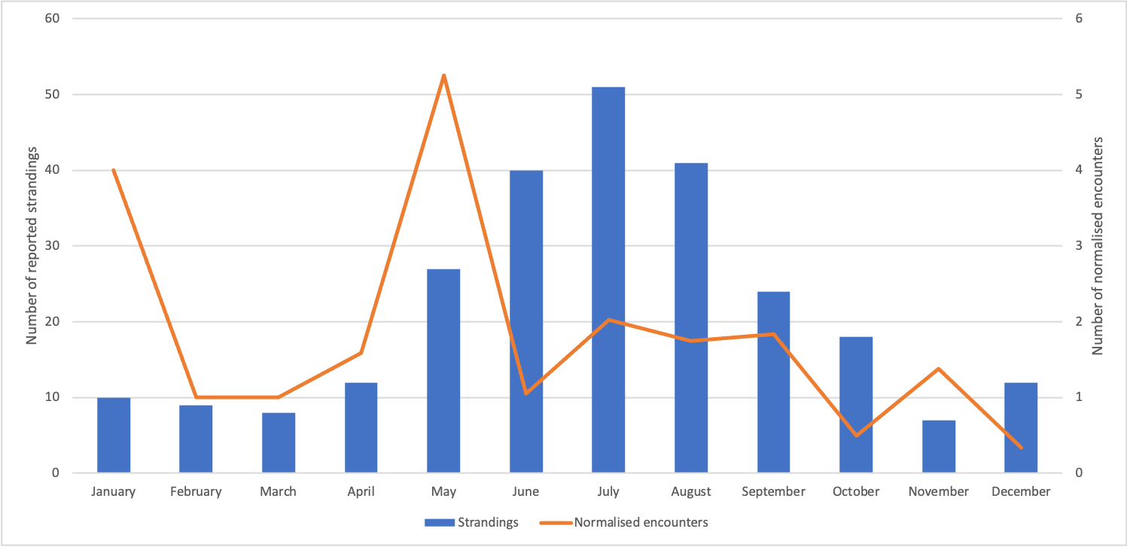
Figure 2.1: Strandings and encounters by month (Jenkins, 2007; Penrose, 2003:2018)
Both sightings data (Jenkins, 2007) and strandings data (Penrose, 2003:2018) indicate a year-round presence, as shown in Figure 2.1. The encounters from sightings peak in May, with the lowest numbers occurring in winter. The number of strandings increase steadily from May, peaking in July and remaining high throughout the summer and early Autumn. Assuming there is some time-lag between the death of a porpoise and its appearance on land, the increase in strandings from May onwards concurs with the peak in encounters. The apparent appearance of porpoises in May correlates with their usual breeding time and is evidence of their use of the area for breeding (Learmonth, et al., 2014).
In contrast, later surveys, summarised in (Oakley, et al., 2016) contradict these findings, showing that the highest number of normalised sightings occurred in November and December, and between February and April.
The discrepancy between the two studies may demonstrate the variable use of the area as a habitat by a highly mobile species, where the numbers of individuals present in the area fluctuate according to the conditions. The sample size too may have had an effect on the results.
In any event, both studies are evidence of the presence of harbour porpoises all year round, suggesting the presence of a resident population in the area but also that seasonal presence varies from year to year (Oakley, et al., 2016).

Conclusion
Further surveys would be useful in obtaining a fuller picture of the population and range of the harbour porpoise in the Swansea and Gower area.

Threats

Introduction
In the UK, the main threats to the harbour porpoise include bycatch and other harm incidental to fishing activities (Omeyer, et al., 2020), pollution (Murphy, et al., 2015), and competition with or attack from other marine species (JNCC, 2019a). They are also threatened by noise and interference from vessels and commercial activities (Roberts, et al., 2019) (Wisneiwska, et al., 2018) and reduction in food availability, both as a result of fishing and climate change (JNCC, 2019a). These broadly reflect the threats to the harbour porpoise globally (Braulik, et al., 2020).
There are challenges with using strandings data to make direct inferences about the mortality rates in harbour porpoises (Calderan & Leaper, 2019) but they may be useful to see how the picture locally compares with the UK as a whole. Table 3.1 sets out the reported causes of death of harbour porpoises stranded on the coastline of Carmarthenshire, Swansea and Neath Port Talbot (together “Swansea and Gower”) and the UK coastline respectively, together with the proportion that each cause of death represents, as a percentage of all animals where a post mortem was carried out.
 | United Kingdom |  | Swansea and Gower
Cause of death | No. of HPs | % | No. of HPs | %
Infection/disease/parasite | 284 | 23.4% | 6 | 9.4%
Starvation | 244 | 20.1% | 14 | 21.9%
Bycatch | 225 | 18.6% | 25 | 39.1%
Bottlenose dolphin | 214 | 17.6% | 0 | 0.0%
Live stranding | 60 | 4.9% | 3 | 4.7%
Other physical trauma | 51 | 4.2% | 7 | 10.9%
Dystocia / still born | 20 | 1.6% | 2 | 3.1%
Vessel strike | 17 | 1.4% | 2 | 3.1%
Grey seal | 5 | 0.4% | 1 | 1.6%
Not established | 70 | 5.77% | 4 | 6.25%
Other | 23 | 1.90% | 0 | 0.00%
Table 3.1: Cause of death of stranded harbour porpoises (Penrose, 2003:2018; (CSIP, 2002:2015))
Figure 3.1 shows how the number of reported strandings varies from year to year and also how the number of stranded neonates makes up these numbers.
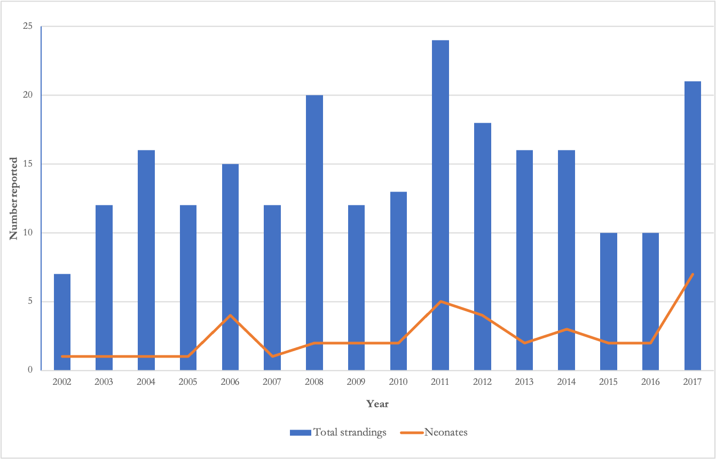
Figure 3.1: Annual reported strandings in Swansea and Gower (Penrose, 2003 to 2018)
A reduction in funding in 2006 decreased the number of post-mortem examinations that could be carried out in Wales (Penrose, 2020). As a result, the causes of death of only a fraction of the stranded harbour porpoises have been reliably established and therefore the sample size is relatively small.

Fishing

Bycatch
Bycatch, primarily relating to gillnet fishing, is recognised as the most significant threat to the species throughout its range globally, with studies from a range of areas showing high mortality rates from bycatch (Braulik, et al., 2020). Bycatch rates in the Celtic and Irish Seas (ICES subarea 7) in 2018 reached between 1.1-2.4% of the population (Calderan & Leaper, 2019). These rates can have a significant impact due to the late maturity and low reproductive rates of the harbour porpoise, which result in slow population growth (Omeyer, et al., 2020).
As shown in Table 3.1, bycatch accounted for the deaths of 18.6% of stranded animals given a post-mortem examination in UK waters. In contrast, bycatch accounted for the deaths of 39.0% of those stranded in Swansea and Gower. (Calderan & Leaper, 2019) suggests that this higher proportion is explained, at least in part, on the prevailing winds off the southwest coast. However, (Northridge, et al., 2017) supports the conclusion that there are relatively high bycatch rates off the southwest coast compared to elsewhere. The study found that Bristol Channel had the second highest estimated total of bycaught porpoises (however, a calculation has not been carried out to account for the relative population densities). This is likely to be as a result of a combination of the high population densities in this area and the heavy use of gillnets (Calderan & Leaper, 2019).

Food reduction
Porpoises’ small size means that they are at particular risk of starvation and hypothermia if they are underfeeding (or failing to eat sufficient high-energy prey) (Roberts, et al., 2019).
They rely on regular and frequent foraging on a wide range of prey species to maintain their blubber reserves (Roberts, et al., 2019)
The overall proportion of stranded harbour porpoises whose deaths were attributed to starvation was similar as between Swansea and Gower (21.9%) and UK-wide (20.1%). However, a much greater proportion of those animals were neonates in Swansea and Gower (14.0% of the total). This may be indicative of a pressure affecting new mothers or neonates in particular, such as a reduction in food or feeding availability, or of the high density of neonates present in Swansea and Gower, in comparison to the population as a whole. If the former, we might expect some increase in the number of adult porpoises for which starvation or hypothermia was a cause of death. Yet the percentage of adults is lower in Swansea and Gower (7.81%) than UK-wide (14.01%).
As well as direct mortality from bycatch, the fishing industry may be having an indirect impact by the reduction of food availability. However, although prey depletion has been identified as a potential pressure (JNCC, 2019a) there have not been any studies found that established a causal link between fishing and harbour porpoise starvation.

Climate change
A greater threat to food availability may yet be developing. The JNCC has identified climate change as an increasing threat, as it may result in the decline or extinction of important prey species, although the impact may be mitigated by the porpoise’s wide range of food sources (JNCC, 2019a).
(MacLeod, et al., 2007) suggested that warmer seas are likely to have an impact on sandeels in springtime, when adult and young porpoises are particularly reliant on this high-energy prey for survival. The study was based on small sample sizes taken over 8 years (although the results were statistically significant), and has not been repeated since.
On the other hand, proposed solutions to reducing the demand for fossil fuel energy supply may themselves constitute a threat, as the construction of offshore of renewable energy structures has been found to disturb the behaviour of porpoises (Graham, et al., 2019).
Various sites along the Welsh Coast have been identified as being attractive locations for offshore wind generation, although the geological features of the Bristol Channel have previously posed technical problems that have defeated plans to construct a large scale windfarm (The Carbon Trust, 2018). According to the JNCC, there are “no plans for development of a commercial offshore windfarm” in or close to the Bristol Channel SAC (JNCC, 2019b) page 13.

Noise and disturbance

Vessels
The UK relies on marine vessels for food, freight and transport, and much of the inshore and offshore marine environments are busy with traffic. Vessel strikes were confirmed as the probable cause of death only 3.1% of the time (Table 3.1) in Swansea and Gower. However, disturbance from vessel traffic may have a substantial impact on the porpoises’ ability to forage sufficient food.
Harbour porpoise use sound for feeding, navigation and communication and noise pollution can therefore be disruptive; they have been observed to react to high level of exposure to noise from vessels by changing their behaviour (Wisneiwska, et al., 2018). (Wisneiwska, et al., 2018) found that porpoises in Danish waters exhibited fluking behaviour and ceased foraging activities and vocalisations when disturbed by the passing of vessels.
These results have been confirmed in research from other areas, for example (Roberts, et al., 2019) found a negative impact between vessel traffic and porpoise behaviour in studies of the waters off the Devon coast, and suggested that this could affect the porpoises’ ability to keep healthy. In particular, interrupting their feeding, leaving them at greater risk of starvation and hypothermia. The impact included all vessels, under sail or motor, and whether moving or stationary.
Porpoises appear to be particularly sensitive to this sort of disturbance, partly because of their vulnerability to starvation/hypothermia and partly because of their sensitivity to noise (Roberts, et al., 2019).
Harbour porpoises appear to favour particular habitats in South Wales for specific uses (Oakley, et al., 2016). Such reliance on certain areas locally accordingly makes them vulnerable to displacement due to vessel activity or construction. Compounding this problem, vessel traffic is often busiest in May or June, which coincides with the breeding time for porpoises (Roberts, et al., 2019) (Oakley, et al., 2017).
Results from studies measuring vessel interaction have varied as between the reactions to different vessels and movements (Roberts, et al., 2019) (Oakley, et al., 2017); however, the consensus is that porpoises generally have a negative reaction to vessels and this is likely to affect their feeding opportunities.
(Oakley, et al., 2017) found that porpoises in Swansea Bay had neutral reactions to larger stationary ships, where previously there had been negative reactions, suggesting that porpoises may habituate to certain vessels over time.

Construction
[add in note about echolocation and social vocalisations – Learmont?]
Porpoises’ hearing operates at a higher frequency than most other toothed whales (Stone, et al., 2017). (Stone, et al., 2017) found that harbour porpoises appear to be particularly sensitive to underwater noise, compared to other cetaceans. [is there evidence of recovery/return?][mitigation measures: soft start and marine mammal observers]
Guidance for the protection of marine European Protected Species from deliberate injury, killing and disturbance has been drafted (JNCC 2010a; Marine Scotland, 2014). Marine Industries generate a variety of noise through activities such as geophysical surveys (e.g. seismic surveys), construction (e.g. pile driving) and decommissioning (e.g. use of explosives). As part of the licencing procedures, developers and operators are required to utilise JNCC guidelines to minimise the risk of injury to cetaceans when undertaking such activities (JNCC, 2010b, 2010c; JNCC 2017). The guidelines advise on conducting marine mammal observations prior to and during the activity and, where suitable, utilising procedures such as soft start (gradual introduction of the sound) to reduce and avoid direct harm to animals. A review of the marine mammal observer data (e.g. (Stone, 2015) demonstrated the effectiveness of soft start approach (Stone et al., 2017). (JNCC, 2019a)

Pollution
Harbour porpoises appear to prefer coastal depths of around 20m (Jenkins, 2007). This near-shore presence places them close to sources of pollution from onshore activities.
Studies concerning the impact of pollution on harbour porpoises have focussed on the level and impact of concentrations of polychlorinated biphenyls (PCBs), which have been found to have a particularly significant impact on HPs. This may be particularly significant in Swansea, as the industrial heritage in Swansea Bay has left a legacy of contamination, including PCBs (Waters, et al., 2005).
PCBs have been linked to reproductive problems in female harbour porpoises (Murphy, et al., 2015). However, the study was based on strandings data alone, so may not be a true reflection of the population as a whole. The evidence of the impact of PCBs poses particular challenges: the pollutants can be passed on maternally, so may cause harm from one generation to the next, and it is difficult to establish causal relationships between a source of pollution (e.g. industrial activity) and harm caused (Murphy, et al., 2015).
Notwithstanding these concerning findings, the concentration of PCBs found in stranded HPs on UK coastline decreased between 1990 and 1998 and between 1998 and 2012 remained at a similar level (Jepson, et al., 2016).
establishing measures beyond the historic ban on PCB use, has not been achieved to date. (JNCC, 2019a)
[impact of pollution on parasites/disease]

Bottlenose dolphin attack
While attacks of bottlenose dolphins on harbour porpoises accounted for the cause of death of 17.6% of the stranded harbour porpoises UK-wide, the Swansea and Gower area does not have a resident population of bottlenose dolphins, so there were no recorded incidences of this species attacking harbour porpoise.

Management

Protected status
The harbour porpoise enjoys protected status in the UK under both national and international law. The European Commission Council Directive 92/43/EEC on the Conservation of Natural Habitats and of Wild Fauna and Flora (the “Habitats Directive”) (European Commission, 1992), as implemented by UK law by The Conservation of Habitats and Species Regulations 2017 and The Conservation of Offshore Marine Habitats and Species Regulations 2017, lists the species under Annex II, obliging member states to anticipate future threats to their population and habitat and take steps to avoid them. These include the establishments of special areas of conservation (SACs).
There are currently six SACs designated specifically for the protection of harbour porpoise, including a SAC covering parts of the Bristol Channel (JNCC, 2020). It is perhaps too early to provide a firm assessment of the impact of the SACs on the status of the harbour porpoise (Omeyer, et al., 2020). However, the UK Government has stated that it considers the overall future prospects for the harbour population to be favourable and, in particular, the status of its habitats to be “very positive” on the basis of the introduction of these SACs [page 10] (JNCC, 2019a).
The Bristol Channel Approaches SAC for harbour porpoise was designated as a SAC in February 2019 (JNCC, 2020). The extent of the SAC is shown in Figure 4.1 (JNCC, 2020).
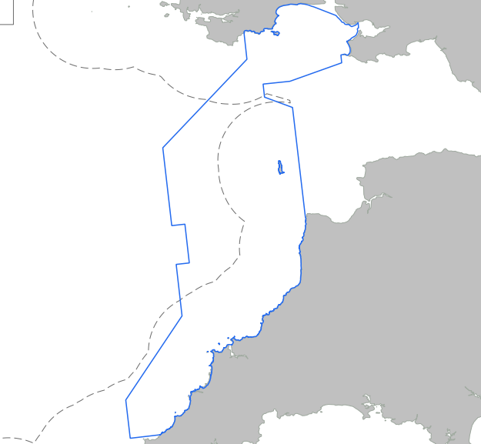
Figure 4.1: Bristol Channel Approaches SAC boundary (shown in blue)
Swansea and South Gower are not included, at any time of year, in the Bristol Channel SAC. (Oakley, et al., 2016) have argued that the SAC should also extend into Swansea Bay and remaining parts of the Gower, given the density and year-round presence of harbour porpoise in that area, as well as the use of those areas for breeding.
While it is important to ensure that the critical habitats within SACs are protected, conservation efforts must look outside SACs as well, as the majority of gillnet activities are outside these areas (Calderan & Leaper, 2019).

Management solutions

Acoustic deterrents
Acoustic alarms (known as pingers) are the most common method used to mitigate bycatch (Omeyer, et al., 2020). In the Bristol Channel pingers are required all year round but only for vessels 12m or over using bottom set gillnets or entangling nets (Marine Management Organisation, 2017).
(Northridge, et al., 2017) estimates that pingers could reduce the mortality rate from bycatch in the Bristol Channel by around 6.5%. There have been concerns that pingers could have long-term behavioural effects on harbour porpoise, but the results of a recent study suggest that the effect of pingers was localised and did not result in the porpoises being displaced from their habitats (Omeyer, et al., 2020).
The use of pingers carries an economic cost for the fishing industry, but it does allow gillnet fishing to continue as a practice (Coram & Northridge, 2018).

Fishing restrictions
There is pressure to look beyond pingers and address fishing practices, such as introducing temporary exclusions and gillnet alternatives (Calderan & Leaper, 2019). The risk of bycatch appears to be localised, with areas of high porpoise density and fishing activities (including the southwest coast) (Northridge, et al., 2017). Mitigation efforts may therefore be better tackled locally.
The sightings data in Jenkins (2007) demonstrated that there are wide seasonal variations in the presence of harbour porpoises. Seasonal closures/restrictions at a local level may therefore be an effective way of balancing strengthened protection with the needs of residents and businesses.

Reduction of pollutants
The use of PCBs was banned in the UK in 1981. JNCC advice for the management of the SAC recommends the use of habitat assessments where any project may involve the release of pollutants that might affect the site or its environs (JNCC, 2019b)

Vessel traffic management
There are no specific management strategies for vessels in Swansea Bay. (Oakley, et al., 2017) suggested measures to control behaviour by smaller and recreational vessels. The council prepared a voluntary code of conduct for marine vessels in 2015 and distributed it by leaflet, but there has been no follow-up campaign or materials produced since then.

Challenges to conservation
One of the barriers to implementing further protection for harbour porpoises has been a lack of research data on the population and distribution of the harbour porpoise (Oakley, et al., 2016). This can be partly attributed to the difficulties involved in collecting data on harbour porpoise numbers as a result of their high mobility and wary nature (Oakley, et al., 2016). (Embling, et al., 2009) (JNCC, 2017)
Harbour porpoises are, by their nature, a mobile species, which travel between habitats in different locations to find food or mates (Jenkins, et al., 2009) [insert another behavioural reference]. It has been recognised that the distribution and behaviour of the harbour porpoise poses difficulties in terms of designating particular boundaries for protection areas (JNCC, 2017). It was being suggested in 2009 that management strategy should focus on managing the whole ecosystem, including using marine protection areas to preserve those key habitats on which the porpoise relies at different times (Jenkins, et al., 2009).
As recently as 2015, the apparent stability of the population and range of the harbour porpoise decreased the urgency with which the protection of porpoises was treated, and there were no specific protections for the species (IAMMWG, et al., 2015).
Indeed, there are few indications that the current UK Government will take bold action nationally to address the threats to the harbour porpoise. The UK Marine Strategy (DEFRA, 2019) groups the harbour porpoise together with all other cetaceans, and the conclusion reached for cetaceans as a whole is that the population is not threatened significantly by human activities. Despite the lack of monitoring data being identified as a problem, the monitoring and mitigation measures already in place are continuing, but no further initiatives or solutions have been proposed.
To date, UK Government has not appeared to have been proactive in its establishment of marine protection areas for the harbour porpoise, and the designation of SACs specific to this species followed an adverse judgment from The European Court of Justice (on application by the European Commission) that found that the UK had failed to fulfil its obligations under the Habitats Directive because it had not established sufficient sites to protect the harbour porpoise (European Commission v United Kingdom, 2018).
It is as yet unclear how the legal and policy framework for marine management will look after the Brexit transition period ends. The Fisheries Act 2020 does not contain the measures that might reduce cetacean bycatch, as such measures if implemented will be contained in secondary legislation, so it is unclear how bycatch will be monitored or mitigated after EU legislation no longer applies to UK waters.

Conclusion
Insufficient data was frequently cited as a barrier to effective conservation efforts. Further monitoring efforts are therefore required to establish a more complete picture of the status of harbour porpoise in South Wales and more widely. Understanding of the pressures at a local scale is key to our ability to effectively protect the species.
It is unclear what the legislative framework for fishing and the management of the marine environment will look like in the near future, but it is clear that more action is required on both a local and national scale to tackle the key threats to the harbour porpoise; in particular bycatch rates.

References
Braulik, G., Minton, G., Amano, M. & Bjørge, A., 2020. Phocoena phocoena. The IUCN Red List of Threatened Species. [Online]
Available at: https://dx.doi.org/10.2305/IUCN.UK.2020- 2.RLTS.T17027A50369903.en
[Accessed 20 November 2020].
Calderan, S. & Leaper, R., 2019. Review of harbour porpoise bycatch in UK waters and recommendations for management, Nairobi: United Nations Environment Programme.
Coram, A. & Northridge, S., 2018. Bycatch and Mitigation Approaches for Harbour Porpoise Special Areas of Conservation, s.l.: DEFRA.
CSIP, 2002-2015. UK Cetacean Strandings Investigation Programme. [Online]
Available at: http://ukstrandings.org/csip-reports/
[Accessed November 2020].
DEFRA, 2019. Marine Strategy Part One: UK updated assessment and Good Environmental Status. [Online]
Available at: https://assets.publishing.service.gov.uk/government/uploads/system/uploads/attachment_data/file/921262/marine-strategy-part1-october19.pdf
Embling, C. et al., 2009. Using habitat models to identify suitable sites for marine protected area for harbour porpoises (Phocoena phocoena). Biological Conservation, Volume 143, pp. 267-279.
European Commission v United Kingdom (2018).
European Commission, 1992. Council Directive 92/43/EEC of 21 May 1992 on the Conservation of Natural Habitatsand of Wild Fauna and Flora. [Online]
Available at: https://eur-lex.europa.eu/legal-content/EN/TXT/PDF/?uri=CELEX:31992L0043&from=EN
[Accessed November 2020].
Graham, I. et al., 2019. Harbour porpoise responses to pile-driving diminish over time. Royal Society Open Science, 6(190335).
Hammond, P. et al., 2017. Estimates of cetacean abundance in European Atlantic waters in summer 2016 from the SCANS-III aerial and shipboard surveys, s.l.: Wageningen Marine Research.
Heinänen, S. & Skov, H., 2015. The identification of discrete and persistent areas of relatively high harbour porpoise density in the wider UK marine area, Peterborough: JNCC Report 544.
IAMMWG, Camphuysen, C. & Siemensma, M., 2015. A Conservation Literature Review for the Harbour Porpoise (Phocoena phocoena), Peterborough: JNCC Report No. 566.
Jenkins, R., 2007. Aspects of Harbour Porpoise Population Dynamics in the Bristol Channel and Strategies for ConservationManagement, Swansea: s.n.
Jenkins, R., Brown, R. & Phillips, M., 2009. Harbour porpoise (Phocoena phocoena) conservation management: A dimensional approach. Marine Policy, Issue 33, pp. 744-749.
Jepson, P. et al., 2016. PCB pollution continues to impact populations of orcas and other dolphins in European waters. Scientific Reports, Volume 6, pp. 1-17.
JNCC, 2017. SAC Selection Assessment: Bristol Channel Approaches / Dynesfeydd Môr Hafren, UK: Joint Nature Conservation Committee.
JNCC, 2019a. Fourth Report by the United Kingdom under Article 17, s.l.: European Community Directive on the Conservation of Natural Habitats and of Wild Fauna and Flora (92/43/EEC).
JNCC, 2019b. Harbour Porpoise (Phocoena phocoaena) Special Area of Conservation: Bristol Channel Approaches; Conservation Objectives and Advice on Operations, s.l.: Joint Nature Conservation Committee.
JNCC, 2019b. Harbour Porpoise (Phocoena phocoena) Special Area of Conservation: Bristol Channel Approaches / Dynesfeydd Môr Hafren. Conservation Objectives and Advice on Operations, s.l.: Department for Environment Farming and Rural Affairs.
JNCC, 2020. 1351 Harbour porpoise Phocoena phocoena. [Online]
Available at: https://sac.jncc.gov.uk/species/S1351/
[Accessed 25 November 2020].
JNCC, 2020. Bristol Channel Approaches MPA. [Online]
Available at: https://jncc.gov.uk/our-work/bristol-channel-approaches-mpa/
[Accessed November 2020].
Learmonth, J. et al., 2014. Life history of harbor porpoises (Phocoena phocoena) in Scottish (UK) waters. Marine Mammal Science, 30(4), pp. 1427-1455.
MacLeod, C. D. et al., 2007. Linking sandeel consumption and the likelihood of starvation in harbour porpoises in the Scottish North Sea: could climate change mean more starving porpoises?. Biology Letters, Volume 3, pp. 185-188.
Marine Management Organisation, 2017. Areas where the use of acoustic deterrent devices is required under Council Regulation (EC) No 812/2004 and the vessels/gear and times of year when it applies. [Online]
Available at: https://assets.publishing.service.gov.uk/government/uploads/system/uploads/attachment_data/file/314526/acoustic_deterrent_devices_map.pdf
[Accessed 1 December 2020].
Murphy, S. et al., 2015. Reproductive Failure in UK Harbour Porpoises Phocoena phocoena: Legacy of Pollutant Exposure?. PLoS ONE, 10(7), pp. 1-32.
NAMMCO, 2019. Report of Joint IMR/NAMMCO International Workshop on the Status of Harbour Porpoises in the North Atlantic. Tromsø, North Atlantic Marine Mammal Commission and the Norwegian Institute of Marine Research.
Northridge, S., Kingston, A. & Thomas, L., 2017. Annual report on the implementation of Council Regulation (EC) No 812/2004 during 2016, United Kingdom: University of St Andrews.
Oakley, J. et al., 2016. Assessing harbour porpoise populations in south-west Wales, data issues and implications for conservation and management. Ocean & Coastal Management, January, Volume 119, pp. 45-57.
Oakley, J., Williams, A. & Thomas, T., 2017. Reactions of harbour porpoise (Phocoena phocoena) to vessel traffic in the coastal waters of South West Wales, UK. Ocean & Coastal Management, Volume 138, pp. 158-169.
Omeyer, L. et al., 2020. Assessing the Effects of Banana Pingers as a Bycatch Mitigation Device for Harbour Porpoises (Phocoena phocoena). frontiers in Marine Science, 7(285).
Penrose, R., 2003. Marine Mammal & Marine Turtle Strandings (Welsh Coast), Ceredigion: Marine Environmental Monitoring.
Penrose, R., 2004. Marine Mammal & Marine Turtle Strandings (Welsh Coast): Annual Report 2003, Ceredigion: Marine Environmental Monitoring.
Penrose, R., 2005. Marine Mammal & Marine Turtle Strandings (Welsh Coast): Annual Report 2004, Ceredigion: Marine Environmental Monitoring.
Penrose, R., 2006. Marine Mammal & Marine Turtle Strandings (Welsh Coast): Annual Report 2005, Ceredigion: Marine Environmental Monitoring.
Penrose, R., 2007. Marine Mammal & Marine Turtle Strandings (Welsh Coast): Annual Report 2006, Ceredigion: Marine Environmental Monitoring.
Penrose, R., 2008. Marine Mammal & Marine Turtle Strandings (Welsh Coast): Annual Report 2007, Ceredigion: Marine Environmental Monitoring.
Penrose, R., 2009. Marine Mammal & Marine Turtle Strandings (Welsh Coast): Annual Report 2008, Ceredigion: Marine Environmental Monitoring.
Penrose, R., 2010. Marine Mammal & Marine Turtle Strandings (Welsh Coast): Annual Report 200, Ceredigion: Marine Environmental Monitoring.
Penrose, R., 2011. Marine Mammal & Marine Turtle Strandings (Welsh Coast): Annual Report 2010, Ceredigion: Marine Environmental Monitoring.
Penrose, R., 2012. Marine Mammal & Marine Turtle Strandings (Welsh Coast): Annual Report 2012, Ceredigion: Marine Environmental Monitoring.
Penrose, R., 2013. Marine Mammal & Marine Turtle Strandings (Welsh Coast): Annual Report 2012, Ceredigion: Marine Environmental Monitoring.
Penrose, R., 2014. Marine Mammal & Marine Turtle Strandings (Welsh Coast): Annual Report 2013, Ceredigion: Marine Environmental Monitoring.
Penrose, R., 2015. Marine Mammal & Marine Turtle Strandings (Welsh Coast): Annual Report 2014, Ceredigion: Marine Environmental Monitoring.
Penrose, R., 2016. Marine Mammal & Marine Turtle Strandings (Welsh Coast): Annual Report 2015, Ceredigion: Marine Environmental Monitoring.
Penrose, R., 2017. Marine Mammal & Marine Turtle Strandings (Welsh Coast): Annual Report 2016, Ceredigion: Marine Environmental Monitoring.
Penrose, R., 2018. Marine Mammal & Marine Turtle Strandings (Welsh Coast): Annual Report 2017, Ceredigion: Marine Environmental Monitoring.
Penrose, R., 2019. Marine Mammal & Marine Turtle Strandings (Welsh Coast): Annual Report 2018, Ceredigion: Marine Environmental Monitoring.
Penrose, R., 2020. Marine Mammal & Marine Turtle Strandings (Welsh Coast), Ceredigion: Marine Environmental Monitoring.
Roberts, L., Collier, S., Law, S. & Gaion, A., 2019. The impact of marine vessels on the presence and behaviour of harbour porpoise ( Phocoenaphocoena ) in the waters off Berry Head, Brixham (South West England). Ocean & Coastal Management, 1 September.Volume 179.
Shakun, J. K., 2012. Global warming preceded by increasing. Nature, 484(7392), pp. 49-54.
Stone, C., Hall, K., Mendes, S. & Tasker, M., 2017. The effects of seismic operations in UK waters: analysis of Marine Mammal Observer data. Journal of Cetacean Research and Management, Volume 16, pp. 71-85.
The Carbon Trust, 2018. Future Potential for Offshore Wind in Wales. [Online]
Available at: https://gov.wales/sites/default/files/publications/2019-07/future-potential-for-offshore-wind.pdf
[Accessed 25 November 2020].
Waters, C. et al., 2005. Urban geology of Swansea: Neath : Port Talbot. In: M. G. Bassett, V. K. Deisler & D. Nicol, eds. Urban geology in Wales : 2.. Cardiff: National Museum of Wales, pp. 7-22.
Wisneiwska, D. M. et al., 2018. High rates of vessel noise disrupt foraging in wild harbour porpoises (Phocoena phocoena). Proceedings of the Royal Society B, 285(20172314).

