Social Epidemiology and Public Health Development
Component 2: Analytical Report
Program: MSc Public Health and Social Care in Practice
Module: Social Epidemiology and Public Health Development
Module Code: LCHS7000
Lecturer: Dr Hamdi Hussain
Assignment Title: Health Needs Assessment of Older Adults in the London Borough
Name: Paul Amoh
Student number: 2246297

Submission Date: 20 July 2026

Table of Contents
Introduction 3
2. Contextual Background and Underlying Factors 4
2.1 Higher Prevalence of Cardiovascular Disease 4
2.2 Increasing Burden of Dementia 5
2.3 Higher Mortality and Multimorbidity Rates 6
2.4 Social Isolation and Loneliness 6
2.5 Poverty 7
2.6. Poor Housing 7
3. National Responses to Reduce Health Inequalities 7
4. Organisation Supporting Older Adults 7
Conclusion 8
Task 2 9
Epidemiological Analysis 9
1. Introduction 9
2. Public Health Measures for Type 2 Diabetes Control 10
2.1 Prevention 10
2.2 Protection 11
2.3 Promotion 11
2.3 Determinants and Risk Factors of Type 2 Diabetes 11
2.4 Epidemiological Studies and Health Needs Assessment 12
2.5 Monitoring and Surveillance Systems 12
6. Public Health Impact 13
7. Health Intervention Programme 13
8. Strengths and Weaknesses of the Epidemiological Approach 14
9. Conclusion 15
References 16

Introduction
Health inequalities involve an unfair and preventable variation in health and access to health care caused by social, economic and environmental factors. This report will concentrate on the older people (aged 65 years and over) in the United Kingdom, a group who are especially at risk of health inequalities as a result of increasing socioeconomic disadvantage and the process of ageing. In 2025, around 11 million people (around 19%) in England were aged 65 years and over, highlighting the increasing significance of tackling age-related health needs (Jacob et al., 2025).
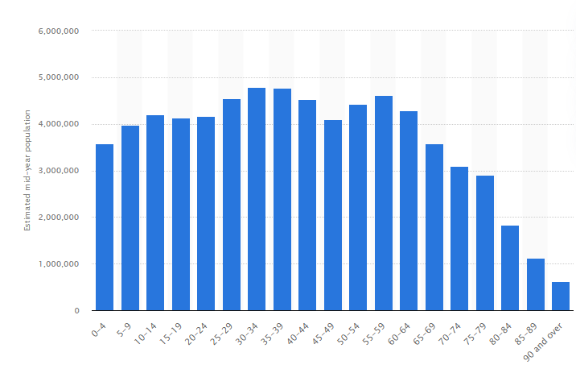
Figure 1. Population Distribution by Age Group in England, 2025
Source: Adapted from Office for National Statistics (2025).
Chronic conditions including cardiovascular diseases, dementia, diabetes is disproportionately affecting older people, as are social issues such as poverty, loneliness and poor housing conditions. Therefore, tackling age-related health inequalities is central to healthy ageing, enhancing quality of life and to achieve equity in access to health services in the United Kingdom.

2. Contextual Background and Underlying Factors

The combined effects of biological ageing and other societal factors of health contribute to seniors having multiple health inequalities. These inequalities are associated with diminished health and poorer health outcomes, higher healthcare utilization, and lower quality of life. Three key inequalities in the UK relating to older people and disease are discussed in the following sections.

2.1 Higher Prevalence of Cardiovascular Disease
Heart disease (CVD) are the major cause of sickness and fatality in older people in the United Kingdom. As age goes up, so does threats of CHD, stroke and heart failure, as there are changes to the body and exposure to behavioural risk factors and chronic health conditions (Townsend et al., 2025). Currently, around 7.6 million people in the UK have heart and circulatory diseases, with the largest numbers found in people aged 65 years and over (Palaniappan et al., 2026). The inequalities in income, education, lifestyle and healthcare access are also linked to older adults from deprived communities being significantly more likely to have cardiovascular disease (Marmot et al., 2020).
Table 1. Prevalence of Major Cardiovascular Diseases in the United Kingdom
Disease | Estimated People Living with the Condition
Coronary heart disease | 2.3 million
Stroke | 1.4 million
Heart failure | 920,000
Source: Author own’s illustration,2026
Reducing these inequalities requires effective prevention strategies, including blood pressure screening, smoking cessation programmes, healthy lifestyle promotion and improved access to primary healthcare services (Visseren et al., 2021).

2.2 Increasing Burden of Dementia
Dementia is a major neurological condition in older people and a public health problem in the UK. Around 60-70% of diagnosed dementias are Alzheimer's disease (Nandi et al., 2022). The Alzheimer's Society (2025) report that there are approximately 1 million people living in the UK with dementia and the majority of those are over the age of 65.
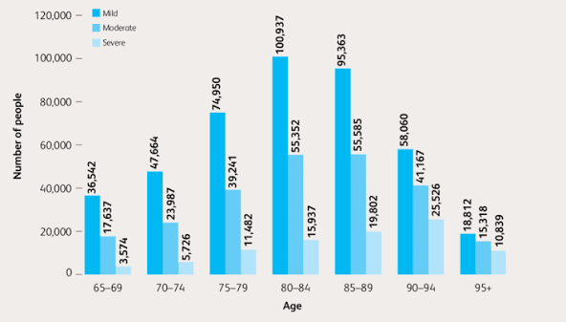
Figure 2. Estimated Number of People Living with Dementia by Age Group and Severity in the United Kingdom
Source: Adapted from Alzheimer's Society (2025).
For older people living in deprived communities, the diagnosis of dementia may be delayed, they may have less access to specialist services and specialist services may not be as continuous as they are in more affluent communities (Mukadam, Cooper and Livingston, 2020). Such disparities have a negative impact on disease progression, on the burden on caregivers, on healthcare expenses and on the quality of life. Thus, the importance of improving early diagnosis, memory assessment services and community-based dementia support as a way of closing health inequalities is still a priority (Nair et al., 2026).

2.3 Higher Mortality and Multimorbidity Rates
Older people have disproportionately high death rates as they are more probable to have several chronic illnesses (LTHCs) which are often called multimorbidity. Healthy life expectancy continues to be significantly lower for those in the most deprived areas of England, as shown by Welsh, Matthews and Jagger (2021) and highlighting inequalities in health outcomes in later life. Cardiovascular disease, diabetes, arthritis and chronic respiratory disease often occur in combination in older people, which can lead to higher levels of disability, hospitalisation and early death (Barnett et al., 2012).

2.4 Social Isolation and Loneliness
senior citizens live in an environment of social isolation and loneliness, and this plays a major role in health inequalities. Age UK (2025) estimate that 1.4 million senior citizens in England suffer from chronic loneliness. Less social interaction leads to an increase in depression, cognitive decline, cardiovascular disease, and decrease in wellbeing (Santini et al., 2020). Social prescribing and community support groups, as well as digital inclusion programmes can all contribute to tackling a sense of loneliness and enhancing healthy ageing.
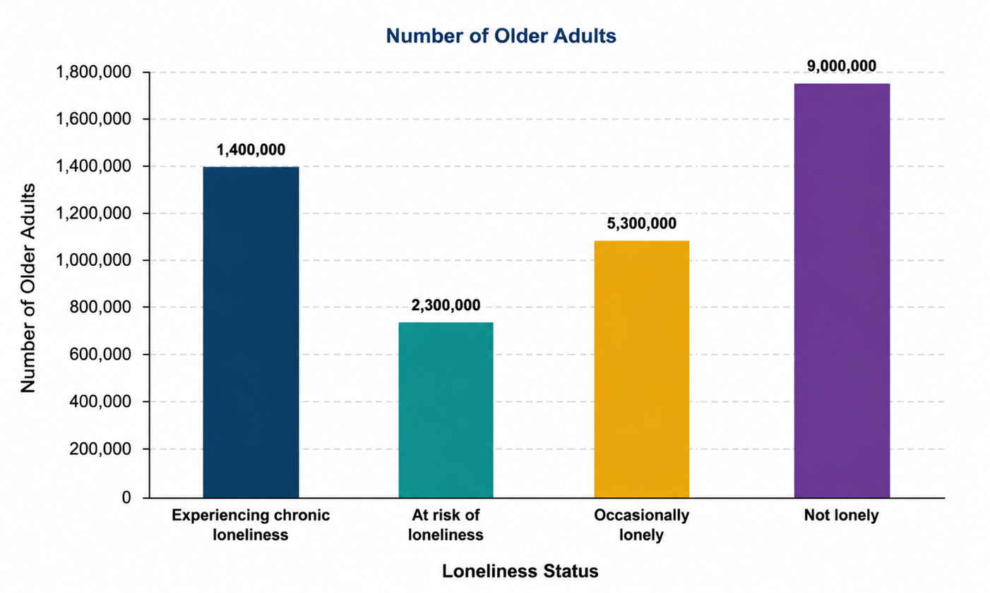
Figure 3. Older Adults Experiencing Chronic Loneliness in England (2025)
Source: Author own’s illustration Adapted from Age UK (2025).

2.5 Poverty
In the UK, approximately 2 million pensioners are living in 'relative poverty' and cannot afford nutritious food, heat and health care (Cooper, 2026). Financial difficulties are linked to an increased risk of chronic disease, mental health problems and diminished health satisfaction. The gaps can be minimised by increasing the take-up of Pension Credit, enhancing financial support and reducing living costs.

2.6. Poor Housing
The poor quality of housing places health risks to older people at the forefront through contributing to respiratory illness and falls, as well as excess winter deaths. Limited income and disabled people are the most likely to be affected by cold, damp and inaccessible homes (Ackerman et al., 2025). It is possible to mitigate these health disparities and foster independent living by improving home insulation and by adapting homes to accommodate mobility requirements and increase housing support.

3. National Responses and Organisation Supporting Older Adults
There have been several initiatives undertaken by the UK Government to tackle inequalities in health outcomes for older people, such as the NHS Long Term Plan and the Ageing Well Programme. These approaches include: Integrated community care, Personalised healthcare, Early intervention, Frailty management and Falls prevention, which are all important factors in promoting healthy ageing and preventing avoidable admissions to hospital (Atella, 2025; Oliver, 2023). These policies have helped to increase the quality of care that is preventive and person-centred, but evidence shows that significant inequities remain. Older people in disadvantaged areas also have less access to health services and a shorter healthy life expectancy, and are also more likely to face the adverse impacts of social factors of health like poverty and social isolation. This indicates that national policies will not be enough if they do not include local policies and investments to tackle broader socio-economic inequalities. In addition to government work, Age UK also has a crucial role in helping to tackle health inequalities in its advocacy, research and support for older people in the community. The organisation is able to offer guidance on health, housing, benefits and social care and offers befriending services to help alleviate loneliness and improve wellbeing (Age UK, 2025). It also works to fight against age discrimination and to advance knowledge of and awareness about healthy ageing. As a charitable organisation however, its capacity is limited by funds and volunteer working. Thus, it is imperative that there is improved interagency working between government, health services and the voluntary sector to provide equitable and sustainable support for older people to reduce health inequalities.

Conclusion
Chronic disease and social disadvantage, such as loneliness and poverty and poor housing, are a major source of health inequalities among older people. These inequalities harm people's quality of life and drive up health services use. National initiatives, including the NHS Long Term Plan and Ageing Well Programme, and Age UK's support are key in helping to tackle these inequalities. The future of healthy ageing and the health outcomes for older people in the United Kingdom depends on continued investment in prevention, access to health services and community support, that is equitably available to everyone.

Task 2

Epidemiological Analysis

1. Introduction
Non-insulin-dependent diabetes mellitus (NIDDM) is a chronic non-communicable metabolic disorder that involves insulin resistance and reduced insulin production, leading to chronic hyperglycaemia (Davies et al., 2026). It is a significant public health issue due to its linkage with cardiovascular diseases, chronic kidney disease, blindness, lower-limb amputation, and early death. Additionally, T2DM impacts on the quality of life and places significant financial burden on healthcare systems due to chronic treatment and disease management (Rob et al., 2025). The International Diabetes Federation (2025) estimated that 589 million adults worldwide were living with diabetes, while Diabetes UK (2025) estimated that approximately 5.8 million people in the United Kingdom were living with diagnosed or undiagnosed diabetes. Diabetes prevalence is one of the highest in England across the London Borough of Tower Hamlets, with a high prevalence amongst older adults, due to the interplay between ageing, socio-economic deprivation and ethnic differences (Mathur et al., 2020).
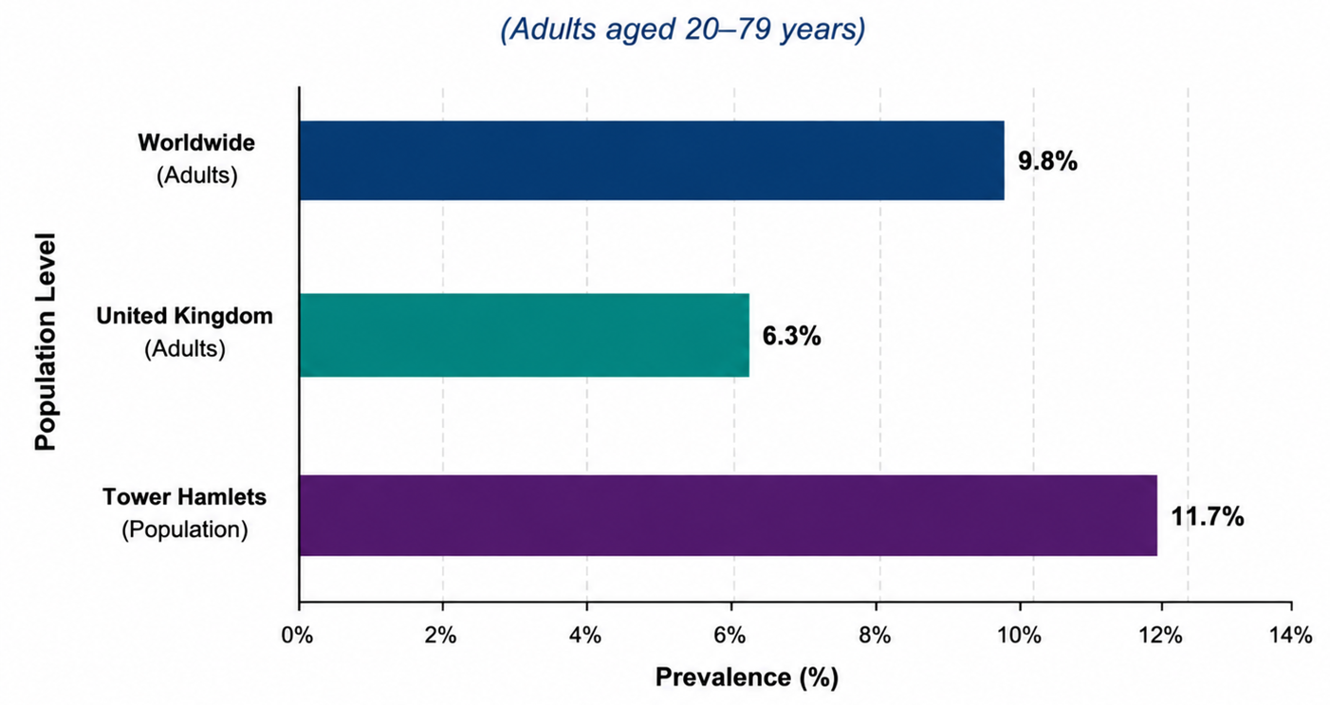
Figure 4. Prevalence of Type 2 Diabetes Worldwide, the United Kingdom, and Tower Hamlets
Source: Author own’s illustration,2026

2. Public Health Measures for Type 2 Diabetes Control
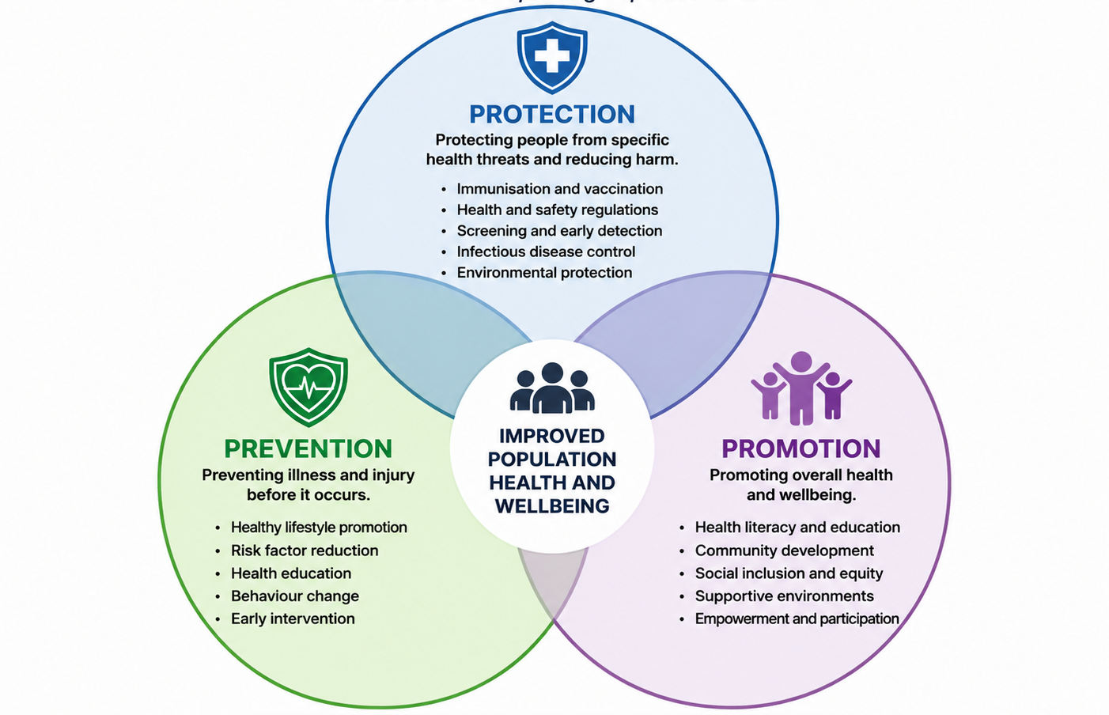

Figure 5: Three Ps of Public Health
Source: Author own’s illustration,2026

2.1 Prevention
The goal of prevention is to minimize the occurrence of Type 2 diabetes by changing the factors that can be changed before the disease develops. The NHS Diabetes Prevention Programme is a series of healthy eating advice, physical activity and weight management support to people who are at high risk of developing type 2 diabetes (NHS England, 2025). Locally delivered lifestyle programmes with culturally appropriate dietary advice and behavioural support are offered to older adults and South Asian communities in Tower Hamlets, who are at higher risk of diabetes as a result of living in an economically deprived area and having a genetic predisposition (Vaja et al., 2021).

2.2 Protection
In the case of protection, the emphasis is on preventing disease progression and complication, by diagnosis and ongoing clinical surveillance. Standard testing for HbA1c levels, yearly foot exams, eye checks and regular blood glucose checks help health care providers detect complications early. According to American Diabetes Association Professional Practice Committee (2025), these measures lower the risk of cardiovascular disease, kidney failure, blindness, lower-limb amputation and help improve long-term health outcomes.

2.3 Promotion
Health promotion is about supporting better behaviors by educating the community and people. Awareness campaigns, exercise programmes, culturally adapted health education and GP-led advice have a positive impact on diabetes knowledge and self-management in Tower Hamlets. Yet these efforts have failed to eradicate health disparities that impact access to health services and life choices. So continued investment and action to address wider social determinants of health are key to further reduce the burden of Type 2 diabetes (Haig et al., 2025).
Table 2. Public Health Measures for Type 2 Diabetes in Tower Hamlets
Public Health Function | Examples | Intended Outcome
Prevention | - Healthy eating programmes, weight management, NHS Diabetes Prevention Programme | - Reduced incidence of Type 2 diabetes
Protection | - Annual screening, foot examinations, blood glucose monitoring | - Early diagnosis and reduced complications
Promotion | - Community awareness campaigns, exercise programmes, health education, GP education | - Improved self-management and healthier li

2.3 Determinants and Risk Factors of Type 2 Diabetes
Type 2 Diabetes is a combination of lifestyle, demographic, social and environmental factors. Insulin resistance and glucose regulation problems are caused by the following lifestyle factors: obesity, physical inactivity, unhealthy diet (Davies et al., 2026). Older age, ethnicity (South Asian) and family history of diabetes are other risk factors. Diabetes UK (2025) states that individuals from the South Asian community are more likely to have Type 2 diabetes at a younger age and lower BMI than other ethnic groups. Social determinants such as poverty and deprivation, as well as poor housing quality, limit access to nutritious food, health and physical activity opportunities (Bentley et al., 2025). However, limited green spaces and an unhealthy food environment, among other environmental factors, also hinder healthy living. This means that Tower Hamlets has a higher prevalence of diabetes as it has high socio-economic deprivation, a large South Asian population and an ageing population, all of which have multiple overlapping risk factors that lead to an increased number of people becoming ill from diabetes.

2.4 Epidemiological Studies and Health Needs Assessment
A Health Needs Assessment (HNA) is an epidemiological, demographic and socio-economic evidence-based process used to inform allocation of resources for the purpose of addressing the health needs of a population (Jaidee et al., 2026). Epidemiological studies in Tower Hamlets identify that older people, South Asian communities and deprived populations are at higher risk of Type 2 diabetes. Higher prevalence, multimorbidity and hospital admission rates in older ages are related to ageing and reduced physical activity. Genetic susceptibility, diet and elevated central obesity lead to higher risks for South Asian communities. Poor outcomes for deprived populations are because of poverty, poor access to healthy food and delayed diagnosis. Thus, HNA promotes targeted screening, personalised care and culturally responsive interventions to mitigate disparities in health outcomes and population health due to diabetes.

2.5 Monitoring and Surveillance Systems
Monitoring and surveillance systems are essential for epidemiology, as they provide ongoing information on the prevalence, distribution and outcomes of Type 2 diabetes. In Tower Hamlets, systems like NHS Digital, the Quality and Outcomes Framework (QOF), National Diabetes Audit (NDA), OHID Fingertips, GP records, Hospital Episode Statistics (HES) and ONS mortality data enable the detection of disease patterns, tracking inequalities and assessing healthcare interventions. The datasets contain data on diagnosis, therapy, complications, hospital admissions, mortality trends, and can be used to inform evidence-based decisions. Surveillance helps public health to identify high-risk groups (such as older people, deprived communities and ethnic minorities) and plan targeted interventions. Limitations include incomplete reporting, data delays and differences in data recording practices that may impact the accuracy.
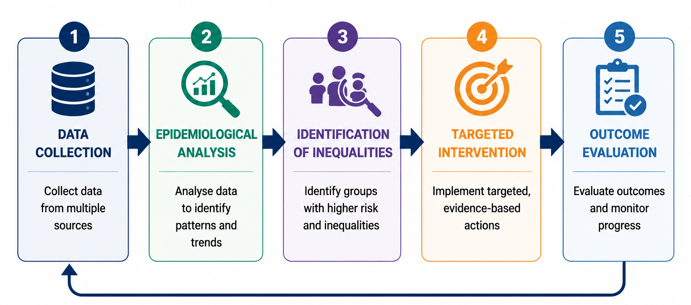
Figure 6. Surveillance and Public Health Action Cycle for Type 2 Diabetes in Tower Hamlets (2025)
Source: Author own’s illustration,2026

6. Public Health Impact
Type 2 diabetes is a serious public health issue. High blood sugar also causes infections and hospitalizations in the short-term and complications such as blindness, chronic kidney disease, lower-limb amputations, cardiovascular disease and early death in the long-term (World Health Organization, 2025). The impact of these outcomes is higher health care costs, increased burden on informal carers, lower quality of life, and economic losses due to higher health care costs and losses in productivity (Diabetes UK, 2025).

7. Health Intervention Programme
The Healthy Ageing Diabetes Programme will screen older people in Tower Hamlets, provide exercise sessions, offer nutritional advice, offer GP follow-up, provide digital reminders, and review the programme annually, all to reduce the number of people who develop Type 2 diabetes. The programme would be delivered in partnership between the NHS, local authority, Diabetes UK and GP practices and measured in terms of attendance and uptake of screenings as process indicators and improved HbA1c, BMI and reduced hospital admissions as outcome indicators.

8. Strengths and Weaknesses of the Epidemiological Approach
Epidemiology offers a solid evidence base to guide understanding of distribution, determinants and burden of Type 2 diabetes, to inform the efficiency of resource allocation and effectiveness of interventions by healthcare organisations. But data availability and quality are critical to its usefulness. Confounding variables and delayed diagnosis and under-reporting can result in errors in surveillance and impact policy decisions. Moreover, observational, epidemiological studies only demonstrate associations not causation, and can only explain more complex health behaviours. Epidemiological evidence should be combined with clinical knowledge and local population knowledge and community participation to create effective, equitable and evidence-based public health interventions (World Health Organization, 2025).
Table 3. Strengths and Weaknesses of the Epidemiological Approach
Strengths | Weaknesses
• Evidence-based decision-making | • Under-reporting of cases
• Identifies high-risk populations | • Delayed diagnosis
• Supports policy development | • Incomplete datasets
• Guides resource allocation | • Observational bias
• Monitors disease trends over time | • Confounding factors may influence findings
Source: Adapted from World Health Organization (2025), Office for Health Improvement and Disparities (2025), and Gordis (2024).

9. Conclusion
Type 2 diabetes is a complex, costly public health problem due to its high prevalence, significant burden and morbidity. Epidemiological monitoring allows for constant monitoring of disease patterns, the detection of priority populations and assessment of the effectiveness of interventions. Prevention is better than the consequences of preventing complications, is cheaper and makes better long-term health outcomes. Thus, effective and targeted evidence-based interventions that meet the needs of older and deprived people in Tower Hamlets are crucial to close health inequalities and support a healthy ageing and sustainable public health practice (Diabetes UK, 2025; NHS England, 2025).

References

Ackerman, S., Aghevli, A., Aguilar, J., Alfano, N., Altayeb, Y., Bennett, M., Bergendorf, A., Bouret, M., Canazart, M., Campbell, S. and Carter, J. (2025) Accessibility challenges encountered by people with disabilities and older residents of rural areas. Available at: https://docs.lib.purdue.edu/ugcw/7/ (Accessed: 16 July 2026).
Age UK (2025) Our work and priorities. Available at: https://www.ageuk.org.uk/our-impact/policy-research/ (Accessed: 16 July 2026).
American Diabetes Association Professional Practice Committee (2025) ‘10. Cardiovascular disease and risk management: Standards of Care in Diabetes 2025’, Diabetes Care, 48(Suppl. 1), pp. S207–S238. Available at: https://doi.org/10.2337/dc25-S010
Atella, V. (2025) The urgent need for an NHS reform: Adapting to overlooked years of transformation in healthcare. Available at: https://grins.it/sites/default/files/2025-12/The_urgent_need_for_an_nhs_reform__adapting_to_overlooked_years_of_transformation_in_healthcare.pdf (Accessed: 16 July 2026).
Barnett, K., Mercer, S.W., Norbury, M., Watt, G., Wyke, S. and Guthrie, B. (2012) ‘Epidemiology of multimorbidity and implications for health care, research, and medical education: A cross-sectional study’, The Lancet, 380(9836), pp. 37–43. Available at: https://doi.org/10.1016/S0140-6736(12)60240-2
Bentley, R., Mason, K., Jacobs, D., Blakely, T., Howden-Chapman, P., Li, A., Adamkiewicz, G. and Reeves, A. (2025) ‘Housing as a social determinant of health: A contemporary framework’, The Lancet Public Health, 10(10), pp. e855–e864.
Cooper, H. (2026) ‘How did COVID-19 feed into later life financial vulnerability in the UK?’, in Viral Debt. Abingdon: Routledge, pp. 128–160. Available at: https://www.taylorfrancis.com/chapters/oa-edit/10.4324/9781003481461-9/covid-19-feed-later-life-financial-vulnerability-uk-hilary-cooper (Accessed: 16 July 2026).
Davies, M.J., Lim, S., Slater, T., Goldney, J., Philis-Tsimikas, A., Franco, D.R., Lamptey, R., Yates, T., Tankova, T. and Lingvay, I. (2026) ‘Type 2 diabetes mellitus’, Nature Reviews Disease Primers, 12(1), p. 13. Available at: https://www.nature.com/articles/s41572-026-00687-w
Diabetes UK (2025) Diabetes prevalence. Available at: https://www.diabetes.org.uk/about-us/about-the-charity/our-strategy/statistics/about-diabetes (Accessed: 16 July 2026).
Haig, M., Therianos, P., Miracolo, A., Satish, K., Kolovou, V. and Kanavos, P. (2025) The burden of diabetes and options for reform.
International Diabetes Federation (2025) IDF Diabetes Atlas. 11th edn. Brussels: International Diabetes Federation. Available at: https://diabetesatlas.org/ (Accessed: 16 July 2026).
Jacob, P., Bruce, G., Kay, S. and Thakrar, S. (2025) ‘Ageing-related research in the UK: A landscape analysis’, Health Open Research, 7(11), p. 11. Available at: https://doi.org/10.21955/healthopenres.1115023.1
Jaidee, W., Chaoniyom, W., Piboon, K., Yingklang, M. and Jaidee, P.H. (2026) ‘Enhancing community health services through a health needs assessment approach during the COVID-19 pandemic in Eastern Thailand’, Discover Public Health, 23(1), p. 66.
Marmot, M. (2020) ‘Health equity in England: The Marmot review 10 years on’, BMJ, 368, m693. Available at: https://www.bmj.com/content/368/bmj.m693 (Accessed: 16 July 2026). https://doi.org/10.1136/bmj.m693
Mathur, R., Hull, S.A., Badrick, E., Robson, J., Durbaba, S., Bansal, N. and Millett, C. (2020) ‘Cardiovascular multimorbidity: The effect of ethnicity on prevalence and risk factor management’, British Journal of General Practice, 70(694), pp. e378–e386. Available at: https://doi.org/10.3399/bjgp20X709253
Mukadam, N., Cooper, C. and Livingston, G. (2020) ‘Improving access to dementia services for people from underserved groups’, Current Opinion in Psychiatry, 33(2), pp. 105–111. Available at: https://doi.org/10.1097/YCO.0000000000000574
Nair, P., Junghans, C., Kay, M., Harris, M., Majeed, A. and Hayhoe, B. (2025) ‘Transforming dementia care pathway: Why shifting to a universal, comprehensive, proactive, local, and integrated model is imperative to improve outcomes’, Frontiers in Dementia, 4, p. 1719630. Available at: https://doi.org/10.3389/frdem.2025.1719630
Nandi, A., Counts, N., Chen, S., Seligman, B., Tortorice, D., Vigo, D. and Bloom, D.E. (2022) ‘Global and regional projections of the economic burden of Alzheimer's disease and related dementias from 2019 to 2050: A value of statistical life approach’, EClinicalMedicine, 51. Available at: https://www.thelancet.com/journals/eclinm/article/PIIS2589-5370(22)00310-8/fulltext
NHS England (2025) Healthier You: NHS Diabetes Prevention Programme. Available at: https://www.england.nhs.uk/diabetes/diabetes-prevention/ (Accessed: 16 July 2026).
Oliver, D. (2023) ‘Integrated care systems: Can they improve care for older people?’, BMJ, 381, p. 1073. Available at: https://doi.org/10.1136/bmj.p1073
Palaniappan, L.P. et al. (2026) ‘2026 Heart Disease and Stroke Statistics: A report of US and global data from the American Heart Association’, Circulation. Available at: https://www.ahajournals.org/doi/full/10.1161/CIR.0000000000001412
Rob, A., Hoque, A., Asaduzzaman, M.M., Khatoon, M.A.A., Khalil, R., Thomas, D., Ilyas, M., Mahmood, H. and Chowdhury, T.A. (2025) ‘The global challenges of type 2 diabetes’, Bangladesh Journal of Medicine, 36(2), pp. 92–98. Available at: https://banglajol.info/index.php/BJMED/article/view/78406
Santini, Z.I., Jose, P.E., York Cornwell, E., Koyanagi, A., Nielsen, L., Hinrichsen, C., Meilstrup, C., Madsen, K.R. and Koushede, V. (2020) ‘Social disconnectedness, perceived isolation, and symptoms of depression and anxiety among older Americans’, The Lancet Public Health, 5(1), pp. e62–e70. Available at: https://doi.org/10.1016/S2468-2667(19)30230-0
Sylvia, E.O. (2025) The effects of lifestyle changes on type 2 diabetes prevention among teachers in Egor LGA Edo State. Doctoral dissertation. University of Benin.
Townsend, N., Timmis, A., Erglis, A., Miličić, D., Perrone-Filardi, P., Weidinger, F., Guzik, T. and Gale, C.P. (2025) ‘Challenges in the prevention, treatment and management of cardiovascular disease among older adults’, The Lancet Regional Health – Europe, 56. Available at: https://www.thelancet.com/journals/lanepe/article/PIIS2666-7762(25)00164-4/fulltext
Vaja, I., Umeh, K.F., Abayomi, J.C., Patel, T. and Newson, L. (2021) ‘A grounded theory of type 2 diabetes prevention and risk perception’, British Journal of Health Psychology, 26(3), pp. 789–806. Available at: https://doi.org/10.1111/bjhp.12503
Visseren, F.L.J., Mach, F., Smulders, Y.M., Carballo, D., Koskinas, K.C., Bäck, M., Benetos, A., Biffi, A., Boavida, J.M., Capodanno, D. and Cosyns, B. (2021) ‘2021 ESC Guidelines on cardiovascular disease prevention in clinical practice’, European Heart Journal, 42(34), pp. 3227–3337. Available at: https://academic.oup.com/eurheartj/article/42/34/3227/6358713 (Accessed: 16 July 2026).
Welsh, C.E., Matthews, F.E. and Jagger, C. (2021) ‘Trends in life expectancy and healthy life years at birth and age 65 in the UK, 2008–2016, and other countries of the EU28: An observational cross-sectional study’, The Lancet Regional Health – Europe, 2. Available at: https://www.thelancet.com/journals/lanepe/article/PIIS2666-7762(20)30023-5/fulltext
World Health Organization (2025) Ageing and health. Available at: https://www.who.int/news-room/fact-sheets/detail/ageing-and-health (Accessed: 16 July 2026).

