  Component One:  What are the key skills required when working in the housekeeping team? 750 words (+/- 10%)  Contribution to Overall Module Assessment: 25% | Student No: | 2128512
 | Module Title: | Operating Hotel Facilities
 | Module Code: | BMIH4006
 | Lecturer: | Kathryn Roberts
- Introduction
Each firm needs the competent ability to maintain a clean and organized atmosphere. Each hotel operation has to have good housekeeping, which entails paying close attention to every detail and having much patience (Bhatnagar and Dheeraj, 2019). Creating a warm and comfortable atmosphere for visitors is achievable with the help of a highly effective and methodical housekeeping service, which ultimately improves their entire experience and leaves a lasting impression. Yet, obtaining such unmatched brilliance requires essential skills, including time management, accuracy, multitasking, and good team communication.
- Key Skills Required
  - Communication Skills
The primary skill of good communication is necessary for the field of housekeeping. For duties to be completed effectively, coworkers' communication must be clear and concise (Lin et al., 2017). This needs strong communication skills to ensure rapid understanding and quick fulfilment of requests. Also, good communication abilities help to diffuse disagreements and avoid misunderstandings.
  - Problem-Solving Skills
Problem-solving skills are essential for cleaning staff in the hotel business (Frantz and Misaal, 2016). A situation like a room that has yet to be cleaned to the anticipated standard could be encountered by cleaning staff. The team must develop a long-term solution to prevent recurrence after determining the root cause of the problem, which might be anything from a lack of equipment to inadequate training. Marriott International's "Green Hotels" project serves as a concrete illustration of the value of problem-solving abilities in the hotel industry (Hashmi and Muff, 2017). By implementing sustainable practices, including lowering water and energy use, this initiative seeks to lessen the environmental effect of Marriott's properties. To properly execute this programme, Marriott's housekeeping staff had to develop their problem-solving skills to identify areas where they could make lasting improvements and come up with answers (Kuo et al., 2016).
  - Time Management
For housekeeping staff, time management is crucial in the hospitality sector. They must do their responsibilities efficiently and quickly while ensuring the guest rooms are immaculately clean. Time management techniques that work may increase output, lower stress levels, and improve customer satisfaction. The "CleanStay" project from Hilton Hotels illustrates how vital time management is in the hotel industry (Leroi et al., 2021). The program aims to give visitors a clean, safe atmosphere by establishing new cleaning procedures and hygiene standards. The cleaning staff must manage their time wisely and efficiently to ensure every guest room is cleaned correctly and on time. Hilton has implemented various tools and services, like computerized timetables and checklists, to help cleaning staff members manage their time.
  - Multitasking Abilities
The hotel sector requires multitasking skills from housekeeping employees (Daskin, 2016). The teams must manage several jobs at once, such as cleaning numerous rooms, attending to visitor requests, and keeping an eye on the stock of cleaning materials. Effective multitasking may increase output, reduce wait times, and improve customer happiness. For instance, the cleaning staff is required to do upkeep at Marriott Marquis. The team uses a method of prioritizing to guarantee that the job is completed effectively. Tasks are categorized according to their significance and urgency. With effective multitasking, the crew can ensure excellent cleaning standards and immediate attention to guest demands.
  - Focus on details
Focusing on details is a critical skill for housekeeping workers in the hotel industry. It involves paying particular attention to the small details that considerably influence how satisfied visitors are, such as assuring that every hotel area is immaculately organized and clean and that all commodities are supplied and working correctly. The "Mystique" programme at Ritz-Carlton Hotels is an excellent example of the importance of paying attention to detail in the hospitality industry (Wan, 2015). By recognizing their particular tastes and demands, this programme aims to give tourists one-of-a-kind and unforgettable experiences. To do this, the hotel staff must pay great attention to every factor that enhances a guest's stay, such as their favourite dining venue or room temperature.
- Conclusion
In conclusion, the cleaning staff is essential to the hotel industry's success. The personnel has to have a wide range of abilities and expertise to guarantee client happiness and loyalty. The cleaning team may create an environment of excellence that goes above and beyond visitor expectations by skillfully employing these abilities. The housekeeping crew must continuously learning and growing in order to be competitive, as the hotel business is continually changing. Hotels must thus make sure to invest in their cleaning personnel in order to guarantee that they have the essential training and expertise to give guests with great service.

Word Count | 750

Component Two:
Contribution to Overall Module Assessment: 25%
In this scenario – You have just been promoted to the team leader for a floor within the hotel. A guest complained that on their arrival, their room had not been properly cleaned. Create an action plan and answer the following questions.

Problem | Why did it happen? | What are you going to do? | How will you prevent this from happening in the future? | What measures would you introduce to improve team effectiveness?
A guest complained that their room had not been properly cleaned upon their arrival, and there is also a bad smell in the room. | The staff did not pay close attention to every detail in the room and the sweeper was not clean enough which resulted in bad smell in the room. | The first step in resolving the issue would be to apologise to the visitor for any inconvenience created and provide choices like redoing the room's cleaning or moving to a new one. It's important to listen to the customer's complaints and respect their input. My plan of action would be to investigate the occurrence and get more information from the cleaning staff in order to identify the main contributing factors. I would make sure to conduct a thorough inspection for any leftover food or garbage and confirm that the air circulation system is operating as intended to eliminate the offensive stench. | I would implement more extensive maintenance checklists and make sure the cleaning team has enough time to fully sanitize each area in order to avoid such problems in the future. I would also put in place a mechanism that allows visitors to comment instantly on how clean their room is. | I would plan frequent training sessions for the cleaning crew to keep them up to date on the newest cleaning techniques and tools in order to increase the team's effectiveness.
Broken Item in the room | It's possible that when cleaning the space, the cleaning personnel unintentionally caused the harm. | To find out what went wrong, I would look into the situation by interviewing the workers who were engaged in the cleaning procedure. I would make swift arrangements to have the broken item fixed or replaced. | I would implement more thorough inspection checklists for the cleaning crew so they could see faults in the room and report them right away in order to avoid such problems in the future. In order to make sure that any problems are found and dealt with right away, I would also put in place a system for routine maintenance checks of the rooms. | To foster a sense of shared accountability for upholding the standard of excellence and cleanliness of the hotel rooms as well as for quickly recognising and reporting any concerns with the rooms, I would promote open communication and teamwork among the staff.
The guest complained that the washroom in their room had not been properly cleaned. | Because of the cleaning staff's lack of attention to detail or insufficient training, the restroom may not have been cleaned thoroughly. | I would apologise for the inconvenience, offer to have the restroom cleaned again, and/or suggest an alternate room to the guest in order to allay their worries. To figure out what went wrong, I would look into the situation and interview the personnel who were engaged in the cleaning procedure. | I would implement more extensive inspection checklists for the cleaning team to make sure that every section of the restroom is cleaned completely in order to prevent this problem from occurring again. Also, I would provide the workers greater instruction on the value of paying close attention to detail when cleaning the restrooms as well as methods for efficiently cleaning various restroom components. | I would implement routine training programmes for the cleaning personnel to advance their abilities and understanding of cleaning methods and tools in order to increase team performance. To encourage the workers to perform to their highest potential, I would also put in place a mechanism for performance evaluation and reward.
The guest complained that the bedsheets in their room had not been changed. | It's possible that the cleaning crew didn't replace the bedsheets because of a breakdown in communication or a lack of attention to detail. | I would apologise for the inconvenience and make the offer to have the bedsheets changed right away to allay the guest's worries. I'll have a discussion with the employees to discuss why there was negligence on their part. | I would set up a mechanism for verifying the freshness of the rooms once they have been cleaned in order to stop this problem from occurring again. This would entail having a different member of staff check the room to make sure that everything has been thoroughly cleaned, including replacing the bedsheets. I would also stress how crucial it is for the cleaning team to pay attention to detail and communicate clearly with one another. | I would encourage a culture of cooperation and teamwork among the team members, where everyone accepts responsibility for upholding high standards of cleanliness and customer satisfaction.
A guest has reported that an item is missing from their room, and they suspect it may have been stolen. | It's conceivable that the item was taken by someone who had access to the guest's room without authorization or that the guest just misplaced it. | I would reassure them that I would look into the situation and take the necessary steps. In addition, I would alert the hotel's security staff and adhere to its established protocols for managing instances of this nature. This can entail reviewing surveillance footage, speaking with employees who had access to the room, and, if required, notifying the police. | I would make sure that all visitors were informed of the hotel's security regulations and procedures when they checked in order to stop future occurrences of this kind. Moreover, I would make certain that staff personnel who have access to guest rooms are fully vetted and instructed in the correct handling techniques for managing visitor things. | To encourage workers to achieve to their highest potential, I would implement a system for performance evaluation and reward. In order to develop a sense of cooperation and shared responsibility for protecting the safety and security of visitors and their possessions, I would also encourage open communication and collaboration among the staff.

Component Three:
Contribution to Overall Module Assessment: 50%
Your task is to create and prepare a presentation following the detailed scenario provided below.

As the floor housekeeping manager and given the recent guest complaints, you need to put together a basic training presentation for your colleagues within the housekeeping team to get the best out of them, ensure that brand standard is being achieved and that Health and Safety procedures are also being followed.

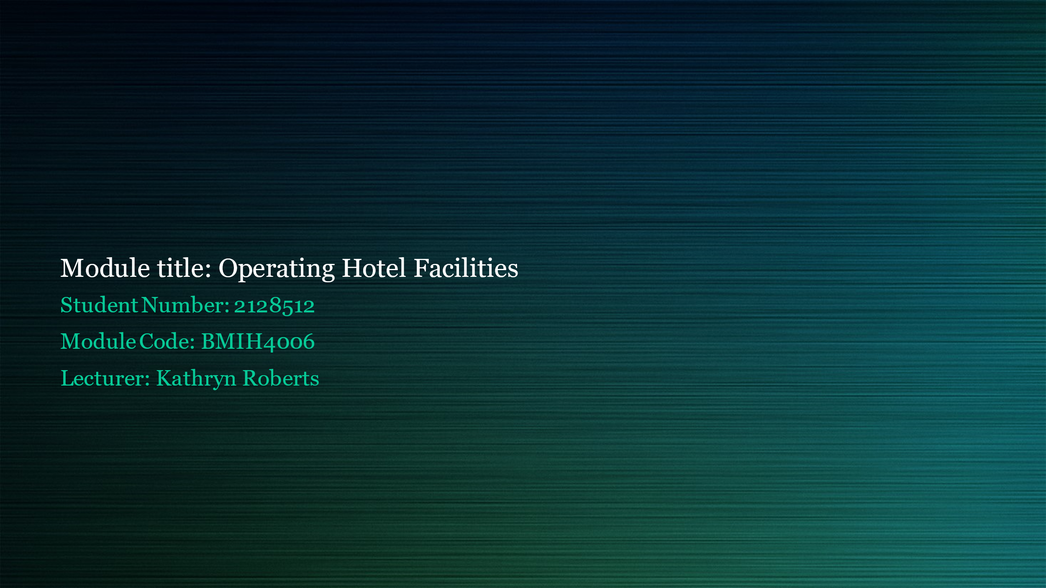
Title Slide
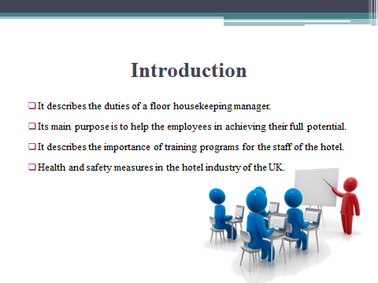
Training Notes: In this section of the report, a complete understanding of the duties of a floor manager in the housekeeping department is provided. The primary purpose of creating this presentation is to encourage the employees of a housekeeping team to attain their full potential and perform the tasks assigned to them with great dedication. This component of the report also describes the importance of the training sessions provided by the hotels along with the employee engagement model. In addition to this, the health and security measures that the hotel industry of the UK considers are also elaborated to offer a better understanding.
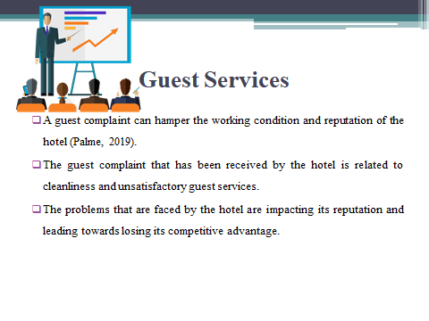
Training Notes: According to Palme (2019), guest complaints aids in assessing the situation and improving it so that future problems can be resolved. To improve hotel standards, it is required by operational staff and managers to handle complaints effectively. The complaints of guests are handled by GRE or Junior executives. These complaints can impact the hotel's reputation as well as working conditions. The complaints that have been received from guests are associated with unsatisfactory services and cleanliness that the hotel is failing to maintain.
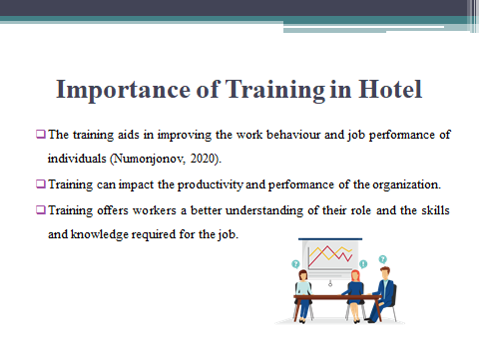
Training Notes: In the view of Numonjonov (2020), training is considered the process of improving the skills and knowledge of workers for a job. Training aids in improving confidence which impacts performance positively. Through effective training, hotel managers would be able to enhance job performance as well as the work behaviour of staff.
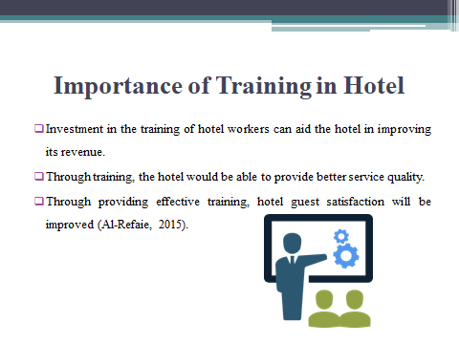
Training Notes: Through training and performance productivity of the hotel would be positively influenced. Through training, the hotel staff would gain appropriate information about their skills and knowledge as well as their role in providing better services (Dhar, 2015).
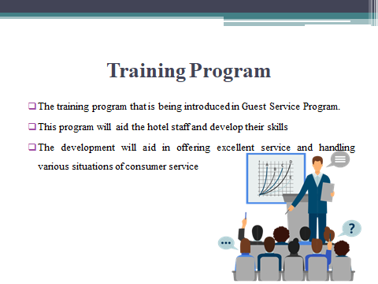
Training Notes: The guest Service Training Program is being introduced by the hotel to develop the skills of their staff. The staff would be able to learn the importance of skills related to consumer service. Through this program, the hotel staff would learn how to deal with guest complaints.

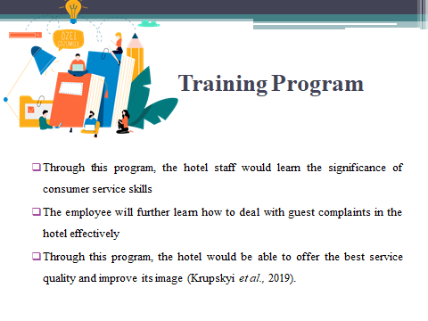
Training Notes: They would further learn the importance of maintaining cleanliness and providing better guest services. The training program will contribute to developing skills and knowledge that will aid in reducing the complaints that the hotel is facing. The staff, through this program, will learn to work with guests and assess their complaints so that they can be reduced and the hotel can improve its image and gain a competitive edge (Krupskyi et al., 2019).
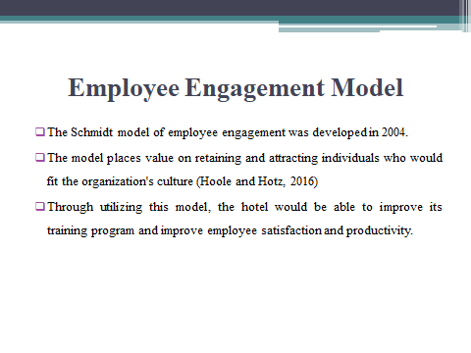
Training Notes: The employee engagement model by Schmidt can aid in working towards policies and behaviour of hotels for maximising satisfaction and productivity (Kwon and Kim, 2020). The hotel would be able to improve the training program that they are developing to reduce guest complaints and improve hotel conditions so that future complaints do not arise.
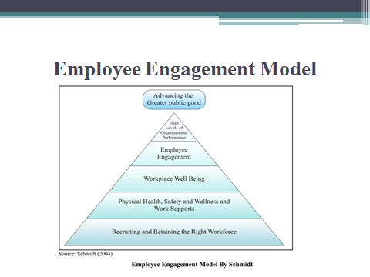
Training Notes: Through this model, the hotel would be able to improve its focus on employee engagement in hotel operations.
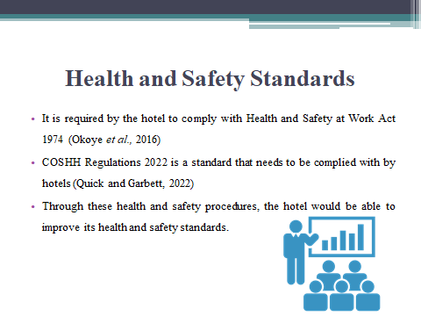
Training Notes: The hotels that operate in the UK need to comply with appropriate acts and regulations that have been imposed by the government (Jallow et al., 2021). The hotel is required to follow COSHH guidelines that will aid in improving hotel cleanliness and provide an effective guideline about measures that need to be taken in a situation where health and safety are being dangered.

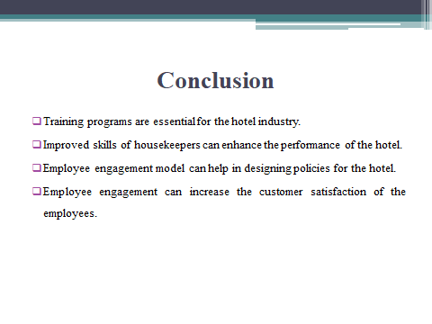
Training Notes: In a nutshell, this section of the report describes that providing training to the employees of a housekeeping team can result in enhancing the performance of the business of the hotel. Therefore, hotels should organise different training programs for their workers. It is also essential for the betterment of a hotel that employee engagement is up to the mark in the hotel. Hence, there is an employee engagement model provide that can be of great service to enhance the policies and actions of the hotel and ultimately improves customer satisfaction in the hotel.


Thank You Slide
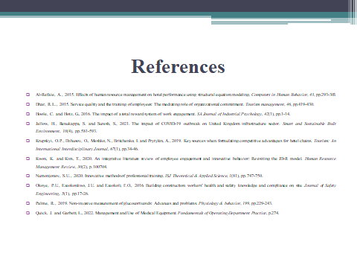
References

References
Al-Refaie, A., 2015. Effects of human resource management on hotel performance using structural equation modeling. Computers in Human Behavior, 43, pp.293-303.
Dhar, R.L., 2015. Service quality and the training of employees: The mediating role of organizational commitment. Tourism management, 46, pp.419-430.
Hoole, C. and Hotz, G., 2016. The impact of a total reward system of work engagement. SA Journal of Industrial Psychology, 42(1), pp.1-14.
Jallow, H., Renukappa, S. and Suresh, S., 2021. The impact of COVID-19 outbreak on United Kingdom infrastructure sector. Smart and Sustainable Built Environment, 10(4), pp.581-593.
Krupskyi, O.P., Dzhusov, O., Meshko, N., Britchenko, I. and Prytykin, A., 2019. Key sources when formulating competitive advantages for hotel chains. Tourism: An International Interdisciplinary Journal, 67(1), pp.34-46.
Kwon, K. and Kim, T., 2020. An integrative literature review of employee engagement and innovative behavior: Revisiting the JD-R model. Human Resource Management Review, 30(2), p.100704.
Numonjonov, S.U., 2020. Innovative methods of professional training. ISJ Theoretical & Applied Science, 1(81), pp.747-750.
Okoye, P.U., Ezeokonkwo, J.U. and Ezeokoli, F.O., 2016. Building construction workers’ health and safety knowledge and compliance on site. Journal of Safety Engineering, 5(1), pp.17-26.
Palme, R., 2019. Non-invasive measurement of glucocorticoids: Advances and problems. Physiology & behavior, 199, pp.229-243.
Quick, J. and Garbett, L., 2022. Management and Use of Medical Equipment. Fundamentals of Operating Department Practice, p.274.
Hashmi, Z.G. and Muff, K., 2017. Evolving towards truly sustainable hotels through a “well-being” lens: the S-WELL sustainability grid. In Sustainability in Hospitality (pp. 117-135). Routledge.
Leroi-Werelds, S., Verleye, K., Line, N. and Bove, L., 2021. Value proposition dynamics in response to external event triggers. Journal of Business Research, 136, pp.274-283.
Wan, T., 2015. Analyzing the relationship between customer satisfaction and customer loyalty: case: Ritz-Carlton Guangzhou.
Lin, P.M., Kim, Y., Qiu, H. and Ren, L., 2017. Experiential learning in hospitality education through a service-learning project. Journal of Hospitality & Tourism Education, 29(2), pp.71-81.
Daskin, M., 2016. Linking polychronicity to hotel frontline employees’ job outcomes: Do control variables make a difference. EuroMed Journal of Business.
Kuo, C.M., Chen, H.T. and Boger, E., 2016. Implementing city hotel service quality enhancements: Integration of Kano and QFD analytical models. Journal of Hospitality Marketing & Management, 25(6), pp.748-770.
Frantz, A. and Misal, A., 2016. Essential generic skills for human resources in hospitality: A literature review. International Journal of Business and Administrative Studies, 2(5), p.124.
Bhatnagar, E. and Dheeraj, N., 2019. Impact of housekeeping services and practices on customer satisfaction and repeat business. Prabandhan: Indian Journal of Management, 12(8), pp.46-57.

