Mr Ionut Tudureanu
Student number: 1917144
Programme: BA Business Management Level 4
Module title: Marketing Fundamental
Module code: LCBB4004
Assignment Title: Assessment 1- Blogging to communicate
Module Lecturer: Malani Gunaratnam

Marketing Fundamentals

Gucci

History of Gucci
Gucci is one of the largest and luxury brands and includes fragrances, accessories, home decoration, ready to wear, and handbags. It is a company of house based in Florence and founded in 1921 in Italy. Gucci was the founder of Gucci and its headquarter is in Florence in Italy. Alessandro Michele is the creative directive of Gucci. It is a brand of leather product level and an Italian brand of fashion. The revenue of Gucci was €9.628 billion in 2018 and the number of employees is 17,157 in 2019. In 2010 it was an iconic Geek Chic brand worldwide. Guccio Gucci the founder of Gucci distributed their share of the company among their three sons. Gucci introduced its first-ever handbag in 1947 and also launched the first global tagline-"Quality is remembered long after price is forgotten". In 1952 it launched iconic moccasins. In 1053 it's introduced its first United States shop in New York City (Caruso et al., 2017). In 1960 it launched its second shop in Saint Regis and in 1973 it launched a third shop in the NY area. Gucci introduced its first Jackie Bags in 1961 in Palm Beach and London. It introduced the first log for accessories and belt buckles in 1964. Gucci operates more than 540 stores all over the world and gained a profit of €3.2 billion. In 2001 it launched 14th-century palazzo on the occasion of 90th anniversary. Gucci provides funds for social work and it also funds a movie to promote social change and the movie was presented at Tribeca Film Festival. It also sells a t-shirt with the logo "My Body My Choice "to promote social change (Caruso et al., 2017).
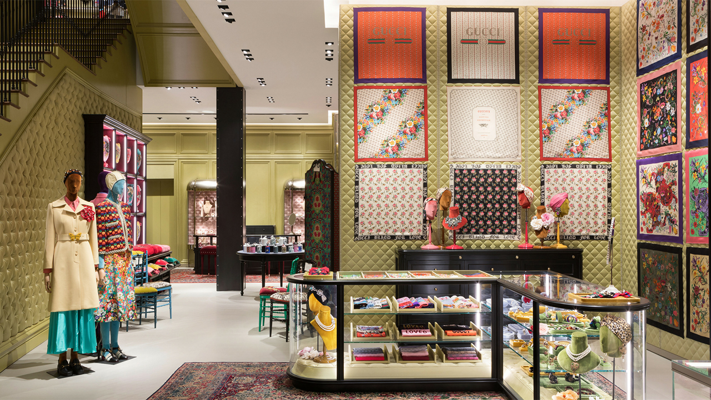
Current situation of Gucci
In 1921 it was just a leather products manufacturer and after this, it becomes one of the best prestigious and glamorous luxury brands. Gucci is the main player in the global luxury product market and it continuously grew and enhancing its sustainability. The target market of Gucci is celebrities; fashion lists upper class and wealthy people. At present, it has changed its target market and includes upper-middle-class and middle-class people. It had excluded women in its target consumers as they think that women could not afford high-quality brands but at present, it also includes women in its target market and now the current consumer target market includes both are female and male ages between 21-50. They launched a kid's collection of clothes and include kids in their target consumer (Caruso et al., 2017).
Collection of products
Gucci provides unbeatable quality leather products and a symbol of undoubted quality. It is one of the best fashion brands and provides luxury fashion accessories, jewelry, and clothing. The quality, material, originality, and fabric of its product are very high and unbeatable. Gucci collection is famous for its innovative fashion ideas.
Gucci handbags
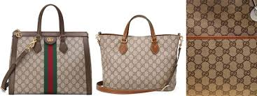
Gucci handbags are highly innovative and very good in quality. Its handbags are the personification of Italian grace and craftsmanship. Its handbags are popular because of unmatched design and quality. It uses fines leather signature fabric. It put the stamp of the logo on its bags and consumers can buy handbags anywhere such as from the office, café, and home (Du et al., 2017).
Gucci Women's shoes
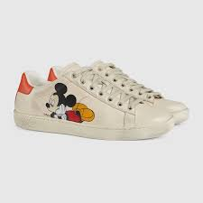
It also provides women's shoes and uses the finest material to make it more attractive and comfortable. It manufactures wedges, fantastic flats, and stilettos. They use a very attractive color palette and diverse in style.
Men's shoes
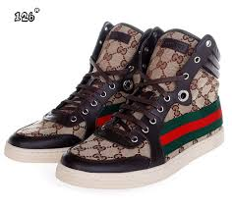
It also produces men's shoes with higher quality and elegant look. TI uses iconic logos, Italian craftsmanship, and many other higher quality materials (Du et al., 2017).
Gucci dress shirts
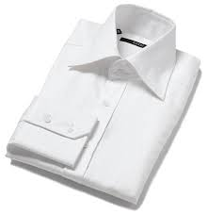
It maintains its quality and produces a higher quality of shirts. The quality of its shirts is very high with classic lines and perfect fit. These shirts can be going with a three-piece suit and simple slacks.

Gucci men's and women's belts
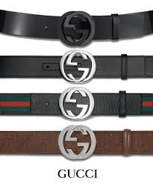
Gucci manufacture women's belt with bold contrast and subtle support. The quality of material and hardware is very high. For men's belt, it provides leisure and office look, all these belts are instantly recognizable.
The logo of Gucci
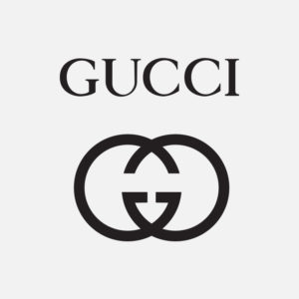
The logo of Gucci is most identifiable in terms of trendy and luxury brands. The logo of Gucci contains double c and Double G in the logo shows the name of Guccio Gucci. The logo is designed by one of the sons of Guccio Gucci named Aldo Gucci. This logo is designed artistically and classic and one of the most recognizable and memorable logo. This logo symbolizes greatness and is seen all over the world. It is very simple and easily applicable to all applications (Gucci et al., 2019).
Mission and vision of Gucci
The main mission of Gucci is to become a leader in the fashion industry and the luxury market. It presents itself as responsible, Value-based on its craftsmanship and cool company. Another mission of the company is an increment in its social responsibilities which are an essential element of its global strategy. They use different approaches such as holistic and realistic. It tries to promote sustainability as it thinks that it is their duty. The values of Gucci are related to ethics and facts. Its start worked on sustainability in 2004 and the quality of products is the main priority of Gucci. Environment and sustainability are an important part of the quality concepts of Gucci. All the stakeholders of Gucci support the strategy of sustainability. In June 2010 it introduced recyclable packaging in their company to reduce pollution. After this, it also introduced a big collection of eco-friendly glasses made by recycling able metal and biodegradable plastics. This new collection of glasses was introduced in 2013. They also use biodegradable plastics in their shoe collection and also use a mixture of new material and style of quality. It tries to reinvent modern approaches of fashion with the help of a new vision of their creative directive named Alessandro Michele. It also reinforces their position in the market and become one of the most desirable fashion companies. It also motivates their employees to give new ideas and encourage the flow of idea. Gucci is developing many new strategies to enhance their consumer's experience, values, and internal nature of culture. They are making effective business practices and decisions to enhance the profitability of their product (Moriondo et al., 2019).
Pricing strategy of Gucci
Premium-priced goods offered by Gucci and prices of their product depending on the quality and work done on the product. They use a higher quality of material and fabric for production. It uses a marketing mix strategy that includes all expenses and changes. The process of the product is increasing because of the various changes that occur during production. It uses premium quality of raw material for its products which automatically increases the price of its product. The finished goods of Gucci contain a trademark of Italy that provides the symbol of premium quality. It also follows a premium pricing strategy for its products because of higher quality. The consumers of Gucci are not affected as it provides high and premium quality of product and sometime company offer a discount for their loyal consumers and maintain their loyalty. The unique quality and features of their product are one of the major reasons behind the huge sale of Gucci. The finished product of the company is very sophisticated and attractive (Moriondo et al., 2019).
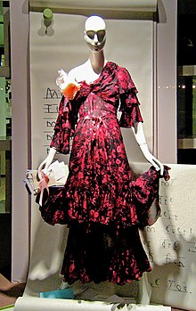
Gucci designs its entire product with a lot of care and maintains the style statement. They also manufacture baby wear which is fashionable and comfortable. They provide a relaxing environment for their consumers to create an attachment between the brand and consumers. They located their stores in high profile and expensive street to attract high profile consumers. They have decorated their outlet with unique and classic teats. The interiors of their shops are appealing and help to create a comfortable environment for consumers as well as staff. The display windows of their shops are provocative and the staff is dressed smartly. Gucci uses market penetration strategies to expand their business and as per this strategy, they have opened various new retail shops in different places in the world market (Piening et al., 2018). They established many outlets in Paris, Rome, London, Tokyo, and New York. Gucci already entered the e-commerce business and make big sales with the help of online marketing. They cannot provide their product at reasonable prices as they do not comprise with the quality of their product hence price cutting is not possible. Many times it offers some discount for their consumers and makes them happy.
Many international and celebrities are associated with Gucci and there is a huge list of legendary clients who are associated with this company. Jackie Kennedy, Audrey Hepburn, and Grace Kelly are some legendary clients of Gucci. It introduced a handbag named Jackie O which is a big hit. It is also associated with American actors and models to promote their products. Model Charlotte Casiraghi, Kate Moss, and actor Blake Lively are brand ambassadors of Gucci (Srinivasan et al., 2019).
Promotion strategy of Gucci
Gucci is investing a huge amount of investments to promote its brand and also invest in advertising and marketing. They have used many innovative marketing strategies to deal with the current dynamic environment. They have also used many new experimental marketing strategies for the new generation. They maintain traditional marketing strategies to maintain their loyal consumers. Many times it uses controversial strategies for promotion. It used a controversial strategy for the promotion of its perfume which is called Opium as scandalous advertisements are very useful for companies and helped to gain media coverage all around the world. They also hold many fashion weeks that are unique in nature for its popular brands. They also use various leading fashion magazines for advertisement but these fashion magazines are very expensive and used by aristocratic and rich people. At present internet and televisions play a very significant role in the promotion strategies of many companies. Gucci also uses the internet and television for their promotional activities (Srinivasan et al., 2018).
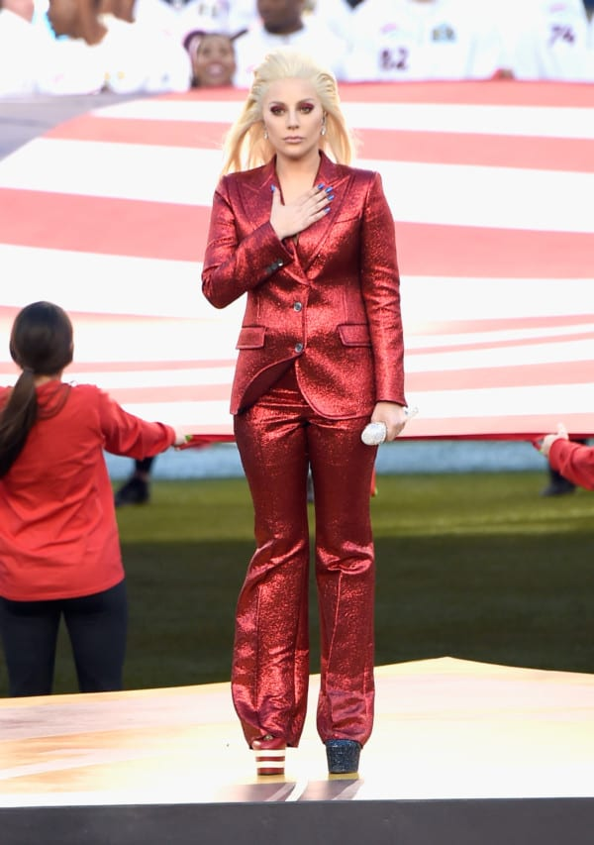

Distribution strategy of Gucci
Many channels can be used by Gucci in their distribution strategies. They also use company-owned stores, retailers, wholesalers, e-commerce sites, and distributors. In 2015 Gucci has more than 510 company-owned stores all over the world and help to gain 34% revenue only in the Asia Pacific. At present, the main aim of Gucci is to reduce the wholesale distribution as it giant the revenue of 88% only from e-commerce. They trying to use a new approach and create a new way of selling which helps them to increase the profitability of their company (Turrini et al., 2017).
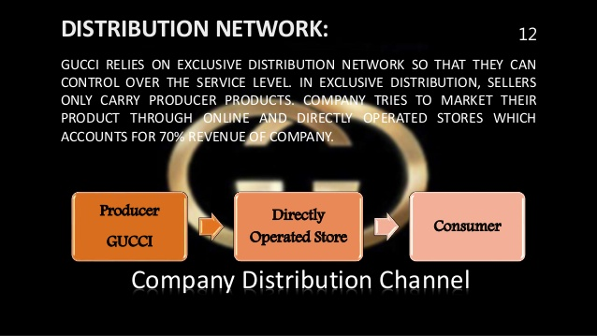
Strategies to maintain the global presence of Gucci
Gucci re-launches and redesign its websites and changed its e-commerce experience. They provide a luxurious brand that helps to enhance the shopping experience of consumers. They also recreate the luxury brand experience online and all online stores provide ready-to-wear production. They represent the collection of women's wear in a very subtle and smart way which helps to attract more consumers. They also issue the image drive content for its websites and product pages (Vignozzi et al., 2019). For a website, it uses visual content featuring the campaigns and collections of brands. It also uses popular culture and brand visibilities. It holds popular culture programs with the help of successful artists. Lady Gaga also associated with Gucci and performed in many cultural programs. Popular culture helps to enhance the goodwill of the company and increase the sales of the company. They have collaborated with popular visual artists on Instagram to promote their products. They also use memes images to sell their product and attract consumers with the help of memes images as people like to share these images with their friends because they are very. This trend is very popular and Gucci launched its new collection of watches to take the benefits of this trend. They use the social media platform because they know the trends and needs of social media (Zhang et al., 2018).


References
Caruso, G., Gucci, R., Sifola, M.I., Selvaggini, R., Urbani, S., Esposto, S., Taticchi, A. and Servili, M., 2017. Irrigation and fruit canopy position modify oil quality of olive trees (cv. Frantoio). Journal of the Science of Food and Agriculture, 97(11), pp.3530-3539.
Du, B., Gucci, F., Porwal, H., Grasso, S., Mahajan, A. and Reece, M.J., 2017. Flash spark plasma sintering of magnesium silicide stannide with improved thermoelectric properties. Journal of Materials Chemistry C, 5(6), pp.1514-1521.
Gucci, R., Caruso, G., Gennai, C., Esposto, S., Urbani, S. and Servili, M., 2019. Fruit growth, yield and oil quality changes induced by deficit irrigation at different stages of olive fruit development. Agricultural Water Management, 212, pp.88-98.
Moriondo, M., Leolini, L., Brilli, L., Dibari, C., Tognetti, R., Giovannelli, A., Rapi, B., Battista, P., Caruso, G., Gucci, R. and Argenti, G., 2019. A simple model simulating development and growth of an olive grove. European Journal of Agronomy, 105, pp.129-145.
Piening, B.D., Zhou, W., Contrepois, K., Röst, H., Urban, G.J.G., Mishra, T., Hanson, B.M., Bautista, E.J., Leopold, S., Yeh, C.Y. and Spakowicz, D., 2018. Integrative personal omics profiles during periods of weight gain and loss. Cell systems, 6(2), pp.157-170.
Srinivasan, B., Gellé, A., Gucci, F., Boussard-Pledel, C., Fontaine, B., Gautier, R., Halet, J.F., Reece, M.J. and Bureau, B., 2019. Realizing a stable high thermoelectric zT∼ 2 over a broad temperature range in Ge 1− x− y Ga x Sb y Te via band engineering and hybrid flash-SPS processing. Inorganic Chemistry Frontiers, 6(1), pp.63-73.
Srinivasan, B., Fontaine, B., Gucci, F., Dorcet, V., Saunders, T.G., Yu, M., Cheviré, F., Boussard-Pledel, C., Halet, J.F., Gautier, R. and Reece, M.J., 2018. Effect of the processing route on the thermoelectric performance of nanostructured CuPb18SbTe20. Inorganic chemistry, 57(20), pp.12976-12986.
Turrini, A., Caruso, G., Avio, L., Gennai, C., Palla, M., Agnolucci, M., Tomei, P.E., Giovannetti, M. and Gucci, R., 2017. Protective green cover enhances soil respiration and native mycorrhizal potential compared with soil tillage in a high-density olive orchard in a long term study. Applied Soil Ecology, 116, pp.70-78.
Vignozzi, N., Agnelli, A.E., Brandi, G., Gagnarli, E., Goggioli, D., Lagomarsino, A., Pellegrini, S., Simoncini, S., Simoni, S., Valboa, G. and Caruso, G., 2019. Soil ecosystem functions in a high-density olive orchard managed by different soil conservation practices. Applied Soil Ecology, 134, pp.64-76.
Zhang, R.Z., Gucci, F., Zhu, H., Chen, K. and Reece, M.J., 2018. Data-driven design of ecofriendly thermoelectric high-entropy sulfides. Inorganic chemistry, 57(20), pp.13027-13033.

