Radisson Blu Hotel Birmingham



Valdimir Romaine Anderson 2014220
Personal Resourcing and Development
Research Project Proposal - Employee Engagement
BMIH5005
Emily Williams

Executive Summary

Radisson Blu Hotels Birmingham is a beautiful hotel with a wonderful view of the city. Morale amongst staff is low because of the United kingdom leaving the European Union and friends, family and loved ones leaving the business. Radisson Blu Hotel doing a report on staff engagement and valued talent retention. The data collection methods that were chosen were questionnaire and why a questionnaire was chosen. The report looks at employee engagement and why it's important. The report also looks into employee retention and the five steps in Maslow’s hierarchy of needs.

Content Page

Introduction 4

Proposal Theme and Benefits 5

Employee Engagement 6

Employee Retention 8

Maslow’s Hierarchy of Needs 11

Conclusion 13

Reference List 14

Introduction

We are going to develop suggestions on the Radisson Blu Hotel in Birmingham employee engagement, retaining a talented workforce and the post pandemic impact within the hospitality industry. We are going to utilise primary research to accumulate relevant information in the form of a questionnaire with secondary research to reinforce our methodology and how it can improve employee engagement. We are going to address why we adopt our research method and the advantages.

(RadissonBluHotelsuk, 2014) Radisson Blu hotels is a chain based in the United Kingdom. There are seven brands that function under the umbrella of Radisson Blu Hotels and Resorts. The seven brands are Park Inn by Radisson, Park Plaza, Country Inns and suites, Hotel Missoni and Club Carlson. The Radisson Blu Hotels and Resorts worldwide head office is in Middlesex, United Kingdom with hotels in several major cities including Belfast, Birmingham, Cardiff, Derby, Durham, Edinburgh, Glasgow, Leeds, Liverpool, London, Manchester, Stansted International Airport and Surrey.

(Radissonhotel, 2021) Radisson Blu Hotel in Birmingham is a stylish hotel situated in the centre of the city with a thirty nine storey complex with a sophisticated and contemporary decor and floor to ceiling windows and stunning view of the city. There are two hundred and eleven rooms and suites with great transport links, links to Birmingham attraction, entertainment, business area and shopping. We can offer shopping and sightseeing from the Birmingham Arts and museum, the national sea life center, the Hippodrome and several theatres and the 02 academy.

Maciuca (2021) was a useful source of information. The United Kingdom has left the European Union and the hospitality industry in the United Kingdom is struggling for workers after the European Union citizens have returned home. This situation of no fault of our own has caused a lack of morale within our team with friends, families and loved ones leaving the hotel on short notice. We planned to do a questionnaire to find out how we can boost employee engagement and retain our talented staff.

Proposal Theme and Benefits

Pattern (2016, p.1) argues that there are strengths and weaknesses to all data collection methods. The results of questionnaires are typically easy to categorise or score, data resulting from questionnaires is easy to analyse especially if the questionnaire contains a majority of open ended questions, the author recommends that you include checkboxes. There are benefits to using questionnaires to collect data, it provides a structural way to collect information. A questionnaire can collect information from a large number of people instead of a telephone or face to face interview which may take a long time. Collecting information which may be sensitive in matters of a questionnaire may be useful. You can administer questionnaires anonymously knowing respondents are more likely to be truthful when they know their answers are anonymous. Questionnaires can be less expensive than other data collecting methods, the main cost of the questionnaire is in mailing and creating the questionnaire. Drawbacks to using questionnaires are often people responding to, if the researcher mails the questionnaire to someone who has never met the researcher, then this is especially important. A questionnaire may only provide a snapshot of the situation, when items with choices are included, questionnaires generally work best since responses can be scored objectively. Respondents to questionnaires provide socially acceptable responses, therefore they may give answers that are socially desirable even if they are not complete. Gillham, (2008) stated that only a small percentage of people are motivated by questionnaires unless they believe they are personally relevant. Data protection ( Gov.uk, 2018). The employee will be notified that they are protected by The Data Protection Act 2018 is the UK’s implementation of the General Data Protection Regulation (GDPR). Everyone in charge of utilising personal data must follow strict "data protection principles." They must ensure that information is used fairly, lawfully, and transparently for specific, explicit purposes, and that it is used in a way that is adequate, relevant, and restricted to only what is necessary, and that it is precise and, where necessary, kept up to date, and that it is kept for no longer than is required, and that it is handled in a way that ensures adequate protection, including safeguard against wrongful or unapproved processing, access, loss, destruction, or damage.

Employee Engagement

According to Freifeld (2013, p.7) there are five I’s of employee engagement, inform, inspire, instruct, involve and incent.

Inform
Inform Provide employees with information that will help them understand the company's vision, its brand values, and how customers view the company.

Inspire
Ensure that employees understand the organization's goals and values so they are inspired to perform well and to take pride in their work.

Instruct
Ensure that employees receive the training, coaching, and feedback they need to deliver the brand's promises to clients.

Involve
You should take action with your employees when designing their jobs, improving work processes, and solving problems identified by feedback from customers or employees.

Incent
Motivating employees to perform at their best can be achieved by implementing a rewarding and reinforcement system that measures, rewards, and reinforces desired employee behaviors.

( Markos and Sridevi, 2010, p.89) The definition of employee engagement is an advantage over competitors in terms of public relations and marketing as well as improved profitability and customer satisfaction. Managers can drive employee engagement by allowing employees to develop a sense of community, giving them the freedom to be themselves, and enabling them to reach their potential are all valuable aspects of bringing employers and employees together for both parties' benefit. The way managers can do this is ensure that efforts are aligned with strategy, provide empowerment, teamwork and collaboration should be encouraged and promoted, contribute to the growth and development of others and whenever possible, provide recognition and support. Employee engagement statistics ( Peoplemanagingpeople, 2021) Employees engagement is important because employees are only 15 percent actively engaged in global work. This concludes, 85 percent of employees are not actively engaged or actively disengaged at work. Engagement leads to better results for companies as opposed to those without one. Productivity increased by 17percent, customer rating increased by 10 percent, sales increased by 20 percent, profitability increased by 21 percent, absentees reduced by 41 percent. Disengaged employees cost companies 450 to 550 billion dollars per year.

Employee Retention

According to Griffeth and Hom (2001, p.1-30) the cost of employee turnover is very high. Professionals in human resources estimate that turnover costs range from 93% to 200% of a leaver salary.

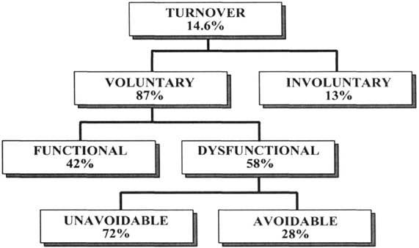

Ways to improve employee retention ( peoplemanagingpeople, 2021). For both managers and the human resources department, employee turnover is a nightmare. You spend time reviewing resumes, interviewing people, recruiting, onboarding, and hope that new hires will stick around. You put money into them, train them, and expect to reap the benefits of your efforts only to lose them to a competitor. The ways you can enhance retention is orientation and onboarding, benefits and salaries, work-life balance should be encouraged, concentrate on your supervisors, make room for expansion, invest in the most up-to-date office equipment available, employee appreciation.

Orientation and onboarding
New employees need to feel welcomed by everyone from the first day. Aid them in charting their course for the future by establishing clear objectives, milestones, and expectations that can be used to assess their abilities and development while keeping them motivated, team building exercise and pairing new staff with experienced staff as some sort of mentor.

Benefits and Salaries
The compensation is the reason for 45 percent of people leaving their jobs. It's easy to believe that a great salary is all you need to keep staff happy. Compensatory packages are more than just a pay raise.

Work-Life Balance Should Be Encouraged
Human Resources and management should be in charge of establishing a decent work-life balance for their employees to help retain them by having flexible shifts and encouraging staff to leave on time, offer help for parents and focus on productivity rather than hours.

Concentrate on your Supervisors
Employees quit for a variety of reasons, one of which is their manager. They are unconcerned with the job or the pay, but they may have severe issues with their bosses, who are often referred to as insensitive, arrogant, or in component. Spend the time to educate your administrators "soft skills" that would help them manage people better as you educate them on the technical aspects of operating a group.

Make room for Expansion
Employees who feel their jobs are stagnant are more inclined to quit for another job, while those who stay are prone to become unproductive and disinterested. There are ways to keep them interesting, provide clear avenues for employees to advance through job titles, change their job responsibilities, set up workshops and short courses to assist them in honing their talents.

Invest in the most up-to-date office equipment available
One of the most crucial features of a workplace, according to 93 percent of millennials polled, is modern and up-to-date technology. 71% of employees want their companies to provide technology that is comparable to, if not better than, what they have at home.

Employee Appreciation
Sixty-five percent of employees believe their efforts are undervalued. Thank you notes don't provide anything in the way of acknowledgement. Rather, create a culture of rewarding employees for a job well done or for supporting the type of conduct you want your business to be identified with.

Maslow’s Hierarchy of Needs

According to Pichère, Cadiat, and Probert, (2015) there are five different levels of needs experienced by all humans that motivate our behavior. Adapt your marketing methods to meet as many of these criteria as possible, and your target market will become a devoted customer, giving the tools needed to swiftly grasp the key theories and concepts that shape today's economic environment. Way Maslows’s hierarchy needs matter ( Booth, 2019). The five needs are physical needs,safety needs, love and belonging, esteem and self-actualisation.

Physical Needs
The physiological demands, such as breathing, eating, drinking, and sleeping, come first. When we've had enough of it and are awake and our tummies are full, we're driven by the next item.

Safety Needs
Maslow’s hierarchy needs in the workplace ( lyon, 2016). We want to be protected now. We try to generate money, gather resources, and establish a safe haven where we can be safe from danger. If we are fulfilled and safe, we have time to think about what we want next.

love and belonging
We are yearning for affection and a sense of belonging at this time. We desire to be close to our families and friends, to belong to a society, or to join a gang. We begin to wish to stand out as soon as we feel fully incorporated into a group.

Esteem
We seek regard, self-confidence, and respect from our peers at stage four. We aspire to be somebody. If we have enough money, we will get a high-end timepiece. We write, think, and work a lot if we have a brain. The desire to perform and compete is at an all-time high. Students, athletes, and inventors all succeed.

Self-Actualisation
We can only reach stage five: self-actualization if we breathe, drink, eat, and sleep sufficiently, and if we feel safe, part of a group, and still unique. We can now unwind, be inventive, accept reality as they are, give back, or do whatever we choose. There's no need for any more pressure, unless there's an issue underneath.

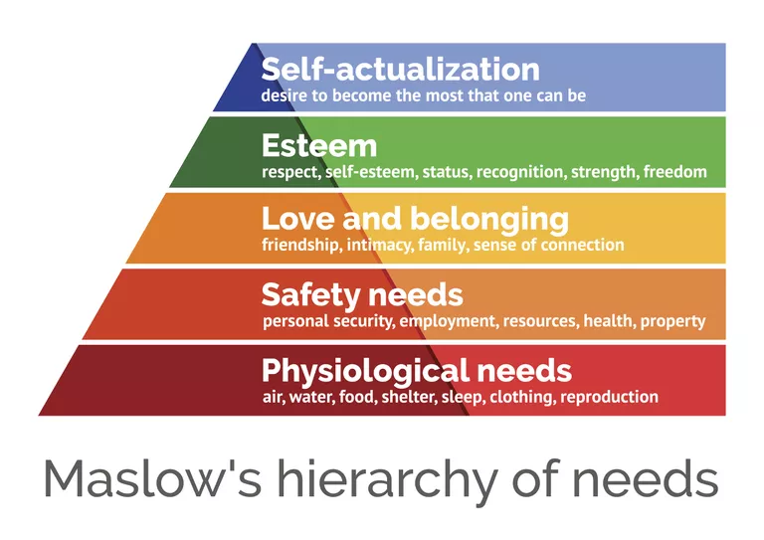

Conclusion

The Radisson Blu Hotel in Birmingham is looking to engage with its current workforce. Radisson Blu Birmingham ( Hotels.com, 2021). The hotel is a four star hotel accommodation with 211 guest rooms within walking distance from the Mailbox and many other city centre attractions. Morale is low amongst staff because of the United kingdom leaving the European Union and many European citizens returning home. Employee engagement ( Donovan, no date). Engagement is a blend of cognitive and emotional drivers that, when aligned with an organization's vision, values, and goals, results in maximum effort and high fulfilment. ( Buck and Watson, 2002, p.175-193) Employee retention is determined by the level of commitment shown by the organisation. McLeod, ( 2007) stated that there are five stages to Maslow’s hierarchy of needs. Individuals must attend to lower-level demands before they can attend to higher-level requirements. Physiological, safety, love and belonging, esteem and self actualisation are the needs from the bottom of the hierarchy to the top.

Reference List

Anonymous, (2014) Radisson Blu Hotels UK - Company Capsule. World Market Intelligence

Booth, M. (2019) Why maslow’s hierarchy of needs matters: Mike Booth [video]. Available at: https://www.youtube.com/watch?v=L0PKWTta7lU (Accessed: 16 November 2021).

Buck, J.M. and Watson, J.L. (2002) Retaining staff employees: The relationship between human resources management strategies and organizational commitment. Innovative higher education, 26(3), pp.175-193.

Donovan, J. (no date) Employee engagement. Available at: https://hstalks-com.ezproxy.uwtsd.ac.uk/t/1364/employee-engagement/?business (Accessed: 24 November 2021).

Freifeld, L. (2013) ‘Five I’s of employee engagement’, Training (New York, N.Y.), 50(4), p. 7.

Gillham, B. (2008) Developing a questionnaire. A&C Black.

Gov.co.uk, (2018) Data protection. Available at: https://www.gov.uk/data-protection (Accessed: 02 November 2021).

Griffeth, R.W. and Hom, P.W. (2001) Retaining valued employees. Thousand Oaks, Calif. ;: SAGE.

Hotels.com, (2021) Radisson Blu Birmingham. Available at: https://uk.hotels.com/ho236044/radisson-blu-hotel-birmingham-birmingham-united-kingdom/?q-rooms=1&q-room-0-adults=2&q-room-0-children=0 (Accessed 20 November 2021).

Lyon, A. (2016) Maslow’s hierarchy at work: Alex lyon [video]. Available at: https://www.youtube.com/watch?v=nASV5I_WG3k (Accessed: 18 November 2021).

Maciuca, A. (2021) EU worker went home. Available at: https://www.thelondoneconomic.com/news/uk-hospitality-eu-workers-went-home-267222/ ( Accessed: 15 November 2021).

Markos, S. and Sridevi, M.S. (2010) Employee engagement: The key to improving performance. International journal of business and management, 5(12), p.89.

McLeod, S. ( 2007) Maslow's hierarchy of needs. Simply psychology, (1-18), p.1.

Peoplemangingpeople, (2021) 12 Employee Engagement Statistics You Need To Know In 2020. Available at: https://peoplemanagingpeople.com/general/employee-engagement-statistics/ (Accessed: 16 November 2021).

Peoplemanagingpeople, (2021) 7 Novel Ways For HR To Improve Employee Retention Available at: https://peoplemanagingpeople.com/articles/ways-to-improve-employee-retention/ (Accessed: 10 November 2021).

Patten, M. (2016) Questionnaire research: A practical guide. Routledge.

Pichère, P., Cadiat, A.C. and Probert, C. (2015) Maslow’s hierarchy of needs. Namur: Lemaitre Publishing.

RadissonBluHotelsuk, (2014) Radisson Blu Hotels UK - Company Capsule2014, , GlobalData plc, London.

Radissonhotel, (2021) Radisson Blu Birmingham. Available at: https://www.radissonhotels.com/en-us/hotels/radisson-blu-birmingham?cid=a:se+b:gmb+c:emea+i:local+e:rdb+d:ukirwe+h:GBBHX1 (Accessed: 01 November 2021).

