Lighting Layout and Sound Index Calculation - Assignment
Module code: ACBA4006

Julia James
Student No: 0251098

Contents

Task A (Part 1)
- The Room Index ………………………………………………………p.3
- The Utilisation Factor …………………………………………………p.4
- The number of lamps required ………………………………………p.5
- A suitable layout (value S) for the lamp fittings ……………………p.5 - 6
Task A (Part 2)
- Luminaire layout plan …………………………………………………p.7
Task B (Part 1)
- Calculation of the overall sound reduction index for the entire wall p.8 - 10
Task B (Part 2)
- Internal Sound Management …………………………………………. p.11 - 15
- Amplitude, loudness or volume …………………………………. p.12
- Frequency and pitch ……………………………………………… p.12
- Wavelength ………………………………………………………... p.13
- Velocity …………………………………………………………….. p.14
- How does sound behave? ……………………………………….. p.14 - 15
- Partition wall construction ………………………………………... p.15 - 16
- Sound Insulation ………………………………………………... p.16 – 17

- References ……………………………………………………………… p.18
- Bibliography …………………………………………………………….. p.19
- Appendix
No. 1 ……………………………………………………………………... p.20 - 21
No. 2 ……………………………………………………………………... p. 22

Task A (Part 1)

The information we are given:
Length of factory = 60m
Width of factory = 24m
Height of factory = 8m
Work benches = 1m (above floor level)
Ceiling reflectance = 0.3
Wall reflectance = 0.5
Light Loss factor = 0.75
A Lighting Design Lumen (LDL) output of 18,000 lumens is required
Working plane illumination of 200 lux is required

1.The Room Index:
RI = (LxW) = (60x24) = 1440 = 1440 = 2.44 Room Index
(H_{m} (L+W)) 7 (60+24) 7x84 588

Where:
L = length of the room
W = width of the room
H_{m} = mounted height of the luminaire above the working plane

2.The Utilisation Factor = 0.46
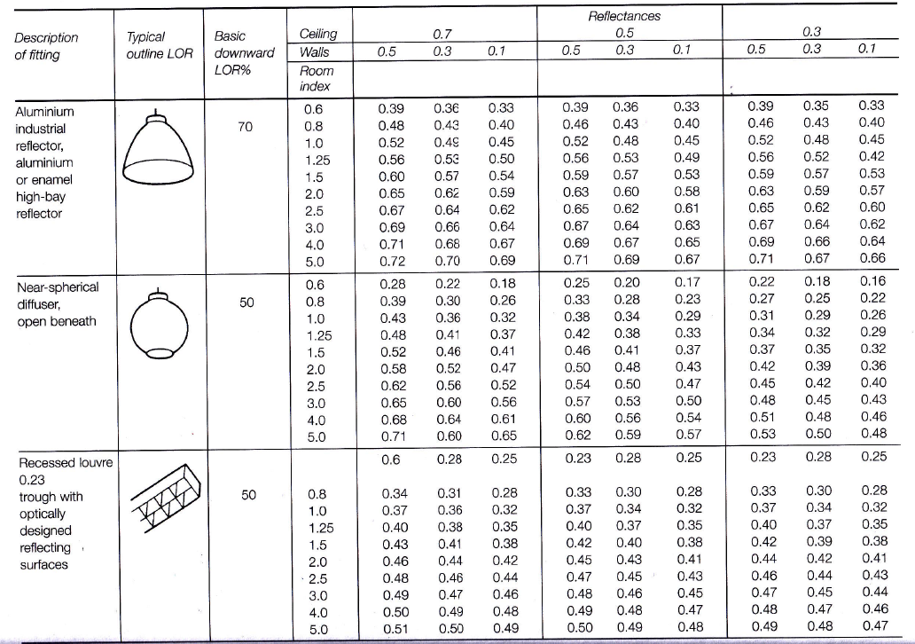
(Nantel, Artificial Lighting, 2020)
To calculate the Utilisation Factor (UF) the above chart can be used. By using the Ceiling and Wall Reflectance figures and the Room Index calculated as 2.44 (as in previous section No. 1) and rounding this figure up to 2.5, following the lines on the chart and using these figures as the arrows indicate, the Utilisation Factor of 0.46 is identified.

3.The number of lamps required
N = E x A
F x UF x LLF
N = Number of lamps required
E = Illuminance level required (Lux)
A = Area of working plane height (m²)
F = Average luminous flux from each lamp (Lumen)
UF = Utilisation factor
LLF = Light loss factor
In this example:
E = 200 Lux
A = 60x24 = 1440m²
F = 18,000 Lumens
UF = 0.46
LLF = 0.75
N = 200 x 1440 = 288,000 = 46.376 rounded up to 48 required lamps
18,000 x 0.46 x 0.75 6,2010

- A suitable layout (value of S) for the lamp fittings
Smax = 1.5 x Hm
= 1.5 x 7m = 10.5 metres apart maximum
Suitable layout would be 12 lights across the length of the factory and 4 lights across the width of the factory, the lamps should begin being positioned 1m in from each corner.

This leaves 60m – 2m (for the distance stated above) = 58m left to position the 12 lights across the length of the factory
58m = 5.272m (to position the lights 5.272m length apart)
11 spaces

This leaves 24m – 2m (for the distance stated above) = 22m left to position the 4 lights across the width of the factory
22m = 7.3 (to position the lights 7.3m width apart)
3 spaces

The following Building Regulations apply to lighting:

‘Building Regulations 2010 Approved Document L – Conservation of Fuel and Power’ (Welsh Government, 2018)

British Standard BS EN IEC 60598

Task A (Part 2)

- Luminaire Layout Plan

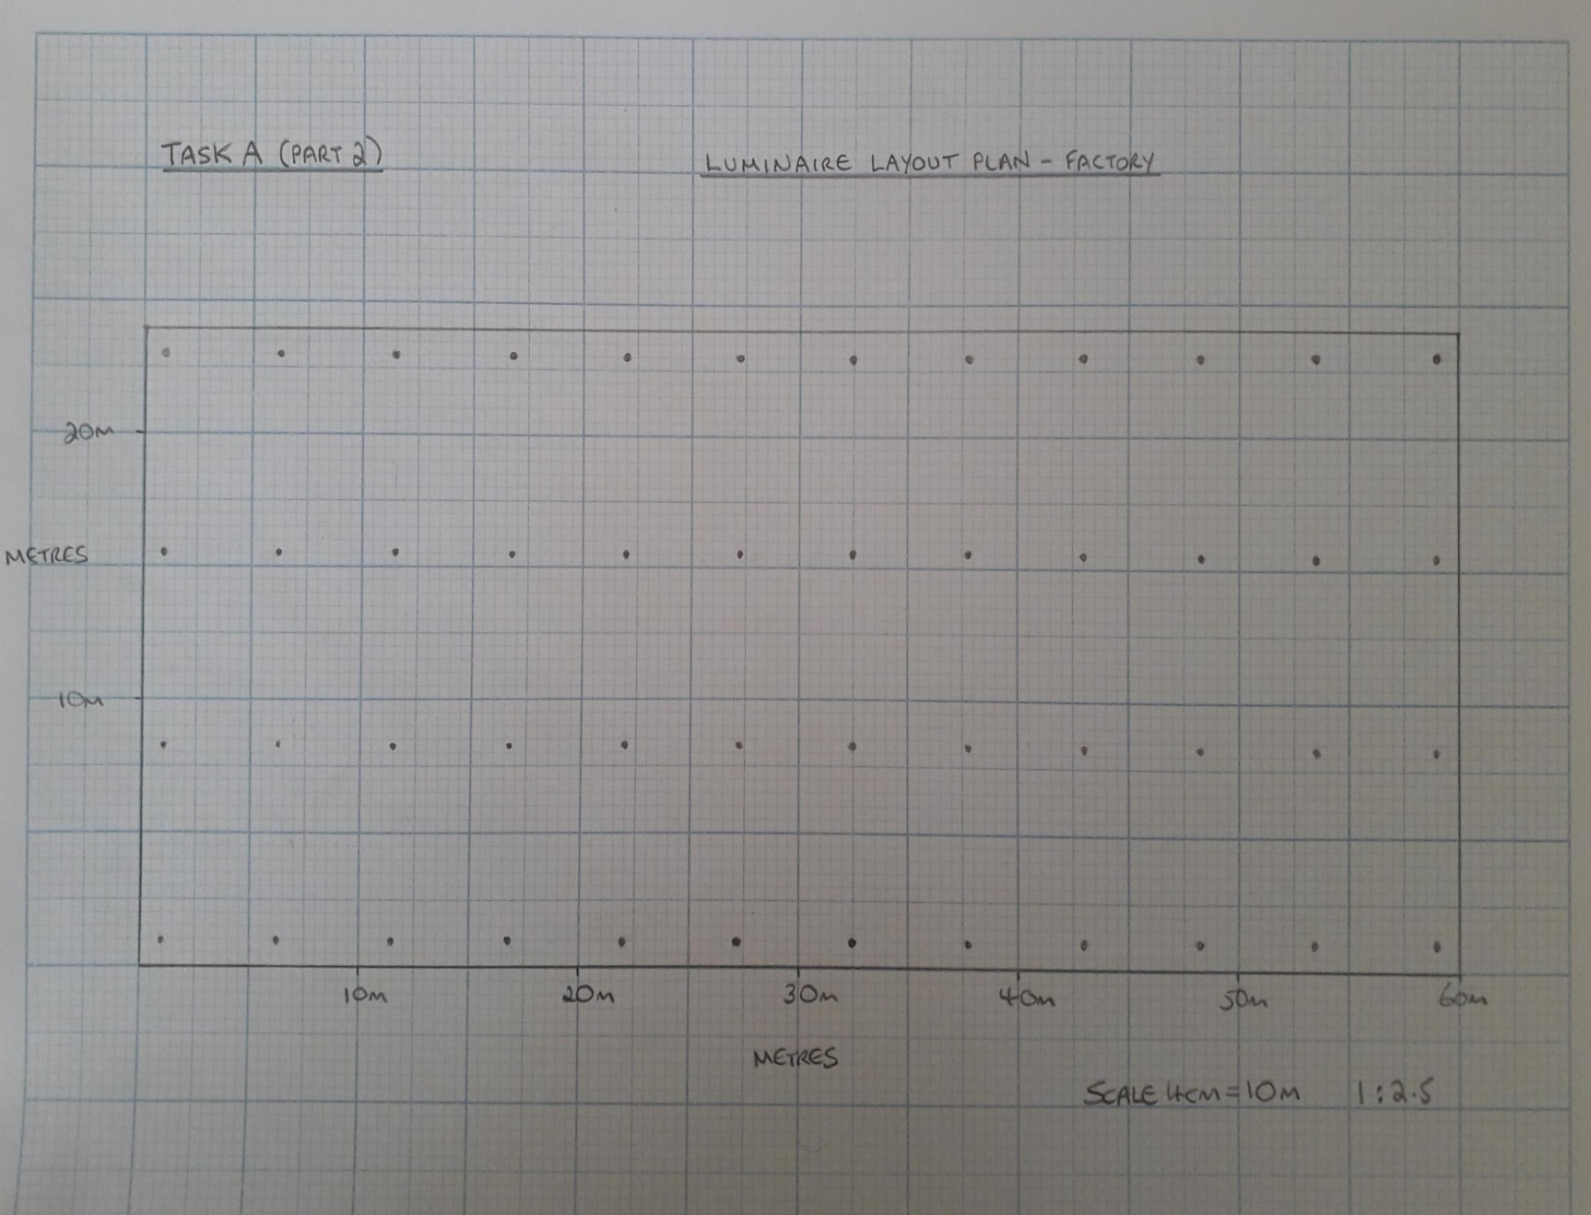

Task B (Part 1)

- Calculation of the overall sound reduction index for the entire wall
‘Transmission Coefficient (T) is the measure of the amount of sound energy transmitted through the wall.’ (Nantel, Sound, 2020)

Transmission Coefficient (T) = Transmitted sound energy
Incident sound energy

‘The ear doesn’t judge sound according to energy content, so the ratios of energy found in the transmission coefficient need to be converted to a decibel scale, as read by our decibel meter.
The sound reduction index is used as a practical sound insulation value.
The Sound Reduction Index (SRI) is a measure of the insulation against the direct transmission of airborne sound’ (Nantel, Sound, 2020)

The information we are given:
Total brick wall area = 20m²
One window with an area of = 4m²
Sound reduction index for brickwork = 50dB
Sound reduction index for window = 10dB

Brickwork: T1=? A1= 20m² – 4m² = 16m² SRI 50dB
Window: T2=? A2= 4m² SRI 10dB

Brickwork
SRI = 10 x (log₁₀ (1/T) )
50 = 10 x (log₁₀ (1/T₁) )
5 = log₁₀ x (1/T₁)
1/T₁ = 10⁵
T₁ = 10⁻⁵
T₁ = 0.000010 Transmission Coefficient for the brickwork

Window
SRI = 10 x (log₁₀ (1/T) )
10 = 10 x (log₁₀ (1/T₂) )
1 = log₁₀ x (1/T₂)
1/T₂ = 10¹
T₂ = 10⁻¹
T₂ = 0.10 Transmission Coefficient for the window

Where T0 = overall (averaged) transmission coefficient
T1 = transmission coefficient of one component
A1 = area of that component

T₀ = (T1 x A1) + (T2 x A2)
A1 + A2

= (10⁻⁵ x 16) + (10⁻¹ x 4)
16 + 4

= (0.000010 x 16) + (0.10 x 4)
20

= 0.00016 + 0.4
20

= 0.40016
20

= 0.020008 Average Transmission Coefficient

Using the Sound Reduction Index (SRI) formula:

SRI = 10 x (log₁₀ (1/T))
= 10 x (log₁₀ (1/0.020008))
= 10 x (log₁₀ (49.980007))
= 10 x 1.69
= 16.9 rounded up to
17dB SRI for the wall (containing one window)

Task B (Part 2)

- Internal Sound Management
Internal sound management in buildings is important for the comfort of its occupants, this can be managed by the correct use of construction techniques including for partition walls and the choice of sound insulation.

The following Building Regulations apply:
‘Building Regulations 2010 Approved Document E -
Resistance to the passage of sound
E1 – Protection against sound from other parts of the building and adjoining buildings
E2 – Protection against sound within a dwelling-house etc
E3 – Reverberation in the common internal parts of building containing flats or rooms for residential purposes

Regulation 41 The Building Regulations 2010
Regulation 20(1) and (5) The Building (Approved Inspections etc) Regulations 2010’ (Welsh Government, 2018)
British Standard BS EN ISO 3740:2019 – TC

Understanding sound:
‘Sound is the quickly varying pressure wave travelling through a medium’
‘The number of pressure variations passing a given point per second is called the frequency of sound, and is measured in Hertz (Hz) which is defined as cycles per second’ (Nantel, Sound 1, 2020)

- Amplitude, loudness or volume
‘Volume (also called loudness) relates to the maximum pressure produced as particles are squeezed together as they are made to vibrate.’
‘Loudness of sound is measured in decibels (dB). This is actually a measure of intensity, which relates to how much energy the pressure wave has.’ (Science Learn, 2020)
- Frequency (f) – Unit: hertz (Hz) and Pitch (high and low)
‘Pitch is the frequency of a sound as perceived by human hearing’ (McMullan, 2002, p.181)
‘Every sound has a range from a high to a low pitch.
The pitch of a sound depends on the frequency of the vibrations that cause it. The frequency of a sound is the number of complete waves or vibrations that go past a particular place each second.
- The more vibrations per second, the higher the frequency and sound pitch
- The fewer vibrations per second, the lower the frequency and sound pitch’
(Sound Proofing Company, 2020)

Low frequency sound causes more discomfort to the human ear. It can travel long distances without reducing in level. Single frequency sound for example from machines can also cause more discomfort than sound with multiple frequencies.

- Wavelength - Unit: Meter (m)
‘Sound waves vibrate at different rates or "frequencies" as they move through the air’. When a wave is created, the distance between one compression and the next compression is called the wavelength. The faster the sound waves pass a given point, the shorter the wavelength and the higher the frequency’
(Science Learn, 2020)

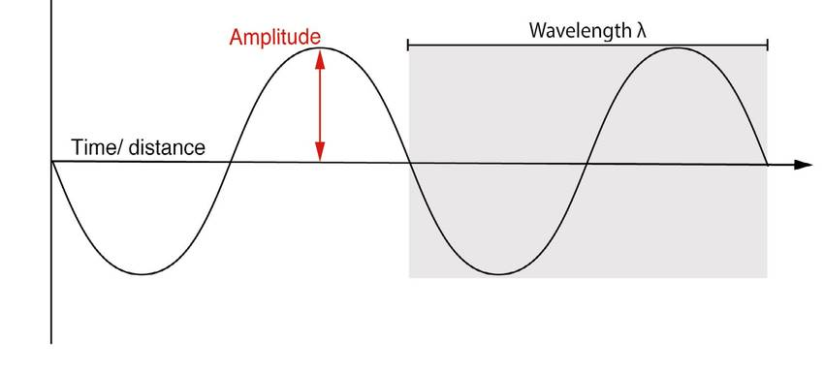

‘A sound wave, showing characteristics of wavelength (the length of a complete cycle) and amplitude (proportional to energy) (Science Learn, 2020)

‘Sound waves between 2 and 5kHz can resonate most efficiently within the ear canal, causing higher pressures and therefore making these frequencies the ones for which we are most sensitive’ (Nantel, Sound, 2020)

- Velocity (v) – Unit: meters per second (m/s)
‘For every vibration of the sound source the wave moves forward by one wavelength. The number of vibrations per second therefore indicates the total length moved in 1 second; which is the same as velocity, this can be written as the following formula:

v=f x ƛ
v=velocity
f=frequency in Hz
ƛ=wavelength in m’
(McMullan, 2002, p.180)

- How does sound behave?
‘The velocity of sound is affected by the properties of the material through which it is travelling’ (McMullan, 2002, p.180)
Sound moves through gases, liquids and solids at different speeds (the fastest through solids and then liquids due to the particles being closer together) temperature and humidity also affects the speed of sound.

Sound behaviour in a room?
Sound in a room can be reflected, absorbed and transmitted through materials.
Reflection - sound that bounces back within the room
Absorption - sound is absorbed or partially absorbed by a material as part of the room.
Transmission – sound is transmitted through the room materials

The transmission of sound through a partition wall can be airborne or impact (structure borne) sound. Airborne sound travels through the air from the source and impact sound originates often by close contact or impact on materials and travels through those materials resulting in vibration.

Examples of airborne sound can be voices, music, sound from a TV also external noise from traffic. Examples of impact sound could originate internally as footsteps, doors, household systems like plumbing or vibrations caused by appliances.

Sound Transmission Coefficient
‘The Transmission Coefficient (T) is the measure of the amount of sound energy transmitted through the partition’ (Nantel, Sound, 2020)

T = Transmitted sound energy
Incident sound energy This will be provided as a ratio.

Using the Sound Reduction Index formula (SRI) measured in dB (as per Task B part 1) illustrates the ‘practical sound insulation value’ of room materials, different elements in a room will have their own absorption coefficient.

‘Noise Criteria (NC) curves are one system used to establish allowable background sound levels for various interior spaces in Decibels’ (Nantel, Sound 1, 2020)

- Partition Wall Construction
There is a large choice of materials to use in the construction of partition walls and depending on the type of room (bedroom, bathroom etc.) and use within the room with dictate the type chosen. Other considerations will be cost, weight of materials and the space taken up internally.
Types include: ‘Plain brick, Hollow clay brick, Reinforced brick, Brick noggin, Glass (many types), Plaster Slab, Plaster Block, Metal Lath, Plasterboard and Timber partition walls.’ (Ferriz-Papi, Partition Walls, 2020)
Hollow clay brick partition walls have less weight and ‘increased thermal and acoustic insulation’ (Ferriz-Papi, Partition Walls, 2020)
However, plasterboard is the most commonly used, the cost is relatively low, and the layers produce ‘good acoustic insulation’, but it is not suitable for wet environments. (Ferriz-Papi, Partition Walls, 2020)
Building Regulations Part B and BS 1230-1:1985 / BS 8212:1995 would apply.

- Sound Insulation
‘Sound Insulation is the reduction of sound energy transmitted into an adjoining airspace’ ‘It is the principle method of controlling both airborne and impact sound in building’ (McMullan, 2002, p.215)
For sound insulation to work effectively it needs to insulate both airborne and impact sound and sound at different frequencies, high to low pitch.

Sound insulation can be achieved through:
- The weight/mass of the wall/partition, ‘high mass transmits less sound energy’ (McMullan, 2002, p.217)
‘The Mass Law: the sound insulation of a single leaf partition is proportional to its mass per unit area’ (McMullan, 2002, p.218)
- Ensuring the room is airtight so that sound does not enter or escape (completeness) and thickness is uniform
- Isolate physical materials from making contact to limit or prevent any resonance (vibration) e.g. air cavities in windows, carpets, floating floors etc.
- Flexibility - the stiffness or fixing of a partition could affect sound insulation ‘high stiffness can cause loss of insulation at certain frequencies where there are resonances’ (McMullan, 2002, p.220)

‘Reduce impact and airborne sounds that pass through stud walls by combining soundproof materials. Increase the mass and density for the best sound insulation for interior walls’ (Noise Stop Systems, 2020)

Additional methods to improve sound insulation:
- Ensuring airtight seals and joins with partitions, floors, ceilings, windows, doors, pipes etc.
- ‘Triple glazed glass or remove, limit the number of openings
- Sound insulating shutters
- Acoustic plasterboard
- Sound proofed stud walls
- Acoustic mineral wool insulation fitted into the cavity of a stud wall, each side of the wall to be built on a separate timber frame providing mass and isolation
- Heavier doors, acoustic seals, no open locks
- Sound absorber fitted to upper walls and ceilings to reduce reverberation
- Acoustic vents for air circulation, trunking lined with sound insulating foam’
(Sound Service, 2020)

Compliance
To ensure compliance with Building Regulation Part E, new properties can be registered and built to Robust Detail specifications with Robust Certificates supplied, the alternative is to carry out sound testing pre completion to meet building regulations (see Appendix No.1 & No. 2)

- References

Ferriz-Papi, J. (2020, February). Partition Walls

McMullan, R. (2002) Environmental Science in Building.5th Ed. Hampshire: Palgrave MacMillan

Nantel, A. (2020, January). Artificial Lighting

Nantel, A. (2020, February). Sound 1

Nantel, A (2020, February). Sound 2

Noise Stop Systems (2020) Soundproof a stud wall
Available at: https://www.noisestopsystems.co.uk/how-to-soundproof-a-stud-wall/
(Accessed: 15th March 2020)

Science Learn (2020) Measuring Sound
Available at: https://www.sciencelearn.org.nz/resources/573-measuring-sound
(Accessed: 16th March 2020)

Sound Proofing Company (2020) What is sound?
Available at: https://www.soundproofingcompany.com/soundproofing_101/what-is-sound
(Accessed: 16th March 2020)

Sound Service (2020) Sound Insulating
Available at: http://www.soundservice.co.uk/sound_insulating_room.html
(Accessed: 14th March 2020)

Welsh Government (2018) Building Regulations.
Available at: https://gov.wales/building-regulations-approved-documents
(Accessed: 15th March 2020)

- Bibliography

Acoustic Consultants Ltd Report (2019) Noise Assessment at Oriel, Port Talbot

Ferriz-Papi, J. (2020, February). Partition Walls

HM Government (2015) Assets Publishing Service - Approved Document E
Available at: https://assets.publishing.service.gov.uk
(Accessed: 4th April 2020)

Journal of Low Frequency Noise (2009) Review of Low Frequency Noise
Available at: https://journals.sagepub.com/doi/pdf/10.1260/0263-0923.28.2.79
(Accessed: 4th April 2020)

McMullan, R. (2002) Environmental Science in Building.5th Ed. Hampshire: Palgrave MacMillan

Nantel, A. (2020, January). Artificial Lighting

Nantel, A. (2020, February). Sound 1

Nantel, A (2020, February) Sound 2

Noise Stop Systems (2020) Soundproof a stud wall
Available at: https://www.noisestopsystems.co.uk/how-to-soundproof-a-stud-wall/
(Accessed: 15th March 2020)

Science Learn (2020) Measuring Sound
Available at: https://www.sciencelearn.org.nz/resources/573-measuring-sound
(Accessed: 16th March 2020)

Sound Proofing Company (2020) What is sound?
Available at: https://www.soundproofingcompany.com/soundproofing_101/what-is-sound
(Accessed: 16th March 2020)

Sound Service (2020) Sound Insulating
Available at: http://www.soundservice.co.uk/sound_insulating_room.html
(Accessed: 14th March 2020)

Welsh Government (2018) Building Regulations.
Available at: https://gov.wales/building-regulations-approved-documents
(Accessed: 15th March 2020)

- Appendix No. 1
Robust Details

Robust Details Explained

What are Robust Details?
Robust details provide an alternative to pre-completion testing for demonstrating compliance with the performance standards of Part E for new build dwellings.

How does it work?
In order to use Robust Details for this purpose, you must first register your use for each plot with them. (please note: you will need a copy of the Robust Details Handbook in order to enter the relevant Robust Detail(s) you require on the form). Once your plots are registered, they will provide you with registration documentation. This will be accepted by all building control bodies as evidence that you are entitled to use Robust Details instead of pre-completion sound testing.

Benefits
The benefits are clear - using Robust Details avoids the need to carry out pre-completion sound testing. This eliminates the risk and uncertainty of remedial action being required on completed floor or wall constructions, with the potential delays in completing the property. You will be investing in constructions that add real value to the building rather than paying test fees. You will also avoid the delays and uncertainties of pre-completion sound testing.

Disadvantages
It is important that Robust Detail constructions are properly constructed because sometimes when they have been spot checked they have not met the current Part E requirements for sound control. When this happens it is usually due to one or both of the following.
1) Incorrect materials used
2) Incorrectly installed
When working to Robust Detail requirements, it is important that the exact materials are used that are detailed in the Robust Detail Manual and that they are properly installed. A common reason for failure with a concrete separating floor for instance is bridging between the screed and base floor. Bridging is caused if the resilient layer has breaks or gaps within it allowing the screed to come into contact either with the base floor or surrounding walls. A spot test failure through a separating wall is often due to the wrong density blocks being used. Low density blocks do not block sound the same as high density blocks so it is important to take notice of what is specified in the Manual.

Performance Monitoring
Due to the above, Robust Details Ltd monitor the performance of current Robust Detail constructions through feedback from third parties such as building control bodies and new home warranty providers, together with independent spot checks. The spot checks include both sound testing and visual inspections.
You can read more and apply here http://www.robustdetails.com

Looking for a floor RD compliant system?
Check out our Acoustic Cradles and Isorubber Top products.
Written by Stephen Young
© Sound Service (Oxford) Ltd. 2009

(Sound Service, 2020)

Appendix No. 2

Example of a Robust Certificate

