

LEVEL 4 ASSESSMENT SPECIFICATION
Student name: | Fathi Sharif | Student ID number: | 1701105
Programme: | Computing Portfolio
Module: | Software Development
Module code: | ACCA4017 | Contribution to Overall Module Assessment (%): | 70%
Lecturer: | Mike Dacey/Tim Bashford | Internal Verifier: | Tim Bashford
Assignment Title: | Programming in C | Word count (or equivalent): | 2800
Submission deadline: | 5/4/19 | Return date of provisional marks & written feedback: | 3/5/19

Exercise 1 (50%)

I will be building two players game. Here the rules of the game, the first player (player one) enters 7 numbers between 1 and 10. The game shows (player two) the first value and the game asks the player two to guess whether the next value is higher or lower than the one being shown by the game. When the player two enter the guess, the game shows player two the next number and player two has to keep guessing until all 7 values are shown. When all the guesses made, then the game ends and the player two wins but the player one wins if any incorrect guesses are made by player two.

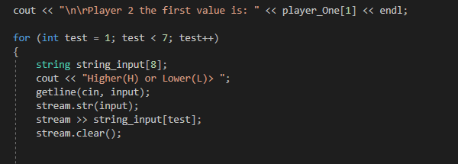
Here, me building the game. At begin I was having issue taking player one input, so recently I have found a way to take player one input. as you can see, I have used a loop variable as an array index to loop through all the player one input.
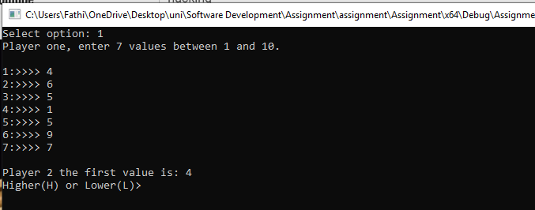
Here as you can see the player one entered 7 numbers that is between 1 and 10.
One of main issue that I was having while I was creating this game, was taking player two input and see if the player two input is correct.
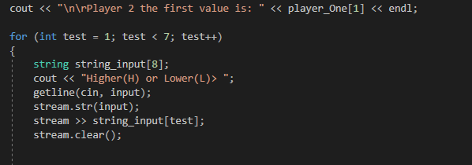

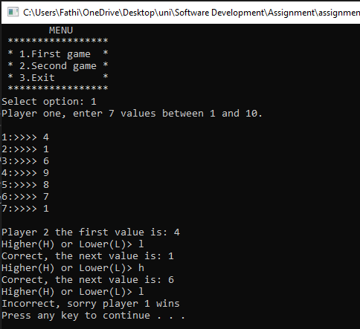
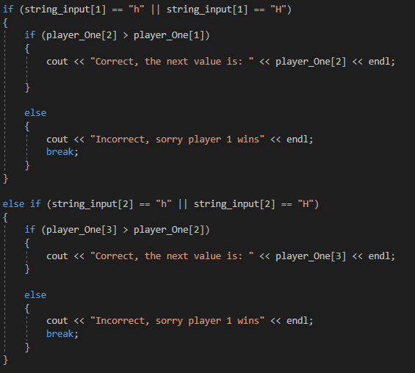
As you can see, after the player one enters the 7 numbers and then the player two must make guesses. Then there is if statements that checking if the player two is correct.
Exercise 2 (Medium difficulty) (30%)

This second game that I’m going to create is for two players game and here are the rules of the game. The first player (player one) hides 3 treasures, the second player must make guess where they are by entering the row and the column of the allocation on an 8X8 grid.

The second player has 3 lives. If the player two fail to find the treasure, then the program let player know that there is no treasure here and they lose live. If the second player finds the treasure, then the program displays x and the player two win if they discover all three treasures. The program re-displays after each guess, as well as appropriate messages such as (you found the first treasure).

Here as you can see, I was trying to create grid table, so the user can choice from the table.

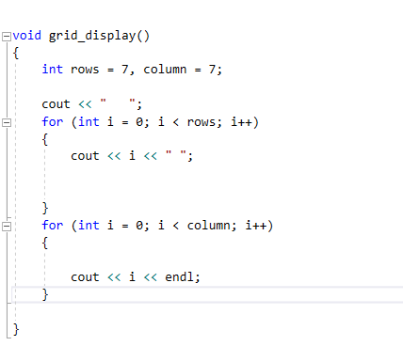

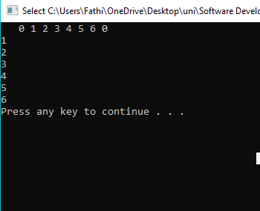

this screen shot, is just me who trying to learn how multi-dimensional array works and here is the code, I have output numbers by using multidimensional array. I am familiar how multidimensional Array works and I found out that multidimensional array is just array of arrays.
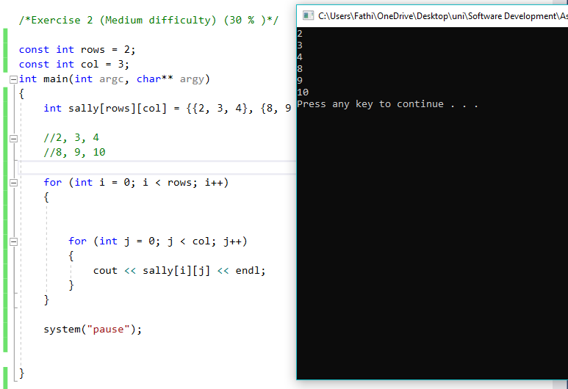

As you can see, I have two-dimension, it becomes an array of arrays and I finally created the table with rows and columns.

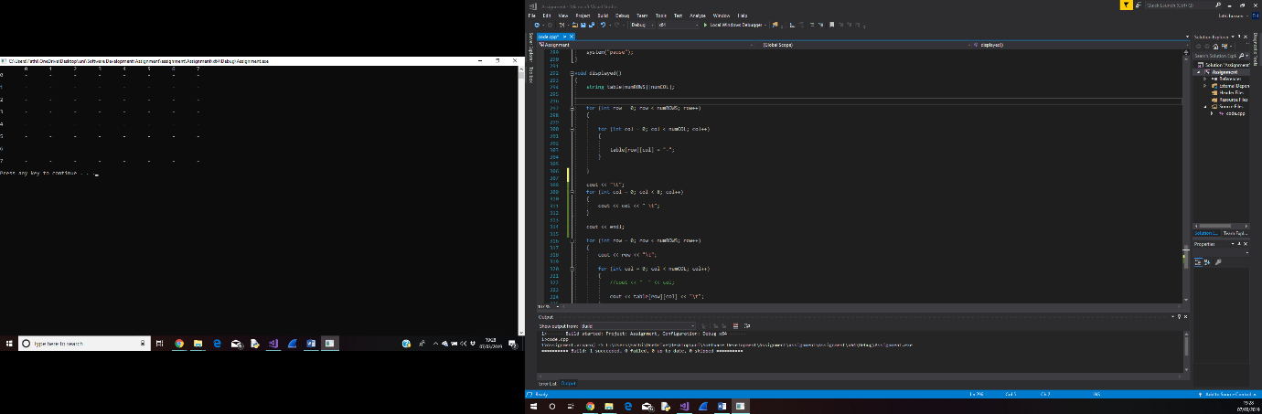

When I creaeted the table, there was issue that I was having with the function and it was passing arrays to the function as an argument.
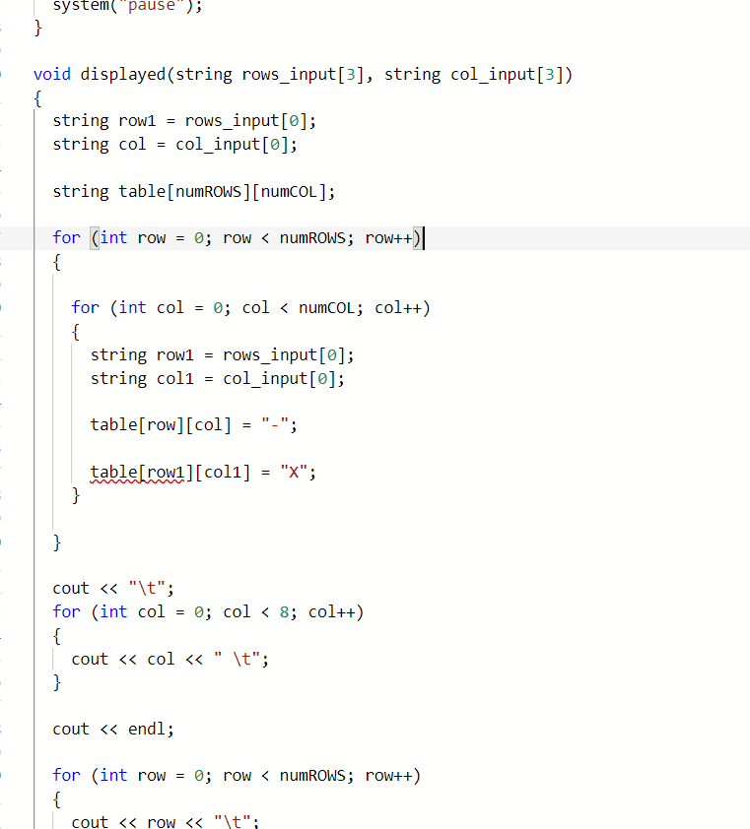

finally passed the player choice as an argument to a function.
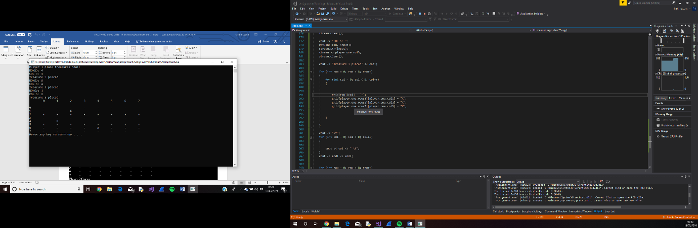

One of the main issues that I was having was, when the user enters the guess the program should output (you have found the treasure) if the player is correct.
As you can see, the screen shot when the player is correct the for loop is outputting many times (you have found the treasure).
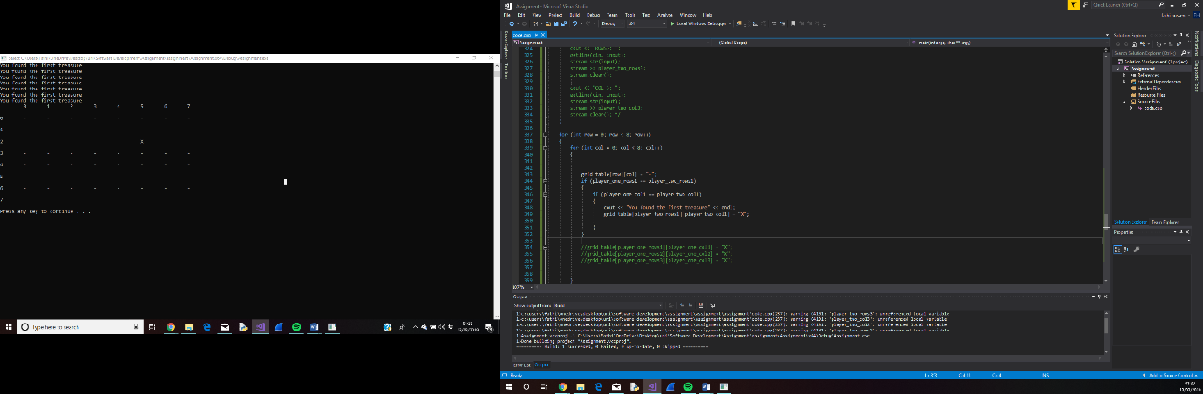

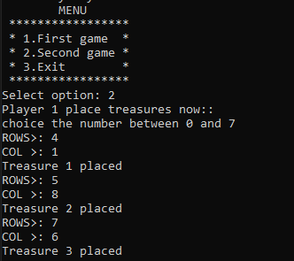
After the player one choice the game from the menu, here as you can see the player enters the 7 numbers and the once the player one hides a treasure. the program tells the user that the treasure is hidden now.

Here player two is making guesses and the player two is chosen (4, 1), then the player two found the first hidden treasure.


