NAME: ADEBOMI OLUYINKA SALU
STUDENT NUMBER: 1809923
MODULE CODE: LCMB7000
MODULE NAME: HUMAN RESOURCE MANAGEMENT
LECTURER: DR GLADIUS KULOTHUNGAN
ASSIGNMENT TITLE: 1
SUBMISSION DEADLINE: THURSDAY 13TH JANUARY 2022
WORD COUNT:

TABLE OF CONTENT

INTRODUCTION 3
OVERVIEW OF COMPANY 4
HUMAN RESOURCE STRATEGY IN WAITROSE & PARTNERS 4-5
PEOPLE RESOURCING 5
WORKFPRCE PLANNING 5-6
THE EXTERNAL ENVIRONMENT 6-7
COVID-19 PANDEMIC AND BREXIT 7
EFFECT OF COVID-19 AND BREXIT ON HRM STRATEGY IN WAITROSE 8
APPLICATION AND ANALYSIS OF AN HRM MODEL TO ADDRESS THE CHANGES CAUSED BY COVID-19 AND BREXIT 8-10
RECOMMENDATIONS 10-11
CONCLUSION 11
REFERENCES 12-14

INTRODUCTION
Human Resourcing in an organisation is believed through research and evidence that it is normally affected and informed by internal and external factors which invariably influences policies, procedures, processes, and strategies embraced by the organisation. Research has found that Human Resource Management (HRM) is looked at from two perspectives which are, ‘Personnel Management’ and ‘Management of People’ (Torrington, et al., 2014). The first perspective of personnel management means a body of management activities whilst the second perspective can be described as the approach employed in carrying out the activities as further explained by the authors. Broadly, it can be surmised that HRM activities involves “human capital management, knowledge management, organisational design and development, resourcing (workforce planning, recruitment and selection, talent management), performance management, learning and development, reward management, employee selection and employee well-being” (Armstrong, 2008).
The internal and external environmental factors play a significant role in the effectiveness of an organisation by the considerable influence it has on how it functions, and is impacted by social, legal political, technological, and economic issues (Armstrong, 2020). In this report, emphasis will be laid on the external environmental factors especially the Covid pandemic and Brexit; the changes it has made in relation to people resourcing strategies of a chosen organisation. In addition, this report will also be assessing and evaluating how the organisation responded to the changes in the external environment (especially Covid-19 and Brexit) within their resourcing strategies. The chosen organisation is Waitrose Limited, a supermarket company.
The first part of this report will present the overview of Waitrose as an organisation that is part of John Lewis Partnership. The second part will be looking at the human resourcing strategy of the company with focus on Strategic Human Resource Management (SHRM) in general and specific to Waitrose; including the organisation’s People Resourcing and Workforce Planning. The next part of this report will explore the changes in the external environment and its effect on human resourcing in Waitrose & Partners. Next is the critical analysis of these external changes in relation to the company’s human resource strategies and steps taken to address these changes with the application of HRM framework or models. The final section will be based on recommendations on identified gaps and conclusion.

OVERVIEW OF COMPANY
Waitrose and Partners “A Supermarket with Ethics and Ambition” came into being in 1904 on the Acton high street through Wallace Wyndham Waite, Arthur Rose, and David Taylor, with Taylor leaving the business two years later leaving Waite and Rose hence becoming Waitrose Ltd (Waitrose, 2021). The business continued to grow despite Rose also leaving a few years later due to ill health with Waite’s stewardship. Waitrose Partnership and John Lewis Partnership merged in 1937 and has remained partners till date, as reported in the company history. The first supermarket was opened in 1955 in Streatham, London and by 2004, the business has grown to over 200 branches including some abroad and the growth of online shopping (Waitrose, 2021). Waitrose nowadays is regarded and recognised globally as an international food retailer from their export to more than fifty countries, their branded and own-label products. In the 1980s, the integration of organic produce into the business model and business partnership with the Royal family helped their growth amongst competitors especially in the U.K.
Waitrose’s model of co-ownership of all their employees started over 100 years ago through the vision of John Lewis & Partners’ founder named John Spedan Lewis from the vision and values of the organisation. John Lewis & Partners together with Waitrose & Partners has the largest employee-owned business in the U.K., placing the Partner’s well-being and satisfaction at the core of their business strategy (Indeed, 2021).

HUMAN RESOURCE STRATEGY IN WAITROSE & PARTNERS
Waitrose’s strategy is based on the foundational values and beliefs of the founder who had the extraordinary vision of all employees becoming Partners of the organisation because he realised the importance of paying attention to their wellbeing and opinion for a successful organisation (John Lewis, 2018). Waitrose organisational culture plays a big part in their human resource strategy. Once you become an employee of Waitrose & Partners and John Lewis & Partners, you are regarded as a shareholder who enjoys the financial benefits and remunerations from the profits of the organisation. As a result of all employees being co-owners, there are no external shareholders which invariable means that all Partners have freedom to make collective business decisions and financial investments in which the profits are shared through an annual Partnership bonus (John Lewis, 2018).
Organisations should have human resource strategies to meet the business goals which leads to an understanding of Strategic Human Resource Management (SHRM). Providing a structure that links people management and developmental practices to continuing human resourcing within the organisation’s purpose and developing business (CIPD, 2021). Armstrong & Taylor (2014), stated that the foundational purpose of SHRM is for an organisation to build their organisational ability by making certain they have engaged, committed, skilled and motivated employees needed for achieving and maintaining competitive advantage.
Therefore, Waitrose HRM strategy begins with recruitment and selection of the right people who fits into their culture through the interview process, followed by training and developing those selected which takes the form of on-the-job training and continuous learning and development. Part of their organisational policy is to provide avenues for developing their employees through career progression training for staff retention. A major human resource strategy of Waitrose is in the Partner’s Apprenticeship programme offered to their employees. As everything the organisation does is powered by their unique purpose of “putting the happiness of our Partners” at its core; and the Partnership values which defines the partner’s commitment to their jobs. Waitrose & Partners have run 25 Apprenticeship schemes since the U.K. government levy was introduced in 2017, covering areas in Leadership, Butcher and Fishmonger, Sewing Machinist, Human Resources and Advanced CIMA qualifications (JLP, 2021).
PEOPLE RESOURCING: This involves the use of relevant workforce planning data through the right sourcing approaches and digital tools to draw in people with diverse abilities and skills into an organisation, through recruitment into the right roles at the right time (CIPD, 2021). Waitrose utilises their website and other job agencies to implement their people resourcing strategy. For example, the John Lewis & Partners (JLP) jobs website which covers Waitrose & Partners, states the policy that drives the company people resourcing and make use of ‘Indeed Job Search’ platform for posting job advertisements. Their policy also involves supporting responsible sourcing, building a long-term relationship with the farmers and suppliers for the benefit of their customers receiving the best food and drink possible (Waitrose, 2021). Emphasis is however laid on joining Waitrose to become a co-owner with career opportunities which develops employee growth with a stake in the business.
WORKFORCE PLANNING: Workforce Planning is about matching employees with the right job to improve productivity in an organisation. It is a crucial part of human resource strategy to align organisational policies, purposes, vision, and mission to get the people resourcing right. Workforce planning is having a re-emergence in most organisations especially in the current unsettling times of Covid-19 and Brexit in the U.K. Strategic workforce planning and its implementation has become important for business survival in more turbulent environments because of the issues of competing for skills and talents and restraining payroll costs (Torrington, et al., 2014). CIPD (2021), agrees with this by highlighting the advantages of workforce planning which are: reduction of labour cost to favour workforce deployment and flexibility, identifying skills gap and areas of succession risks, appropriate strategies for talent management and people development, staff retention initiatives, work-life balance improvement, and response to changes in the educational system regarding recruitment and training.
Waitrose had to introduce a workforce management solution package in 2013 to enable an efficient time and attendance management at a newly opened distribution centre in Leyland. Waitrose recognised that the paper-based workforce management process formerly being used was not serving the needs of over 300 employees, therefore decided to set up the new technology to aid consistent and accurate payroll; record working time and overtime and holidays, lateness and introduce flexible working hours and time banking (Briggs, 2013). As a result of the current climate of Covid-19 and Brexit, Waitrose has developed a five-year Partnership Plan which started in 2020, focusing on three key areas of championing equality, wellbeing, and sustainable living, for the benefit of Partners, customers, suppliers, and society, which shapes their employment practices (John-Lewis-Partnership, 2021).

THE EXTERNAL ENVIRONMENT
Researchers, Academics and Authors in the field of Human Resource Management have come up with their perspective of the factors in external environment which influences or causes human resource strategies in a company to change. The external environment in general terms comprises political, economic, social, legal developments and competitive pressures in addition with accelerating and embracing new technology (Armstrong, 2008). Another perspective of the external environmental factors revolves around a wider outlook as illustrated in Fig. 1 below:
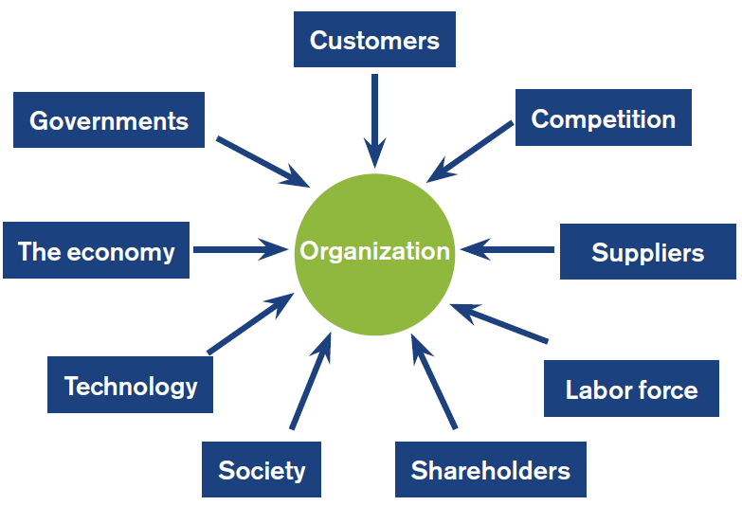
Fig. 1 The External environment (Source: HRM module)
These external factors cannot be controlled by the organisation and have an influence on various human resource operations. Also, the external factors work together with internal environment such as culture, structure, and strategy to meet organisational requirements and goals for the future (Lussier & Hendon, 2020). In essence, the human resourcing department of organisations set out to employ people who would welcome and fit into their ultimate strategic goals as evident with Waitrose’s recruitment strategy. In addition, climate change is at the forefront of Waitrose strategy as it is included within the external environment risks as a change that can impact delivery of some of its strategic objectives and business operations (John-Lewis-Partnership, 2021).

COVID-19 PANDEMIC AND BREXIT
Covid-19 is a disease caused by a virus known as SARS-CoV2 which causes mild and severe illness that could lead to death through its spread from an infected person to another (CDC, 2021). The Covid-19 pandemic and Brexit has impacted heavily on human resource management in organisations worldwide. Gifford & Green (2020), agrees by stating that organisations and the labour market will be impacted resulting in extensive work and people management which gives greater meaning to the term ‘VUCA’ meaning volatility, uncertainty, complexity, and ambiguity. As a result, and due to government advise changing as the virus mutates into new variants, furlough ending, there is enormous uncertainty for job security, people’s sustenance, organisational productivity, and the economy at large. The world of work as it was known has changed with organisations having to become more agile in their strategy.
Brexit is the removal of the U.K. from the EU Single Market and Customs Union with the EU laws no longer applies to the U.K. leading to changes in free trade and friendly relationships with U. K’s European neighbours (GOV.UK, 2021). As reported on the CIPD Brexit hub, Brexit has brought about three milestones which are that; new points-based immigration system commences from January 1st, 2021, extension to the deadline given to those qualified for the EU Settlement scheme (EUSS) and EU/EUSS/EAA/Swiss members right to work in the UK must be checked by employers.
As a result of the changes from Covid-19 and Brexit on the business environment and dealings, it is pertinent to predict that crucial to the long-term adjustment of these occurrences are investment in both physical and human capital (Lyon & Dhingra, 2021).

EFFECT OF COVID-19 AND BREXIT ON HRM STRATEGY IN WAITROSE
Waitrose & Partners have seen some changes in strategy which can be classified as tough on employees and on the other hand beneficial to them. A message from the Chairman on the 2021 Annual report gives credit to the commitment and dedication of its Partners through the unimaginable difficult times of lockdown, giving credence to the creativity, agility, and adaptability of the employees because of being Partners of the business. One of the early strategies adopted was that ahead of it becoming law, to be the first organisation to introduce social distancing, rapid testing, and investing more on mental health support for Partners because of its awareness (John-Lewis-Partnership, 2021). Another new strategy saw the Partnership board deciding not to pay the yearly bonus to its Partners which was had a negative impact on the Partner’s (employees) finances. However, it was a tactical and financial decision to help the business return to sustainable profit, though a 25% shopping discount and free food provided on site was introduced during the three lockdowns (John-Lewis-Partnership, 2021).
Waitrose have currently introduced a five-year Partnership Plan (strategic review) in a bid to reinvest their profits back into the business to enable a return to benefit Partners and customers, started at the start of the financial year February 2021 till end of the financial year in January 2026 (John-Lewis-Partnership, 2021). Covid-19 has seen more impact on Waitrose employment plan which has led to a reduction of the total population of its Partners (employees) where about 1800 had to be made redundant. Brexit’s impact on Waitrose’s business has been felt mostly with the repercussions of EU nationals returning to their country leaving a gap and big impact on shortage of lorry drivers. In addition, lorry drivers requiring testing at various ports due to post-Brexit customs have had a disruptive effect on people resourcing for Waitrose. This five-year Partnership plan supports Armstrong (2008), suggesting that there has been pressure for businesses becoming ‘lean and mean’ with downsizing through cutting down layers of supervision and management as Waitrose are putting in place. In contrast to the ‘lean and mean’ strategy however, Waitrose have seen increases to its online orders with 240,000orders a week (Since February 2020), with the support of a new Customer Fulfilment Centre in Enfield, London with the support of 850 Partners (employees), old and new (John-Lewis-Partnership, 2021).

APPLICATION AND ANALYSIS OF AN HRM MODEL TO ADDRESS THE CHANGES CAUSED BY COVID-19 AND BREXIT
Human resources models and frameworks are essential tools which HR executives apply to enhance organisational performance. Business models is central to HR leaders’ strategy in aiding the identification of their function of people processing to add value to the business (Armstrong, 2008). Vulpen (2021), explained how some of these models namely, the 8-box model by Paul Boselie, The Harvard Framework, The Hr Value Chain model, The Standard Casual Model of HRM and The HR Value Chain advanced Model, can be used in organisations. In addition, other authors have also mentioned the Guest model of HRM, Best Practice Model, Story’s Hard and Soft HRM, Patterson’s Model of HRM and Best Fit or Contingency Model, whose functions are to explain the nature and importance of human resources, validate certain HR practices and serves as an analytical framework for Human resource management.
Applicable to Waitrose & Partners amongst these models and framework is ‘The 8-box model of Paul Boselie although another point of view suggests that ‘The Harvard Framework’ also fits their HR strategy. The Harvard framework with its five components as shown in Fig. 2 is known to take a more comprehensive and integrated approach to human resources which compares in similarities with the 8-box Model.
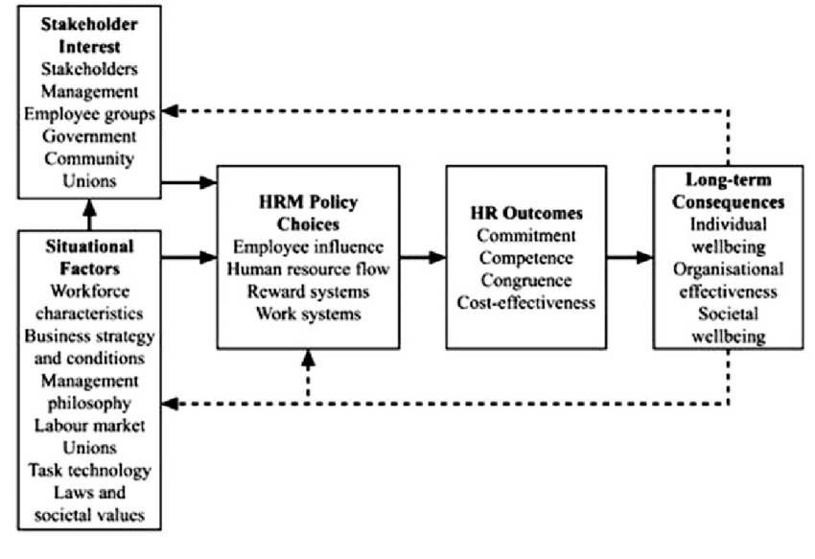
Fig. 2 The Harvard Framework (Source: ResearchGate)
It is one of the leading systematic, and flexible models in its approaches to human resources being used by organisations (Greenberg, 2021). The left side of the framework is the ‘stakeholder interest’ which comprises of management, shareholders, employee groups, the government and community unions (Vulpen, 2021), which defines the stakeholders in Waitrose & Partners and their policies. On the same left side are the ‘situational factors’ guiding the stakeholder’s interests which includes the business strategy and conditions in addition to the management philosophy or policies as included in the 8-box model. The connection to Waitrose is the fact that their Partner’s interests are influenced by the company business strategy, and policies. Both the stakeholder interest and situational factors guides HRM policy choices like recruitment and selection, training, work, and reward system (Vulpen, 2021). These four policy areas lead to the next component of the ‘four C’s’ in HR outcomes which are Commitment, Competence, Congruence and Cost-effectiveness as proposed by Beer et al (1984). If these outcomes of the four C’s become successful, they lead to ‘long-term consequences’ of which benefits are individual wellbeing and organisation and social wellbeing of stakeholders.
Then again, it could be argued that the 8-box model takes cognizance of the external factors influencing the HR strategies or policies like Covid-19 and Brexit have done more than any other models. As can be seen in the change of legislation and government rules because of the pandemic and Brexit, on working hours, shortage of employees, social distancing affecting the number of staff, all impacts on human resourcing strategies.

RECOMMENDATIONS
Taking into consideration the how Waitrose & Partners have used the existing human resources models to address the problems caused by the external factors of Covid-19 and Brexit, the following recommendations are suggested:
- Collaborative models: Rather than be rigidly operating within one model, there should be a collaboration of models that would work like having a hybrid working strategy. For this to work, it is important that companies design detailed processes, set up capabilities which facilitates decision making within teams (Jost, et al., 2020). For instance, Waitrose & Partners could adopt the Warwick model which is a refined form of the traditional Harvard model (Greenberg, 2021), The Warwick model sets out to balance the external influences with the internal influences on the HR strategies
- Choose models that fit organisation’s changing needs: As the impact of Covid-19 restrictions and changes to immigration rules due to Brexit are still being felt which has resulted to staff shortages in HGV drivers, Waitrose should consider more innovative methods as other Supermarkets have done. For instance, collaboration with organisations like Tesco who have hired dedicated trains to distribute stocks in addition to John Lewis & Partners hiring their own cargo ships.
- Changing the operating model: Waitrose should embrace agility regarding their HRM strategy. In agile organisations, as their processes change so should the people models do especially in the times of a worldwide pandemic, to meet the next wave of productivity, speed, customer engagement and employee-engagement benefits (Jadoul, et al., 2020). Waitrose & Partners should look inwards to be able to meet the demands in their supply chain.

CONCLUSION
Covid-19 pandemic has happened and is still happening, so is the repercussions of Brexit which has led to the current and predicted changes in the people resourcing strategies of most organisations. As a result, companies and organisations have had to change their human resourcing strategies in response to these external environmental changes by adopting new models and frameworks or fine tuning these existing models. People resourcing and workforce planning have had to take the forefront in organisational strategies due to people relocating because of Brexit, reskilling, retraining, and reenergising and prioritising mental health and wellbeing to Covid-19.
Waitrose & Partners believes that their Partners are central to the differentiation of the business, not just about sharing profits but sharing knowledge and power to shape the Partnership’s future and to ensure that their Partner’s opinion in decision making is intrinsic to the employee ownership model for long term sustainability and success (John-Lewis-Partnership, 2021).

REFERENCES

Armstrong, M., 2008. Armstrong's Handbook of Strategic Human Resource Management. 5th ed. London: Kogan Page.
Armstrong, M., 2020. Armstrong's Handbook of Human Resource Management Practice, London: Kogan Page.
Armstrong, M. & Taylor, S., 2014. Armstrong's Handbook of Human Resource Management Practice. 13th ed. London: Kogan Page.
Briggs, F., 2013. Waitrose picks workforce management solution from Kronos for new RDC. [Online]
Available at: https://www.retailtimes.co.uk/waitrose-picks-workforce-management-solution-from-kronos-for-new-rdc/
[Accessed 1st January 2022].
CDC, 2021. Covid-19 Frequently asked questions. [Online]
Available at: https://www.cdc.gov/coronavirus/2019-ncov/variants/omicron-variant.html
[Accessed 4th January 2022].
CIPD, 2021. Resourcing: Identifying, attracting and recruiting to get the right people for the organisation. [Online]
Available at: https://peopleprofession.cipd.org/profession-map/specialist-knowledge/resourcing#gref
[Accessed 1st January 2021].
CIPD, 2021. Strategic human resource management. [Online]
Available at: https://www.cipd.co.uk/knowledge/strategy/hr/strategic-hrm-factsheet#gref
[Accessed 30th December 2021].
CIPD, 2021. Workforce planning practice. [Online]
Available at: https://www.cipd.co.uk/knowledge/strategy/organisational-development/workforce-planning-practice
[Accessed 1st January 2021].
Gifford, J. & Green, M., 2020. How could COVID-19 change the world of work?. [Online]
Available at: https://www.cipd.co.uk/news-views/changing-work-views/future-work/thought-pieces/covid-19-change-work#gref
[Accessed 4th January 2022].
GOV.UK, 2021. Summary: The UK’s new relationship with the EU. [Online]
Available at: https://www.gov.uk/government/publications/summary-the-uks-new-relationship-with-the-eu
[Accessed 4th January 2022].
Greenberg, A., 2021. The Ultimate Guide to Human Resources Models and Theories. [Online]
Available at: https://www.contractrecruiter.com/human-resources-models-theories/
[Accessed 5th January 2022].
Indeed, 2021. About Waitrose & Partners. [Online]
Available at: https://uk.indeed.com/cmp/Waitrose-&-Partners/about
[Accessed 29th December 2021].
Jadoul, Q., Nascimento, A., Salo, O. & Willi, R., 2020. Agility in time of Covid-19: Changing your operating model in an age of turbulence. McKinsey & Company, 18th November, pp. 1-15.
JLP, 2021. Partnership Apprenticeships. [Online]
Available at: https://www.jlpjobs.com/apprenticeships/
[Accessed 30th Decmber 2021].
JohnLewis, 2018. Welcome to our Partnership. [Online]
Available at: https://pdw.partnerintranet.co.uk/JPDW/media/4892879/20180109-welcome-to-our-partnership-booklet
[Accessed 29th December 2021].
John-Lewis-Partnership, 2021. John Lewis Partnership Plc Annual Report and Accounts 2021, s.l.: John Lewis & Partners.
John-Lewis-Partnership, 2021. Our Partnership Plan, London: John-Lewis-Partnership.
Jost, G., Mahadevan, D., Pralong, D. & Sieberer, M., 2020. How COVID-19 is redefining the next-normal operating model. Mckinsey Quaterly, 10th December, pp. 1-15.
Lussier, R. N. & Hendon, J. R., 2020. Fundamentals of Human Resource Management: Functions, Applications, Skill Development, London: Sage.
Lyon, J. D. & Dhingra, S., 2021. The impacts of Covid-19 and Brexit on the UK economy: early evidence in 2021, London: Centre for Economic Performance.
Torrington, D., Hall, L., Taylor, S. & Atkinson, C., 2014. Human Resource Management. 9th ed. harlow: Pearson.
Vulpen, E. V., 2021. 5 Human Resources Models Every HR Practitioner Should Know [blog]. [Online]
Available at: https://www.aihr.com/blog/human-resources-models/#author
[Accessed 4th January 2022].
Waitrose, 2021. Company History. [Online]
Available at: https://www.waitrose.com/ecom/content/about-us/company-information/company-history
[Accessed 29th December 2021].
Waitrose, 2021. The Waitrose & Partners Difference. [Online]
Available at: https://www.jlpjobs.com/waitrose-and-partners/
[Accessed 1st January 2021].

