University of Wales Trinity Saint David
School of Engineering

Technical Report

Steffan Robinson
1801468
BEng Automotive
4/2/19
M4X02063
Engineering Applications & Study Skills
Introduction
There weren’t any aims or objectives to this session it was more of a benefit session for us to gain a better understanding rather than more objective based. We had some clutches, flywheels and gearsets laid out on different tables Barry lectured us on them firstly and then gave us a chance to hold/feel a get a better knowledge of how the components work. He then moved onto differentials and their importance in the handling of a vehicle. He told us how differentials have a massive role in the handling of a car. Barry told us that we would be starting by looking at the flywheels and how you can have various types and how different flywheels get used for different vehicles. We then went onto clutches where Barry told us about various clutches and what makes some better than others. Next we discussed different gear sets and explained the format of how we change gear in our cars. Finally, we spoke about “diffs” or differentials and how important they are in the handling of vehicles and their importance in the drive of the wheels.

Background Research
There wasn’t any background research I had to conduct, there wasn’t many legislations into where we did the session. We did it in a regular workshop which had some metal work benches and under a few of the benches there were engines and engine parts. There were also a few benches at the back that were being worked on that had a barrier stopping us from reaching them. We had to wear our steel toe capped boots to protect our feet from anything getting dropped on them, also lab coats to protect our clothes from and grease or oil from the engine components. We also got given the option to wear gloves in case anyone had dry or sensitive hands to the oil. We also had to be careful while handling some of the components because there were many holes and cogs Barry said for us not to put our fingers too far into the parts because it could get stuck or get injured from doing so. We were also told to be careful of the metal work benches because they were sharp at the corners and we didn’t want anyone walking or stepping into it causing injury.

Methodology
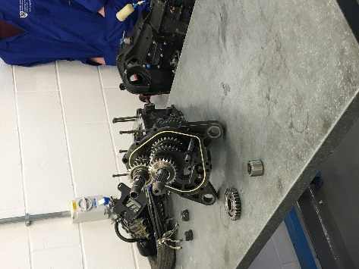
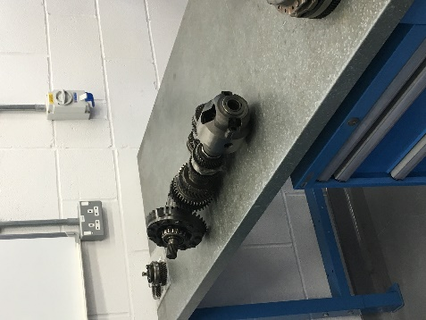
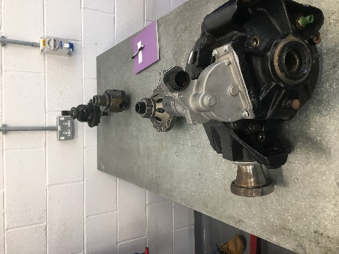

Here are some pictures of the equipment we used in the engine workshop session. As you can see, we had various car components including flywheels, clutches gearsets and differentials. Barry then started to discuss flywheels and how they work. He taught us that you must make sure when you’re taking a flywheel off you must put it back on the right way otherwise it will not work. He told us that the weight of a flywheel is important as well with a heavier flywheel it increases the inertia and helps engine speed recovery, whereas a lighter flywheel decreases inertia so that it gives a quicker response to either acceleration or deceleration. He told us that in sports cars where the RPM is constantly changing you need the lightest possible flywheel because it gives that quick response to the acceleration.
He then brought out some clutches for us to hold and have a look at. He told us that the best clutches have better frictional surfaces/ materials to helps its performance. The clutch also must go the right way around otherwise if the rough side isn’t the right side it will cause the clutch to slip. Barry said that a used clutch would have no grip on it and would then begin to slip if it was still in operation. Also, you must make sure that both flywheel and clutch are dry and that there isn’t any oil on them otherwise they will not work properly.
Barry then showed us some gearsets and began to explain them. He said there are two shafts in the transmission system, an input and an output. There are 2 patterns on the input shaft; helical and straight. The output shaft doesn’t always rotate only the gear you’re in does. The whole point of having helical shaped patterns are to make the transmission system be a lot smoother because the helical gears are at an angle, they create a thrust load on the gear when they mesh. The only gear with a straight pattern is the reverse gear.
We finally had a look at some differentials, differentials are used to transmit the power to the wheels. Barry said that in 4x4 it is important to correctly ratio up the diffs properly otherwise the front wheels and the back wheels would be moving at different speed which could cause the car to brake. In rear wheel drive cars, the rear diff is connected to rear shaft to drive back wheels.

Discussion & Conclusion
At the end of this workshop session I managed to gain a much better of how the different components worked not only individually but as a collective and helped me gain a better understanding of how the car works. I particularly liked the fact that we got to have a feel/hold of the different components to see how they weighed and how they felt. It gave a better understanding of how they worked when you put them into a car. I felt like after having a look at the gearsets I gained a much greater knowledge of how a manual transmission car works and how the gears all link together with different shafts and cogs to help the car move.

