

Website Development
January 16

UWTSD
Authored by: Jake Semmens



Contents
Table of Contents
Contents 2
Abstract 3
Requirements 3
Implementation 4
Validation 11
Evaluation 12
References 14
Appendices 14

Abstract
This report will contain a vast amount of information regarding the website which I have developed called ‘The Boxing Network’. It will go over a variety of subjects regarding the requirements of the website where I will discuss the target audience of the website and how I will accommodate for them, the implementation of the website where I will display screenshots of the website and the validation results of the coding, and the evaluation of the website where I will discuss the websites web usability, accessibility, search engine optimisation and any improvements I believe I could make.

Requirements
The website which I have created is a boxing news website called ‘The Boxing Network’, the website keeps boxing fans up to date with all the latest boxing news, upcoming fights as well as the various champions across the large number of weight divisions and boxing organisations.
The reason why it is so important for boxing fans to have a single website which compiles all the latest boxing news is due to the vast amount of weight divisions and organisations which makes it incredibly difficult for your average boxing fans to keep up to date. There are a total of 17 weight classes and 4 major governing bodies which all have their own champions, this means that across the entirety of men’s boxing there are 68 belts to be competed for.
My main target audience is going to be “18-34 year old’s who make up 56% of boxing viewership”[1], however those aged “55 years old and older make up 16% of boxing viewership”. Although the boxing is a primarily male dominated sport with “43% of men saying they watch boxing”[1] compared to the “26% of women saying they enjoy watching boxing live”[1] there has been a massive increase of interest within the women’s sport, this has been proved in “The world title boxing matchup between Katie Taylor and Amanda Serrano which drew in an audience of 1.5 million making it the most watched female headline boxing match in history”[2]. Furthermore, the number of women participating in boxing has seen a massive increase with “Over 400,000 women being involved in boxing from 2018-2019 in the UK” [3]. Due to the diverse target audience, I have ensured that the website is appealing to those of all genders and ages above 18. To do this I have used a neutral colour scheme which is applicable and associated to the sport itself, I have also ensured that a user-friendly font has been used which ensures that any older aged boxing fans won’t have any difficulties when reading any articles, furthermore, I have ensured that the website can be easily navigated with all sections clearly highlighted and a consistent website design.

Implementation
Home Page
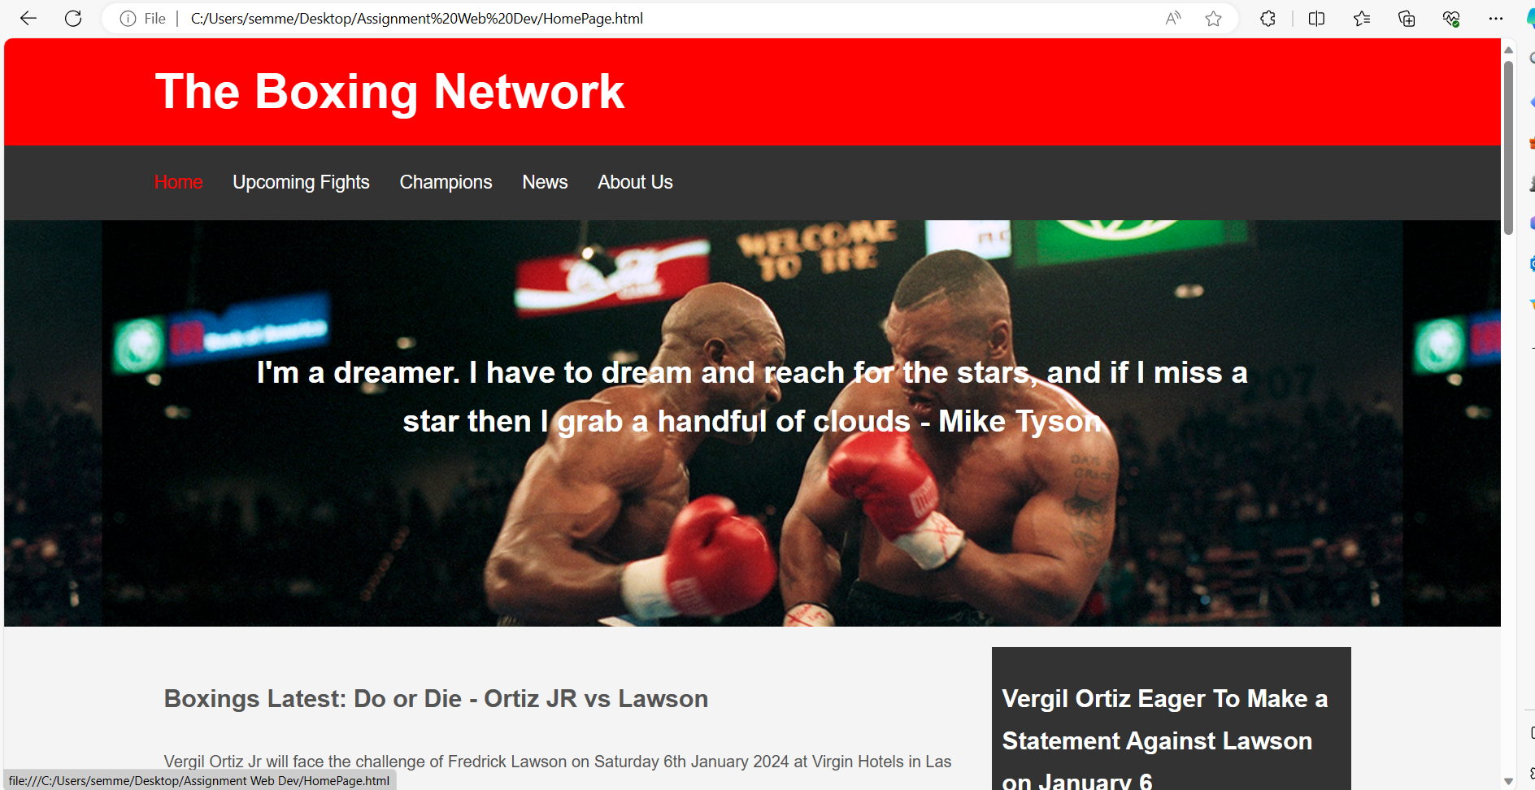
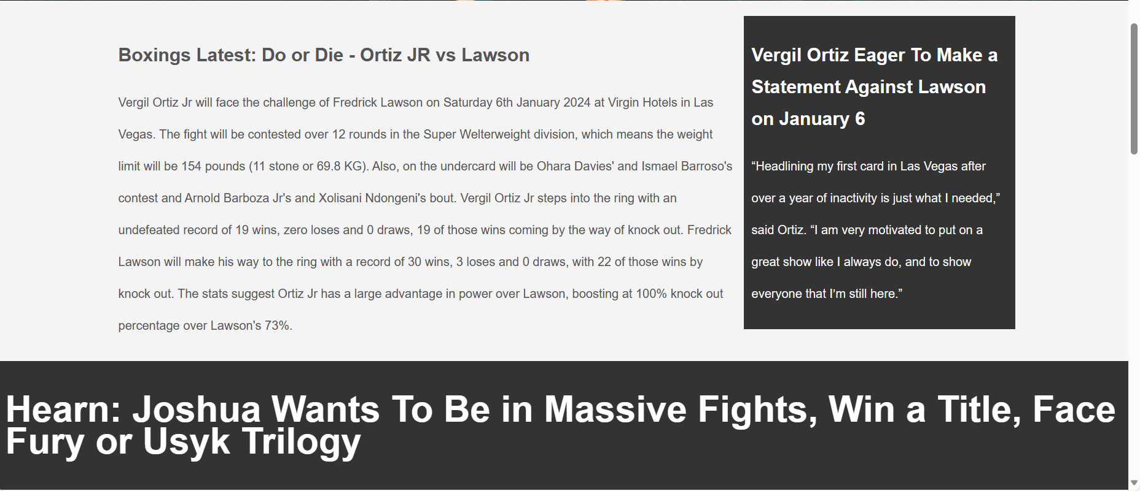
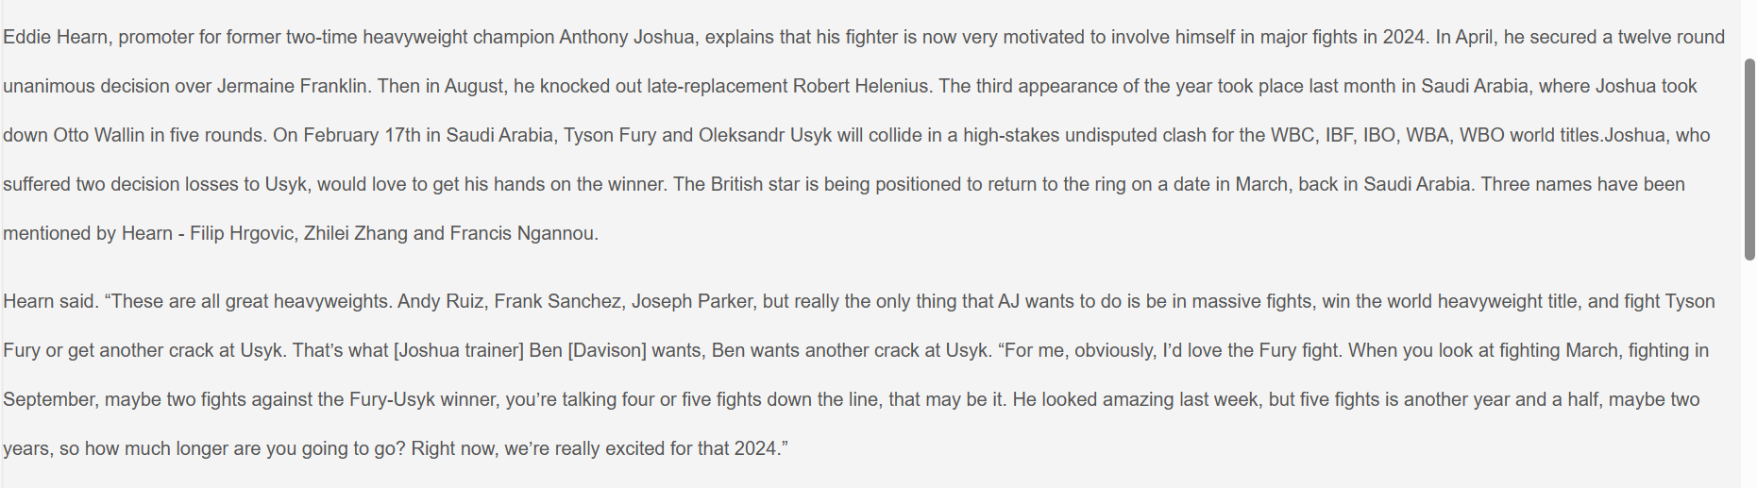
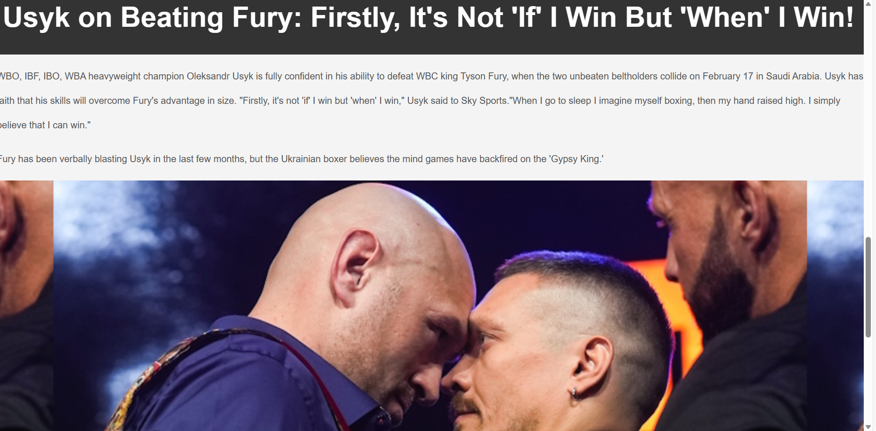
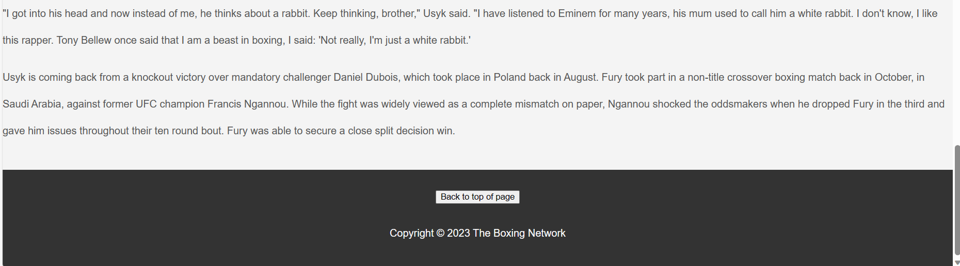

Upcoming Fights
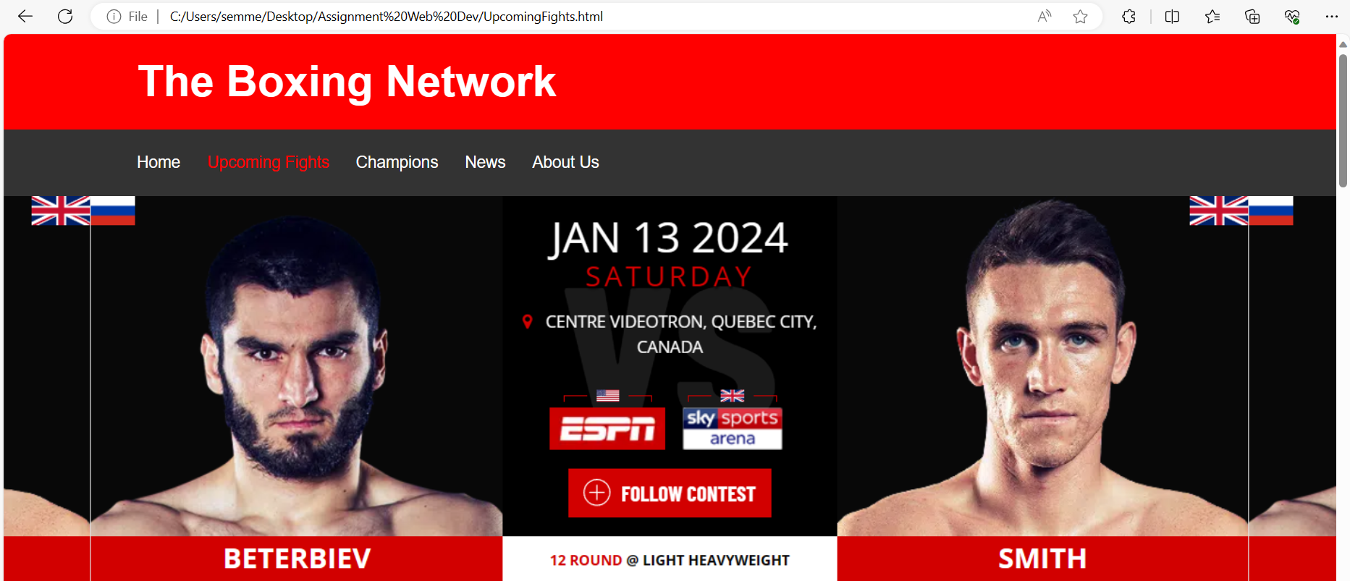
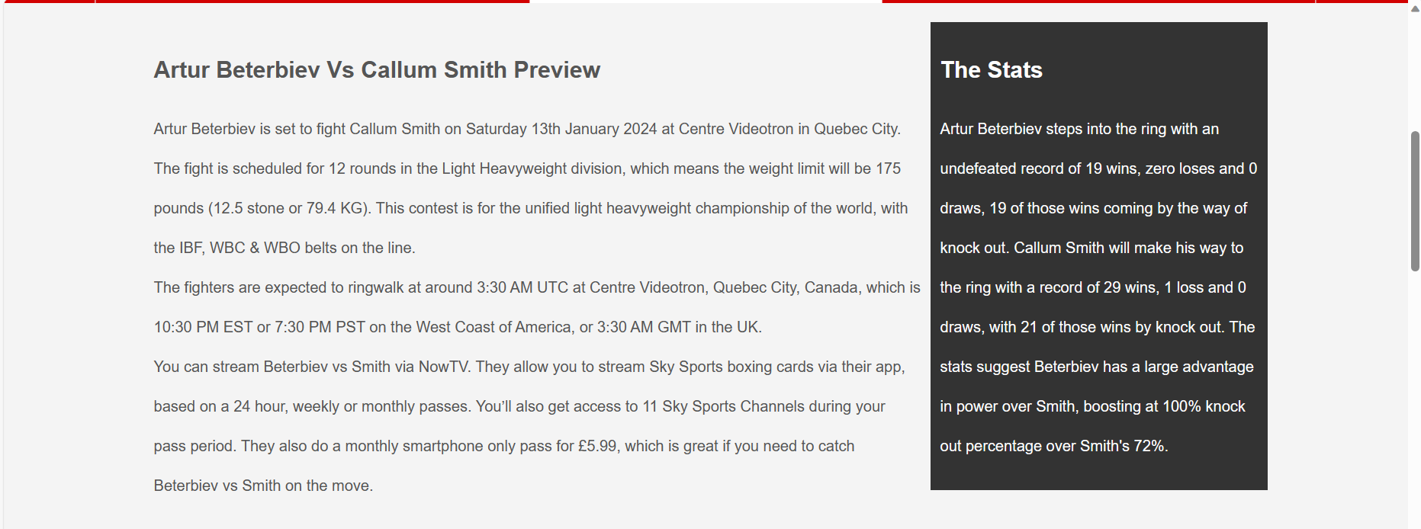
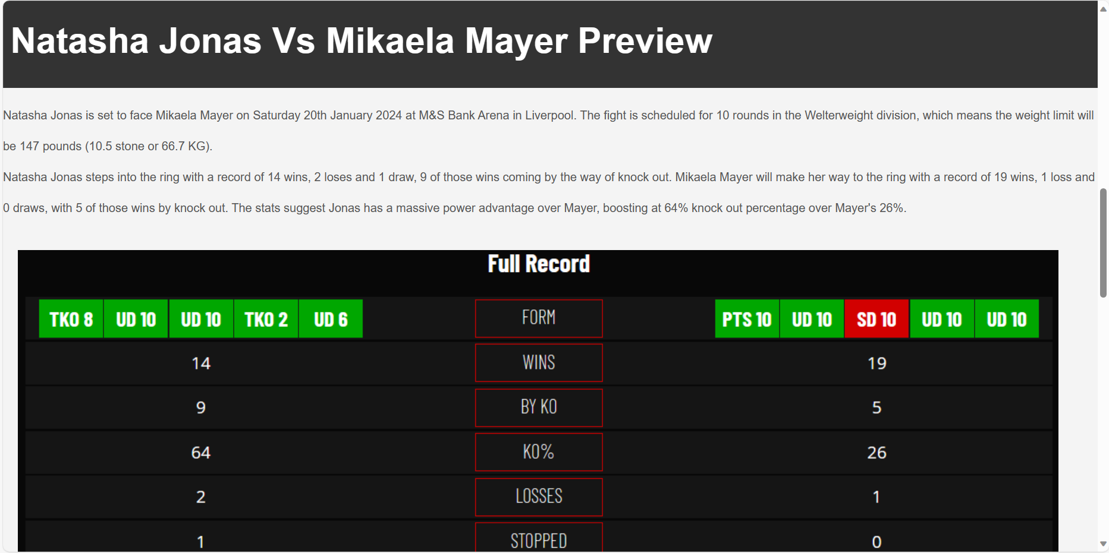
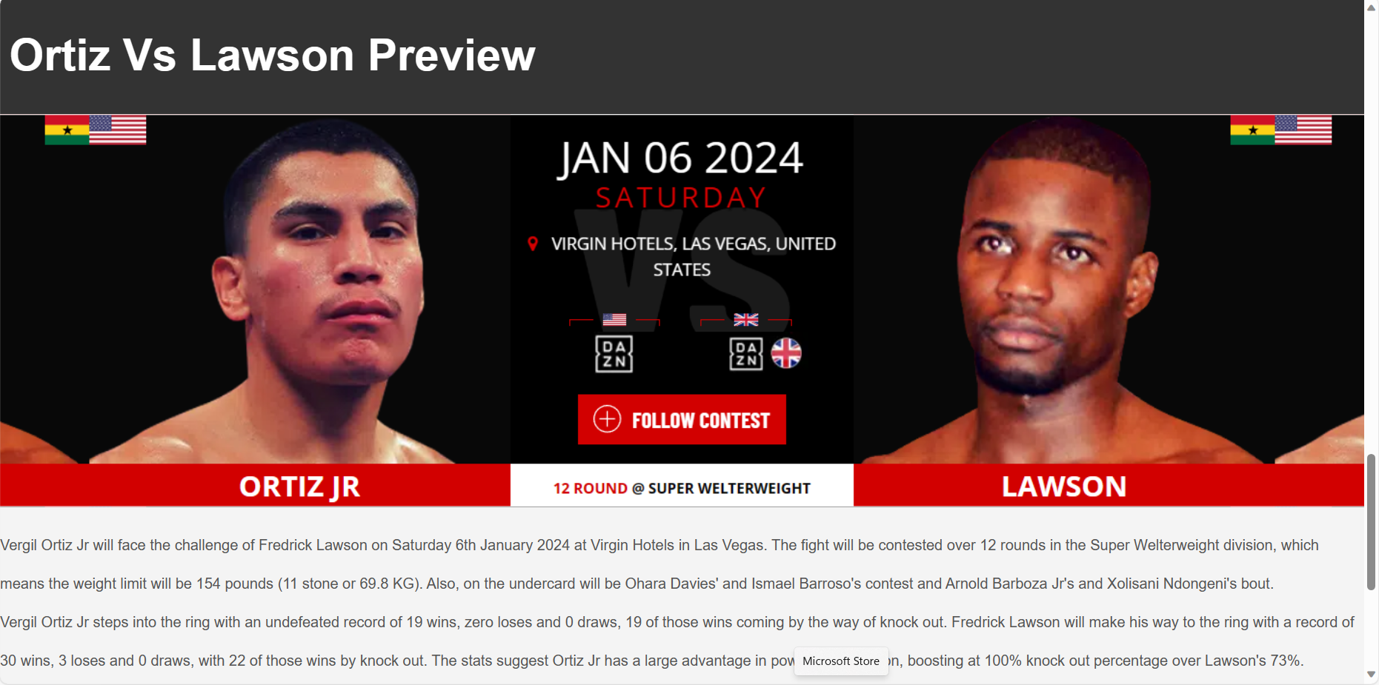
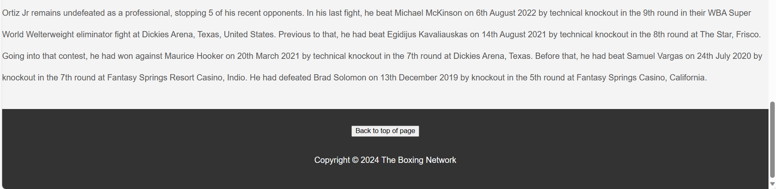
Champions
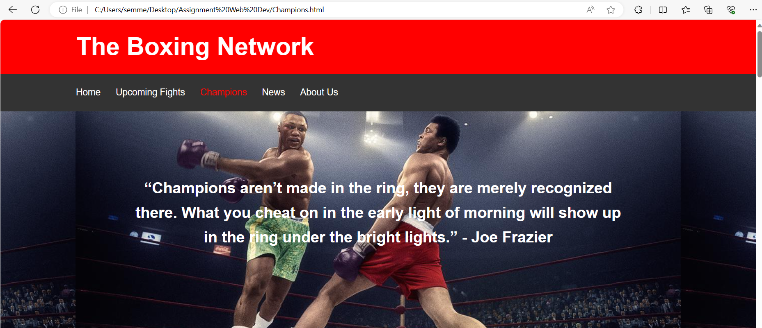

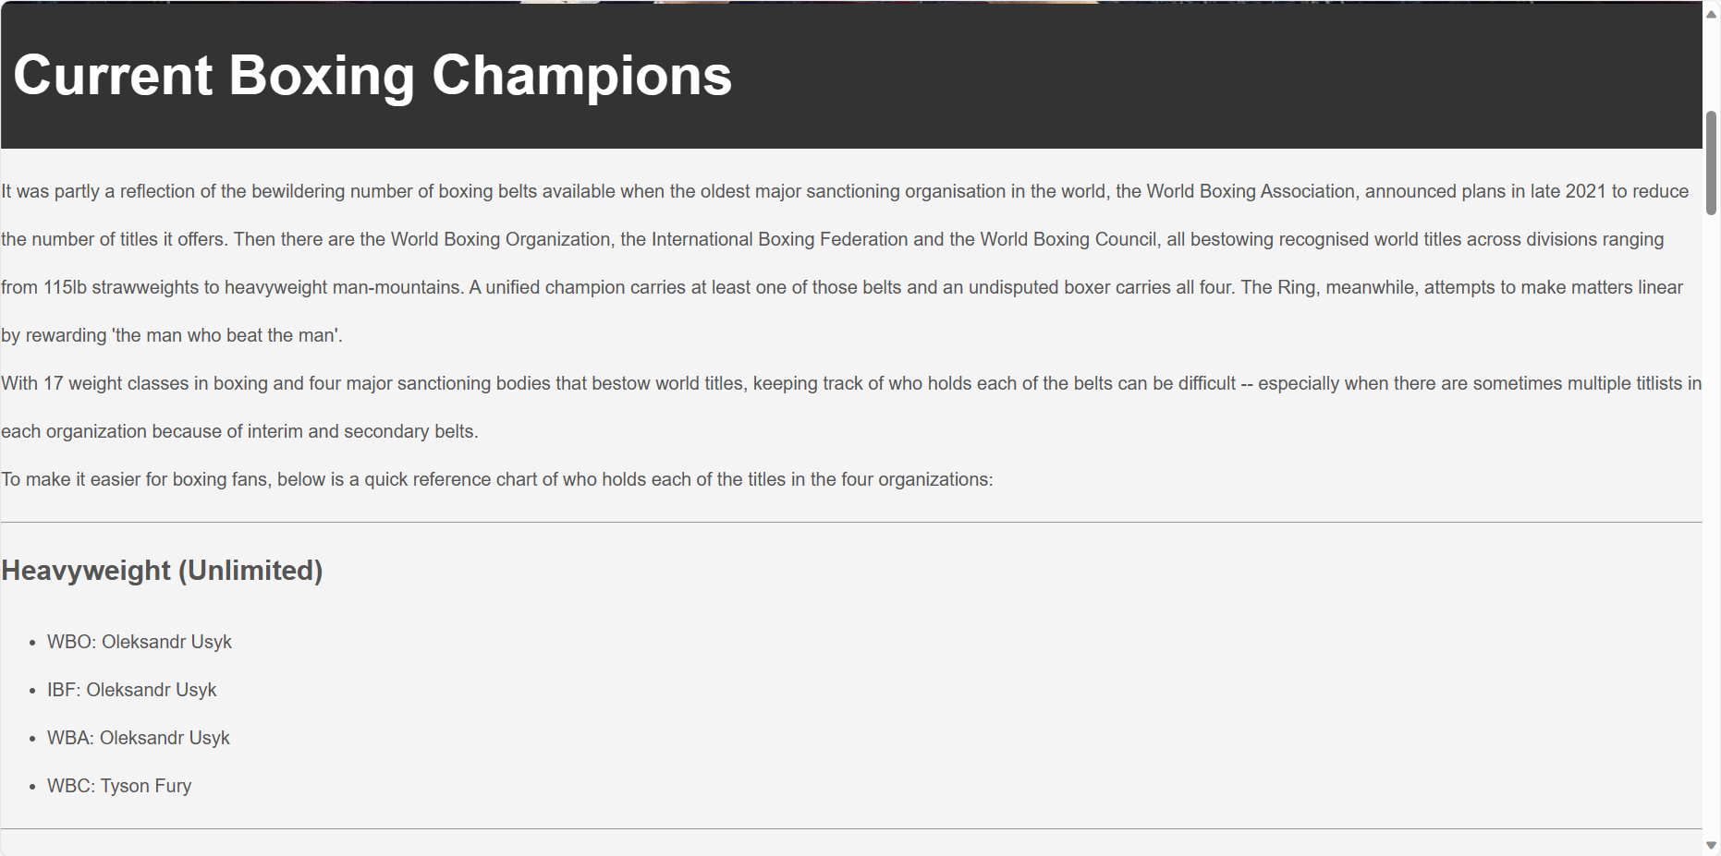

News
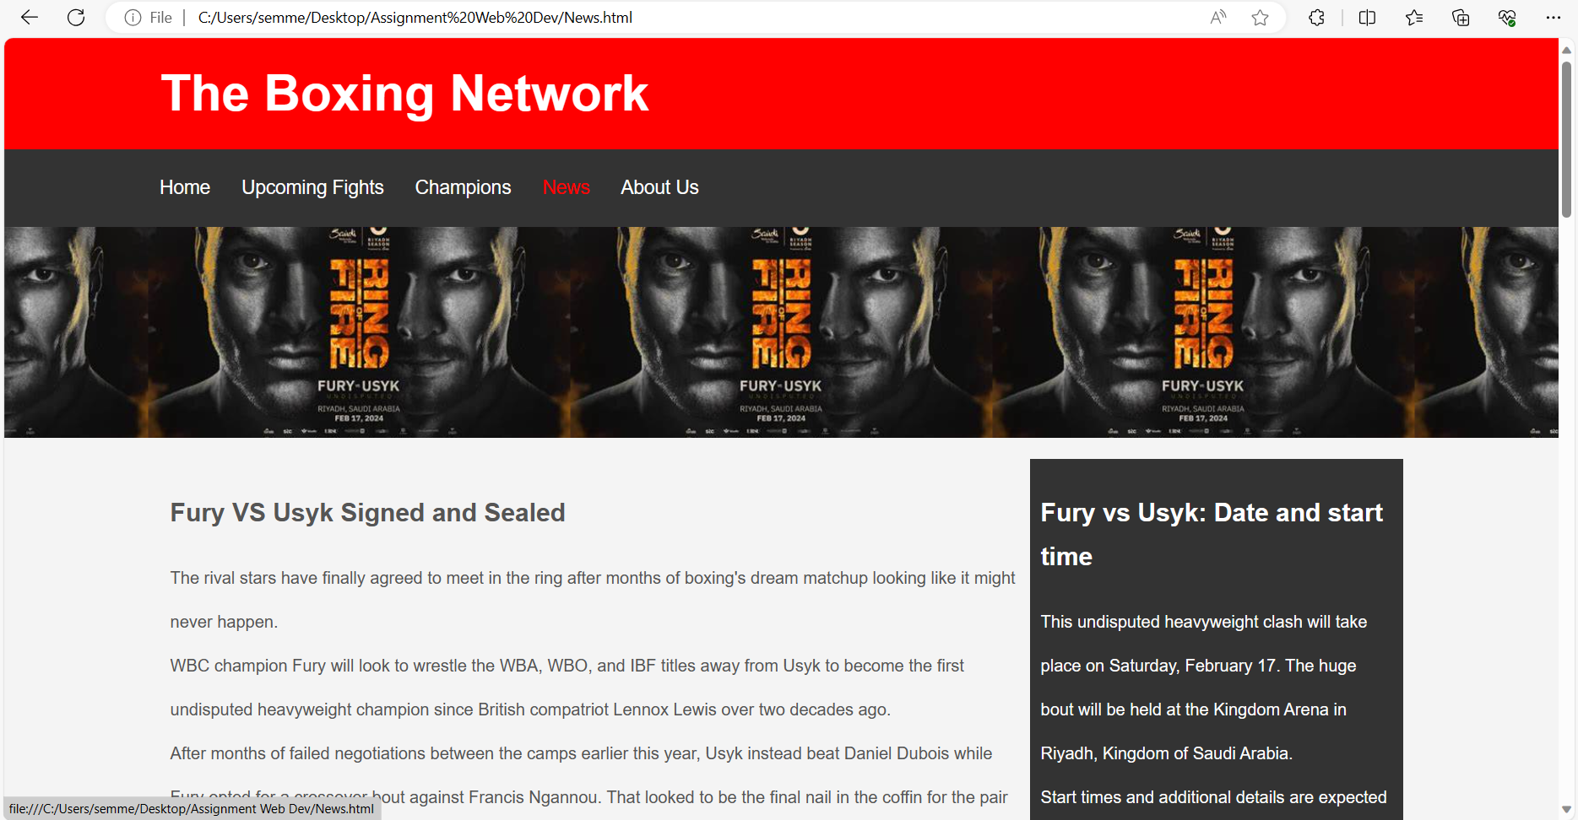

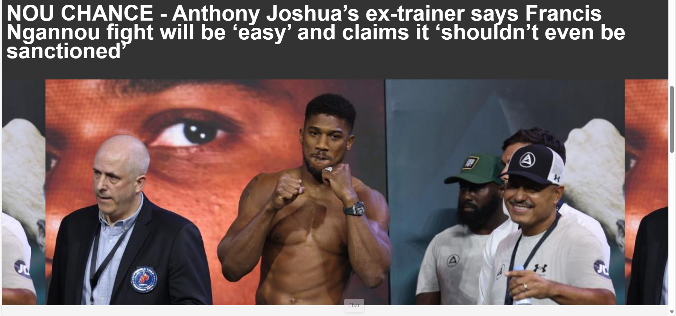
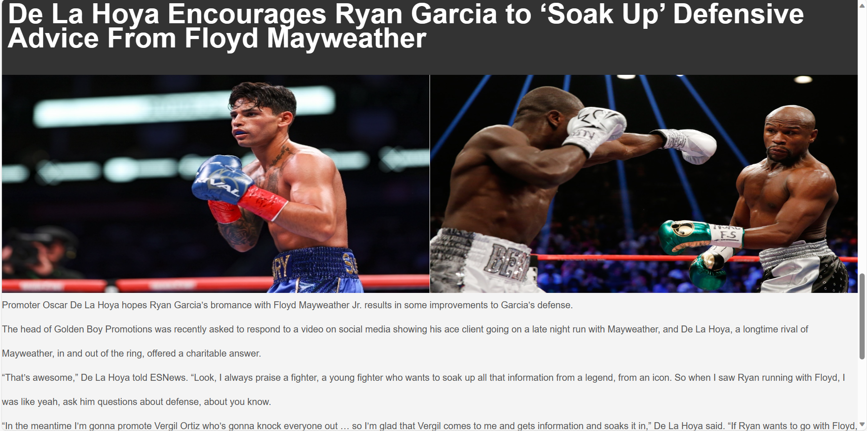
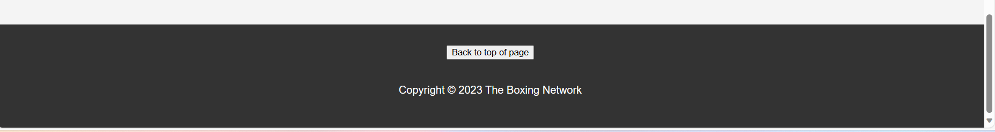

About Us
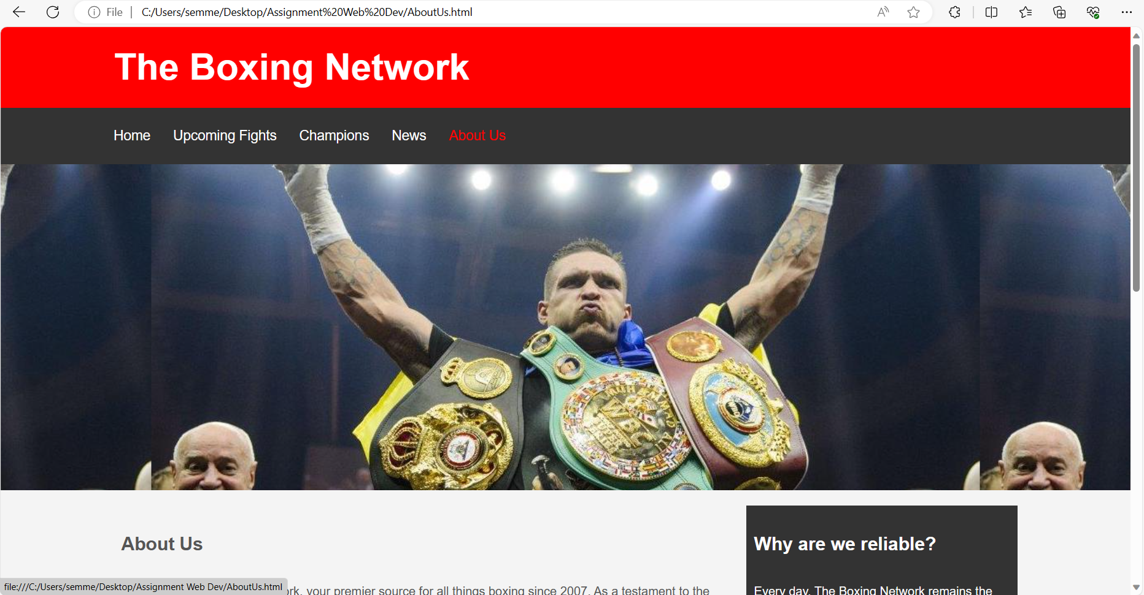
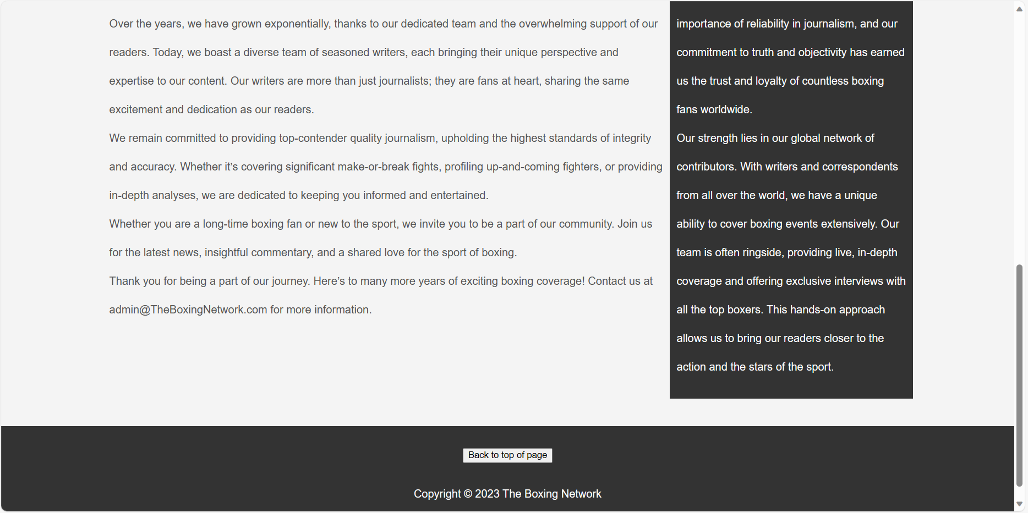

Validation
CSS Validation
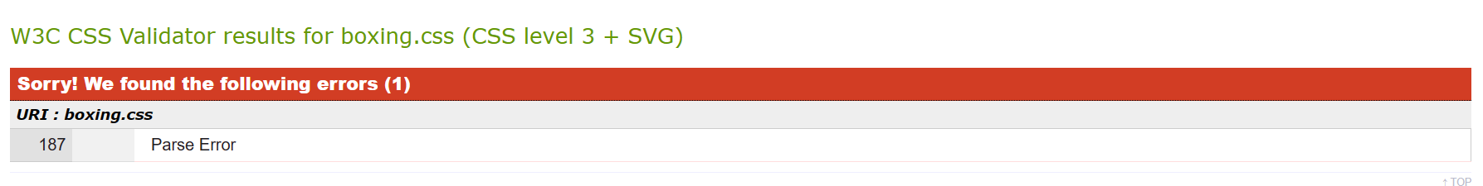
The CSS validator has highlighted a parse error on line 187 which is usually an invisible character such as a space. After going to line 187 in my CSS code I have been unable to find any invisible characters as displayed in the image below:
As I have been unable to find this parse error I have not been able to amend it. However, apart from that error the validator has not picked up anything else wrong with the CSS code.
HTML validation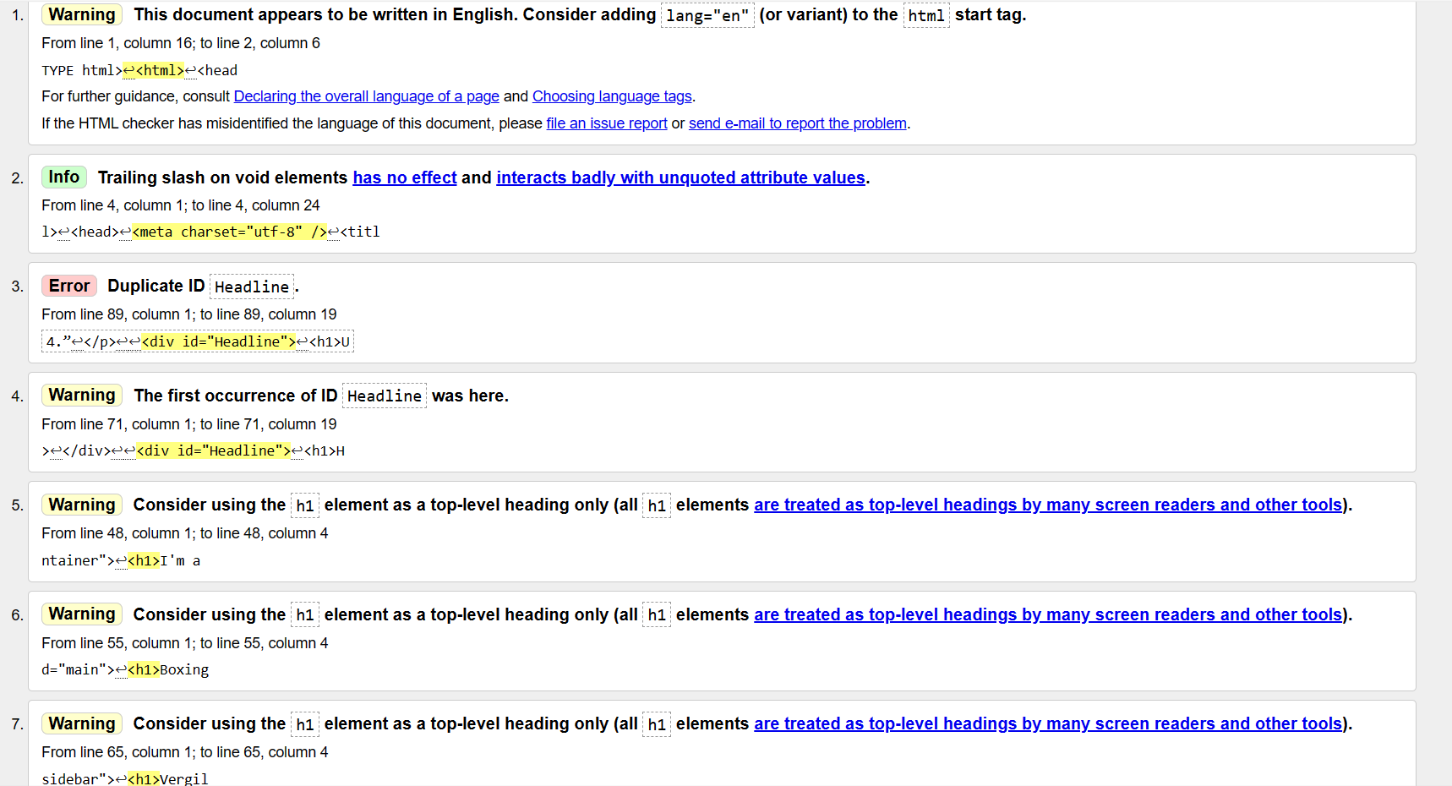
The HTML validator has picked up multiple warnings regarding the large number of h1 headers, the reason I have used so many is due to the amount of article headlines which I want to stand out to the users and capture their attention while also making it easier to view and find new articles for those with viewing impairments. The validator also found an error regarding the use of a duplicate ID, I have done this as all headlines follow the same format so that the website can keep to a consistent structure and colour scheme which will help users identify where different articles are. I could have made multiple headline ID’s in html and used the same CSS code for each ID however I believe that would be a waste of storage and time.

Evaluation
Website usability is “the ease of understanding the structure of a website, its functions, interface and the contents that can be observed by the user and the ability of the user to control what they are doing, and where they are, at any given moment” [4]. What is important to understand when developing a website is that aesthetics aren’t everything, website usability plays an equally vital role in web development. By having a website with a strong usability users will be able to access the websites features and navigate the website with little issue. The reason why usability is so important is because “it's directly linked to user engagement.” A website which is difficult or frustrating to use or navigate is going to drive users away from the website. This is why it is vital to provide a pleasant user experience which will increase user engagement as well as generate more traffic for the website.
The problem with most websites is that they have accessibility barriers which makes it difficult for many people with disabilities or any form of impairment to use them. The most common accessibility barrier which we see in most websites is the use of a font which is hard to read making it impossible for those with poor vision to read without any assistance, this barrier alone effects “2.2 billion people globally who have a near or distance vision impairment” [5]. “Web accessibility is about removing accessibility barriers” [6], by removing those accessibility barriers and creating an accessible website a developer would be welcoming those with disabilities and impairments to their website and creating a user-friendly environment for them which will help the developer retain and attract users.
Search Engine Optimisation refers to “improvement of the ranking of a website in the search results for given key keywords” [7]. The ranking of a website in the search results will determine how many people will see the website. For example, when the word ‘Nike’ is entered into a search engine such as google the Nike clothing website will be displayed at the top of the page, this is because it is top of the search result rankings. In order to optimise your website, you must have an effective optimisation strategy, this could involve a variety of roles such as “analytics, backend engineering and UX design” [8]. If done correctly a search engine optimisation strategy could provide the website with a variety of benefits such as increased engagements, improved website visibility and increased web traffic and revenue.

The usability of a website is an incredibly crucial factor to consider when developing a website, this why I have put website usability at the center of my project. One key example of this is the ease of navigation within my website which is made possible by two aspects, the first is the navbar which has been designed to be as easy and simple to use as possible, the user can simply click the page they want to view and they will be taken there instantly, to further improve the usability of this navbar I have made it so that when the user hovers their cursor over the page they desire the hyperlink will change colour to inform the user that they are about to go to another page. The second aspect of easy navigation is the ‘back to top’ button located in the footer of the page which when clicked takes the user back to the top of the page they are currently on, to ensure that the button is easily visible I have made the button a white colour with black text to set it apart from the dark grey footer. Another key example of the websites usability is the clearly labelled content contained within the website, the website contains a variety of articles regarding boxing which means that if not displayed in a correct manner the user could struggle to find certain articles, to overcome this problem I have made a header in between articles with a dark grey container which displays the article title, by doing this articles will be divided so that users will easily be able to read the latest articles on the website easier and without getting lost. I have also included a sidebar in some articles to display any extra information which the user may find useful, this sidebar keeps to the same colour scheme as the article headers, by keeping to a consistent colour scheme the website will look aesthetically appealing to users. The final example of my websites usability is the use of bullet points and line breaks within the ‘Champions’ page, due to the various weight divisions and organisations I have used line breaks to create sections for each weight division which is clearly highlighted using a header, the champions of the different organisations are then displayed using bullet points within each weight section, this inclusion makes it easier for users to find specific champions for specific weight divisions and organisations.
On page search engine optimisations is the process of “internally improving a websites search ranking” [9], I have used various on page SEO (Search Engine Optimisation) techniques throughout my websites which would help it climb the search rankings if published. One such technique is the inclusion of keywords, one example of this is the inclusion of the names of relevant and trending boxers throughout in strategic locations such as main headers (H1), first paragraphs and sub headers (H2 etc.). The inclusion of these keywords would help a search engine gain context regarding the contents of the page and allows users to identify whether or not the page is of any interest to them. Another example is the implementation of a well-structured design within the website, by having a well-structured web page with various headers, sub headers and you will “be helping Google better understand your page’s structure and determine whether your page matches a user’s search intent. Which can help you rank higher for relevant keywords” [9]. Another method of search engine optimisation which I have included is the use of internal links which I have used to lead to different news articles within the website, the use of internal links is vital to improving your websites search rankings as they “They signal to Google that the linked-to page is valuable” [9]. One final method is the use of external links to trusted sources, I have included this when I mention a boxer’s name in an article and the link will take the user to their verified BoxRec page. By including external sources, you are providing value to your users and build trust among your community which will lead to users coming back to your page and sharing it which will increase traffic and engagements as well as improving the web ranking.
The “Web Content Accessibility Guidelines (WCAG) 2.1 outlines how a web designer may make Web content more accessible to people with disabilities” [10]. Accessibility disabilities can range from visual and auditory disabilities to physical and cognitive. The guidelines are structured around four key principles which set the foundations for accessibility within web content. The first key principle is that all “Information and user interface components must be presentable to users in ways they can perceive” [10]. I have been able to accomplish this principle by using fonts and colours which do not clash with each other and make information and components such as button easy to see and use. The second principle states that the “User interface components and navigation must be operable” [10]. This principle has been achieved as all navigation buttons including the ‘back to top’ buttons and external links are 100% working as they should. The third principle states that “the Information and the operation of the user interface must be understandable” [10]. This has been achieved by clearly labelling buttons and clearly highlighting different segments of information with headers and sub headers, the use of clearly readable fonts and the use of non-complex vocabulary has also helped the understanding of information. The final key principle of the WCAG 2.1 states that “The content should be robust enough that it can be interpreted reliably by a wide variety of user agents, including assistive technologies” [10]. I have achieved this final principle by formatting my web content in an effective manner which will allows user agents such as screen readers to help their user read the content. To further accommodate to this principle, I have ensured that all user interface components such as buttons, links etc. are properly marked up so that screen readers and keyboard-only users are able to access these components.
Overall, I believe that throughout this project I have taken into consideration the numerous factors of a website including the utilization, SEO, and accessibility of the website. I have recognized the needs of my target audience as well as any users who have a disability which impairs their use of the internet and I have done my best to create a website which is accommodating and useful to all who use it.

References
[1] Soocial, 17 Boxing Viewership Statistics To Knock You Out (2023), 2023.
[2] R. Daniels, Boxing Statistics UK – How Popular Is Boxing In 2021?, 2023.
[3] E. Dixon, Katie Taylor v Amanda Serrano becomes most-watched female headlined boxing broadcast ever, 2023.
[4] D. Belanche, L. Casaló, M. Guinalíu, Website usability, consumer satisfaction and the intention to use a website: The moderating effect of perceived risk, 2012.
[5] World Health Organisation, Blindness, and vision impairment, 2023.
[6] Friends of ED, Web accesibility: Web standards and regulatory, 2007.
[7] C. Luh, S. Yang, T. Huang, Estimating Google’s search engine ranking function from a search engine optimization perspective, 2016.
[8] Hotjar, Why is website optimization important?, 2022.
[9] Silva. C, On-Page SEO: What It Is and How to Do It, 2023.

Appendices
Home Page
<!DOCTYPE html>
<html>
<head>
<meta charset="utf-8" />
<title>The Boxing Network</title>
<link rel="stylesheet" type="text/css"
href="boxing.css">

<style>
.grid-container {
display: inline-grid;
grid-template-columns: auto auto auto auto;
background-color: olive;
padding: 20px;
}
.grid-item {
background-color: rgba(255, 255, 255, 0.8);
border: 1px solid rgba(0, 0, 0, 0.5);
padding: 20px;
font-size: 30px;
text-align: center;
}
</style>

</head>
<body>
<header id="main-header">
<div class="container">
<h1>The Boxing Network</h1>
</div>
</header>

<nav id="navbar">
<div class="container">
<ul>
<li><a href="HomePage.html">Home</a></li>
<li><a href="UpcomingFights.html">Upcoming Fights</a></li>
<li><a href="Champions.html">Champions</a></li>
<li><a href="News.html">News</a></li>
<li><a href="AboutUs.html">About Us</a></li>
</ul>
</div>
</nav>

<section id="showcase1">
<div class="container">
<h1>I am a dreamer. I have to dream and reach for the stars, and if I miss a star then I grab a handful of clouds - Mike Tyson
</h1>
</div>
</section>

<div class="container">
<section id="main">
<h1>Boxings Latest: Do or Die - Ortiz Jr vs Lawson</h1>
<p>Vergil Ortiz Jr will face the challenge of Fredrick Lawson on Saturday 6th January 2024 at Virgin Hotels in Las Vegas. The fight will be contested over 12 rounds in the
Super Welterweight division, which means the weight limit will be 154 pounds (11 stone or 69.8 KG). Also, on the undercard will be Ohara Davies' and Ismael Barroso's contest
and Arnold Barboza Jr's and Xolisani Ndongeni's bout. Vergil Ortiz Jr steps into the ring with an undefeated record of 19 wins, zero loses and 0 draws, 19 of those wins coming by
the way of knock out. Fredrick Lawson will make his way to the ring with a record of 30 wins, 3 loses and 0 draws, with 22 of those wins by knock out. The stats suggest Ortiz Jr
has a large advantage in power over Lawson, boosting at 100% knock out percentage over Lawson's 73%.
</p>
</section>

<aside id="sidebar">
<h1><a href="https://boxrec.com/en/proboxer/766727">Vergil Ortiz</a> Eager To Make a Statement Against <a href="https://boxrec.com/en/box-pro/562405">Lawson</a> on January 6</h1>
<p>“Headlining my first card in Las Vegas after over a year of inactivity is just what I needed,” said Ortiz. “I am very motivated to put on a great show like I always do, and to show everyone that I’m still here.”
</p>
</aside>
</div>

<div id="Headline">
<h1>Hearn: <a href="https://boxrec.com/en/proboxer/659461">Joshua</a> Wants To Be in Massive Fights, Win a Title, Face <a href="https://boxrec.com/en/box-pro/479205">Fury</a> or <a href="https://boxrec.com/en/proboxer/659772">Usyk</a> Trilogy</h1>
</div>

<p>Eddie Hearn, promoter for former two-time heavyweight champion Anthony Joshua, explains that his fighter is now very motivated to involve himself in major fights in 2024.
In April, he secured a twelve round unanimous decision over Jermaine Franklin. Then in August, he knocked out late-replacement Robert Helenius. The third appearance of the year
took place last month in Saudi Arabia, where Joshua took down Otto Wallin in five rounds. On February 17th in Saudi Arabia, Tyson Fury and Oleksandr Usyk will collide in a
high-stakes undisputed clash for the WBC, IBF, IBO, WBA, WBO world titles.Joshua, who suffered two decision losses to Usyk, would love to get his hands on the winner. The British
star is being positioned to return to the ring on a date in March, back in Saudi Arabia. Three names have been mentioned by Hearn - Filip Hrgovic, Zhilei Zhang and Francis Ngannou.
</p>
<p>
Hearn said. “These are all great heavyweights. Andy Ruiz, Frank Sanchez, Joseph Parker, but really the only thing that AJ wants to do is be in massive fights, win the world
heavyweight title, and fight Tyson Fury or get another crack at Usyk. That’s what [Joshua trainer] Ben [Davison] wants, Ben wants another crack at Usyk.
“For me, obviously, I’d love the Fury fight. When you look at fighting March, fighting in September, maybe two fights against the Fury-Usyk winner, you’re talking four or five
fights down the line, that may be it. He looked amazing last week, but five fights is another year and a half, maybe two years, so how much longer are you going to go? Right now,
we’re really excited for that 2024.”
</p>

<div id="Headline">
<h1><a href="https://boxrec.com/en/proboxer/659772">Usyk</a> on Beating <a href="https://boxrec.com/en/box-pro/479205">Fury</a>: Firstly, It's Not 'If' I Win But 'When' I Win!</h1>
</div>

<p>WBO, IBF, IBO, WBA heavyweight champion Oleksandr Usyk is fully confident in his ability to defeat WBC king Tyson Fury, when the two unbeaten beltholders collide on February 17
in Saudi Arabia. Usyk has faith that his skills will overcome Fury's advantage in size. "Firstly, it's not 'if' I win but 'when' I win," Usyk said to Sky Sports."When I go to
sleep I imagine myself boxing, then my hand raised high. I simply believe that I can win."</p>
<p>Fury has been verbally blasting Usyk in the last few months, but the Ukrainian boxer believes the mind games have backfired on the 'Gypsy King.'
<div id="FuryUsyk">
</div>
<p>"I got into his head and now instead of me, he thinks about a rabbit. Keep thinking, brother," Usyk said. "I have listened to Eminem for many years, his mum used to call him a
white rabbit. I don't know, I like this rapper. Tony Bellew once said that I am a beast in boxing, I said: 'Not really, I'm just a white rabbit.'</p>
<p>Usyk is coming back from a knockout victory over mandatory challenger Daniel Dubois, which took place in Poland back in August.
Fury took part in a non-title crossover boxing match back in October, in Saudi Arabia, against former UFC champion Francis Ngannou. While the fight was widely viewed as a complete
mismatch on paper, Ngannou shocked the oddsmakers when he dropped Fury in the third and gave him issues throughout their ten round bout. Fury was able to secure a close split
decision win.</p>
<footer id="main-footer">
<input type="BUTTON" value="Back to top of page" onclick="window.location.href='#top'">
<p> Copyright &copy; 2023 The Boxing Network</p>
</footer>
</body>
</html>
News Page
<!DOCTYPE html>
<html>
<head>
<meta charset="utf-8" />
<title>The Boxing Network</title>
<link rel="stylesheet" type="text/css"
href="boxing.css">

<style>
.grid-container {
display: inline-grid;
grid-template-columns: auto auto auto auto;
background-color: olive;
padding: 20px;
}
.grid-item {
background-color: rgba(255, 255, 255, 0.8);
border: 1px solid rgba(0, 0, 0, 0.5);
padding: 20px;
font-size: 30px;
text-align: center;
}
</style>

</head>
<body>
<header id="main-header">
<div class="container">
<h1>The Boxing Network</h1>
</div>
</header>

<nav id="navbar">
<div class="container">
<ul>
<li><a href="HomePage.html">Home</a></li>
<li><a href="UpcomingFights.html">Upcoming Fights</a></li>
<li><a href="Champions.html">Champions</a></li>
<li><a href="News.html">News</a></li>
<li><a href="AboutUs.html">About Us</a></li>
</ul>
</div>
</nav>

<section id="showcase4">
<div class="container">
</div>
</section>

<div class="container">
<section id="main">
<h1>Fury VS Usyk Signed and Sealed</h1>
<p>
The rival stars have finally agreed to meet in the ring after months of boxing's dream matchup looking like it might never happen.<br>
WBC champion Fury will look to wrestle the WBA, WBO, and IBF titles away from Usyk to become the first undisputed heavyweight champion since British compatriot Lennox Lewis over two decades ago.<br>
After months of failed negotiations between the camps earlier this year, Usyk instead beat Daniel Dubois while Fury opted for a crossover bout against Francis Ngannou.
That looked to be the final nail in the coffin for the pair facing off but, much to the delight of boxing fans around the world, Fury and Usyk will now look to top the 1974 Rumble in the Jungle as
boxing's biggest-ever event.<br>
Ahead of their 'Ring of Fire' clash, Usyk watched Fury get knocked down by Ngannou before taking a controversial split decision win over the MMA star.
</p>
</section>

<aside id="sidebar">
<h1><a href="https://boxrec.com/en/box-pro/479205">Fury</a> vs <a href="https://boxrec.com/en/proboxer/659772">Usyk</a>: Date and start time</h1>
<p>
This undisputed heavyweight clash will take place on Saturday, February 17. The huge bout will be held at the Kingdom Arena in Riyadh, Kingdom of Saudi Arabia.<br>
Start times and additional details are expected to be announced in due course. The event will be broadcast live on TNT Sports Box Office but pricing is yet to be revealed.
talkSPORT will have updates throughout fight week and talkSPORT.com will be running a live blog of all the action as well.
</p>
</aside>
</div>
<br>
<div id="Headline">
<h1>NOU CHANCE - <a href="https://boxrec.com/en/proboxer/659461">Anthony Joshua</a>’s ex-trainer says <a href="https://boxrec.com/en/box-pro/1170712">Francis Ngannou</a> fight will be ‘easy’ and claims it ‘shouldn’t even be sanctioned’</h1>
</div>
<section id="Joshua">
</section>
<p> AJ is looking for alternatives to Deontay Wilder after the American blew their £100m super-fight deal<br>
Joshua had beaten Otto Wallin, 32, in Saudi Arabia but moments beforehand Wilder lost to Joseph Parker, 31. So AJ's super-fight with the American former heavyweight champion has been KO'd for now.
Joshua's promoter named ex-UFC champion Ngannou along with Filip Hrgovic, 31, and Zhilei Zhang, 40, as alternatives to Wilder. But Robert Garcia - formerly coach to AJ - slammed the idea of Ngannou
facing Joshua.<br>
Garcia told ESNEWS: "It’s an easy fight for Joshua. Those fights shouldn’t even be sanctioned. "Ngannou, fighting the heavyweight champion of the world, Fury, it shouldn’t have been sanctioned.
"It’s a disrespect to boxing not to train one single day for that fight. It was embarrassing." Ngannou, 37, put on hold his MMA career this year to fight WBC champ Tyson Fury, 35, in Saudi Arabia in
October.<br>
He astonishingly dropped Fury only to be controversially beaten on points but his stock has risen. So much so that he is now in the running for another huge boxing payday against Joshua, 34. Hearn
told iFL TV: "Right now, we have three fights that we're in discussions for. "They're all big and that doesn't involve Deontay Wilder for March. Our aim, and they've expressed this is to fight the
winner of Fury-Usyk. "That's all we want to do, obviously there's the Hrgovic fight out there for the world heavyweight title. "There's a Francis Ngannou fight out there which would be absolutely
colossal. "There's other heavyweights as well, there's a Zhang fight possible as well with Queensberry."
</p>
<div id="Headline">
<h1><a href="https://boxrec.com/en/box-pro/8253">De La Hoya</a> Encourages <a href="https://boxrec.com/en/box-pro/765995">Ryan Garcia</a> to ‘Soak Up’ Defensive Advice From <a href="https://boxrec.com/en/box-pro/352">Floyd Mayweather</a></h1>
</div>
<img src="Garcia.jpg" width="736px" height="375px" align="left">
<img src="Mayweather.jpg" width="736px" height="375px" align="right">
<p> Promoter Oscar De La Hoya hopes Ryan Garcia’s bromance with Floyd Mayweather Jr. results in some improvements to Garcia’s defense.<br>
The head of Golden Boy Promotions was recently asked to respond to a video on social media showing his ace client going on a late night run with Mayweather, and De La Hoya, a longtime rival of
Mayweather, in and out of the ring, offered a charitable answer.<br> “That’s awesome,” De La Hoya told ESNews. “Look, I always praise a fighter, a young fighter who wants to soak up all that
information from a legend, from an icon. So when I saw Ryan running with Floyd, I was like yeah, ask him questions about defense, about you know. <br>
“In the meantime I’m gonna promote Vergil Ortiz who’s gonna knock everyone out … so I’m glad that Vergil comes to me and gets information and soaks it in,” De La Hoya said. “If Ryan wants to go with Floyd, and not to me, so be it, it’s great. Because that’s another legend. Different styles but another legend. So it’s all information that these young fighters are soaking in, which is great.”
De La Hoya and Garcia, of course, have been involved in a protracted feud since last spring, after De La Hoya failed to show up in the press conference after Garcia’s loss to Gervonta Davis.
De La Hoya then sued Garcia over his contract; that lawsuit is believed to be ongoing.<br>
Despite their rift, Garcia fought under the Golden Boy banner in December, stopping Oscar Duarte in eight rounds at Toyota Center in Houston, Texas. Garcia has long maintained friendly relations
with Mayweather, although their relationship has prompted the occasional snide comment from De La Hoya. On social media, Garcia made it clear that Mayweather was “mentoring” him, but he also
pushed back against those who interpreted his run with Mayweather as being disloyal to his coach, Derrick James. “Floyd is mentoring me, And I love and respect him, he is so authentic so stop judging
him,” Garcia wrote. Judging a book by its cover will stop you from reading but Derrick James is my coach, and I love him too.”
</p>
<footer id="main-footer">
<input type="BUTTON" value="Back to top of page" onclick="window.location.href='#top'">
<p> Copyright &copy; 2023 The Boxing Network</p>
</footer>
</body>
</html>
Upcoming Fights Page
<!DOCTYPE html>
<html>
<head>
<meta charset="utf-8" />
<title>The Boxing Network</title>
<link rel="stylesheet" type="text/css"
href="boxing.css">

<style>
.grid-container {
display: inline-grid;
grid-template-columns: auto auto auto auto;
background-color: olive;
padding: 20px;
}
.grid-item {
background-color: rgba(255, 255, 255, 0.8);
border: 1px solid rgba(0, 0, 0, 0.5);
padding: 20px;
font-size: 30px;
text-align: center;
}
</style>
</head>
<body>
<header id="main-header">
<div class="container">
<h1>The Boxing Network</h1>
</div>
</header>

<nav id="navbar">
<div class="container">
<ul>
<li><a href="HomePage.html">Home</a></li>
<li><a href="UpcomingFights.html">Upcoming Fights</a></li>
<li><a href="Champions.html">Champions</a></li>
<li><a href="News.html">News</a></li>
<li><a href="AboutUs.html">About Us</a></li>
</ul>
</div>
</nav>

<section id="showcase2">
</section>

<div class="container">
<section id="main">
<h1>Artur Beterbiev Vs Callum Smith Preview</h1>
<p>Artur Beterbiev is set to fight Callum Smith on Saturday 13th January 2024 at Centre Videotron in Quebec City. The fight is scheduled for 12 rounds in the Light Heavyweight division,
which means the weight limit will be 175 pounds (12.5 stone or 79.4 KG). This contest is for the unified light heavyweight championship of the world, with the IBF, WBC & WBO belts on the line.<br>
The fighters are expected to ringwalk at around 3:30 AM UTC at Centre Videotron, Quebec City, Canada, which is 10:30 PM EST or 7:30 PM PST on the West Coast of America, or 3:30 AM GMT in the UK.<br>
You can stream Beterbiev vs Smith via NowTV. They allow you to stream Sky Sports boxing cards via their app, based on a 24 hour, weekly or monthly passes. You’ll also get access to 11 Sky Sports
Channels during your pass period. They also do a monthly smartphone only pass for £5.99, which is great if you need to catch Beterbiev vs Smith on the move.
</p>
</section>

<aside id="sidebar">
<h1>The Stats</h1>
<p><a href="https://boxrec.com/en/box-pro/646981">Artur Beterbiev</a> steps into the ring with an undefeated record of 19 wins, zero loses and 0 draws, 19 of those wins coming by the way of knock out.
<a href="https://boxrec.com/en/box-pro/631178">Callum Smith</a> will make his way to the ring with a record of 29 wins, 1 loss and 0 draws, with 21 of those wins by knock out. The stats suggest Beterbiev has a large advantage in power over Smith,
boosting at 100% knock out percentage over Smith's 72%.</p>
</aside>
</div>

<div id="Headline">
<h1><a href="https://boxrec.com/en/box-pro/803069">Natasha Jonas</a> Vs <a href="https://boxrec.com/en/box-pro/803614">Mikaela Meyer</a></h1>
</div>
<p> Natasha Jonas is set to face Mikaela Mayer on Saturday 20th January 2024 at M&S Bank Arena in Liverpool. The fight is scheduled for 10 rounds in the Welterweight division, which means the weight
limit will be 147 pounds (10.5 stone or 66.7 KG).<br>
Natasha Jonas steps into the ring with a record of 14 wins, 2 loses and 1 draw, 9 of those wins coming by the way of knock out. Mikaela Mayer will make her way to the ring with a record of 19 wins,
1 loss and 0 draws, with 5 of those wins by knock out. The stats suggest Jonas has a massive power advantage over Mayer, boosting at 64% knock out percentage over Mayer's 26%.
</p>
<div id="MayerJonas">
<img src="MayerJonas.png"width="1400px">
</div>
<p> Jonas has won 5 of her most recent fights, stopping 2 of them, going the distance 3 times. In her last fight, she defeated Kandi Wyatt on 1st July 2023 by technical knockout in the 8th round at
Manchester Arena, Manchester, United Kingdom. Previous to that, she had defeated Marie Eve Dicaire on 12th November 2022 by unanimous decision in their 10 round contest at Manchester Arena,
Manchester. <br>
Mikaela Mayer has beaten 4 of her last 5 opponents. In her last fight, she defeated Silvia Bortot on 2nd September 2023 by points in the 10th round at Manchester Arena, Manchester, United Kingdom.
Previous to that, she had defeated Lucy Wildheart on 15th April 2023 by unanimous decision in their 10 round contest at Copper Box Arena, London.Going into that contest, she had been beaten by
Alycia Baumgardner on 15th October 2022 by split decision in their 10 round contest at The O2 Arena, London.
</p>
<div id="Headline">
<h1><a href="https://boxrec.com/en/proboxer/766727">Ortiz</a> Vs <a href="https://boxrec.com/en/box-pro/562405">Lawson</a> Preview</h1>
</div>
<section id="OrtizLawson">
</section>
<p> Vergil Ortiz Jr will face the challenge of Fredrick Lawson on Saturday 6th January 2024 at Virgin Hotels in Las Vegas. The fight will be contested over 12 rounds in the Super Welterweight division,
which means the weight limit will be 154 pounds (11 stone or 69.8 KG). Also, on the undercard will be Ohara Davies' and Ismael Barroso's contest and Arnold Barboza Jr's and Xolisani Ndongeni's bout.<br>
Vergil Ortiz Jr steps into the ring with an undefeated record of 19 wins, zero loses and 0 draws, 19 of those wins coming by the way of knock out. Fredrick Lawson will make his way to the ring with a
record of 30 wins, 3 loses and 0 draws, with 22 of those wins by knock out. The stats suggest Ortiz Jr has a large advantage in power over Lawson, boosting at 100% knock out percentage over Lawson's
73%.<br><br>
Ortiz Jr remains undefeated as a professional, stopping 5 of his recent opponents. In his last fight, he beat Michael McKinson on 6th August 2022 by technical knockout in the 9th round in their WBA
Super World Welterweight eliminator fight at Dickies Arena, Texas, United States. Previous to that, he had beat Egidijus Kavaliauskas on 14th August 2021 by technical knockout in the 8th round at The
Star, Frisco. Going into that contest, he had won against Maurice Hooker on 20th March 2021 by technical knockout in the 7th round at Dickies Arena, Texas. Before that, he had beat Samuel Vargas on
24th July 2020 by knockout in the 7th round at Fantasy Springs Resort Casino, Indio. He had defeated Brad Solomon on 13th December 2019 by knockout in the 5th round at Fantasy Springs Casino,
California.
<footer id="main-footer">
<input type="BUTTON" value="Back to top of page" onclick="window.location.href='#top'">
<p> Copyright &copy; 2024 The Boxing Network</p>
</footer>
</body>
</html>
Champions Page
<!DOCTYPE html>
<html>
<head>
<meta charset="utf-8" />
<title>The Boxing Network</title>
<link rel="stylesheet" type="text/css"
href="boxing.css">

<style>
.grid-container {
display: inline-grid;
grid-template-columns: auto auto auto auto;
background-color: olive;
padding: 20px;
}
.grid-item {
background-color: rgba(255, 255, 255, 0.8);
border: 1px solid rgba(0, 0, 0, 0.5);
padding: 20px;
font-size: 30px;
text-align: center;
}
</style>

</head>
<body>
<header id="main-header">
<div class="container">
<h1>The Boxing Network</h1>
</div>
</header>

<nav id="navbar">
<div class="container">
<ul>
<li><a href="HomePage.html">Home</a></li>
<li><a href="UpcomingFights.html">Upcoming Fights</a></li>
<li><a href="Champions.html">Champions</a></li>
<li><a href="News.html">News</a></li>
<li><a href="AboutUs.html">About Us</a></li>
</ul>
</div>
</nav>

<section id="showcase3">
<div class="container">
<h1>“Champions aren’t made in the ring, they are merely recognized there. What you cheat on in the early light of morning will show up in the ring under the bright lights.” - Joe Frazier
</h1>
</div>
</section>

<div id="Headline">
<h1>Current Boxing Champions</h1>
</div>
<p>It was partly a reflection of the bewildering number of boxing belts available when the oldest major sanctioning organisation in the world, the World Boxing Association, announced plans in late
2021 to reduce the number of titles it offers. Then there are the World Boxing Organization, the International Boxing Federation and the World Boxing Council, all bestowing recognised world titles
across divisions ranging from 115lb strawweights to heavyweight man-mountains. A unified champion carries at least one of those belts and an undisputed boxer carries all four. The Ring, meanwhile,
attempts to make matters linear by rewarding 'the man who beat the man'.<br>
With 17 weight classes in boxing and four major sanctioning bodies that bestow world titles, keeping track of who holds each of the belts can be difficult -- especially when there are sometimes
multiple titlists in each organization because of interim and secondary belts.<br>
To make it easier for boxing fans, below is a quick reference chart of who holds each of the titles in the four organizations:
</p>
<hr>
<h2>Heavyweight (Unlimited)</h2>
<ul>
<li> WBO: Oleksandr Usyk</li>
<li> IBF: Oleksandr Usyk</li>
<li> WBA: Oleksandr Usyk</li>
<li> WBC: Tyson Fury</li>
</ul>
<hr>
<h2>Cruiserweight (200 lbs.)</h2>
<ul>
<li> WBO: Chris Billam-Smith</li>
<li> IBF: Vacant</li>
<li> WBA: Arsen Goulamirian</li>
<li> WBC: Norair Mikaeljan</li>
</ul>
<hr>
<h2>Light heavyweight (175 lbs.)</h2>
<li> WBO: Artur Beterbiev</li>
<li> IBF: Artur Beterbiev</li>
<li> WBA: Dmitry Bivol</li>
<li> WBC: Artur Beterbiev</li>
</ul>
<hr>
<h2>Super middleweight (168 lbs.)</h2>
<li> WBO: Canelo Alvarez</li>
<li> IBF: Canelo Alvarez</li>
<li> WBA: Canelo Alvarez</li>
<li> WBC: Canelo Alvarez</li>
</ul>
<hr>
<h2>Middleweight (160 lbs.)</h2>
<ul>
<li> WBO: Janibek Alimkhanuly</li>
<li> IBF: Janibek Alimkhanuly</li>
<li> WBA: Erislandy Lara</li>
<li> WBC: Jermall Charlo</li>
</ul>
<hr>
<h2>Junior middleweight (154 lbs.)</h2>
<ul>
<li> WBO: Tim Tszyu</li>
<li> IBF: Vacant</li>
<li> WBA: Jermell Charlo</li>
<li> WBC: Jermell Charlo</li>
</ul>
<hr>
<h2>Welterweight (147 lbs.)</h2>
<li> WBO: Terence Crawford</li>
<li> IBF: Jaron Ennis</li>
<li> WBA: Terence Crawford</li>
<li> WBC: Terence Crawford</li>
</ul>
<hr>
<h2>Junior welterweight (140 lbs.)</h2>
<ul>
<li> WBO: Teofimo Lopez Jr.</li>
<li> IBF: Subriel Matias</li>
<li> WBA: Vacant</li>
<li> WBC: Devin Haney</li>
</ul>
<hr>
<h2>Lightweight (135 lbs.)</h2>
<ul>
<li> WBO: Vacant</li>
<li> IBF: Vacant</li>
<li> WBA: Vacant</li>
<li> WBC: Shakur Stevenson</li>
</ul>
<hr>
<h2>Junior lightweight (130 lbs.)</h2>
<ul>
<li> WBO: Emanuel Navarrete</li>
<li> IBF: Joe Cordina</li>
<li> WBA: Lamont Roach</li>
<li> WBC: O'Shaquie Foster</li>
</ul>
<hr>
<h2>Featherweight (126 lbs.)</h2>
<li> WBO: Rafael Espinoza</li>
<li> IBF: Luis Alberto Lopez</li>
<li> WBA: Vacant</li>
<li> WBC: Rey Vargas</li>
</ul>
<hr>
<h2>Junior featherweight (122 lbs.)</h2>
<ul>
<li> WBO: Naoya Inoue</li>
<li> IBF: Naoya Inoue</li>
<li> WBA: Naoya Inoue</li>
<li> WBC: Naoya Inoue</li>
</ul>
<hr>
<h2>Bantamweight (118 lbs.)</h2>
<ul>
<li> WBO: Jason Moloney</li>
<li> IBF: Emmanuel Rodriguez</li>
<li> WBA: Takuma Inoue</li>
<li> WBC: Alexandro Santiago</li>
</ul>
<hr>
<h2>Junior bantamweight (115 lbs.)</h2>
<ul>
<li> WBO: Vacant</li>
<li> IBF: Fernando Martinez</li>
<li> WBA: Kazuto Ioka</li>
<li> WBC: Juan Francisco Estrada</li>
</ul>
<hr>
<h2>Flyweight (112 lbs.)</h2>
<ul>
<li> WBO: Jesse Rodriguez</li>
<li> IBF: Jesse Rodriguez</li>
<li> WBA: Artem Dalakian</li>
<li> WBC: Julio Cesar Martinez</li>
</ul>
<hr>
<h2>Junior flyweight (108 lbs.)</h2>
<ul>
<li> WBO: Jonathan Gonzalezv
<li> IBF: Adrian Curiel</li>
<li> WBA: Kenshiro Terajiv</li>
<li> WBC: Kenshiro Teraji</li>
</ul>
<hr>
<h2>Strawweight (105 lbs.)</h2>
<ul>
<li> WBO: Oscar Collazo</li>
<li> IBF: Ginjiro Shigeoka</li>
<li> WBA: Knockout CP Freshmart</li>
<li> WBC: Yudai Shigeoka</li>
</ul>
<hr>
<footer id="main-footer">
<input type="BUTTON" value="Back to top of page" onclick="window.location.href='#top'">
<p> Copyright &copy; 2023 The Boxing Network</p>
</footer>
</html>
About Us Page
<!DOCTYPE html>
<html>
<head>
<meta charset="utf-8" />
<title>The Boxing Network</title>
<link rel="stylesheet" type="text/css"
href="boxing.css">

<style>
.grid-container {
display: inline-grid;
grid-template-columns: auto auto auto auto;
background-color: olive;
padding: 20px;
}
.grid-item {
background-color: rgba(255, 255, 255, 0.8);
border: 1px solid rgba(0, 0, 0, 0.5);
padding: 20px;
font-size: 30px;
text-align: center;
}
</style>

</head>
<body>
<header id="main-header">
<div class="container">
<h1>The Boxing Network</h1>
</div>
</header>

<nav id="navbar">
<div class="container">
<ul>
<li><a href="HomePage.html">Home</a></li>
<li><a href="UpcomingFights.html">Upcoming Fights</a></li>
<li><a href="Champions.html">Champions</a></li>
<li><a href="News.html">News</a></li>
<li><a href="AboutUs.html">About Us</a></li>
</ul>
</div>
</nav>

<section id="showcase5">
<div class="container">
</div>
</section>

<div class="container">
<section id="main">
<h1>About Us</h1>
<p>Welcome to The Boxing Network, your premier source for all things boxing since 2007. As a testament to the sweet science, our website has been at the forefront of delivering the latest and most
insightful boxing news, results, analysis, and features.<br>
Over the years, we have grown exponentially, thanks to our dedicated team and the overwhelming support of our readers. Today, we boast a diverse team of seasoned writers, each bringing their unique
perspective and expertise to our content. Our writers are more than just journalists; they are fans at heart, sharing the same excitement and dedication as our readers.<br>
We remain committed to providing top-contender quality journalism, upholding the highest standards of integrity and accuracy. Whether it’s covering significant make-or-break fights, profiling
up-and-coming fighters, or providing in-depth analyses, we are dedicated to keeping you informed and entertained.<br>
Whether you are a long-time boxing fan or new to the sport, we invite you to be a part of our community. Join us for the latest news, insightful commentary, and a shared love for the sport of boxing.<br>
Thank you for being a part of our journey. Here’s to many more years of exciting boxing coverage! Contact us at admin@TheBoxingNetwork.com for more information.
</p>
</section>

<aside id="sidebar">
<h1>Why are we reliable?</h1>
<p>Every day, The Boxing Network remains the most trusted source of fast, accurate, and unbiased boxing news. We understand the importance of reliability in journalism, and our commitment to truth and
objectivity has earned us the trust and loyalty of countless boxing fans worldwide.<br>
Our strength lies in our global network of contributors. With writers and correspondents from all over the world, we have a unique ability to cover boxing events extensively. Our team is often
ringside, providing live, in-depth coverage and offering exclusive interviews with all the top boxers. This hands-on approach allows us to bring our readers closer to the action and the stars of the
sport.
</p>
</aside>
</div>

<footer id="main-footer">
<input type="BUTTON" value="Back to top of page" onclick="window.location.href='#top'">
<p> Copyright &copy; 2023 The Boxing Network</p>
</footer>
</body>
</html>
CSS
body{
background-color:#f4f4f4;
color:#555;
font-family:Arial, Helvetica, san-serif;
font-size:16px;
line-height:2.6em;
margin:0;
}

.container{
width:80%;
margin:auto;
overflow:hidden;
}

#main-header{
background-color:red;
color:#fff;
font-size:24px
}

#navbar{
background-color:#333;
color:#fff;
}

#navbar ul{
padding:0;
list-style:none;
}

#navbar li{
display:inline;
}

#navbar a{
font-size:18px;
padding-right:25px;
}

a{
color:white;
text-decoration: none;
}

a:hover{
color:red;
}

#main-footer {
background:#333;
color:#fff;
text-align:center;
padding:20px;
margin-top:40px;
}

#main{
float:left;
width:70%;
padding:10px;
box-sizing: border-box;
}

#sidebar{
float:right;
width:30%;
background:#333;
color:#fff;
padding:10px;
box-sizing: border-box;
}

#showcase1{
background-image:url("Tyson.png");
background-size: 1280px;
opacity:1.0;
background-position:top;
min-height:400px;
margin-bottom:20px;
text-align:center;
}

#showcase1 h1{
color:#fff;
font-size:30px;
line-height:1.6em;
padding:100px;
}

#Headline{
background-color:#333;
color:#fff;
padding: 10px;
font-size:24px;
}

#FuryUsyk{
background-image:url("Fury.jpg");
background-size: 1280px;
opacity:1.0;
background-position:top;
min-height:600px;
margin-bottom:20px;
}

#MayerJonas{
padding:20px
}

#OrtizLawson{
background-image:url("OrtizLawson.png");
background-size: 1280px;
opacity:1.0;
background-position:top;
min-height:425px;
margin-bottom:20px;
text-align:center;
}

#showcase2{
background-image:url("BerbSmith.png");
background-size: 1280px;
opacity:1.0;
background-position:top;
min-height:425px;
margin-bottom:20px;
text-align:center;
}

#showcase3{
background-image:url("Frazier.jpg");
background-size: 1180px;
opacity:1.0;
background-position:center;
min-height:425px;
text-align:center;
}

#showcase3 h1{
color:#fff;
font-size:30px;
line-height:1.6em;
padding:100px;
}

#showcase4{
background-image:url("FuryUsyk.jpg");
background-size:400px;
opacity:1.0;
background-position:center;
min-height:200px;
margin-bottom:20px;
}

#showcase5{
background-image:url("UsykBelts.jpg");
background-size: 1080px;
opacity:1.0;
background-position:center;
min-height:425px;
margin-bottom:20px;
}

#Joshua{
background-image:url("Joshua.jpg");
background-size:1280px;
opacity:1.0;
background-position:top;
min-height:500px;
margin-bottom:20px;
}

@media(max-width:600px){
#main{
width:100%;
float:none;
}

#sidebar{
width:100%;
float:none;
}

#navbar li{
display:block;
}

