University of Wales Trinity Saint David
School of Engineering

CP Laboratory Case Study
Manufacturing Systems and Simulation
ACMA6002
Robert Dale Gubbins
2316959
05/10/2026

Contents
1 Introduction 3
2 Process Selection 3
3 Current State Model Development 4
3.1 Model Development and Structure 4
3.2 Model Verification and Experimental Setup 7
4 Waste Identification 7
5 Value Analysis 9
5.1 Customer Value and Value-Adding Activities 9
5.2 Quantification of value-adding and non-value adding time 10
6 Simulation Analysis 11
7 Opportunity Identification (Lean Evaluation) 12
7.1 Increasing Drilling Capacity 12
7.2 Increasing Cap Dispenser Capacity 13
7.3 Overall Evaluation of Improvement Opportunities 14
8 Conclusion 15
9 References 17
10 Appendices 18
10.1 Appendix A – Arena Verification Run: 100 parts, 10-Replication Output Summary 18
10.2 Appendix B – 8 Hour Simulation Results 19
10.3 Appendix C – Two-Drill Scenario Simulation Results 21
10.4 Appendix D - Two-Drill and Increased Dispenser Capacity Simulation Results 23

Introduction
Discrete Event Simulation (DES) is a modelling method used to represent how a system operates through a sequence of events over time. It is well suited to manufacturing systems, where components move through different processes and make use of shared resources, allowing performance to be assessed without interrupting actual production (Turner and Garn, 2022). DES can also be used to identify inefficiencies and evaluate possible Lean improvements before changes are made to the physical system (Oleghe and Salonitis, 2016).
This report applies DES to the Festo Industry 4.0 CP Laboratory, which represents a modular automated manufacturing system. The current-state model is used to assess key performance indicators (KPIs), identify waste and value-adding activities, and investigate possible opportunities for Lean improvement.

Process Selection
The selected process is the Festo Industry 4.0 CP Laboratory, which is represented in Arena as a modular automated manufacturing system. As shown in Figure 1, the model begins with components entering through the Parts-In Create block. This is used as the simulation entry point rather than representing a physical CP Lab operation. Components then pass through automated optical inspection before moving through drilling, cap dispensing, pressing, labelling and finally the Output module, where completed assemblies leave the system. 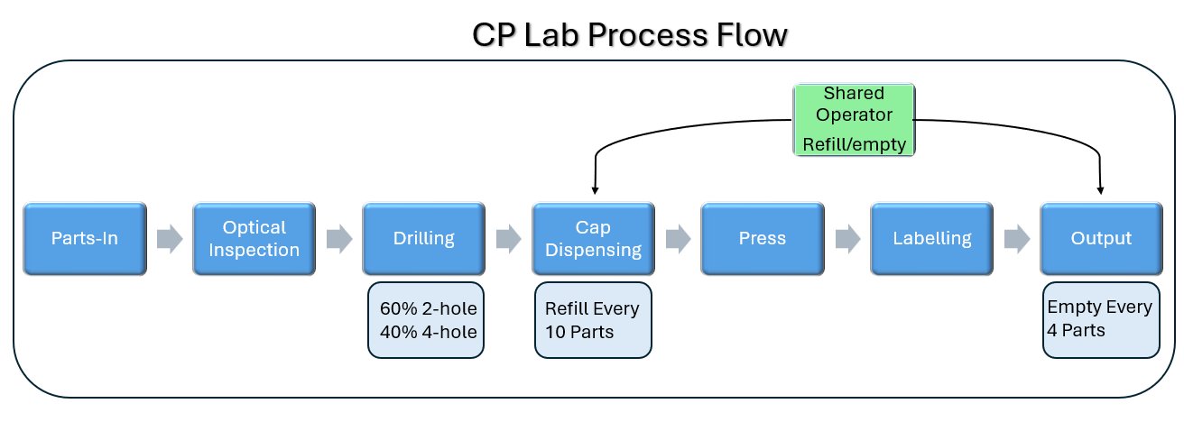
Figure 1 - CP Lab Process Flow
The model uses the specified 60:40 product mix, with 60% of components following the two hole drilling route and 40% following the four hole route. A single production operative is shared between refilling the cap dispenser after every 10 components and emptying the output station after every four completed assemblies. These operating constraints are included within the current state simulation boundary. The process is well suited to DES because the sequence of operations, variable processing and transfer times, shared resources and capacity limits can all affect queueing, resource utilisation and throughput (Goldsman and Goldsman, 2015).

Current State Model Development

Model Development and Structure
The Arena model was built using the process data supplied in the CP Lab case study. All processing times were entered in seconds, with the stated minimum, average and maximum values represented using triangular distributions where required. Fixed movement times between stations were entered directly from the supplied data. The main model inputs are summarised in Table 1.
Process Function |  | Min(s) |  | Average(s) | Max(s)
1.Parts in From Robot Assembly |  | 15 |  | 18 | 21 |  | Legend
2.Automated Optical Inspection |  | 2 |  | 2.4 | 3.4 |  | Part Creation Time
Camera to Drilling |  |  |  | 8.2 |  |  | Movement times
3.Drilling (2 Holes) |  | 16 |  | 18 | 20 |  | Process Times
3.Drilling (4 Holes) |  | 30 |  | 33 | 36
Drill to Dispensing |  |  |  | 7.3
4.Top Cap Dispensing |  | 2.7 |  | 3 | 3.5
4.Refill (every 10x cycles) |  | 110 |  | 120 | 135
Mag Back to Press |  |  |  | 7.3
5.Hydraulic Press |  | 11.7 |  | 12.3 | 12.9
Press to Label |  |  |  | 8.2
6.Label Printing |  | 6.2 |  | 7 | 8.7
Label to Output Station |  |  |  | 8.2
7.Output Station |  | 3.6 |  | 4.1 | 5.1
7.Remove Parts (Every 4x Cycles) |  | 20 |  | 26 | 32
Table 1 - CP Lab Model Input Data
The main entity in the model represents a component moving through the CP Lab process. Resources were created for the Camera System, Drill, Dispenser, Press, Printer and Output Robot. A single production operative was also included and is shared between replenishing the cap dispenser and removing completed assemblies from the output station. Each equipment resource is seized and released within its corresponding process module.
The routing and control logic were set up to reproduce the main operating constraints of the system. Components are routed to either two-hole or four-hole drilling according to the specified 60:40 product mix, while Hold modules control progression based on downstream availability. Counter based logic triggers dispenser replenishment after every 10 components and output removal after every four completed assemblies, with both activities requiring the same operative. Figure 2 shows the completed current-state Arena model.

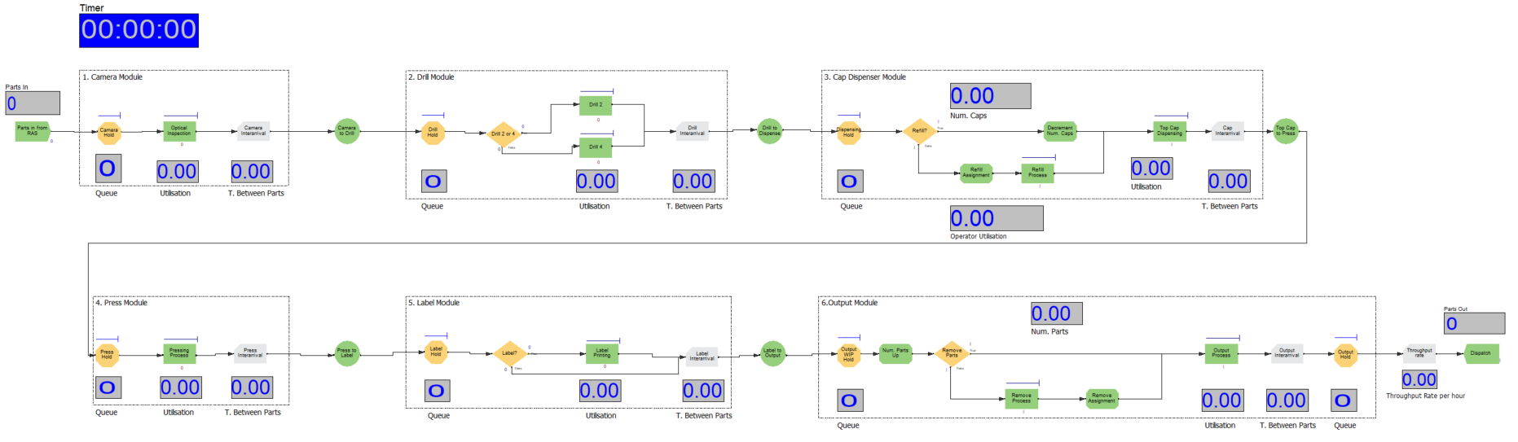Figure 2 – Current State Arena Simulation Model

Model Verification and Experimental Setup
The completed model was verified using 100 components over 10 replications to check entity flow, the 60:40 drilling split, periodic process logic and allocation of the shared operative. This follows the principle that simulation verification should confirm that the model has been implemented as intended (Sargent, 2010). As shown in Table 2, all 100 components completed the process and the drilling split closely matched the specified product mix. The model also produced the expected 10 dispenser refills, 25 output removals and 35 operator seizures. Transfer time was recorded as 39.2 seconds, matching the combined fixed movement times in the model and providing an additional check that the transfer stages were represented correctly. Supporting Arena output is provided in Appendix A.
Performance Measure | Identifier | Expected | Simulation Result
Components entering | Entity 1.NumberIn | 100 | 100
Components completing | Entity 1.NumberOut | 100 | 100
Two-hole drilling route | Drill 2 Number In | ≈60% | 61.3%
Four-hole drilling route | Drill 4 Number In | ≈40% | 38.7%
Cap-dispenser refill cycles | Refill Process Number In | 10 | 10
Output removal cycles | Remove Process Number Out | 25 | 25
Operator 1 seizures | Operator 1.NumberSeized | (10+25) = 35 | 35
Transfer time | Entity 1.TranTime | 8.2 + 7.3 + 7.3 + 8.2 + 8.2 = 39.2s | 39.2s
Table 2 - Model Verification Results
Following verification, the current state experiment was set to run for an eight-hour production shift with no fixed limit on the number of entities entering the system. Thirty replications were then completed to provide the dataset used for the subsequent analysis. The corresponding current state Arena output is provided in Appendix B.

Waste Identification
The current state simulation identified waiting, excess work-in-progress (WIP) and uneven process flow as the main forms of waste within the system. Waiting and excess inventory are recognised Lean wastes that can reduce manufacturing flow and operational efficiency (Rajab, Afy-Shararah and Salonitis, 2022). The key results from the 30 eight hour replications are summarised in Table 3, with the supporting Arena output provided in Appendix B.
Performance measure | Identifier | 8 Hour mean
Components entering system | Entity 1.NumberIn | 1,600.80
Completed assemblies | Entity 1.NumberOut | 1,186.60
Throughput | Calculated from:  NumberOut ÷ 8 hours | 148.3 assemblies/hour
Shift-end WIP | Calculated from:  NumberIn − NumberOut | 414.2 components
Drill Hold waiting time | Drill Hold.Queue.WaitingTime | 3,610.7 s
Drill Hold average queue | Drill Hold.Queue.NumberInQueue | 200.8 components
Entity total time | Entity 1.TotalTime | 3,845.5 s
Entity waiting time | Entity 1.WaitTime | 3,737.7 s
Table 3 - Simulation Performance Summary
Table 3 shows that waiting is the main source of waste in the current system. The largest restriction occurs at the drilling stage, where the Drill Hold queue has an average waiting time of 3,610.7 seconds and an average queue length of around 201 components. Across the full process, completed entities spend an average of 3,737.7 seconds waiting out of a total system time of 3,845.5 seconds. Around 1,601 components enter the system during each shift, compared with approximately 1,187 completed assemblies, leaving about 414 components in the system at the end of the shift. These results show a clear build-up of WIP, long waiting times and restricted production flow.
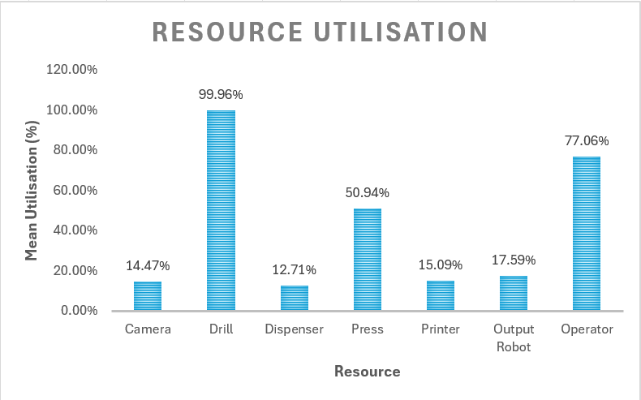
Figure 3 - Resource Utilisation Across 30 Eight Hour Replications
The resource utilisation shown in Figure 3 supports these findings. Drill utilisation reaches 99.96%, compared with 50.94% for the press and less than 18% for the camera, dispenser, printer and output stations. This difference shows that the drilling stage is restricting flow while much of the downstream capacity remains underused. The shared operator reaches 77.06% utilisation, although it is not the main constraint in the current state.
Overall, the simulation shows a clear pattern of waiting, excess WIP and uneven flow around the drilling bottleneck. From a Lean perspective, these activities increase lead time without adding customer value, making them an obvious area for improvement. DES also provides a practical way of measuring this waste and supporting improvement decisions (Vilela et al., 2022).

Value Analysis

Customer Value and Value-Adding Activities
Within Lean, value is considered from the customer’s point of view. Value-adding activities are those that transform the product or provide a feature that the customer is willing to pay for (Xiao et al., 2022). Activities that use time or resources without increasing customer value are classed as non-value adding and should be reduced or removed where possible (Kumar, Devadasan and Elangovan, 2022).
For the CP Lab, drilling, cap dispensing, pressing and required labelling are treated as value-adding because they physically change the component towards its finished specification. Waiting, queuing and unnecessary movement do not change the product and are therefore non-value adding. Optical inspection is required for quality control, but as it does not directly transform the component, it is classed as necessary but non-value adding.

Quantification of value-adding and non-value adding time
The Arena simulation was used to measure how the total time spent in the system was divided between value-adding, non-value adding, waiting and transfer activities. The results from the 30 eight hour current-state replications are summarised in Table 4, with the supporting Arena output provided in Appendix B.
Time classification | Identifier | Mean time (s) | Proportion (%)
Value-adding | Entity 1.VATime | 43.1 | 1.1%
Non-value adding processing | Entity 1.NVATime | 25.5 | 0.7%
Waiting | Entity 1.WaitTime | 3,737.7 | 97.2%
Transfer | Entity 1.TranTime | 39.2 | 1.0%
Other | Entity 1.OtherTime | 0.0 | 0.0%
Total | Entity 1.TotalTime | 3,845.5 | 100%
Table 4 - Entity Time Classification
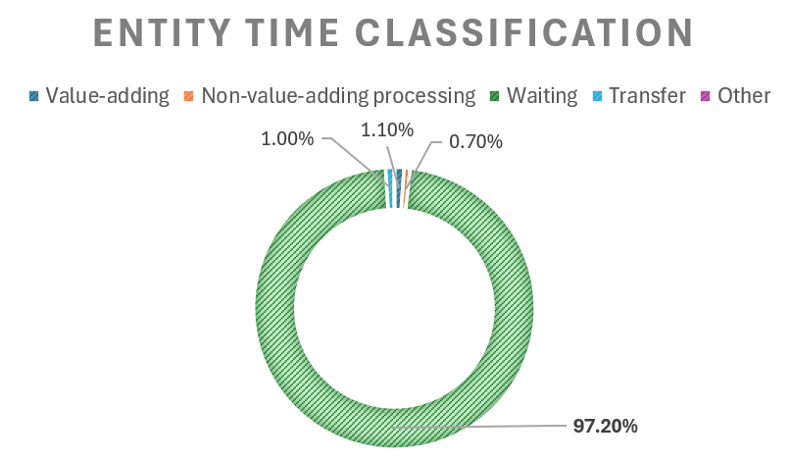
Figure 4 - Entity Time Distribution Pie-Chart
As shown in Table 4 and Figure 4, only 43.1 seconds of the average 3,845.5-second entity time is classed as value-adding, which is approximately 1.1% of the total. In comparison, waiting accounts for 3,737.7 seconds, or 97.2%, meaning that most of the time spent in the current system does not directly contribute to transforming the product. Transfer and non-value adding processing make up only a small proportion of the remaining time.
The DES results show that the main improvement opportunity is not simply reducing individual processing times, but reducing the large amount of waiting caused by restricted process flow. This supports the drilling constraint identified in Section 4 as the main area to target for Lean improvement.

Simulation Analysis
The current state simulation was analysed across 30 eight hour replications, with the principal production and flow KPIs summarised in Table 5.
KPI | Identifier / Calculation | Current state result
Component arrival rate | Entity 1.NumberIn ÷ 8 h | 200.1 components/hour
Completed assemblies | Entity 1.NumberOut | 1,186.6 per shift
Throughput rate | Entity 1.NumberOut ÷ 8 h | 148.3 assemblies/hour
Average entity total time | Entity 1.TotalTime | 3,845.5 s (64.1 min)
Average entity waiting time | Entity 1.WaitTime | 3,737.7 s (62.3 min)
Drill utilisation | Drill.ScheduledUtilization | 99.96%
Operator utilisation | Operator 1.ScheduledUtilization | 77.06%
Drill Hold average waiting time | Drill Hold.Queue.WaitingTime | 3,610.7 s
Drill Hold average queue | Drill Hold.Queue.NumberInQueue | 200.8 components
Approx. shift-end WIP | Entity 1.NumberIn − Entity 1.NumberOut | 414.2 components
Table 5 – Current State Key Performance Indicators
The system completes an average of 1,186.6 assemblies during each eight-hour shift, giving a throughput of 148.3 assemblies per hour. This is lower than the component arrival rate of 200.1 per hour, leaving around 414 components still in the system at the end of the shift. Average entity time is 64.1 minutes, with 62.3 minutes of this being waiting time, showing that overall lead time is mainly caused by queueing.
Drilling is the main bottleneck in the current state, operating at 99.96% utilisation with an average upstream queue of about 201 components and a waiting time of 3,610.7 seconds. The shared operative is also relatively highly utilised at 77.06%, meaning it could become more restrictive if upstream capacity is increased. Overall, drilling is the main constraint on throughput and lead time, although any improvement should be considered at system level because bottlenecks can move when capacity is changed (Liu et al., 2023).

Opportunity Identification (Lean Evaluation)
The current state analysis identified drilling as the main restriction on production flow. Improvement scenarios were then tested within the verified simulation model to see whether relieving this constraint would improve overall system performance.

Increasing Drilling Capacity
As drilling was identified as the main bottleneck in the current state, its capacity was increased so that two components could be processed at the same time. The related Hold logic was also changed so that a component could move forward when either unit of drilling capacity became available. This removed the original drilling restriction, reducing drill utilisation from 99.96% to 66.60% and clearing the severe congestion that had previously formed before the drilling stage.
However, the change did not improve the overall performance of the system. Completed output fell from 1,186.6 to 1,030.7 assemblies per shift, with throughput reducing from 148.3 to 128.8 assemblies per hour. This is consistent with Rocha and Lopes (2022), who showed that changes expected to improve manufacturing output can sometimes lead to poorer overall performance when assessed using DES. Average entity time also increased from 3,845.5 to 5,202.4 seconds. This showed that although the drilling constraint had been relieved, a new restriction had appeared elsewhere in the system. The main results from the two-drill scenario are shown in Figure 5, with the full simulation output provided in Appendix C.
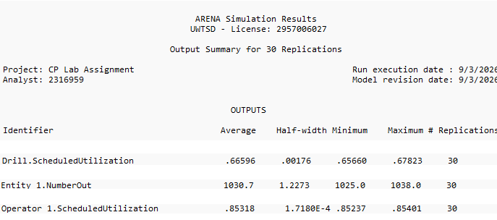
Figure 5 - 30-Replication Summary Results for the Two-Drill Scenario
Further review of the two-drill results showed that the original congestion at drilling had moved further downstream. Mean waiting at the Dispensing Hold increased from 44.5 to 1,117.9 seconds, while waiting at the Output WIP Hold increased from 82.4 to 4,267.0 seconds. Operator utilisation also rose from 77.06% to 85.32%, showing greater demand on the shared operative. The extra drilling capacity therefore removed the initial bottleneck but exposed downstream restrictions that had previously been less significant, showing how bottlenecks can shift when system capacity is changed (Liu et al., 2023). Supporting mean performance measures are provided in Appendix C.

Increasing Cap Dispenser Capacity
Following the two-drill scenario, the large increase in Dispensing Hold waiting and operator utilisation showed that the cap-dispensing stage and its replenishment requirement had become more restrictive. A second improvement scenario was therefore tested while keeping the increased drilling capacity in place and increasing the dispenser refill interval from 10 to 20 components. This effectively increased dispenser capacity by reducing how often the operator was required to carry out replenishment. 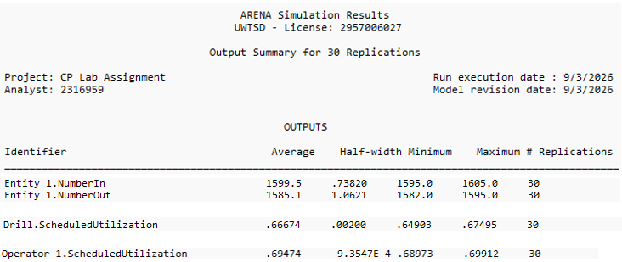
Figure 6 - 30-Replication Summary Results for the Two-Drill and Increased Dispenser Capacity Scenario
As shown in Figure 6, completed output increased to 1,585.1 assemblies per shift while operator utilisation fell to 69.47%. Supporting mean results show that average entity time reduced to 218.9 seconds and waiting time to 117.2 seconds. Waiting at the Dispensing Hold and Output WIP Hold also reduced to 38.2 and 38.6 seconds respectively, showing that most of the downstream congestion seen in the two-drill scenario had been removed.
Operator utilisation fell from 85.32% to 69.47% even though production output increased. This suggests that reducing the frequency of dispenser replenishment lowered the demand placed on the shared operative and allowed the additional drilling capacity to improve overall system flow. Supporting mean performance measures and the complete Arena simulation output are provided in Appendix D.

Overall Evaluation of Improvement Opportunities
The results show why improvement opportunities need to be considered at system level rather than focusing on individual resources alone. Increasing drilling capacity removed the original bottleneck, but overall throughput fell as congestion moved further downstream. When the increased drilling capacity was combined with greater dispenser capacity, system performance improved considerably. The main results from the three simulation configurations are compared in Table 6, with the corresponding throughput comparison shown in Figure 7.

Performance measure | Current state | Two drills | Two drills + dispenser capacity
Completed assemblies / 8 h | 1,186.6 | 1,030.7 | 1,585.1
Throughput (assemblies/h) | 148.3 | 128.8 | 198.1
Drill utilisation (%) | 99.96 | 66.60 | 66.67
Operator utilisation (%) | 77.06 | 85.32 | 69.47
Dispensing Hold waiting (s) | 44.5 | 1,117.9 | 38.2
Output WIP Hold waiting (s) | 82.4 | 4,267.0 | 38.6
Average entity time (s) | 3,845.5 | 5,202.4 | 218.9
Table 6 - Comparison of Current State and Improvement Scenario Performance
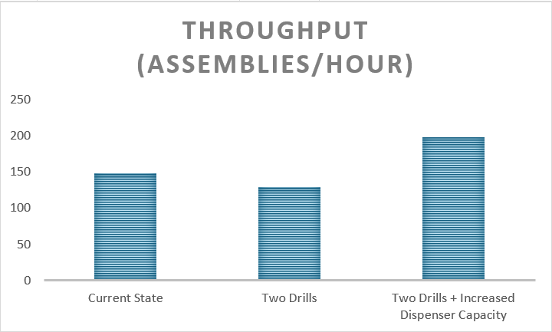
Figure 7 - Mean Throughput Across Current State and Improvement Scenarios
The comparison shows that removing one bottleneck does not automatically improve the performance of the whole system. In this case, the extra drilling capacity shifted congestion further downstream, while the combined scenario produced the best result, reaching 198.1 assemblies per hour. This is a 33.6% increase over the current state, with average entity time also falling from 3,845.5 to 218.9 seconds.
There are still other areas that could be investigated. Additional operator capacity could reduce competition between dispenser replenishment and output removal, while reducing the 39.2 seconds of fixed transfer time could lower non-value adding movement. Buffer sizes and replenishment frequencies could also be adjusted to improve flow and reduce the chance of another bottleneck developing. These options were not simulated in this study, so their effects cannot be quantified here. Further DES work could be used to test these changes at system level before any physical implementation (Oleghe and Salonitis, 2016).

Conclusion
This study developed and verified a Discrete Event Simulation of the Festo CP Lab to evaluate current state manufacturing performance and identify opportunities for Lean improvement. The model represented the specified product mix, processing and transfer times, shared operative activities and periodic replenishment and output-removal requirements. Simulation of the verified model enabled system performance to be quantified through throughput, waiting time, WIP and resource utilisation, while value analysis showed that only 1.1% of total entity time was value-adding, with waiting accounting for 97.2%.
The current state analysis identified drilling as the principal bottleneck, operating at 99.96% utilisation. Increasing drilling capacity relieved this constraint but shifted congestion downstream and reduced overall throughput, demonstrating the limitations of local optimisation. Addressing the subsequently exposed dispenser constraint increased throughput to 198.1 assemblies per hour, 33.6% above the current state, while reducing average entity time from 3,845.5 to 218.9 seconds. Overall, the study demonstrates how DES can complement Lean analysis by quantifying waste, identifying interacting constraints and evaluating improvement opportunities at system level before physical implementation.

References
Goldsman, D. and Goldsman, P. (2015) ‘Discrete-Event Simulation’, in Loper, M.L. (ed.) Modeling and Simulation in the Systems Engineering Life Cycle. London: Springer, pp. 103–109. doi: 10.1007/978-1-4471-5634-5_10.
Kumar, D.R., Devadasan, S.R. and Elangovan, D. (2022) ‘Mapping of non-value adding activities occurring in classical manufacturing companies with lean strategies’, Proceedings of the Institution of Mechanical Engineers, Part E: Journal of Process Mechanical Engineering, 236(3), pp. 894–906. doi: 10.1177/09544089211051595.
Liu, D., Guo, Y., Huang, S., Wang, S. and Wu, T. (2023) ‘Dynamic production bottleneck prediction using a data-driven method in discrete manufacturing system’, Advanced Engineering Informatics, 58, 102162. doi: 10.1016/j.aei.2023.102162.
Oleghe, O. and Salonitis, K. (2016) ‘Manufacturing system lean improvement design using discrete event simulation’, Procedia CIRP, 57, pp. 195–200. doi: 10.1016/j.procir.2016.11.034.
Rajab, S., Afy-Shararah, M. and Salonitis, K. (2022) ‘Using Industry 4.0 capabilities for identifying and eliminating lean wastes’, Procedia CIRP, 107, pp. 21–27. doi: 10.1016/j.procir.2022.04.004.
Rocha, E.M. and Lopes, M.J. (2022) ‘Bottleneck prediction and data-driven discrete-event simulation for a balanced manufacturing line’, Procedia Computer Science, 200, pp. 1145–1154. doi: 10.1016/j.procs.2022.01.314.
Sargent, R.G. (2010) ‘Verification and validation of simulation models’, Proceedings of the 2010 Winter Simulation Conference, Baltimore, MD, USA, pp. 166–183. doi: 10.1109/WSC.2010.5679166.
Turner, C.J. and Garn, W. (2022) ‘Next generation DES simulation: A research agenda for human centric manufacturing systems’, Journal of Industrial Information Integration, 28, 100354. doi: 10.1016/j.jii.2022.100354.
Vilela, F.F., Braga, C.C., Cruz, J.R.B., Bócoli, G.M. and Montevechi, J.A.B. (2022) ‘Discrete event simulation and lean production: quantification of waste in a pharmaceutical industry’, Journal of Lean Systems, 7(2), pp. 90–110.
Xiao, Y., Li, C., Thürer, M., Liu, Y. and Qu, T. (2022) ‘Towards Lean Automation: Fine-grained sentiment analysis for customer value identification’, Computers & Industrial Engineering, 169, 108186. doi: 10.1016/j.cie.2022.108186.

Appendices

Appendix A – Arena Verification Run: 100 parts, 10-Replication Output Summary
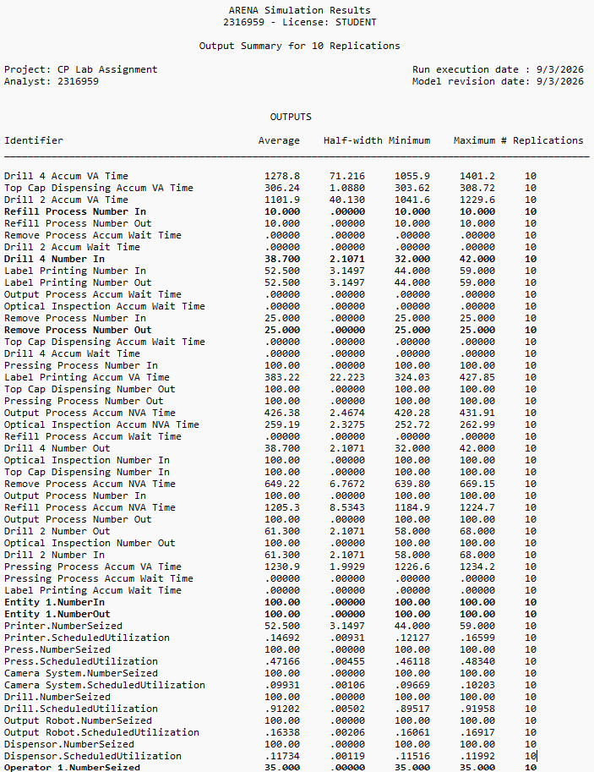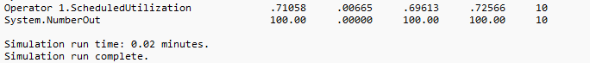

Appendix B – 8 Hour Simulation Results
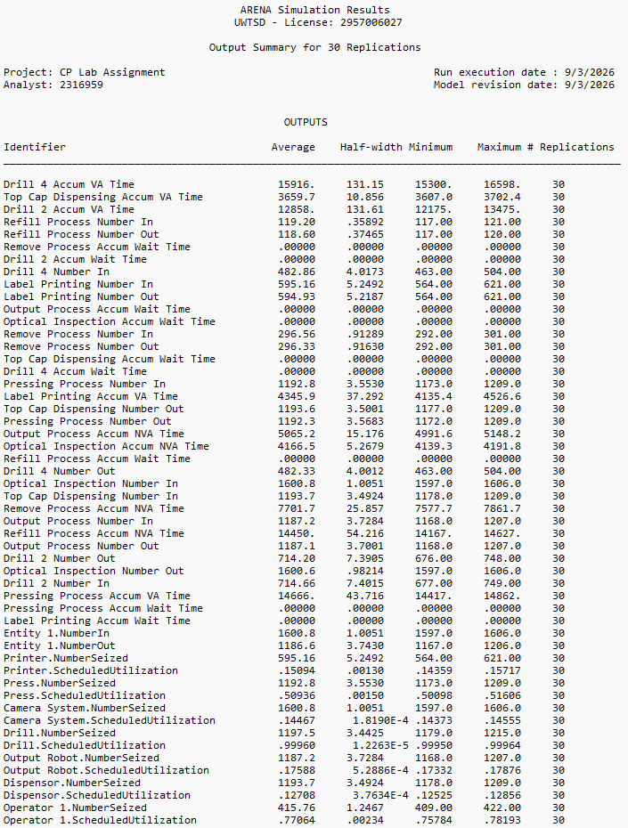

KPI | Identifier | Mean across 30 replications
Value-adding time | Entity 1.VATime | 43.1 s
Non-value adding processing time | Entity 1.NVATime | 25.5 s
Waiting time | Entity 1.WaitTime | 3,737.7 s
Transfer time | Entity 1.TranTime | 39.2 s
Other time | Entity 1.OtherTime | 0.0 s
Total entity time | Entity 1.TotalTime | 3,845.5 s
Drill Hold waiting time | Drill Hold.Queue.WaitingTime | 3,610.7 s
Drill Hold average queue | Drill Hold.Queue.NumberInQueue | 200.8
Dispensing Hold waiting time | Dispensing Hold.Queue.WaitingTime | 44.5 s
Press Hold waiting time | Press Hold.Queue.WaitingTime | 22.6 s
Output WIP Hold waiting time | Output WIP Hold.Queue.WaitingTime | 82.4 s
Output Hold waiting time | Output Hold.Queue.WaitingTime | 10.6 s
Where a mean statistic was not provided within the Arena Output Summary, the reported value was calculated as the mean of the corresponding statistic across the 30 individual replication summaries.

Appendix C – Two-Drill Scenario Simulation Results
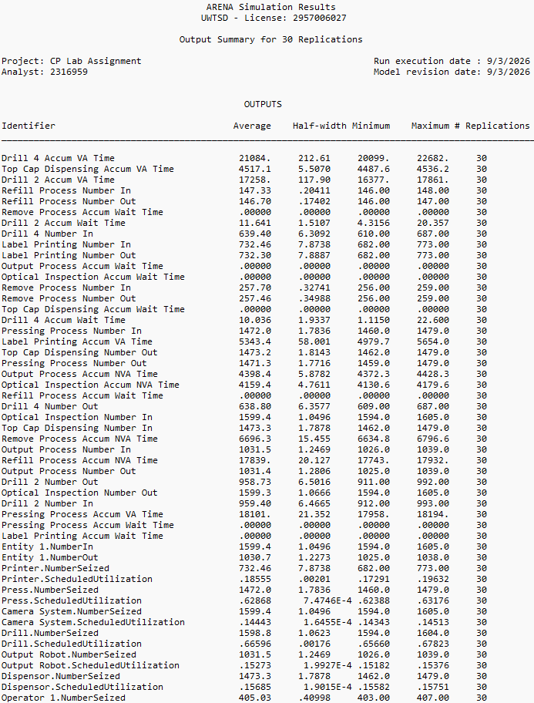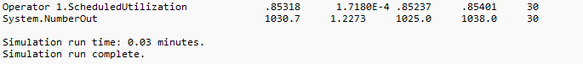

KPI | Identifier / Calculation | Result
Completed assemblies | Entity 1.NumberOut | 1,030.7 / shift
Throughput | Entity 1.NumberOut ÷ 8 h | 128.8 / h
Drill utilisation | Drill.ScheduledUtilization | 66.60%
Operator utilisation | Operator 1.ScheduledUtilization | 85.32%
Average entity total time | Entity 1.TotalTime | 5,202.4 s
Dispensing Hold waiting time | Dispensing Hold.Queue.WaitingTime | 1,117.9 s
Output WIP Hold waiting time | Output WIP Hold.Queue.WaitingTime | 4,267.0 s
Where a mean statistic was not provided within the Arena Output Summary, the reported value was calculated as the mean of the corresponding statistic across the 30 individual replication summaries

Appendix D - Two-Drill and Increased Dispenser Capacity Simulation Results
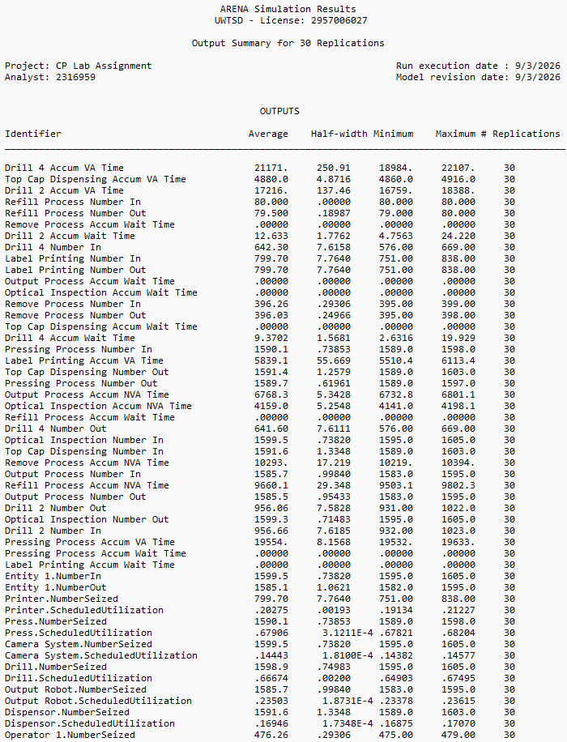

KPI | Identifier / Calculation | Result
Completed assemblies | Entity 1.NumberOut | 1,585.1 / shift
Throughput | Entity 1.NumberOut ÷ 8 h | 198.1 / h
Drill utilisation | Drill.ScheduledUtilization | 66.67%
Operator utilisation | Operator 1.ScheduledUtilization | 69.47%
Average entity total time | Entity 1.TotalTime | 218.9 s
Average entity waiting time | Entity 1.WaitTime | 117.2 s
Dispensing Hold waiting time | Dispensing Hold.Queue.WaitingTime | 38.2 s
Output WIP Hold waiting time | Output WIP Hold.Queue.WaitingTime | 38.6 s
Where a mean statistic was not provided within the Arena Output Summary, the reported value was calculated as the mean of the corresponding statistic across the 30 individual replication summaries.

