

Assignment Title:
Managing Projects in the Organisation

Student name- Laszlo Gamsz
Student No- 1922117
Module Name- BA (HONS) Leadership and Management Skills for the Workplace
Module code: BMSW5104
Module Tutor- Mr. Yajesh Kumar
Word count of submission: 2686.-
No. of pages submitted in total, including this page: 18.

Task 2- Evaluation of Project Management Plan
Slides:10 +2 references
Word count submission: 1065.
No. of pages: 7

Executive Summary:
In this report, the author introduces his project management plan to create a new way for guest hospitality. This new system is a mix for a hotel, a guest house and the contemporary city based car rental system. The structure of the report is to introduce the ideas behind the project, the project manager qualities and his Personal Development Plan. The structure of the organisation to develop and implement the project, the Project Management Scope and the typical Work Breakdown Structure of the project. The report consists also stake holder analysis, Gant Chart, Risk Matrix and Risk Assessment. The report closes with conclusions and recommendations supported with relevant data and diagrams as appendixes.

Table of Contents:

Page 1. Cover Page,

Page 2. Executive Summary

Page 3. Table of Contents

Page 4. Introductions

Page 4. The idea behind the project

Page 5. Introduction of Project Manager, his Personal and the Project Development Plan.
Page 5. The structure of the organisation to develop and implement the project.

Page 6. Stakeholder analysis

Page 6. Eco Hotel Project Quad

Page 6. Project Management Scope and Breakdown Structure

Page 7. Gant Chart

Page 7. Financial plan

Page 9. Market analysis

Page 9. Risk matrix and risk assessment

Page 10 Conclusion

Page 10 Recommendation

Page 11-12 References

Page 13-17 Appendix
Introduction
With the Covid-19 pandemic, the hotel and hospitality traditional business models have come under stress with the introduction of health and safety rules and government laws.
Hotels and guest accommodations. (Government UK, 2021) The main change in habits of the chosen hotels are guest bookings. Luxury hotels and places with huge social events are suffering a loss of revenue as guests reduced their bookings for business and work. For family and leisure, most people preferred booking whole separated flats or apartments like Airbnb, private rentals, etc. Single business travellers also choose hotels based on the easiest check in and check out procedure and expensive hotels with lots of extra services are of lower interest to them now. For many travellers, the accommodation budget is reduced and safety and convenience is now the most important consideration when planning. Based on the prediction of professionals the economy hotels will have the fastest return to pre-pandemic levels, luxury and upper scale will have the slowest. Hospitality and Covid-19: How long until “no vacancy” for US hotels? (McKinsey & Company, 2021)
The idea behind of the project is to explore changes to the operation of a low booked hotel to increase business prosperity. The project will start with one hotel and later on with more in different countries under the umbrella of Eco-Room system. The idea can work anywhere and the plan of the project manager is to do this with a real global franchise. After the completion of the first hotel in England, further business have been selected some in England and Hungary. All project management steps will be introduced with the relevant project management theories.
The idea behind the project.
It can be as hard to find a good idea for the project as it is to manage them, therefore the author of this report would like to avoid the usual mistake with his good idea, of managing it in an amateur way. His idea will be presented below briefly and the whole project management plan will be put forward convincingly for a decision. (Scott, 2008, p. 214)
The idea is to change the hotel structure for smaller double rooms in two categories, those with an ensuite bathroom and those without a bathroom. The two categories will be on different levels of the building, the ensuite bathroom requires only a toilet and a shower. On the levels of rooms without bathroom are communal showers with unisex toilets. Rooms can be booked on the Eco-room website or through the downloaded Eco-room application. The application works in a similar way to Zipcar, offering hourly car rental.
How Zipcar Works (Zipcar 2021). All bookings require a payment-in-full deposit, which is reduced as the used hours pass. At the end of the rental time, any unused portion of the deposit is transferred back to the user; typically the refund happens within 48 hours. This model can be used for hotel stays, with the unused portion of their room fee returned after the guests leave the room, (this is providing there is no further reduction based on any damage or additional costs, etc). Ordinarily, the hotel will operate a bar solely for hotel guests and purchases can be charged to the room account. With a pre-paid booking, it may be required to avoid room charging for consumption as the pre-paid portion could be depleted through these additional beverage purchases. Hotel guests can accept visitors from outside but just in the bar where they can consume. The bar is open from the evening hours and because of no reception, the staff of the bar can help hotel guests with any issue; this gives the impression the hotel is attended, they can help people also with bookings and room rental, or anybody who has a problem with their online booking. The bar should make a small profit, but its primary function is to gives a nice social feeling and atmosphere for hotel guests, giving them a chance for meetings with friends and also helps the security and seamless daily life of the hotel. If the profit of the bar beverage traffic offsets the staff salary, the hotel rooms make almost clear profit.
Introduction of Project Manager, his Personal and the Project Development Plan.
The Project Manager has more than thirty years of hospitality experience, including the management of hotels, golf clubs, river cruise ships and luxury residential apartments; this is divided between Hungary for twenty years and in England for ten years. Gamsz (2021) He is the author of this report. He has a good operational understanding of how the high end of hospitality and hotel business suffered since the beginning of the pandemic. His personal development fits with the project development plan, to change his hotel manager professional level for a project management level and to realize a new successful way of the hospitality and hotel business.
It will become necessary to change the culture and career plans on personal or organisational level during the global financial and hospitality crisis and consider the potential of changes that are beneficial. Organisational values can develop together with the personal values of all employees. van Hoorne (2017)
Behind the success of every person and organisation is continuous learning, assessing the relevant changes also continuously try to choose the best solutions from the actual possibilities in line with the changes.

The structure of the organisation to develop and implement the project.

The project development starts with a hotel in Golders Green with serious occupancy problems since the start of the pandemic, the owner is well aware of the advances and methods of the new system and is more than happy to take part in the project. As one of the main stake holders with the value of his hotel, he will change his hotel to the first Eco-Hotel. The other stake holder has a successful investment and building company in Hungary the owner of the Korshak Capital company, and would like to extend his profile in England; with his professional knowledge and experience and with the necessary financial investment, he is happy to take part in the project and will be responsible to alter the hotel for the desired level. He will be called as building manager further in the project plan. Further stakeholders in the project will be the chosen building company, advertisement portals to promote the services of the hotel and the trained staff of the hotel.
Project oriented organizations are conceptualized as entrepreneurial, future and stakeholder oriented organisations. The actual projects used as temporary, task-focused organizations developing strategies, transforming their culture and behaviour to services or business models. Three main points of all project-oriented organizations:
- Segments
- Values
- People
(Gemunden, Lehner and Kock, 2017, p.147)
Stakeholder analysis
(See appendix 1.)
Eco-Hotel Project Quad:
(See appendix 2.)

Project Management Scope and Breakdown Structure

The project management is comprehensive activity, involving knowledge, skills and techniques relevant for the project in case to meet the goals of the project. To define all demands by different stakeholders and circumstances the responsibility of the project manager and all things gives the scope of the project. To define and understand all stakeholder and business demands and accurately cover them by Project Breakdown Structure, gives all the necessary things for success. To miss them or not precisely measure them straight way could lead to project failure. (Lock, 2013, p. 175)
In the Eco Hotel project plan, the management followed the traditional steps of project management including
Gant-Chart
(See appendix 3.)

WBS, the Work Breakdown Structure, should outline all details of and components of the project, in an easily viewable form, as to how the project will be delivered. It will show who delivers, at what time and how it relates to other participants of the project. In the Eco-Hotel Project, the author has used a Gant Chart to show the main steps and the time frame. The WBS defines the scope of the project and the Gant Chart represents the currently approved statements.
Poorly or not well represented WBS can cause failure of many projects; to avoid any scope creep or mismanagement, the organisation will follow the WBS steps in the Gant Chart and will adopt all details in time. Roles and responsibilities are clarified clearly and the relevant tasks completed in time or not.
Luijbregts (2020)

The Gant Chart is a huge help to check and monitor all step follows the SMART objectives. The goals and milestones of the project have to be Specific, Measurable, Assignable, Realistic, Time- framed.

Financial Plan
Before the start of the project, the costs, benefits, risks and project budgets for all elements should be put into a comprehensive Project Financial Plan. During the process of the cost determination, we develop the budget and use this process to identify any new or hidden costs. The advantages in comprehensive financial planning, can help estimating the profit, reduce the financial risk and avoid unexpected costs. There are two key methods for financial planning:
- Top-Down cost estimating, by first deciding the maximum cost of the project and to fit in all the features of the project. If the exact details are not known, they can be substituted with data based on a similar project.
- Bottom-Up Estimating, which collects all expected costs, determines all the desired features and creates a detailed plan based on them. Hales (2021)
Because this is the first hotel to use the Eco-Rooms plan; and as the expectation is to further continue the project internationally, the financial planning will be a Bottom-Up-Estimating Hotel plan and exact details will added later in the roll-out after the Engineer Plan is ready and the construction phase has begun. Because the hotel owner is the main stakeholder, the biggest financial investment is already covered. The hotel owner will own 65% of the new management company of the hotel. 35% is owned by another company whose owners are the Project Manager and the Building Manager. The Project Manager is responsible for the whole scope of the project while the Building Manager is just for the reconstruction of the hotel building and to change the structure of the building according to the requirements of the project. It is envisioned to extend their activities as a franchise hotel in many countries, therefore getting the business to profitable operation as swiftly as possible is an essential part of project. The estimated profit of this hotel is easy to calculate as there are only 2 categories of rooms. For rooms with double occupancy, an extra £10 GBP per nights is charged. For the financial plan, half of the rooms in each category are calculated with single occupancy, however this is a known underestimation as in standard operation the hotel sees less than 40% with single occupancy. The hotel will have 20 rooms with bath and 40 without bath with communal bathrooms on each floor. The price per person £39 per night with bath and £29 person without bath. The whole investment and the project coast should return in five years. Based on the calculation sheet below, it is possible to see the estimated daily income is £3210 GBP, the annual income is £1,171,650 GBP with 100% occupancy. This is impossible of course, the planned occupancy forecast is for a minimum of 80%. The financial plan is deliberately below expectations. The management team want to follow the SMART objectives always, therefore the cheaper single occupancy is overestimated, while the occupancy rate is underestimated. Based on this very realistic expectations the yearly income should be at least: £937,320 GBP with a 5 years expectation of £4,686,600 GBP
After Tax payments and salaries with operating costs still 60% of this sum should remain:
£2,921,160.
The calculation is very realistic and careful, because without reception, the main costs of the staff, the bar profit should cover, main salaries is the room housekeeping.

Room Category | Room price | Number of rooms in that category | Income daily | Annual income with 100% occupancy
Rooms with bath double occupancy | 78 | 10 | 780 | 284700
Rooms with bath single occupancy | 49 | 10 | 490 | 178850
Rooms without bath double occupancy | 58 | 20 | 1160 | 423400
Rooms without bath single occupancy | 39 | 20 | 780 | 284700
 |  |  | 3210 | 1171650

Based on the Market Analysis sheets, it is possible to see the 80% occupation rate underestimated and because most of the hotel works by daily price calculation based on the actual occupancy, this hotel and hopefully later hotel-net, will offer attractive daily prices that will prevent much fluctuation in either occupancy or room revenue.
As mentioned earlier the project, investment should return in 5 years, which means 3 million clear profit in 5 years. All the costs will be continuously registered in the following sheet and the main financial stakeholder and investor the building manager will be in the best position to follow all the necessary costs. Also after opening in the first month, the hotel will offer an introductory discount, selling rooms at 60% of the normal price.

Project Fiancial Plan sheet
(See appendix 6.)

Market analysis
(See appendix 4.-5)
“The average cost for an overnight stay in a double room in London, UK in February 2021 was 153 euros, up from the previous year's average of 140 euros. In 2019, the average cost for overnight accommodation in London was particularly higher during the warm months of June to August. However, as a result of the travel restrictions imposed due to the coronavirus pandemic, the cost of an overnight accommodation in London significantly increased in 2020 compared to the previous year, reaching its peak in August and December.”
Lock (2021)

Risk matrix and risk assessment.
(See appendix 7.-8.)
The project is design to take advantage of the resources and opportunities arising from the pandemic. Uncertainty, challenges and risks will arise and have to be calculated in advance. One of the most important aspects of the project success is good risk assessment, which requires tools to help to identify, categorize, prioritize, mitigate or avoid the risks ahead in time. One of the best tools of the risk assessment is the risk matrix. The Eco Hotel Project management use the Smartsheet.com risk matrix application for risk assessment. It is possible to use this to identify the greatest to the smallest risk along with the severity and likelihood.
The biggest risk of course for any hotel project is a new lockdown and problems with noisy guests because, except in the bar, there are no staff in the nights dedicated to guest control problems. Room damage is the smallest problem, because of the minimal design of the rooms and the pre-payment and pre-authorisation system of the online booking system.
Conclusion
The project management plan is the main tool and help to realise the business plan, achieving the business goals and installing the updated business processes. Step by step descriptions of which tasks will be accomplished, when and by who will be laid out in detail. Useful tools will be implemented to manage the project and register timing and status, such as Gantt charts and the Risk Assessment Matrix by the Smartsheet.com website. Projects can fail for many reasons, but the managements awareness and focus to identify available risks can be accepted. To grow and renew a business, project management is inevitable to minimize and mitigate risks and by ongoing operation increase the success potential.
Developing New Products and Services (Saylor Academy, 2021).
In the Eco Hotel Project Management Plan the management tried to follow the traditional project management steps including a precise work breakdown structure to describe the scope of the project by Gant Chart and mitigate or avoid the risks by Risk Assessment Matrix. The Smartsheet.com website special electric sheets were a great help for that to assess all necessary investment even by financially or by knowledge to realise the project.
Recommendations
After the assessment of the project plan, the project appears to be a very profitable and promising business. Based on the described details the only two questions are, how good is the business policy to focus on lower standard prices against the contemporary moving prices, based on the occupancy; the second question is how to minimize guest problems with minimal staffing. The bar being just for hotel guests will mitigate this risk as well as reducing the staff cost by utilising the automatic check in system. This new way of operation reduce all staff costs (excluding housekeeping) and helps the hotel transition to a new way of hotel hospitality.

References

Gamsz, L. (2021) Laszlo Gamsz
Available at: https://www.linkedin.com/in/l%C3%A1szl%C3%B3-gamsz-b734007a/
Accessed: 2021)

Gamsz, L (2021) Eco Hotel
Available at: https://app.smartsheet.com/sheets/vXPjFRGhgWwXX6WXgw7FmPJCG7wxJCCQf7mCrMV1?view=gant
(Accessed: 31 January 2021)

Gemunden, H. Lehner, P. and Kock, A. “The project-oriented organization and its contribution to innovation” International Journal of Project Management 36(1).pp. 147-160

Government UK (2021) Hotels and Accommodations
Available at: https://www.gov.uk/guidance/working-safely-during-covid-19/hotels-and-guest-accommodation
(Accessed: 23 December 2021)

Hales, L. (2021) Financial Planning in Project Management
Available at: https://study.com/academy/lesson/financial-planning-in-project-management.html
(Accessed: 14th January 2021)

Lock, D. (2013) Project Management
10th Ed. London: Routledge

Lock, S. (2020) Average room rate of hotels in selected cities in the United Kingdom in 2016
Available at: https://www.statista.com/statistics/515740/average-hotel-room-rate-in-uk-cities/
(Accessed at: 19th November 2020)

Lock, S. (2021) Average cost of overnight accommodation in London from 2019 to 2021, by month
Available at: https://www.statista.com/statistics/614026/overnight-accommodation-costs-london-city/
(Accessed: 18th November 2021)

Luijbregts,E. (2020) A Project Manager’s Guide to Work Breakdown Structure
Available at: https://thedigitalprojectmanager.com/work-breakdown-structure/
(Accessed: 28th April 2020)
McKinsey & Company (2021) Hospitality and Covid-19: How long until “no vacancy” for US hotels?
Available at: https://www.mckinsey.com/industries/travel-logistics-and-infrastructure/our-insights/hospitality-and-covid-19
Accessed: 10th June 2020

USAID.GOV (2016) Project Financial Plan Template
Available at: https://www.usaid.gov/sites/default/files/documents/1865/201sab.pdf
(Accessed: September 2016)

Saylor Academy (2021) Developing New Products and Services
Available at: https://saylordotorg.github.io/text_developing-new-products-and-services/
(Accessed:2021)

Scott, B. (2008) Making things happen, mastering project management.
Springfield: O’Reilly

Smartsheet.com (2021) Risk Assessment Matrix
Available at: https://app.smartsheet.com/sheets/9q6jxH33HhFwQqXxW9jhrwR264MgvM4xVjFmHrp1
Accessed: 02nd January 2021

Van Hoorne, A (2017) Organizational Culture in the Financial Sector: Evidence from a Cross-Industry Analysis of Employee Personal Values and Career Success

Zipcar (2021) How Zipcar Works
Available at: https://www.zipcar.com/en-gb/how-it-works
Accessed: 2021

Appendix 1.- Stakeholder Analysis
Stakeholder | Interest | Importance | Influence
Laszlo Gamsz  Project Manager  Attila Korshak  Building Manager  Hotel Owner  Advertisement portals  Chosen Building company  Trained staff of the hotel | High  High  High  Low  Medium  Medium | High  High  High  Medium  High  High | High  High  Medium  Low  Medium  Low

Appendix 2. Eco-Hotel Project Quad
Purpose: The purpose of the project management to build and to start to manage the first hotel what is suitable for the goals and requirements of the project plan. The hotel have to be built, managed and advertised on that way as it is really just the first hotel and many more will follow. | Customers: The customers or stakeholders of the project first of all the owner of the first hotel, the building manager and the project manager. Further stakeholders are the advertisement portals for the project and the chosen building company. The trained staff also one or even the most important customers of the project.
Desired end result: The first hotel is ready and working well in order. Guest feedbacks are positive and the pub of the hotel became a real social place for hotel guests and their friends. All financial and professional investor stakeholder is happy with their investment. | Measure of success: Over 85-90 percentage occupation rate after six months of active business period, the project is ready to expand in more hotels and possible to start the advertisement for join a franchise. The main aim of the project to give a new business way to operate for suffering hotels, because of the current pandemic situation.

Appendix 3. Gant-Chart.
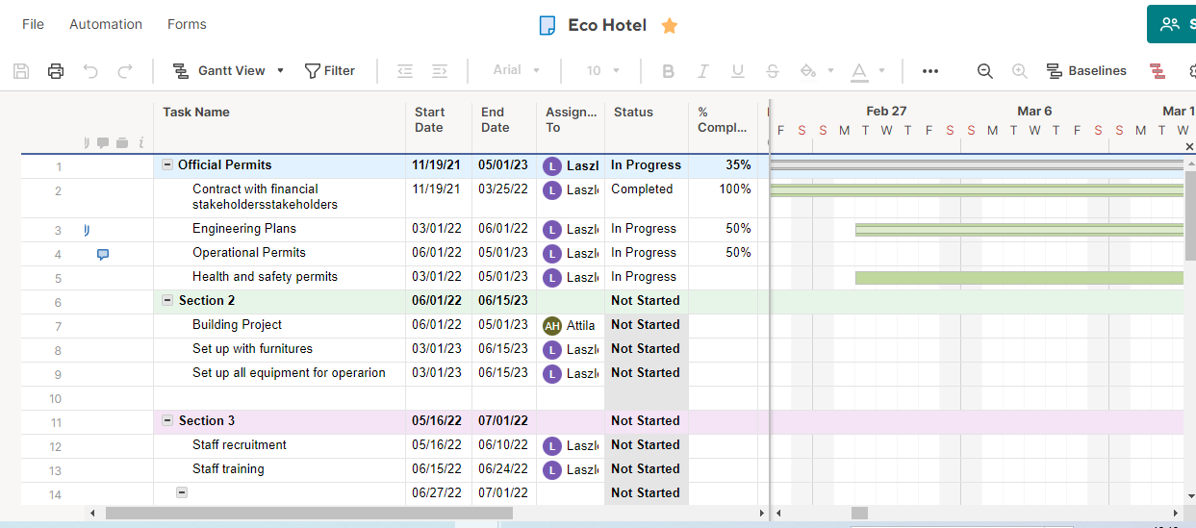
Gamsz (2021)

Appendix 4-5. Market analysis
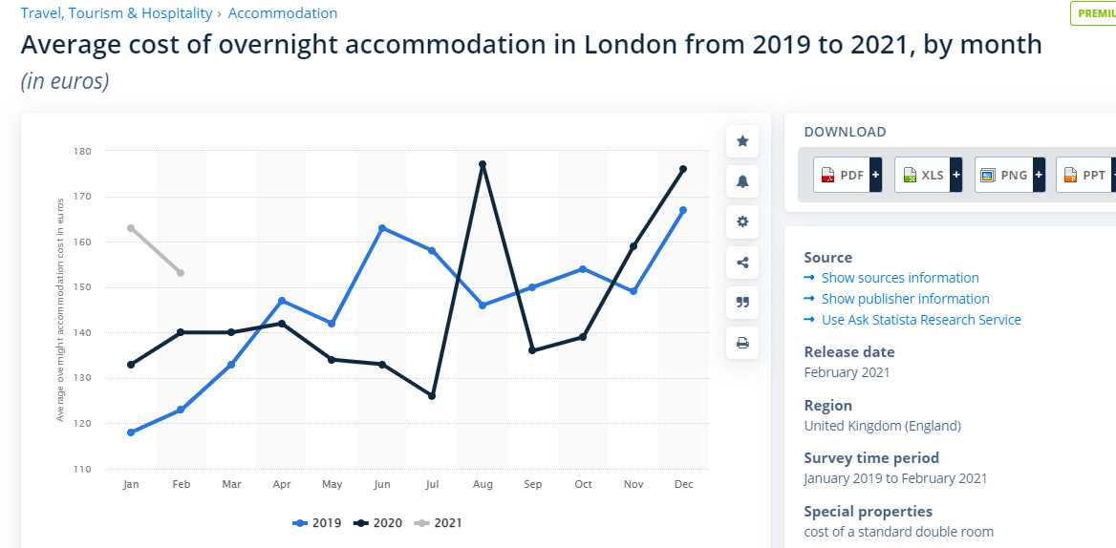
Lock (2021)
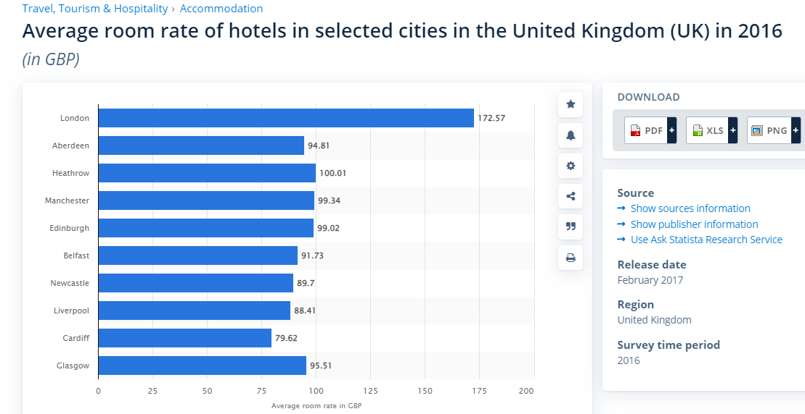
Lock (2020)

Appendix 6. Project Financial Sheet
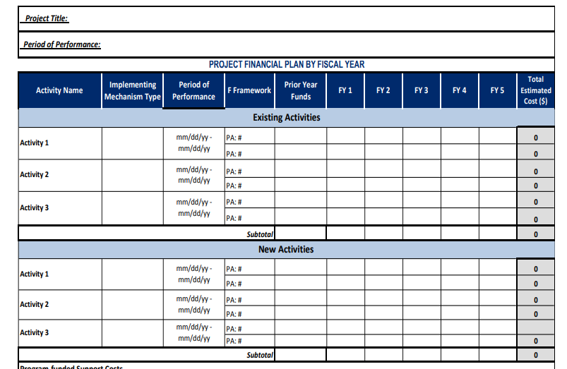
Project Financial Plan Template (USAID.GOV 2016)

Appendix 7.-8. Risk matrix and risk assessment.
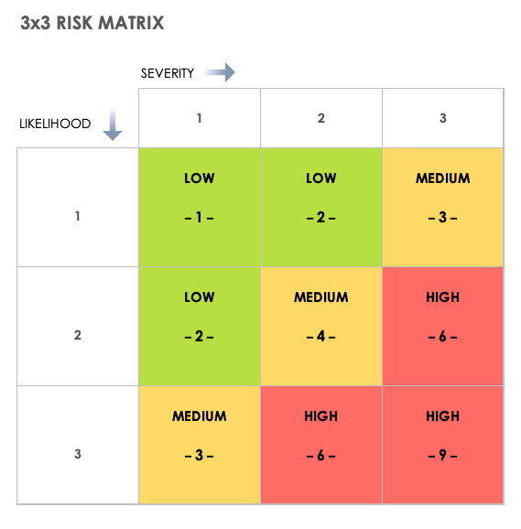
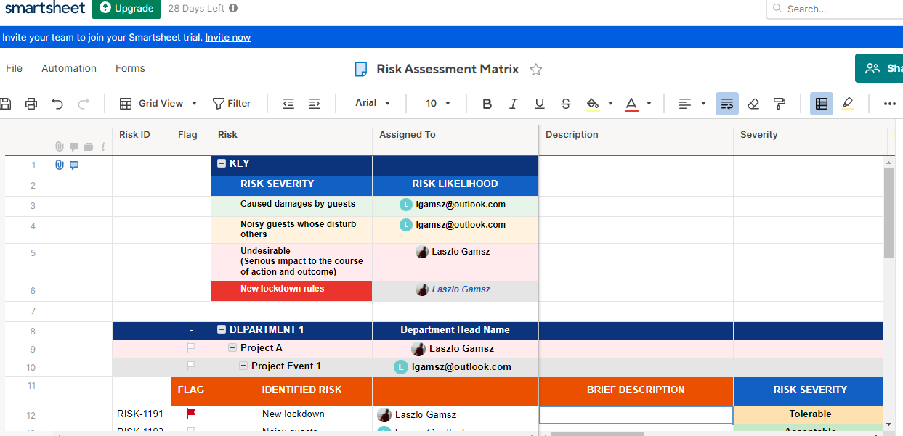
Risk Assessment Matrix (Smartsheet.com, 2021)

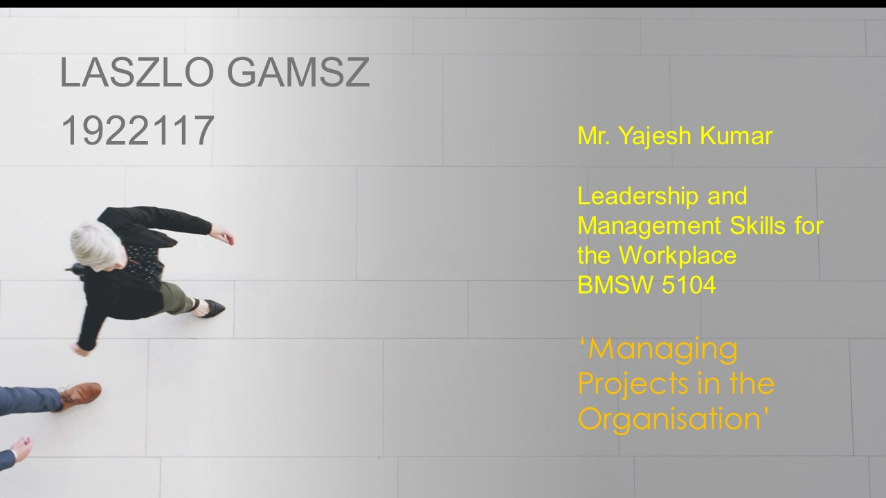

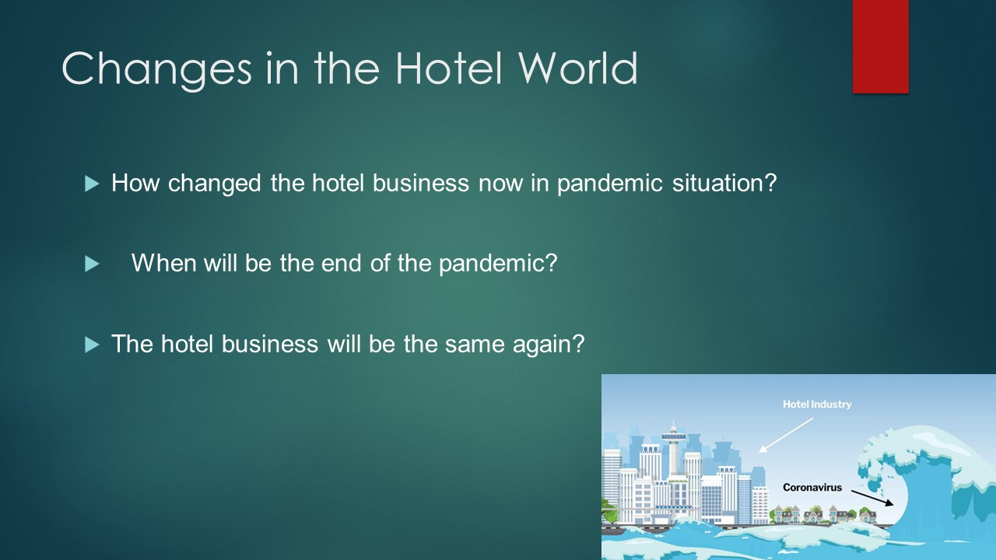
We are all affected since years by the actual pandemic situation, what is started in late January in 2020. Covid-19 timeline (British Foreign Policy Group, 2021)
Our personal and our professional life changed dramatically. The virus situation changed the life not just the people, but also all of the business organisations. One of the most influenced business is the hotel and hospitality sector.
Across the globe hotel industry experiencing the lowest booking rates since 9/11.
What is the future? For sure will be different. Reduced touchpoints, less interactions with guests with each other and keyless solutions will be used and the guests will looking for accommodations whose can provide that. Wheeler (2020)

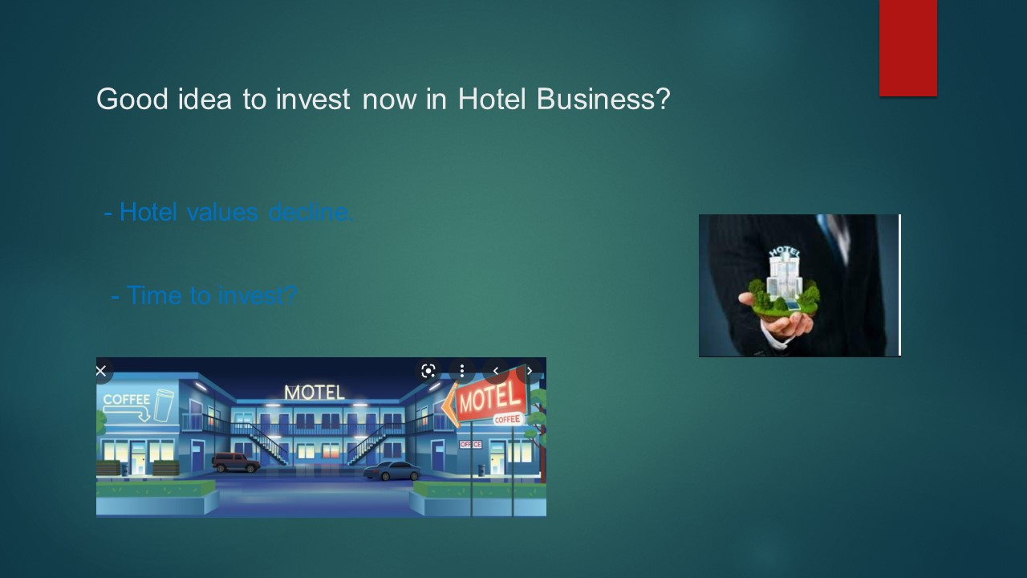

The deteriorations of hotels not the same, different by service, category, level of services, economy and midscale hotels whose provide city services with limited-service suffered the lowest value reduction. The sources of their services remained essential, transportation industry, construction crews, and travellers. Luxury properties are the most impacted group.
Pierce (2020)
Leading stock investment professionals suggest, this is the best time for investment for special parts of the market.
Should I buy stock during the coronavirus crisis? (The Times Money Mentor, 2021).

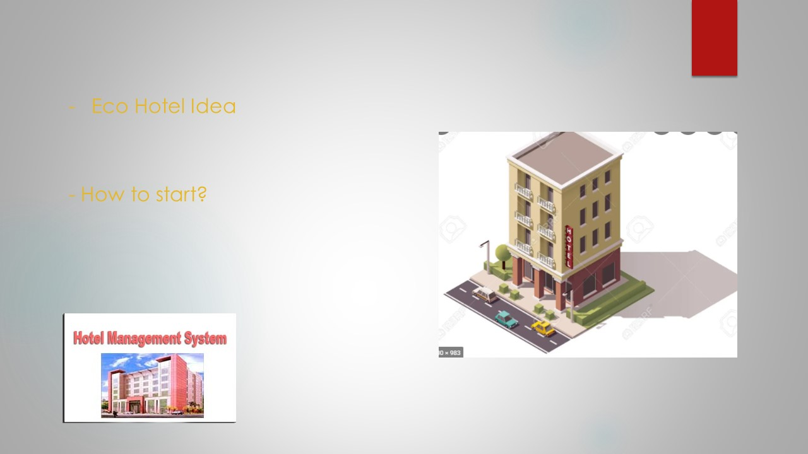

If the traditional hotel business is suffering, the hotel prices are down, most of the hotel through many generations, they don’t want to sale them at all. And even hotel investors and companies don’t want to sale when the prices are down. They are looking for a new way to keep their properties and make profit. We can offer them the new Eco-Hotel management system and already we have the first hotel owner who would be happy to start. After the first hotel is ready and operates well, will be much easier to find new ones all around the world with the same operation system. The first hotel to start and to change the design is in London, in Golders Green.

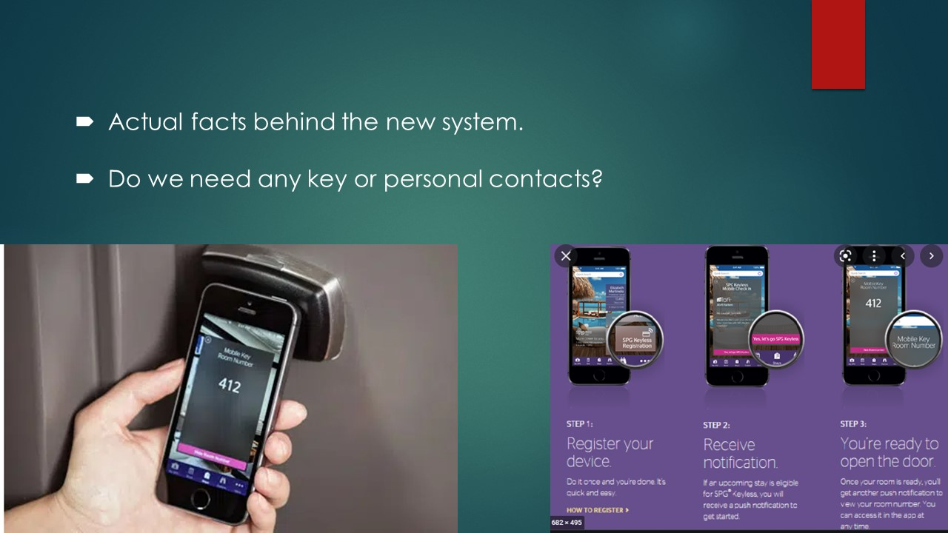

- The idea is an improved version of the Clink Hostels systems, whose operating very successfully in London in 2 hostels since 1997 and the second since 2007 and now they will open 2 new ones in Dublin and Lisbon. Long Term Accommodation London (Clink Hostels, 2021)
Clink Hostels do not have paid reception staff, long term guests do reception service usually for price reduction or free accommodation, the new hotel system even doesn’t have a reception.
- And the other part is from the companies whose offer keyless and contactless apartment rentals already worldwide. Milne (2020)
More and more peoples and families avoid to visit hotels, they rather rent flats or apartments where they can avoid any personal contact with other guests, the Airbnb and keyless apartments rentals are booming. More and more Airbnb apartments offer keyless service also. Keys can be lost, copied, stolen or locked inside. Smart locks solve all this problem, operated by key cards or smartphones.
6 Best Airbnb Smart Locks for 2022: Side by Side Comparison (Operto, 2021).

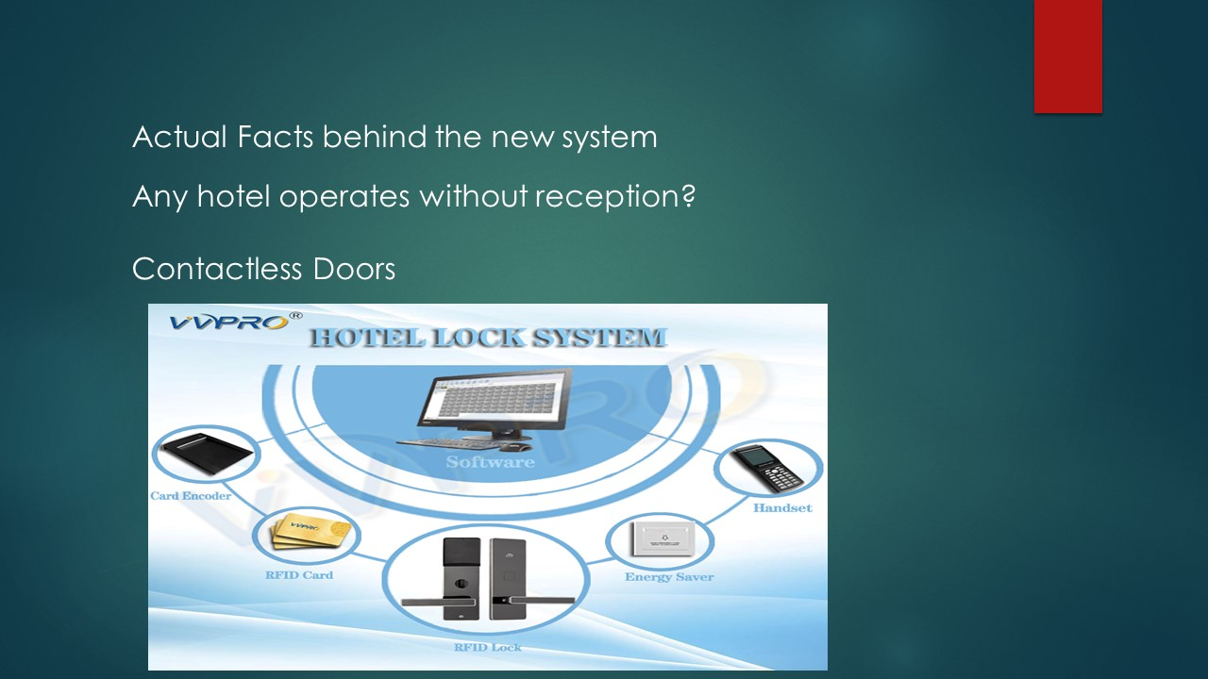
The Eco-Rooms hotel provide absolute contactless reservation and check in, returning guests can get hotel cards from the pub, what is after reservation provide contactless entrance to the rooms, or first time guests or even returning guests can check in just through online reservation. After pre-paid reservation, they got the email what is have the sign, just have to touch close to the door to open, the same way as the popular and city used Zip Car application works. How Zipcar Works (Zipcar 2021

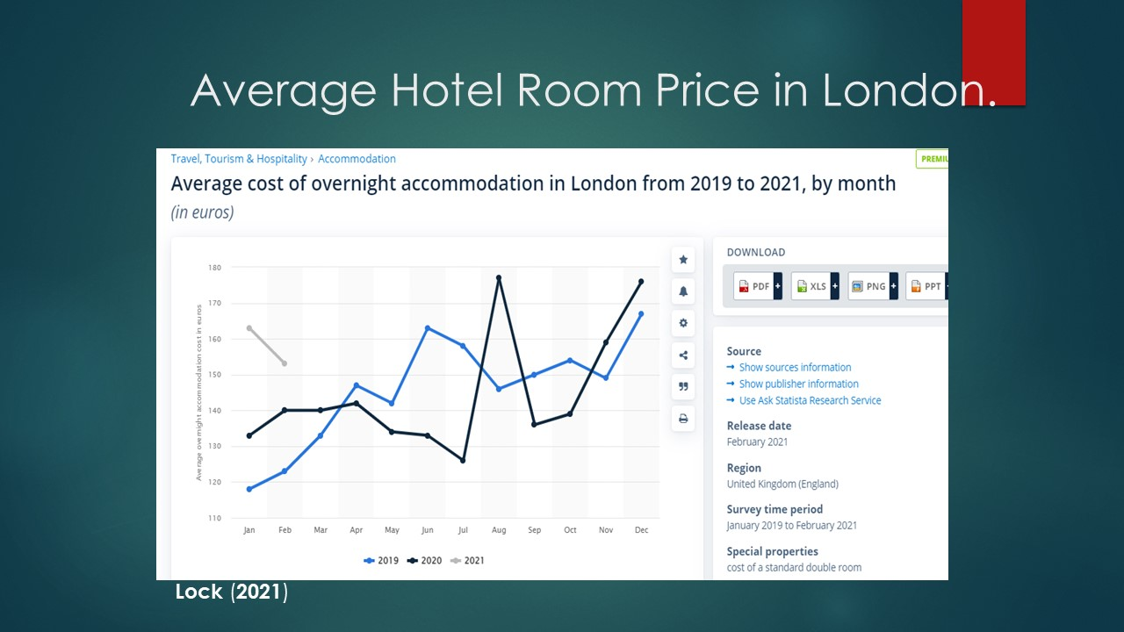

As possible to see the on the diagram above, the average hotel room prices in London never went really under 120 GBP per night.
Our new system will offer even much cheaper, and much more health secure total personal or physical contactless solution.

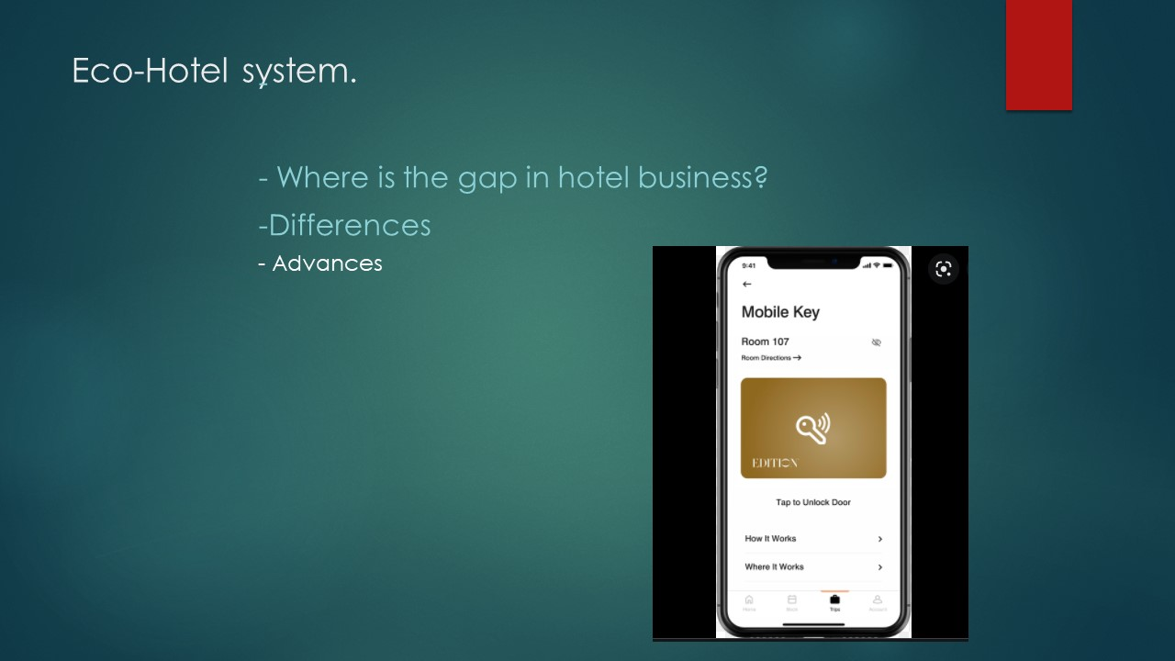
Luxury and top quality hotels the main victims of the situation, but people still travel to work, to trade and to start new life in new cities. Many people have to move to different countries or to different city to work and to live. Eco- Hotel system is a brilliant way to live on reduced price even for a long time, before they can find a final accommodation solution. Investment interesting in any business when the prices are down, and the new hotel system offer contactless online check in, check out and reservation solution.

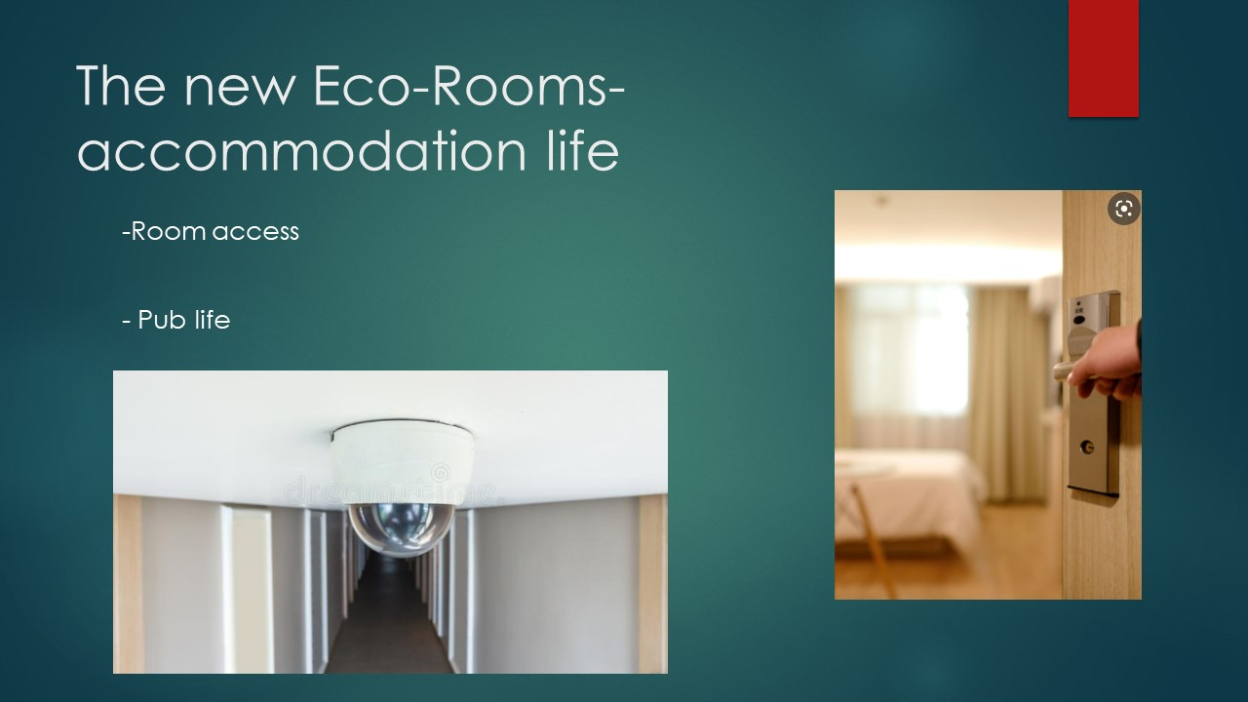
- After successful reservation, if the wished hotel room is paid, the door opening sign is activated and the guest gets that by email or can download the hotel application system. No reception, no personal contact regarding of check in and check out at all.

- The reason of the pub is a kind of security, to give the impression of the guests they are not alone in the hotel building. If the profit of the bar covers the wage of the stuff, except the housekeeping what possible to solve with subcontracted company, no employees costs. Easy to control the stock and staff honesty in the bar, because any consumption possible just to room charge. No one can come in from the street, the guest room keys operates the main entrance to the building so possible to come in just for the guests responsibility, and just to the pub. The entrance to the rooms beside the pub and signs warns everyone, just for hotel guests, if anyone tries to go to the room section with hotel guests, the staff can warn them. Cameras on all corridor and possible to monitor them by the staff in the pub, and if more hotel joined, centralised camera surveillance are planned.


Based on the previous slides hopefully was possible to convince you, with the first hotel whose owner is ready to change and take part in the project and the building manager ready to do the necessary changes and ready to invest the necessary financial support. The only one question is the operation plan.
On the slides and the attached Project Plan tried to answer any possible open question. Happy to listen any more, but we have an unique possibility to do something huge and not the single hotel profit our main aim, rather the high occupancy, in case to start something big. After the occupancy is always high than possible to get more and more hotels in the ECO-Room Accommodation system, but the aim is always to get more and more hotels, to get them close 100% occupancy rates, rather than higher room prices. All the new hotel owners whose step in the project will be financial shareholders of the operation company, this can compensate of them instead of higher prices in their own hotel. Our aim is high occupation, not high price.


