Kieran Brown (2204069)
University Of Wales Trinity St David
Applied Computing – Databases and Application Development
Assignment 1

Table of Contents

Page 3 – Introduction

Page 4 – Task 1 ER Diagram

Page 5 – Task 2

Page 6 – Task 3

Page 7-11 – Task 4 evidence

Page 11 – Conclusion

Page 12 – Bibliography

Introduction

In recent years, digital marketing has been at the forefront of how businesses connect with their customers, allowing 24/7 availability to the businesses products ensures the business is maximising customer purchases. Adventureworks Cycles, a renowned bicycle manufacturer based in the heart of the city. Are looking to expand their customer reach and modernise its operations. Adventureworks are known for their wide range of bicycles including mountain bikes, road bikes and hybrid models aswell as many cycling accessories are now looking to build an online platform where current and potential customers can browse, purchase and even customise their own bikes from Adventureworks. In order to achieve this, they need a well-structured database which can be personalised to customer interactions.

In response, Adventureworks have requested for my team to guide and create a high quality database which is the most suitable for their online marketplace. This database will be a high-performance database system that will align with both Adventureworks requirements and growth objectives to ensure that customers have an excellent experience.

Task 1

Analyse the requirements of Adventure Works Cycles and propose a database design by creating a database schema prototype using a suitable Entity Relationship Diagram (ERD). Implement a Microsoft SQL Server database using SQL statements to manage Adventure Works Cycles' operations effectively.

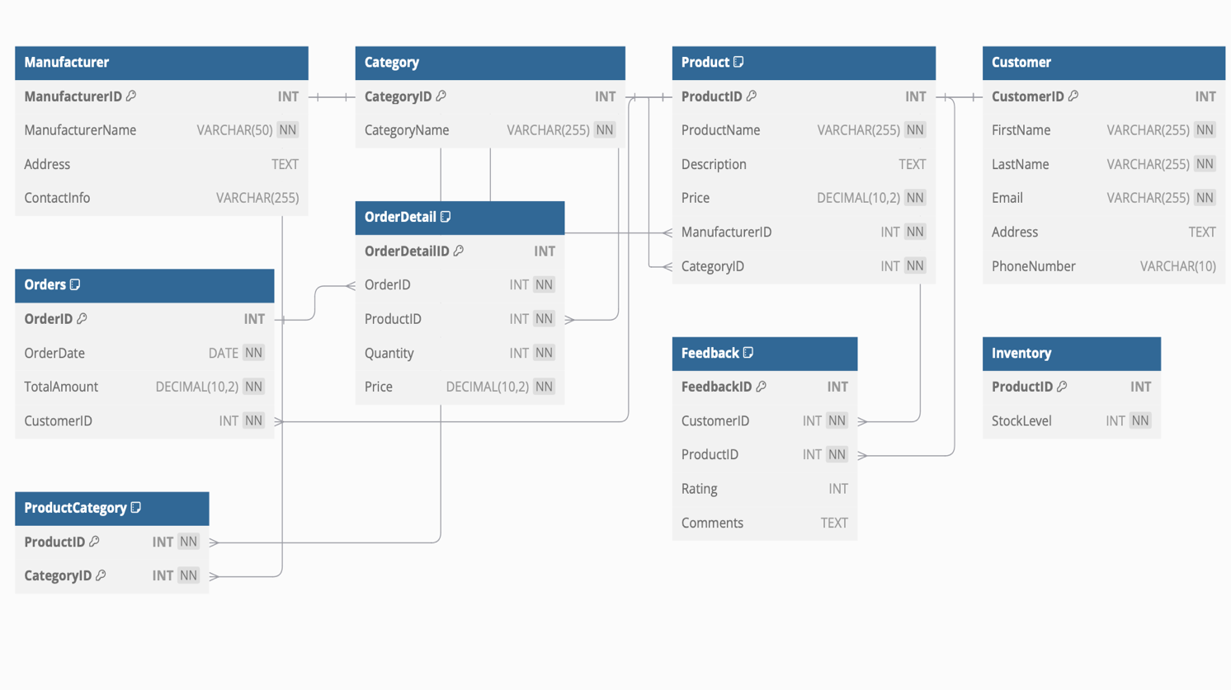

An ER Diagram can be used “to design a new database, or to visualise and understand an existing one” [1] This ERD illustrates the path chosen for the Adventureworks database. This design ensures that each table includes appropriate attributes, primary and foreign keys for suitable relationships in 3NF for optimal performance.

Task 2

Design and execute a transactional scenario where you demonstrate the use of rollback and commit operations in this database system. Ensure your scenario involves multiple SQL statements and includes conditions under which you decide to commit or rollback the transaction. Describe the rationale behind your choice of operations.

Transactional scenarios in databases are “made up of basic database operations like reading, writing, updating and deleting data” [2] In this database for Adventureworks it is used to handle a customer placing an order. Demonstrating the use of rollback and commit to ensure data integrity. By using the transaction it ensures that all operations such as recording the order, updating inventory etc is completed. Which prevents a situation where inventory levels are reduced without an order being placed.

Consistency across tables – The design ensures that data remains consistent between the tables, which “ensures that data across various systems is accurate, coherent and aligned with predefined standards”[3]

Error handling with rollback – The use of rollback ensures that there are no errors within the database such as allowing customers to place orders with insufficient stock. Which prevents customer complaints and order issues.

Scalability – By implementing rollback and commit operations the database is better equipped to deal with more complex transactional scenarios. Like processing multiple orders at the same time. This makes for a better customer experience and helps to “maintain data integrity and consistency” [4]

In summary the rationale behind the decisions of the transactional design were to mainly ensure data integrity and to improve customer experience. By minimising errors it ensures that Adventureworks have a robust system for managing transactions.

Task 3

Performance Tuning Enhancement: Investigate the most important transactions for Adventure Works Cycles in order to improve query performance.
Data queries are database transactions used to query the database for information. Think of the data query requirements that are going to be important and/or frequently executed in the database and identify any secondary indexes that can be added to improve the performance of such data queries. You should also indicate why you have chosen to index these columns.

Performance tuning enhancement is “the process of optimising database systems for improved performance and efficiency” [5] For the Adventureworks database it is critical for query execution as by adding secondary columns in frequently queries, the database can retrieve data quicker than manually. The most important transactions and queries for Adventureworks would be:

Customer Order Retrieval – For the customer order retrieval ProductName and CategoryID in the Product table were indexed which ensures fast access to specific orders placed by customers. This can be good for Adventureworks order reporting.
Feedback Analysis – For the feedback analysis by product ProductID in the feedback table was indexed. This ensures that Adventureworks are able to find feedback on specific products.

Retrieving Products by name or category – For retrieving products by name or category ProductName and CategoryID in the product table were indexed. This ensures that Adventureworks are able to speed up their inventory management and customer queries by finding the correct product that they have been asked about.

Date-based Sales Report – For the Data-based sales report OrderDate in the orders table was indexed. By doing this it reduces the amount of time taken to create a sales report which is essential for Adentureworks performance monitoring.

Task 4

- SQL code used to generate each table structure

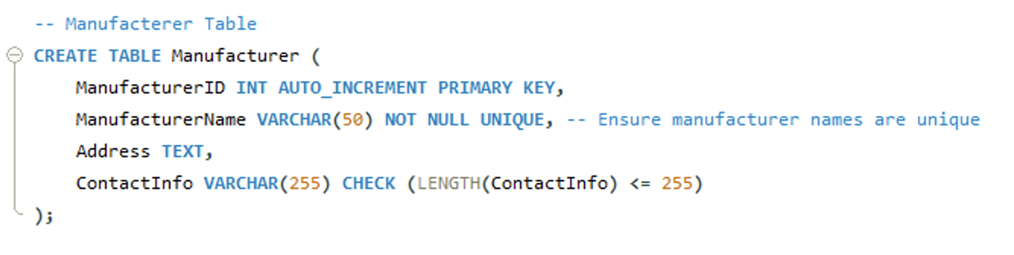

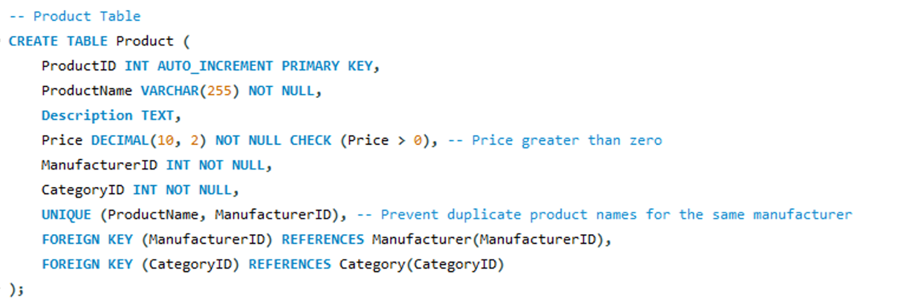

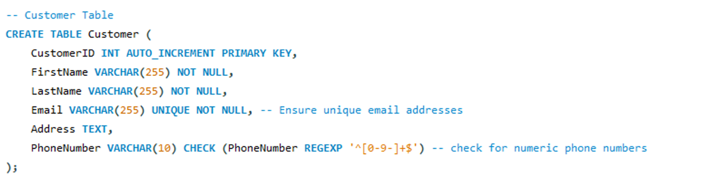

The creation of table structures ensures that the database is organised logically so that it can adhere to its designed schema. These steps are crucial for defining the framework of the database and ensuring that all of the relationships and attributes align with Adventureworks needs. By designing the tables in this way they will benefit from a well-defined data model with both supports scalability and simplifies querying

- SQL code used to create referential integrity constraints





Implementing referential constraints ensures that the database has consistency and accuracy between related tables by using foreign key dependencies. By using this it enables Adventureworks to prevent issues in the data. This is essential for ensuring the system is reliable.

- SQL code used to create check constraints

Check constraints are essential for validating data as soon as it is entered into the database, ensuring that only valid and correct data is stored. The three constraints are an example of the types of constraints entered into the database. TotalAmount can’t be less than zero, amount in price field can’t be negative and a rating system having only numbers between 1 and 10. This reduces the likelihood of errors which makes the database reliable.

- SQL code to populate each table with sample data (minimum of four records per table)

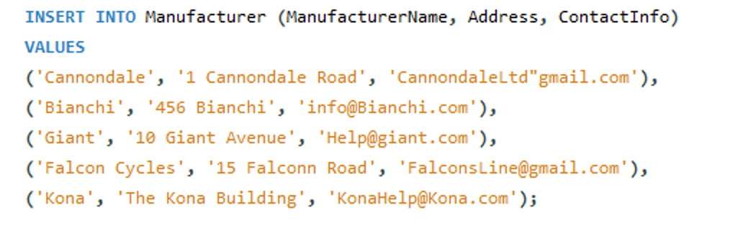

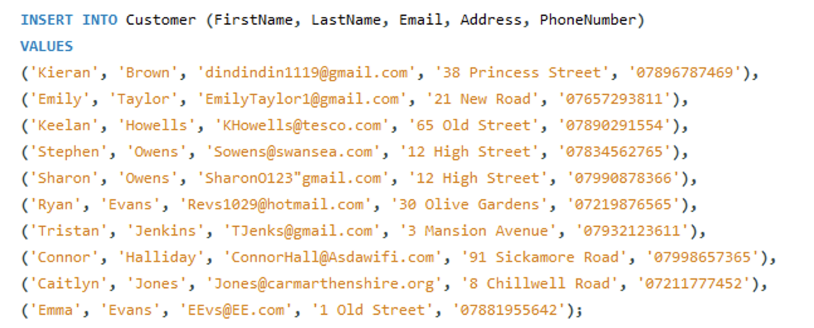

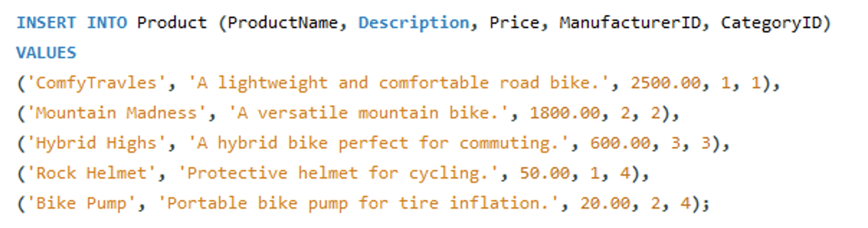

The database was populated with sample data in all tables. By doing this it enabled the functionality of the database to be tested using the queries and constraints from the previous steps. For Adventureworks, it ensures that it ready for application and provides them with a foundation for potential issues in the data structure.

- SQL code to demonstrate evidence of testing carried out to validate the constraints
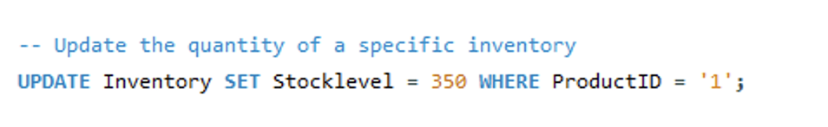

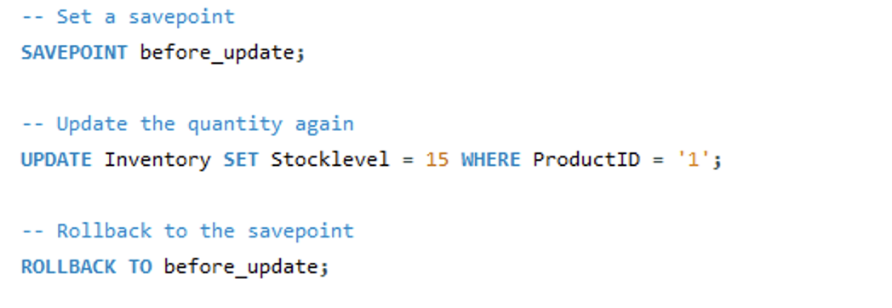

Testing the database by validating constraints ensures that the rules are working as intended. This test ensures that invalid data is correctly rejected and confirms that the database can handle data entry errors.

- SQL code to demonstrate evidence of transaction rollback and commit operations

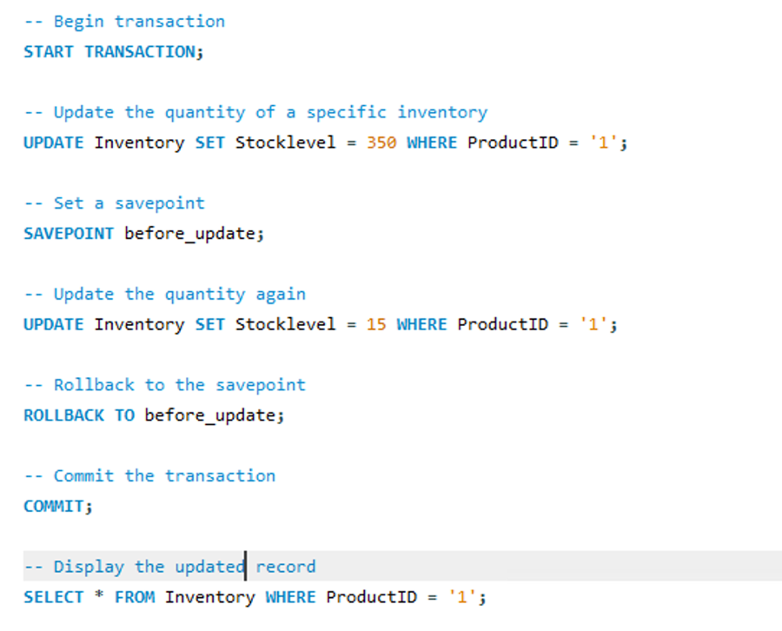
Transaction management is vital for ensuring that the database can maintain consistency during complex operations. For this example the quantity of stocklevel was rolledback. This was important for order placement to show customers the correct amount of stock for the specific product.

- SQL code to build the database performance tuning enhancements

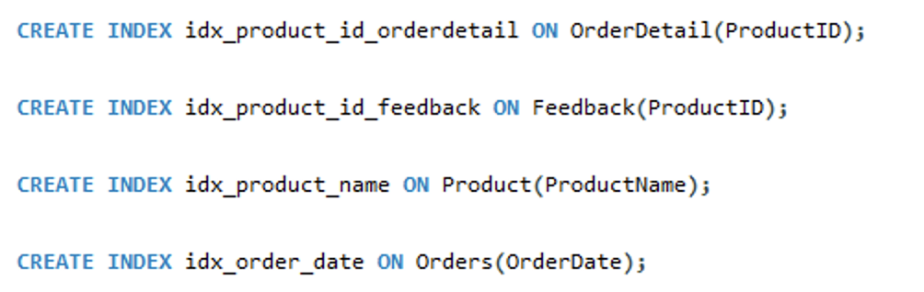

Adding indexes to key columns improves query performance as it reduces the time it takes for a user to search for data. Indexing colums like ProductName, OrderDetail and ProductID optimises frequently used queries which ensures that as the database grows, it can still be very easy to find specific data.

Conclusion

In this assignment, The Adventureworks database was designed and implemented with a main focus on having a robust system with emphasis on data integrity, functionality and performance optimisation. The database schema was created to ensure that Adventureworks system met their criteria and operational needs. Performance tuning enhancements were used by indexing key columns for fast operations from a business end, and rollback and commit were used to validate the systems reliability.

Bibliography
[1]
Secoda, “An Entity Relationship Diagram (ERD) is a visual representation of different data using conventions that describe how these data are related to each other,” www.secoda.co, Sep. 16, 2024. https://www.secoda.co/glossary/entity-relationship-diagram (accessed Dec. 21, 2024).

[2]
Snowflake, “What Is a Transactional Database?,” Snowflake. https://www.snowflake.com/guides/what-transactional-database/ (accessed Dec. 21, 2024).

[3]
Atlan, “Data Consistency 101: Causes, Types and Examples,” atlan.com, Aug. 16, 2023. https://atlan.com/data-consistency-101/ (accessed Dec. 21, 2024).

[4]
GeeksforGeeks, “Difference between COMMIT and ROLLBACK in SQL,” GeeksforGeeks, Apr. 07, 2020. https://www.geeksforgeeks.org/difference-between-commit-and-rollback-in-sql/ (accessed Dec. 23, 2024).

[5]
Dremio, “Database Performance Tuning | Dremio,” www.dremio.com. https://www.dremio.com/wiki/database-performance-tuning/ (accessed Jan. 01, 2025).

