Information Engineering exam 13/01/2020
Shaun Davies 1903572

Celtic Caterers

Local business with their first and main store located in Swansea who supply catering services to local businesses and functions. They have recently expanded and now have stores in Neath, Port Talbot, Llanelli and, Carmarthen. Each store has a commercial kitchen and suitably sized refrigerated area.
Each store is run by a store manager whom take the orders from customers. The store manager then relays this information to the kitchen staff via a hand-written diary which has now become an issue due to the increase in orders.
The accounts department monitor their business through the paper receipts but wish to update their data processing provision in order to improve the running of the business and financial status.
They wish to use a system to store customer details and orders and have an online presence. They wish to eradicate double booking as this has been an issue of late and an automatic provision of customer invoices to allow them to efficiently monitor their profits.
They have a number of suppliers and they wish to record their outgoings as well as their profits and be presented with quarterly and yearly profits.

DFD Context
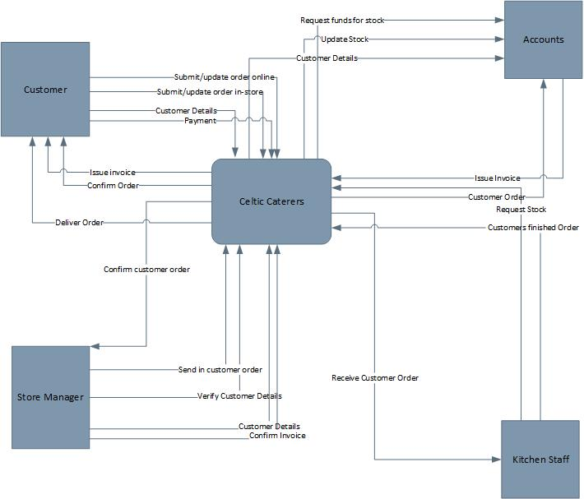

DFD Level 0
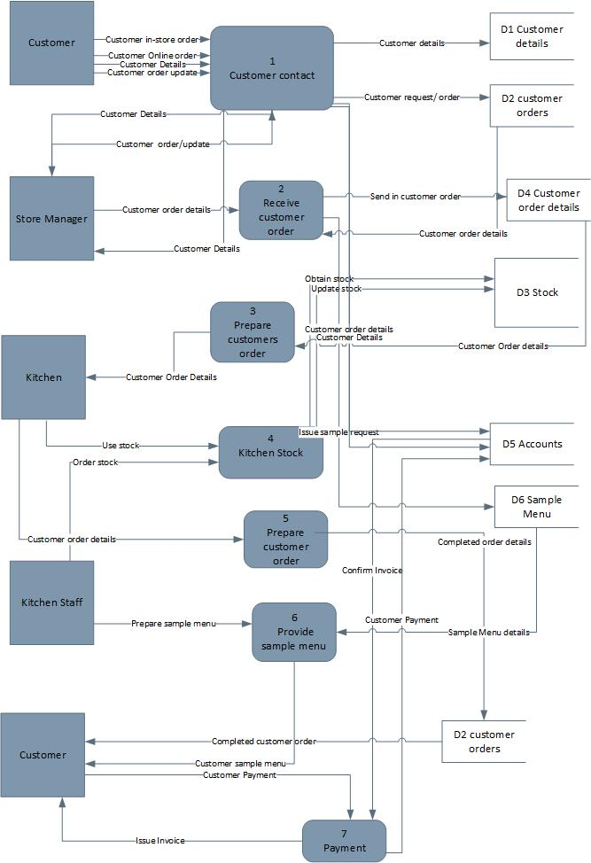

DFD Level 1
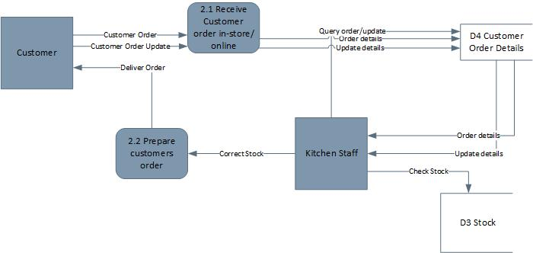

ERD on page 5


