Dissertation Proposal

Context

This proposal will look at how the way main stream anime has changed throughout the years, through the use of modern technology and the impact of social media. Anime has changed drastically due to many circumstances, due to technological advances and through the use communication via social media, through the use of the internet, anime is now easily accessible and can be shared with the world to millions of people and locations in seconds, due to websites such as, Crunchyroll etc. I will be looking at the history of anime, from its conception over 60 years ago, from the 1960s to the modern day, the 2000s. I will talk about how the various styles that have been used throughout the years, from the simple black and white animations used in the 1960s to the stunning visuals of the 80s and to the now common streamlined style that is solely used post 2010 and how this change has effected how anime is made and seen by the world. I will analyze works by Rayna Dension, and Jonathan Clements, and explore how style, genre and the community all play a massive role in how anime is created and viewed today.

Style
In this section of the dissertation proposal I will write about my first keyword and why it is a very important keyword that will lead me to asking the question that I will be answering in the dissertation proper. The first keyword that I have decided is Style.

The word style contains many meanings and in many situations, the definitions that best suite my situation is the method (as stated by the Cambridge dictionary) of something and technique of something (Oxford dictionary). Whilst genre and style to overlap in some areas they are different enough to warrant their own sub sections.

Styles are very important in the creation of main stream anime, this is because it allows the animation company to stand out so to speak and to add a unique level of originality to their animations. Styles are important because most main stream anime these days are either direct copies of each other, to the point that you can call it plagiarism, as in the most extreme cases, contain the same locations and story as other anime, with name changed. Other reasons as to why styles are important is because they contain the same basic shading style of animation as this has become the norm to do, basic shapes, basic animation, its fast and cheap to produce, through using the use of different style the anime show can stand out more, and seem more original that it might actually be. Styles can also attract specific people who enjoy that particular visual and effects.

This definition helps me to examine the core ideas that I wish to cover in my dissertation because I wish to cover how the style of main stream anime has changed throughout the years from the beginning in 1960s of the first anime to the modern interpretation of anime in the 2000s and how the style used now is an inferior style in both quality and quantity compared to what was used earlier on, mainly in the 80s and 90s

However to counter this, the new main stream anime style has some advantages over the old style, mainly that it is easier to produce and cheaper to make, which allows more shows to be pump out every year, due to the increase of demand since the 90s, however sometimes this is not always the best way of doing things, stevens universe for example, and duck tales, which are cartoons and anime, however stevens universe has the worst animation in history, the bodies of the characters are round, simply because its cheap and easy to make, and looks just plain terrible and duck tales which is a Disney production, no longer seems to make use of the 12 principles of animation, something that Disney themselves created the guide for.
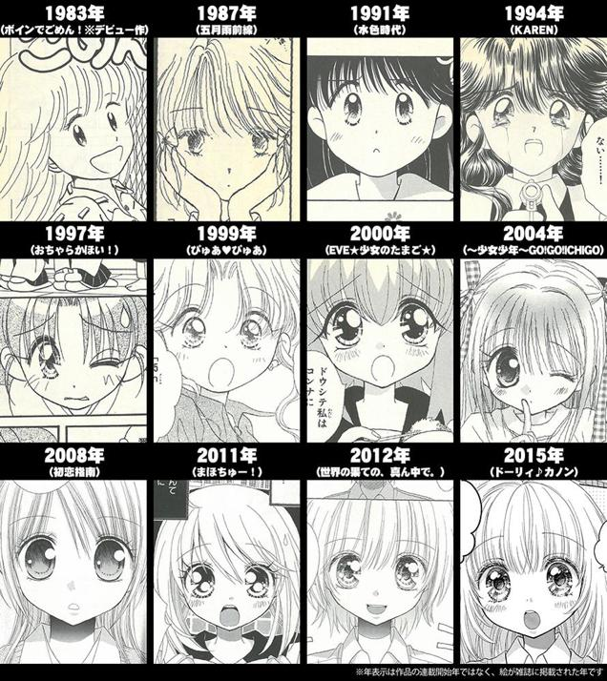
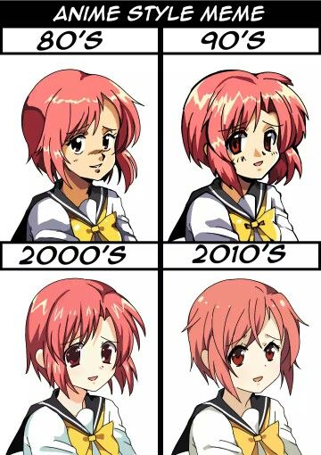

Genre
In this section of the dissertation proposal I will write about what the second keyword that I have chosen, so that I may answer the question that I will be answering in the dissertation proper. The second keyword that I have chosen is genre, I will answer in this dissertation proposal what the definition of the word means, why it is important and how it differs from the work style that is the first keyword that I have chosen as they can be easily confused.

The word genre contains many definitions, the most relevant for this topic is, category and grouping. In the context of anime, the definition of genre means, the category of anime that was created, for example, there are many anime shows that are considered to be in the genre family of sci-fi, fantasy, cyberpunk, adventure, so on and forth. Whilst the terms genre and style are often confused with one another, they are both vastly different from each other, the word genre is the word for a categorization, for example, rock music, progressive rock etc. are all examples of genres, a style on the other hand, is what the specific elements of music here as an example are, an example of r a style of music, would be, pop, rock, metal, world, classical, jazz etc. this is the definition of the terms style and genres within music, however within anime it is slightly different, where as genre is how the anime is defined world wise, whether or not it’s a sci-fi anime, or a fantasy based anime, etc. the definition of style in this context is art style, where the animators are using, for example, whether the drawing style of the anime, that I being produced by the animation studio in question, draws their characters and world, realistic, or unrealistic, chibi or SD as is also known as (super deformed) where anatomy is thrown out of the widow and proportions are not correct, these are all examples of styles and this is how they are different within the context of anime.

Genres are both similar and dissimilar to styles in many ways, where they overlap is in the community, like styles, genres can attract certain types of people, those who like fantasy based things are more likely to watch a fantasy based anime, however where they differ is in how they are viewed, styled can give a sense of originality however genres directly effect how the style will be created, a slice of life anime is more likely to have an extremely stylized look than a serious sci-fi anime will, so the genre in most cases dictates the style.

This definition helps me to explain the core ideas that I wish to cover in mt dissertation because I wish to cover how the genres of main stream anime have changed throughout the years, from the 1960 to the modern days 2000s anime, going from different popular styles that have existed, e.g. cyberpunk, to how most of these styles have been fazed out of main stream anime, e.g. cyberpunk is a genre that hasn’t been used since the late 90s in anime, although it making a return in retroism and may one day return to main stream anime, and how newer genres have been introduced or become more popular, e.g. the slice of life genre has dominated main stream anime.

However to counter this genres may not be as important as they seem, as social media has become a good way or marketing any kind of anime that is in production, and some groups in the community will watch an anime show just because a certain company was in charge of making the animation.
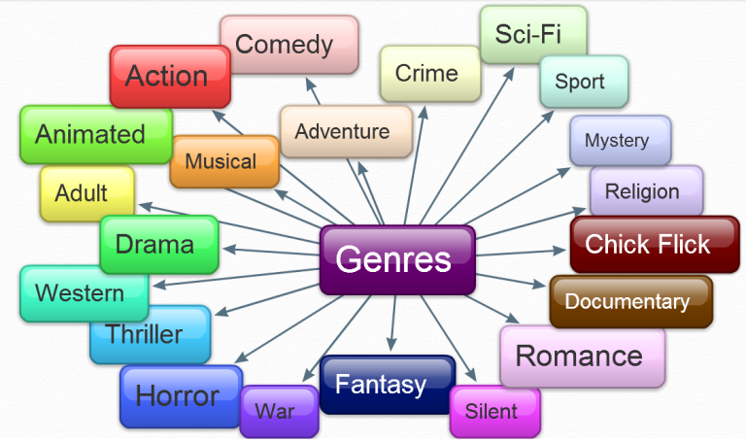

Community
The final keyword that I have selected is the word community, I will answer in this proposal what the definition of such as word is and why it is important.

The meaning of the word of community in the context that I am referring too, means primarily a group of people and factions, both very important but they both contain slightly different meanings. A group of people is self explanatory, it’s a group of people coming together to form a community, in this case the anime community, where a bunch of people who enjoy the same media, come together to talk about the thing they love, in this case anime, this is what the group of people definition means, the factions however is slightly different from a group of people, its sill a part of the community, however in this context, its not about the community as a whole, however it is instead about different views from within the community, whether or not they are arguing with each other on which view is the best or correct one, or they are separate in name only, to keep an organized way of keeping track of things, for example, an example of this would be the age old argument of subs vs dubs, this is about whether or not anime should be viewed in its untampered original language that contains the truest definition of the media that the anime industry are trying to convey of whether or not dubs are the way to go, whilst sometimes words have to be changed from language to language, due to limitations in altering the footage that dubbing industries are given, at least we can understand the language and not need to look at the subtitles all the time, there is also the argument on voice acting, whether or not the English cast for the dubs are good or, as typically dubbing companies tend to hire the same people all the time for all of their projects, which leads to a more boring time, when you hear the same voices over and over and over again, where as the Japanese voices always hire someone new for their projects and when they use the same voce actors, they are incredibly talented in disguising their voice to not sound like themselves.
These are the primary definitions for the term community at least in the context of anime, these examples are from my own observation through the many, many years that I have been watching anime, in both the shows and the community.

The community is important to the world of main stream anime, the reason is fairly obvious as the community is the very thing that allows animation companies to continue to create main stream anime, as the community or this case the viewer, watchers, reviewers etc. are paying mass amounts of money in merchandise, whether this be DVDs, Blue Rays, keychains, t-shirts, jumpers, jackets, trousers, hats, bags, props etc. all of these people who are buying merchandise are funding the animation companies to create more animation down the line.

This definition of community helps me to example the core ideas that I wish to cover for the dissertation that I will be writing about next year, because I wish to write about how, communities in the anime industry, shape how anime is made, from people leaving reviews on anime, from new genres that start up and the people, which leads to hundreds of copies of the genre being made because its now relevant, to the divided community, e.g. subs or dubs is once such example, in where one section of the community favors to see the anime show that they like to watch in the original language and no voice over created, and the other half who like the opposite, where the anime they like to watch is directly translated and voiced over by English speaking people.


Contextualization of the question

In this section of the dissertation proposal, I will write about, how each of the keywords that I have mentioned in the document above has helped me to develop the question that I will be answering in the dissertation in the next module. exploring each of the three keywords and researching the work by the authors that I have mentioned at the start of the essay, I have come to the conclusion that I will be writing my final dissertation on how mainstream main stream anime has changed throughout the various years that it has been on for and its many interesting aspects on the topic. From how the style has changed, groin from its earliest incarnation in the 1960, which was simple and displayed in black and white, due to technological limitation, (no colored TVs) to the beautiful, colorful and wonderfully animated anime shows were like in the 1970s 1980s and 1990s to the now modern style of main stream anime, which evolved to a clean and crisp but simple style, which is seemingly a regression in some areas, I will talk about why this regression in style happened and what the culprit of such a regression is, e.g. time and money. I will the talk about the genres of anime and how that has changed throughout the years, from bizarre genres to the more mundane genres, about how most 80s genres have been fazed out and replaced with newer genres e.g. sci-fi genre which is hardly seen anymore, and the newer slice of life anime which has now dominated main stream anime, and finally to finish it off I will talk about how main stream anime has been shaped around their community, from what the early community was like, where finding anime to watch was hard and only available via illegal piracy due to no localization releases, thus people resorted to buying fan translations of anime. To how anime gained popularity amongst the west when before it was treated like kids show, much like video games at the time. To finalize this proposal I will structure the question that my research has led me to below:

How has main stream anime changed throughout the years through the use of popularity?

Words: 2309 (excluding bibliography)

Bibliography

https://www.amazon.co.uk/Anime-Film-Genres-Rayna-Denison/dp/1847884792/ref=sr_1_fkmr0_1?keywords=anime+film+genres+ryana+sension&qid=1582801188&sr=8-1-fkmr0

Summary – Anime Genres and History Rayna dension

https://www.amazon.co.uk/Anime-History-Jonathan-Clements/dp/1844573907/ref=sr_1_fkmr0_2?keywords=anime+film+genres+ryana+sension&qid=1582801188&sr=8-2-fkmr0

Summary – Anime History Jonathan Clements

Google Books. (2020). Anime. [online] Available at: https://books.google.co.uk/books?hl=en&lr=&id=M36hCgAAQBAJ&oi=fnd&pg=PP1&dq=Rayna+denison&ots=9EaWd23ZTm&sig=ANDNN8Xer9kk2TAMK6mEFqTox2I&redir_esc=y#v=onepage&q=Rayna%20denison&f=falsef [Accessed 27 Feb. 2020].

Summary – (Book) Anime Genres and History by Rayna Dension

Google Books. (2020). Anime. [online] Available at: https://books.google.co.uk/books?id=dyBdDwAAQBAJ&printsec=frontcover&dq=Jonathan+Clements&hl=en&sa=X&ved=0ahUKEwjp26fczfHnAhVfThUIHY0lBRQQ6wEILTAA#v=onepage&q=Jonathan%20Clements&f=false [Accessed 27 Feb. 2020].

Summary – (Book) Anime by Jonathan Clements

