Engineering design and materials
submission date: 19th March 2023
submission deadline: 10pm on 19th March 2023
module name: Material selection report
module code: ACHA4001
Name: Ewan Evans
Student number: 2200899
Lecturer: Kerry Tudor

1)Contents page:
1. Contents page___________________________________________________________2
2. Introduction_____________________________________________________________3
3. Material properties_______________________________________________________3
3.1) Corrosion resistance______________________________________________3
3.2) Stiffness________________________________________________________3
3.3) Toughness______________________________________________________3
3.4) Strength/ impact strength__________________________________________3
3.5) hard___________________________________________________________3
3.6) heat resistance__________________________________________________3
3.7 weight/ mass____________________________________________________4
4. Material selection________________________________________________________4
4.1) compressive strength_____________________________________________4
4.2) fracture toughness_______________________________________________6
4.3) Hardness_______________________________________________________7
4.4) Maximum service temperature_____________________________________8
4.5) resistance to petrol ______________________________________________9
4.6) price__________________________________________________________10
4.7) overall table____________________________________________________11
4.8) extra material information________________________________________11
5. material selection_______________________________________________________15
5.1) general casting_________________________________________________15
5.2) Sand casting___________________________________________________16
5.3) Die casting____________________________________________________16
5.4) Investment casting______________________________________________16
5.5) General forging________________________________________________16
5.6) machined and standard open die machining _________________________16
5.7) closed die forging_______________________________________________16
6. conclusion_____________________________________________________________17
7. reference______________________________________________________________17
2.Introduction
This report is an investigation into different materials can be used as pistons in a standard road car, in this case a petrol 1.25litre ford engine. There are certain requirements and restrictions when making a piston as it needs to last a long time whilst given a consistent output.
3.Material properties
Pistons need to operate effectively and efficiently. The properties that are key to piston are for it to be corrosion resistant, stiff, tough, strong, hard, and have hard resistance, these go into more detail below. A piston needs these features for a variety of reasons to make sure they don’t become damaged over time as well as the most providing power to vehicle.
3.1) Corrosion resistance:
Pistons will experience different chemicals when operating and need to ensure that it will not corrode and deviate away from the original model. It needs to be resistant to the fumes being sucked in (oxygen) and then C02 from when its being released after combustion. Also, it needs to be resistant to the oils as well, if they do not the piston will deteriorate over time.
3.2) Stiffness:
Stiffness is ‘the ability to not alter or change shape due to a force being applied’ (Oxford university press, 2013). This is key to a piston as large amounts of forces are being applied to the top of the piston. If the piston deviates in shape due to the forces, it experiences it will become less efficient and need to be replaced. The change in shape could also cause damage to other parts of the engine.
3.3) Toughness:
Toughness is key to a piston as it is the ‘ability to absorb energy being applied without cracking/fracturing’ (Oxford university press, 2013). If a piston is to crack it will have a significant influence on the performance of the engine. If the crack does occur, it can cause damage to the engine block due to an alteration in shape. If it is just the piston that cracks it would need to be replaced.
3.4) Strength/ impact strength:
Strength and impact strength is vital to the longevity of the piston. Strength is about ‘the maximum stress applied to a component before failure’ (Oxford university press, 2013), while impact strength is ‘being resistant to the stress being applied’ (Oxford university press, 2013).
3.5) Hard:
Pistons must not deviate in their design and shape as it reduces the efficiency at which they operate. Therefore, they need make sure that they are hard – ‘the ability to withstand deformation’ (Oxford university press, 2013). Each deformation will reduce the pistons efficiency.
3.6) Heat resistant:
Engines reach extreme temperatures when in operation. These temperatures can reach ‘around 2800°F’ (VEHQ, 2021) (around 1538°C). Very few materials have a melting point over 1500°C, hence engines have a cooling system pumping cold fluid through the engine to lower the temperature. Therefore, only reaching ‘around 1200°F’ (around 650°C). If a piston started to melt it would become inefficient.
3.7) Weight/mass:
Pistons are objects that are moved in order to create pressure. The mass of an object that is being moved rotationally can have an impact on the performance. This is because an object with a greater mass takes more energy to move the same distance as a lighter object. Therefore, a lighter piston will be able to rotate more times than a heavier piston if the force remains the same. Having a piston that is heavy, such as one made from concrete would not be very energy efficient.

4.Material selection
There is a vast range of materials that can be used to make products. Below is a list of options:
  - Ferrous metals
  - Non-ferrous metals
  - Plastic
  - Ceramic
  - Composite
  - Nano materials
These materials have different properties suited for different purposes. In this case ferrous and non-ferrous metals and ceramics are most likely to be the best options due to them generally being able to withstand more stress and heat.
The graphs show the categories and for ones that are greyed in the second graph are ones that don’t reach over the limit. Tables are used to do a comparison to either other materials or the value needed to achieve (green is great/ over the value, yellow is medium/ around the value, red is bad/ below the value).
4.1) Compressive strength:
Compressive strength is a good way to get a reading on how strong the materials are as it can be calculated using the formula below and then compared to what the materials value is. If the material has a reading under this, then it is likely depending upon how far away from the calculated value it is to be damaged due to the force being applied.
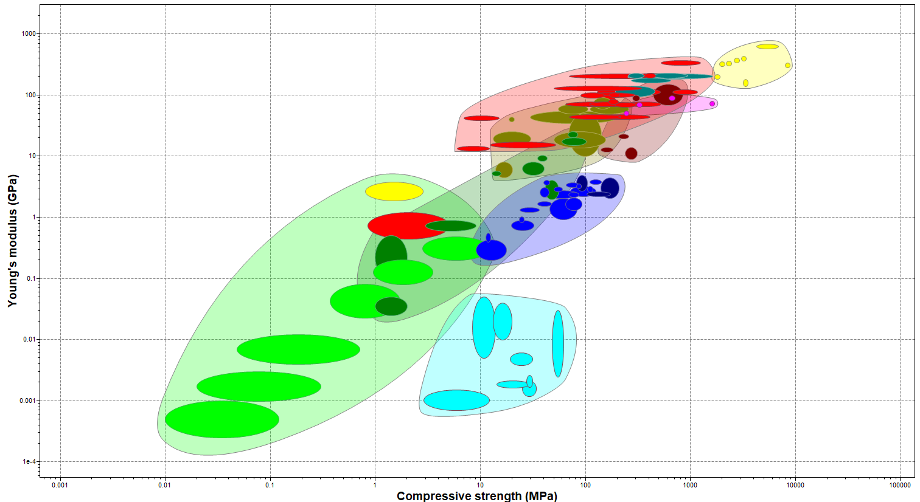
Graph of young’s modulus against compressive strength
Granta Edupack (Ansys, 2021) can be used to collect material data. ​

Compressive strength calculation:
$$compressive strength(s)=\frac{maximum force (f)}{area (a)}$$
$$force=area X presure$$
Bore diameter = 71.9mm = 0.0719m
$$area= \frac{πd^{2}}{4}$$
$$a=\frac{{π0.0719}^{2}}{4}$$
$$a={4.06x10}^{-3}m^{2}$$
Pressure= 160 bar = 160${x10}^{6}$
$$f=a p$$
$$f={4.06x10}^{-3} X 160{x10}^{6}$$
$$f=649.6{x10}^{3}N$$

$$compressive strength=\frac{649.6x{10}^{3}}{4.06x{10}^{-3}}$$
$$s=160x{10}^{6}pa$$
$$s=160Mpa$$
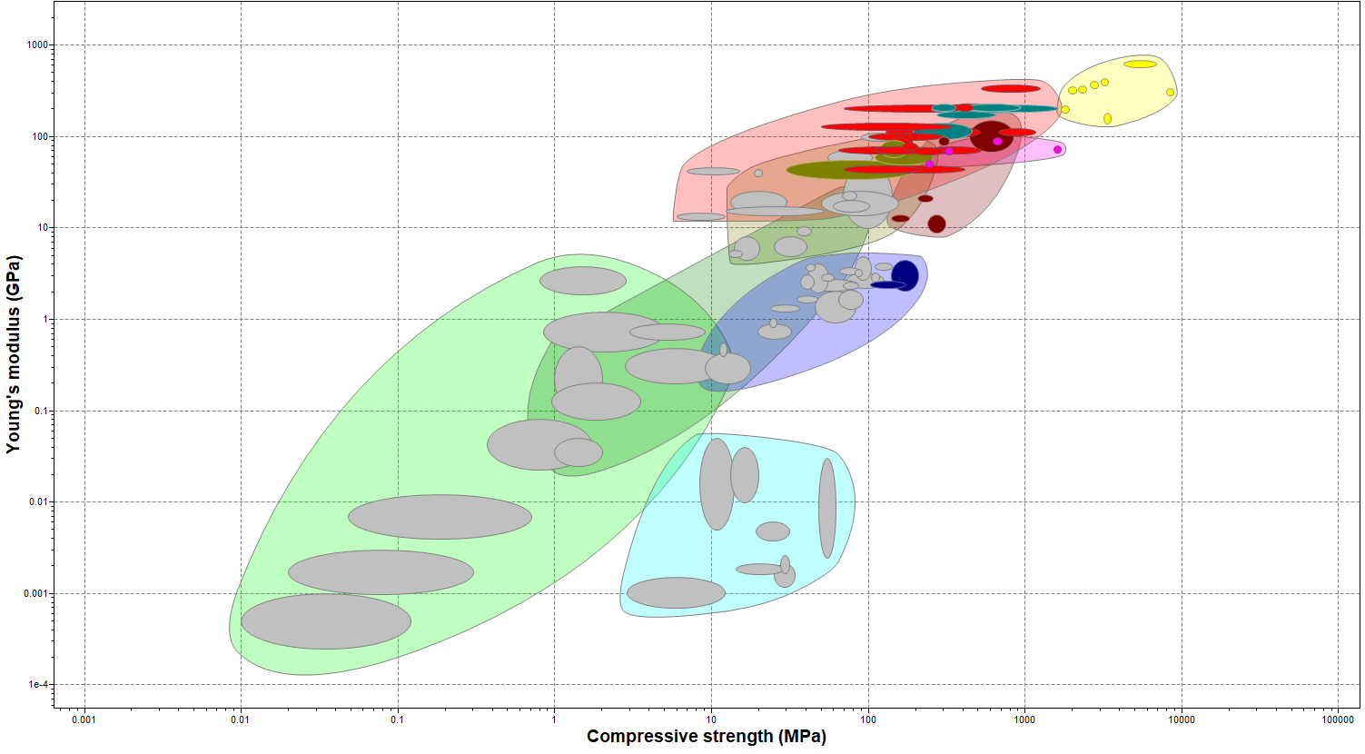
Graph of young’s modulus against compressive strength(only showing good strength)
Granta Edupack (Ansys, 2021) can be used to collect material data. ​
 | material
property | Stainless steel | aluminium | tungsten | titanium | bronze
Compressive strength  >160Mpa | 252-1200 | 1900-2100 | 523-1230 | 680-1150 | 130-560
Material properties table on fracture toughness.
4.2) Fracture toughness:
Fracture toughness gives a good reading to calculate how tough the piston is however there is not a clear way to calculate this when you do not know how much the object is going to weigh. So, it is done more as a comparison between materials available. The higher the fracture toughness the better the material overall.
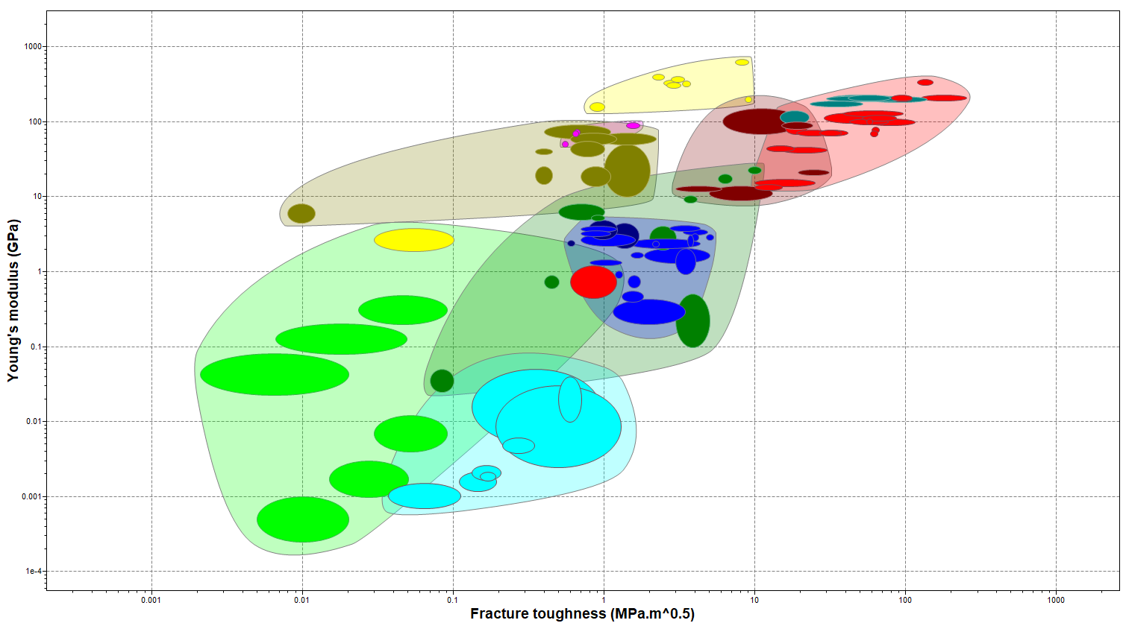
Graph of young’s modulus against fracture toughness (only showing good toughness)
Granta Edupack (Ansys, 2021) can be used to collect material data. ​
 | material
property | Stainless steel | aluminium | tungsten | titanium | bronze
Fracture toughness Mpam^0.5 | 57-137 | 3.3-3.7 | 120-150 | 51.3-86.1 | 28.8-67.9
Material properties table on fracture toughness.
4.3) Hardness:
It is like fracture toughness in the fact that it is hard to gather any data for this, so is more down to the better the hardness, the better the material is overall. Resulting in the better value the better the pistons quality.
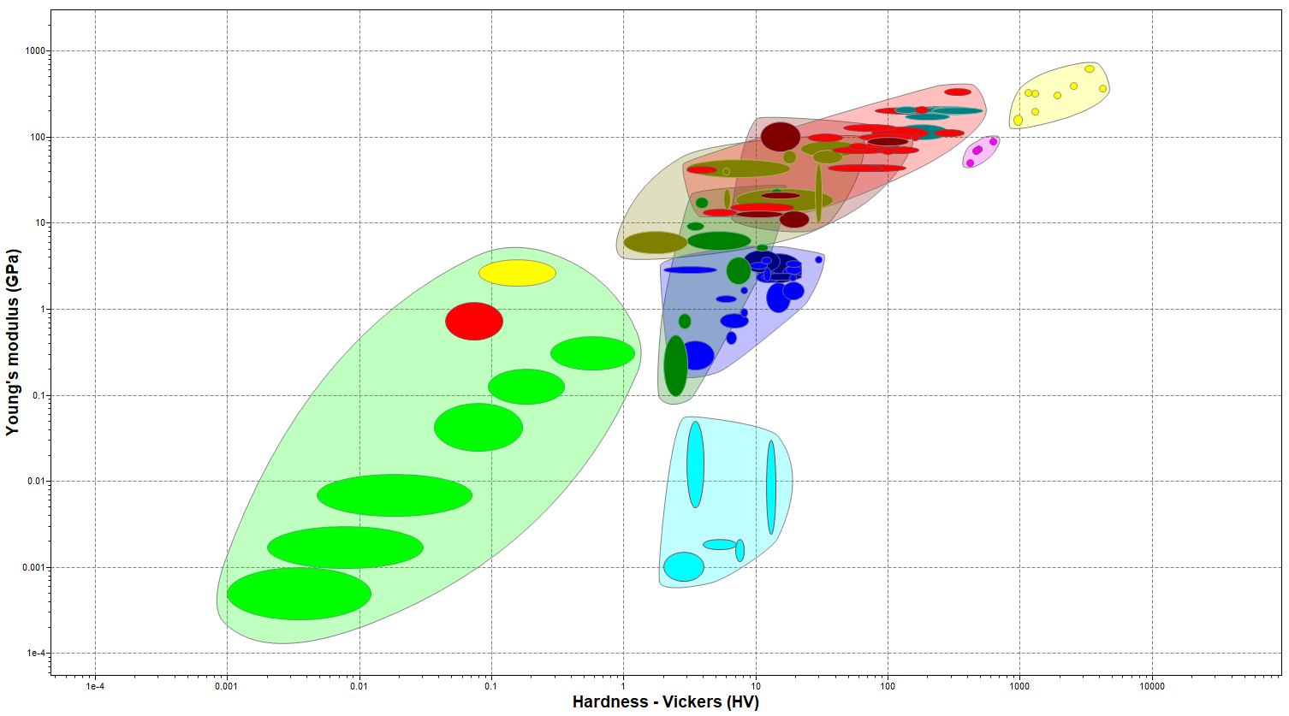
Graph of young’s modulus against hardness – Vickers (only showing good hardness)
Granta Edupack (Ansys, 2021) can be used to collect material data. ​
 | material
property | Stainless steel | aluminium | tungsten | titanium | bronze
Hardness -vickers | 170-438 | 1220-1340 | 268-419 | 223-373 | 75.6-200
Material properties table on hardness – Vickers.

4.4) Maximum service temperature:
This is to make sure that the maximum temperature experienced within the engine is not over the melting point of the material, if this is the case the material will deform causing damage to the piston.
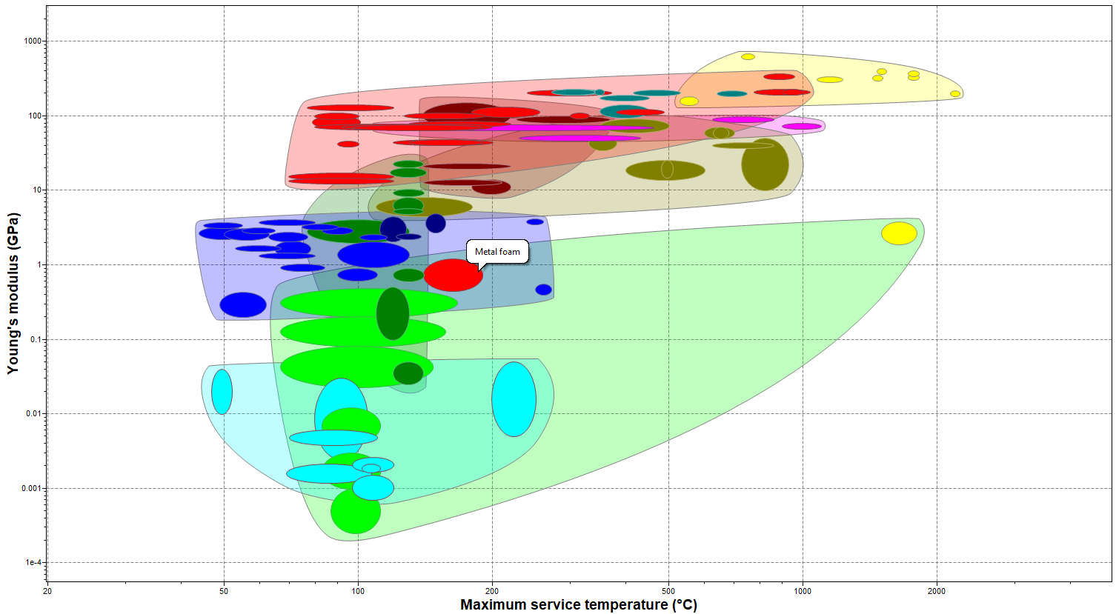
Graph of young’s modulus against maximum service temperature
Granta Edupack (Ansys, 2021) can be used to collect material data. ​
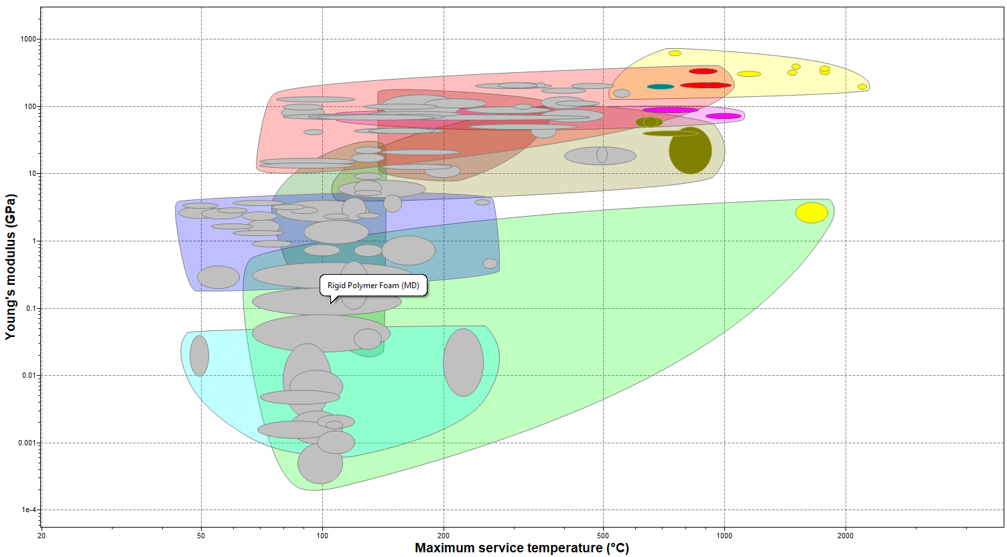
Graph of young’s modulus against maximum service temperature (only showing good temperatures)
Granta Edupack (Ansys, 2021) can be used to collect material data. ​
 | material
property | Stainless steel | aluminium | tungsten | titanium | bronze
Maximum service temperature  >650 °C | 640-747 | 1440-1500 | 817-957 | 380-487 | 180-255
Material property table for maximum service temperature.
4.5) Resistance to petrol oil:
Piston needs to be resistant to petrol and therefore needs to have an excellent reading to make sure that it doesn’t become damaged due to the petrol reacting with the material.
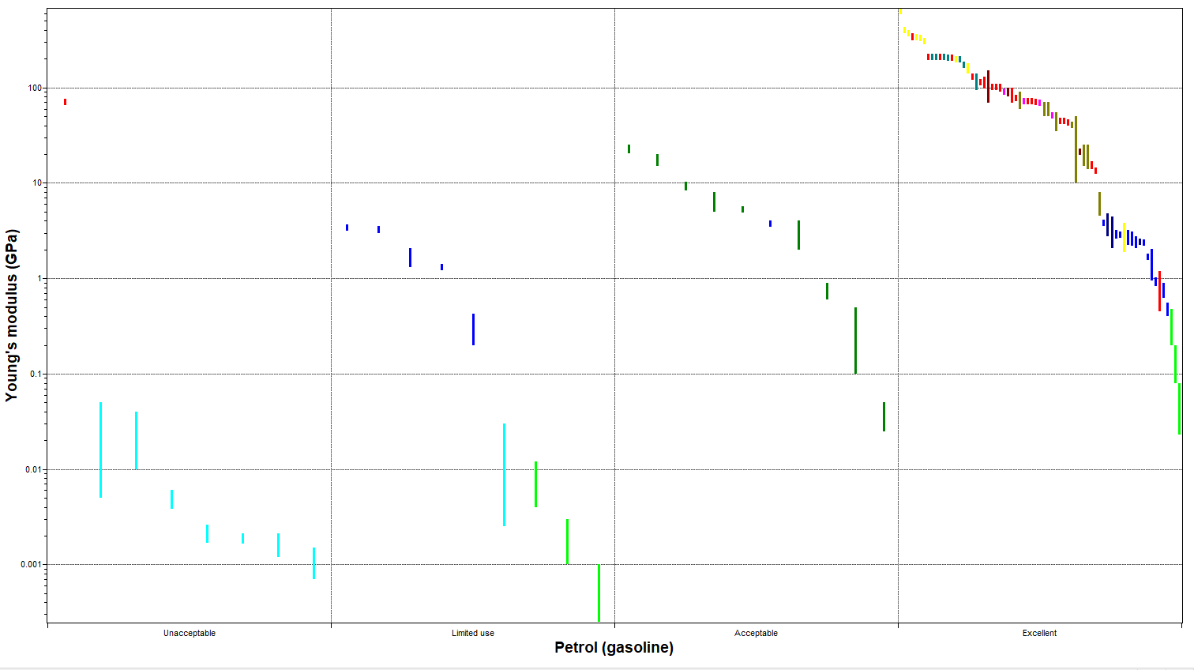
Graph of young’s modulus against petrol resistance
Granta Edupack (Ansys, 2021) can be used to collect material data. ​
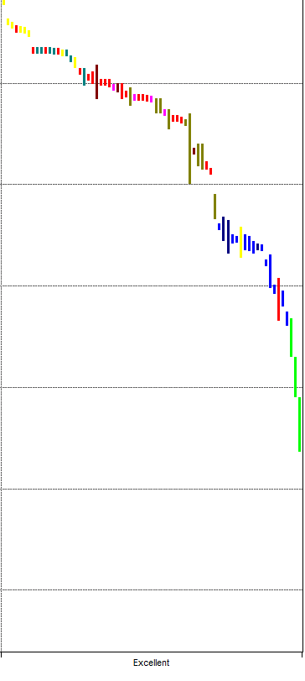
Graph of young’s modulus against petrol resistance (only showing excellent)
Granta Edupack (Ansys, 2021) can be used to collect material data. ​

 | material
property | Stainless steel | aluminium | tungsten | titanium | bronze
Resistant to petrol | excellent | excellent | excellent | excellent | excellent
Material properties of resistance to petrol.

4.6) Price:
A good maximum price for the material is under £20/Kg this is because there will be a markup of around 25% for the production cost and then a 25% to 50% markup on that for the profit which means that they are being sold for around a £30 to £40, which is reasonable when being compared to pistons being sold online.
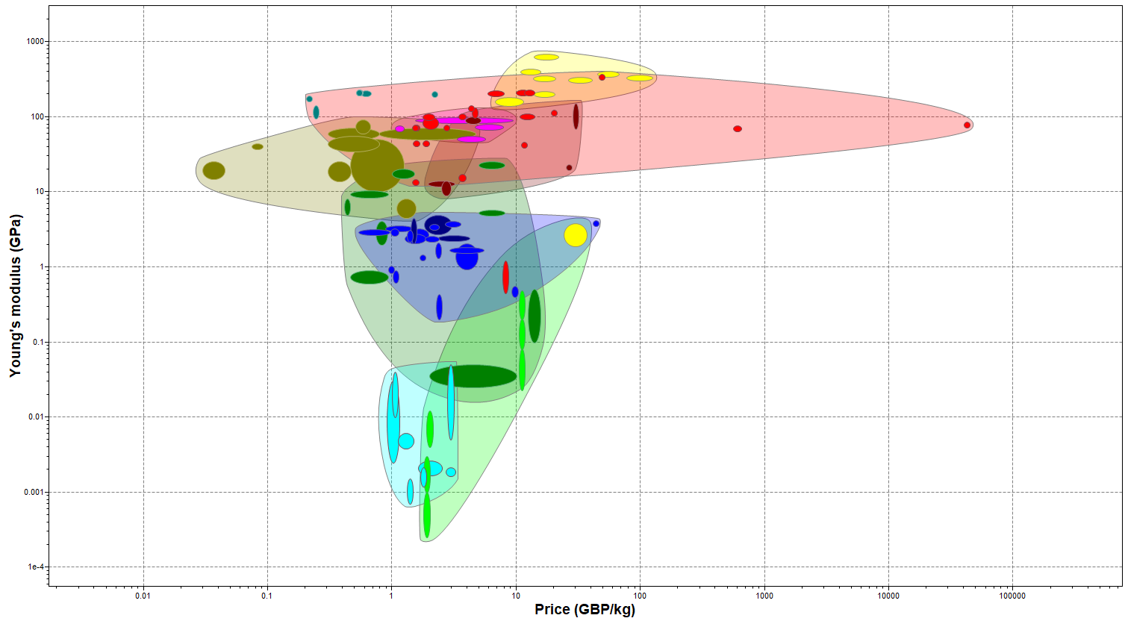
Graph of young’s modulus against price
Granta Edupack (Ansys, 2021) can be used to collect material data. ​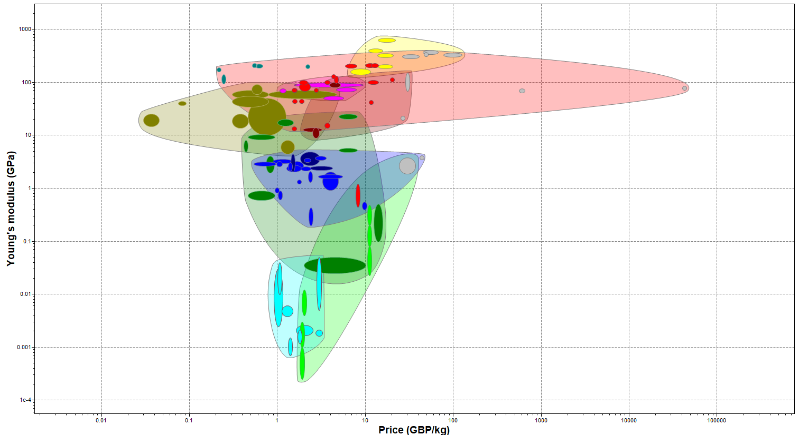
Graph of young’s modulus against price (only showing good price)
Granta Edupack (Ansys, 2021) can be used to collect material data. ​
 | material
property | Stainless steel | aluminium | tungsten | titanium | bronze
Price  <£20Kg | 2.12-2.2 | 13.7-20.6 | 46.6-51.6 | 19.1-20.9 | 4.45-4.48
Material property reading for price/kg
4.7) Overall table:
 | material
property | Stainless steel | aluminium | tungsten | titanium | bronze
Compressive strength  >160Mpa | 252-1200 | 1900-2100 | 523-1230 | 680-1150 | 130-560
Fracture toughness Mpam^0.5 | 57-137 | 3.3-3.7 | 120-150 | 51.3-86.1 | 28.8-67.9
Hardness -vickers  >47.57 | 170-438 | 1220-1340 | 268-419 | 223-373 | 75.6-200
Maximum service temperature  >650 °C | 640-747 | 1440-1500 | 817-957 | 380-487 | 180-255
Resistant to petrol | excellent | excellent | excellent | excellent | excellent
Price  Under £20/kg | 2.12-2.2 | 13.7-20.6 | 46.6-51.6 | 19.1-20.9 | 4.45-4.48
Overall table to the material property values.
4.8) Extra material information:
Tables on some materials being used and property values:
Stainless steel:

Table on stainless steels properties
18/02/2023 301 Stainless Steel (matweb.com)
Copper:
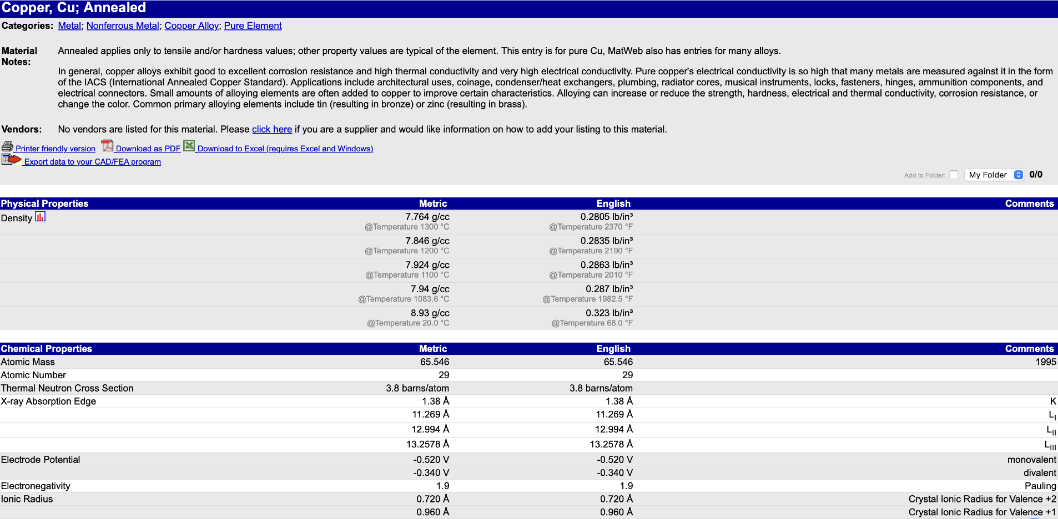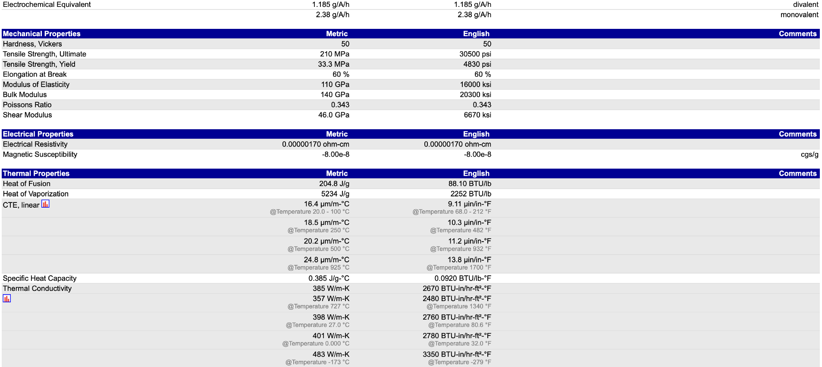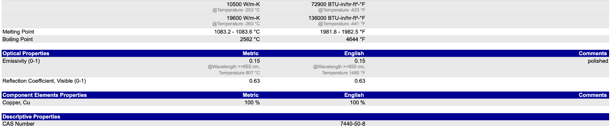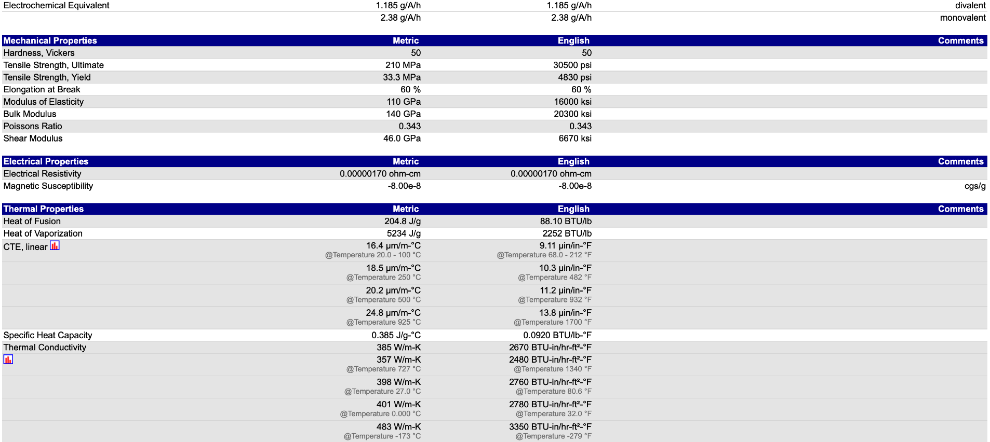
Table on copper properties
19/03/2023 https://matweb.com/search/DataSheet.aspx?MatGUID=9aebe83845c04c1db5126fada6f76f7e
Aluminium:
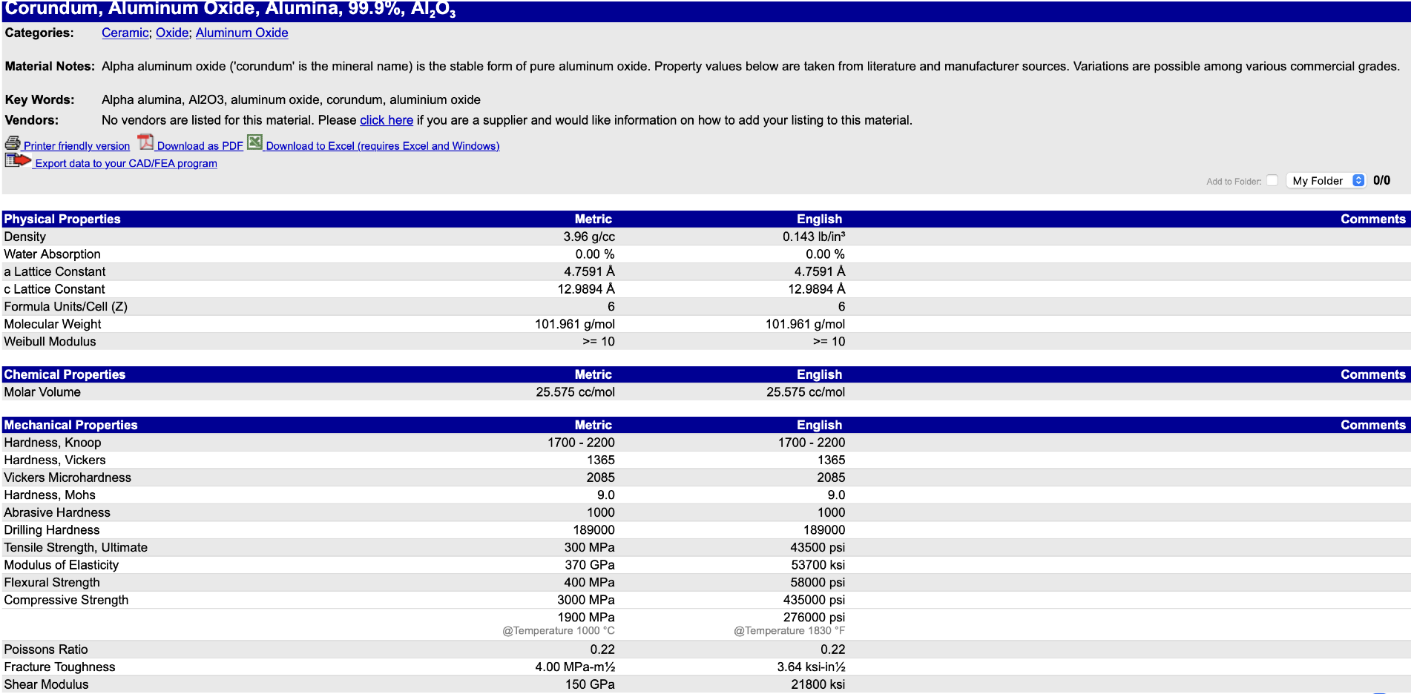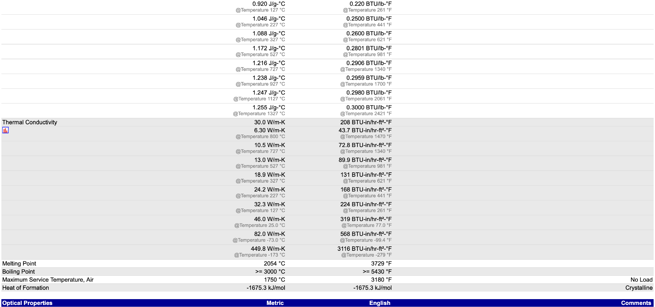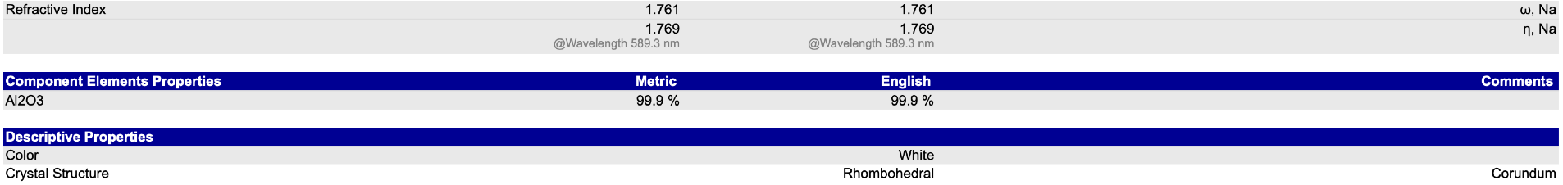
Table on aluminium properties
26/02/2023https://matweb.com/search/DataSheet.aspx?MatGUID=c8c56ad547ae4cfabad15977bfb537f1
5.Manufacturing Processes
Pistons are mass made due to them being made cars around the globe. The choice of manufacturing process is going to be due to accuracy of production, rate of being made, and amount of waste. Being in tolerances is key to reduce the number of pistons that must be rejected by regular and thorough checks. Furthermore, they need to be cost effective to make a profit.
There are a few options when it comes to the manufacturing of the pistons. These include:
  - Casting
    - Sand casting
    - Die casting
    - Investment casting
  - Forging
    - Machined and standard open die forging
    - Closed die forging
5.1) General Casting:
This is the process where the molten material (commonly metal) is poured into a mould. The mould is then left until the object becomes cold. Once cold the mould can be opened to give the finishing product. However, it can take a long time for the mould to be cooled.
5.2) Sand casting:
This is an old process where the mould is made from sand. Using sand casting results in a cheaper tools, complex shapes can be made and any scrap metal left over can then be recycled. Some issues with sand casting is that it has porosity, where air is trapped in the metal reducing its overall strength. The accuracy is poor as it can shrink while cooling, therefore it is a low tolerance product often requiring further machining.
5.3) Die casting:
Is when a mould made from steel has metal injected into it and then left to cool. This process is common with aluminium, magnesium and zinc. Some advantages are that the tolerance is very accurate, its production time is fast and there is a low amount of leftover scrap that can be recycled. Complex parts can be made and more than one part can be made, variable wall thickness. However, this process is not suitable for metals with high melting point or large sheet metal parts, they have a high die cost and long lead time needed.
5.4) Investment casting:
This process starts by creating a wax replica of the final model which is placed on a frame with many others of the exact same design (called a tree). A coat of refractory materials covers the object, this is repeated until there is a wall around the original wax model. The wax is then melted to leave just the shell. This shell mould is then slightly heated and the material is then poured into the mould. Once cooled the outside shell is broken leaving the final product. This process leaves a fine surface finish and complex parts can be made. Also, large parts can be made, tolerances of each part can be around +/- 0.075mm meaning they are highly accurate. However, the equipment is expensive, it is also highly technical and time consuming.
5.5) General Forging:
Forging is a common process where materials are shaped through hammering, rolling or in the case of a piston pressing. The forces are delivered through either a hammer or die and at a variety of temperatures depending on what is happening.
5.6) Machined and standard open die forging:
Open die forging is the process where a heated metal object changes shape due to it being between two dies and a force being applied from the top die. A common example of this is blacksmiths making horseshoes. The difference between machined open and standard open is that the machined open is using a machine as a force being applied to the hot metal. Whereas it is likely to be a hammer by hand that applies the force to the top die. Some advantages are that it has a better structure and therefore less resistance to fatigue as well as having a better overall strength, less waste and less chance of voids, it is also fairly cost efficient. However, it is not very accurate and machining is often required afterwards.
5.7) Closed die forging:
This is the process where a material is placed in between two dies that are shaped/moulded, a hammer is then dropped onto the top die, this may be several times very fast. Leaving the object being forged into the desired shape. Some advantages of this process is that it leaves the material with a good structure and therefore makes it stronger. It is economic when making many parts, as well as there being no limitation in terms of material. Tight tolerances are possible and requires little to no machining. Not economical as short runs and prevents a dangerous working environment.
6.Conclusion
To conclude, Aluminium is the best option with stainless steel being the other close option. This is because aluminium is good in a lot of the areas and only area where it is below stainless steel is hardness and price per kilogram. Also, stainless steel is twice the density of aluminium and has a lower maximum service temperature. The manufacturing process most suited to the production of the piston is closed die forging. This is because it is an economic process and require little to no machining after due to great tolerances. Furthermore, there are few negatives about the process.
7.References
Matweb (2023) material property data [online] Matweb Metal, Plastic, and Ceramic Search Index (matweb.com) (18/02/2023)
Iman Hansra Tech explained | F1 aerodynamic cooling [online] race car engineering Tech Explained: F1 Aerodynamic Cooling - Racecar Engineering (racecar-engineering.com) (28/02/2023)
Performance trends Inc cylinder pressure [online] Performance trends Inc Cylinder Pressure (performancetrends.com) (15/03/2023)
VEHQ (23/08/2021) how does a combustion chamber get in a vehicle? [online] VEHQ.com How Hot Does A Combustion Chamber Get In A Vehicle? [The Answer Might Surprise You!] (vehq.com) (15/03/2023)
Kit Chapman (28/07/2022) the chemistry of the combustion engine [online] royal society of chemistry How car engines work | Article | RSC Education (15/03/2023)
Kate Onissiphorou (28/07/202) how car engines work [online] royal society of chemistry What Chemicals Are In Petrol? | The Science Blog (reagent.co.uk) (15/03/2023)
Antoun (3/03/2021) how to evaluate the compressive strength of concrete [online] Antoun https://blog.antoun.com.au/compressive-strength-of-concrete#:~:text=Referencing%20AS%201012.9%2C%20the%20compressive,or%20side%20dimensions%20of%20cubes. (13/03/2023)
x-engineer engine piston [online] x-engineer Engine piston – x-engineer.org (15/03/2023)
Amy Tikkanen Vickers hardness [online] Britannica https://www.britannica.com/science/Vickers-hardness (14/03/2023)
Autodoc (2023) piston crown [online] autodoc 0 results found for piston crown - AutoDoc Search (15/03/2023)
eBay (2023) piston head [online] eBay 1.25l petrol ford piston head for sale | eBay (16/03/2023)
JC Casting (07/02/2021) sand casting [online] JC casting What is Sand Casting | Process | Application | JC casting (investmentcastingpci.com) (16/03/2023)
Rapid direct (6/05/2022) what is die casting? Process, materials, applications and costs [online] Rapid direct Die Casting: Processes, Materials, Applications, Costs | RapidDirect Blog (16/03/2023)
Rapid direct (11/09/2022) a guide to investment casting: process, benefits and application [online] Rapid direct Investment Casting: Know Its Process, Benefits, Applications | RapidDirect (16/03/2023)
CFS forging closed die forging [online] CFS forging Closed Die Forging | Steel Forging (16/03/2023)
Steelforging 17/11/2017 open die forging vs closed die forging [online] CFS forging Open Die Forging vs. Closed Die Forging | Steel Forging (16/03/2023)
Car spec A-Z 2012 ford fiesta 1.25 [online] Car spec A-Z https://www.carfolio.com/ford-fiesta-1.25-302731 (18/11/2017)

