A noise management plan for a race circuit within the UK.

University of Wales Trinity Saint David School of Engineering
Daniel Tate 1701938
Motorsport Management and Logistics Level 5
Modelling Logistic Operations
M5X01280

Word count:

Circuit of Wales

Noise pollution plan

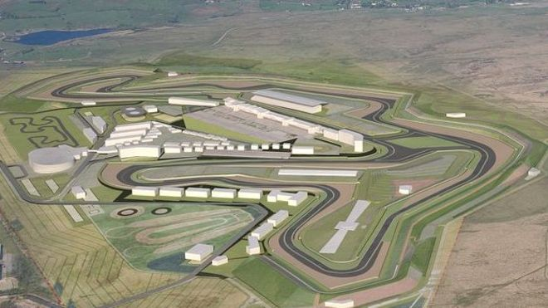
Artists impression - (BBC, 2013)

Issue 1.1
Date: May 2019
Review date: May 2021

Table of Contents
Section 1.1 – Responsibility of Noise 4
Section 1.2- Operational Noise 5
Section 1.3- Static Noise Testing 5
Section 1.4- On Track Noise Testing 6
Section 1.5- Aircraft Movement 6
Section 1.6- No Fly Zones 7
Section 1.7- Bank Holiday Operating Hours 7
Section 1.8- PA Systems 8
Section 1.9- Construction Noise 8
Section 2.0- Late Night Non-racing Events 8
Section 2.1- Complaints 8
Section 2.2- Update Meetings 9
Conclusion 9
Bibliography 11

  - Introduction
The circuit of wales is a £280 million purpose-built technology and race centre. The circuit is located close to the town of Ebbw Vale in the county of Blaenau Gwent. The Circuit of Wales is going to be the home of Welsh motorsport and is pinnacle to the development of new and existing welsh driving talent. Alongside driver development motorsport orientated businesses and teams will be able to use the proposed facilities to conduct business and testing of vehicles/components. The perimeter of the circuit is specially designed to reduce the noise produced within its grounds.

This report will be addressing some of the major concerns proposed by the local public and councils surrounding the problem of noise. This report will also consider how vehicles are allowed to operate in the surrounding areas as well as on the track.

This report will also cover how the construction of the circuit can also cause an increased noise pollution level and what plans are going to be implemented to alleviate any unnecessary noise.

This report is produced with local councils’ advice and guidance and is to be reviewed every two years or if any major changes are conducted in or around the circuit itself. This report is a dynamic management document and can be constantly assessed and altered if under scrutiny.

Section 1.1 – Responsibility of Noise

Noise pollution is one of the highest concerns for any race circuit within the UK. The Circuit of Wales is devoted to limiting any excess noise, whether produced from the vehicles competing themselves or those travelling in and around the circuit itself. The circuit of wales employs a specialist noise control member of staff that covers all aspect of noise pollution. The noise control officer works alongside the sporting director, circuit clerk and circuit manager to ensure all proposed noise levels are enforced and maintained. The noise control officer is responsible for all noise testing equipment, including track sound recording devices along with devices used in scrutineering.

The circuit of wales works alongside the Noise Abatement Society in an effort to reduce its total noise pollution.

If the track is being used under private hire, those organising the event take full responsibly for any noise complaints and can be removed from the track if excessive noise levels seem to be surpassing the agreed noise level.

Section 1.2- Operational Noise

The Circuit of Wales can operate a total of 80 active race days per year. The circuit will operate on a 4-level noise structure.
Noise rating | Noise levels | Example
A | High | High Tear Race weekend- BTCC, F1
B | Medium | Club based racing- Mazda mx5 cup
C | Low | Car/ Motorbike track days
D | Virtually Zero | Filming/ instructor lessons
A quarter of these race days are A rated (high noise level) events. Events that are A rated often attract large numbers of spectators, thus local traffic and noise enforcement is implemented.

All information surrounding noise decibel levels will be provided to the organiser when hiring the track and will be enforced at all times. Failure to comply to these regulations will result in an exclusion from the track.

In the event of a grade A high noise event, the Circuit of Wales has to adhere to a two-day silence period. Grade D vehicles are still permitted but will be observed stringently.

Section 1.3- Static Noise Testing
All vehicles must complete a noise decibel test when being scrutineered. This test is conducted in a controlled environment. The vehicle should be held at ¾ of maximum revs and a noise measuring device will then record a decibel level at a distance of half a meter away from an exhaust exit at a 45-degree angle. This decibel level recorded must not surpass 105 for a grade A events, grade B-D must not surpass 100db the Circuit of Wales is allowed to conduct random spot checks when cars are waiting to join the circuit. The Circuit of Wales follows MSA imposed protocol with regards to twin exit rear exhausts. “Where more than one exhaust outlet is present, the test will be repeated for each exhaust and the highest reading will be used. In circumstances where the exhaust outlet is not immediately accessible, the test may be conducted at 2.0m from the centre line of the vehicle at 90° to the centre line of the vehicle, with the microphone 1.2m above the ground.” (Motorsport Association, 2019 )
Under track day (noise rating of C-B) rules set by the Circuit of Wales, if on inspection the vehicle surpasses the maximum decibel level, the vehicle in question will be excluded for the day and no refund will be given. If the vehicle in question is part of an A rated championship with a governing body, the vehicle will be able to return to the track after altercations have been made to the exhaust system and the vehicle has gone through a second sound measurement reading with a member of the governing body and sound officer present.

Section 1.4- On Track Noise Testing
All vehicles that are making use of the track and have an operational noise level of A, B or C will be subject to spot checks at various different points around the track. On-track noise testing is being conducted to ensure that vehicles are conforming to the strict rules set by the circuit and local council.

On track noise testing is set at 10% off the static noise testing figure. This figure is imposed due to some championships having different set noise limits. For the majority of events the set on noise track testing decibel limit is 10% off 100db, making the on-track rolling noise figure of 90 db. For grade A vehicles 10% off the 105db limit is 95.4db. Information recorded by these noise testing devices is available to both the Circuit of Wales and the Blaenau Gwent council (at their request) and obtained data will be stored for up to a month after recorded, this is done to ensure maximum efforts are made to reduce noise levels in the surrounding area. If a vehicle on the track was seen to be in breach of these set rules, the car will be black flagged by the marshals under instruction by the circuit clerk and will be obliged to return to the pits. This flag will only be waved after the vehicle has passed through multiple testing zones and is confirmed to be over the set noise decibel limit. The vehicle will then not be able to compete in any track-based events throughout the day.

Section 1.5- Aircraft Movement
With respect to aircraft movement, local authorities, Blaenau Gwent Council and local residence will be informed of any increased aircraft activity in and around the vicinity of the Circuit of Wales. This information will be provided with at least a 48-hour notice period prior to the event.

Drones are not permitted within the grounds of the Circuit of Wales unless permission is granted from the course clerk. Pilots who are wanting to operate a drone must be fully qualified and provide proof of the qualification. All drone pilots must comply with stringent no fly areas (stated in section 1.6) and must also adhere to media rules imposed by the Circuit.

The circuit of wales will have 6 active helipads that are active between 6am and 10pm excluding a helipad that is based at the medical centre for air ambulance and police aircrafts only. Aircraft must notify circuit officials 4 hours prior to the intended landing slot, this is to ensure that the pilot doesn’t operate within the strict no fly zones.

Section 1.6- No Fly Zones
ACTIVE NO FLY ZONE


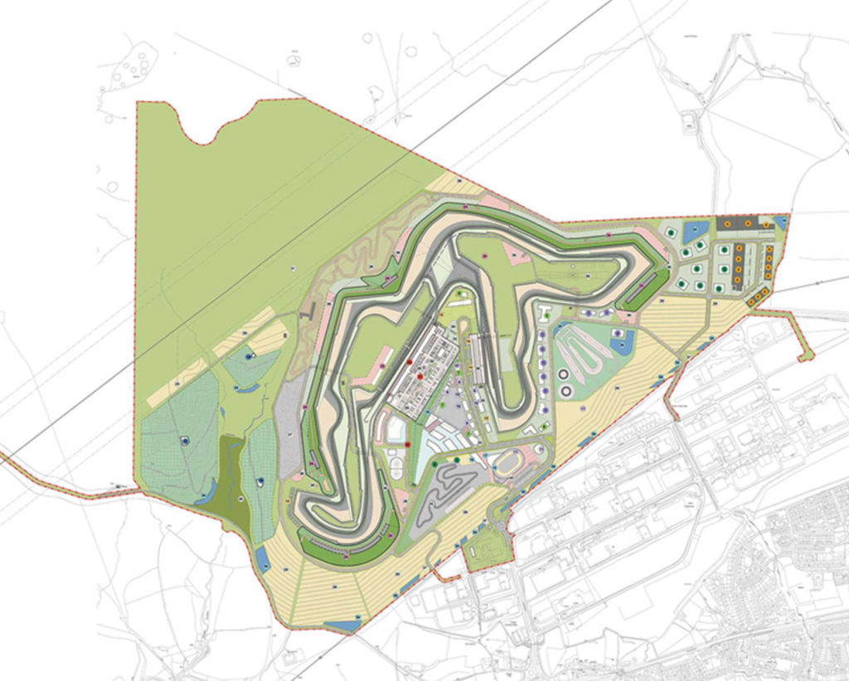

Figure 1.1 (Davies, 2017)

When the track is occupied there is a strict no fly zone over the vicinity of the race track. This excludes the air ambulance and police helicopter responding to a call outs. Drones may be used for filming as stated in section 1.5. No fly zones are in operation 5 minutes prior to the start of the warm up/out lap. Aircrafts should approach and leave the circuit from the north in an effort to reduce noise around the village of Rassau and the Rassau industrial estate. Pilots must be aware of the A465 Heads of the Valley road when operating an aircraft near the circuit.

Section 1.7- Bank Holiday Operating Hours
The Circuit of Wales will be running club level motorsport events on bank holidays within the race calendar season. These events will showcase a vast amount of local businesses and will be a low-cost family day event. Locals within a set distance will be offered free tickets as a gesture of goodwill. Operating hours on bank holidays are between 08:00 am and 19:00 pm vehicles. Vehicles that are seen to be exceeding acceptable noise levels before these times will be banned from the circuit’s grounds. (public) In the case of a race vehicle exceeding the acceptable noise level a formal warning will be given and could result in a potential race ban.

Section 1.8- PA Systems
Public address systems are in use on A and B noise rated events. PA systems will be in use from 8:00am to 18:30pm in the pit lane area of the circuit. Additionally, PA systems based around the spectator area of the track will be in operation from 9:00 am to 18:00pm.

There will be an hour break in commentary in the scheduled lunch hour of the event. PA systems noise will be checked at various points throughout the day of the event and will be altered depending on vehicle operational noise. (example: PA systems will be turned up during the race due to the vehicles being louder. When the vehicles are returning to the pits the volume of the PA system will be reduced.)

Section 1.9- Construction Noise
The Circuit of Wales will be subject to constant changes and alterations to the buildings, stands and race track. Although most construction will be completed during the daytime during the off season period, some changes to the circuit may have to be made throughout the season, this could be due to an increase or decrease in attendance throughout the season. The Circuit of Wales will work alongside the contracted companies to ensure the lowest working noise levels are achieved. Due to the nature of construction there will always be some sort of noise pollution that is exerted, for example noise pollution from the tools they would be using on the site. All work carried out will be scrutinised by both the Blaenau Gwent Council and the circuit management team. Circuit management will hold regular meetings with local councils to discuss any construction plans. Due to building work still being completed there will be an increased presence of heavy goods vehicles/ machinery in and around the Circuit of Wales Race Track.

Section 2.0- Late Night Non-Racing Events
The Circuit of Wales complies with all entertainment licence protocol and can also operate between the hours 23:00 pm and 08:00am. The local council and citizens will be informed of a late-night event 6 weeks prior to any event. All noise must be reduced by 12:00 am latest, this to ensure good relationship is maintained within the local community.

Section 2.1- Complaints
All noise complaints are taken seriously by the Circuit of Wales. The Circuit of Wales is determined to maintain an excellent relationship with local residents and councils. Due to the nature of racing, there will always be a certain element of noise pollution. The Circuit of Wales follows a complaint procedure, which in turn prevents the risk of any further action being needed.

Formal complaints that are addressed to the council, will be relayed to the Circuit of Wales within a 48-hour period. All formal complaints should be noted to the circuit manager and necessary steps should be taken to prevent the complaint reoccurring at a later date.

Section 2.2- Update Meetings
The circuit has proposed a quarterly meeting every three months with local authority’s, councils and neighbouring communities. This meeting will be held on the Circuit of Wales premises and will discuss upcoming events, provide information on the circuit’s operation and also any complaints that have arisen succeeding the previous quarterly meeting.

Conclusion
This report has focused specifically on how the Circuit of Wales observes and tests stringent noise pollution levels. It specifically focuses on the following: Responsibility of Noise, Operational Noise, Static Noise Testing, On track noise testing, Aircraft Movement, No fly zones, Bank holiday operating hours, PA systems, Construction noise, Late Night non-racing Events, Complaints and Update Meetings.

As stated before, any form of motorsport event including electric powered vehicles will produce an increased level of sound. The circuit of Wales cannot and should not be held responsible for any noise complaints in the local area unless otherwise in accordance with the proposed noise pollution plan.

Update meetings should be run to reduce un-necessary noise complaints being filed to the local authority’s or councils as discussed in section 2.2. Update meetings should be used to adjust this plan and add any ore points if needed.

Review Date: May 2021

Bibliography
BBC. (2013, 09 30). Circuit of Wales, Ebbw Vale: Work to start on £280m race circuit. Retrieved from BBC: https://ichef.bbci.co.uk/news/660/media/images/70196000/jpg/_70196822_circuit_aerialimage.jpg
Davies, L. (2017, 01 10). Circuit of Wales . Retrieved from Llewelyn Davies : http://www.ldavies.com/circuit-of-wales/
Motorsport Association. (2019 ). Common Regulations for Competitors: Vehicles. Retrieved from MSA BLUE BOOK : http://www.brandshatch.co.uk/media/973161/competitiors_vehicles.pdf

