EBITIMI B MCQUADE-2112488

Statement of Confirmation of Authenticity
By the act of making this submission, the student declares that this is the work of the student name above. The work has not, in whole or part, been knowingly presented elsewhere for assessment, or where assessment has been built on a previous assessment, this has been identified. Where materials have been used from other sources it has been properly acknowledged. If this statement is untrue, the student acknowledges that the assessment offence has been committed.
Attention is drawn to plagiarism and unfair practice of both the University of ILM
Lecturer: Asim Satti
University of Wales Trinity Saint David | London Campus
Module: Digital Skills and Research Methods
Module Code: BMSW4003
Assignment Title: DSR Assessment 2 Individual Report

Table of Contents
Introduction to VLE 1
Content management: 2
Curriculum and assessment: 2
Learner engagement: 2
Administrative Use: 2
Communication Tools: 2
Advantages of Distance learning 3
Easy: 3
Simple: 3
Inexpensive: 3
Mobile Access: 3
Disadvantages of Distance Learning 3
Increase in learners’ isolation: 3
Technical issues: 4
Challenges and Future of Distance Learning: 4
I. Language barrier: 4
II. Future of distance learning: 4
VLE becoming Integral part to learning: 5
Conclusion: 5
References 5
Bibliography 6
Appendix 7
Individual presentation of the group work done. 7
Questionnaire with survey and graphs generated. 11
References for Data Research and Survey questions. 13

Introduction to VLE

This is a virtual learning environment which gives educational content online. It can be a cloud-based solution online. “Virtual” means the online nature of the forum, therefore VLE can be accessed through electronic devices such as computer, laptops, iPad or tablets, or mobile phones. This App is set up by the school, college or university for the staff and for the learners. There is some part of the App meant only for the learners and some part meant only for the staff, for instance every user must have a logon which is personalized to every member by the institution in order to use the App. There are various elements of the VLE which will be discussed below:

Content management:

This is like the folder of the App; it gives the staff and learners the information they require for their various programs, it has the course materials, PDF, Powerpoint slides, Videos, web site pages.

Curriculum and assessment:

Lesson plans, assessment and progress advice and syllabus is added in this section of the VLE. It enables Learners and staff to use them easily.

Learner engagement:

This App is for use by the learner when he or she are not in the class. They can join from home or at their study time. There are tools like quizzes and multimedia content which can prompt the learners to re-visit their course materials. The teachers can add more content, video, webpages of use to the learner.

Administrative Use:

The staff can also use VLE to include information regarding the learners’ advancement, for example, special educational need data, class and program information – it can connect to the learner system through the Management Information System In order to provide all learner information in one place.

Communication Tools:

This can include 1 to 1 or 1 to many communications; you can message, email, live chat between students and teachers. As part of this layout, you get the real-time teaching video communication or verbal communication where the teacher can share the screen. According to Firefly, the teacher can use the VLE to connect students to other online pathways and incorporate video or other items of data from YouTube, articles from newspapers and provide platforms for learners to create podcasts. The VLE is a valuable pathway of limitless connection content and learning from which teachers, college leaders, students and advanced learners’ benefit.
(Evans, 2020)

Advantages of Distance learning

Easy:
There are many benefits to the VLE learner or the staff, for instance it accumulates a large source of information, the learners and the staff can communicate at any time, the learner can study at his own time and can get access to the resource.

Simple:
My college VLE is called Microsoft Team, it is quite easy to use all you need is your college user details and you are sent a pin to verify you are the one and you can login. The setup is easy – it is self-explanatory. It also opens door for class discussion. It allows the learners to turn in their assignment without having to look for their teachers.

Inexpensive:
It appears to be inexpensive as it comes as part of the package of Microsoft Office and all the user needs to do is login online. The VLE saves cost as we do not have to print out course materials and it is therefore environmentally friendly for the institutions and for the learners. It provides hubs for a limitless number of resources in the form of documents, worksheets and PowerPoints, thereby saving a large amount of physical school space.

Mobile Access:
The impact of having VLE App is most welcome by the learners as they can access it from wherever they are during class time or when they want to go over some of the class materials, for instance if the institution had to close due to Covid or some other reason the leaners can still access their study materials and can still go to class online. There was an instance when I could not get to school on time so I connected with my phone, and I could hear what my teacher was saying, and I could read up the topic he was teaching.
(Firefly, 2021)

Disadvantages of Distance Learning

According to (Creighton, 2021) Learners are not able to ask questions in the moment and get an instant answer to the question pertaining to the module in front of them therefore learners must just go through the training session and complete it and do the exercise to that chapter. As a result, learners could have limited understanding of the material and content.

Increase in learners’ isolation:
if there is no actual visual training forum on the VLE where learners can interact with each other or with the teacher on an on-going basis, the learner can in some cases feel isolated and disengage with learning and sometimes give up learning. There was an instance where a learner could not do the assignment given because they were not in class when it was being explained, they were online but yet did not understand it, so they found it difficult to complete the assignment.

Technical issues:
VLE and platforms are likely to have problems for example security issues, bandwidth glitches, the learner not being conversant with technology might find it hard to connect. There was a case just last month when we had a presentation and this learner was an online student, when it was her turn to give the presentation, the learner did not know how to share her presentation; we waited for her but in the end, she gave up and did not give her presentation. Furthermore, on Sundays due to late train schedules I join my class online via Microsoft Team, which is the VLE App my college uses, sometimes I cannot hear what is being said by my teacher, also if he writes on the board I will not see it, then sometimes he does not hear me when I try to say something. I normally just leave it on but am not very interested until I get to college about 9:30 am – It is not the same as being in class.

Challenges and Future of Distance Learning:
The challenges that face VLE reflecting from my experience with the App my college uses (Microsoft Team) relate to the kind of learners whom my college attracts, mostly non-English speaking learners. They might find it hard to cope with, rather than having a teacher in the class giving and explaining to them chapter by chapter.

Language barrier:
The application would have to be translated into different languages to make it easy to understand.
The content of the application like course materials all will have to be in different languages if the college wants to encourage inflows of students from all around the world.

    - Future of distance learning: According to (firefly, 2021)

- VLE includes all kinds of technologies it can work with, interacting and modelling for learners, parents, and school leaders and teachers. Furthermore, they aim to eliminate barriers in education and increase communication between individual learners, their classmates and the content of the classroom.
- VLE provides the platform for learners to get motivated and undergo a self-learning experience.
- For example, at the beginning of my course it all came too fast, and the chapters were somewhat confusing, and with two lecturers each teaching a different module, I could not find the content of the course materials. It was in the third week I decided to have a look at the VLE and the course material, and in clicking the different course materials my knowledge of different layouts, pages and folders increased. That was when I became conversant with different links, like the Student Hall, the Digital skill link, the Academic and Employability for Workplace link, the Student essential link, the Assignment Brief folder, and the Turnitin folder.

VLE becoming Integral part to learning:
In schools and institutions all around the world it is easy to see VLE now part of the requirement for a school to implement due to unforeseen situations like the covid pandemic. As the technology develops the refinement increases, innovatively VLEs are leading education to a new era. They are changing the way schools and classrooms operate.

Conclusion:

Firstly, VLE is really needed in this modern time where we are moving to the point where technology has developed, and you can study from anywhere as we have seen in the covid pandemic, when there were school closures, with VLE learners like us still carrying on with our education. Those people who wish to go back to college at a later age can do so by studying from wherever they are, they do not necessarily have to commute to the institution. Having said that, according to a survey I conducted as part of my assignment most of my classmates preferred to study at the college with the lecturer. Why could this be? It could be a technology issue, language barrier, not conversant with the computer, not conversant with the different pages and folders of the application. Lastly, teachers want to do what they do best: teach. Students wants to learn in different ways and grow in competence as regards the technology, for we are at the era where learners can go at their own pace, and they could learn alone or with a group. Moreover, parents want to keep a close interaction with the learners’ progress and development. School leaders must move forward with the times and use VLE to the best advantage of their students. (Firefly, 2021)

References

Creighton, K., 2021. 5 Potential Disadvantages to Virtual Training You Should Consider - HR Daily Advisor. [online] HR Daily Advisor. Available at: <https://hrdailyadvisor.blr.com/2018/06/25/5-potential-disadvantages-virtual-training-consider/> [Accessed 25 December 2021].
Evans, M., 2021. What is a VLE (Virtual Learning Environment)? - 2021 Guide. [online] Learning Ladders Education. Available at: <https://www.learningladders.info/news/what-is-a-vle/> [Accessed 24 December 2021].
firefly, 2021. What is a Virtual Learning Environment (VLE)?. [online] Firefly. Available at: <https://fireflylearning.com/what-is-a-virtual-learning-environment-vle> [Accessed 24 December 2021].
University of Leicester. 2021. Writing Reports. [online] Available at: <http://www2.le.ac.uk/offices/ld/resources/writing/writing-resources/reports> [Accessed 27 December 2021].
Aberdour, M., 2013. Moodle for Mobile Learning. Packt Publishing.
Mindtools.com. 2022. What Is Time Management? Working Smarter to Enhance Productivity. [online] Available at: <https://www.mindtools.com/pages/article/newHTE_00.htm> [Accessed 2 January 2022].
Murphy Paul, A., 2013. Why Confusion Can Be a Good Thing | KQED. [online] KQED. Available at: <https://www.kqed.org/mindshift/27166/why-confusion-can-be-a-good-thing> [Accessed 26 December 2021].
Port.ac.uk. 2019. Reflective Writing. A Basic Introduction. [online] Available at: <https://www.port.ac.uk/-/media/microsite-student/files/ask-handouts/reflective-writing.pdf?la=en&hash=14A730B7EEF02BED313A1119478BA67FF306322D> [Accessed 27 December 2021].
Sharpe, M., 2019. Academic Writing. International Education Program: Kochi University, pp.1-8.

Bibliography
Evans, M., 2020. Learning Ladders. [Online]
Available at: https://www.learningladders.info/news/what-is-a-vle/

Academic and Employability Skills: Report Writing — Week 6 (Oct-2021)
Digital Skills and Research Method: Introduction to Research Methods — Week 5; Topic 1

Appendix

Individual presentation of the group work done.
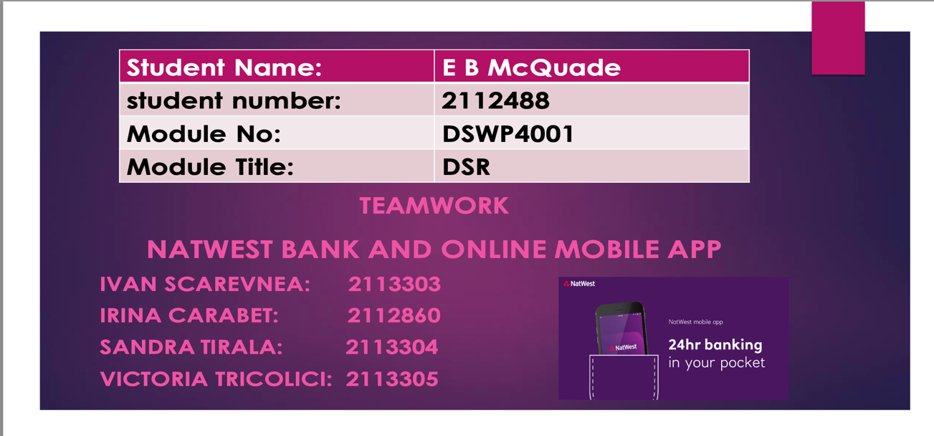

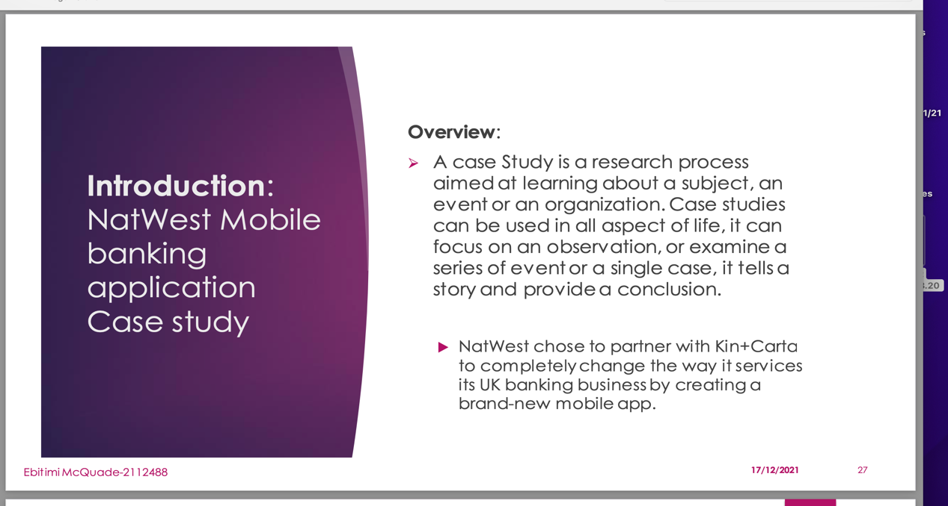
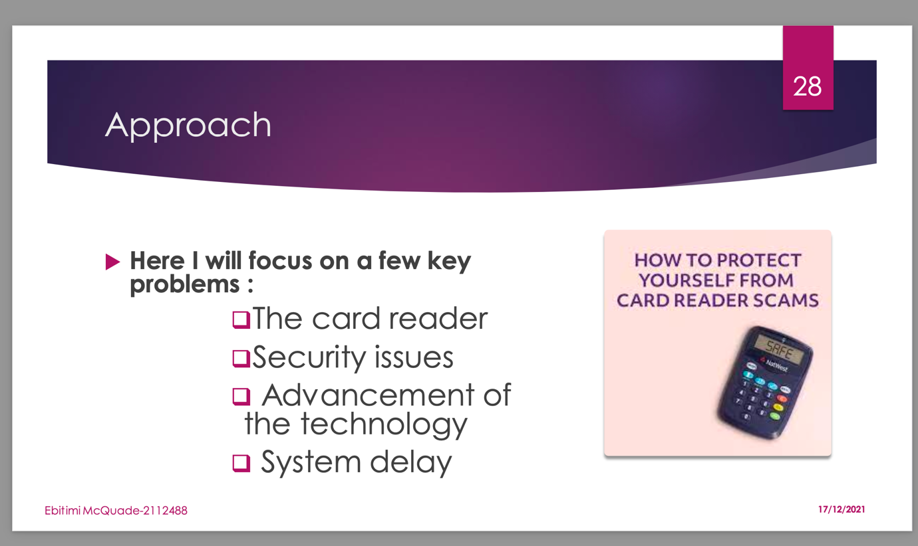

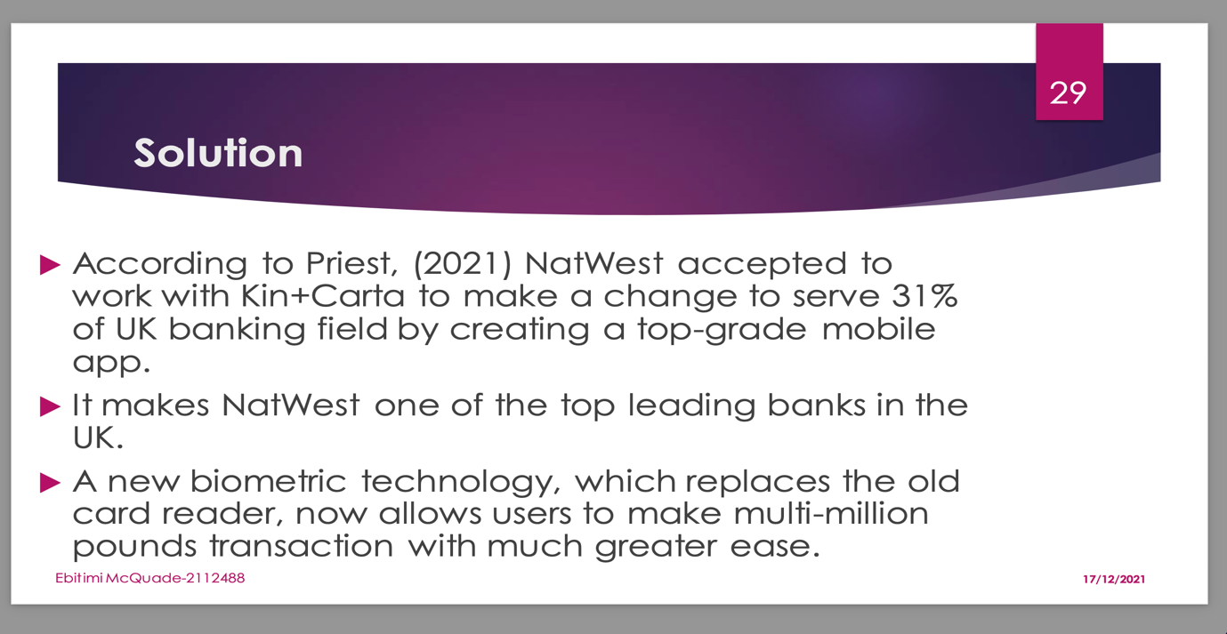

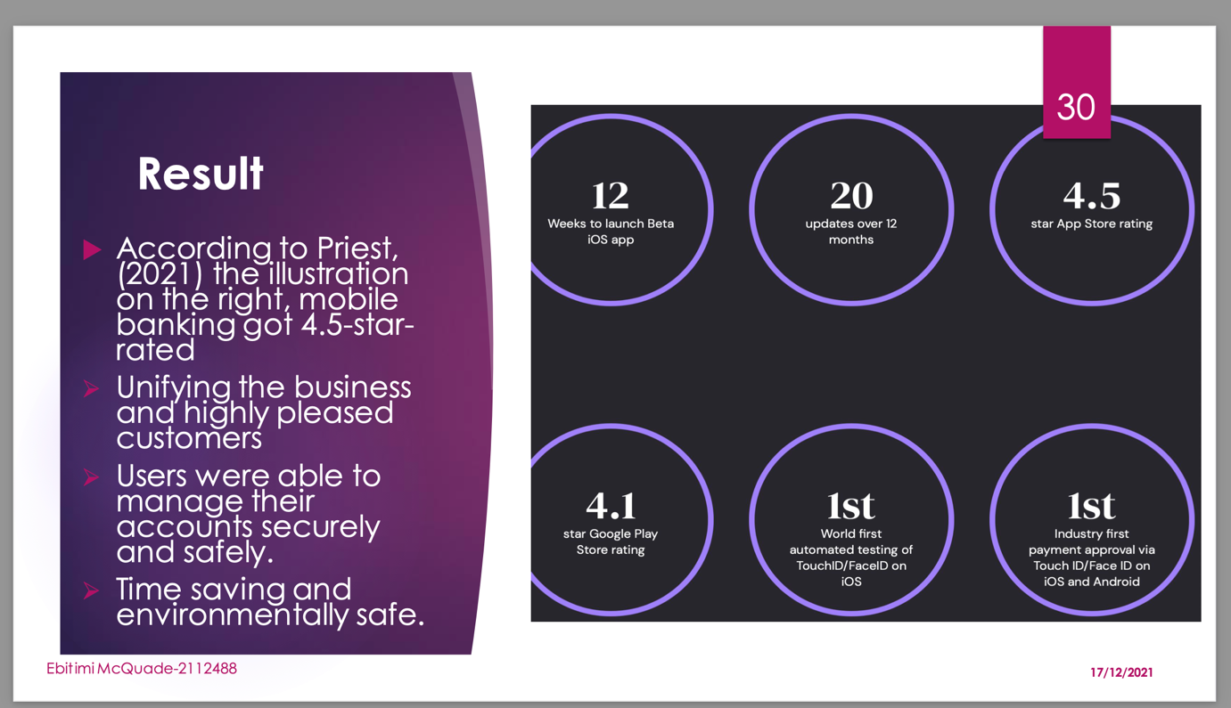

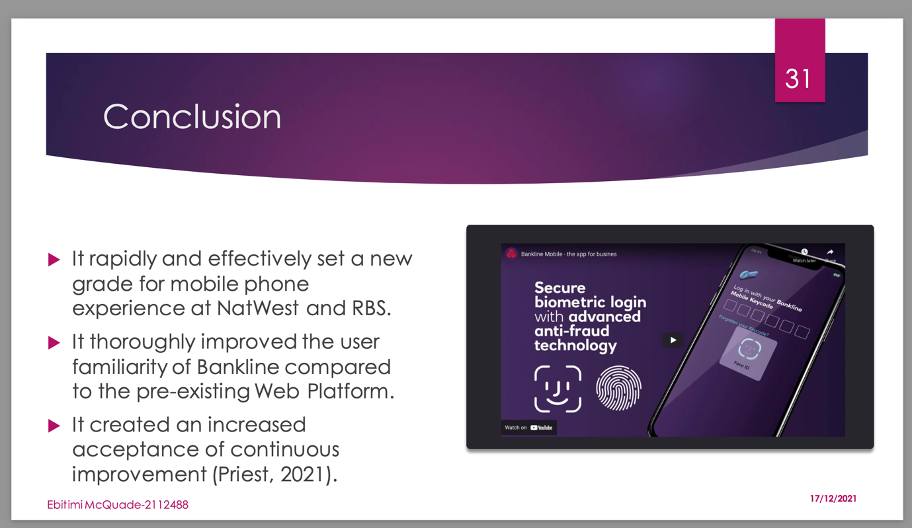
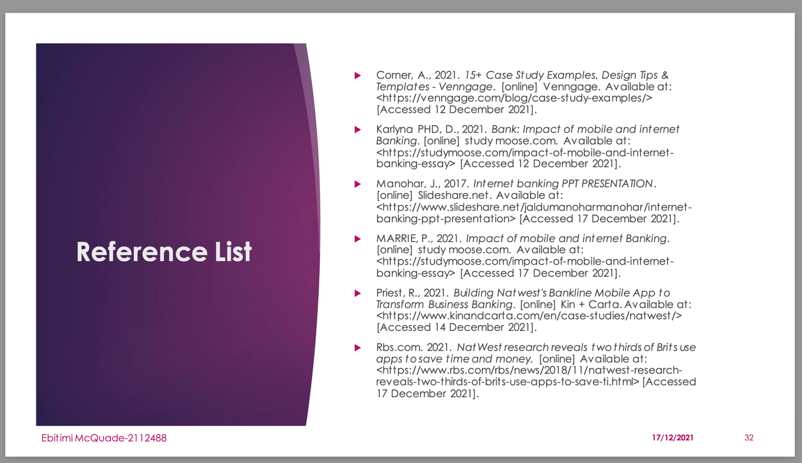

Questionnaire with survey and graphs generated.

Research done on impact of VLE experience at the University of Wales Trinity Saint David London Campus.
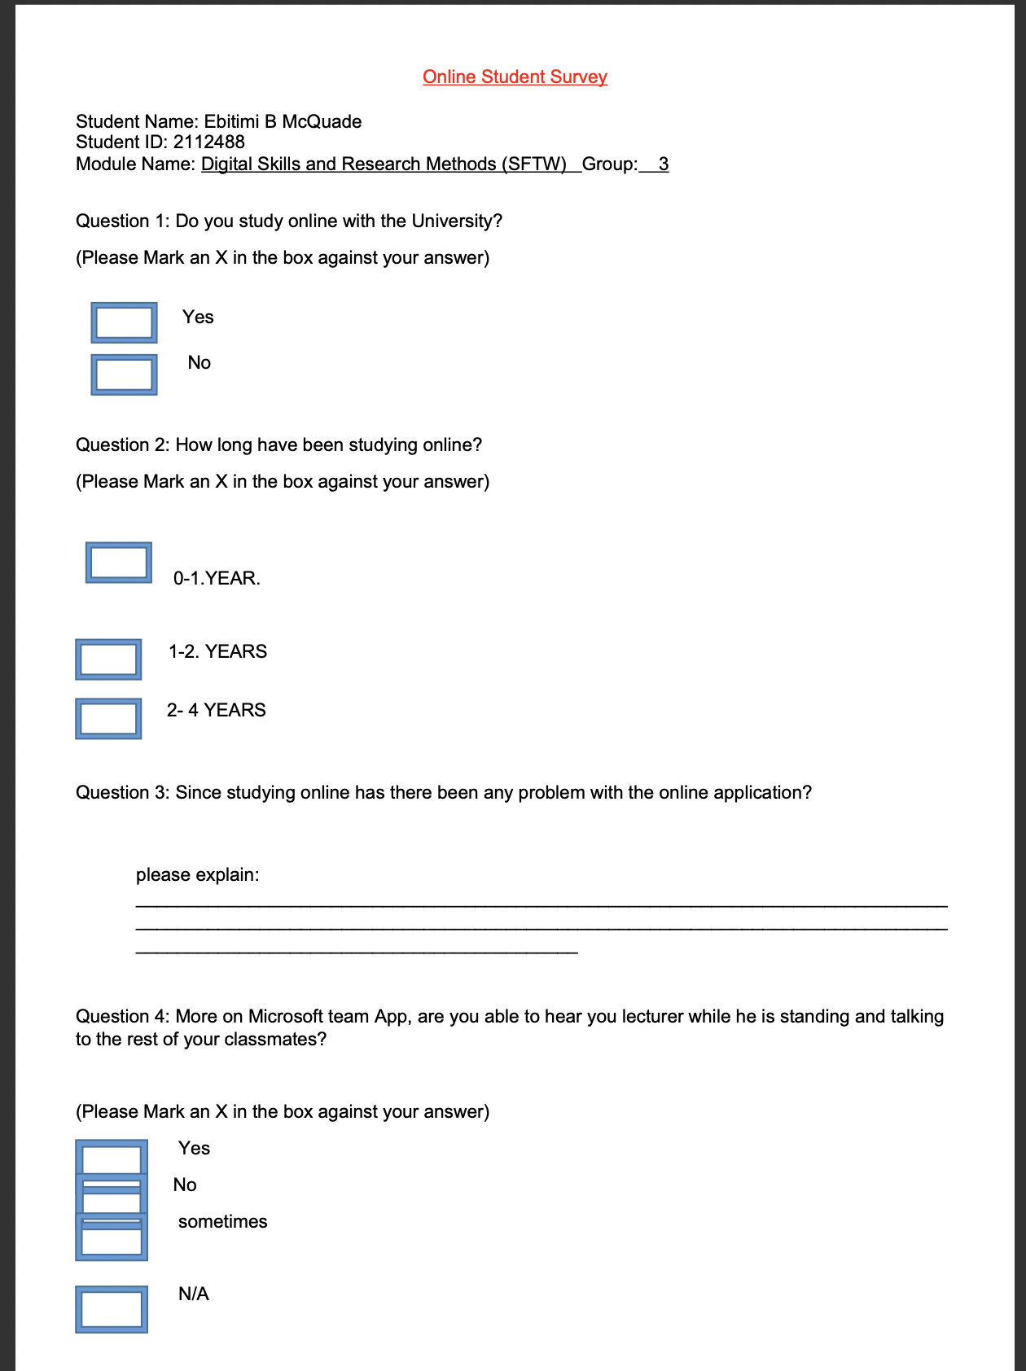

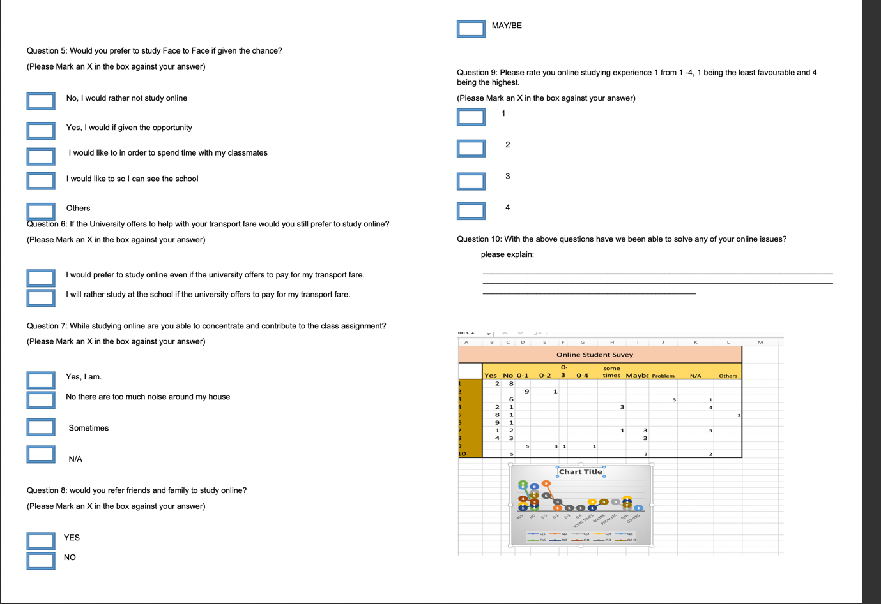

References for Data Research and Survey questions.

Ali, S., 2012. Questionnaire design & admin. [online] Slideshare.net. Available at: <https://www.slideshare.net/cadella49/questionnaire-design-admin> [Accessed 15 December 2021].
Jaikumar, M., 2012. SURVEY RESEARCH DESIGN. [online] Slideshare.net. Available at: <https://www.slideshare.net/maheswarijaikumar/survey-research-design-122265053> [Accessed 15 December 2021].
Nalzaro, L., 2010. Method of Data Collection. [online] Available at: <https://www.slideshare.net/ludymae/chapter-9methods-of-data-collection]> [Accessed 19 December 2021].

