Steve’s Project 26 April 2024 UPDATED AFTER THE LECTURE.

LECTURE SUMMARY. (17.30 on 26-04-2024)

- You are unlikely to be able to do a full systematic literature review (Section 2 of the assignment).
Please look at past documents shared or parts of my past PowerPoints to see the advantages /disadvantages of the different types of literature reviews. Please ask at the next session if you cannot find them.
Please note the PRISMA format for a systematic review. (There are other ways to conduct one. In section 1, you might comment on this and then say what you plan to do in section 2).
In most systematic reviews, particularly using PRISMA, the sample number of papers seen is very large, 2000+. You are unlikely to be able to read this many, in the time available. However you might start planning now if you want to do it for your ultimate thesis.

- We used Diane’s plans in relation to Gen-Zero to try to map the way her research was moving.
There are several interesting ideas, bodies of knowledge, models for applications, possible research methods etc.
However she also identified things she is NOT interested in or things she feels are irrelevant to her research question.
She felt bad that she ended up with only 13 articles which she thinks are directly relevant to her research.
I would not feel bad, depending on how many other articles she has read and the reasons for rejecting many of them, 13 could allow her to generate a workable hypothesis that she might test in a numerical/quantitative data collection plan or at least some possible influential variables, that she could explore in a qualitative method.
She was strong in focusing on a geographical location, type of management impact and time frame for her selection of key articles.
This indicates the importance of having a research question/title, which allows you to justify narrowing down the relevant field of literature that you will primarily use.
See my picture drawn as she related her investigation.
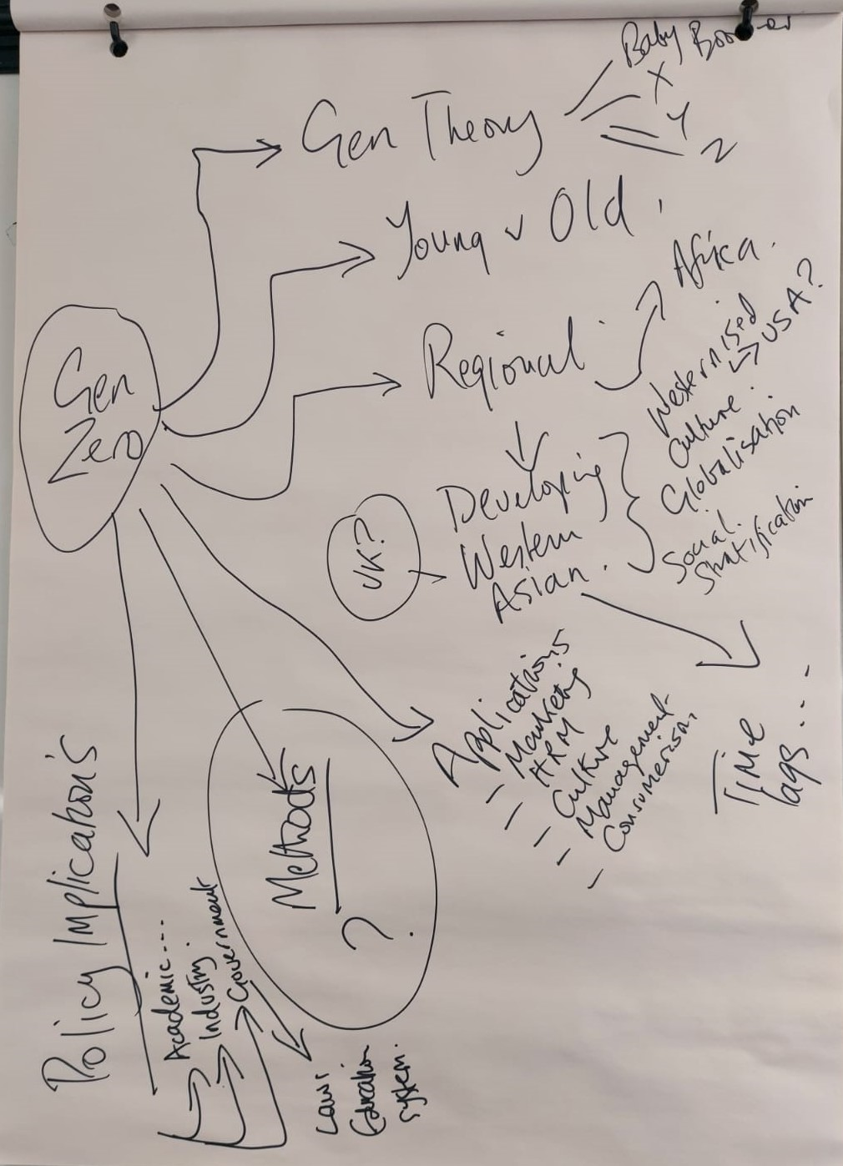

It is not perfect. Olivia could do much better. However we might revisit the picture to discuss the choices of where to specialise and analyse whether some of the “side roads” might be more important and therefore be allowed into the identification of key articles e.g. some articles from China or USA.
- Using PRISMA as part of your assignment.
As said above, Section 1 asks for the rationale for writing the literature review. There are 4 or 5 types (depending on who you read, see my comments in previous lectures), which all achieve different things, but all achieve understanding and allow the researcher to build on past research an academic discussion.
Even if you are NOT doing a systematic literature review, because it does not suit your research plan or help you achieve your research objective, you could mention that you understand what a systemic review might offer and why you have rejected it.

If you do intend to do a systematic literature review, you could say that you are aware of the need to cover the enormous range of literature and that in the time and word limit you could not achieve it fully. Nevertheless you can approximate it by following the typical stages and method of collecting, analysing, evaluating relevance and usefulness and eliminating irrelevant papers to conclude on what the most important articles are.
From these you can then derive research questions and comment on possible methods.
- Sources
Section 1 and 2 should be using reputable sources and these must be available in your reference lists. Different lists in section 1 and 2, although here might be an overlap.
The lists can then be imported and annotate for section 3 of the assignment.
Why not use some of the sources in my and Caroline’s ppts???????? So long as you analyse them.
- We confirmed the deadline for submission as 5 June, although I do not know why I agreed this. It was when I was ill and perhaps delirious.

- Bias: We did not talk about this in any depth so perhaps it would be good to cover it on 3 May. See it is in the PRISMA checklist of Page et al (2021)
Steve

A systematic literature review of Coopetition.
This is a not too serious and not too good, pretend exercise, by Steve to try to illustrate how you might organise a systematic review. He is a little embarrassed that it is not particularly good. However…..

‘An evaluation of Coopetition a new module for understanding reality of competition.’
- Introduction
I would quote my journey re finding Zineldin (2004). Teaching the concept. Supervising dissertations at Masters level and planning for book publication.
- Research background.

- Problems of definition and disclosure
- Cultural assumptions
- Theoretical model provenance.
The research question is;
What are the necessary conditions for the existence and maintenance of coopetition in private sector corporations?

Looking for patterns, see the UCL guide in another document on this tile. Therefore will review mixed methods in the source publications. Reviews may make inferences from theory or statistical evidence.

Sub questions.
- Did the partners know each other before collaborating?
- What cultural common factors existed to allow formation of the relationship?
- What barriers have been overcome to maintain the relationship?
- How are the positive and negative impacts assessed by participants?
- How likely are the partners to continue this form of relationship?

- Method and sample

3.1. Overview of the study
A systematic review is conducted to explore the tools, activities, and focus on Coopetition and its necessary conditions for establishment and continuation.
Systematic reviews differ from more traditional literature reviews in that it is grounded on pre-defined criteria that are methodologically, justifiably, and consistently implemented, and it enables researchers to synthesise the results of previous studies and produce evidence-based statements (Gough, Oliver, and Thomas 2017; Zawacki-Richter et al. 2020).

This paper synthesises a corpus of empirical studies on coopetition, attained after several steps of identification conducted systematically.

To achieve a systematic and reproducible approach to attaining the reviewed studies, I have followed the steps below – modified from Gough (2007, 218–219):
- determining the review question and protocols.
- setting inclusion and exclusion criteria.
- articulating the search strategy and choosing information sources.
- screening the articles based on the inclusion/exclusion criteria.
- mapping the results of the search strategy in a flowchart.
- extracting relevant descriptive data from included studies.
- appraising the quality and the relevance of main findings and arguments.
- synthesising all collected evidence that answers the review questions.

3.2. Search strategy and selection procedure.
Table 1. Search string.
Topic | Search string
Negotiation process | Senior, middle , functional management
Nature of competition | Competition for contracts. Competition for human resources
Nature of cooperation | Shared personnel. Shared capital.
Legal safeguards | Contract, IP protection, shared personnel, shared investment capital resources.
Length of relationship | Early, established, long standing
Future planned collaboration | Contract by contract. Integrated cultures and organisations.

Table 2. Final inclusion and exclusion criteria.
Criteria | Inclusion | Exclusion
Publication Year | 2020 | Pre 2020
Language | In English and Mandarin | Not in English or Mandarin
Level of business | National and International | SMEs and local
Relationship stage | Developed/long standing | Early negotiations
Methodology | Empirical, primary research | Non-empirical research, reviews, commentaries
Publication type | Academic journal articles indexed in EBSCO Source, Scopus, or Management Today. | Non journal article (e.g. editorial notes, book reviews, book chapters)
Industry sector | Manufacturing and service | Primary, agriculture, extractive etc.

Table 3. Initial search results.
Database searched | Date of search | Number of articles retrieved
Management Today | 01 April 2024
ABI EBSCO | 01 April 2024
Scopus | 01 April 2024

  - Data extraction and coding process
Some examples as illustrations.
Source:
Kyungmee Lee, Olaf Zawacki-Richter & Berrin Cefa Sari (2024) A systematic literature review on technology in online doctoral education, Studies in Continuing Education, 46:1, 38-64, DOI: 10.1080/0158037X.2022.2135499.
https://www.tandfonline.com/doi/full/10.1080/0158037X.2022.2135499
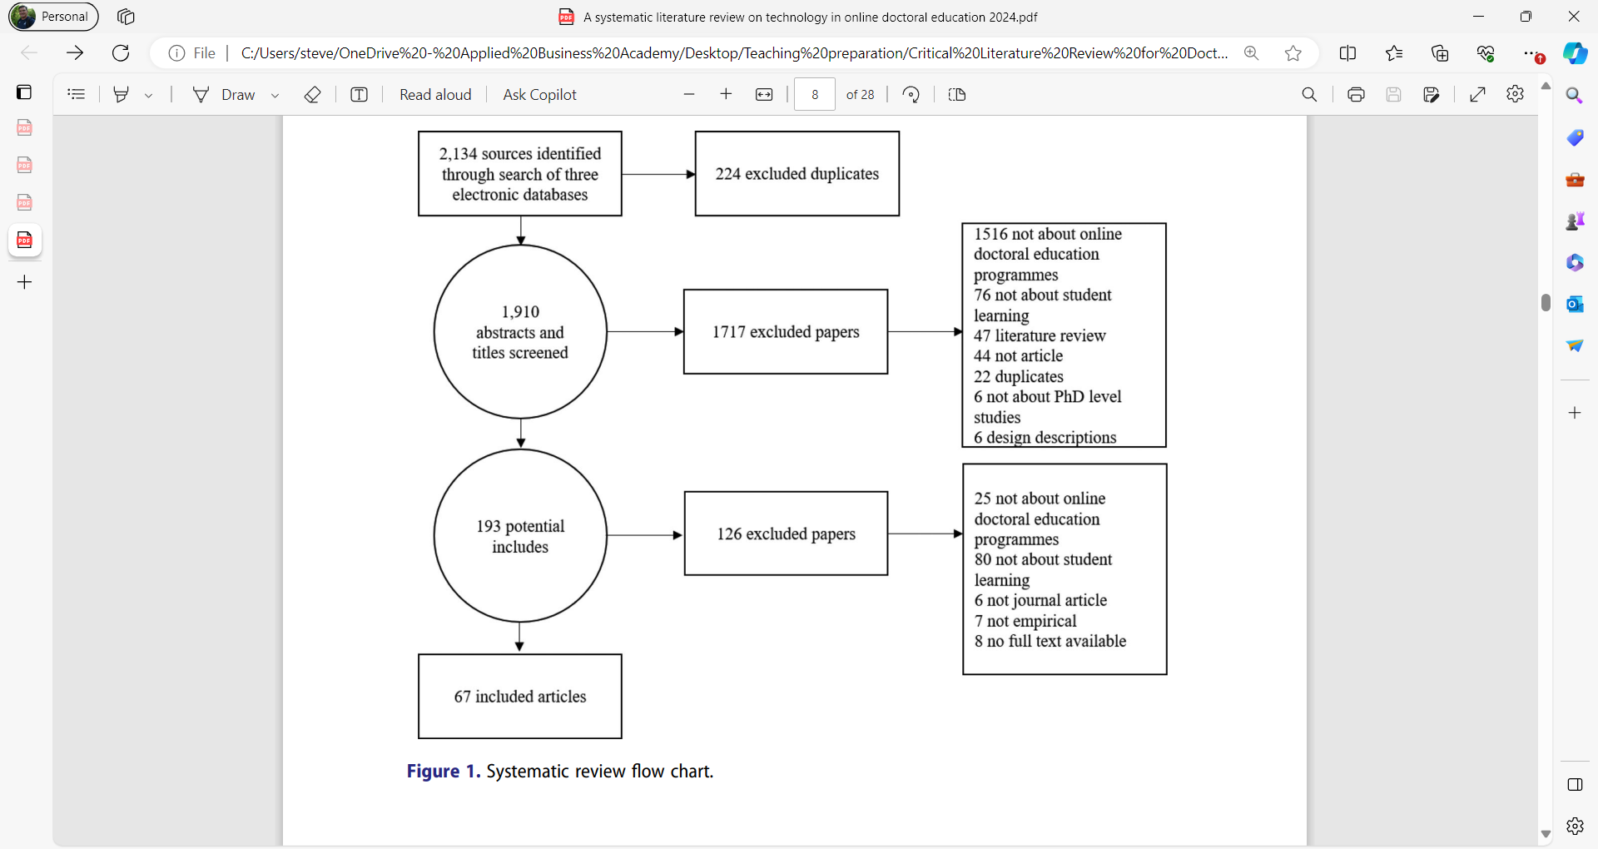
Source: Schmidt, K., Aumann, I., Hollander, I., Damm, K. & Graf von der Schulenburg, J-M. (2015). Applying the Analytic Hierarchy Process in healthcare research: A systematic literature review and evaluation of reporting. BMC Medical Information Decision Making 15, 112 (2015). https://doi.org/10.1186/s12911-015-0234-7
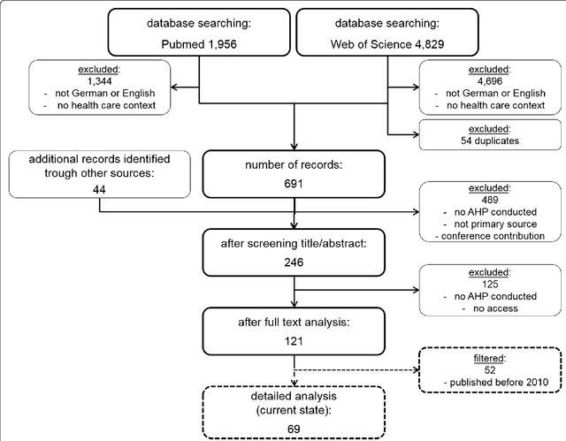
  - Study characteristics.
3.4.1. Geographical and methodological characteristics of the corpus
THIS IS SIMPLY A COPY FROM ONE OF THE READINGS UPLOADED ON THE VLE TO ILLUSTRATE WHAT YOURS MIGHT LOOK LIKE.

The previous studies have predominantly originated from the USA (71.6%, n = 48), followed by the UK (9.0%, n = 6), and EU (7.5%, n = 5). Other studies are undertaken in PRC, Ghana, the Netherlands, Portugal, New Zealand, Sweden, South Africa, Saudi Arabia, and Spain, each sharing an equal number of contributions (n = 1). In parallel with these results, across the 67 articles, the reviewed
3.4.2. Coopetition characteristics
- Informal communications
- Formal regular meetings
- Integrated organisational links, similar to mergers.

4. Results and discussion
4.1. What cultural requirements are needed for establishment of a relationship?
4.2. What are the intended objectives of the relationships for the participants?
4.3. What are the associated challenges with the cases identified?
5. Conclusion and implications
- There is great diversity in reported cases. In terms of recognition of it, the types, the motives for doing it, the valuation of whether it is good or bad.
- Some cases of coopetition are not acknowledged. Perhaps because some forms of cooperation are unfair practice/illegal fixing governed by anti-competition (in USA anti-trust) legislation.
- Some are unconsciously entered into. There is a minimal form, which relates to agreement on the basic rules of how to compete, or openness about product qualities, use of distribution networks etc.
- Some cases if coopetition are virtually mergers or examples of actionable unfair practices. Therefore there is a need for regulatory guidance on when it is illegal or subject to regulation.

References

EPPI Centre Home (ioe.ac.uk) (Retrieved 01-04-24).
Gough, D. (2007). “Weight of Evidence: A Framework for the Appraisal of the Quality and Relevance of Evidence.” Research Papers in Education 22 (2): 213–228. doi:10.1080/ 02671520701296189.
Gough, D., S. Oliver, and J. Thomas, eds. (2017). An Introduction to Systematic Reviews. 2nd ed. London: Sage
Zawacki-Richter, O., M. Kerres, S. Bedenlier, M. Bond, and K. Buntins, eds. (2020). Systematic Reviews in Educational Research: Methodology, Perspectives and Application. Springer. http:// link.springer.com/10.1007978-3-65

