Control System Design
Martyn McGinlay
L5 OME (ACDB5011) Instrumentation and Control
University of Wales Trinity St David
19 July 2023



Declaration page
The work of this report was completed under the supervision of Stalin Jacob Wilson Packia Dhas. I declare that this report is the product of my own work and is not being submitted for any other degree etc.
M.McGinlay (Signed Electronically)

Abstract
This report details information on how to design a closed-loop control system. There are two different types of control systems, an open control system which has no feedback sent back into the control system but with a closed-loop control system feedback is supplied back. The aim of this report was to use MATLAB (simulation software) to create a closed-loop system for a CIWS turret. The parameters for this control system had to be able to bring the control system under control within two seconds and an overshoot of less than five percent. By using MATLAB, a closed-loop system was designed, and by using the last three digits of the student number 2113330 to form the transfer function. The first simulation using the digits 330 did not meet the set parameters therefore a second simulation took place using them and then the results were tuned to adapt the PID figures to successfully fall within the set parameters. A third simulation took place and was also successful. Further information can be found detailed within the report.

Contents
 | Page number
- Introduction | 1
- Simulation Setups | 4
- Results | 6
- Discussion | 13
- Conclusion | 14
- References | 15

- Introduction
If you have never come across a control system, it is easy to assume a question may arise within your head along the lines of what is a control system? A very brief and simple explanation of a control system is a system that has the control over other systems [1]. It can also be described that an input may be added to a control system which in turn will give out the desired output. This can be seen in [Fig.01]

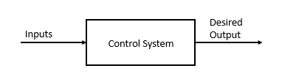
Figure 1 - Basic Control System. Source: Adapted from [2]
A very early control system was designed by James Watt which was the Flyball Governor [Fig.02] and was designed by James Watt to enable the control of the speed of a steam engine [3].

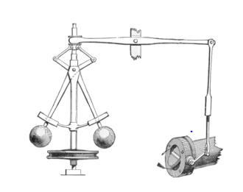
Figure 2 - Flyball Governor. Source: Adapted from [3]
The early design of the airplane by the Wright brothers was said to be enabled by the understanding of controls and was further progressed into the modern-day airplane through the use of cockpit controls such as the stick, yoke, and rudder pedals. These are controlled by sensors that pick up electrical signals which in turn are sent to actuators that drive the appropriate surfaces [4].
In order for a control system to function a transducer is required which is a device that can convert different variations of quantities such as pressure, brightness, and electrical signals [5]. There are two types of transducers which are the following:
- Electrical – These will convert a form of energy into an electrical signal and will give electrical energy as an output [6].
- Mechanical – These will respond to a physical quantity with a mechanical output such as force, displacement, and torque [7].
An example of an electrical transducer can be a resistive transducer for resistance thermometers [7].
An example of a mechanical transducer can be temperature being measured by fluid expansion (displacement and force as an output signal) [7].
Within an electrical transducer, there are two parts. A sensing or detecting part which is a sensor and a transduction element which will therefore transfer the output of the sensor into an electrical output [5]. Sensors can be identified as both active and passive. For an active sensor to work a power (external) supply is required to help produce the output signal. A passive sensor does not require power to operate, and the output signal is created from external stimulus [5]. There are two main types of sensors, switches, and transducers.
There are two types of control systems that we will take a closer look at. The first control system is an open-loop control system. Within the open loop system, no feedback is fed to the input of the system. It is also known as a non-feedback control system. With an open loop system, the control system will follow its input regardless of the final results it will be experiencing. The disadvantage of an open loop system is that it may experience instances that it is unable to complete the desired tasks due to disturbances it may face. Examples of an open loop control system are a traffic light system and also a washing machine. A closed-loop system will provide feedback to the input system. It is also called a feedback control system. Basically, the output of the system controls the input applied. Feedback will be provided to the input which can come in two forms, positive and negative feedback. Positive feedback is when the input signal and the feedback signal are in phase with each other. Negative feedback is when the input signal and the feedback do not match and there not in sync with each other as required. A thermostat will use a closed loop system as it allows the user to set a temperature as an input and this will work to achieve this as its output and maintain this until it is either changed or turned off. A human can be said to have a closed-loop control system. This can be proved by the situation of a human trying to cross a busy road. The aim is to cross the road, but the human will wait until the road is safe to cross. The input can be seen as information on their surroundings and the plant is the human. The controller is the human’s brain, and the output is the adjustment of the human’s position.
The purpose of this report was to design a closed-loop system for the angular positioning system attached to an automatic Closed In Weapon system (CIWS) turret. A CIWS [Fig.03] is a gun weapon system used by many militaries throughout the world. Raytheon is the manufacturer of the Phalanx CIWS which is said to be a “rapid-fire, computer-controlled, radar-guided gun that can defeat anti-ship missiles and other close-in threats on land and at sea” [8].
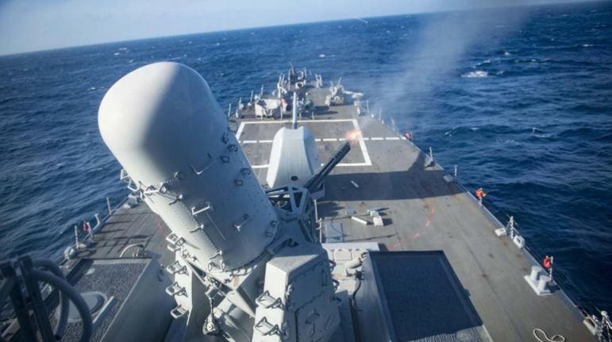
Figure 3 - CIWS in action. Source: Adapted from [8]
In order to design the closed loop system an application called MATLAB was used with a built-in program called Simulink used to design and test the system. For the simulation to take place a transfer function must be used. A transfer function can be described as using mathematics to define the behaviour of a system. For the purpose of this report and simulation to take place the transfer function used can be found in [Fig.04].
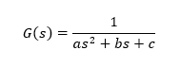
Figure 4 - Transfer Function for Simulink
The aim of the simulation was to ensure once the closed loop system was designed and ready to be used that the process could be brought under control under the following limitation:
- Process to be controlled within two seconds.
- Overshoot of less than five percent.

- Simulation Setups
In order to make the simulation a closed loop system was to be created. Simulink (within MATLAB) was used and can be found in [Fig.05].
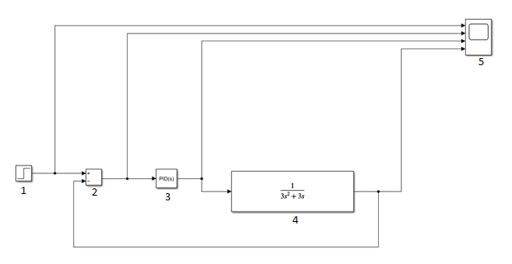
Figure 5 - Closed loop control system

Information on the closed loop system in [Fig.05] can be found below:
- Step block – Step between two definable levels at a specific time. If the simulation time is less than the step time value, then the blocks output is the initial value parameter value. If the time is greater than or equal to the step time, the output is the final value parameter value. For this simulation, the sample time was 10e-6.
- Sum block – Performs addition and subtraction on its inputs. For this simulation, there were two inputs, one plus and one minus.
- PID (Proportional Integral Derivative) Control – Use the absolute error value, integral of the error, and derivative of the error to control the process value. Values entered for the simulation were P=1, I=1 D=0. There are two other controllers that can be used but for the purpose of this report the following were for information only:
- PI (Proportional Integral) – Only accounts the current error which leads to steady-state error.
- PD (Proportional Derivative) – Uses the rate of change of the error signal to control the overshoot.
- Transfer Function – Models a linear system by the transfer function of the Laplace-domain variables. Can be either a SISO (Single Input Single Output) or SIMO (Single Input Multiple Output). For this simulation, the formula in [Fig.04] was used but changed to reflect student number 2113330. The last three digits (330) were used.
- Scope – Displays signals generated during simulations.
The aim of the simulation was to design the closed loop system with the process being controlled in under two seconds and with an overshoot of less than five percent.

- Results
The closed-loop control system in [Fig.05] was used to begin the initial simulation and the results can be found in [Fig.06].

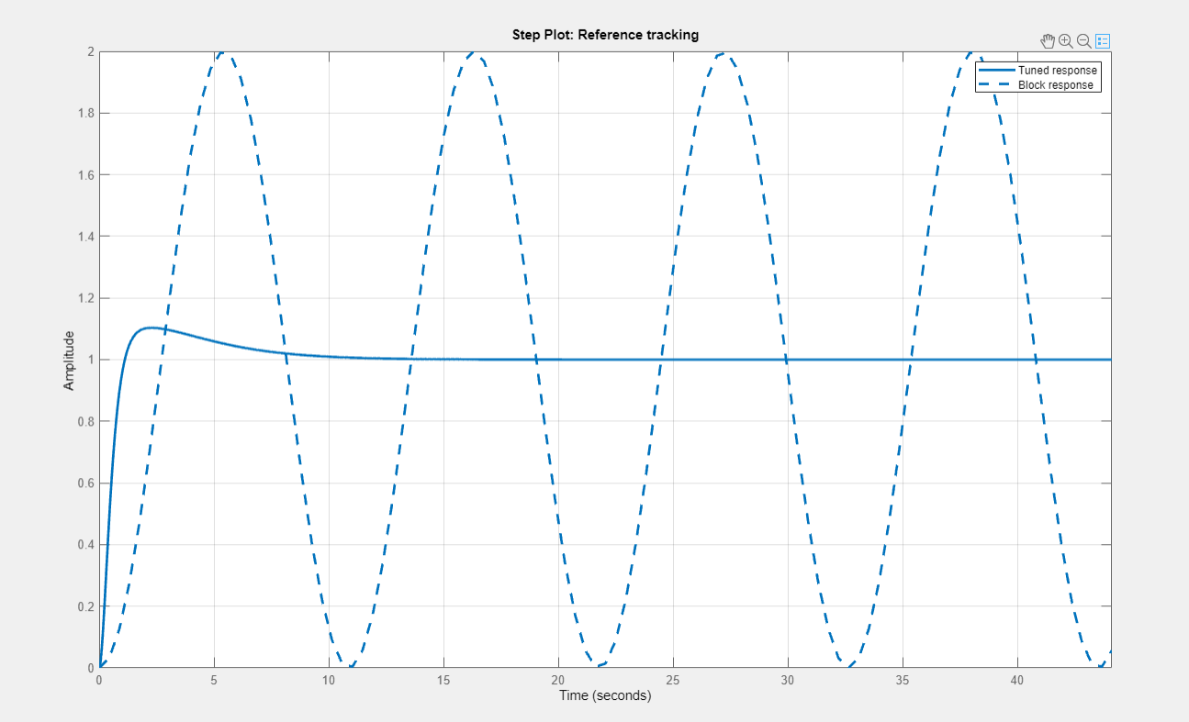
Figure 6 - Reference tracking
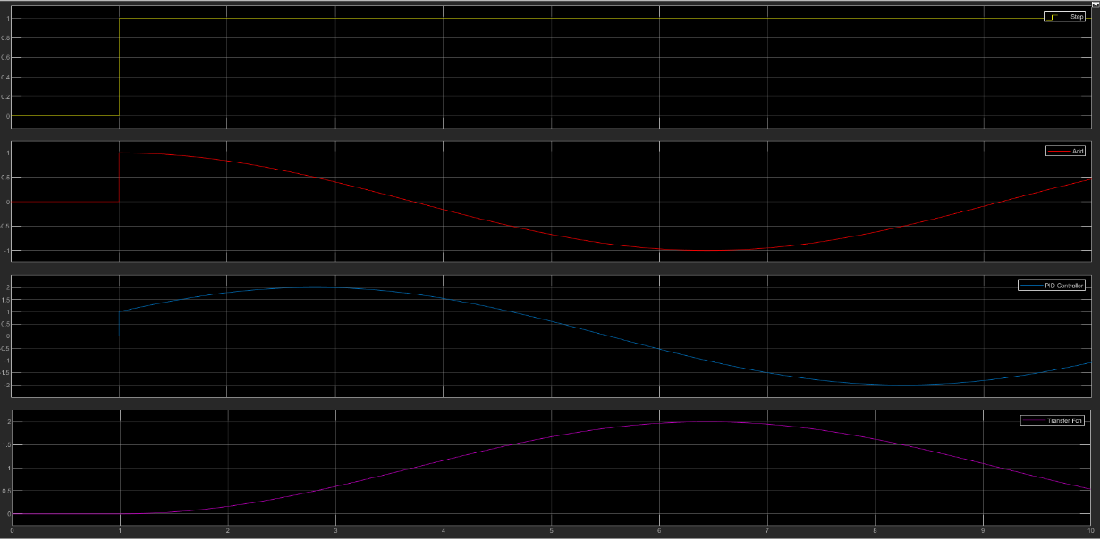
Figure 7 - Step / PID / Transfer Function in graph form
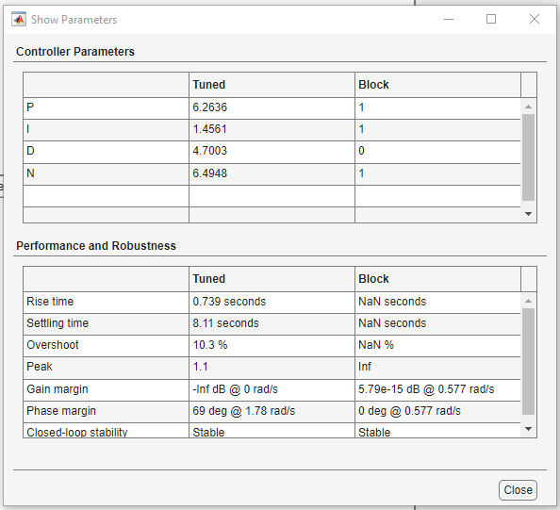
Figure 8 - Results for initial simulation
The main standout piece of information comes from [Fig.08] which displays the results from the initial simulation. As per the aim of the simulation which was to ensure the simulation is controlled within under two seconds and an overshoot of less than five percent. It can be seen this is not to be the case as the simulation had a settling time of over eight seconds (8.11s) and an overshoot of over ten percent (10.3%).
To rectify this discrepancy the PID had to be re-tuned to bring the simulation under control within the set parameters. [Fig.11] shows the results after tuning of the PID.
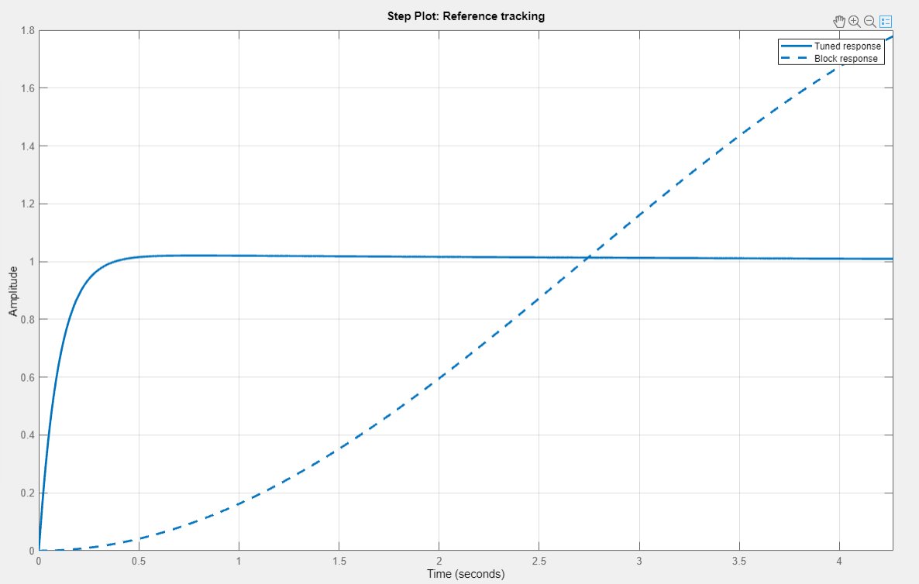
Figure 9 - Reference tracking after tuning
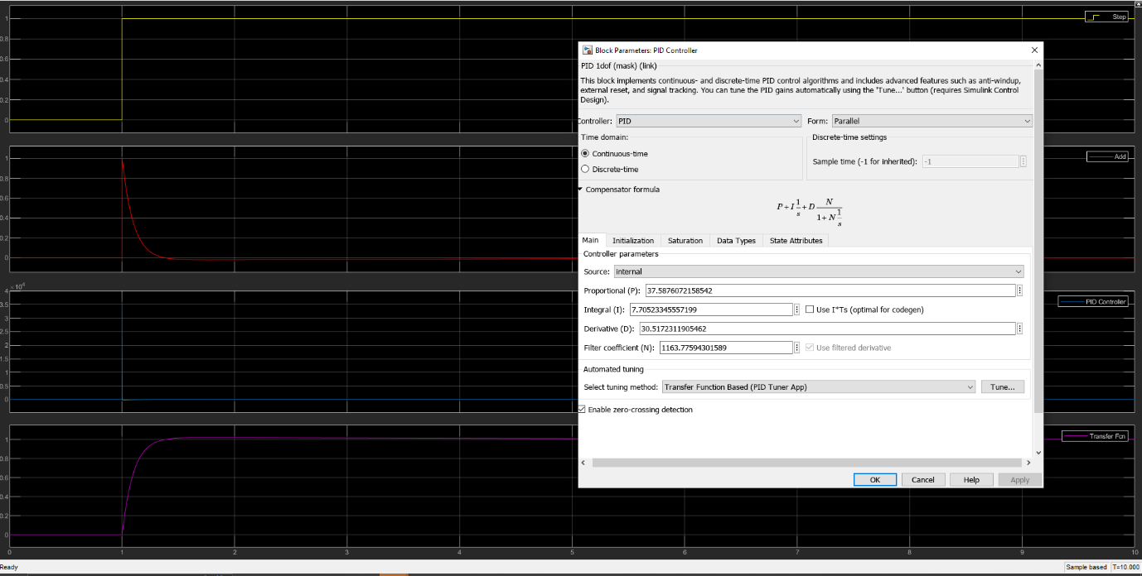
Figure 10 - Step / PID / Transfer function in graph form
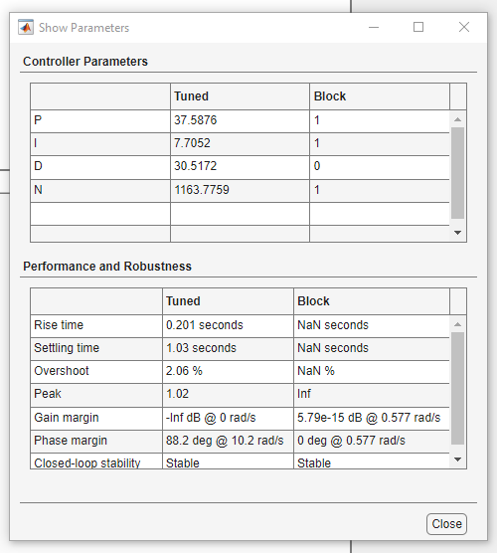
Figure 11 - Results from tuned figures
[Fig.11] provides a positive result which proves after the tuning of the initial simulation that the set parameters could be achieved. This tuning successfully achieved the results required and show a settling time of over one second (1.03s) and an overshoot of just over two percent (2.06%).
The final task was to input the PID figures from [Fig.11] into the transfer function and then retune to obtain the final result. To obtain the full transfer function equation, a mathematical equation was completed. [Fig.12] shows the transfer function equation for the PID Controller.
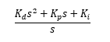
Figure 12 - Transfer Function for PID Controller
The next step was to multiply the controller’s transfer function with the transfer function. The next step was to calculate the transfer function of the system as a whole while using the equation in [Fig.13].
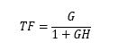
Figure 13 - Transfer function for the whole system

The full mathematical solution for this system can be seen in [Fig.14].
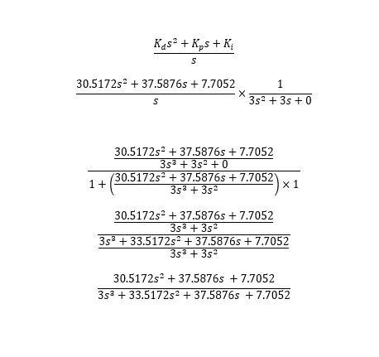
Figure 14 - Worked example.

The final answer from [Fig.14] was then inserted back into the transfer function [Fig.15] and simulated then re-tuned to as close as the figures as presented in [Fig.11].
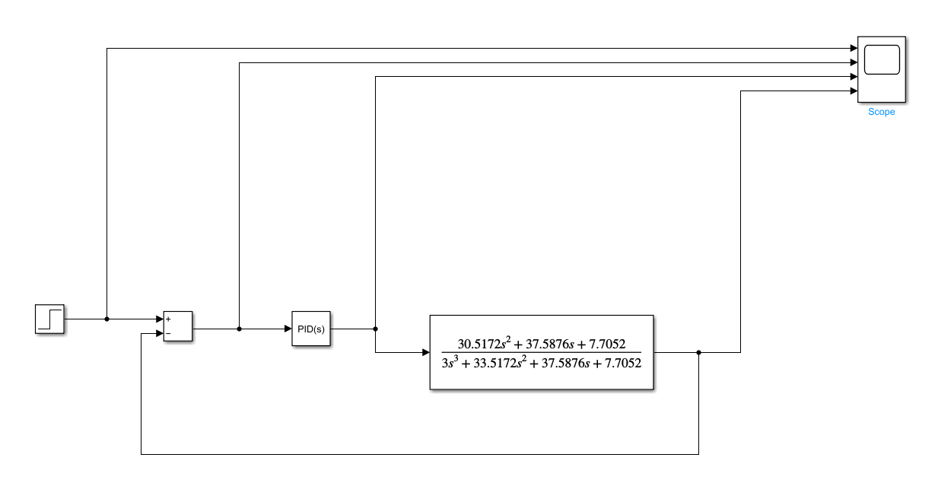
Figure 15 - Updated transfer function

[Fig.16] shows the reference tracking and [Fig.17] shows the PID Controller values in Graph form.
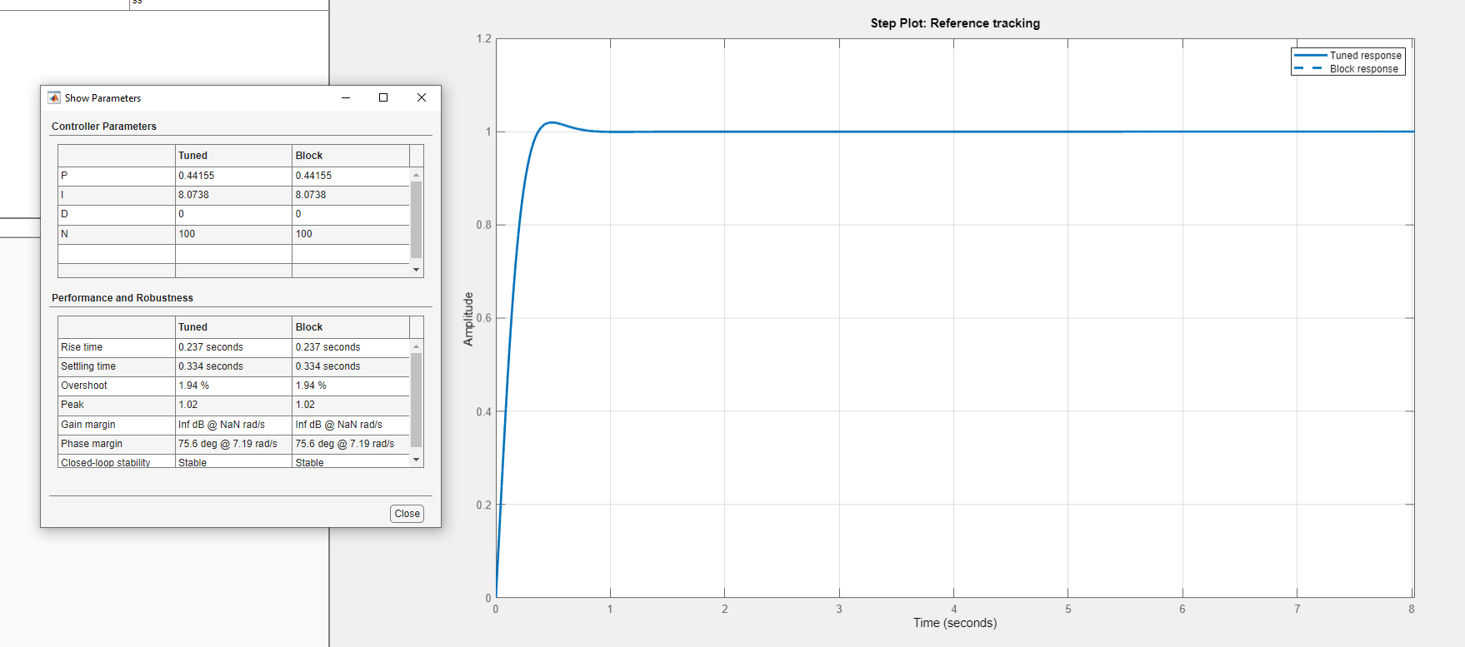
Figure 16 - Reference Tracking

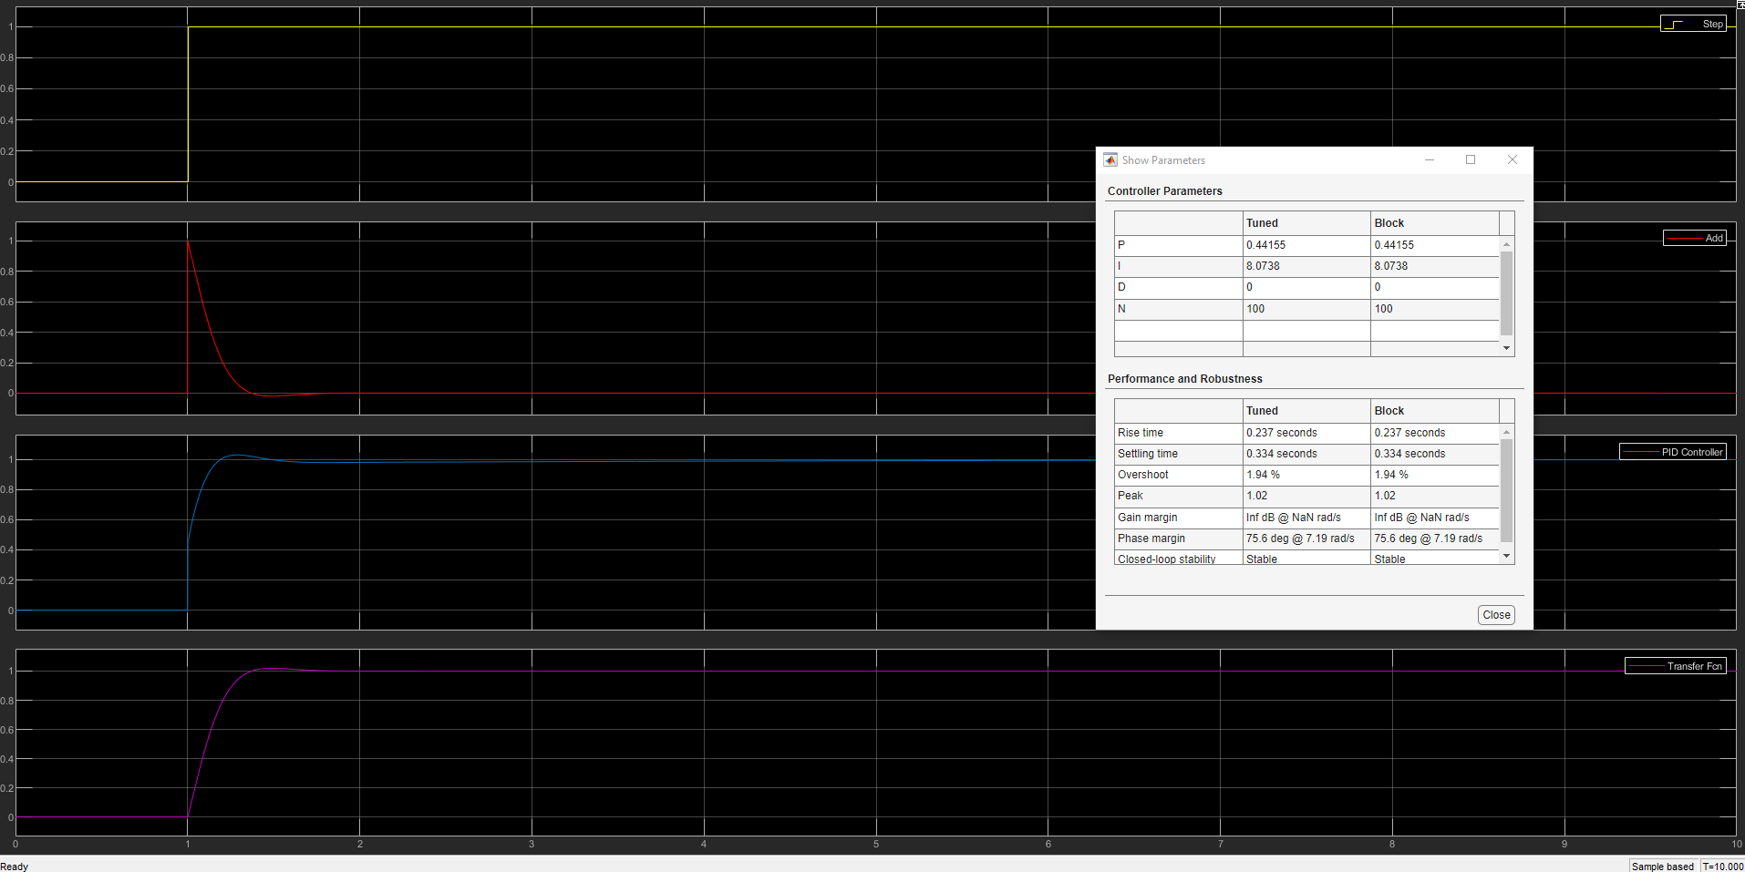
Figure 17 - Step / PID / Reference tracking in graphs

The final step parameters [Fig.18] shows a settling time over under one second (0.334s) and an overshoot of just under 2 percent (1.94%).

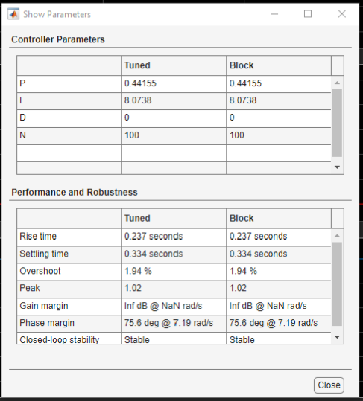
Figure 18 - Results for final retune

The standout piece if information from this simulation shows that it has a less of an overshoot and less of a settling time than previously seen within [Fig.11].

- Discussion
The initial simulation that took place which incorporated the last three numbers of the student number (2113330) which is shown in [Fig 6, 7, 8] demonstrates that for this simulation it did not in fact meet the control process parameters which was to be controlled within two seconds and an overshoot of less than five percent. You can also see by the graph in [Fig.7] that the PID and Transfer Function are not stable and did not settle at any point. The reason can be said for this not meeting the required parameters can be that these are raw figures that have only been entered and nothing has tuned to try and ensure that it can perform under the required parameters set. Based on the information presented this simulation did not meet the required parameters set as the settling time and overshoot as seen in [Fig.8] is greater than what was allowed.

The second simulation showed that by re-tuning the first simulation it was possible to bring the control system under control within the set parameters. By re-tuning the PID controller it allowed the settling time and overshoot to remain under the set parameters meaning this simulation was deemed to be a success. By performing the re-tuning, it allowed the overshoot and settling time [Fig.11] to have successfully met the set parameters. The reason for tuning the PID Controller is to ensure the closed-loop system can operate in a stable manner and reducing oscillations can help improve the effectiveness of the system. This simulation can be deemed as successful as it meets the requirements set out for the control system.
The third and final simulation that was undertaken took the PID figures [Fig.11] and input them into a mathematical equation [Fig.14]. The transfer function [Fig.15] was then updated with the answer from the mathematical equation and was then re-tuned to meet the set parameters. [Fig.18] established even more successful results and it managed to have a greater result than the second simulation for the settling and overshoot. A possible reason for this occurring could be that the tuning in simulation two and then entering a more accurate transfer function within simulation three allowed it to be finer-tuned to have greater accuracy.
Comparing the Transfer Function from [Fig.10] and [Fig.17] proves that the output for both was similar and proved a success that the control system designed was successful and was able to bring the process under control within the set parameters.

- Conclusion
By performing the simulations for the PID controller and performing tuning to bring the process under control within the set parameters the following can be determined:
- Closed-loop control systems can help remove deficiencies that would occur with an open-loop system. The output within a closed-loop system is a process that helps adjust and remove abnormalities.
- The input does not always give the desired output therefore adjustments may be required.
- As per simulation two and three adjustments had to be made after the transfer function was entered. This was completed by re-tuning the PID to obtain figures within close proximity to the set parameters.
- From the simulations that took place it proved that it may not be possible to achieve absolute perfection within the set parameters. From simulations two and three, it was difficult to tune the PID to achieve the set parameters, but it was possible, and this was achieved.

- References

References

[1] | E. 4. U, "Control Systems: What Are They? (Open-Loop & Closed-Loop Control System Examples)," 27 December 2020. [Online]. Available: https://www.electrical4u.com/control-system-closed-loop-open-loop-control-system/?utm_content=cmp-true. [Accessed 24 June 2023].
[2] | Tutorialspoint, "Control Systems - Introduction," [Online]. Available: https://www.tutorialspoint.com/control_systems/control_systems_introduction.htm. [Accessed 03 July 2023].
[3] | F. Owen, "Control Systems Engineering A Practical Approach," California , 2012, pp. 1-1.
[4] | F. Owen, "Control Systems Engineering," in A Practical Approach, California, 2012, pp. 1-2.
[5] | S. Jacob, Instrumentation and Control - Lecture 1, Swansea, 2023.
[6] | "Electrical Transducer Working and Advantages," Elprocus, [Online]. Available: https://www.elprocus.com/electrical-transducer-working/#:~:text=An%20electrical%20transducer%20can%20be,be%20frequency%2C%20current%20or%20voltage.. [Accessed 24 June 2023].
[7] | R. Teja, "Different Types of Transducers | Characteristics, Classification, Applications," Electronics Hub, 26 August 2021. [Online]. Available: https://www.electronicshub.org/types-of-transducers/. [Accessed 24 June 2023].
[8] | Raytheon, "Phalanx Weapon System," [Online]. Available: https://www.rtx.com/raytheon/what-we-do/sea/phalanx-close-in-weapon-system. [Accessed 24 June 2023].

