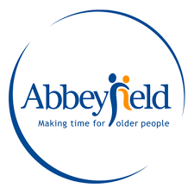

Placement Portfolio 2022

Table of contents

Reflective Commentary……………………………………………………………………....3
References………………………………………………………………………….....5
Portfolio of Evidence ………………………………………………………………………...8
Evidence 1: Background Information……………………………………………….8
Section A: Background Information ………………………………….……..8
Section B: Abbeyfield’s Heritage …………………………………………....9
Section C: Independent Living ………………………………….…………10
Evidence 2: Reflective Logs ………………………………………………..………11
Evidence 3: Volunteering Process ………………………………………..………..18
Section A: Policies ………………………………………………………….19
Section B: Art Afternoon ………………………………….………………..26
Section C: Other Activities …………………………………………………27
References …………………………………………………………….…………….28
Appendices ………………………………...………………………………………..30

Reflective Commentary

Using Gibb’s (1988) Reflective Cycle I am reflecting on my first placement. I am more familiar with crisis care within a domestic abuse service setting. Against my desire for a familiar, easy route, I reached out to Abbeyfield House in Swansea, an independent living facility for older people, with low mental health needs. Covid-19 had a big impact on attending placement and interrupted plans made. I was expecting to gain experience through my interactions with residents however the conversations had with the House Manager and other staff members were also insightful and found myself using my counselling skills during interactions, particularly whilst discussing personal lives. I was surprised at how much I enjoyed myself, and how quickly I managed to settle in and build a rapport with the residents.
I experienced a range of emotions. I felt anxious and apprehensive whilst securing the placement, but I felt strongly that I should get out of my comfort zone. I was proud that a part of me quietly but firmly told me to try. I felt incapable of interacting with residents and worried that they would not warm to or accept me. Once I attended my first day the ‘unknown’ stopped pestering me and it felt like a huge achievement. I was encouraged by my own confidence whilst introducing myself to both staff and residents and my eagerness to settle and blend in. I felt a lot a peace at times, especially whilst sat in communal areas with residents. I also felt relieved that the residents were ‘safe’ now within the home, no longer in the situations they have faced. I experienced sadness, sympathy and empathy whilst getting to know the residents but also a lot of joy and happiness when witnessing them interacting at mealtimes or with Harri the dog, or act activities.
I practiced my counselling skills such as active listening and paraphrasing, in a real life setting and witnessed the impact the skills can have (Barth & Moody, 2019). When I was feeling nervous interacting or approaching residents, I would use SOLER (Nandini, M. (2020) and remember the core conditions (Velasquez & Montiel, 2018). I especially noticed how effective active listening and being present can be, as powerful as having an in-depth conversation.
A highlight moment would have to be the art afternoon, finding out that a resident spent more time in a communal area, using her talent of painting, was really overwhelming and I felt that I had achieved a positive change which I was not expecting at all. Also, the impact that Harri the dog visiting had, so simple but so effective, everyone seemed happier and lighter. Art therapy has been found to be effective in combating cognitive decline (Schouten et al.,2015; Masika et al., 2020) and recently found beneficial in helping individuals open up and share their experiences (Israeli et al., 2021). I believe that this has been subtly reflected in my own experiences, finding that the residents that took part in the activity did open up and conversation flowed. I also feel that it had a positive impact on ‘Da’s self-esteem and confidence, which was also a finding in Israeli et al’s (2021) study. However, I am aware that these outcomes may be affected by a ‘Hawthorne effect’ (Jones, 1992), spending uninterrupted, planned period of time together may have created a comfortable and safe space for the residents who joined to feel relaxed, seen and heard rather than the art itself (David et al., 2021). Pet therapy has also been found effective in combating behavioural and psychological issues in older adults (Baek et al., 2020). Although there are risks, they can be managed and the benefits appear to outweigh these (Cherniack & Cherniack, 2014).
It was difficult to hear the background of the residents, as most have suffered trauma and mental health difficulties. But it was comforting and inspiring to see how intervention and care can help an individual recover and move forward with their lives (Pitkala et al., 2011). Two residents are now a romantic couple after meeting while being at Abbeyfield, their relationship seemed gentle and healing for them both, which I find inspiring. Having previously worked in crisis care, the daily routine appeared to be a comfort to the residents, maintaining the slow and steady pace of the days, an integral part of the community of the home. I noted how powerful this was, not a direct intervention from any staff but maintained collaboratively between staff and residents (Perkins et al., 2012). Mealtimes appeared especially important, bring everyone together, sometimes being the only social part of some residents’ day (Watkins et al., 2017; O’Conor et al., 2019). I faced an ethical issue, when a resident asked if I could help set up her online banking. Although I was clear that this would be unethical and reported to a house manager, the resident seemed to feel rejected as they became defensive and said someone else had previously helped them. I realised that this resident needed gentle explanation but firm boundaries. I thought the staff balanced resident needs and dependency well and could see how good relationships had been built (Van der Weele et al., 2021). Although, the house manager shared the struggle of balancing independence and autonomy but also ensuring residents are aware of the risks of catching Covid-19 and possibly endangering other residents.
I was aware of the pressure Covid-19 has had on staff, many spoke about ‘burn out’ and how they are coping with the effect on their own personal lives and how this intertwines with work life (Zhao et al., 2021). My own plans were affected by Covid-19 which impacted my hopes for further activities with the residents.
The whole experience has made me feel ‘richer’, throughout the placement I have felt honoured to be able to spend time with the residents, each one has taught me something valuable. Listening to their experiences has humbled me and made me feel connected to each one, which I am grateful for. I feel a lot of appreciation for my own relationships and feel inspired to continue my studies. I was surprised by the impact of both Harri the dog and the art activity and would like to continue to explore this, within the health and safety policies and with support from the house manager. I really saw a benefit of practising my counselling skills and plan to continue to volunteer.

References

Baek, S. M., Lee, Y., & Sohng, K. Y. (2020). The psychological and behavioural effects of an animal‐assisted therapy programme in Korean older adults with dementia. Psychogeriatrics, 20(5), 645-653.
Barth, A. L., & Moody, S. J. (2019). Theory use in counseling practice: Current trends. International Journal for the Advancement of Counselling, 41(3), 313-328.
Cherniack, E. P., & Cherniack, A. R. (2014). The benefit of pets and animal-assisted therapy to the health of older individuals. Current gerontology and geriatrics research, 2014.
David, I. A. B., Or, M. B., Regev, D., & Snir, S. (2021). Changes over time in therapeutic and art therapy working alliances in simulated art therapy sessions. The Arts in Psychotherapy, 75, 101804.
Gibbs, G. (1988). Learning by Doing: A Guide to Teaching and Learning Methods. Oxford: Oxford Further Education Unit
Israeli, Regev, D., & Goldner, L. (2021). The meaning, challenges, and characteristics of art therapy for older Holocaust survivors. The Arts in Psychotherapy, 74, 101783–. https://doi.org/10.1016/j.aip.2021.101783
Jones, S. R. (1992). Was there a Hawthorne effect?. American Journal of sociology, 98(3), 451-468.
Masika, Yu, D. S. F., & Li, P. W. C. (2020). Visual art therapy as a treatment option for cognitive decline among older adults. A systematic review and meta-analysis. Journal of Advanced Nursing. https://doi.org/10.1111/jan.14362
Nandini, M. (2020). SOLER Way of Communication in Nursing. Asian Journal of Nursing Education and Research, 10(1), 110-111.
O’Conor, R., Benavente, J. Y., Kwasny, M. J., Eldeirawi, K., Hasnain-Wynia, R., Federman, A. D., ... & Wolf, M. S. (2019). Daily routine: Associations with health status and urgent health care utilization among older adults. The Gerontologist, 59(5), 947-955.
Perkins, M. M., Ball, M. M., Whittington, F. J., & Hollingsworth, C. (2012). Relational autonomy in assisted living: A focus on diverse care settings for older adults. Journal of aging studies, 26(2), 214-225.
Pitkala, Routasalo, P., Kautiainen, H., Sintonen, H., & Tilvis, R. S. (2011). Effects of Socially Stimulating Group Intervention on Lonely, Older People’s Cognition: A Randomized, Controlled Trial. The American Journal of Geriatric Psychiatry, 19(7), 654–663. https://doi.org/10.1097/JGP.0b013e3181f7d8b0
Schouten, K. A., de Niet, G. J., Knipscheer, J. W., Kleber, R. J., & Hutschemaekers, G. J. (2015). The effectiveness of art therapy in the treatment of traumatized adults: a systematic review on art therapy and trauma. Trauma, violence, & abuse, 16(2), 220-228.
Van der Weele, S., Bredewold, F., Leget, C., & Tonkens, E. (2021). What is the problem of dependency? Dependency work reconsidered. Nursing Philosophy, 22(2), e12327.
Velasquez, P. A. E., & Montiel, C. J. (2018). Reapproaching Rogers: a discursive examination of client-centered therapy. Person-Centered & Experiential Psychotherapies, 17(3), 253-269.
Watkins, R., Goodwin, V. A., Abbott, R. A., Backhouse, A., Moore, D., & Tarrant, M. (2017). Attitudes, perceptions and experiences of mealtimes among residents and staff in care homes for older adults: a systematic review of the qualitative literature. Geriatric Nursing, 38(4), 325-333.
Zhao, Cui, Y., Liu, S., Wen, Y., Ding, Y., & Xu, Q. (2021). Staff’s Psychological Well-Being and Coping Mechanisms During COVID-19 Lockdown in Care Homes for Older Adults: A Structural Equation Modeling Analysis. Research in Gerontological Nursing, 14(4), 180–190. https://doi.org/10.3928/19404921-20210325-01

Evidence 1: Background Information
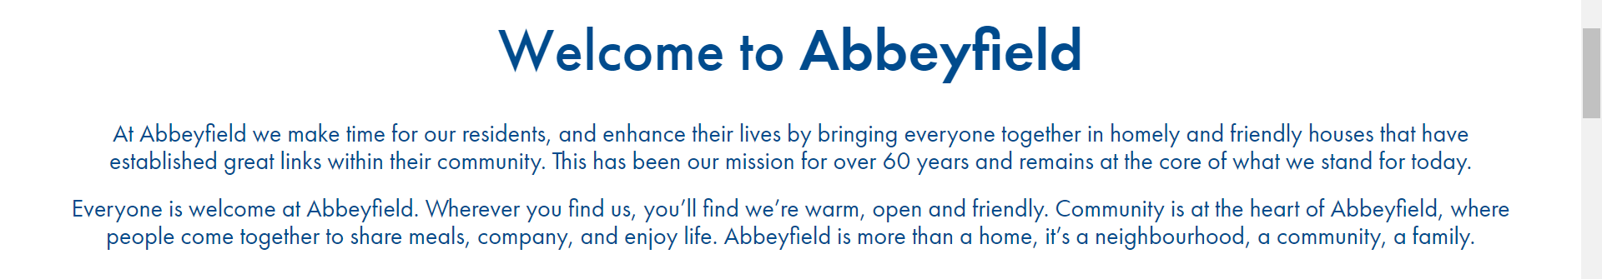(Abbeyfield | Here’s To Enjoying Your Retirement Years, n.d.-b)

Section A: Guiding Principles
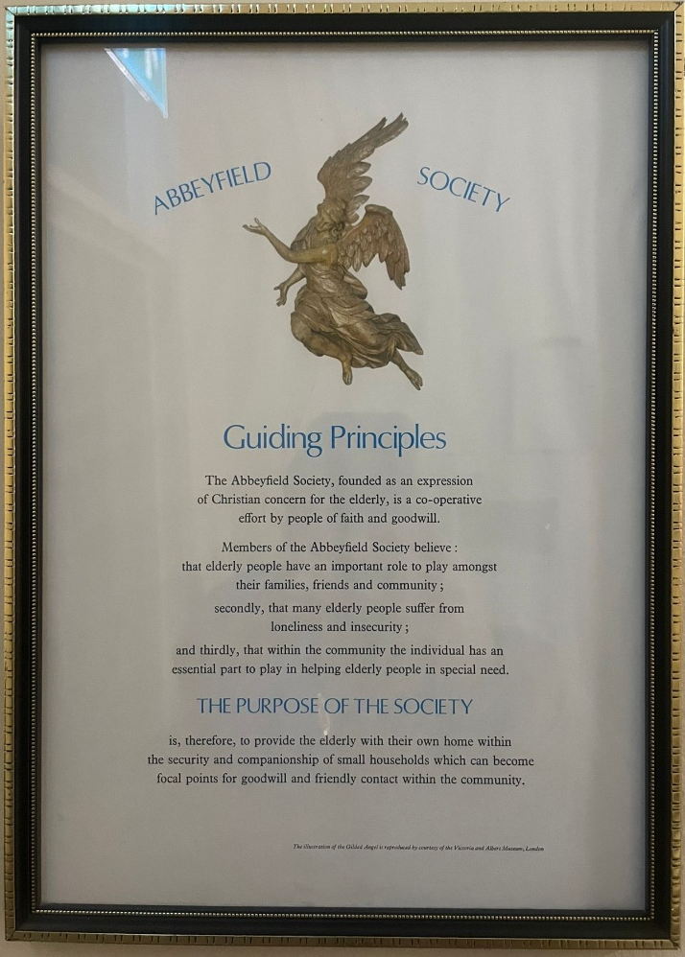
Abbeyfield’s Guiding Principles are based on reducing loneliness, encouraging community and respect for the elderly. Focus is not only on building relationships and creating a safe environment for individuals to thrive within the community but increasing self-esteem and autonomy. In keeping with Roger’s (1959) humanistic approach.
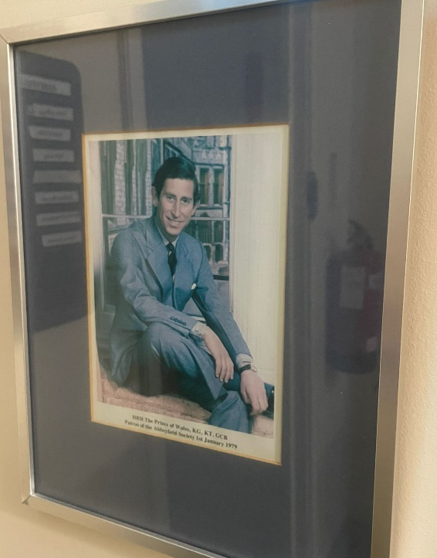
(

(Photograph of Guiding Principles)
His Royal Highness, Prince Charles, Patron of Abbeyfield Society

(Photograph of picture of the patron of the Abbeyfield Society)

Section B: Abbeyfield’s Heritage
Abbeyfield strongly believe that inclusion into a positive community helps combat loneliness. They also value relationships and creating a nice environment to promote health and well-being. This approach is reflected in studies of older people’s care (Siette et al., 2020; Campbell et al., 2021).

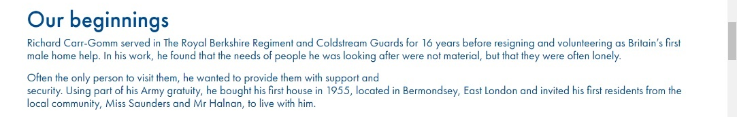
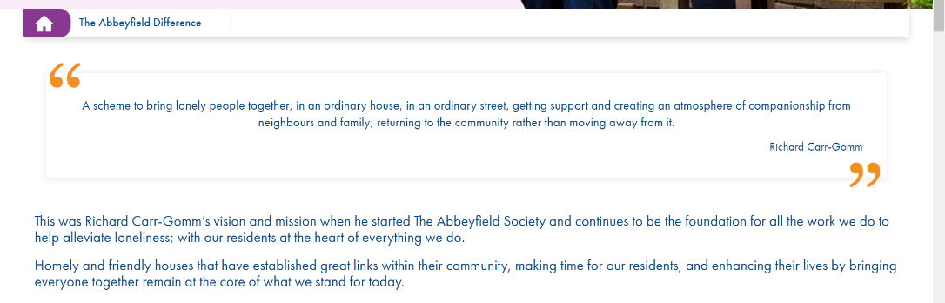
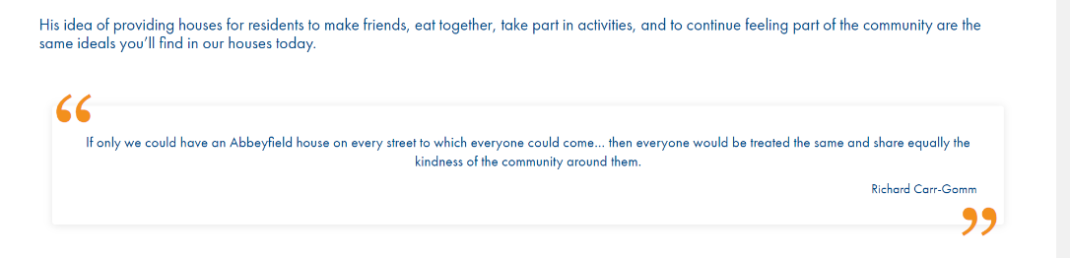

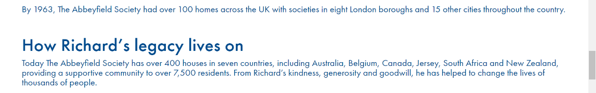
Richard Carr-Gomm’s work is very inspiring. He started off small but ended up making a huge, lasting impact. Showing how ordinary people can extraordinary things, the power of kindness and helping others.

(Abbeyfield | About Us - The Abbeyfield Difference, n.d.)

Section C: Independent Living
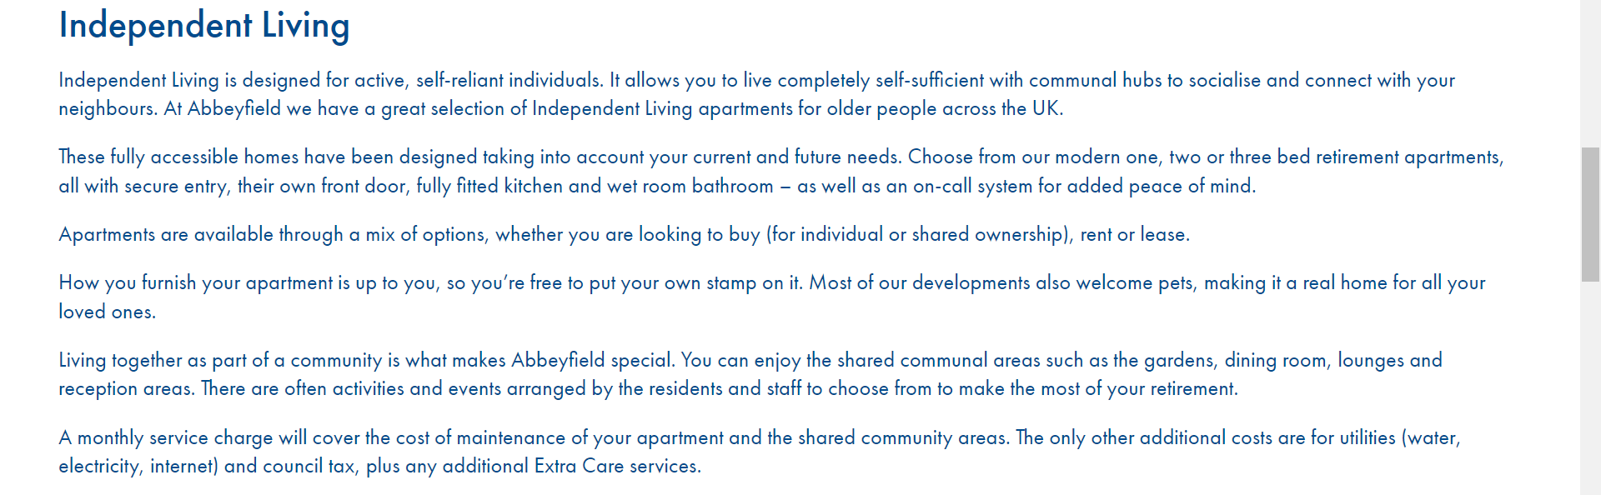
(Independent (Senior) Living | Retirement Communities | Abbeyfield, n.d.)
Another core principle of Abbeyfield Swansea is to promote and encourage independence; found to be a vital component of older people care (Hillcoat-Nallétamby, 2014; Altomonte,& Munson, 2021).

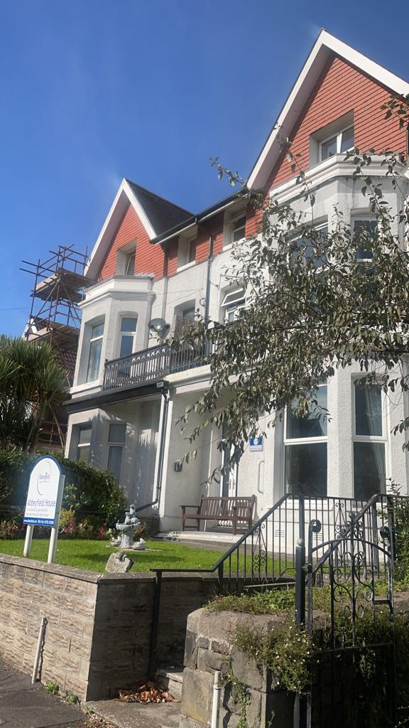

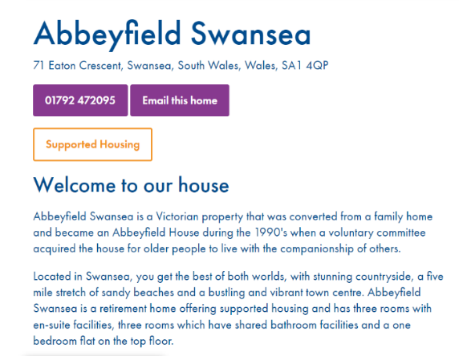

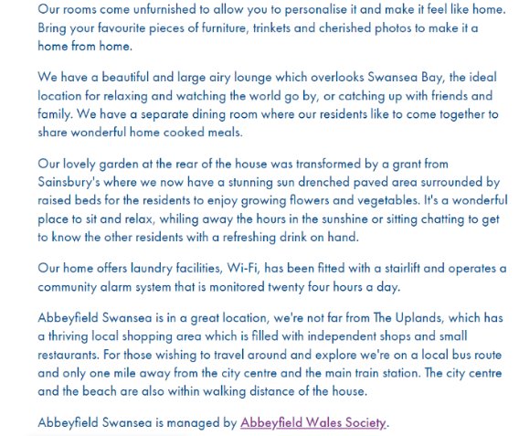

(Photograph of Abbeyfield Swansea) (Supported (Sheltered) Housing in Swansea, South Wales | Abbeyfield Swansea | Abbeyfield, n.d.)

Evidence 2:
Reflective Logs

Student Name: | Eliesha Day
Name of Host Employer: | Abbeyfield Swansea
Date: | 12/10/2021
Tasks completed: | - First day of placement  - Introductions
Reflection: | I was relieved to secure a placement as I was feeling anxious about being the only person unprepared, having joined second year as a new student. I was tempted to go back into my comfort zone, return to a domestic abuse service where I have previously worked. The unknown of assisted living environment was unnerving, and I was feeling anxious. Worried that I was incapable of relating or connecting with the residents. I noticed the home itself was warm and homely, a peaceful environment – a contrast to DV environment where safety is always a concern and often urgent, high alert. I met the manager and the cook and immediately felt relieved to have the introductions over – felt calmer. I was keen to introduce myself to the residents and blend in. I met a few the residents and was shown around the house. I sensed some reservation from the residents, perhaps I was aware of my own insecurity too. I spoke with the manager, and she discussed policy and explained the independent living and gave examples of the importance. I was relieved to discover that policies were like those of Women’s Aid and felt comfortable and more capable.

Date: | 21/10/2021
Tasks completed: | - Assisting at mealtimes  - Socialising with residents
Reflection: | Second placement day, I feel more confident as I now know what they expect from the house and where things were and had introduced myself to as many residents as I could on my first day. I am excited to be attending again and feel privileged to be attending again, especially as covid-19 had been putting a stop to in person placements. I helped with lunch as it provided an opportunity to meet all the residents as they all sit around the dining table for mealtimes, an important part of the day. I felt that it helped me to be more familiar with the residents, especially helping deliver and prepare the food. After lunch, I thought it would be nice to sit in the living room, assuming everyone else would join. One resident ‘E’ was watching the news, so I asked if she minded me joining her. She asked me when the interviews would be starting. I realised that the residents must have been discussing between themselves and assumed why I was there. I felt it was important to clearly state my reason for being there, aware of the impact that the thought of being interviewed may have had on interactions between myself and residents. Also, how approachable I was. Later in the afternoon I was told that ‘E’ likes to watch the news after lunch by herself, other residents do not join her as she likes to have this time alone. I was aware that although this was not a ‘rule’ it appeared to be part of a routine and I made a mental note to not disturb this part of her day myself next time. She was friendly and talkative, but I thought it would be best not to disturb this part of her day if I wanted to build a rapport.

Date: | 09/11/2021
Tasks completed: | - Assisting at mealtimes  - Socialising with residents
Reflection: | I am more aware of the routine of the house, conscious of keeping within the waves of routine and avoid disrupting daily routines but also putting myself out there to be able to build relationships with residents. I found it most helpful if I joined them in a communal area, such as the living room. This afternoon I noticed ‘J’ and ‘E’ were sat in the living room, I checked that I was not disturbing them and asked if they minded me joining them. They appeared to be grateful for me checking rather than just barging in and sitting down. ‘J’ appears to be the matriarch of the home, she lays the table every evening for dinner and is very aware of the goings on, checking in on each resident. This was reflected in her discourse with myself, asking me questions about my background and life. I felt it was best to just be present with them both, at times we sat in silence, but I was surprised how relaxed I felt, I did not feel the need to fill the silence as I felt that being together was a ‘communication’ choosing to sit with each other. I reflected questions back to ‘J’, she was very proud to tell me about her family. I noted she reeled off each family member and how often they visit or called. This seemed to be very important to her and I felt that this was maybe a contrast to other residents. ‘J’ and ‘E’ told me about their friendship, they felt connected through their experiences during in the war. They told me how both their families dealt with the difficult and scary times, explaining that some families would take a bus from the centre of town to the outskirts and sleep rough, to avoid any bombings through the night. It really struck me how little I knew about the local experience of the war, instead of a more general view. It really impacted me hearing their experience and made it more real, hearing their personal experiences. I was grateful for them sharing this with me and felt it built rapport.

Date: | 18/11/2021
Tasks completed: | - Assisting at mealtimes  - Socialising with residents
Reflection: | Today I met ‘D’, he introduced himself and immediately told me he was married but his wife lived in another care home. It struck me that he was immensely proud to be married and loved his wife. As I am a lover of love, I asked how they met. I was aware of the situation as to why his wife why was living in another care home, as the manager had given me a small amount of background information of each resident, which I was grateful for, as I was concerned about discussing anything that may be triggering or upsetting for them. I was impacted by ‘D’s background story and felt even more so when hearing how they met and their life now. ‘D’ told me that he married his wife at a local church, described his wedding day in detail and his eyes lit up and his body language changed considerably. He appeared lighter and animated. ‘D’ told me that he honeymooned to Paris and appeared happy to recall these memories. I felt very present and connected with ‘D’, as I love to discuss people’s relationships and am an old romantic. ‘D’ told me that he visits his wife as much as possible, they like to go swimming together. I discussed the logistics of this as he must travel by bus. ‘D’ told me he loves to colour, and I suggested that we could arrange an afternoon of colouring if management were happy to allow it. This seemed to have a big impact as later in the afternoon ‘D’ brought down artwork he had painted and seemed delighted by my reaction. After clearing with management, I suggested that we have a colouring afternoon on my next visit. I used dinner time as an opportunity to let all the residents know and ensure everyone felt included.

Date: | 19/11/2021
Tasks completed: | - Art Activity
Reflection: | When I arrived today, I noticed that there were a few bits of colouring already set up in the living and it was a welcome sight, it made me happy. I popped into the dining room at lunchtime to let the residents know I was there and encourage the residents to join if they wanted to. ‘D’ appeared very excited and had already set up in the living room, another resident ‘Da’ was being encouraged by the manager and housekeeper to join in but she was very reserved. I felt it was best to make sure that everyone felt invited and welcome to join in, but not pressured. Every other resident said that they either had other plans or did not feel up to joining, others said they didn’t enjoy colouring in or art. I jumped on this opportunity and asked what activities they would prefer to do, discussing different options. I was pleasantly surprised to find ‘Da’ in the living room after lunch. I acknowledged and encouraged her, but felt it was best not to disturb her. ‘D’ and I sat in the window and shared colouring pencils, this seemed to open a conversation easily, as he seemed proud to share with me. We continued discuss his relationship with his wife, which appears to be his favourite subject. At one point he brought up working in France and I reflected to his honeymoon in Paris, this appeared to be appreciated by ‘D’ as seemed that he felt seen and heard by me. He opened up a little more. I got to witness ‘D’ and his wife together as she was visiting that afternoon. I noted that he was very excited and would jump up to check if she was arriving with each car that went past. It was wonderful to witness them together, especially after learning more about the tough times they have faced as a couple. Their love was tangible, gentleness with each other which brought emotion out in myself, and I was careful not to show how emotional I was, but I had to hold back tears. Due to this visit, at times, ‘Da’ and I were alone in the living room. She had continued to paint all afternoon; I would give her compliments and encouragement but was careful not to be too intrusive. Often, we sat in silence and coloured and painted. I felt that this was enough, to be present, I felt connected to her, in each other’s company. This was a new experience for me, as I generally feel pressure to fill silences. However, I had learnt the impact of listening ang being present, letting conversation flow, rapport to build; or in this case, being present. ‘Da’ asked if she could give me a painting she had done, I was very touched, and expressed me appreciation and joy. Towards dinner time other residents joined us in the living room and encouraged ‘Da’. It was then I discovered that ‘Da’s Mother had been a painter and the residents appeared very proud of ‘Da’ and expressed their wish to see her paint more as they were very impressed. ‘Da’ seemed grateful but still shy and reserved. It was a wonderful day, very emotional for me. I was told by the house manager that ‘Da’ continued to spend more time in the living room painting over the next few days, when she usually spends most of the day in her room.

Date: | 29/11/2021
Tasks completed: | - Assisting at mealtimes  - Socialising with residents  - Assisting a resident with IT difficulties
Reflection: | My first ethical issue today, one resident asked me if I could help connect her smart watch to her phone. I sat with her and went through the instructions step by step. I have not had a lot of contact with this resident, only briefly at mealtimes. It was lovely to have a simple conversation with her and I encouraged her as I showed her how to set up the app and tried to build her confidence. Later, ‘S’ approached me and asked if I could help set up her online banking, I explained that this was not appropriate, and I would not be able to due to data protection. ‘S’ stated that she had asked someone before and they had helped her do this, she appeared insulted. I gently explained there it was dangerous to share personal information such as bank details and passwords with anyone and suggested that she contact her bank or pop into a branch to ask for further help. ‘S’ still appeared deflated but stated that she would try going into the bank. I reported this to the manager immediately. I was disappointed to have to let ‘S’ down and it showed me how ethics can be difficult in a real-life scenario, as although there are guidelines for a reason, it can have an impact on building rapport, as you are not meeting an expectation, even if the expectation is unethical.

Date: | 17/01/2022
Tasks completed: | - Meeting with house manager  - Socialising with residents  - Pet Visit
Reflection: | Brief meeting with house manager, discussed placement so far and requirements for portfolio. Discussed risks of burn out within a care setting and ways to manage this. The house manager shared their own experience and discussed the extra pressures and difficulties that Covid-19 has presented. Discussed how Covid-19 has impacted the residents and changed the house dynamics, some residents have become more isolated and withdrawn whereas others have continued to socialise and continue their regular activities within the community. The house manager shared that although this is good there is a difficulty balancing the risk of Covid-19 being brought in by the residents. I shared my frustration of not being able to attend over Christmas, meaning I could not fulfil the plans I had arranged with the residents of gingerbread decorating, having made the decision not to attend as Covid-19 cases were rising and felt it was safer not to attend and risk a resident catching Covid-19. I feel that I have let the residents down as they seemed to be looking forward to doing some festive together as a group and gingerbread decorating was agreed upon as a group. After the art activity I was excited to arrange an activity that seemed to be of interest to every resident. This reflects my personal feelings on the impact Covid-19 has had on my personal life, having to cancel plans and make difficult and disappointing decisions, in the hope that this will protect others. I had been told by residents and staff that they enjoy it when the next-door neighbour’s cat or a staff member’s dog visits. I brought my own dog, Harri, in, agreed to through the house manager, and was pleasantly surprised at the reaction. Each resident appeared excited and joyful interacting with Harri. Whilst sat in the communal living area, other residents joined and stroked him and fed him treats. It really warmed my heart to see this reaction and how this then impacted the resident interactions with each other. Some residents shared memories of their own pets, others asked questions about Harri. It was nice to experience such a joyful moment, that brought everyone together. It has motivated me to research pet therapy.

Evidence 3: Volunteering Process
Section A: Policies

Safeguarding Vulnerable People Policy (Abbeyfield, 2021)
Full policy available on request
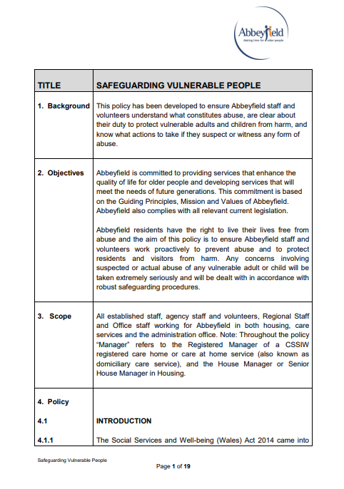
During the placement, the house manager and I discussed policies in theory and in practice. Sharing previous experiences of ethical issues and boundaries and acknowledging how important policies are for guidance and structure within a care setting. However, this is also relevant within a counsellor role (Amis, 2017).

Personal Risk Management Policy (Abbeyfield, 2019)
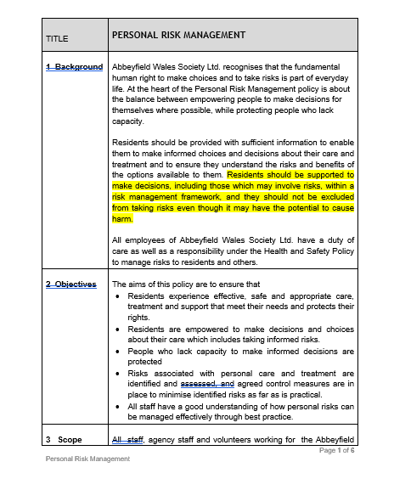
Full policy available on request

Staff at Abbeyfield appear to prioritse the autonomy of the residents however care needs sometimes impacted decisions, a constant balancing act between assessing capacity and encouraging independence (Moilanen et al., 2020).

Behaviour That Presents Risk Policy (Abbeyfield, 2019)
Policies are not only for resident safety but also safety of staff. An integral part of training and a beneficial for building confidence within a care setting role. Highlighting the importance of contracting and accessing risk within a counsellor role (Wheeler et al., 2004).

TITLE | BEHAVIOUR THAT PRESENTS RISKS
1 Background | Occasionally, staff may need to respond to behaviour that presents risks and will need to ensure residents are treated with dignity and respect at all times and are protected from the risk of harm or abuse.
2 Objectives | Abbeyfield is committed to providing services that enhance the quality of life for older people and developing services that will meet the needs of future generations. This commitment is based on the Mission and Values of Abbeyfield. Abbeyfield will also comply with all relevant and current legislation.  If a resident displays behaviour that presents a risk to themselves or others, staff will respond sensitively and appropriately to the situation ensuring that the individual resident concerned, and others who may be affected, are properly supported and protected.
3 Scope | All established staff, agency staff and volunteers working in the care home; regional staff; staff based at head office.
4 Policy  4.1  4.1.1  4.1.2  4.1.3  4.1.4 | UNDERSTANDING BEHAVIOUR THAT PRESENTS RISKS  It is important that staff understand the value of meaningful activity, a stimulating environment and effective communication in preventing behaviour that presents a risk. Whilst for some people boredom may trigger behaviour that presents a risk, over stimulation and too much going on can also trigger such behaviour.  Behaviour that presents risks may include actual or threatened violence to self or others, and abusive or inappropriate behaviour or language that can cause harm or distress to others. This type of behaviour is sometimes referred to as challenging behaviour.  Staff should understand what factors may cause an individual to display such behaviours. The following list, which is not exhaustive, includes some of the factors that should be considered:  - Physical or mental ill health  - Personal unhappiness or distress  - Difficulty communicating  - Frustration and anger  Certain triggers may result in behaviour that presents risks such as the time of day, particular situations or people, or specific incidents or events. Once identified, causes or triggers can be controlled or eliminated and meaningful strategies can be developed for reducing the incidence of the behaviour and for managing potentially difficult situations effectively and appropriately.
4.2 | RESPONSIBILTIES OF THE HOME MANAGER  The Home Manager is responsible for ensuring that:  - Residents are not placed at risk of harm or abuse.  - A risk assessment is carried out where there is reason to believe that a resident may display behaviour that presents a risk to themselves or others.  - Risk assessments identify likely causes and triggers of behaviour that presents a risk.  - Appropriate strategies are formulated, with the assistance of other health professionals as necessary, to manage behaviour that presents a risk in a manner which preserves dignity and self-respect.  - Where a resident is known to sometimes behave in a manner which presents a risk to themselves or others, their care plan should contain sufficient information to enable staff to reduce or eliminate probable causes or triggers of the behaviour and to respond appropriately.  - Restraint is never used except as a last resort, and where restraint is being considered as the only option, staff must refer to the home’s policy on the Appropriate use of Restraint.  - All staff receive sufficient instruction, training and information to enable them to deal with behaviour that presents a risk sensitively and appropriately.  - All incidents of behaviour that presents a risk are properly recorded and individual care plans are updated following every incident of such behaviour.  - The CSSIW are informed of any incident which adversely affects the wellbeing or safety of any resident.  - Serious incidents resulting in abuse must be referred to external agencies e.g. the Police, the local Social Services Department, the local safeguarding team, as soon as possible.  - The individual care needs of each resident are properly monitored and reviewed to ensure that the care home is meeting their needs effectively.  - Residents who display behaviour that presents a risk to themselves or others have ready access to the services of all available health care professionals to ensure that their needs are being properly met.  - Staff have the opportunities to talk about how they prevent and manage behaviour that presents a risk with others so that learning is shared and the risk of further incidents is reduced.  - Where an individual resident repeatedly displays behaviour that presents a risk to themselves or others and which becomes unmanageable, the manager may seek to assist the resident to find more suitable alternative care and accommodation. The manager will only pursue this course of action once all available options have been exhausted.  - Serious incidents are reported to the Regional Operations Manager responsible for the care home as soon as possible
4.3 | RESPONSIBILITIES OF STAFF  Members of staff are responsible for ensuring that:  - All incidents of behaviour that present a risk, however minor, are reported to a senior member of staff.  - All incidents of behaviour that present a risk are recorded in an accurate and objective manner in the resident’s care planning records in accordance with the homes’ recording procedures.  - Any concerns about actual or potential behaviour that presents a risk are reported to the senior member of staff on duty.  - They participate in any training activities that may assist in understanding and managing behaviour that presents a risk.
5 Finance, Value for Money & Social Value | TBC
6 Supporting  Appendices | Resident’s ABC Behaviour Monitoring Chart
7 Linked  Policies | Appropriate Use of Restraint  Incidents and Significant Events  Safeguarding Vulnerable People and Dealing with Abuse
8 Legislation / Regulation | Section 20 regulations of the Health & Social Care Act 2008  Essential Standards of Quality and Safety  Outcome 4: Care and welfare of people who use services  Outcome 7: Safeguarding people who use services from abuse
9 Review | Every 3 years, subject to any regulatory or legislative updates.
10 Procedure/  Guidance | MANAGING BEHAVIOUR THAT PRESENTS A RISK
10.1 | When dealing with behaviour that presents a risk, the safety of the resident concerned, and other residents, staff, volunteers or visitors who may be affected must be paramount. If safety is in doubt, immediate assistance should be summoned.  Where the potential for behaviour that presents a risk has been identified in a resident’s care plan, staff should be familiar with the assessed needs of the resident and the agreed strategies for managing the behaviour.  When responding to behaviour that presents a risk, staff should:  - Always remain calm and show respect for the person concerned  - Never display aggressive behaviour regardless of how threatening a situation may seem  - Seek to understand the behaviour and the reason(s) for it  - Be aware of physical closeness - never invade personal space  - Keep posture, facial expression and gestures relaxed  - Be aware that eye contact and/or staring can be perceived as aggressive or threatening  - Listen to what is being said and not respond to anger or personal insults etc.  - Try to identify the core problem and ask open questions  - Sympathise with the resident’s problem.  - Try to provide an opportunity for the resident to become calm  - Offer the resident an opportunity to talk with a member of staff at another time.  - If there is no change in the resident’s behaviour, leave the room/area and report the incident to a senior member of staff.  Repeated incidents of behaviour that presents a risk should be monitored to look for previously unidentified triggers. ABC charts are widely used for this purpose. An ABC chart is used to record the date and time of day of the behaviour and three following elements:  - Antecedent – what happened immediately before the behaviour  - Behaviour – what the actual behaviour looked like  - Consequence – what happened after or as a result of the behaviour including who was at risk.  Incidents of behaviour that present a risk should be recorded in accordance with the Incidents and Significant Events policy and procedure.
11 Supporting  Appendices | Resident’s ABC Behaviour Monitoring Chart


Section B: Art Afternoon
Beautiful painting by resident ‘Da’, gifted to me, which I will treasure. Verbal consent given to share in portfolio.
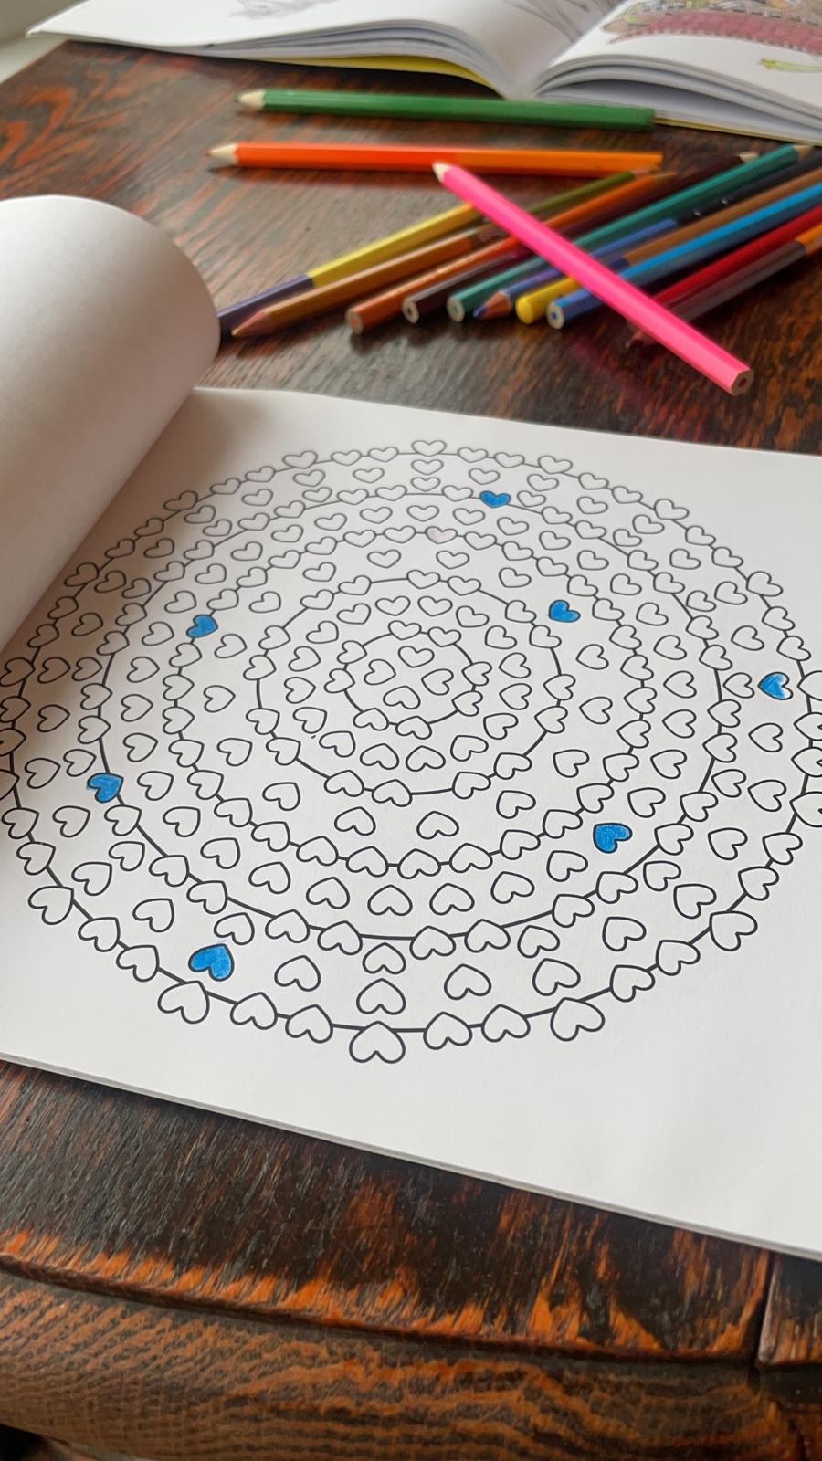
(Photograph of colouring book)
(Photograph of painting by resident)
My own colouring. I was surprised how relaxing this activity was and how I quickly got into a state of thought flow, reflecting Csikszentmihalyi's (1990) flow theory (Ilies et al., 2017).

Section C: Other Activities
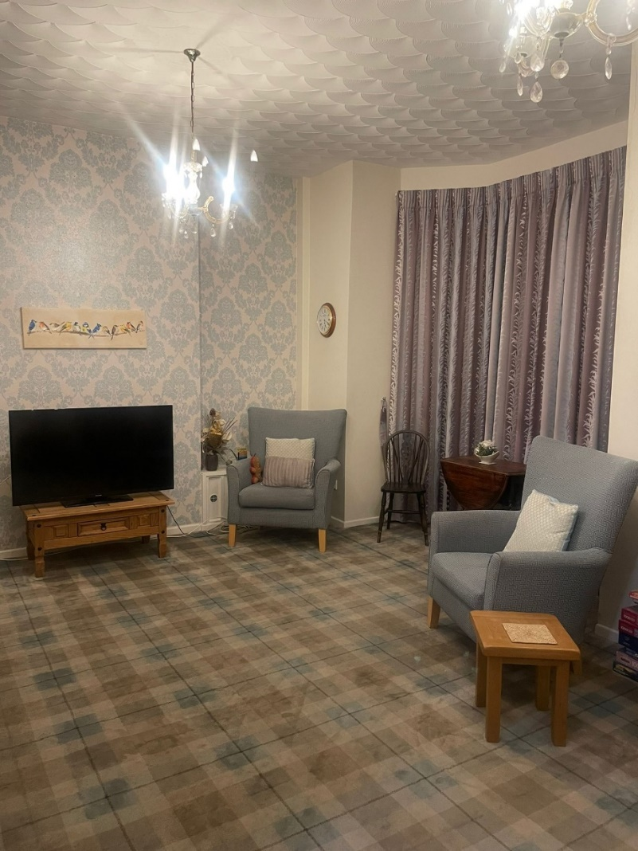

(Photograph of Harri)
(Photograph of communal area)
Harri, the ‘therapy dog’.
A very welcomed visitor. Even the most reserved residents appeared delighted to see him and confidently approached him. I noted that everyone smiled and laughed when they interacted with him and appeared brighter after.
Most of my time is spent in this communal living area. I quickly learnt the routine of the residents, knowing when to avoid this space as not to disturb a resident’s routine such as watching the news and when to join in. Before mealtimes residents sit in the living room and socialise together, again, another subtle part of the daily routine.
References

Abbeyfield | About Us - The Abbeyfield Difference. (n.d.). Abbeyfield. Retrieved January 18, 2022, from https://www.abbeyfield.com/the-abbeyfield-difference/
Abbeyfield | Here’s To Enjoying Your Retirement Years. (n.d.-b). Abbeyfield. Retrieved January 18, 2022, from https://www.abbeyfield.com/
Altomonte, G., & Munson, A. B. (2021). Autonomy on the horizon: comparing institutional approaches to disability and elder care. Theory and Society, 1-29.
Amis. (2017). Boundaries, power and ethical responsibility in counselling and psychotherapy. SAGE Publications Ltd.
Campbell, M., Stewart, T., Brunkert, T., Campbell-Enns, H., Gruneir, A., Halas, G., ... & Doupe, M. (2021). Prioritizing supports and services to help older adults age in place: A Delphi study comparing the perspectives of family/friend care partners and healthcare stakeholders. PloS one, 16(11), e0259387.
Csikszentmihalyi, M. (1990). Flow: The psychology of optimal experience.
Hillcoat-Nallétamby, S. (2014). The meaning of “independence” for older people in different residential settings. Journals of Gerontology Series B: Psychological Sciences and Social Sciences, 69(3), 419-430.
Ilies, Wagner, D., Wilson, K., Ceja, L., Johnson, M., DeRue, S., & Ilgen, D. (2017). Flow at Work and Basic Psychological Needs: Effects on Well‐Being. Applied Psychology, 66(1), 3–24. https://doi.org/10.1111/apps.12075
Independent (Senior) Living | Retirement Communities | Abbeyfield. (n.d.). Abbeyfield. Retrieved January 18, 2022, from https://www.abbeyfield.com/independent-living/
Moilanen, T., Kangasniemi, M., Papinaho, O., Mynttinen, M., Siipi, H., Suominen, S., & Suhonen, R. (2020). Older people’s perceived autonomy in residential care: An integrative review. Nursing ethics, 0969733020948115.
Rogers, C. R. (1959). A Theory of Therapy, Personality, and Interpersonal Relationships: As Developed in the Client-Centered Framework. In S. Koch (Ed.), Psychology: A Study of a Science.
Siette, J., Georgiou, A., Brayne, C., & Westbrook, J. I. (2020). Social networks and cognitive function in older adults receiving home-and community-based aged care. Archives of gerontology and geriatrics, 89, 104083.
Supported (Sheltered) Housing in Swansea, South Wales | Abbeyfield Swansea | Abbeyfield. (n.d.). Abbeyfield. Retrieved January 18, 2022, from https://abbeyfield.com/supported-housing/abbeyfield-swansea-in-swansea-at-sa1-4qp/
Wheeler, Bowl, R., & Reeves, A. (2004). Assessing risk: confrontation or avoidance-what is taught on counsellor training courses. British Journal of Guidance & Counselling, 32(2), 235–247. https://doi.org/10.1080/03069880410001697288

Appendices
Appendix A
Placement Information Form

Placement Information Form
Name of Student: | Eliesha Day
Proposed Placement Setting and Address: | Abbeyfield Swansea – Supported Housing  71 Eaton Crescent, Swansea, SA1 4QP
Proposed Dates of Placement: | 4th October – Jan 2022
Name of Contact for Venue:  Please also state their position: | Sharon Davies  Manager
Email Address: | Sharon.davies@abbeyfieldsw.co.uk
Telephone Number for Contact at Placement: | 01792 472095
Is a DBS required for you to attend this placement? | - Yes  - No  (Possibly, awaiting confirmation)  If Yes, have you applied for this?  - Yes applied on _________________  - No
Explain how your role in this organisation/on this placement meets the criteria for the assessment for the module | (e.g., what duties/tasks will you be undertaking that are relevant for the module assessment)  Supporting the residents with daily activities, encouraging independent living. Mental health and well-being support. Opportunity to experience professional boundaries and sign posting. Assisting in preparation of meals and with housework.
ALL information must be provided. Incomplete forms will be returned to the student.
Please return this form to Ruth Groff (ruth.groff@uwtsd.ac.uk)
Points for submission:
Wednesday 21st July
Wednesday 1st September
FINAL opportunity to submit Wednesday 22nd September

Appendix B
Email confirmation – Verbal confirmation given in person

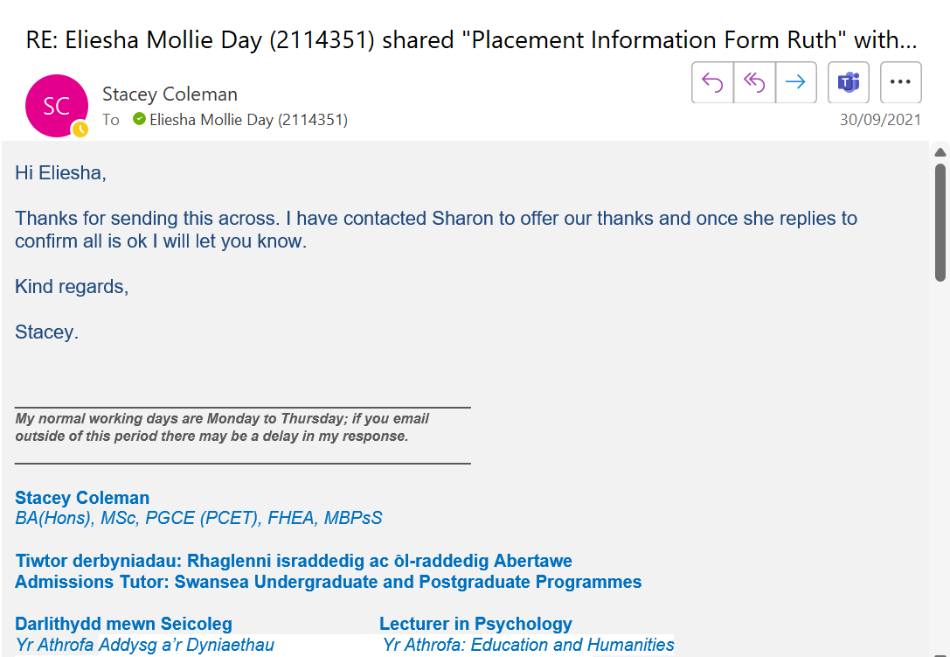

Appendix C
Email confirmation from Sharon
Note: Verbal agreement enquiry led to agreement for placement, no email thread available.
House manager confirmed via email.

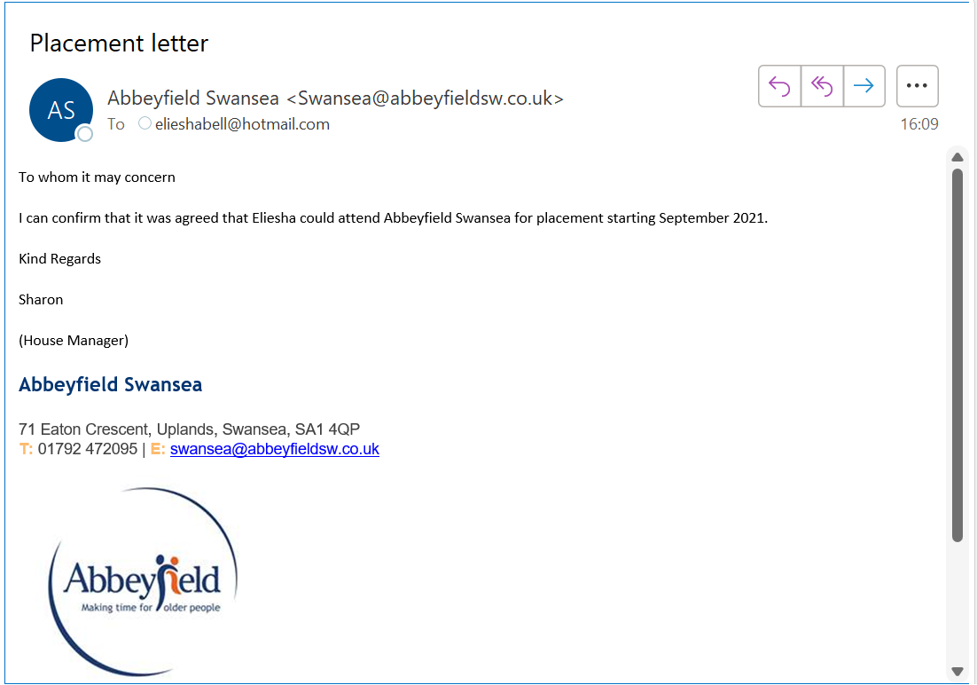
Appendix D
Record of attendance form

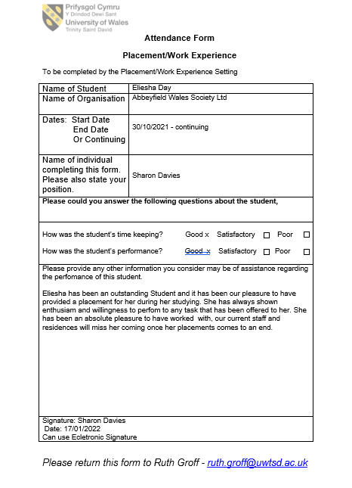
Appendix E
Attendance logged through Reflective Log
Date | Hours
12/10/21 | 7
21/10/21 | 7
09/11/21 | 6
18/11/21 | 5
19/11/21 | 5
29/11/21 | 6
17/01/2022 | 2
Total | 38

