Jack Harries
155847

Environmental Protection and Sustainable Manufacturing Systems
Research Report
Kadi Berry

Contents
Abstract 2
Introduction 2
Vapour Recovery Units (VRU) 3
How it Works 3
Process Flow 4
Methods Involved to Reduce Energy Loss 5
Task 2 – Treatment of Waste Water and Chemicals 8
Bibliography 10

PCPO4003
Environmental Protection and Sustainable Manufacturing Systems
Research Report

Task 1 – Vapour Recovery units (VRU)

Abstract
In this research study, we find out how a vapour recovery works how to saves energy to an industry. A vapour recovery unit is a system used on petrochemical sites which aims to lower emissions coming from gasoline or other fuels while recovering hydrocarbons to be sold or reused on the site. There are a few types of VRU and in this report we compare the standard VRU, and the newly engineered ‘Distribution Terminal Line’ (DTL) Vapour Recovery Unit. The standard VRU unit is more commonly found on petrochemical sites, whereas the DTL VRU is only recently being introduced. Following research into the two, a conclusion was come to and it was clear which VRU is the better option.

Introduction
A vapour recovery unit, otherwise known as a ‘VRU’ is an engineered unit used on petrochemical sites which aims to lower emissions levels coming from the vapours of gasoline or other fuels while recovering valuable hydrocarbons to be sold or reused as fuel onsite. This engineered unit is designed to capture in the region of 95% of BTU-Rich vapours, which comes with many benefits to the system. There are two main benefits that a VRU provides, firstly there is the profitability and reduced operating costs. Recovered vapours can be re-ejected in oil wells, sent to users, or used as fuel resulting in increased revenue or cost reduction for a facility. The second main benefit is the social and environmental responsibility. Venting is eliminated and emissions of dangerous pollutants are reduced up to 95%. This demonstrates a commitment to social responsibility and environmental protection. There are many applications where a vapour recovery unit can be used on a petrochemical site:
- Truck Loading (RTW)
- Oil Tank Vapours (Storage tank farm)
- Marine Loading Terminals (Jetty)
- Railcar Loading
- Barge Degassing
- Vapour Particulate Filters
(Garo, 2021)

Vapour Recovery Units (VRU)

How it Works
Storage tanks on petrochemical sites use Vapour recovery systems to eliminate any vapours which build up above the liquid in the tank. When crude oil is stored in these tanks, the vapour space above the liquid will become saturated in VOCs to reach equilibrium. When the liquid level changes in the tank through loading and unloading, the vapour space will change.
Vapour must be added to the tank as it gets unloaded (drained) to maintain a positive pressure. If a positive pressure is lost, there is the chance of the tank collapsing. On the other hand, when the tank then gets filled with liquid, the vapours inside must be removed in some way. If the vapours are not removed then the tank can become over pressured and potentially become damaged. Vapour pressure inside a tank can also be changed by the ambient temperature. This can lead to the venting of the VOC saturated vapour to the atmosphere or allow air being let into the tank. An explosive atmosphere can then be formed within the tank if it is rapidly cooled. The VOC containing vapour that is vented through boil-off (hot ambient days) or through loading operations can be recovered and compressed.
This process is based on well-known technology of absorption on active carbon and regeneration of the activated carbon vacuum. Barge, Truck, Rail, Tanks, and ship loading are all well used applications of this process. The design is in place to make it durable, safe and make it an efficient plant process. It is also designed to meet international standards (ISO) which are recognised in the oil and gas industry, such as ASME VIII, ASME B31.3, EN 60079 and EN 1127. Vapour Recovery Units (VRU) are designed to meet all of the health and safety requirements which are set out by the European ATEX and machinery directives. The typical vapours that are treated are:
- Methanol
- Benzene
- Toluene
- Xylene
- MTBE
- ETBE
- Naphtha
- Crude Oil
- Petrol
- Diesel
- Gas Condensate.
(Assentech, N.d)

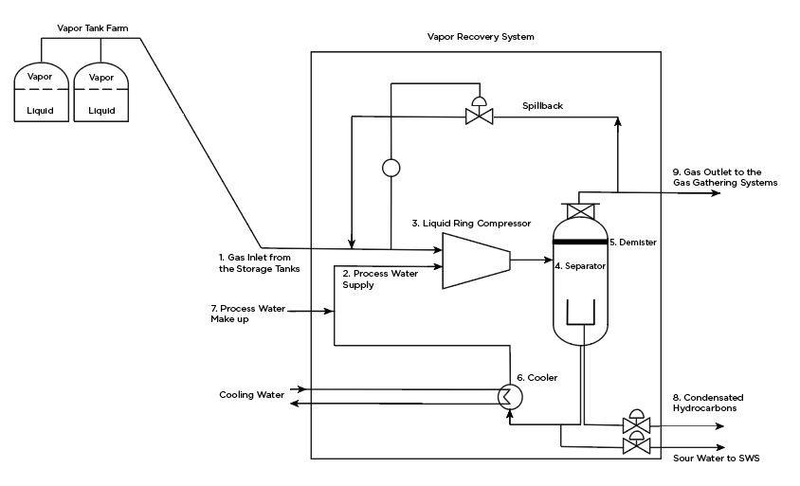
Process Flow
Figure 1: vapour Recovery System
(Garo, 2021)
Figure 1 above shows a simple layout of how a vapour recovery system works for storage tanks on a petrochemical site. First stage of the system shows the gas (1) coming from the storage tank in the tank farm and enters the ‘Liquid Ring Compressor’ (2) aswell as the ‘Process Water Supply’ (3). Once these inlets have passed through the compression phase of the system they then enter the separator (4) where these elements are all parted once again. The gas goes through the demister (5) where any droplets get removed and the gas leaves the top of the vessel dry. Condensed hydrocarbon and water are removed from the vapour stream through the bottom of the vessel through gravity to reduce the gas speed. Once the water leaves the bottom of the vessel it goes through the cooler (6), and is then sent back to the compressor. This process is in constant circulation. In addition to the process water supply, a continuous process water makeup line (7) is provided to the compressor suction to ensure a continuous water ring in the compressor. The condensed hydrocarbons are then discarded or are directed back into the correct storage tanks (8). The gas that leaves the top of the separator then heads to the gas gathering system or back to the storage tanks to be used in the Vapour recovery System again (9).

Methods Involved to Reduce Energy Loss
Loading and unloading chemical, petrochemical, and petroleum terminals, operators strive to find new opportunities to reduce the operation expenditures. The launch of Vapour Recovery Units (VRUs) has not yet been directly related to the reduction of energy and expenditures. In a traditional VRU, the vacuum is regenerated by a vacuum pump. Originally, liquid ring pumps were used, however as years went by there were other vacuum pumps used, such as rotary vine and screw type pumps. A very high proportion of the operation expenses on a traditional VRU is the energy costs to operate the vacuum pumps. Not just the cost of operation, the cost of maintenance when they are to break down. Since the year 2000, there have been no development to the standard VRUs with regards to energy saving and cost reduction.

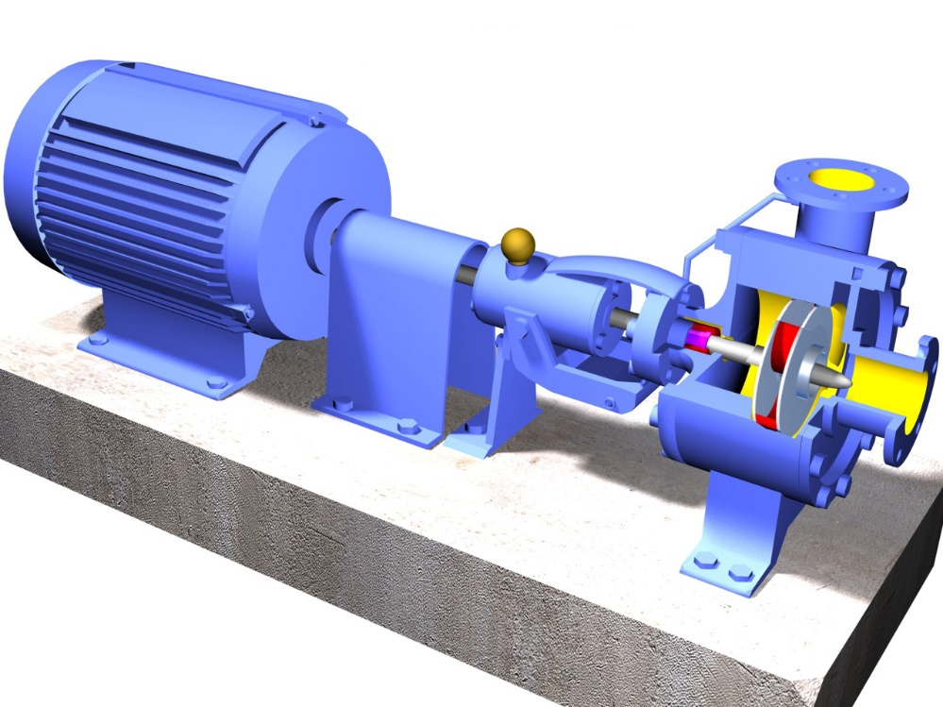
There has been a new generation of VRUs introduced. The distribution of the Distribution Terminal Line (DTL) VRU has started a far superior energy efficiency level. The DTL is a pre-engineered range of VRU, covering the vapour recovery needs in terminals from one to fourteen loading racks or normal VOC vapour capacities of 100 to 6,000m3/h.
Figure 2: Vacuum Pump Model
Distribution Terminal Line (DTL) Vapour Recovery Units (VDU), are a form of VDU in which VOC vapour would be returned from the loading of a ship, and/or includes VOC balancing with the storage tanks. DTL VRUs are the most common form of VRU as it has many energy saving features. The main feature that provides a very high level of energy saving is called the “Absorber to Absorber Equalisation” (ATAE). 20% of energy usage in a power swing VRU is spent by the vacuum system on evacuating the absorber vessels from atmospheric pressure down to 50% vacuum. However, in the DTL VRUs, the absorber vessel which has finalised the regeneration of the activated carbon is still at 90% vacuum, is equalised back to a higher pressure from the other absorber vessel, which is at atmospheric pressure and going into regeneration. The resulting pressure of the two vessels after the equalisation is 45% vacuum. This description is shown below in figure 3.
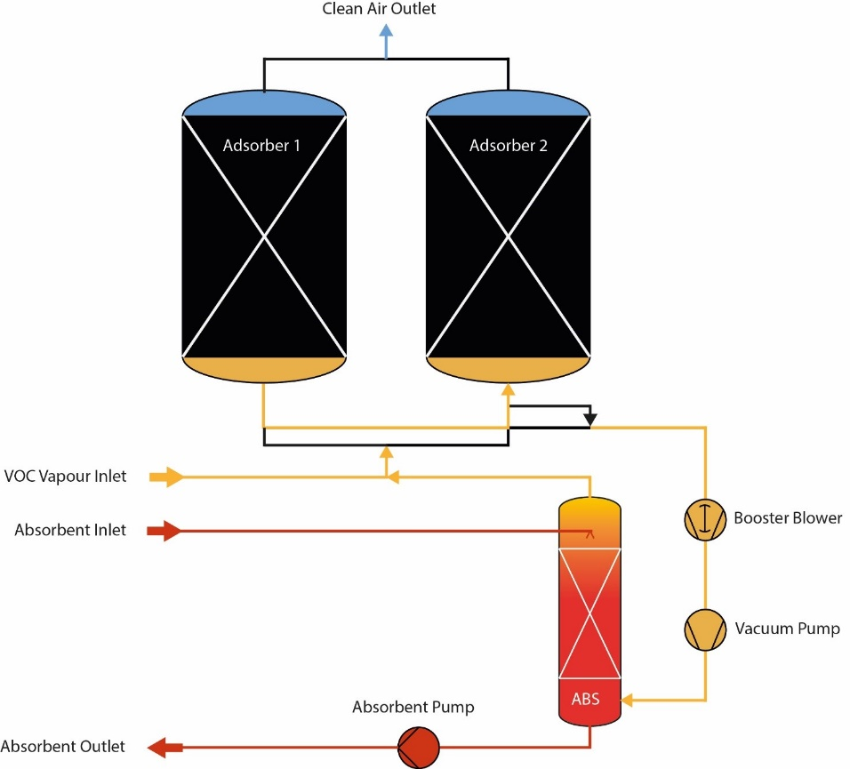
Figure 3: Absorber to Absorber Equalisation (ATAE)
(Assentech, n.d.)
The inert gas which is then located in the second absorber vessel is then evacuated to regeneration, which then takes atmospheric pressure down to 45% vacuum. This vacuum system does not spend any energy. The ATAE energy-saving features which are built into the default DTL VRUs, reduce the energy consumption of the DTL with 20-50% per m3 VOC vapour processed, relative to conventional pressure swing VRUs.
Another example of energy saving feature on a Distribution Terminal Line VRU is the “Emission Control Energy Manager” (ECEM). The ECEM measures the emissions coming from the vent of a VRU. When these emissions reach a pre-set value, absorption switches from one absorber to another. This process then starts the regeneration of the absorber which is saturated with VOC. When loading in a terminal is below design volumes, or the loading mainly involves gas oil or diesel, the absorbers will last longer before saturation and the vacuum system will rest for a longer period.
As oil distribution terminals usually have their peak hours throughout the days, weeks or months, the ECEM will show significant energy savings in the low loading hours. Combining with the optimised vacuum systems, the “Absorber to Absorber Equalisation” and “Emission Control Energy Manager” energy saving features will save a considerable amount of operating expenses or expenditure (OPEX). This is one of the main reasons why a DTL VRU is used compared to a conventional VRU. (Assentech, n.d.)
From carrying out the research above, there is a clear difference to me between the different types of Vapour Recovery Units (VRU). In my opinion, the DTL VRU is the vastly superior form of VRU and I think it should be implemented in many more plants across the world. Research above shows that certain features of the DTL VRUs can reduce the energy consumption by 20-50% of that would be used in a standard VRU. Not only does it use less energy, it is much more cost effective and could save companies a lot of money on running and maintenance costs of vacuum pumps. The main disadvantage to the standard VRU is the use of pumps for the vacuum and how they could be unreliable and costly. My improvement to this system would be to start replacing the standard VRU systems which haven’t been developed in 21 years, and start introducing the newly engineered DTL VRUs much faster to the petrochemical industry.

Task 2 – Treatment of Waste Water and Chemicals
At my Place of work, the monitoring and treatment of waste water is carried out at the ‘Waste Water Treatment Plant’ section of Pembroke Refinery. The operation of Pembroke Plant as whole results in the production of large quantities of contaminated water, typically some 3 million gallons per day. This contaminated water has to be effectively treated in order to bring its quality to within the standards required by Environment agency (EA), before it can be discharged into the Milford Haven waterway. There are 5 main sources to the WWTP and they are as follows:
- Ballast Water
  - Water that is discharged from Ocean going and coastal trading tankers arriving to load petroleum products at the Refinery jetty.
- Process Water
  - Water used in Refinery processes, which may become heavily contaminated with oils, Phenols Ammonia and Sulphides.
- Surface Water
  - Mostly rainwater that has collected in the Refinery storm drains along with water pumped from the West Reservoir.
- Product Tankage
  - Any water accumulation drawn off product tanks located in the Refinery tank farm area.
- Sanitary System
  - Waste from the toilet facilities within the Refinery complex.

After Treatment to the above sources, the WWTP will deliver effluent to the outfall then discharges to the Milford haven waterway, however the conditions of the water must be strictly adhered to. The conditions can be found below.

Temperature | 35⁰C
Suspended Solids | 85ppm
pH | 6 – 9
COD | 270ppm
Sulphides | 1ppm
Ammonia | 20ppm
Phenols | 3ppm
Cyanide | 250 ug/1
Copper [Cu] | 80 ug/1
Nickel [Ni] | 85 ug/1
Zinc [Zn] | 560 ug/1
Oil | 17ppm

(Valero, 2021)

The first stage of the WWTP is the Surge Pond. The surge pond is in place to store grossly contaminated effluent that can’t be immediately treated in WWTP and capture excess volumes. The second stage is then the API separators. The main objective of the API separators is to remove separable oil and solids from the untreated water. This is done by gravity. The separable oil and solids will work their way to the surface, whereas the untreated water will be removed from lower down. As the untreated water is being moved on in the plant, the separable oil and solids are being scraped off the surface. When the untreated water leaves the APIs, it flows to the Dissolved Air Floatation Units (DAFs). In this section, solids and oil particles, attached to air bubbles, rise to the surface of the tanks from where they are collected by a rotating skimmer blade. Heavy particles settle to the base of the tank for collection by a floor scraper. The treated effluent water flows via underflow baffles and adjustable ‘V’ notch weirs to a collection channel around the edge of each DAF unit, which directs the treated water to the equalisation basins. In these basins the water travels through three different zones where chemical processes take place; aerobic zone, anoxic zone, and the molasses system. The water must be moved on from this stage within 18 hours or it will become off spec. After this process, the treated water moves to the clarifiers for a final clean. In the clarifiers, the remainder of TSS is removed in order to meet discharge limits. Once the treated water is then sampled and tests correctly, it then goes to the storm ponds for it to be pumped out to the Milford Haven waterway. Below is an image of how the plant is laid out.
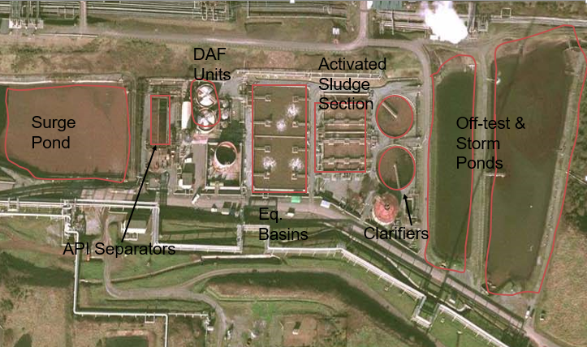
Figure 4: Pembroke Refinery WWTP

(Valero, 2021)
In regards to the disposal of waste and chemicals, Pembroke refinery has procedures in place in order for them to be disposed correctly. When disposing of oils from the units, it’s important that the process fluid goes down the correct raised drains. These drains take the fluid to the sump where it is then taken away by external companies. Same applies for other dangerous chemicals. Pembroke refinery will arrange a collection from external specialist companies to ensure that these chemicals do not harm the environment.

Bibliography
- Garo, 2021. Vapor Recovery Unit - VRU | GARO Engineered Solutions. [online] garo. Available at: <https://www.gardnerdenver.com/en-gb/garo/applications/vapor-recovery-units> [Accessed 31 March 2021].
- Assentech, n.d. Vapour Recovery System UK Petrol-Diesel-Petrochemicals | Assentech. [online] Assentech | The Experts in Tank Storage and Process Safety. Available at: <http://www.assentech.co.uk/products/vapour-recovery-refinery-petrochemicals-vru/> [Accessed 31 March 2021].
- Assentech, n.d. Vapour Recovery Operation Energy Management | Assentech. [online] Assentech | The Experts in Tank Storage and Process Safety. Available at: <http://www.assentech.co.uk/products/vapour-recovery-refinery-petrochemicals-vru/vapour-recovery-unit-operation-energy-management/> [Accessed 31 March 2021].
- Assentech, n.d. Vapour Recovery-Reducing Operational Expenditures Of Standard Vapour Recovery Units In Tank Storage | Assentech. [online] Assentech | The Experts in Tank Storage and Process Safety. Available at: <http://www.assentech.co.uk/products/vapour-recovery-refinery-petrochemicals-vru/vapour-recovery-system-unit-reducing-operational-expenditures-tank-storage/> [Accessed 31 March 2021].
- Valero, 2021. PLANT OPERATOR - WASTE WATER TREATMENT PLANT, PLANT AND PROCESS KNOWLEDGE. 6th ed. Valero.

